DS2 Scenario 1: Green Leaf Grocers
You are helping a small shop called Green Leaf Grocers.
They want to understand which items need restocking.
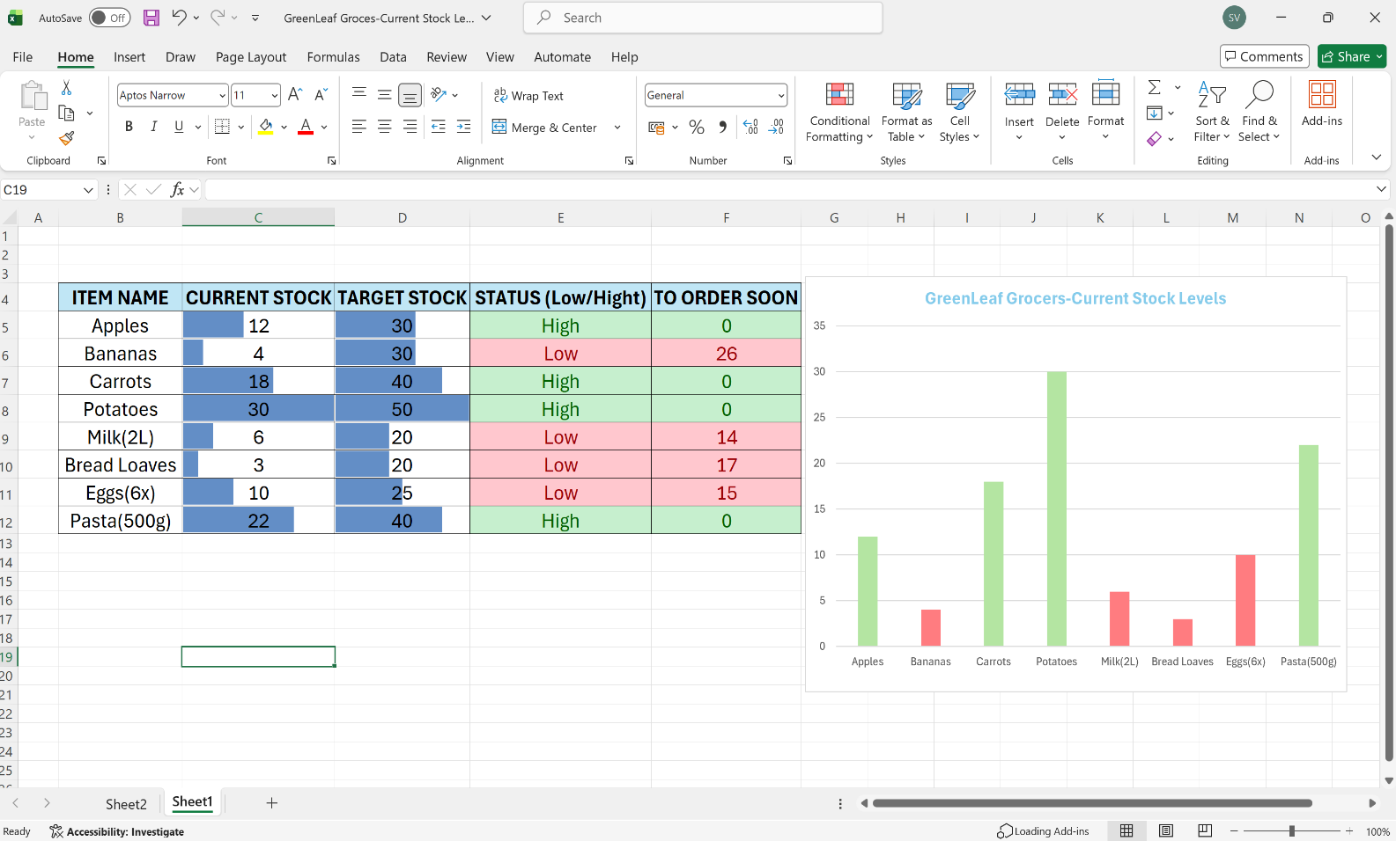

Why you chose your tool?
I chose Excel because helps me to manage inventory and create table with names and number to have clear understanding.
What information you used?
I used inventory data for Grean Leaf Grocers including products name, current levels, target stock levels and stock status.
What changes you made?
I used conditional formatting from Excel to see the level of stock, red for low stock and green for high stock, I created charts for better understanding.
How you improved your work?
I improve my work adding colours to charts to be more easy to understand and identify the products and also to see the level of the stock .

