University of Wales Trinity Saint David

Module name: MARKETING FUNDAMENTALS
Module code: LCBB4004
Student name: DANIELA GABRIELA LISENCHE
Student id: 2029607
Lecturer:TUSHARA BALENDRAN

Blogging to Communicate
Introduction
Mark and Spencer is a retail brand that has many side branches of food, clothing & home, bank & services in the UK and international countries, with their own label brand. 959 stores have been run by M&S in the whole UK and among those stores, food products are available in 651 stores only, it advertises its products through TV and shows off the exclusively luxurious nature of its beverages. It also offers online delivery services by joining hands with Ocado. Mark and Spencer, also known as "Marks and Sparks" or "M&S", had earned recognition for selling British products in the early twentieth century (Marksandspencer. 2021). It started a lengthy relationship with European manufacturers and known for selling fashion wears and also food in the name of "St Michael" brand, launched in the year of 1928 and it had unique technique of sales that if a person can show his/her buying receipt then the person can return the unwanted product whether it's been purchased long ago.

Blog 1:
Best women active wears to pick at Mark and Spencer
Women's active wear isn't only limited to fashion wear, it has turned into a trend. Women are seen everywhere wearing those active wears, celebrities also and the trends have been set by them. They wear it from the gym studios to street runways, from parks to yoga classes everywhere. Many brands offer activewear and gym wear clothes to workout so that they can fit into this multifaceted luxurious lifestyle. These athleisure markets are evolving every day, so it's hard to choose the right sportswear brand and buy. Have you been spending your days in confusion? Do not worry, We Have the best option for active wear which is also fashionable and trendy. To put you in the right direction, We have created a list of the best activewear and athleisure brands, you must shop from. You can find there from comfort workout clothes to smart yoga pants, also if you want to look good you can buy stylish leggings. We Have shortlisted some active wear brands, you can wear them working from home, running errands and even you want to wear them to hang out with your friends. In these fashion wear brands, We would suggest you to buy from Marks and Spencer.

Blog 2:
Styles that you wouldn't miss - best Mark & Spencer new arrivals to check out
Those days are gone that people can take M&S for granted, it's the place you can go for good quality basics. It is most probably at the top of the fashion list when it comes to autumn and winter fashion. We are waiting for the Mark and Spencer Collection, whether it's funky jumpers or winter coats or it could be a leather jacket. They usually provide fashion wear all year but especially their winter and autumn collection is worth waiting for. If you're looking to make a gloomy October day bright by wearing a floral dress then you should go to M&S.
In this frosty weather you're looking for some warmth and comfortable wearings, then you should try out Mark and Spencer's winter sleepwear collection. It can give you a warm hug at the end of your tiring and chilli day, it's that much snuggly. These sleepwears are available in suitable colors for the festive season. We all want to style fashionable trends in every winter, to enhance our style statement and that's why Mark and Spencer is the best choice for winter shopping. We could renew our wardrobe with varieties of their newly arrived winter clothes and fill it up. For your leisure days you can survive your no shower days with a favourite hoodie! On work days you can pair up a long shirt with denims and a pair of boots and this look will take you from day to night. For mood lifting either you can choose a shacket with belt or a cardigan in contrasting colour. M&S will not disappoint you with their collection whether you want to keep a personal style or you want to look vibrant and follow the trend. Their key to success is giving comfort.
Blog 3:
Best places to shop casual wear online in UK
Marks and Spencer or we can say M&S is famous for its quality which is exceptional and style which has elegance with comfort. They always stay in the trend, their fashion style has a uniqueness which no brand has. It has a legacy of 135 years for its large number of fashion wears and a strong sustainability. The company brand believes in sourcing goods reliably because they believe that style has uniqueness and eternal quality. Just like the Earth revolves around the Sun, it also keeps spinning around comfort. People stand outside the stores for hours just to get the new arrivals of M&S and that's their success of quality or profit which they gain from people's trust. Whatever clothes you choose, you will find patterns which are always on trend and the piece of work is full of elegance which makes the brand a luxurious one plus it will give a stylish look and comfortness. Women's Collection Whether you work from home, wear a nightgown or hang out with friends, you can rely on women's clothing to make you feel good. From women's jackets, tops and women's T-shirts, jeans and women's underwear, we always cover you. On days when you need a splash of color, Marks and Spencer women's tops include basic cotton, graphic tees, and printed blouses. Women's jeans are a multi-purpose asset for video calls and meetings. To look slimmer, pair a pair of formal women’s pants with linen buttons at the top for a vibrant and flowing option. The best thing about patterned blouses is that they are flexible for both work and weekends and are easy to put on or off. As an excellent base for colder days, our long-sleeved tops and short women's t-shirts come in many pockets.
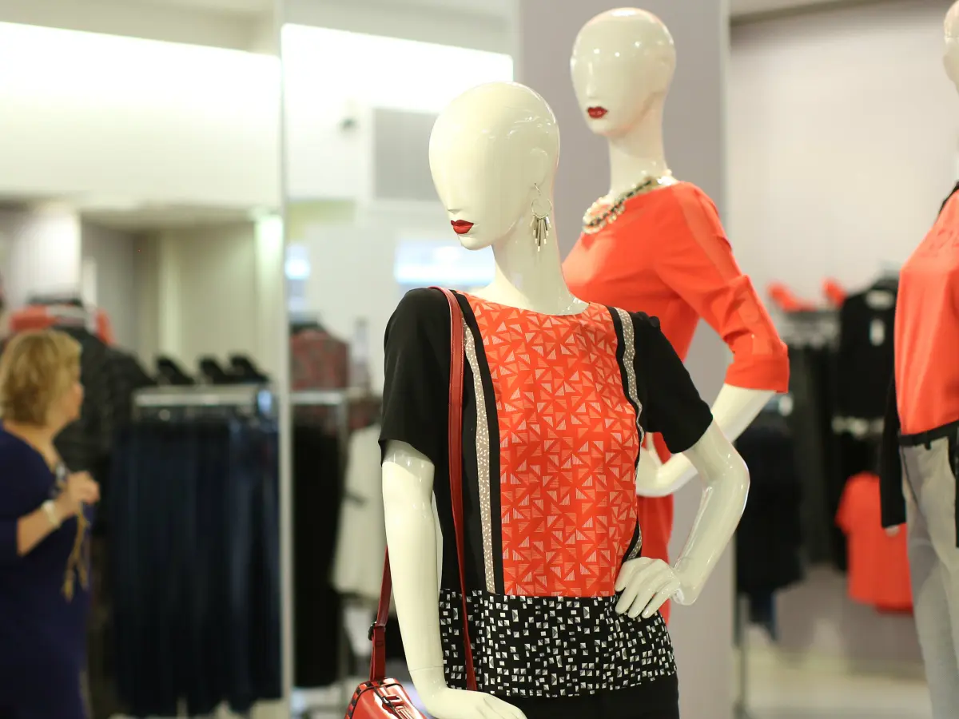
Figure 2: Clothes designs
Blog 4:
Reasons to shop at Mark & Spencer
There's nothing like getting comfortable with comforter loungewear. On cold days, we can all add woolen layers to our life. The women's collection of our company has a reflection of style and elegance and you can embrace it with your fashion style. We know what women want, understand their needs. Our designs can help you express yourself with your uniqueness. In the women's collection, we have many varieties like stylish tops, skirts for girls, blouses and shirts, jumpsuits, and dresses. Your fashion search can end at our store and you can shop without any worry because we have loads of collections. Regarding whatever you prefer, style of clothing, color or it can pattern of the clothing, you will definitely love our work from any of our collections. To give a complete look you can pair one of our shoe collections, it can be sandals and heels. There are plenty of offers that can match your budget, M&S holds seasonal auctions to offer its customers the best offer. M&S always provides you with a luxurious shopping experience. If you want to buy your favorite items of clothing for you and your loved ones at a reasonable price, you will be happy to see our offerings, without worrying about your budget. We have a special "inspire me" section where you can find unique style statements which can give you a highlighted glamour look. Mark and Spencer's aim is to provide a vast range of collections from casual wear to contemporary to its fashionista customers. Their goal is to make your self-esteem high and their blogs will help you achieve that.
Blog 5:
Customers first!- All you need to know about the marketing and selling strategy of M&S
The promotion is the last part to be discussed with the Marks & Spencer (M&S) marketing mix (Budianto, Bastaman and Fauziyah, 2019). The company spends millions of dollars on advertising and other marketing strategies. However, it recently decided to reduce commercial spending by 50 million spent on traditional media such as TV and media. M&S is a leading supermarket and as a result, many of its products have a price range from medium to high. However, it should be noted that many customers see prices as the amount of money that reflects the number of people that a company provides. M&S pricing strategies have recently been criticized by many customers. Ocado's home delivery company and partner have been found charging customers different prices for the same products. Some products have been found to be more expensive in stores and others more expensive online. Although in theory, this is an example of a pricing strategy, many customers are upset by this.
In Kotler & Armstrong's theory, a product is anything that can be offered on the market to be considered, taken, used, or used that may satisfy a need or need. Market supply may only be available for pure material goods, clean resources, and everything in between. Item organizers need to think about three levels when settling on administrations and items. Second, the essential advantage should be changed over into a genuine item. At last, an extra item ought to be worked close to the genuine item by offering types of assistance.e built next to the actual product by providing services.
Blog 6:
Market situation of Mark & Spencer - All you need to learn
Mark and Spencer has been one of the renowned brands of the UK for over 100 years, it caters to customer needs which is growing rapidly. Mark and Spencer has a large number of contenders, they are from corporate sectors, with the help of them Mark and Spencer can achieve their success. Their home increment has changed the serious concern, with help of increasing numbers of One of the keys to Marks and Spencer's improvement all through the draw out has been the thing's ability to meet the constantly changing prerequisites of a total customer base. Fundamental brand regards ​​for quality, regard, organization, headway, and reliability have perpetually been the reinforcement of Marks and Spencer's recommendation. Imprints and Spencer moreover won different distinctions in 2003/4, including the World's Leading Retailer 2004 in the Dow Jones Sustainability Index for the second year in a row. It was also situated by Greenpeace as a fundamental food retailer for its show in non-GM food assortments and was allowed the title of 'Most Advanced Supermarket' by Compassion In World Farming. Imprints and Spencer is generally famous for its women's clothing, a particularly genuine market with a 11% stake. Its test is to resolve the issues of more settled customers while anticipating a more young style. Women will undoubtedly shop genuinely than they buy all through the long haul and are more ready to endeavor. This preparation has descended on the stock of standard clothing yet moreover helped with sustaining their circumstance in standard clothing.
Conclusion
Marks & Spencer's separation strategy prioritizes the quality of goods and its perfect & pocket-friendly prices. It is now must redefine its efforts to bring newness, customer-centered business. The strategy is focused on welcoming new products and services, adding new features with products and services already available, and also developing new ways to deliver those to the buyers. M&S is intensifying efforts to touch this goal through a combined journey with the strategic partners to achieve a greater competitive convenience. Then it should increase its revenue from advertising in mass media to create and grow its own brand image in the fashion world following the latest fashion trend. M&S requires External challenges of increasing competition and technological development to continue development and It will make it rely primarily on its internal resources and capabilities to grab combative advantages. Lastly, to gain the ability to deliver the right product to the right customer at the right time through the right channel to provide the specialty of the brand. Customer information will always be a defining factor in the way to success or failure of any of the future of Marks & Spencer strategy.

References
Budianto, A., Bastaman, I.D. and Fauziyah, A., 2019. Modern Market Customer Loyalty: Advertising Promotion Strategies. Jurnal Manajemen (Edisi Elektronik), 10(2), pp.111-122.
Marksandspencer. (2021). Home. Available at www.marksandspencer.in (accessed 26th Dec, 2021)

