MODULE: DIGITAL MARKETING

MODULE CODE: LCMB7010

ASSIGNMENT TITLE: DIGITAL MARKETING

Student Number: 2128283

Student Name: MIDHUN KOPPARAMBIL VIKRAMAN

Table of Contents
Task 1 3
Introduction 3
Discussion 3
Critically appraise and analyse how Amazon is represented digitally 3
Internal or external communication structural flows, information architecture and effective strategies 8
Design thinking theory of digitalisation 9
Promotions for the product and services. 10
Conclusion 11
Task 2 12
Introduction 12
Discussion 12
Machine learning for getting a return on investment 12
Machine learning and artificial intelligence applied by Amazon 14
Recommendations 15
Conclusion 15
References 16
Appendices 19
Appendix 1: Machine Learning used by Amazon Webservices 19

Task 1

Introduction
A digitalisation strategy can be defined as a long-term plan of a company to evolve with rapid transformations of digital categories occurring in relevant sectors and the market. All companies should have a clear strategy for adopting a digitalised atmosphere in the workplace. Digitalisation is using digitally advanced technology for altering business models and providing new kinds of revenue and opportunities which produce. In this assignment, the digital representation of Amazon will be critically appraised and analysed. Amazon is a multinational technology of American origin having headquarters in Seattle, Washington and Arlington, Virginia, U.S. It generally focuses on artificial intelligence, digital steaming, Cloud Computing, E-Commerce and online advertising. It has been referred to as one of the most influential economic and cultural forces in the world. On the other hand, the details about the digital marketing applied by Amazon will be signified in this particular task in a detailed way. On the other hand, the digital assets by Amazon along with the communication structure will be highlighted in this task with proper detailing. However, the information architecture effective Strategies and promotions for the products and services delivered by Amazon will be specified in this assignment.

Discussion

Critically appraise and analyse how Amazon is represented digitally
Amazon is not only considered among the richest companies in the world, but it is one of the most customer-oriented companies on a global scale. Amazon has been ranked the best and most trusted platform for online shopping for customers staying in North America and Europe.

Figure 1: Amazon logo transformation
(Source: Aboutamazon, 2023)
Amazon develops “Customer Relationship Management” software in-house which helps in capturing the data of customers at their point of purchase. It is used to customise the online experience of the users. On the other hand, it should be noted that the interface of Amazon is quite simple and easier to use. The CRM of Amazon runs smoothly, and its customer-oriented approach is comprehensive (Hassan and Hassan, 2021). The CRM digitalised strategy of Amazon mainly provides customers with a smooth experience of online shopping with no compromise associated with safe transactions and downtime.
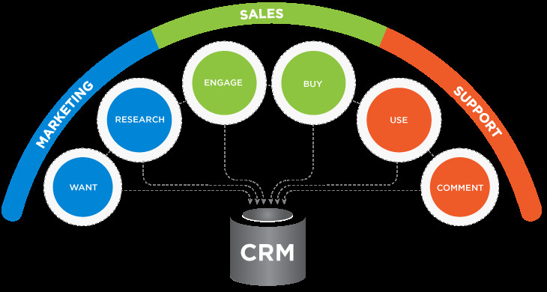
Figure 2: Ways by which Amazon uses CRM
(Source: Hassan and Hassan, 2021)
The main benefits associated with Amazon's CRM strategy of Amazon generally initiated with its intuitive and easy-to-use user interface that helps in making the website a blessing for all online shoppers. The nature of this interface is navigable, minimal, easy to understand and de-cluttered. Some of the elements that make the CRM of Amazon successful one is a higher quality of images, precise descriptions, clearly visible prices, and structured categories, easy and clear processes of checkout, old or visible ratings (Ayyagari, 2019). These types of elements make it easier to shop at the E-commerce website of Amazon just like shopping in a grocery store a better experience of shopping is provided. Apart from a comprehensive user interface, a robust and impressive help centre is maintained by Amazon. Whether a customer wants to review the orders or manage accounts along with checking out the representatives of customer support, it can be accessed with the help of a single screen.
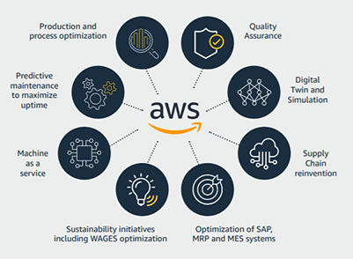
Figure 3: Amazon web services (AWS)
(Source: Amazon Industrial Digitalization Platform, 2021)
On the other hand, if the customer is not able to find out the appropriate answer for the query, then it can be searched in the search bar. The AWS-managed services provide a better customer relationship management process for the organisation to ensure that a good relationship is established between the organisation and the customers. The CRM process allows Amazon Managed Services for using consistent methods for delivering services to consumers (Richardson et al. 2020). This process involves identifying the key stakeholders along with establishing a team of governance. It has been reported that Amazon has generated a revenue of at least an amount of 75.45 million for its strong online sales despite the current situation due to the pandemic. Along with impressive sales, this organisation has been proven to be a powerful influence in this industry with high popularity and proper reach among customers.
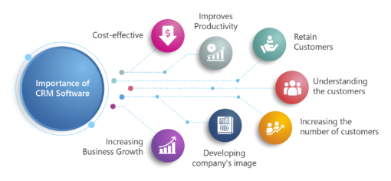
Figure 4: Benefits of CRM software
(Source: Asadullah et al. 2020)
The main reason behind the success of Amazon is proper evolution. Over the years, Amazon has been capable of adapting to the constant alterations in technological trends and shopping experiences (Asadullah et al. 2020). It has been identified by this organisation that the increase in using the internet and Digital Services has changed the shopping behaviour of consumers permanently. One of the innovations introduced by Amazon involves the method of one-click shopping. Till the year 2017, Amazon was considered the only retailer in the online category who are involved in offering this method of purchase to customers. These features have enhanced how products are delivered by online retailers to customers.
When customers are ready to purchase on the website of Amazon, they are not required to re-enter the information if they have purchased items on the website previously (Čirjevskis, 2021). The purchase can be done with the help of just one click and the order will be conveniently ready. This feature also provides customers with an option of reordering the items multiple times without the complexity associated with re-entering the information of payment and answering the inquiries again. One-click shopping has been essential for providing a positive experience shopping for customers who are trying to purchase items quickly on online platforms.
Amazon has been successful in offering a service called Amazon Prime. Through the service, the customers can select the process of ordering and receive a free couple of days or same-day delivery along with streaming favourite movies and TV shows of the consumers. This service has helped in shaping the first space of the market associated with E-Commerce along with its offering to the consumer (Narasayya and Chaudhuri, 2021). Amazon has also supplemented its services with the help of a return policy. This policy allows the consumers who are properly satisfied with the products to get a refund. There are some events where Amazon provides the scope for the consumers to own the product without any kind of fee.
Along with E-Commerce marketing, the impact of Amazon has been extended into the area of other marketing. Amazon has always been providing a positive experience to consumers in their strategy of marketing. Entirely, this organisation has been able to adapt to the purchasing behaviour and proper preferences of the customers through the optimisation of the product (Areiqat et al. 2021). Amazon generally performs this marketing technique dependent on the type of products purchased by the customers. After a product is purchased by the customers, their feed will be optimised by Amazon to provide them with the exact requirement dependent upon their previous purchase history. This type of marketing strategy of the consumer-centric category has influenced other e-commerce providers to make the purchasing experience of consumers more comfortable.
Analysis of digital assets Amazon owns
Different types of influential digital assets are owned by Amazon for getting hold of different industries in digital platforms or online platforms in a convenient way. Bill pack is an organisation dealing in online pharmacy that has been acquired by Amazon. It was an online pharmacy which was founded in the year 2013, Amazon acquired this company for expanding its business into online prescriptions. Due to the extensive network of delivery owned by Amazon, it has been quite beneficial for shipping medicine prescriptions overnight across borders (Lnenicka and Komarkova, 2019). It has been seen that Amazon has tried to gain the online market and represent itself as a digital platform in a structured way.
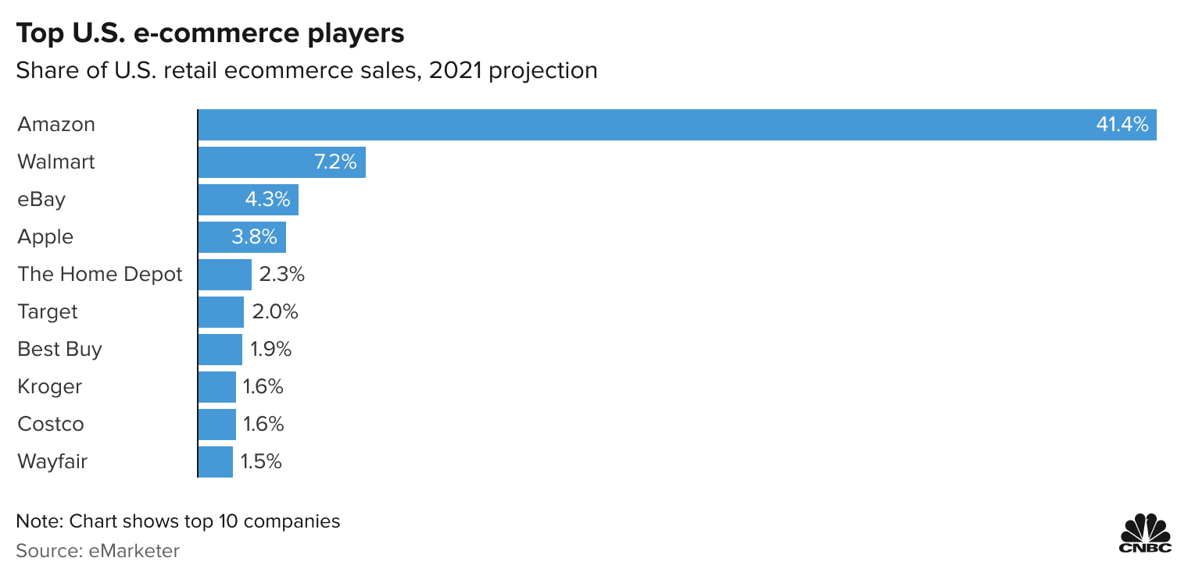
Figure 5: E-Commerce sales of Amazon in 2021
(Source: Lnenicka and Komarkova, 2019)
To be specific, it can be stated that it is trying to get a hold of different online and digital markets required for assessing the needs of consumers in the quick possible way (Watanabe et al. 2022). Therefore, the effort of Amazon to acquire the online pharmacy company has stated the fact that it has an effort towards providing authentic necessary services to consumers in the fast possible manner. On the other hand, it has been seen that a live-streaming video company owned by Amazon is named twitch interactive.
It is a particularly popular company among the people who play video games and influence the expansion of Amazon in the business of streaming and video games (Correa Tavares et al. 2021). Amazon has been progressive towards interacting with customers through live streaming, moreover, Amazon is trying to provide them with proper value by interacting with them in a positive way and through live streaming platforms. In these live-streaming videos, the customers can directly interact with the authoritative boards of the organisation.
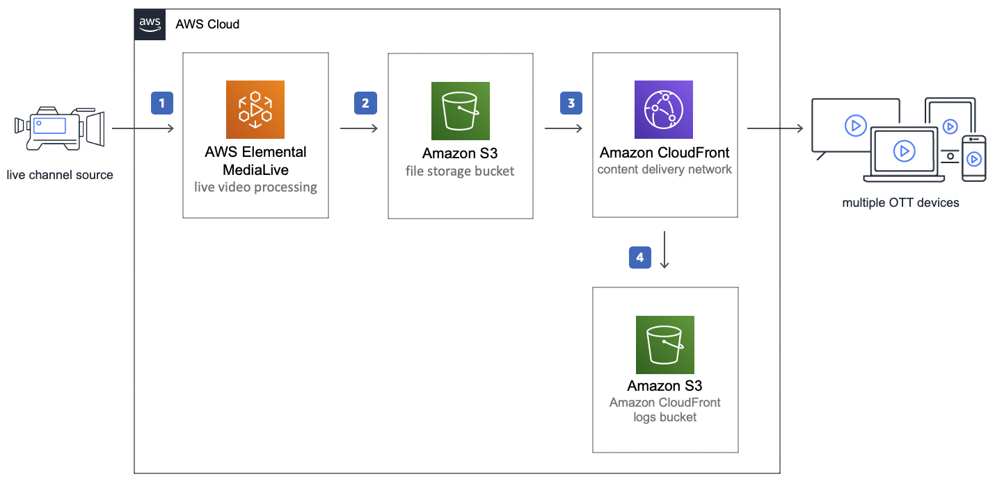
Figure 6: Amazon live-streaming videos
(Source: Correa Tavares et al. 2021)
Many questions are asked to the authoritative board by the customers through this platform which has made it easier for identifying solutions to some kinds of problems and issues (Farrell and Newman, 2019). However, it should be noted that Amazon has made progressive efforts towards using digital technology to interact with consumers and expand its brand in different types of industries. This is the reason why this organisation has got huge Global recognition and popularity. Amazon's approach to getting hold of the live streaming platform is to reach customers who use digital platforms while purchasing necessary items.
Amazon has proceeded with the acquisition of Twitch interactive for a sum of 970 million dollars. It can be stated that Amazon is trying to expand into different industries with the help of its popularity and high network distribution strategies. The loyal and increased customer base of Amazon has made it easier for them to gain the trust of other companies (Kretschmer et al. 2022). This is the reason why Amazon has been successful in maintaining acquisition over different influential companies of online category which are dealing in digitised services.
Companies which provide services for businesses in third-party categories ranging from the services of data management and cloud storage up to secure messaging for swelling the profitable services named Amazon Web Services of Amazon. Amazon Web Services generally creates cloud computing and different kinds of software used for Storage for businesses. Just after the announcement of investment by Amazon in the cloud communication platform business organisation based in San Francisco, a deal has been signed by the two companies (Parker et al. 2021). The software developers who are utilising the platform of Amazon Web service can now access the service of real-time messaging named Twilio and the notifications.

Internal or external communication structural flows, information architecture and effective strategies
Exchanging internal email needs to be changed by the CEO Bezos of Amazon. It has been realised by the leader that it is required to change the internal infrastructure of communication before a change can be introduced in the by-product of this organisation. It has been understood by the leader that a radical change in the organisation is required to arrange internal dynamics in a manner that will allow the creation of Amazon Web Services. To be specific, the internal system of communication has been designed for embracing high accessibility as the core commandment to enable a mindset of strong platforms along with incentivizing extreme hard work (Min et al. 2019). It can be stated that there is a huge contribution of proper internal communication practices towards its success. The corporate teams of communications can gain some lessons from this E-Commerce giant company and the unusual method of Amazon to run meetings.
The two-pizza rule is followed by this particular organisation as the method of maintaining internal communication. Larger groups can lead to confusion in the discussions and difficulty is seen in reaching conclusions within large teams (Kopp et al. 2019). The leader has tried to manage the groups by putting limitations on the count of people in the meetings in the form that more than two pizzas will not be required to feed the people. It can be stated that the groups have been segregated and the number of people has been limited in order to eradicate any type of confusion related to some types of discussion. This has enriched internal communication within teams. The scope of difficulty in reaching confusion has been properly removed with the help of forming smaller segregated groups within the team of employees. On the other hand, PowerPoint has been banned by Amazon along with other presentations of the slide.
Instead of that, the employees of this organisation create a memo having six pages. It contains proper narratives with full sentences rather than just involving bullet points. This type of narrative memo has been accepted well due to the tendency of the human brain for processing good storytelling rather than relying on hard data. This type of memo provides scope for the authors for communicating the thoughts behind the ideas and provides the participants of meeting a scope of understanding the concepts thoroughly (Genzorova et al. 2019). Naturally, the quality associated with memos varies highly. The memos are written and properly rewritten along with shared with the colleagues who have been asked to make improvements in the work. A proper time is given to them and it is suggested to the employees that they take time and keep the memo aside for a few days and then again start editing it with a fresh perspective.
It means that providing authentic internal communication structures has given a considerable period for the employees to help them improve in writing memos. Producing memos can be considered as the effort of a team. Someone in the team must acquire strong writing skills (Elg et al. 2021). However, according to the view of the leader, a person having strong skills in writing does not need to be the top executive. The meetings generally start with everyone reading out a particular memo by maintaining silence.
The leader has compared this atmosphere of the organisation with a Study Hall or a library. Busy executives might face the failure of reading the materials and can skip the meetings as if they are reading the background information properly (Kopp et al. 2019). The participants of the meetings who are unprepared generally waste time by asking questions that have been answered previously. This can be considered the weirdest culture of a meeting. The step of meeting memo reading assures the preparation of the attendees. It is easier to create power points although people proceed with processing information better through reading rather than watching a presentation.
On the other, it should be noted that the external communications preferred by Amazon are in the form of communicating with customers on social media platforms such as Twitter, Instagram and Facebook. Amazon has a huge number of followers on Instagram, Facebook and Twitter collaboratively (Correa Tavares et al. 2021). The social media platforms are highly utilised by this organisation by communicating its recent launch with the customers in the fast possible way. And excitement is created by Amazon within the segment of customers on the social media platforms before the launch. It increases the engagement of the customers for the products or services provided by Amazon.
The comments and responses of the customers about a particular product are provided with proper feedback by this organisation. The proper response is given to the comments of the customers on the social media post done by Amazon. It makes the customers feel properly valued and it increases customer loyalty in the long term. Different types of live video streaming platforms are used by Amazon to interact and communicate with customers about their issues, problems or regulations (Lnenicka and Komarkova, 2019). This type of effort from the organisation increases the interaction with the consumers and they believe that this organisation is working for their well-being and trying to provide them with authentic products or services. In this way, the customers can eradicate any type of confusion in them about the company procedures and methods.
Frequent posts are done by Amazon on its social media platforms about their offers and discounts to maintain the engagement of the customers increasing day by day. It is an important strategy for maintaining the constant engagement of customers on the social media platform for Amazon. On the other hand, Amazon tries to use CRM apps for customising the requirements of customers. It can be stated that based on the previous purchases of the customers, the preferred products are provided at the time when the customers are coming to this web page again. However, it should be noted that this customisation strategy of Amazon has given rise to an increase in the crowd towards its web page. Different social media campaigns are conducted by Amazon in order to attract a new section of customers. To be specific, this organisation has focused on a diverse variety of customers through the help of digital platforms.

Design thinking theory of digitalisation
Any single definition associated with design thinking of the digitisation process is not available as it involves different interpretation through various authors and organisations numerous definitions helps in representing different views on the process of decision thinking. The core idea associated with design thinking is generally based upon the human response to finding the solutions which will remain constant. Design thinking can be considered as the human-centred approach to introduce innovation for integrating the requirements of gaining success in business, possibilities associated with technological advancement and requirements of the people (Kopp et al. 2019). One of the core principles of differentiating which is constant within various interpretations of design thinking is the human-centric approach to solving problems.
Human Centred design can be considered as the design philosophy which stands for good understanding by the people and requirements that are convenient for meeting the goals. It states a fact that the preferences of customers cannot be understood by simply asking questions about them although maintaining a proper process and system which can help understand the customers on an intense scale (Genzorova et al. 2019). This is generally applied by Amazon as it follows a customer-centric approach. Therefore it should be noted that the process of design thinking contains different logical sequences for techniques and recommendations that are useful for accelerating the process of project development. It should be noted that Amazon follows this kind of model or theory for taking a particular decision for solving a problem based on the needs of the customers.
Different approaches are used by Amazon such as utilising live streaming video platforms, customisation for the customers and responding to the comments of the customers on social media platforms to understand the needs of the customers. Different internal communication strategies are implemented by Amazon to utilise design thinking for digitisation processes (Elg et al. 2021). It can be stated that the design thinking process is highly utilised by Amazon to proceed with giving proper structure to the human-centred design that will be convenient for assessing the demands of the customers properly. On the other hand, different communication strategies are adopted by Amazon internally for the employees to still diversify their ideas and make them properly understand the need of assessing the demands of the consumers. The ideas are properly written in a storytelling manner which is expressed by the employees in the meetings. This type of internal communication strategy can be considered a systematic approach to understanding the requirements of the customers conveniently.

Promotions for the product and services.
There are some promotional offers provided by Amazon which can be named Amazon lightning deals. This can be stated as promotional offers that generally last for a shorter period. The Lightning deal of each product only lasts within 4 to 6 hours and it is a popular feature of Amazon. The sections of lightning deals are changing constantly. It is enticing or influencing many people to purchase products from the sellers of Amazon. Lightning deals can be referred to as a great strategy for a business to enhance sales (West, 2019). The organisation attracts an audience for purchasing products because the discounted price is available on a product.
It is also extremely helpful for reducing the inventory in the quick possible manner. Amazon only allows those items which have a 3 + star rating in their section of lightning deals. This criterion can be changed based on the situation and the time of the year along with the Marketplace. It is best for maintaining higher ranks in order to assure that the products are always qualified (Jindal et al. 2021). Getting a high number of positive reviews will nullify the negative reviews and enhance the eligibility of the product.
One of the most common promotional strategies followed by Amazon is focusing on helping the audience save some money. Special codes are provided for every person in order to provide them with proper offers and discounts. People can purchase some quantity of an item and spend a certain amount to be eligible for some discounts (Caro et al. 2020). It can also determine the free types of shipping. The promotional sellers of Amazon can offer products at low cost to provide an incentive to the audience and influence them to spread positive word of mouth about the product or the offer to a larger section of the audience. It is quite helpful for Amazon to reach new customers resulting in a higher conversion rate.
It can be stated that the promotional strategies designed by Amazon are highly associated with minimising the price tag of the products for making the customers happy about saving some extra money along with getting their preferred products. Seasonal discounts and offers are provided by Amazon which increases its sales highly (Mohd Satar et al. 2019). Therefore, the discounts and offers generate sales revenue which outplays the chance of loss due to the minimization of the price tag. It should be noted that this organisation has tried to analyse the market demand for providing offers and discounts.

Conclusion
It can be concluded that Amazon is among the richest company in the world dealing in e-commerce services. The customer relationship management software is built by Amazon which is white helpful in gathering customer data when the Purchase is done. It also focuses on providing customised services to customers. It is in the form of providing suggestions to the customers when they are visiting the website based on their previous purchases. Transactions and smooth experience of online shopping in the main context of customer relationship management digital strategy in Amazon. It can be stated that higher quality images precise descriptions of the product, clearly visible price tags and properly structured categories are the main positive points of the website within Amazon. It can be also concluded that the Amazon Web service managed services assures the relationship between the organisation and the consumers. The organisation is dealing with an advanced systemwhich has made it easier for assessing the demands of consumers in the fast possible way.

Task 2

Introduction
Machine learning and artificial intelligence provide good returns on investments to business organisations, especially in the industry of e-commerce. In this particular assignment, a detailed analysis of the Return on Investment gained by Amazon due to the application of machine learning and artificial intelligence will be presented. It needs to be stated that the advantages of using machine learning and artificial intelligence will also be signified in this assignment.

Discussion

Machine learning for getting a return on investment
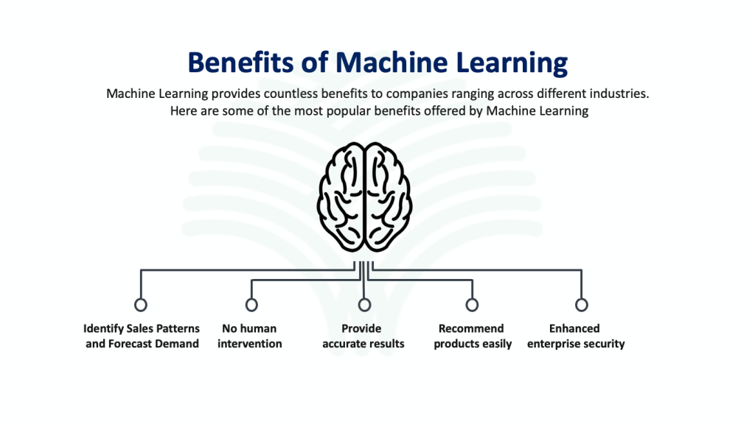
Figure 7: Benefits of machine learning in the organisation
(Source: Khrais, 2020)
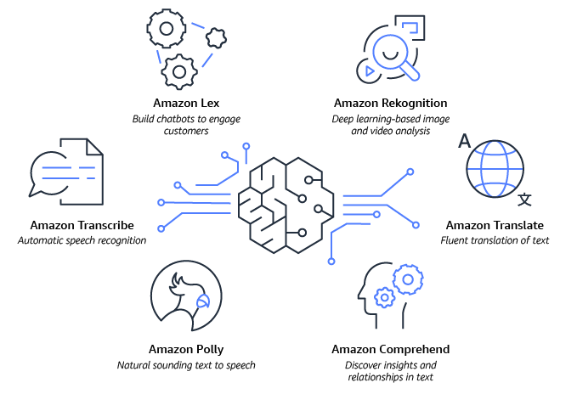
Figure 8: Use of AI in Amazon
(Source: Song et al. 2019)

The most important advancement offered by artificial intelligence is identifying or predicting the behaviour of customers by digital marketers (Khrais, 2020). By feeding huge sets of data into a computer, the algorithms of machine learning can analyse the previous decisions in order to provide a convenient prediction of a particular action that will be taken by the customers next. Due to this factor, marketing strategies are not reactive anymore and it has become highly predictive. Artificial Intelligence and machine learning technology can help in providing a constant update about the current news of a web user. It can be said that this innovation makes way for different strategies that can revolutionise the approach to a digital market.
The biggest challenge faced by some marketers is which channel will be involved in offering the best deal for their products or services. However, Artificial Intelligence and machine learning have resolved these kinds of challenges. By proceeding with predictive analysis, combining big data statistical algorithms and the technology of machine learning (Song et al. 2019). It is possible to highlight the probability associated with future results based on historical activity. A predictive approach can be utilised for identifying the cost-effective strategies of client acquisition, optimal price points in specific channels and the opportunities for product upselling on some campaigns. All the things that need to be remembered are that the quality of outputs reflects the quality of inputs. It means with the accuracy of data the return on investment will be higher.
Retargeting content shows the prospect of a product which has been seen in the hope of securing a cell for the future. However smart algorithms use this one step for analysing the previous search of a consumer and recommend other products which might be liked by them. Amazon uses this kind of machine learning technology which can provide product suggestions specific to the character. By taking customer consent, the movement can be tracked around the web access, actions and the inventory filled with possible purchases (Praveen et al. 2020). This type of correlation metric generally extends to different kinds of capabilities associated with cross-device categories.

Machine learning and artificial intelligence applied by Amazon
In the market of e-commerce millions of users are there all over the world and have different kinds of choices and unlimited interests in different products. Therefore, Amazon has helped store all varieties of data in a database that are searched by the users for the algorithms of machine learning. It is done to learn from Data within the database. Machine learning is generally used by Amazon for utilising the purchase history and patterns of users along with relating it to fraud practices which can be carried out (Matuszelański and Kopczewska, 2022). Additionally, it helps in providing specifically targeted advertisements and suggestions to the users dependent upon the tailor promotions associated with various electronic brands.
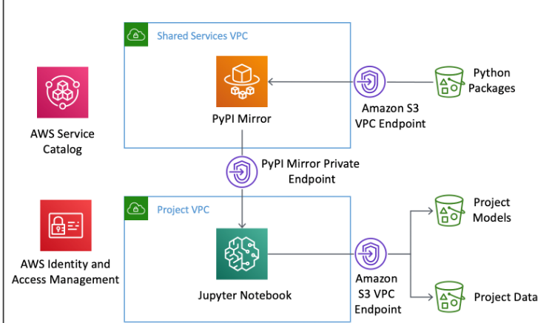
Figure 9: Secure environment of Amazon SageMaker
(Source: Engdahl, 2018)
Amazon collects all the patterns of usage and search history for the consumers in order to suggest products and show them a similar variety of products to meet the demand of forecast in learning place and necessary role in this particular task as it can be difficult if the employees proceed with this kind of task manually. Machine learning gains learning from this data in the database and applies accordingly within their systems of recommendation (Micu et al. 2021). Amazon SageMaker can be referred to as another step towards adapting to the practices of machine learning. It generally utilises terabytes of data from its database of Amazon for helping eliminate all kinds of packaging waste that is done through the prediction of user purchases. After that, it identifies which smaller product will be shipped in small bags and requires less amount of packaging for making reductions in all the wastage due to packaging.
On the other hand, Amazon Prime video delivers users with different kinds of convenience suggestions about the web series which are preferred by customers with the application of machine learning [Referred to appendix 1]. It collects data from the prime account of the users on Amazon and conducts a study about the analytics and statistics for recommending convenient web series. The personalised product recommendations offered by Amazon can be considered as the marketing technique that enables this organisation to proceed with winning a more significant share of the market (Soni, 2020). It also helps in satisfying the customers by anticipating their needs appropriately with the help of product recommendations within a personalised category.
To power its algorithm of recommendation, Amazon utilises collaborative filtering items to an item category (Micu et al. 2019). It is claimed by Amazon that the voice assistant Alexa delivered by it generally allows users for finding out and purchasing products with a voice rather than trying to click a screen. According to Amazon, it allows customers to control the experience of checkout in a hands-free way. Overall, this application of artificial intelligence generally has the objective of increasing convenience for consumers shopping with Amazon. It ranges from creating a list of shopping to getting suggestions from Alexa. For Amazon, this investment in artificial intelligence mainly enables organisations to attempt to solidify their place further in the market.

Recommendations
It can be suggested that Amazon can proceed with the proper implementation of Artificial Intelligence and machine learning for its services by conducting enhanced training and development programmes for the employees (Singh, 2021). It should also be noted that this organisation can work towards the enhancement of work productivity in the organisation by recruiting employees from diverse backgrounds and cross-cultural settings.
It can be recommended that Amazon needs to recruit more employees of IT background in the experience category. Proper training and development programmes should be provided to the employees in order to make them capable of working in cross-cultural workplaces. The team leaders need to understand the strategies of the managers in a detailed way to convey them towards the team members. However, it can also be suggested that Amazon needs to give a detailed view of the types of machine learning and artificial intelligence methods that can be applied to different types of business operations. It can also be recommended that this organisation should deal with different IT companies and acquire them for getting a good hold of experienced IT employees. It needs to be noted that Amazon generally has a positive word of mouth in the market which will help them to get hold of suppliers and different IT companies.

Conclusion
It can be concluded that machine learning and artificial intelligence have helped Amazon to provide customised services to customers. It has made ways for delivering positive experiences to the customers about their purchasing. The suggestions are given to the customers based on their previous purchases.

References
Aboutamazon, (2023), about us. Available at: https://www.aboutamazon.com/ (Accessed: January 7, 2023)
Amazon Industrial Digitalization Platform (2021) automation.com. Available at: https://www.automation.com/en-us/articles/january-2021/amazon-industrial-digitalization-platform (Accessed: January 7, 2023).
Areiqat, A.Y., Alheet, A.F., Qawasmeh, R.A. and Zamil, A.M., 2021. ARTIFICIAL INTELLIGENCE AND ITS DRASTIC IMPACT ON E-COMMERCE PROGRESS. Academy of Strategic Management Journal, 20, pp.1-11.
Asadullah, M., Yadav, R.K. and Namdeo, V., 2020. A survey on security issues and challenges in cloud computing. International Journal of Innovative Research in Technology and Management, 4(4), pp.43-50.
Ayyagari, M.R., 2019. A framework for analytical CRM assessments challenges and recommendations. International Journal of Business and Social Science, 10(5), pp.5-13.
Caro, F., Kök, A.G. and Martínez-de-Albéniz, V., 2020. The future of retail operations. Manufacturing & Service Operations Management, 22(1), pp.47-58.
Čirjevskis, A., 2021. Valuing Dynamic Capabilities-Based Synergies with Real Options. Journal of Risk and Financial Management, 14(2), p.69.
Correa Tavares, E., Meirelles, F.D.S., Tavares, E.C., Cunha, M.A. and Schunk, L.M., 2021. Blockchain in the Amazon: creating public value and promoting sustainability. Information Technology for Development, 27(3), pp.579-598.
Elg, M., Birch-Jensen, A., Gremyr, I., Martin, J. and Melin, U., 2021. Digitalisation and quality management: problems and prospects. Production Planning & Control, 32(12), pp.990-1003.
Engdahl, S. (2018). Greenhaven Press/Gale. Available at: https://aws.amazon.com/machine-learning/building-secure-machine-learning-environments-with-amazon-sagemaker/ (Accessed: January 7, 2023).
Farrell, H. and Newman, A.L., 2019. Weaponized interdependence: How global economic networks shape state coercion. International Security, 44(1), pp.42-79.
Genzorova, T., Corejova, T. and Stalmasekova, N., 2019. How digital transformation can influence business model, Case study for transport industry. Transportation Research Procedia, 40, pp.1053-1058.
Hassan, M. and Hassan, S., 2021. Customer Relationship Management of Different Companies. Recent Trends in Production Engineering, 4(2), pp.1-6.
Jindal, R.P., Gauri, D.K., Li, W. and Ma, Y., 2021. Omnichannel battle between Amazon and Walmart: Is the focus on delivery the best strategy?. Journal of business research, 122, pp.270-280.
Khrais, L.T., 2020. Role of artificial intelligence in shaping consumer demand in E-commerce. Future Internet, 12(12), p.226.
Kopp, R., Dhondt, S., Hirsch-Kreinsen, H., Kohlgrüber, M. and Preenen, P., 2019. Sociotechnical perspectives on digitalisation and Industry 4.0. International Journal of Technology Transfer and Commercialisation, 16(3), pp.290-309.
Kretschmer, T., Leiponen, A., Schilling, M. and Vasudeva, G., 2022. Platform ecosystems as meta‐organizations: Implications for platform strategies. Strategic Management Journal, 43(3), pp.405-424.
Lnenicka, M. and Komarkova, J., 2019. Developing a government enterprise architecture framework to support the requirements of big and open linked data with the use of cloud computing. International Journal of Information Management, 46, pp.124-141.
Matuszelański, K. and Kopczewska, K., 2022. Customer Churn in Retail E-Commerce Business: Spatial and Machine Learning Approach. Journal of Theoretical and Applied Electronic Commerce Research, 17(1), pp.165-198.
Micu, A., Geru, M., Capatina, A., Avram, C., Rusu, R. and Panait, A.A., 2019. Leveraging e-Commerce performance through machine learning algorithms. Ann. Dunarea Jos Univ. Galati, 2, pp.162-171.
Micu, A., Micu, A.E., Geru, M., Căpățînă, A. and Muntean, M.C., 2021. The impact of artificial intelligence use on the e-commerce in Romania. Amfiteatru Economic, 23(56), pp.137-154.
Min, S., Zacharia, Z.G. and Smith, C.D., 2019. Defining supply chain management: in the past, present, and future. Journal of Business Logistics, 40(1), pp.44-55.
Mohd Satar, N.S., Dastane, D.O. and Ma’arif, M.Y., 2019. Customer value proposition for E-Commerce: A case study approach. International Journal of Advanced Computer Science and Applications (IJACSA), 10(2), pp.454-458.
Narasayya, V. and Chaudhuri, S., 2021. Cloud data services: Workloads, architectures and multi-tenancy. Foundations and Trends® in Databases, 10(1), pp.1-107.
Parker, G., Petropoulos, G. and Van Alstyne, M., 2021. Platform mergers and antitrust. Industrial and Corporate Change, 30(5), pp.1307-1336.
Praveen, K.B., Kumar, P., Prateek, J., Pragathi, G. and Madhuri, J., 2020. Inventory management using machine learning. Int J Eng Res, 9(06), pp.866-869.
Richardson, R., North, M., North, S.M. and Garofalo, D., 2020. Business Students’ Perception of Critical and Marketable Skills in Thriving Job Security. International Management Review, 16(1), pp.5-110.
Singh, R., 2021. A Study of Artificial Intelligence and E-Commerce Ecosystem–A Customer's Perspective. International Journal of Research in Engineering, Science and Management, 4(2), pp.78-87.
Song, X., Yang, S., Huang, Z. and Huang, T., 2019, August. The application of artificial intelligence in electronic commerce. In Journal of Physics: Conference Series (Vol. 1302, No. 3, p. 032030). IOP Publishing.
Soni, V.D., 2020. Emerging roles of artificial intelligence in ecommerce. International Journal of trend in scientific research and development, 4(5), pp.223-225.
Watanabe, C., Akhtar, W., Tou, Y. and Neittaanmäki, P., 2022. A new perspective of innovation toward a non-contact society-Amazon's initiative in pioneering growing seamless switching. Technology in Society, 69, p.101953.
West, E., 2019. Amazon: Surveillance as a service. Surveillance & Society, 17(1/2), pp.27-33.
Who we are: Amazon (2020) US About Amazon. US About Amazon. Available at: https://www.aboutamazon.com/about-us (Accessed: January 7, 2023).
Wisetsri, W., 2021. Systematic analysis and future research directions in artificial intelligence for marketing. Turkish Journal of Computer and Mathematics Education (TURCOMAT), 12(11), pp.43-55.

Appendices

Appendix 1: Machine Learning used by Amazon Webservices
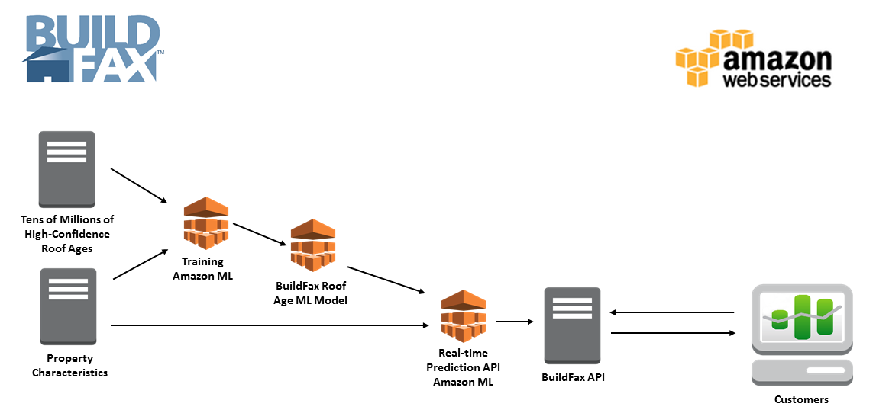
(Source: Khrais, 2020)

