

Executive Summary

The research conducted is on The importance of measuring stress levels on employees from SMEs in South Wales and the reason this theme was chosen is because Wales has the highest stress level in the UK, according to recent studies. Even before Cardiff was known as the most stressed city in the UK. More than 50% of work-related illnesses are caused by stress and organizational change has been identified as a stressor factor in the workplace.
For the research conducted in this study an inductive approach has been used. The purpose is to reach a general conclusion that will help the small and medium enterprises better acknowledge the stress perceived by their employees during organizational change and to implement measures that will help in reducing it.
A mixed method of data collection has been used as it provides different types of information and can lead to a more comprehensive understanding of the research topic.
Organizations can identify people or groups that could be more susceptible to suffering from excessive stress by measuring the amount of stress that is being experienced during organizational transformation.
Organizational changes must be implemented successfully, which depends on effective change management. Stress levels may be measured to offer useful information that helps organizations assess the effectiveness of their change management methods. It enables them to see potential problem areas, make appropriate modifications, and create specialized solutions to deal with certain pressures. This improves the change initiative's overall success.
Managing employee stress during organizational change can be a challenge for small organizations, but there are several strategies that can help their employees navigate the process more effectively, like promoting a transparent communication approach, keep the employees involved constantly during the change process and provide support mechanisms to help cope with the stress.

Contents
Executive Summary 2
Terms Of Reference 4
Procedure 4
Formulation of Research Question 4
Research Question 4
Research Approach 6
Data Collection Methods 6
Sampling Method & Sample Size 6
Primary & Secondary Research Techniques 7
Video Presentation of Idea 8
Analysis Poster 9
Reference List 10

Terms Of Reference
The present E-Portfolio has been requested by Christian Felices on the 03.05.2023 for the module Changemakers- Creativity and Value Creation. It is intended to address four tasks related to a research subject, the methodology used, presenting the idea of research and the analysis of the findings. The portfolio has been written by Corina Cernat and is due to be submitted on the 16.06.2023.

Procedure
For the creation of the e-portfolio a variety of sources have been reviewed and cited, consisting of peer reviewed journal articles and books from the university library, websites and statistical reports from the Health and Safety Executive, Statista, and Welsh Government.

Formulation of Research Question

Research Question

The research question proposed is looking to establish The importance of measuring the stress levels on employees during organizational changes in SMEs in South Wales and identify new theories or ideas of how the stress can be minimized and the negative impact this has on the employee's wellbeing and productivity.
The reason I chose this theme is because change is inevitable in any organization and stress is something that affects all in so many areas. I also think that sometimes organizations do not prepare their employees properly for important changes and do not realize the major impact this can have on their wellbeing.
According to a survey carried out in 2020 (Statista, 2020), the highest prevalence of work-related stress in the United Kingdom was registered in Wales, with 43 percent of respondents reporting work-related stress on a weekly basis. This comes as little surprise, considering the same type of study conducted two years before has shown that Cardiff was the most stressed city in the UK.

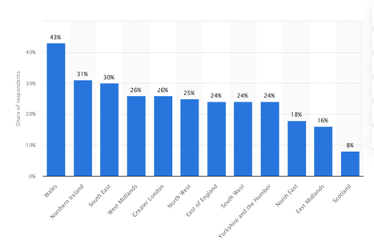
When looking at the analysis of active businesses in Wales, statistics show that 99.4 % are represented by the small and medium enterprises, which accounted for nearly 63% of the employment (GOV, 2022). Among the work-related illnesses cases registered annually, 51% of them are related to stress, anxiety, or depression (HSE, 2022). This has a significant impact on employees’ wellbeing and work performance, where prolonged stress can lead to physical health problems, irritability, lower self-esteem, decreased job satisfaction, interpersonal conflicts, increased absenteeism, burnout, and decreased productivity.
Smaller businesses are more vulnerable to the effects of stress than bigger ones because they lack the human capital capacity to fill the gap left when an employee is absent due to illness or leaves the company entirely. SMEs frequently offer jobs with multiple tasks and higher responsibilities due to a lack of staff, as opposed to large organizations, which tend to have a narrower and more specialized division of work (Lehman et al, 2021)
Some authors believe (Mullins, 2019) that a small amount of stress is not harmful and could improve motivation and productivity, but more recent studies conducted by Perkbox (2020) have shown that only 5% of the employees agreed workplace stress increased their engagement and another 5% said they felt more productive due to stress.
The value this research can bring to SMEs in South Wales and beyond is that it will help in establishing general conclusion or theories that can be applied in the workplace to minimize the impact of the stress perceived during organizational change and look at introducing more tools and strategies to improve the wellbeing while helping the employees to adapt to the new working environment.
By measuring stress levels, organizations can gain insights into the well-being of their employees during organizational change. This understanding enables them to implement strategies to support employee resilience, mental health, and overall well-being.

Research Approach

The research approach used is the inductive one which is a research method that involves developing theories or conclusions based on specific patterns or observations in the analysed data (Shaheen et al, 2019). It begins with the collection of mainly quantitative data from a questionnaire that will then be analysed to identify patterns or trends that emerge from those instances.
The scope is to draw a general conclusion statement about the impact of stress caused by organizational change using the random sample selected from the South Wales population.
I chose to use a mixed method approach for my research as it provides me with different types of information and can lead to a more comprehensive understanding of my research topic, according to Hesse-Biber (2016). This also allows me to identify new ideas that may not be fully explored using only one methodological approach.

Data Collection Methods

The primary research consists in a questionnaire that allows me to collect large-scale data and it helps me to conduct statistical analysis and generate a theory. Within the questionnaire there are also open-ended questions that allowed me to gather qualitative insights on some of the benefits the measuring of the stress level during organisational change can bring to the employees. and some effective ways of supporting them in managing the perceived stress.
For this research a secondary method has also been used. Secondary research has been valuable for the early stages of the research project and helped in gaining a better understanding of the subject and identify gaps or areas for further investigation.
It consisted in a literature review of some academic articles and statistical reports that summarises the negative impact the organisational change can have on the employees’ wellbeing. It also explained why is important to measure the stress level during this process to come with change management strategies that can minimise the stress impact and increase the individuals’ adaptability to change.

Sampling Method & Sample Size

Sampling is known as the process of choosing sample units from the population to estimate demographic characteristics in a way that the sample accurately reflects that population (Singh, 2016). It is essential to ensure that the sample is representative of the population being studied, otherwise the results may not accurately reflect the characteristics, opinions, or behaviours of the larger population, leading to biased or misleading findings. A carefully chosen sampling method increases the likelihood of obtaining a representative sample.
After considering the objective of the research, the characteristics of the target population and available resources, a random sample was selected from the population in South Wales. The participants in this study have been recruited via a Teams invitation where they have been provided a link to complete a questionnaire that consists in the primary research method used.
The survey targeted 30 adults full-time and part-time workers from SME in South Wales who have been experiencing an organizational change in the last two years.

Primary & Secondary Research Techniques
Primary research link
The importance of measuring stress on employees during organizational change (office.com)

Organizational change has become unavoidable and plays an important part of everyone’s work life. It has become the new normal due to the fast pace of how businesses operate today. When an organization undergoes change, the focus is on the desired results rather than how the personnel will psychologically adjust to the new environment.
For a change to be successful, it is essential the employees change too. Research shows that for about 65% of the organizational transformation initiatives, employees must significantly alter their behavior too (Michels, 2019).
Recent studies conducted by Belschak, F. et al. (2020) and Brazzale, P.L. et al. (2022) identified that organizational change is a stressor in the workplace. Change, whether is in the form of new leadership, merger, acquisitions, or reorganization creates uncertainty that can trigger various stress responses in individuals, both at the emotional and physiological levels. This then leads to employees experiencing anxiety and frustration, decreases their work engagement and increases their turnover intentions.
Resistance to change should be perceived as a natural reaction. With the right resources in place for support and control, some of the negative effects of change may be minimized. Organizations should encourage managers to adopt leadership styles that engage and assist the employees since supportive supervision was linked to less negative health symptoms (such as emotional weariness and cynicism) during times of change (Day et al, 2017).
Measuring stress levels can provide valuable data for designing effective change management strategies. Identifying stressors and their impact on employees helps organizations tailor their communication, training, and support mechanisms to combat stress and increase employees' ability to adapt to change. Communication during a time of change should be different from the normal approach in business as it is more important who delivers the message and the level of empathy they show, rather than what is being transmitted.

Video Presentation of Idea

https://www.canva.com/design/DAFliU52aYU/BJdch3ueu2R8nL4Hlhcf5g/view?utm_content=DAFliU52aYU&utm_campaign=designshare&utm_medium=link&utm_source=publishsharelink

For this reflection, the Gibbs' Reflective Cycle has been used, which is a commonly used framework for self-reflection (Negrin et al, 2022).
Description:
For this task, a three-minute video presentation was requested to be delivered to the stakeholders involved in the research project. The main theme was the Area of the research and the methodology used with the purpose of gaining their interest in the subject.
Feelings:
Before delivering the presentation, I was feeling anxious because of my introverted nature and the nervousness I feel every time before addressing an audience. Once I started the recording, I felt more at ease because I had a clear understanding of the subject and followed an easy structure.
Evaluation:
During my presentation I think I managed to deliver my message and make myself understood. I consider I could have improved my pitch sometimes and could have sounded more enthusiastic and less like I was reading a script.
Analysis:
The feedback received was related to staying too close to the camera and not using enough gestures and I think this is because I was focusing more on delivering a clear message and avoiding pauses during my speech.
Conclusion:
One of the areas that needs improvement for future presentations is the use of my body language more when delivering the speech and engaging more with the audience.
Action plan:
For future I consider requesting feedback from my peers for every presentation I deliver and record myself prior to make sure I deliver my message efficiently.

Analysis Poster

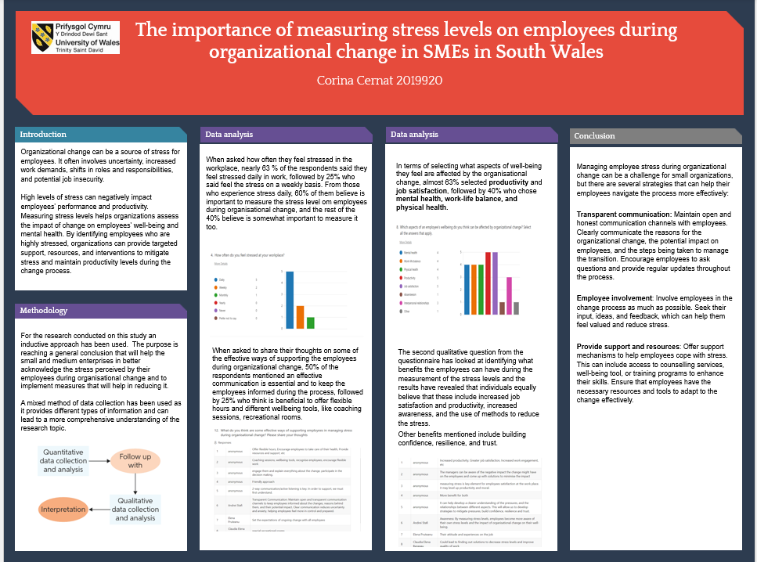

Reference List
- Belschak, F. et al. (2020) ‘When the going gets tough: employee reactions to large-scale organizational change and the role of employee machiavellianism’, Journal of organizational behavior, 41(9), pp. 830–850. Available at: https://doi.org/10.1002/job.2478.
- Brazzale, P.L. et al. (2022) ‘Change ubiquity: employee perceptions of change prevalence from three countries’, Personnel review, 51(2), pp. 770–786. Available at: https://doi.org/10.1108/PR-04-2019-0211.
- Day, A., Crown, S.N. and Ivany, M. (2017) ‘Organisational change and employee burnout: The moderating effects of support and job control’, Safety science, 100, pp. 4–12. Available at: https://doi.org/10.1016/j.ssci.2017.03.004.
- GOV, (2022), Statistical Bulletin. Size Analysis of Active Businesses in Wales, 2021, available at https://www.gov.wales/sites/default/files/statistics-and-research/2022-04/size-analysis-of-businesses-2021-920.pdf, accessed on 12.06.2023
- Hesse-Biber, S.N. and Johnson, B. (2016) The Oxford handbook of multimethod and mixed methods research inquiry. Edited by S.N. Hesse-Biber and B. Johnson. New York, NY: Oxford University Press.
- HSE, (2022), Workplace health and safety statistics for Wales, available at https://www.hse.gov.uk/statistics/regions/wales-statistics.pdf, accessed 12.06.2023
- Lehmann, J.A.M. et al. (2021) ‘Effectiveness and cost effectiveness of a stress management training for leaders of small and medium sized enterprises - study protocol for a randomized controlled-trial’, BMC public health, 21(1), pp. 468–468. Available at: https://doi.org/10.1186/s12889-021-10398-4
- Michels, D. (2019), Change Is Painful, And That's OK, available at https://www.forbes.com/sites/davidmichels/2019/02/26/change-is-painful-and-thats-ok/#4f0fe60e4ed0, accessed 12.06.2023
- Mullins, L.J. and McLean, J.E. (2019) Organizational behavior in the workplace. Twelfth edition. Harlow, United Kingdom: Pearson Education Limited.
- Negrin, K. A., Slaughter, S. E., Dahlke, S., & Olson, J. (2022). Successful Recruitment to Qualitative Research: A Critical Reflection. International Journal of Qualitative Methods, 21. https://doi.org/10.1177/16094069221119576
- Perkbox, (2020), The 2020 UK workplace stress survey, Available at https://www.perkbox.com/uk/resources/library/2020-workplace-stress-survey, accessed 10.06.2023.
- Shaheen, M., Gupta, M. and Prathap Reddy, K. (2019) Qualitative techniques for workplace data analysis. Edited by M. Shaheen, M. Gupta, and K. Prathap Reddy. Hershey, Pennsylvania: Business Science Reference.
- Singh, K. (2016) Quantitative social research methods. New Delhi: SAGE.
- Statista, (2020), Work-related stress in the United Kingdom in 2020, by region/country, available at https://www.statista.com/statistics/1134423/work-related-stress-in-the-uk-by-region/

