ACBA7000 Building & Asset Management assignment

MASTERS DEGREE ASSIGNMENT SPECIFICATION
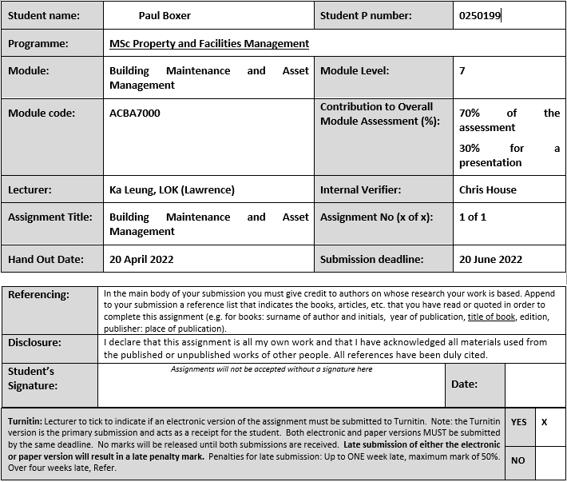
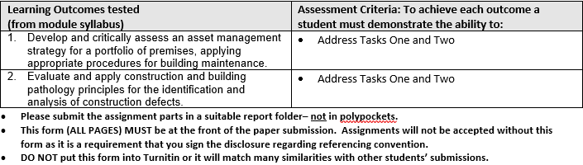
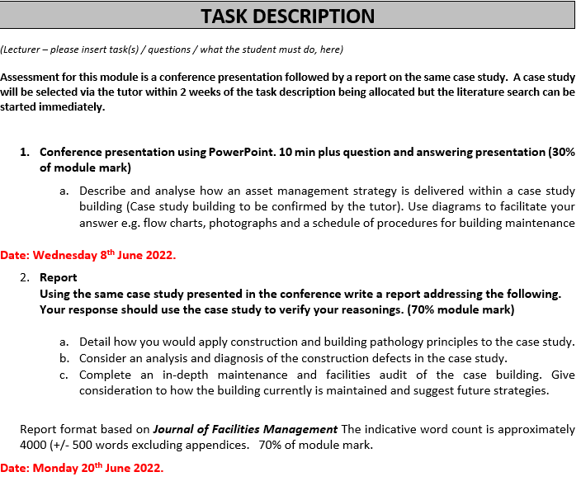

Table of Contents
ACBA7000 Building & Asset Management assignment 1
Abstract 4
Introduction to case study building 5
1 Building pathology principles 6
Identification 7
Investigation 8
Root Cause Identification 8
Solution 9
Design 10
Supervision 10
Monitoring 10
2 Analysis and diagnosis of defects building at case study building 12
What are defects and how do they Occur 12
Defect / Asset Management 13
Building and facility Audit 14
3 Current Maintenance strategies 19
Future Strategies 21
Integration of stand-alone databases 21
Increase focus on asset management of buildings 21
Use of Drones to complete inspections 21
Decarbonisation 22
BIM / 3D Scanning for ATEX areas 22
Integration of SAP into PLC level 1 architecture 22
Conclusion 23
References 24
Appendix 1 – Tata Maintenance concept 25

Abstract

This report uses a structured research method to understand the principles of building pathology and the importance of them within industry. The report looks into each aspect of building pathology comparing the literature against the case study building at all times.
The second part of the report understands defects and asset management and further identifies defects and analysis some of the defects found in the case study building and applying the principles to show real life investigations into the causes and providing a structured solution.
The final section of the report identifies the existing building maintenance and suggests ways in which the case study building can improve their strategies to either improve or meet future demands.

Introduction to case study building

For the purpose of this report the building that will be used is an industrial manufacturing building located within Tata Steel works in Port Talbot South Wales.
The Continuous Annealing Production Line (CAPL) building was built in 2000 on a reinforced concrete foundation with a steel structure; corrugated sheet roofing and panelling; bitumen flat roof for offices; a steam heating system; high bay lighting and a multi-million-pound manufacturing line. The building is over 600m long at is 36m at its highest point. Figures 1 and 2 show the exterior of the CAPL Building just after build completion and the internal production line in operation.
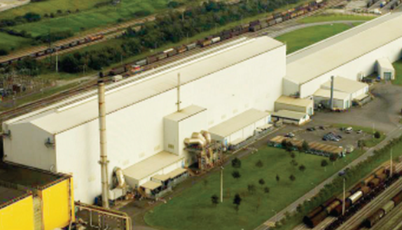
Figure 1 - Tata CAPL Line as built
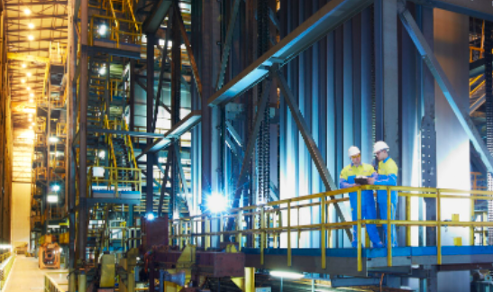
Figure 2 - Production facility with CAPL Building
The CAPL line welds coils together at the entry end, runs the coils through a cleaning section; anneals the coil in a 200m radiant tube furnace with accumulators at furnace entry and exit, tempers and final reduction of the strip through the temper mill and side trims to the required dimensions on the side trimmers; then recoils and cuts the coil to the customers weight specification. The process operates twenty-four hours a day, three hundred and sixty-five days a year and produces over a million tonnes of CAPL coil per annum as depicted in figure 3. involves gasses such as Natural Gas, Steam, Oxygen, Hydrogen acid solutions, Water, Hydraulic oil, Greases and Electricity.
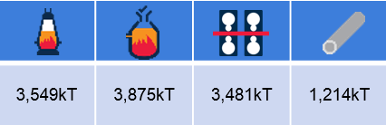
Figure 3 – Tata Production figures
To complete the process the CAPL uses gasses such as Natural Gas, Steam, Oxygen, Hydrogen acid solutions, Water, Hydraulic oil, Greases and Electricity. To further aid the manufacturing process, there are seven overhead cranes; six Roller shutter doors for vehicle access; A fast operating return car to take coil back to the cold mill for rework and a network rail line to enable finished coil to be despatched directly to downstream operations or the customer.

1 Building pathology principles

Duncan et al (2017) define building pathology as
“Building Pathology is the study of building defects, building decay and building performance in order to develop suitable remedial and management solutions.”
(Duncan et al, 2017)
Watt (2009) suggests that building pathology is a term that is becoming popular to define the high-level approach to understanding buildings. Watt further suggest that to implement building pathology to its full extent the approach requires knowledge; that is knowledge of the building design and construction, usage and adaptations and how the materials used, and environmental conditions can affect the building. NBS (2017) Suggests that CDM regulations have put a greater emphasis on building owners to consider some of these issues throughout the design and entire life cycle of a building with the legal requirement for a health and safety file.
Watts (2009) et al suggests that building pathology is essential to building managers with the continual desire to have more accurate, detailed and relevant information from which they can base their decisions. These decisions include the potential to buy, sell or lease a building; to renovate or not; to understand the true cost of the building and stage within its lifecycle; provide detailed budgets reports for planned preventative maintenance before failures occur; ensure statutory compliance to legislative requirements.
Watts (2009) suggests in its simplest form, building pathology can be split into four individual areas of concern:
- Building Knowledge
- Identification, Investigation and diagnosis of defects
- Prognosis of defects diagnosed and recommendations for the most appropriate course of action
- Design, specification, implementation and supervision of appropriate remedial works
Duncan (2017) Suggests that building pathology seeks to identify defects; understand trends and their impacts on building systems at the earliest possible stage. Predicting trends early can potentially reduce the impact of defects as remedies and treatments can be made before the defect has caused serious impact
Hassan (2017) suggests that correct use of building pathology techniques can provide the following benefits for the owner, lease or prospective purchaser of a building. The can include providing confidence for potential purchasers such as in a home owners survey; establish liability for defect; ensure compliance with current legislation; provide strategic maintenance and repair solutions; assess current and future performance through EPC’s and provide costs for remedial works.
Ronsom (2013) suggests that failure to maintain buildings can result in accidents, detrimental health effects, loss of profitability and diminishing value of an asset.

Modern literature research in building pathology from RICS etc has removed building knowledge as an area topic, this is mainly due to the introductions of the CDM Regulations, improved project management and advances in technology such as BIM etc however the benefits for building pathology has not changed.
Table 1 Below shows the three main building pathology principles, these principles have been further split into their simplest form, these will then be further critically evaluated and reviewed against the case study building.
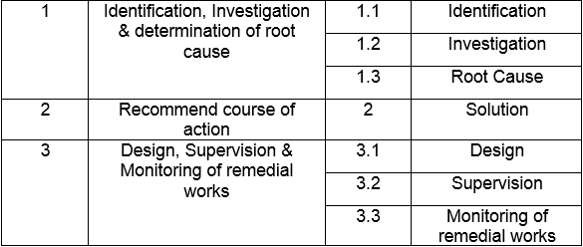
Table 1: Building Pathology Principles

Identification
RICS (2012) Suggests defects are typically identified by a building survey. RICS suggests there are many types of survey available dependant of the client brief or specification. Table 2 identifies different types of survey available that can range from a basic visual survey to a detailed physical survey using instruments to measure readings e.g., dampness measurement in walls. RICS (2012) further suggests that for a survey to be correct it should be carried out by someone who is impartial and has sufficient knowledge.
Types of Survey
Condition Survey
Home Buyer Report
Building Survey
Structural survey
Full Building Survey
Table 2 – Types of building survey
Within Tata the defect identification is similar, defects can either be determined by line operators as part of the plant operation; audits or walkarounds by other staff member or managers; from the technical team from Planned Maintenance inspections or observations whilst carrying out Reactive Maintenance.
All defects withing Tata are to input into the SAP maintenance management system and to a minimum standard. SAP was introduced back in 2009 and took several years to become the useful tool it is today. Figure 4 shows the minimum standard of defect identification required along with suggestions from the creator to the level of risk posed to the business and the potential root cause of the failure.
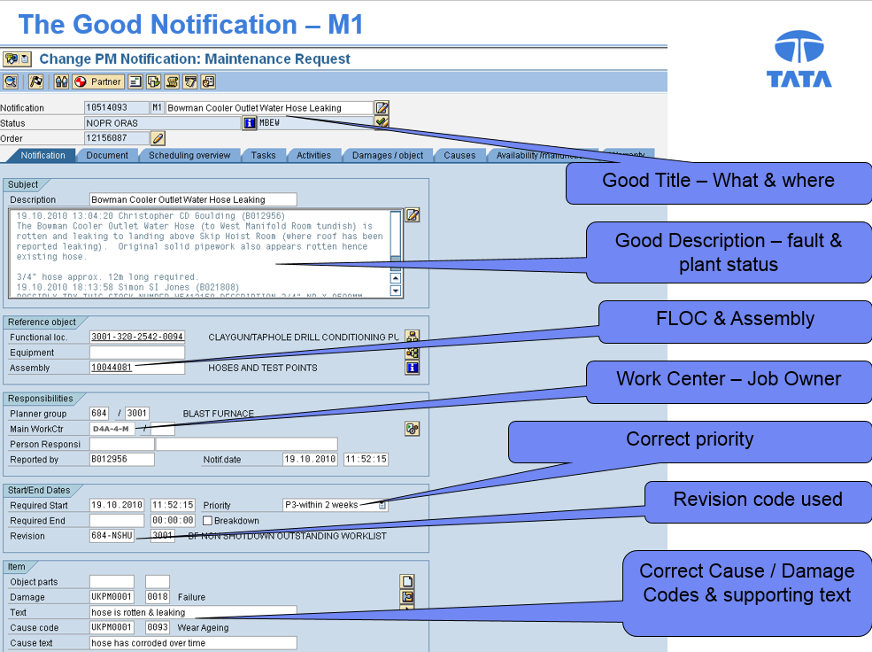
Figure 4 – SAP Notification
There is a comprehensive training package in place for staff with a three yearly refresher to ensure the notification standard is correct and maintained at the minimum level. All notifications are reviewed daily in the “trio” morning meetings

Investigation
Now the defect is identified it is essential to investigate the defect. Eweda (2021) suggests that identifying the cause of the defect is essential to understanding the root cause and potential solutions.
CIB (2020) suggests there are catalogues and databases of typical building defects that can be used by a surveyor dependant of the construction of the property being assessed. Whilst such a catalogue can provide useful information it is important to realise the risk that not all defects are identified and risks a lazy approach to investigation.

Root Cause Identification
Harris (2001) suggests there are many tools and techniques of structured problem solving that can be used to drill down to identify root cause of a defect. Harris (2001) further suggests that many investigations never get to root cause but stick at immediate and underlaying effects.
RICS (2012) Suggest there are three ratings for defects where three is the most serious defect that needs to be investigated, repaired or replaced urgently, although it does not suggest a timeframe for the repair; two defects that need repairing but are not urgent or serious and one where no repair is needed.
Tata has a standard too for identifying root cause depending on the severity of the defect.
The severity is depicted on the notification and achieved from completing the risk matrix assessment, figure 5 shows the tata standard risk matrix for assessing overall risk.
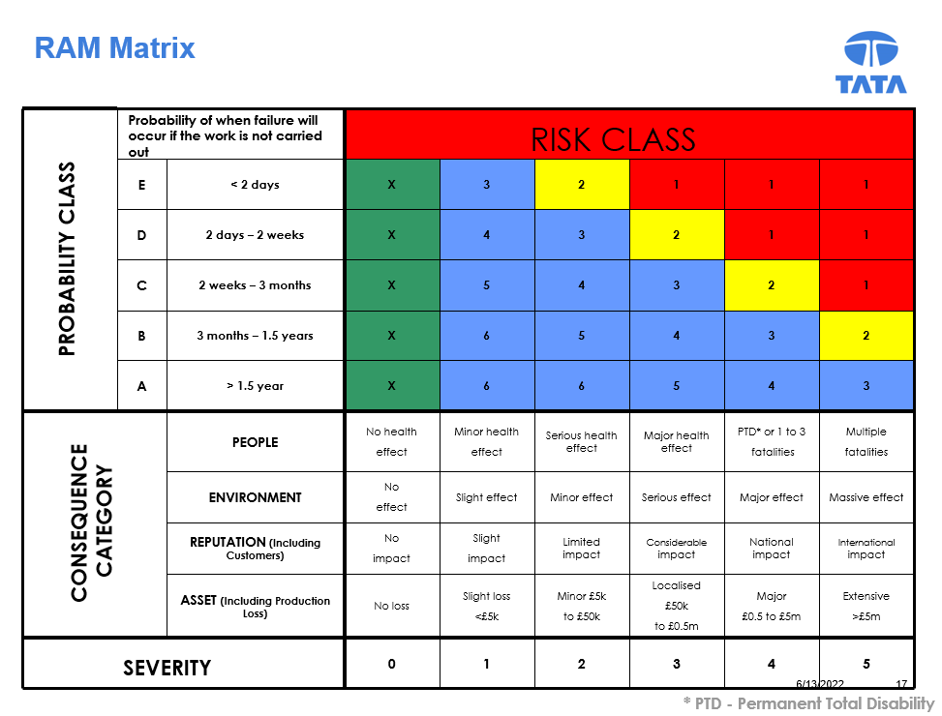
Figure 5 – Tata Risk Matrix
Defects that possess a low risk to the business (score 3 – 6) will go through a supervisor lead five why approach, High risk defects or any defect that causes considerable risk to the customer goes through a management led 8D approach to root cause. Where a defect has the possibility to cause serious harm to the business, people or the environment a senior manager led investigation takes place, here root cause is taken to the lowest level and linked to one of Tatas fifteen key principles.
Tata attempts to put a time frame on when the defect needs to be actioned based on the risk. Figure 6 shows the predicted time frames for solutions to be implemented.
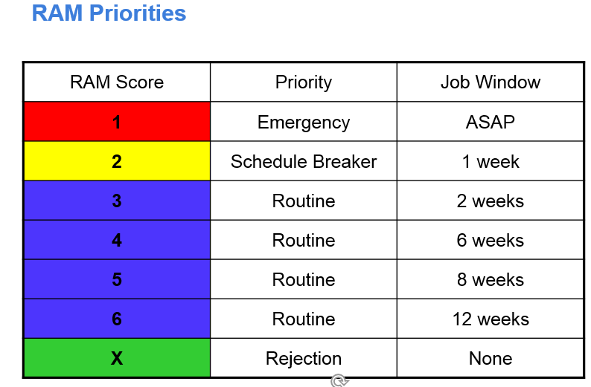
Figure 6 – Tata RAM Timeframes
Whist the intention is good, the timeframes do not consider that some solutions are not as straight forward to identify, design and implement and many will wait until the next maintenance stop for full implementation.

Solution
CIB 2020 Suggests that where possible more than one solution should be identified to allow a cost benefit analysis to be carried out on the proposed solutions. Although defects in their nature can be common, the solution is often the opposite and will depend not just on the defect but the conditions, environment, severity amongst others make each solution unique.
Harris (2001) Suggests that solutions can only be created by individuals that have detailed knowledge of the industry and understand the fundamentals of building design. Hassan (2022) however contradicts this as some defects have a simple legislative solution that does not need an expert to identify.
Within Tata there are employees with varying levels of knowledge and the central engineering team employ industry experts in all fields to provide input to solutions where required, this is particularly relevant where there is legislation surrounding a topic such as Electricity, Provision and Use of Work Equipment Regulations (PUWER), Lifting Operations and Lifting Equipment Regulations (LOLER), Dangerous Substances and Explosive Atmosphere Regulations (DSEAR); Pressure Systems Safety Regulations (PSSR) and numerous other legislative regimes.
Tata understands that a proper permanent solution may not always be the most cost-effective solutions and as such temporary solutions may have to be applied until such time when the final solution can be put in place. Tata operates a strict Management of Change (MOC) system, this is essential for a Control of Major Accidents and Hazards (COMAH) Tier 1 site to control risks to both employees and the public. All changes that are not like for like go through this rigorous approval system that not just identify the solution but look for other hazards created by the change, ensure operating systems, maintenance concepts, spares and drawings are updated. SAP and the MOC database then provide Tata with an historical database of failures and solutions.

Design
Sondalini (2021) suggests that design out maintenance is where the solution identified is designed in a manner to ensure the defect is removed and the equipment is now designed for future reliability by removing a failure cause where tools such as FMEA, FES, HALT and HASS are used to ensure stress; strain; overloading and other aspects such as fatigue are correctly modelled in the design stage of the solution.
Watts (2009) further suggest that this is something companies should outsource to ensure the correct competence and legislation is followed in the design stage.
Tata ensure that Failure analysis is one of the key CAMF systems on which all employees are trained and refreshed in on a three yearly basis. Tata also have their own internal design team in Port Talbot that have experience of 3D modelling and associated FMEA software. Tata also have access to Tata Consultancy Experts (TCE) a worldwide team that can offer engineering design solutions for all aspects of building and plant production process application.

Supervision
Duffy (1990) suggests that supervision of the solution is essential in ensuring that no further defects are created from any material deficiencies, specification issues or workmanship issues. Many companies outsource the supervision of the solution as part of a JCT / NEC works package and use a project manager to ensure work is completed to the correct standards and within the agreed costs.
Tata again are an exception to this rule as the internal project team manages all this type of work. This allows the operational and maintenance teams to concentrate on their core activities whilst the project team manages all major work and ensure that all the correct documentation; QA packs and certificates are collected for materials; design; drawings; testing and commissioning dossiers are compiled.

Monitoring
RICS (2012) suggest that once a defect is repaired or removed by a suitable solution the existing maintenance of the building can continue. Parnham (2000) however suggests this is not the case as the existing maintenance was not effective in the first case and the new solution will have a different maintenance concept or frequency to the existing.
Within Tata all new equipment or solutions goes through a maintenance concepts session to identify the correct level of maintenance and associated frequency to meet legislative requirements and with a risk-based approach provides the most economical maintenance for the company. All maintenance regimes are input into the SAP system and follow the scheduled maintenance process to ensure compliance. SAP planned maintenance is one of the operational measures checked in the “trio” daily morning meeting for the respective maintenance unit
The next section looks at application of the building pathology principles identified within a real-life case study building, the actual risk allocation given and solutions.

2 Analysis and diagnosis of defects building at case study building

What are defects and how do they Occur
Singh (2021) suggest that a defect is a flaw within a building or mistake in the design that either reduces the value of a building or causes a dangerous condition
Parnham (2000) suggests that building defects are caused by common factors, these common factors can be summarised below: -
- Design deficiencies.
- Material deficiencies.
- Specification problems.
- Workmanship deficiencies.
- Deterioration.
- Maintenance and repair deficiencies.
- Improper use.
- Environmental and other external factors.
Watts (2009) further suggests that defects can be classed in one of three categories they are being fundamental, where the building is unsafe or in breach of legislation; Functional, where the defect effects the occupancy or use of the building and cosmetic, where there is no effect to the building occupancy or use.
Tata uses a Risk Matrix as per figure 7 to determine the priority of the defect, initially the inputter identifies to the system and for non-emergency defects ratified in the TRIO Morning meetings to ensure the right priority is assigned to the notification, this allows the notification to be assigned to the correct individual or team to ensure the defect is closed out.
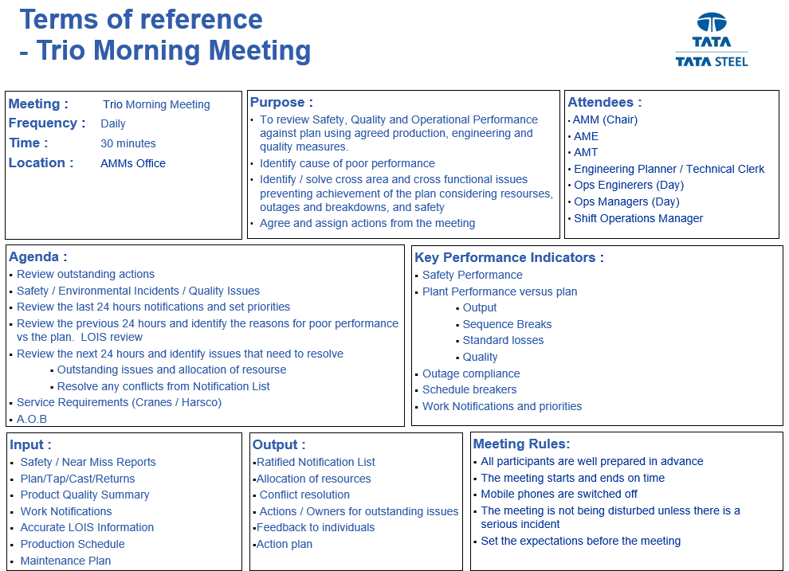
Figure 7 – Trio morning meeting structure

Defect / Asset Management
The project and construction management suggest that defects are typically patent defects where defects are identified by simple visual inspections though out a build process and listed in a snagging list or rectified before handover or Latent defects where defects are only apparent and identifiable after a significant period and usually cannot be detected without a detailed or destructive testing method
Tata is unlike most companies when it comes to building structures. Due to its size Tata has an inhouse design team, project management and specialists and as such act as the principal designer, principal contractor and client in these projects. Tata will only use labour contracts to complete work pages if they are unable to complete internally, whilst there are many cost and time benefits to this methodology the liability and risk for most defects be they patent or latent will remain with Tata, whereas with other procurement routes, the principal contractor will have a responsibility to mitigate and resolve these actions.
Tata operates a very efficient asset management system through SAP and their Company Asset Management Framework (CAMF) identifies flow charts to deal with emerging works, scheduled works, shutdown works, maintenance concepts, failure reduction and Management of Change (MOC) in infinite detail.

Building and facility Audit
The following is a summary of some of the defects found withing the CAPL building. The Existing SAP system only captures limited data from the defect investigation, where investigations and remedies are straight forward then all the data is captured along with planned and actual costs in both cost of spares and cost of labour. Any investigations completed through an 8D or management investigation or that have a management of change applied only have these as references as the systems do not talk to each other.
Interestingly, previous experience within South Wales Police, where they did not have an electronic defect management system did not have this issue. The condition survey being excel based had all this information contained within and the spreadsheet was used by external contractors to complete the actions based on quotes.
Item | Defect Identification | RAM Score
SAP Notification No: 32785 | Paint on south and west elevations of building flaking | X
 | Investigation
Investigation Team: Building | Tata Shotton works suggest that sheeting should be deigned to BS EN 508-3:2000, however it was noted that as Tata own a colour sheeting line, the sheeting was supplied direct from a site based in India to reduce initial building costs. The material supplied did not meet the specification supplied and was note as a known risk in project and deemed noncritical.
 | Course of Action
SAP Order No: N/A | Decision made to leave as is. Defect is known and expected and classed as a cosmetic issue only. Defect to be monitored on annual building façade inspection
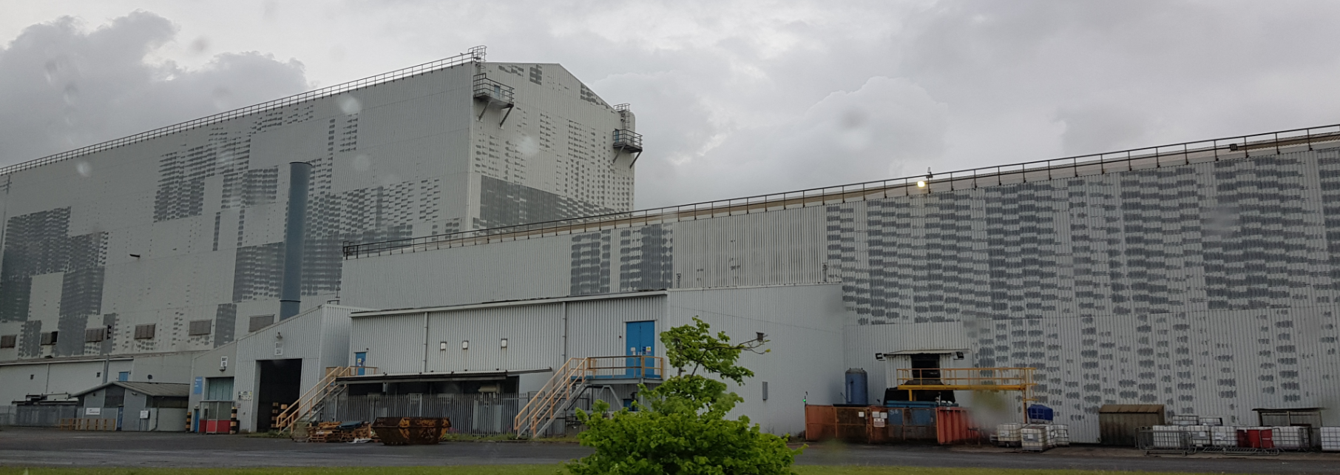

Item | Defect Identification | RAM Score
SAP Notification No: 21835 | Water dripping next to coil storage location X183 | 4
 | Investigation
Investigation Team: Building | National Building Housing Association suggest that flat felt roofing should be designed to BS 6229:2018 and has a life span of 10 - 20 years. Checks made to SAP regarding design and previous visual inspections and all inspections completed. Visual checks made on site and found defect from nesting seagulls that have been pecking at the felt and caused a tear. NRW Contacted to understand legality of disturbing nesting seagulls, which was confirmed as could not be done.
 | Course of Action
SAP Order No: 65130 | Design of patch repair using cold application only (no hot work allowed on roofs) prepared and insulation checked for thermal bridging. Temporary measure to remove Storage location X183 from service due to the risk of dry finished coil rusting form chemical reaction with water and SAP work order in place to monitor condition of leak of weekly basis.  Internal building team assigned work order to complete once seagulls abandoned nest

Item | Defect Identification | RAM Score
SAP Notification No: 32787 | Sheeting outside cleaning section storage tanks corroded. | 4
 | Investigation
Investigation Team: Operations | Visual inspection carried out and bottom section of sheeting at ground level to be corroded, initial inspections could not identify root cause. Only pipework near was cleaning section steam pipework, used on shutdown applications. Further investigation found that there was a slight steam leak on this pipe spraying 6bar 90degree steam at the base of the sheeting. It was also noted that the operational team are using this line as a means of increasing temperature in the cleaning section tanks which is not part of the standard operating procedure.
 | Course of Action
SAP Order No: 66790 | SAP Line order 0010 created for steam pipe isolation and replacement of 3 metre section of schedule 80 pipe to be replaced as per ASME B31 by the mechanical team; painted to ANSI13.2 2015. SAP line 0020 created for 2 sections of sheeting to be replaced by the mechanical team and line 0030 created for the operations team to review the cleaning section operational procedure and create MOC should a change be required.
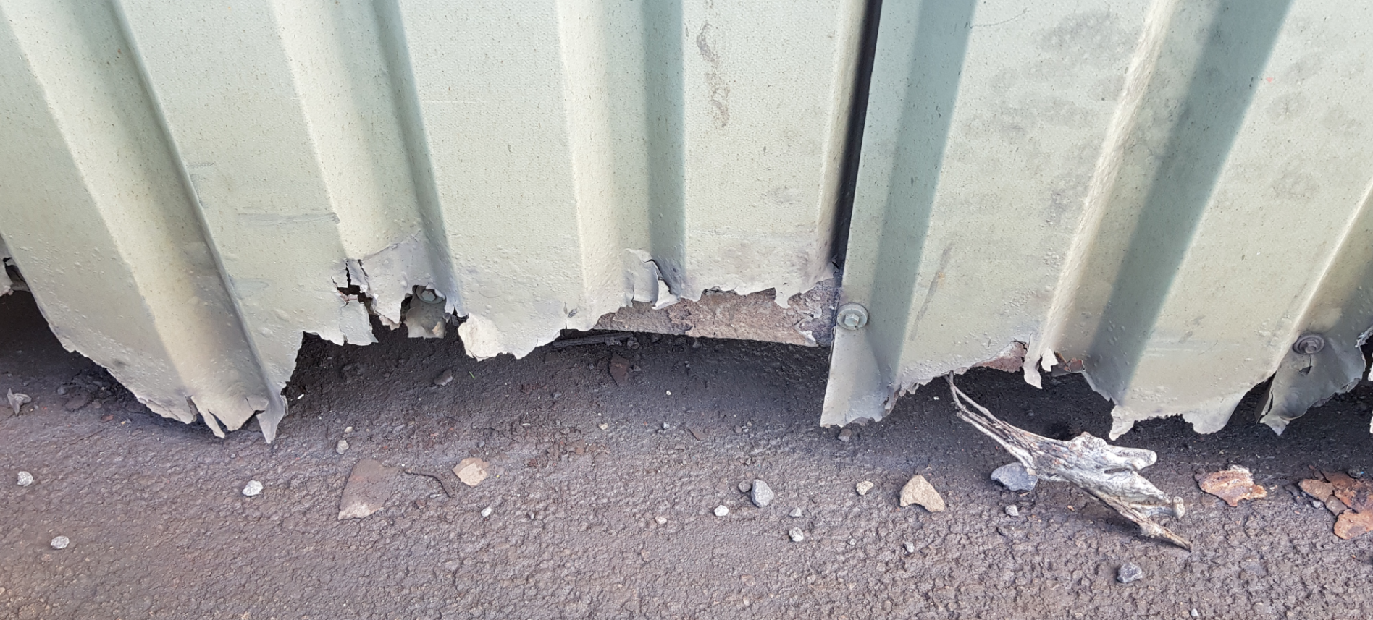

Item | Defect Identification | RAM Score
SAP Notification No: 32788 | Hole identified in west face of building façade, near RSD 4 | 5
 | Investigation
Investigation Team: Mech | Hole identified as missing louvre section on west façade of CAPL Building. SAP shows there are no planned inspections of louvres, but visual inspection identified as part of annual building inspection. Investigation identified damage was a result of recent storm action compounded by lack of maintenance.
 | Course of Action
SAP Order No: 66791 | SAP order created to replace louvre by the building mechanical team.  Action created for area engineer to carry out maintenance concept review for all louvres and create new maintenance plans accordingly
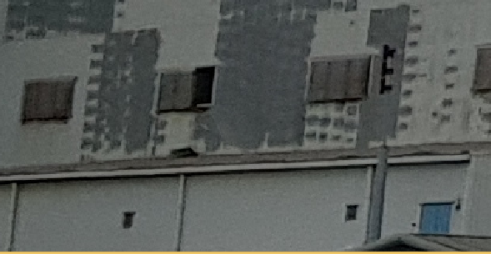

Item | Defect Identification | RAM Score
SAP Notification No: 33001 | Scrap baller concrete foundation cracks under hydraulic ram | 4
 | Investigation
Investigation Team: Building | BSI (2020) suggests reinforced concrete should be made to BS 8500:2019 and reinforcing standard BS EN 10138. The foundations were originally deigned to cater for the loading of the actual hydraulic RAM and axial thrust in the cylinder direction of movement. It was noted that the hydraulic RAM was modified 2 years previous under MOC CA234 from a cylinder failure. It is believed that the crack has formed since the new upgraded RAM was installed as this required a new footprint combined with a chemical degradation of the foundation from continual contact with hydraulic oil.
 | Course of Action
SAP Order No: 66858 | Foundation repairs to be included in the scope being developed to replace the scrap baller with a scrap chopper system

Item | Defect Identification | RAM Score
SAP Notification No: 32789 | Ingress of damp identified in office C4.14 | X
 | Investigation
Investigation Team: Building | Office block C4 was mothballed some years ago and as such all maintenance plans were suspended. It was identified that the seals in the glazed windows had failed. The damp was caused by the cold external air entering the warmer office environment.
 | Course of Action
SAP Order No: | As the office block is no longer used, it was deemed unnecessary to carry out and repairs as the office block is planned to be demolished once an asbestos demolition survey is completed.  It was noted the risk of suspending maintenance plans prior to equipment being physically removed from site.
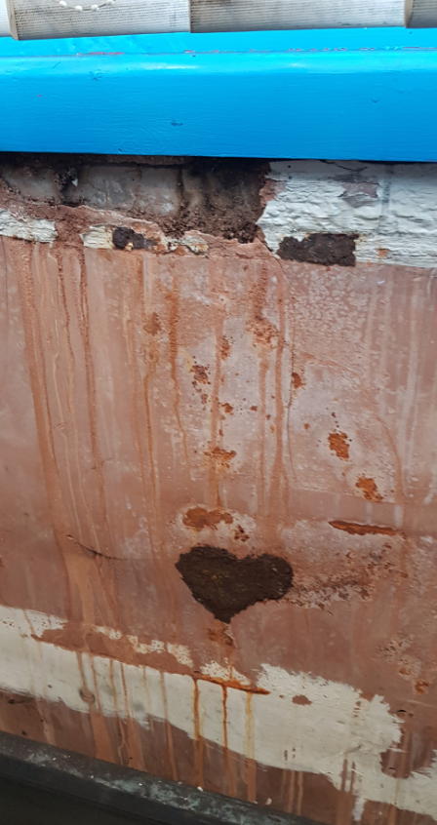

Item | Defect Identification | RAM Score
SAP Notification No: 24589 | Office block C3 heating stuck on full, temperature unbearable | 2
 | Investigation
Investigation Team: Elect | Electrical team investigated initially and found fault with Honeywell 3-way motorised diverter valve. Mechanical team confirmed the divertor valve was faulty and stuck on full heat Honeywell identifies that these valves have a known MTTF rate based on time and number of operations of 58400 hours. Maintenance concepts took this into consideration and a run to failure concept was taken. The issue was compounded as the failure occurred in the summer period.
 | Course of Action
SAP Order No: 64585 | SAP work order created and divertor valve replaced following day with item from stores.

Item | Defect Identification | RAM Score
SAP Notification No: 32958 | Exit hydraulics fluid conditioning pump tripped – line on stop | 2
 | Investigation
Investigation Team: Elect | Electrical team found that the FCP had tripped on phase failure, it was identified that the fuse had blown on one phase. Electrical checks confirmed that one of the motor windings had gone open circuit. The maintenance regime is in place and followed with no defects noted. The assumption is the winding was damaged from a loose connection
 | Course of Action
SAP Order No: 66587 | Motor replaced with spare, line left running.  Review of maintenance concepts for motor and level 1 diagnostics to identify potential issues to the operator based on a discrepancy between current on ease phase.

Item | Defect Identification | RAM Score
SAP Notification No: 33058 | Emergency lighting not tested in C4 Office block | 2
 | Investigation
Investigation Team: Elect | Office block C4 was mothballed some years ago and as such all maintenance plans were suspended.  BS 5266-1 states that emergency lighting should be checked and maintained irrespective if office block not being used
 | Course of Action
SAP Order No: 66700 | Emergency lighting checked by external contractor to BS 5266-1 and certificate produced.  Reinstated SAP maintenance plans for statutory inspections of emergency lighting until office block is demolished

Item | Defect Identification | RAM Score
SAP Notification No: 18699 | Waste Gas fan 4, flange bolts corroded. | 4
 | Investigation
Investigation Team: Mech | Mechanical team identified the bolts were not corroded by rust but as the existing stainless-steel bolts have been replaced with mild steel bolts a galvanic corrosion reaction has occurred between the dissimilar metals.  SAP identified the valve had been replaced after failure on start up some 20 years ago. The SAP Maintenance plan looks at the physical fitting and tightness of the bolts and does not identify the spec. Had the MOC process been in place at the time of the change, then this would have been identified and not allowed.
 | Course of Action
SAP Order No: 63180 | Bolts to be removed, flange cleaned and replaced with SS 304 bolts

The final section looks at potential improvements that Tata can make to its current building pathology and building maintenance strategy.

3 Current Maintenance strategies
Limble (2021) suggests there are five types of maintenance strategies and maintenance strategies evolves through the stages as identified in figure 8 but then further contradicts themselves by suggesting that in the real-world maintenance strategy is dependant on the organisation; their budgets, the assets they operate; their workforce and skill levels and their starting position.
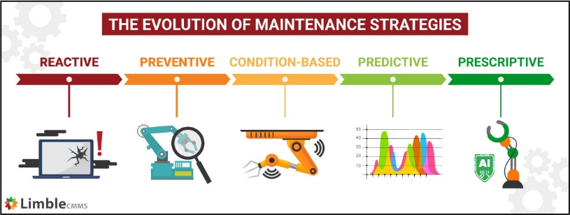
Figure 8 – Maintenance strategy evolution
Tata defines the maintenance strategy based on the Maintenance concept analysis, figure 9 shows the overview of the step involved in determining the correct maintenance concept for that asset based on risk and cost.

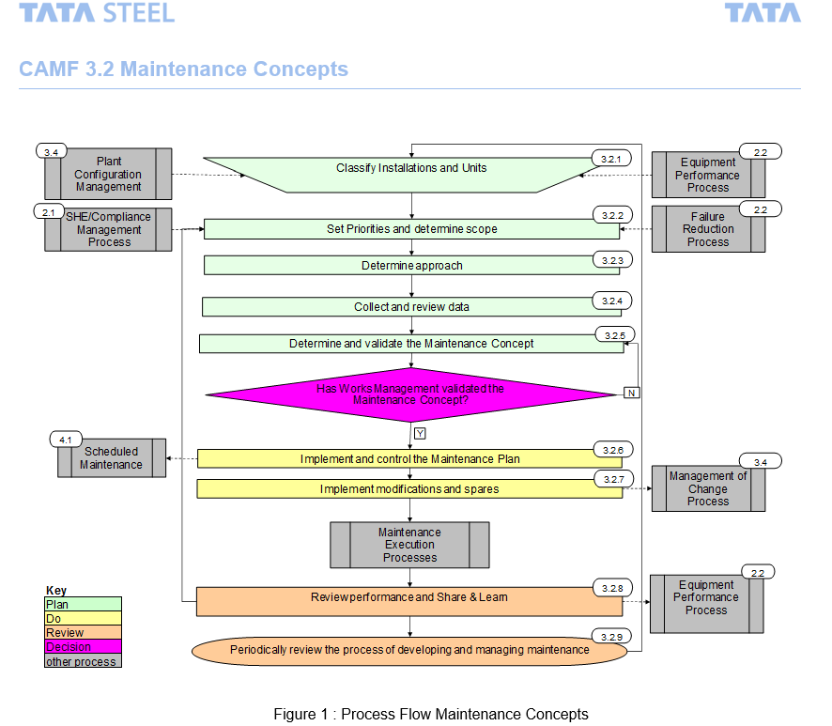
Figure 9 – Maintenance concept flowchart
Tata has its own internal workforce to carry out maintenance whether that is preventative or reactive. Tata would like to perform the optimal maintenance on every asset and replace before end of life as the ideal would suggest, but this ideal strategy is not realistic, and the level of maintenance is decided based on known risks and failures.
Appendix 1 goes into detail of the maintenance concept process in more depth, but the basics include identifying the asset, its known failure modes, the manufacturers guidance on maintenance, the legislative requirements, the risk to people and process and finally the learnt failures from other area of Tata or external parties.
The outcome of the maintenance concept normally falls into one or more of the strategies below:
- Run to Failure (very low risk items only)
- Preventative Maintenance (Tonnage or time based)
- Condition Based Maintenance (Tatas main current maintenance strategy)
- Predictive Maintenance (Tata’s preferred maintenance strategy)
- Prescriptive Maintenance (Intelligent machines predict failure based on algorithms)
Tata has assets in all categories under maintenance concepts, the buildings and office blocks unfortunately fall into the run to failure maintenance concept as very rarely does a building defect have a detrimental impact on safety, production and customer deliveries. This does not mean that working environments are ignored but certainly not dealt with the same level of rigour and speed as an operational line or process or occupational safety defect would.
The maintenance concept is part of the overall company asset management strategy (CAMF) which is similar in principle to building pathology. Table 3 shows the relationship between Building Pathology; Asset Management and Tata steel. Asset Management contains maintenance; defect identification; investigation to root cause; solution generation; implementation and monitoring are virtually identical to the building pathology principles.
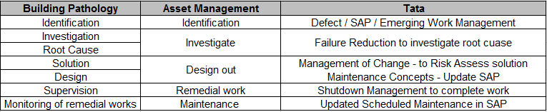
Table 3 – Building Pathology, Asset Management and Tata steel

Future Strategies

Integration of stand-alone databases
It was noted in the building defect analysis that Tata has comprehensive systems in place for asset management, defect identification and maintenance scheduling through SAP that can be manipulated in numerous aspects to provide as much data as is required by the end user, it has already been noted that this is labour intensive but now part of daily operations should not be discarded as introduction of a new system would again take time to embed and risk losing the current level of data and detail. A suggestion would be to ensure the other stand-alone system such as the Management of change, 8D investigation database and management investigation database could be linked to provide a one stop shop where all asset related documentation can be stored.
There is the obvious advantage to this as there would be a single system for all aspects of asset management from concept to removal.
Due to the physical size of Tata as an employer and the number of assets owned then a full cot benefit analysis would need to be completed as there would be a high cost to implement this suggestion from design to implementation; potentially a high cost of implementation from data storage; a very high cost in labour, documentation, management and time for training persons on system changes.

Increase focus on asset management of buildings
It can be seen form the analysis of defects it is clear that Tata’s risk matrix for defects prioritises safety, which with Tata being a COMAH tier 1 site is expected and should remain the main focus. The remainder of the Risk Matrix focuses on the environment, reputation and asset performance which is again understandable but the building itself will always provide a lower rated risk when compared to these headings unless there is a serious risk of building collapse.

Use of Drones to complete inspections
Currently roof inspections are carried out by the building inspection team, this involves the competent person obtaining all the necessary paperwork and permitry and safety equipment such as harnesses then accessing the roof via the vertical ladder walking along the edge of the roof being clipped onto the fall protection system and visually looking for defects.
Drone inspections are becoming more increasing in popularity as technology advances with the ability to have very high detailed HD, IR or thermographic imaging. Drone inspections reduce the time involved in completing the inspections as permitry can take time to be issued; has a greater geographical coverage compared to the human eye; removes the need for people to be at risk by removing the need to work at height for the inspection and provide a record of the inspection that can be shared amongst other and will assist in comparing degradation over time and clearly identifying defects such as holes, thermal bridging; moisture detection and much more.
This approach is relatively low cost and already used for the stack inspections.

Decarbonisation
Decarbonisation is currently the main focus for all companies throughout the world. The UK has agreed through COP26 to reduce carbon emissions of 30% by 2030 and this increases every 10 years. Tata has a lot to do to ensure they comply with this requirement and decarbonising a steel manufacturing plant is expensive requiring a large Capex commitment and is not a quick approach.
Tata can benefit from utilising many of the waste gasses and steam generation to power other aspects of plant such as heating systems. Tata also has a lot of land; deep sea harbour; Reservoirs and several miles of beach which allows for several other technologies such as wind turbines; solar farms and heat networks to be analysed along with associated cost benefit analysis and payback periods to be identified.
Any new buildings within Tata should look to obtain some sustainability certifications such as BREEAM or Passivhaus to lower the U value as maintaining the buildings in this climate could result in a serious reduction in energy used to heat the buildings. Saving energy reduces the carbon footprint and reduces the costs of these utilities.

BIM / 3D Scanning for ATEX areas
Tata uses 3D scanning to provide models for all areas of plant, there are however exceptions to where this can be carried out as some areas of plant are under DSEAR regulations classified as Zones 0 through to 2. Currently there is not a 3D Scanner that is capable of being used within these zones which is potentially where a BIM model could be utilised to build a model from existing line drawings.

Integration of SAP into PLC level 1 architecture
As already mentioned, SAP is a very labour-intensive system and Tata use highly accurate; fast PLCs to control the production line / process within milliseconds. As with the internet of things, the PLC’s have thousands of sensors connected to provide accurate information to control operations. Currently the PLC alerts operators via an alarm system of impending defects or actual defects, the operator then inputs these defects into the SAP system. Tata would benefit on completing a cost benefit assessment of integrating the PLC to the SAP system; this would ensure that all defects are captured as there is a risk that this is not the case at present and reduce the labour requirement for employees in inputting the data into SAP and the risk of numerical errors in typing pump numbers for example which could then in turn provide false data on failure history.

Conclusion

The research has shown that there is not a one fit approach to building pathology. Several authors discuss the topic but are all variations around the same themes, they being to identify a defect, understand how the defect came about, identifying and adopting a solution to contain or totally remove the defect.
It is clear to see that Tata uses this approach under the asset management umbrella using defect management but due to the inherent risks and cost involved in the entire process of steel manufacturing and cold rolling, Tata focuses its resources in area of Process Safety, Occupational Safety, Environment and operations.
Whilst this approach is totally understandable, it leaves the buildings within Tata in a poor state of repair with no immediate plans to solve this issue.
Much of the literature reviewed surrounding building pathology as the name suggests looks at building and is ideal for office blocks, residential houses, schools, hospital, hotel and alike industries but does not consider the standard concrete foundation, steel structure, sheet clad industrial building that is built from a standard design approach and its sole purpose to add an extra layer of protection from some of the production lines to the external environment.
Many of the steel making processes such as Coke Ovens, Sinter Plant, Coal plant and blast furnace do not have building as such, all the assets are exposed to the local environment.
Tatas approach to asset management is excellent and mimics the principles of building pathology. The SAP system Tata uses are so advanced that they can only work in an industry such as steel manufacturing. There are not many companies that can roll out such a detailed programme to every employee within the company, where all the reports generated are based around the CAMF and SAP systems.
The system although not user friendly at first as there are so many options available to the user can be labour intensive to input defect; manage the SAP notification through the process to work order and schedule to complete at the right opportunity. South Wales Police (SWP) achieved a similar result using an excel based system for identifying defects and thought the Total Facilities Management (TFM) Contractor managed the work being completed. SWP however did not have detailed asset registers, was completely reliant on the contractors for defect cause and solution identification and very little in house skills to challenge the contractor on required work.
Several opportunities have been identified for Tata to improve their building maintenance strategy, some of these such as using drone surveys and thermography are relatively low cost and could be implemented easily as this technology is already being used on the manufacturing assets. Decarbonisation is a major player for all industries, new technologies to reduce carbon emissions need to be implemented, if Tata looked after their buildings, they should be able to reduce the energy used to heat these buildings.

References
CIB (2020) CIBW086 Research roadmap. Available at:file:///C:/Users/B079577/Downloads/CIBW086-Research-Roadmap_final-2021-1.pdf Accessed 10 June 2022.
Duffy, F (1990) Measuring building performance.
Duncan, A; Ward, L (2017). A building pathology system in New Zealand – what is possible? Available at: https://d39d3mj7qio96p.cloudfront.net/media/documents/SR366_A_building_pathology_system_in_New_Zealand.pdf Accessed 06 June 2022
Eweda, A; Al-Sakkaf, A; Zayed, T; Alkass, S (2021) Condition assessment model of a building indoor environment: a case study on educational buildings. International Journal of Building Pathology and Adaption 15th September 2021. Available at: https://www.emerald.com/insight/content/doi/10.1108/IJBPA-03-2021-0036/full/html Accessed 21 April 2022
Harris, SY (2001) Building Pathology – Deterioration, diagnostics and intervention. Available at :https://books.google.nl/books?hl=nl&lr=&id=ClnQtqipTtsC&oi=fnd&pg=PA4&dq=building+pathology&ots=EKweIn-e-c&sig=-JQ_zOB55 IDQnGZyYgkZKzM2No&redir_esc=y#v=onepage&q=building%20pathology&f=false Accessed 21 April 2022
Hassan, ZF (2022) Multi-dimensional assessment design for building pathology. Available at: https://link.springer.com/chapter/10.1007/978-981-16-7228-6_22. Accessed 21 April 2022
Hassan, ZF; Ali AS; Chua, SJL; Baharum, MD (2017) Building pathology, maintenance and refurbishment. Available at : https://www.taylorfrancis.com/chapters/edit/10.4324/9781315470535-6/building-pathology-maintenance-refurbishment-zahiruddin-fitri-abu-hassan-azlan-shah-ali-shirley-jin-lin-chua-mohd-rizal-baharum. Accessed 22 May 2022
Napolitano, R; Hess, M; Glisic, B (2020) Quantifying the Differences in Documentation and Modelling Levels for Building Pathology and Diagnostics. Arch Computat Methods Eng 27, 1135–1152 (2020). https://doi.org/10.1007/s11831-019-09350-y. Accessed 28th May 2022
NBS (2017) What is the health and safety file. Available at: https://www.thenbs.com/knowledge/what-is-the-health-and-safety-file. Accessed 2nd June 2022
Parnham, P. (2000), "Review of Building Pathology: Principles and Practice", Structural Survey, Vol. 18 No. 2. https://doi.org/10.1108/ss.2000.11018bae.002. Accessed 18th May 2022
RICS (2012) Building surveying practice notes 1st Edition, Available at: https://www.rics.org/globalassets/rics-website/media/upholding-professional-standards/sector-standards/building-surveying/building-survey-practice-note-1st-edition-rics.pdf Accessed 11th June 2022
Ronsom, B; Douglas, J (2013) Understanding Building Failures. Available at: https://www.taylorfrancis.com/books/mono/10.4324/9780203125175/understanding-building-failures-james-douglas-bill-ransom. Accessed 18th May 2022
Singh, J (2021) Defects in Buildings, causes and remedies. Available at: https://www.nbmcw.com/article-report/infrastructure-construction/highrise-construction/defects-in-buildings-causes-and-remedies.html#:~:text=A%20defect%20is%20a%20building,the%20use%20of%20inferior%20materials. Accessed 12th June 2022
Watt, D S (2009) Building Pathology principles and practice second edition. Available at: https://books.google.nl/books?hl=nl&lr=&id=63HsCQAAQBAJ&oi=fnd&pg=PR5&dq=building+pathology&ots=9Ulp9nzyf3&sig=rnPfhwrj2sx9hnSboZtexQea48Q&redir_esc=y#v=onepage&q=building%20pathology&f=false Accessed 21st April 2022

Appendix 1 – Tata Maintenance concept

Figure 10 - CAMF through asset lifecycle
Step 3.2.1 : Classify Installations and Units
- Review the Functional Location Structure in SAP at least down to unit level amend, if necessary, before moving to next step
- Classify all units by their criticality and review this step, if the results are older than 3 years (or earlier if changes in the strategy or operational context require this) in 3 categories: “a”, “b” or “c”, with “a” being the highest level of criticality by using the selected standard Risk Matrix for this installation (see CAMF Guide EG-70.32.01 “Development and Revision of Risk-Based Maintenance Concepts and Plans”)

Step 3.2.2 : Set Priorities and determine scope for developing or revising Maintenance Concepts and Plans
Set priorities for developing or reviewing Maintenance Concepts and Plans based on the gap actual (under) performance of the installation based on targets resulting from the Strategy Deployment Process to Equipment Performance regarding:
- Availability Killers (units with highest downtime)
- Cost Drivers (units with highest costs)
- Integrity Items (units with highest SHEQ risks)
  - SHE/Compliance- and Process Safety recommendations including results from Process Hazard Reviews (PHR) or Hazard and Operability studies (HAZOP)
- Ageing Assets (units which are soon reaching their end-of-life)
  - End-of-life assets are to be included in a Long-Term Asset Replacement Plan (LTARP). In practice however, lifetime extensions can be reached when optimising preventive maintenance plans.

Step 3.2.3 : Determine approach
- Define which data / documentation is required on:
  - Functional description in terms of capabilities (uptime, tons, costs etc.)
  - Current costs of maintenance
  - Performance (all aspects including environment and safety)
  - Failure history
  - Current maintenance plans, planned downtime & maintenance hours
  - Legislation including mandatory tasks
  - Original Equipment Manufacturers (OEM) Instructions
- Assess maturity level of the process organisation regarding maintenance concepts based on CAMF Assessment on Maintenance Concepts: Entry, Intermediate or Advanced
- Select an RCM trained and experienced facilitator, define the necessary knowledge and disciplines and assign a team

Step 3.2.4 : Collect and review data
- Collect data needed as defined in step 3.2.4 (drawings, manuals, delay/failure/cost records, existing studies, etc)
- If required revise and update Functional Location Structure concerning the units in scope (see Guide “Plant Configuration Management: Functional Location Structure in SAP”)
- Ensure that relevant data is traceable via SAP
- Use the collected data to define and understand the current maintenance regime and failure behaviour
- Assess all compliance obligations; statutory and mandatory

Step 3.2.5 : Determine and validate the Maintenance Concept
- Describe within the Operating Context the functions at unit level contributing to the function of the installation (what does it supposed to do)?
- Identify the measurable outputs against the expected standard of performance (how well does it do)?
- Perform analysis in accordance with the correct application of the chosen methodology (see figure 10 in the Guide “Development and Revision of Risk-Based Maintenance Concepts and Plans”)
- Define the failure modes regarding the defined functions of the unit
- Conduct a thorough assessment of the potential for condition monitoring through sensors or smart cameras.
- Define an appropriate maintenance/modification strategy and related tasks including the required interval.
- Cluster maintenance tasks to create a comprehensive Maintenance Concept for the unit
- Assign the clustered maintenance an interval, completion time, work group etc.
- List (changes to) required spares and modifications (equipment, process, operations, organisation)
- Check changes on possible risks according to Management of Change (MoC) procedures
- Assign the correct Maintenance Activity Type code (MAT) to each task
- Embed all maintenance tasks in an upload file by using the interface Optimizer+ / SAP PM, including deletion of outdated tasks
- Get approval from the works area management for the Maintenance Concept (incl. if applicable list of spares and modifications). If possible, through digital signature in Optimizer+

Step 3.2.6 : Implement and control the Maintenance Plan
- Upload the new Maintenance Plan in SAP PM
- Define the Job Technical Descriptions (JTD) to be written according to the CAMF Guide EG-70.32.02: “Job Technical Descriptions and Templating”.
- Train in new tasks, if deemed necessary to achieve proper implementation
- Attach JTD’s to the regarding tasks
- Plan (frequency of) checks and updates; at least every 3 years or whenever a trigger) requires revising the MC.
- Ensure that the defined process KPI’s and monitors are in place and tracked

