
Programme: Master of Business Administration
Module: Marketing Management
Module code: LCMB7024
Sustainable Indoor Air Quality Solutions: Dyson EcoAir
Student name: Chocha Neha Ramshibhai
Student ID:2542712

Table of Contents
Element 1: Sustainable Brand Extension Poster Presentation 3
Element 2: Develop a Segmentation, Targeting, Differentiation, and Positioning (STDP) 4
2.1 Segmentation Analysis 4
2.2 Targeting Strategy 5
2.3 Differentiation Strategy 6
2.4 Positioning Strategy 7
Element 3: Marketing Mix (4Ps) 9
3.1Introduction 9
3.2 Product 9
3.3 Price 10
3.4 Place 10
3.5 Promotion 11
Element 4: Reflection 12
Reflection Using Rolfe's Reflective Model 12
References 14
Appendix: Element 1 Content 18
Introduction to the Company 18
Sustainable Requirement and Purpose 18
Market Appeal 18
Alignment with Sustainability Goals 18

Element 1: Sustainable Brand Extension Poster Presentation
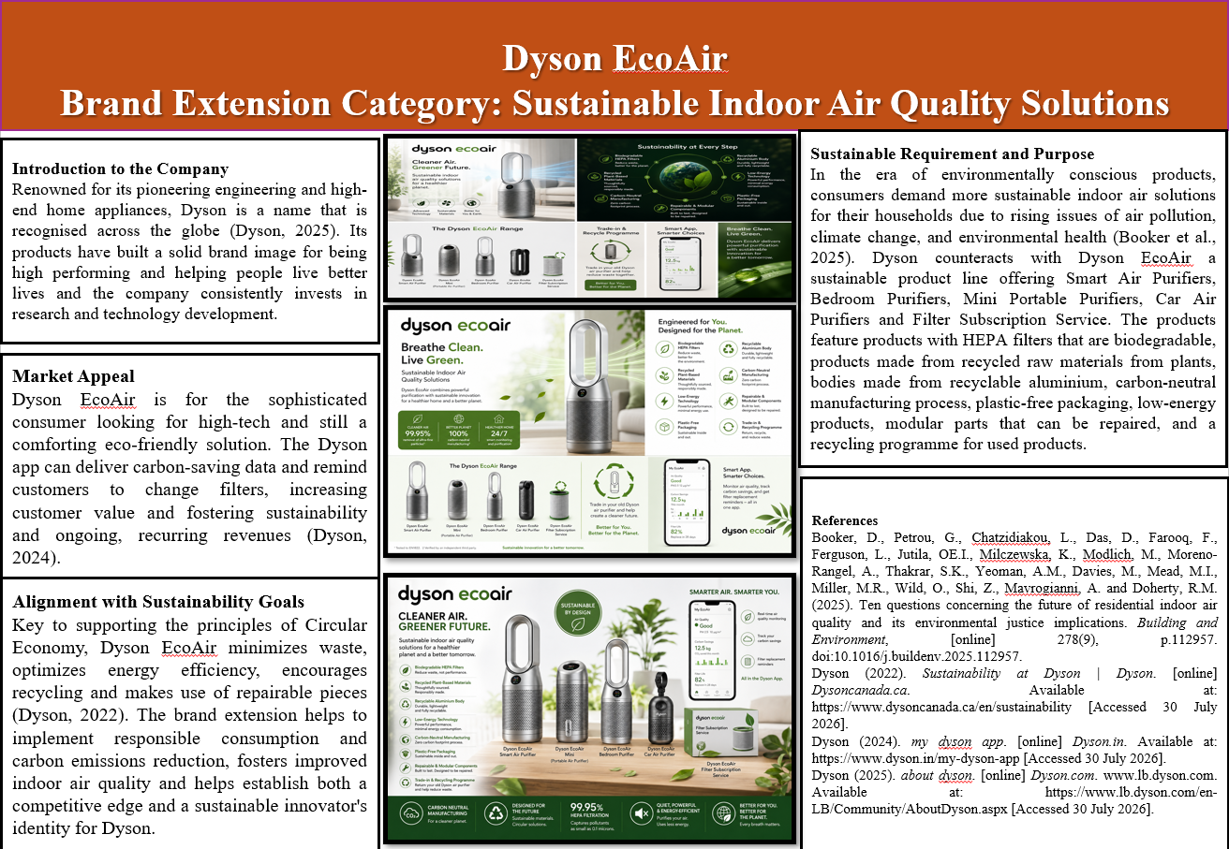

Element 2: Develop a Segmentation, Targeting, Differentiation, and Positioning (STDP)

2.1 Segmentation Analysis
Market segmentation involves dividing a large market into smaller segments with similar purchasing behaviour, characteristics and needs (Clarke, Freytag and Cortez, 2024). By developing segmentation for Dyson EcoAir, the company understands the consumer's preference for a high level of air purifier technology and environmental wellbeing. Air purifier industry growth is set to be propelled by the rising problem of air pollution and the mounting urbanisation rate along with healthcare and environmental concerns among consumers around the world.
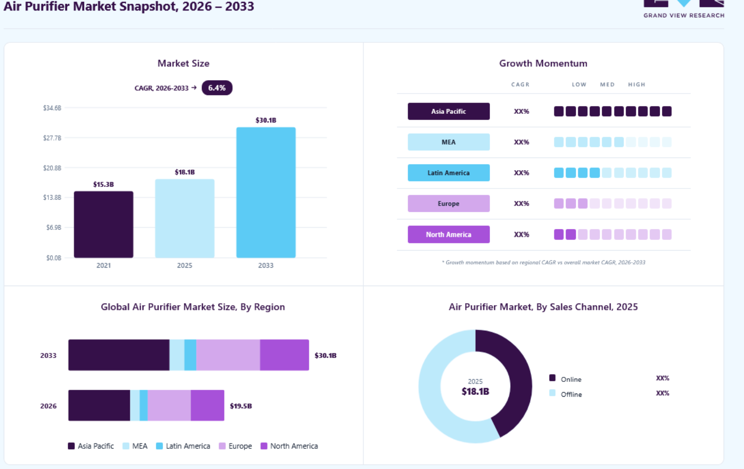
Figure 1: Revenue of air purifier
(Source: Grand View Research, 2024)
The peripheral air purifier market was worth only USD 17.8 billion in 2024 and is expected to top USD 30.5 billion by 2030, with an estimated compound annual growth rate (CAGR) of roughly 9.4% (Grand View Research, 2024).
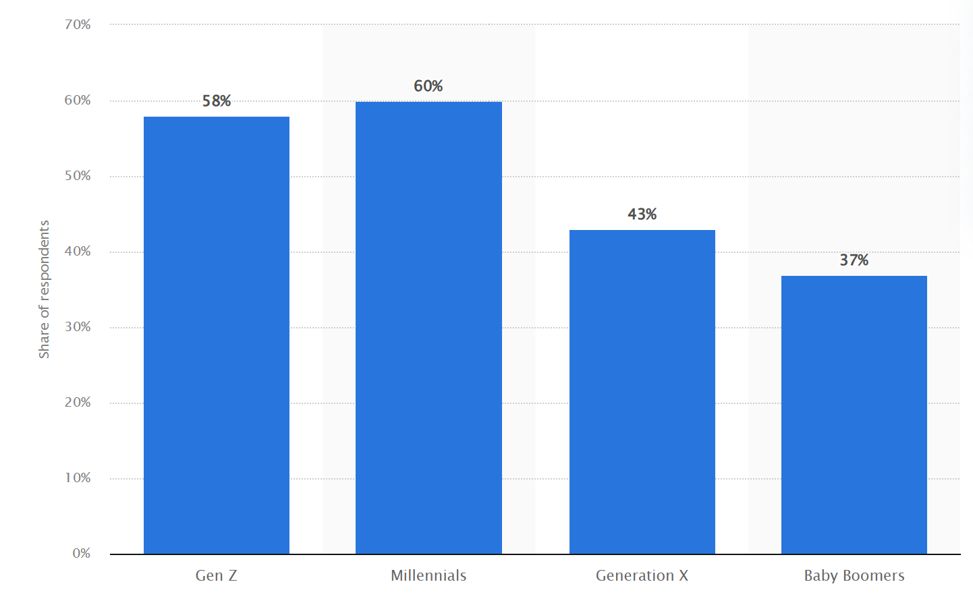
Figure 2: People ready to pay more for sustainable products
(Source: Watty, 2025)
Likewise, Statista (2025) found that over 70% of the global population are prepared to pay a higher amount for products that have sustainable parts, signifying a favorable market for Dyson EcoAir (Watty, 2025).

2.2 Targeting Strategy
Dyson EcoAir's strategy is different – to target pricing, premium quality consumer segments, who value their health, technology and sustainability. The main target group are medium to high income urban professionals and families aged 25-55. They are usually in urban areas with a rising risk of indoor air pollution and have a rich demand for luxury appliances for their homes that enhance their quality of life.
The target customer is also one who is eco-friendly and actively looks for products produced in an environmentally responsible material and energy-efficient technologies. Many of these consumers already are users of electric vehicles, renewable energy, reusable household items and smart home solutions (Cam, 2023). Therefore, Dyson EcoAir adds to their already sustainable lifestyles.
As sustainability is a key driver of purchase habits, millennials and Generation Z are more appealing market segments.One of the second areas that businesses will be targeted is the secondary market. Sustainable indoor air quality is of growing concern for offices, hotels, healthcare and educational institutions, and premium commercial buildings, due not just to the positive impact on employee wellbeing, but also because of the benefits it brings to Environmental, Social and Governance (ESG) goals (Mannan and Al-Ghamdi, 2021). This provides Dyson EcoAir with further business to business (B2B) opportunities. An added biodegradable filter replacement subscription program also helps customers stay longer by seamlessly assuring their constant engagement while boosting their revenue flow.

2.3 Differentiation Strategy
Differentiation is one way for an organisation to achieve a competitive advantage by creating something with added value that the competition cannot easily copy (Thomran et al., 2022). Since its founding, Dyson EcoAir has been distinguishing itself with the integration of high quality engineering and sustainability throughout the product lifecycle. Whereas regular air purifiers are primarily concerned with the amount of filtering they do, Dyson EcoAir is both technologically innovative and environmentally conscious. They offer the following products:
- Biodegradable HEPA Filter Cartridges.
- Filters produced from recycled plant materials.
- Recyclable aluminium construction.
- Carbon-neutral manufacturing.
- Plastic-free packaging.
- Low-energy consumption technology.
- Modular repairable components.
- Trade-in and recycling programme.
- Mobile 'Smart' app, with carbon-saving reminder and filter replacement reminder.
- Introduce continuous product performance with filter subscription service.
These features set Dyson EcoAir apart from key competitors like Philips, Blueair, Coway and Xiaomi, which are mainly focused on filters or simply price. Additionally, Dyson is one of the best-known brands in the world that is involved in engineering excellence and innovation (Stratrix, 2025). This brand equity decreases the customer's uncertainty about purchasing new sustainable products. The Dyson mobile app also improves the degree of differentiation, which enables users to stay up-to-date in real time on the indoor air quality, energy consumption, carbon savings and maintenance timelines. This digital ecosystem not only enhances CX but also fosters sustainable practices.

2.4 Positioning Strategy
According to Rua and Santos (2022), positioning is developing a unique image of a product in the minds of the consumers in comparison with its competitors. With an eye toward the future, Dyson EcoAir aims to be a top-tier sustainable indoor air quality system, powered by world-class engineering, as well as environmental responsibility.
The position is:
Environmentally conscious consumers looking for cleaner indoor air without compromising on sustainability Dyson EcoAir offers advanced smart air purification technology with eco-friendly materials, most energy efficient performance & solution for circular economy, thereby enhancing the personal wellbeing and the environment. In contrast to the lower-priced lifespan-only and less technologically advanced products, Dyson EcoAir is focusing on technology, sustainability, durability and smart connectivity. The brand extension reinforces Dyson's traditional reputation for innovation, and carries out its sustainable manufacturing and circular product design.
It’s up-quality positioning is also in line with the changing consumer expectations. In fact, according to IBM's Institute for Business Value (IWIBV) in 2024, 62 per cent of consumers around the world are willing to change their buying behaviours to help the environment, and around 55 per cent would pay more for products from brands that are doing good for the environment (IBM, 2022). All of these trends show an increased market-acceptance for high quality sustainable products.
Some United Nations Sustainable Development Goals (SDGs) supported by Dyson EcoAir are:
- SDG 3: Good health and well-being - through improved indoor air quality.
- SDG 12: Responsible Consumption and Production via recyclable materials, circular product design.
- SDG 13: Climate action, including through carbon-neutral production and energy-efficient technologies.
So far, Dyson EcoAir is a value not just for customers but also for investors looking for businesses that adhere to the principles of Environmental, Social and Governance (ESG)

Element 3: Marketing Mix (4Ps)

3.1Introduction
The marketing mix is a marketing strategy solution that can help organisations design, and implement value propositions to meet the needs of customers while also securing the organisations' competitive advantage. This strategy will help Dyson build on its high-end image and move in line with the demand by consumers for greener, eco-friendly and energy-efficient home technology devices.

3.2 Product
The product strategy is the core part of the sustainable brand extension of Dyson EcoAir due to the company's dedication to new advances and protection of the environment. Product decisions not only involve product performance but also product design, quality, sustainability and lifecycle management (Jakobsen and Tambo, 2025) The Dyson EcoAir line includes the Smart Air Purifier, the EcoAir Bedroom Purifier, EcoAir Mini, the EcoAir Car Air Purifier and the Filter Subscription Service, that means that it can handle many of the specific requirements users have at home, at work and in their cars. The extension distinguishes itself in sustainable product innovation: biological filter cartridges with HEPA filters, sustainable materials for filtration, made of recycled plants, aluminium construction that is endlessly recyclable, plastic-free packaging, low energy consumption technology, modular repairable parts, carbon-neutral production (Gururaj Fattepur et al., 2024).
By adhering to the Circular Economy paradigms, materials and components should be designed to be as durable, repairable, reusable and recyclable as possible, thereby reducing the amount of waste and raw material needed Velenturf and Purnell (2021). The trade in programme, combined with recycling capabilities, also prolongs the life of their products while minimizing e-waste and boosting the company's environmental proof.
On a strategic level, implementing Dyson smart technologies with the Dyson app offers value to the customer by supplying real-time air quality levels, carbon-saving figures and automatic reminders when it's time to change the filter. This digital characteristic enhances consumer interaction, adding to a brand's sustainability story. The opportunity in the market is huge. As a result, Dyson EcoAir has the opportunity to meet the rising demand of environmentally conscious and tech-savvy consumers.

3.3 Price
The pricing of Dyson EcoAir uses a premium value-based pricing strategy that is based on what customers receive in return for the price, which includes the superior technological capabilities of the product, quality of the products, sustainability advantages and their long-term value.
For premium brands, value-based pricing is more suitable as the customers appraise the overall benefits and not only the purchase price (Ashraf, Li and Mehmood, 2017). Dyson has enjoyed a premium niche by always focusing on technology differences and hence, not competing on pricing with other manufacturers. Despite the higher up-front expense, Dyson EcoAir also offers lower running costs with energy efficiency technology, a durable recycling material, a product design that ensures repairability and changes that involve only the filter, and help with maintenance by signing up for filter replacement services (Juhoantti Köpman and Jukka Majava, 2024). In addition, sustainability becomes a new factor in consumers' willingness to pay for higher prices. This means that as consumers are increasingly willing to buy products with a provable environmental responsibility, price strategies such as the one adopted by Dyson are supported.

3.4 Place
The distribution strategy is designed to optimise customers' access without compromising Dyson's brand up-market positioning and environmental impact along the supply chain. Dyson EcoAir will be available in an integrated omnichannel distribution plan via Dyson stores as well as the official Dyson website, authorised premium retailers, department stores, specialist smart-home stores and selected online marketplaces. This serves to allow customers to perform research on the web and try out products in stores, while making purchases via their preferred mediums. The omnichannel approach takes into account the modification in how consumers acquire products and services (Huu De and Khoa, 2026). McKinsey & Company research shows that more than three-quarters of consumers of premium appliances use more than a single distribution channel before buying, meaning seamless integration between channels is key (Adams, Alldredge and Kohli, 2025).
In a sustainability effort, Dyson will look around the world to optimise distribution centres and minimise shipping distances to generate less carbon emissions. Furthermore, plastic free packaging and the recyclability of packaging contributes to the company's overall carbon reduction strategy, which includes consolidated logistics (Coelho et al., 2020) .Additionally, the filter replacement service is a subscription-based option that allows the filter replacement devices to be scheduled for home delivery to further improve the efficiency of the distribution process without the need for extra shopping trips, while maintaining the performance of the filter.

3.5 Promotion
Communication is essential in promotion activities to help ensure that the value proposition of Dyson EcoAir is understood and that the consumers are aware of the positive effects on environmental and health benefits that using sustainable indoor air quality solutions brings. Dyson will implement an Integrated Marketing Communications (IMC) approach, which integrates all media marketing with digital marketing, social media marketing, influencers, sustainability marketing, public relations, search engine optimisation, experiential marketing and education (EBESCO, 2023).Promotional efforts will prioritise environmental benefits, such as Dyson's commitment to manufacturing carbon neutral products, using recyclable materials, biodegradable filters, and implementing a circular economy model for Dyson EcoAir products.
The Dyson mobile application is a vital communication tool, giving customers significant information about the indoor air quality, energy usage, carbon savings and filter replacement schedules. Such interactive features promote ongoing customer interaction and reinforce sustainable consumption behaviors. Transparency should be highlighted especially in sustainability marketing. NielsenIQ (2024) states that around 78% of consumers feel more confident in each organisation when witnessing evidence for environmental claims (Fernandes, 2024). As a result, Dyson needs to embrace sustainability certifications that are independently verified, a drive to boost its credibility and reduce the risk of greenwashing.

Element 4: Reflection

Reflection Using Rolfe's Reflective Model
Rolfe et al., (2001) offered a reflective framework that consists of three main phases: What? So What? and Now What? As a model, it offers a process to consider and analyze experiences, to determine what is learned, and to make plans for improving in the future (Rolfe, Freshwater and Jasper, 2001). The completion of the Dyson sustainable brand extension and poster presentation allowed me to gain further knowledge in sustainability marketing, whilst also improving my communication skills professionally.
What?
In order to do this evaluation, I have created an affordable and sustainable brand extension for Dyson, which was based on a detailed marketing plan, taking into account aspects such as market segmentation, targeting, differentiation, positioning and the extended 7 P's marketing mix (Saidani, 2019). I chose Dyson EcoAir as the brand is known for technologic innovation, ideal to introduce an environmentally friendly air quality treatment solution (Dyson, 2024). During the development of the project research work was conducted on the latest sustainability trends, a study on consumer habits was carried out and an assessment of how environmental issues impact upon strategic marketing choices was conducted.
So what?
It was really a great experience to get a very good insight on sustainable marketing and how to apply the concepts from theory. Before doing this Assessment, my sustainability knowledge was centred on the environment. But I knew from substantial academic research that sustainability is not solely about value creation, and about ripples of customer satisfaction too, about innovation, long-term competitive advantage (Hermundsdottir and Aspelund, 2021). This wider lens helped me value the possibilities of sustainability as a key part of an organisation's planning, not a corporate social responsibility program.
The strategy of STDP analysis and the preparation of the 7Ps marketing mix helped me appreciate how marketing decisions have to be synced to deliver a consistent value offering. I also learned how to carry out research skills in my academic work using current industry reports, market statistics and peer review literature for supporting strategic decisions. This encouraged stronger consideration of evidence-based decision making in marketing.
The poster presentation was another element that I could develop my presentation and communication skills in. As a result, I realized that the key to making a presentation work is to get your message across concisely, ensure your presentation is easy to understand visually and be confident with your words. Creating the poster helped me to think about how to include only material relevant to the poster, and how to keep the audience engaged. This process has helped me to communicate complicated business ideas in a professional and understandable way.
Now what?
I am content with the results of this assessment, but I find that there are a number of aspects which could be further improved. Future projects: I'd also be interested in further developing my data analysis abilities to use more sophisticated market research methods and consumer data as the basis for recommendations. I wondered what I can learn to do with data visualisation software and tools like PowerPoint that can improve my presentations in a more interesting and professional manner.
Moreover, I'm going to continue working on my public speaking skills as I will need to deliver presentations more often which will help raise my confidence in speaking, enhance my voice projection, and help boost interaction with an audience. Workshops, group presentations and networking with professionals would be good ways of developing these communication skills.

References
Element 1
Booker, D., Petrou, G., Chatzidiakou, L., Das, D., Farooq, F., Ferguson, L., Jutila, OE.I., Milczewska, K., Modlich, M., Moreno-Rangel, A., Thakrar, S.K., Yeoman, A.M., Davies, M., Mead, M.I., Miller, M.R., Wild, O., Shi, Z., Mavrogianni, A. and Doherty, R.M. (2025). Ten questions concerning the future of residential indoor air quality and its environmental justice implications. Building and Environment, [online] 278(9), p.112957. doi:10.1016/j.buildenv.2025.112957.
Dyson (2022). Sustainability at Dyson | Dyson. [online] Dysoncanada.ca. Available at: https://www.dysoncanada.ca/en/sustainability [Accessed 30 July 2026].
Dyson (2024). my dyson app. [online] Dyson.in. Available at: https://www.dyson.in/my-dyson-app [Accessed 30 July 2026].
Dyson (2025). about dyson. [online] Dyson.com. www.lb.dyson.com. Available at: https://www.lb.dyson.com/en-LB/Community/AboutDyson.aspx [Accessed 30 July 2026].
Element 2
Cam, L.N.T. (2023). A rising trend in eco-friendly products: a health-conscious approach to green buying. Heliyon, 9(9). doi:10.1016/j.heliyon.2023.e19845.
Clarke, A.H., Freytag, P.V. and Cortez, R.M. (2024). Revisiting the strategic role of market segmentation: five themes for future research. Industrial Marketing Management, 121(18), pp.A7-A10. doi:10.1016/j.indmarman.2024.07.012.
Grand View Research (2024). Air Purifier Market Size, Share | Global Industry Analysis Report, 2025. [online] Grandviewresearch.com. Available at: https://www.grandviewresearch.com/industry-analysis/air-purifier-market [Accessed 30 July 2026].
IBM (2022). Retail industry reshapes with hybrid cloud and AI to help meet shifting consumer shopping and sustainability preferences. [online] IBM Newsroom. Available at: https://newsroom.ibm.com/2022-01-13-Retail-Industry-Reshapes-with-Hybrid-Cloud-and-AI-to-Help-Meet-Shifting-Consumer-Shopping-and-Sustainability-Preferences [Accessed 30 July 2026].
Mannan, M. and Al-Ghamdi, S.G. (2021). Indoor air quality in buildings: A comprehensive review on the factors influencing air pollution in residential and commercial structure. International Journal of Environmental Research and Public Health, [online] 18(6), p.3276. doi:10.3390/ijerph18063276.
Rua, O.L. and Santos, C. (2022). linking brand and competitive advantage: the mediating effect of positioning and market orientation. European Research on Management and Business Economics, [online] 28(2), p.100194. Available at: https://www.sciencedirect.com/science/article/pii/S244488342100053X [Accessed 30 July 2026].
Stratrix (2025). Dyson’s engineering-led innovation. [online] Stratrix.com. Stratrix. Available at: https://www.stratrix.com/vault/dyson-engineering-innovation [Accessed 30 July 2026].
Thomran, M., Alshallaqi, M., Al-Mamary, Y.H. and Abdulrab, M. (2022). The key enablers of competitive advantage formation in small and medium enterprises: the case of the Ha’il region. Frontiers in Psychology, [online] 13(18), pp.1–15. doi:10.3389/fpsyg.2022.1030405.
Watty, F. (2025). U.S.: Shoppers who prefer buying from sustainable brands 2025| Statista. [online] Statista. Available at: https://www.statista.com/statistics/1626151/shoppers-who-prefer-buying-from-sustainable-brands-us/ [Accessed 30 July 2026].
Element 3
Adams, C., Alldredge, K. and Kohli, S. (2025). State of the consumer 2024: what’s now and what’s next. [online] McKinsey & Company. Available at: https://www.mckinsey.com/industries/consumer-packaged-goods/our-insights/state-of-consumer [Accessed 30 July 2026].
Ashraf, S.F., Li, C. and Mehmood, B. (2017). A Study of Premium Price Brands with Special Reference to Willingness of Customer to Pay. [online] ResearchGate. Available at: https://www.researchgate.net/publication/325125404_A_Study_of_Premium_Price_Brands_with_Special_Reference_to_Willingness_of_Customer_to_Pay [Accessed 30 July 2026].
Coelho, P.M., Corona, B., Klooster, R. and Worrell, E. (2020). Sustainability of Reusable packaging–Current Situation and Trends. Resources, Conservation & Recycling: X, 6(2590–289X), p.100037.
EBESCO (2023). Integrated marketing communications | EBSCO. [online] EBSCO Information Services, Inc. | www.ebsco.com. Available at: https://www.ebsco.com/research-starters/marketing/integrated-marketing-communications [Accessed 30 July 2026].
Fernandes, L. (2024). Consumer outlook 2024. [online] NIQ. Available at: https://nielseniq.com/global/en/insights/report/2024/consumer-outlook-2024-6-consumer-sentiment-driven-strategies-to-drive-growth-and-capture-spending/ [Accessed 30 July 2026].
Gururaj Fattepur, Patil, A.Y., Kumar, P., Kumar, A., Hegde, C., Siddhalingeshwar, I.G., Kumar, R. and Yunus, M. (2024). Bio-inspired designs: leveraging biological brilliance in mechanical engineering—an overview. 3 Biotech, 14(12). doi:10.1007/s13205-024-04153-w.
Huu De, D. and Khoa, B.T. (2026). How customer experience drives repurchase intention in omnichannel retailing: the moderating role of prior omnichannel shopping experience. Journal of Open Innovation: Technology, Market, and Complexity, 18(10), p.100795. doi:10.1016/j.joitmc.2026.100795.
Jakobsen, A.M.S.Ø. and Tambo, T. (2025). Current state of sustainability representation product lifecycle management systems and future Perspectives: A comparative evaluation. Cleaner Logistics and Supply Chain, 15(18), p.100229. doi:10.1016/j.clscn.2025.100229.
Juhoantti Köpman and Jukka Majava (2024). The role of product design in advancing the circular economy of electric and electronic equipment. Resources, conservation & recycling advances, 15(18), pp.200207–200207. doi:10.1016/j.rcradv.2024.200207.
Velenturf, A.P.M. and Purnell, P. (2021). Principles for a sustainable circular economy. Sustainable Production and Consumption, [online] 27(1), pp.1437–1457. doi:10.1016/j.spc.2021.02.018.
Element 4
Dyson (2024). Sustainability at dyson. [online] Dyson.com. Available at: https://www.dyson.com/sustainability [Accessed 30 July 2026].
Hermundsdottir, F. and Aspelund, A. (2021). Sustainability innovations and firm competitiveness: A review. Journal of Cleaner Production, 280(1), pp.1–18. doi:https://doi.org/10.1016/j.jclepro.2020.124715.
Rolfe, G., Freshwater, D. and Jasper, M. (2001). Rolfe, G., Freshwater, D., & Jasper M. (2001). Critical reflection for nursing and the helping professions A user’s guide. London Palgrave Macmillan. - References - Scientific Research Publishing. [online] www.scirp.org. www.scirp.org. Available at: https://www.scirp.org/reference/referencespapers?referenceid=147823 [Accessed 30 July 2026].
Saidani, B. (2019). Marketing Mix-7Ps: the Effect on Customer Satisfaction. Jurnal Pendidikan Ekonomi Dan Bisnis (JPEB), 7(1), pp.81–94. doi:10.21009/JPEB.007.1.7.

Appendix: Element 1 Content

Introduction to the Company
Renowned for its pioneering engineering and high-end home appliances, Dyson is a name that is recognised across the globe (Dyson, 2025). Its products have built a solid brand image for being high performing and helping people live better lives and the company consistently invests in research and technology development.

Sustainable Requirement and Purpose
In the era of environmentally conscious products, consumers demand more sustainable indoor air solutions for their households due to rising issues of air pollution, climate change, and environmental health (Booker et al., 2025). Dyson counteracts with Dyson EcoAir a sustainable product line offering Smart Air Purifiers, Bedroom Purifiers, Mini Portable Purifiers, Car Air Purifiers and Filter Subscription Service. The products feature products with HEPA filters that are biodegradable, products made from recycled raw materials from plants, bodies made from recyclable aluminium, carbon-neutral manufacturing process, plastic-free packaging, low-energy products, modular parts that can be repaired, and a recycling programme for used products.

Market Appeal
Dyson EcoAir is for the sophisticated consumer looking for high-tech and still a comforting eco-friendly solution. The Dyson app can deliver carbon-saving data and remind customers to change filters, increasing customer value and fostering sustainability and ongoing, recurring revenues (Dyson, 2024).

Alignment with Sustainability Goals
Key to supporting the principles of Circular Economy, Dyson EcoAir minimizes waste, optimizes energy efficiency, encourages recycling and makes use of repairable pieces (Dyson, 2022). The brand extension helps to implement responsible consumption and carbon emissions reduction, fosters improved indoor air quality and helps establish both a competitive edge and a sustainable innovator's identity for Dyson.

