Advanced Project Management
Assignment 1 – Report with Gantt Chart

Project – Canolfan Gwili Centre, Hendy, Carmarthenshire

By: Anita Davis – 1908094
Date: January 2025
GENERAL INFORMATION
Report By: Anita Davis
Date: 16th September 2024
Project Name: Canolfan Gwili Centre
Project Address: Canolfan Gwili Centre, Hendy, Carmarthenshire, SA4 0XB
Project Start Date: 16th September 2024
Project End Date (estimate): 24th October 2025
Construction Company: UWTSD Construction
Site Location Plan:
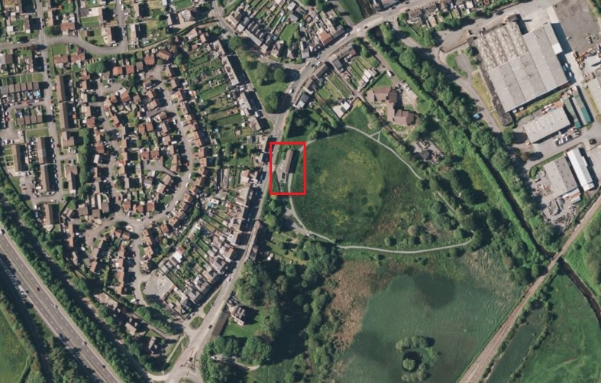

Figure 1 – Site Location Plan (Bing maps)

PROJECT OVERVIEW
The Canolfan Gwili Centre is a proposed community-centered development designed to offer contemporary facilities for the local residents and visitors. The centre aims to provide various services and spaces for community activities, café/bistro, social gatherings, meetings, and educational programs.
The main rooms comprising the centre are as follows:
- Café / Bar;
- Activity / Meeting Room Hospitality;
- Multi-Purpose Hall;
- Storage Rooms;
- Toilet and Changing Room Facilities; and
- Fitness Room (westwaleschronicle (2023))
The main key phases of the construction of the Canolfan Gwili Centre include:
- Design, Planning, and Surveying – engineering and architectural plans, planning permission, and pre-construction surveys;
- Site Preparation and Groundworks – land clearance, preparing foundations, and installation of necessary utilities;
- Construction Phase – the building of the main structure, which includes the frame, walls, floors and roof;
- Internal Phase – installation of doors and windows, interior finishes, and utilities
- Landscaping and External Phase – installation of external infrastructure such as car parks, roads and pavements, green spaces; and
- Final Inspections and Handover – check safety and quality standards and hand over officially to the client.

PROJECT TIMELINE
Phase one – Design and Planning (May 2024 – August 2024)
- Approval of architectural and engineering designs;
- Approval of planning applications;
- Obtain all necessary approvals from relevant regulatory bodies;
- Develop cost estimates and project schedules
Phase two – Site Preparation and Groundworks (September 2024 – November 2024)
- Site clearance, access, and removal of debris;
- Excavation and preparation of foundation area including concrete laying;
- Installation of necessary utilities and drainage systems;
- Laying of any footings and slabs
Phase three – Construction Phase (December 2024 – July 2025)
- Construction of the main framework including walls, beams, supports and roofing;
- Installation of windows, doors, and other structural elements;
- Installation of electrical and plumbing systems
Phase four – Internal Phase (July 2025 – August 2025)
- Interior finishes including fixtures, fittings, painting and flooring;
- Finishing of any plumbing and electrical systems within all necessary rooms;
- Installation of HVAC (Heating Ventilation & Air Conditioning) systems;
- Final decorative features
Phase five – Landscaping and External Phase (August 2025 – September 2025)
- Construction of car park area, roads, pavements and green spaces;
- Finalising external areas of the building such as cladding;
- Installation of outdoor lighting and other external infrastructure
Phase Six – Final Inspections and Handover (September 2025 – October 2025)
- Conduct final inspections against safety and quality standards;
- Finalise final fixes and adjustments;
- Ensure the building is fully operational;
- Client walkthrough and formal handover;
- Issue finalised documents as required (Tom Scalisi(2022))

CRITICAL RESOURCES
Critical resources are the essential components required for the successful completion of a project. These resources are classified into various categories: human resources, materials, tools and equipment, and funding.
The critical resources associated with this project are explained in the subheadings below.
Human Resources
The project team includes; the project manager, construction workers, site manager, health and safety manager, engineers, architects, planners, surveyors, and subcontractors.
The skilled tradespeople include; electricians, plumbers, and carpenters. The availability of skilled labourers during the project timeline is important, especially in specialised fields.
Materials
The main building materials are concrete, steel, wood, bricks, cement, clay, glass, cladding, electrical wiring, plumbing materials, insulation and finishing materials like paint, tiles, and fixtures.
The prompt delivery of materials in accurate quantity and quality is essential to avoid delays and uphold construction quality.
Tools and Equipment
Construction projects necessitate the use of heavy plant and machinery to undertake various tasks that would be difficult or unfeasible to complete manually. This encompasses excavators, cranes, dumpers, drills, saws, concrete mixers, and other construction equipment required for earthworks and lifting.
Other smaller tools and equipment for particular construction activities such as cutting, welding, plumbing, and electrical installations will also be required on site.
Additionally, as per CDM (Construction (Design and Management)) Regulations 2015, every construction site is required to have the essential infrastructure and services to support the workforce and operations on the site. This encompasses site offices, storage spaces, workshops, security measures, and toilet facilities.
Funding
Sufficient budget allocation and financial support from the client, incorporating provisions for unforeseen expenses must be considered at the start of the project. Furthermore, ensuring cash flow is not an issue to secure funds for workers, suppliers, and contractors.(Om Gupta(2024))

BUDGETS AND COSTS
The total budget for the Canolfan Gwili Centre is an essential factor in guaranteeing the project's success. This budget will cover every phase of the construction process including the design, site preparation, building construction, interior fittings, landscaping, and final handover.
With reference to Spon’s Architects’ and Builders’ Price Book and taking into consideration the location is in Wales, the estimated budget for the project is as follows:
- Material costs – estimated at £300,000.00
- Labour costs – estimated at £70,000.00
- Contingency costs – estimated at 10% of the above concluding at £37,000.00
- Design fee costs – estimated at £20,000.00
- Miscellaneous costs – estimated at £10,000.00
The estimated total budget for the Canolfan Gwili Centre is £437,000.00. (Spon’s Price Book(2023))
The financial support for the Canolfan Gwili Centre project has been sourced from a combination of public and private sources, such as:
- Carmarthenshire County Council may provide financial support or grants to aid community development initiatives. These funds could be a part of a larger effort to improve local infrastructure and social services;
- Welsh Government provides multiple grant programs to assist projects that benefit local communities;
- Crowdfunding and Community Fundraising can participate in campaigns to support the project; and
- Private Investments may opt to back the project as a part of their Corporate Social Responsibility (CSR) efforts.
This project’s go-ahead was made possible by the community’s support and more than £250k funding from Welsh Government and Carmarthenshire County Council. (southwalesguardian(2024))

RISK AND DELAY MANAGEMENT
Risk management plays an essential role in every construction project. This process includes recognising, evaluating, and mitigating risks that could potentially delay the project.
The primary risks that could affect the project are as follows:
- Financial Risks – where inaccurate cost estimates and unexpected price increases for materials occur, it could lead to budget overruns. Other possible challenges include potential delays in receiving funding or not obtaining sufficient funding for the project;
- Legal and Regulatory Risks – delays in receiving necessary planning permission or consent from the local authority and/or other regulatory bodies;
- Operational Risks – project delays due to inadequate management, adverse weather conditions, unexpected changes in site conditions, lack of labourers due to limited availability or strikes, and supply chain issues such as delayed deliveries;
- Health and Safety Risks – project delay due to accidents or injuries that have occurred on-site and potential health emergencies such as COVID-19;
- Technical Risks – last-minute changes to the design or technical issues with building systems such as electrical, plumbing installations etc. (Alex Minett(2024))
After identifying the risks, the subsequent step is to evaluate the likelihood and potential impact of each risk. This has been accomplished by allocating a risk rating based on the probability of the risk occurring and the potential severity of its impact on the project.
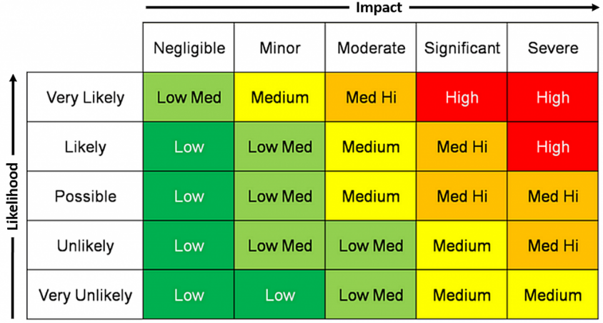

Figure 2 – Risk Assessment Matrix
The risks have been assessed in the table below:
Risk | Likelihood | Impact | Risk Matrix | Outcome
Budget overruns due to inaccurate cost estimates and funding delays | Likely | Significant |  | This may result in significant delays in the project or may potentially lead to a complete project halt
Delay in receiving planning permission or consent from relevant regulatory bodies | Possible | Severe |  | This may result in significant delays in the project or may potentially lead to a complete project halt
Unexpected adverse weather conditions and poor project management | Possible | Significant |  | This may result in significant delays and may incur further unnecessary costs
Supply chain issues and late material deliveries | Possible | Significant |  | This may result in significant delays and may incur further unnecessary costs
Accidents or injuries occurring on-site | Possible | Severe |  | This may result in significant delays in the project or may potentially lead to a complete project stop
Last-minute design changes and/or technical issues | Possible | Moderate |  | This may result in project delays and may incur further costs

Table 1 – Risk Assessment
To reduce the potential outcomes from the risks listed in the table above, the following mitigation measures will be followed:
- The use of project management software (MS Project or similar) to track the allocation of human resources, material usage, and equipment on-site;
- Contingency fund has been allowed within the budget to allow for unforeseen expenses;
- Regularly check the weather forecast for a minimum of one week in advance and maintain effective communication with scheduled contractors;
- Regular project status meetings to review the project timeline;
- Conduct regular inventory audits and daily material delivery records to ensure materials are utilised efficiently and to monitor for any delivery delays, thereby ensuring that the project timeline can be adjusted for the relevant parties;
- A strategy to developed for managing material shortages, and we shall ensure security through our long-term supply agreements with dependable vendors to mitigate the risk of abrupt price surges;
- If any delays should arise, then the Critical Path Method (CPM) will be used to identify which tasks are behind schedule and which resources are contributing to the delay. This will enable us to prioritize these tasks to reduce the impact on the overall project schedule; and
- Implementation of strict health and safety measures on-site such as PPE (Personal Protective Equipment), training, and accident prevention strategies. (K. Hainley & J. Meibers(2024))

REFERENCES
Westwaleschronicles (2023), Available at: https://www.westwaleschronicle.co.uk/blog/2023/10/24/new-community-centre-canolfan-gwili-centre-opening-soon-in-hendy/, (Accessed: Dec 2024)
Canolfan Gwili Report (2024), Available at: chrome-extension://efaidnbmnnnibpcajpcglclefindmkaj/https://www.llanedi-cc.gov.wales/wp-content/uploads/sites/117/2024/04/Canolfan-Gwili-Report.-April-2024.pdf, (Accessed: Dec 2024)
Carmarthenshire Planning Portal, Planning Reference Number: S/36546
Tom Scalisi (2022), The 6 Stages of a Construction Project & Why They Matter, Available at: https://www.levelset.com/blog/construction-project-phases-2/#:~:text=drawings%20to%20completion.-,1.,A%20general%20contractor, (Accessed: Dec 2024)
Om Gupta (2024), Understanding Construction Resource Management: The Ultimate Guide, Available at: https://www.saviom.com/blog/all-you-need-to-know-about-construction-resource-management/#:~:text=Non%2Dhuman%20Resources%3A&text=This%20includes%20bulldozers%2C%20cranes%2C%20excavators,used%20to%20construct%20the%20project, (Accessed: Dec 2024)
Southwalesguardian (2024), Available at: https://www.southwalesguardian.co.uk/news/24185701.hendys-canolfan-gwili-centre-track-community-hub/, (Accessed: Dec 2024)
Aecom (2023), Spon’s Architects’ and Builders’ Price Book, One hundred and forty-eighth edition
Alex Minett (2024), The CHAS Guide To Risk Management In Construction, Available at: https://www.trueambassadors.org.uk/the-importance-of-corporate-social-responsibility-in-the-uk/#:~:text=Key%20sustainability%20initiatives%20include%20switching,on%20long%2Dterm%20environmental%20strategies, (Accessed: Dec 2024)
Adriana Mikova (2024), The Importance of Corporate Social Responsibility in the UK, Available at: https://www.trueambassadors.org.uk/the-importance-of-corporate-social-responsibility-in-the-uk/#:~:text=Key%20sustainability%20initiatives%20include%20switching,on%20long%2Dterm%20environmental%20strategies, (Accessed: Dec 2024)
William Malsam (2024), Construction Risk Management: An Introduction, Available at: https://www.projectmanager.com/blog/construction-risk-management, (Accessed: Jan 2025)
Ajay Kumar (2025), Risk Matrix in Project Management: An Ultimate Guide, Available at: https://www.saviom.com/blog/risk-matrix-and-why-it-is-important/#:~:text=A%20risk%20matrix%20enables%20you,and%20control%20your%20project's%20fate, (Accessed: Jan 2025)
Kelsey Hainley & John Meibers, Construction Risk Management, Available at: https://www.deltek.com/en/construction/construction-risk-management, (Accessed: Jan 2025)

