APPLICATION FOR ETHICAL APPROVAL

In order for research to result in benefit and minimise risk of harm, it must be conducted ethically. A researcher may not be covered by the University’s insurance if ethical approval has not been obtained prior to commencement.

The University follows the OECD Frascati manual definition of research activity: “creative work undertaken on a systematic basis in order to increase the stock of knowledge, including knowledge of man, culture and society, and the use of this stock of knowledge to devise new applications”. As such this covers activities undertaken by members of staff, postgraduate research students, and both taught postgraduate and undergraduate students working on dissertations/projects.

The individual undertaking the research activity is known as the “principal researcher”.

Ethical approval is not required for routine audits, performance reviews, quality assurance studies, testing within normal educational requirements, and literary or artistic criticism.

Please read the notes for guidance before completing ALL sections of the form.

This form must be completed and approved prior to undertaking any research activity. Please see Checklist for details of process for different categories of application.

Delete the Guidance Notes at the end of the form BEFORE submitting your application

SECTION A: About You (Principal Researcher)
Full Name: |  | Kristen Elizabeth Lesley Hyett
Tick all boxes which apply: |  | Member of staff: | ☐ | Honorary research fellow: | ☐
Undergraduate Student | ☒ | Taught Postgraduate Student | ☐ | Postgraduate Research Student | ☐

Faculty/School/Centre: | Yr Athrofa; Psychology
Campus: | SA1: IQ
E-mail address: | 1700850@student.uwtsd.ac.uk
Contact Telephone Number: | 07976602904
For students:
Student Number: | 1700850
Programme of Study: | Psychology and Counselling
Director of Studies/Supervisor: | Dr. Kate Williams

SECTION B: Approval for Research Activity
Has the research activity received approval in principle?  (please check the Guidance Notes as to the appropriate approval process for different levels of research by different categories of individual) |  | YES | ☒ | NO | ☐
 |  |  |  | Date
If Yes, please indicate source of approval (and date where known): Approval in principle must be obtained from the relevant source prior to seeking ethical approval | Research Degrees Committee |  | ☐
 | Faculty Research Committee |  | ☐
 | Other (write in) Dr. Kate Williams |  | ☒ | 23/10/2019

SECTION C: Internal and External Ethical Guidance Materials
Please list the core ethical guidance documents that have been referred to during the completion of this form (including any discipline-specific codes of research ethics, and also any specific ethical guidance relating to the proposed methodology). Please tick to confirm that your research proposal adheres to these codes and guidelines.
UWTSD Research Ethics & Integrity Code of Practice | ☒
UWTSD Research Data Management Policy | ☒
UWTSD Student Code of Conduct | ☒
BPS Code of Human Research Ethics | ☒
BPS Code of Ethics and Conduct

SECTION D: External Collaborative Research Activity
Does the research activity involve collaborators outside of the University? |  | YES | ☐ | NO | ☒
If Yes, please provide the name of the external organisation and name and contact details for the main contact person and confirmation this person has consented to their personal data being shared.as part of this collaboration.
Institution
Contact person name
Contact person e-mail address

Has this individual consented to sharing their details on this form? |  | YES | ☐ | NO |  |  | ☐
Are you in receipt of a KESS scholarship? |  | YES | ☐ | NO |  |  | ☐
Is your research externally funded |  | YES | ☐ | NO |  |  | ☐
Are you specifically employed to undertake this research in either a paid or voluntary capacity? | Voluntary | YES | ☐ | NO |  | ☐
 | Employed | YES | ☐ | NO |  | ☐
Is the research being undertaken within an existing UWTSD Athrofa Professional Learning Partnership (APLP) | If YES then the permission question below does not need to be answered. | YES | ☐ | NO |  |  | ☐
Permission to undertake the research has been provided by the partner organisation | (If YES attach copy)  If NO the application cannot continue | YES | ☐ | NO |  |  | ☐

Where research activity is carried out in collaboration with an external organisation
Does this organisation have its own ethics approval system? | YES | ☐ | NO | ☐
If Yes, please attach a copy of any final approval (or interim approval) from the organisation

SECTION E: Details of Research Activity
Indicative title: | The impact of musical training on susceptibility to auditory misinformation of music
Proposed start date: | November 2019 | Proposed end date: | July 2020
Introduction to the Research (maximum 300 words)
Ensure that you write for a Non-Specialist Audience when outlining your response to the three points below:
- Purpose of Research Activity
- Proposed Research Question
- Aims of Research Activity
- Objectives of Research Activity
Demonstrate, briefly, how Existing Research has informed the proposed activity and explain
- What the research activity will add to the body of knowledge
- How it addresses an area of importance.
Purpose of Research Activity
The purpose of this research activity is to complete a third-year dissertation project as part of an undergraduate degree programme. Given that most research examining the misinformation effect has focused on visual information, the purpose of this research is to understand whether the misinformation effect can also occur for auditory information, and whether higher levels of musical training can circumvent susceptibility to the effect.

(this box should expand as you type)
Research Question
Does musical training help circumvent participants from being susceptible to misinformation of auditory information when a particular instrument is missing from a musical ensemble.

(this box should expand as you type)
Aims of Research Activity
The aims within this study are to find out the differences between variables.
The first independent variable is musical training at two levels which are high and low. The second independent variable is post event information with two levels being told and not told about the missing instrument. The dependent variable will be the recall of the correct song depending on what group the participants are in.

One aim which will be looked at is the main effect of musical training on memory accuracy for music, the second will be the main effect of post-music information on memory accuracy for music choice and the third will be the interaction between them both.

(this box should expand as you type)
Objectives of Research Activity

There are key research studies by Loftus (2005) and Anglada-Tort, Baker and Müllensiefen (2018) which examine the effect of misinformation on the accuracy of recall. Loftus found that individuals tend to retrieve and recreate memories of an event, but distortions can make their way into these memories without conscious awareness, which can become fragments of misinformation. This could happen from inference-based processes, or automatic process, that could add to understanding the distortions seen in the absence of explicit misinformation. This can be seen in a study by Loftus and Hoffman (1989) after finding that misleading post event information can damage the memories of an original event (Loftus, 1975, 1977, 1979). Anglada-Tort, Baker and Müllensiefen (2018) looked at auditory stimuli linked to the misinformation effect. They assessed individual differences such as age, personality and musical training relating to the false information presented to them. They conducted two music recognition tasks where participants would listen to one track which was missing an instrument then given post event information which acknowledged the missing instrument or did not. The results showed the misinformation group were worse on completing the recognition task, with participants picking the incorrect music track (the one they did not hear), but the extent of this depended on some or all of the individual differences. This study showed that the misinformation effect can alter original auditory memories and change what people believe to have heard.
From previous research, it is expected that levels of musical training will interact with the misinformation effect in that those with higher levels of musical training will correctly recall the music track they originally heard without regard of the misinformation provided.

(this box should expand as you type)
Proposed methods (maximum 600 words)
Provide a brief summary of all the methods that may be used in the research activity, making it clear what specific techniques may be used. If methods other than those listed in this section are deemed appropriate later, additional ethical approval for those methods will be needed.
Eighty undergraduate students will be recruited through an online Experiment management system (EMS) within the University of Wales Trinity Saint David with unique participant codes allocated to them to protect their identity. They will be given a consent form to sign prior to the study commencing in order for the researcher to gain fully informed consent. If the participant then agrees to take part in the study, they will then be asked to listen to a one-minute piece of music through headphones. After that they will be asked to complete the Goldsmiths Musical Sophistication Index Questionnaire. This will be done to measure whether the participants are high or low in terms of musical training level and to capture their overall musical abilities. Only the first two sections of the questionnaire will be administered in this study, due to the remaining sections on the questionnaire not being relevant for the purpose of the study. They will then be given a sheet of paper with general information on it about the track they heard. This information was gathered by the researcher from Song facts (2019). For half of the participants, this sheet will contain misinformation about the presence of a particular instrument, while for the other half of participants there will be no misinformation about the presence of an instrument included on the sheet (only general information about the music – e.g., the composer, etc.). The study will also employ counterbalancing measures whereby for those in the misinformation group, there will be two conditions in the first phase – for some participants, the track will include all instruments, while for others, the track will be missing one of the instruments. Then, during the presentation of misinformation, the type of misinformation provided will depend on which version of the track they heard in the study phase (instrument present/absent). The next task will be to complete a Jigsaw puzzle in order to distract them. They will be given five minutes to complete as much of the jigsaw as possible. Finally, they will complete the recall task set up through a PowerPoint presentation, where they will listen to three pieces of music individually one after the other and identify which one they originally heard. Each of the three music piece options will be labelled as “Track One, Two, or Three” and participants will be required to record their answer (i.e., write down the number of the track) on a piece of paper provided. After this task is completed the participants will be given a debrief form outlining the true nature of the study and the opportunity to ask any questions. The debrief will also contain the supervisors contact details.

(this box should expand as you type)

Location of research activity
Identify all locations where research activity will take place.
Psychology Labs, IQ Building, SA1 Campus, University of Wales Trinity Saint David

(this box should expand as you type)
Research activity outside of the UK
If research activity will take place overseas, you are responsible for ensuring that local ethical considerations are complied with and that the relevant permissions are sought. Specify any local guidelines (e.g. from local professional associations/learned societies/universities) that exist and whether these involve any ethical stipulations beyond those usual in the UK (provide details of any licenses or permissions required). Also specify whether there are any specific ethical issues raised by the local context in which the research activity is taking place, for example, particular cultural and/or legal sensitivities or vulnerabilities of participants.
N/A

(this box should expand as you type)
Use of documentation not in the public domain: Are any documents NOT publicly available? | NO | ☒
 | YES | ☐
If Yes, please provide details here of how you will gain access to specific documentation that is not in the public domain and that this is in accordance with prevailing data protection law of the country in question and England and Wales.

(this box should expand as you type)

SECTION F: Scope of Research Activity
Will the research activity include: | YES | NO
Use of a questionnaire or similar research instrument? | ☒ | ☐
Use of interviews? | ☐ | ☒
Use of diaries? | ☐ | ☒
Participant observation with their knowledge? | ☐ | ☒
Participant observation without their knowledge? | ☐ | ☒
Use of video or audio recording? | ☐ | ☒
Access to personal or confidential information without the participants’ specific consent? | ☐ | ☒
Administration of any questions, test stimuli, presentation that may be experienced as physically, mentally or emotionally harmful / offensive? | ☐ | ☒
Performance of any acts which may cause embarrassment or affect self-esteem? | ☐ | ☒
Investigation of participants involved in illegal activities? | ☐ | ☒
Use of procedures that involve deception? | ☒ | ☐
Administration of any substance, agent or placebo? | ☐ | ☒
Working with live vertebrate animals? | ☐ | ☒
Other primary data collection methods, please explain in this box  For example, ‘focus groups’. Please indicate the type of data collection method(s) in this box and tick the accompany box. | ☒ | ☐
Details of any other primary data collection method:  I will be collecting data on memory recall accuracy of the music track  (this box should expand as you type) | ☒ | ☐
If NO to every question, then the research activity is (ethically) low risk and may be exempt from some of the following sections (please refer to Guidance Notes).

If YES to any question, then no research activity should be undertaken until full ethical approval has been obtained.

SECTION G: Intended Participants
Who are the intended participants: | YES | NO
Students or staff at the University? | ☒ | ☐
Adults (over the age of 18 and competent to give consent)? | ☒ | ☐
Vulnerable adults? | ☐ | ☒
Children and Young People under the age of 8? (Consent from Parent, Carer or Guardian will be required) | ☐ | ☒
Prisoners? | ☐ | ☒
Young offenders? | ☐ | ☒
Those who could be considered to have a particularly dependent relationship with the investigator or a gatekeeper? | ☐ | ☒
People engaged in illegal activities? | ☐ | ☒
Others (please identify specifically any group who may be unable to give consent) please indicate here and tick the appropriate box. | ☐ | ☒
Other – please indicate here:  (this box should expand as you type) | ☐ | ☒

Participant numbers and source
Provide an estimate of the expected number of participants. How will you identify participants and how will they be recruited?
How many participants are expected? | 80 (40 per experimental group)  (this box should expand as you type)
Who will the participants be? | The participants will be undergraduate students at the University of Wales Trinity Saint David, Swansea, who are studying one of the psychology related degrees and eligible to sign up to take part in the study via the EMS to gain course credits. Other fellow third year Psychology students will also be eligible to take part in the study. However, they will do so on a purely voluntary basis, not through the EMS, and they will not receive course credit or any other payment.  (this box should expand as you type)
How will you identify the participants? | All undergraduate students studying one of the Psychology related degrees at the University of Wales Trinity Saint David, Swansea are expected to take part in departmental research studies via the EMS in exchange for course credit and eligibility to use the system to recruit participants for their own research in the third year. Therefore, participants will be those who choose to sign-up to the study as part of this procedure within the department. They will be identified from a unique participant code when they sign-up via the EMS.  (this box should expand as you type)

Information for participants: | YES | NO | N/A
Will you describe the main research procedures to participants in advance, so that they are informed about what to expect? | ☒ | ☐ | ☐
Will you tell participants that their participation is voluntary? | ☒ | ☐ | ☐
Will you obtain written consent for participation? | ☒ | ☐ | ☐
Will you explain to participants that refusal to participate in the research will not affect their treatment or education (if relevant)? | ☒ | ☐ | ☐
If the research is observational, will you ask participants for their consent to being observed? | ☐ | ☐ | ☒
Will you tell participants that they may withdraw from the research at any time and for any reason? | ☒ | ☐ | ☐
With questionnaires, will you give participants the option of omitting questions they do not want to answer? | ☒ | ☐ | ☐
Will you tell participants that their data will be treated with full confidentiality and that, if published, it will not be identifiable as theirs? | ☒ | ☐ | ☐
Will you debrief participants at the end of their participation, in a way appropriate to the type of research undertaken? | ☒ | ☐ | ☐
If NO to any of above questions, please give an explanation
No observation is required for this experiment.

(this box should expand as you type)

Information for participants: | YES | NO | N/A
Will participants be paid? | ☐ | ☒ | ☐
Is specialist electrical or other equipment to be used with participants? | ☐ | ☒ | ☐
Are there any financial or other interests to the investigator or University arising from this study? | ☐ | ☒ | ☐
Will the research activity involve deliberately misleading participants in any way, or the partial or full concealment of the specific study aims? | ☒ | ☐ | ☐
If YES to any question, please provide full details
There will be an element of deception within the study as it is necessary to provide misinformation to see if it effects the accuracy of recall, but participants will be fully debriefed afterwards.

(this box should expand as you type)

SECTION H: Anticipated Risks

Outline any anticipated risks that may adversely affect any of the participants, the researchers and/or the University, and the steps that will be taken to address them.

If you have completed a full risk assessment (for example as required by a laboratory, or external research collaborator) you may append that to this form.
Full risk assessment completed and appended? |  | Yes | ☐
 |  | No | ☒
Risks to participants
For example: emotional distress, financial disclosure, physical harm, transfer of personal data, sensitive organisational information
Risk to Participant:  Participants will be taking part in a number of tasks during the study. The tasks will include an element of deception which is not expected to induce any element of stress in participants although this will be dealt with within the debrief form at the end of the study to inform participants of this.  The overall risk in terms of the collection of explicitly sensitive data is low, however due to the collection of levels of musical training, the data will be kept anonymous, so no data stored from the study can be linked back to the person  Right to withdraw  (this box should expand as you type) | How will you mitigate the Risk to Participant:  The element of deception will be dealt with through the debrief sheet to fully inform the participant of what has happened and thus giving them the right to withdraw.  Data collected from participants will be anonymised so that no identifying features regarding the participant are linked to the data stored for analysis purposes.  Participants have right to withdraw without penalty but must do so before leaving the lab. After that point their data cannot be traced back to them.  (this box should expand as you type)
If research activity may include sensitive, embarrassing or upsetting topics (e.g. sexual activity, drug use) or issues likely to disclose information requiring further action (e.g. criminal activity), give details of the procedures to deal with these issues, including any support/advice (e.g. helpline numbers) to be offered to participants. Note that where applicable, consent procedures should make it clear that if something potentially or actually illegal is discovered in the course of a project, it may need to be disclosed to the proper authorities
N/A for this study

(this box should expand as you type)
Risks to investigator
For example: personal safety, physical harm, emotional distress, risk of accusation of harm/impropriety, conflict of interest
Risk to Investigator:  Due to the research taking place in a laboratory there is the potential for the researcher to be in a one-to-one environment with the participant  The researcher may find themselves asked for information outside of their scope of knowledge as an undergraduate student  The researcher could receive an abusive message reading the attitudes towards the study  There could be a risk of accusations due to the element of deception regarding the misinformation.  (this box should expand as you type) | How will you mitigate the Risk to Investigator:  To avoid researchers being in a position of isolation with a participant, data collection in the laboratory will only take place between the hours of 9am – 5pm Monday to Friday during term-time to ensure that members of university staff are on hand in the laboratory should any issues arise.  Prior to the commencement of data collection, the supervisor will sign off the consent and debrief if they are satisfied that adequate information has been provided for participants. In addition, contact details are provided on the debrief for the supervisor and either the participant or the researcher can contact the supervisor for clarification or to raise concerns.  If this does occur, the researcher must contact their supervisor straight away to inform them of the issue and then work with them to solve the problem  Within the debrief form, it will be stated clearly that in order to examine the effect of misinformation, an element of deception was required. It will then be stated that if they are not comfortable with this, then they can withdraw themselves and their data from the study at this point. Any further questions may be directed to myself or my supervisor.  (this box should expand as you type)
University/institutional risks
For example: adverse publicity, financial loss, data protection
Risk to University:  Potential for researcher or participant conduct, should it be of a nature unbecoming of the UWTSD Student Code of Conduct, to behave in a way that may be a risk to the university.  (this box should expand as you type) | How will you mitigate the Risk to the University:  All students in the academic discipline of Psychology are expected to adhere to the UWTSD Student Code of Conduct and all researchers and participants are provided with contact details for the supervisor who is an experienced researcher and who has set out clear guidance for this study regarding ethical and code of conduct expectations.  (this box should expand as you type)

Disclosure and Barring Service
If the research activity involves children or vulnerable adults, a Disclosure and Barring Service (DBS) certificate must be obtained before any contact with such participants. | YES | NO | N/A
Does your research require you to hold a current DBS Certificate? | ☐ | ☐ | ☒

SECTION I: Feedback, Consent and Confidentiality
Feedback
What de-briefing and feedback will be provided to participants, how will this be done and when?
A debrief will be provided at the end of the study containing contact details of the researcher and supervisor. It will also contain details of the true aims of the study. Participants will be given the opportunity to ask questions immediately after the study has ended and can email the researcher who took the participant through the study about any further questions at any time. It will also contain how the data will be stored confidentially and will give the participant the right to withdraw.

(this box should expand as you type)
Informed consent
Describe the arrangements to inform potential participants, before providing consent, of what is involved in participating. Describe the arrangements for participants to provide full consent before data collection begins. If gaining consent in this way is inappropriate, explain how consent will be obtained and recorded in accordance with prevailing data protection legislation.
A consent form will be created to inform the participants of the tasks they will be taking part in.
Participants will sign up via the EMS. This will contain a brief description of the study, therefore if participants feel comfortable taking part in the study they can choose to sign up. In arriving at the lab, they will be given an information sheet with details of the study procedure. If they are happy to take part, they will then sign consent.

(this box should expand as you type)
Confidentiality / Anonymity
Set out how anonymity of participants and confidentiality will be ensured in any outputs. If anonymity is not being offered, explain why this is the case.
Participants will sign up to the study through a unique study ID code within the EMS.
A different study ID code will be assigned to all collected data in place of the participants name.
The collected data will be stored anonymously and separately to consent forms.
The collected data and signed consent forms will be stored confidentiality in line with the data protection act.

(this box should expand as you type)

SECTION J: Data Protection and Storage
In completing this section refer to the University’s Research Data Management Policy and the extensive resources on the University’s Research Data Management web pages (http://uwtsd.ac.uk/library/research-data-management/).
Does the research activity involve personal data (as defined by the General Data Protection Regulation 2016 “GDPR” and the Data Protection Act 2018 “DPA”)? | YES | NO
“Personal data” means any information relating to an identified or identifiable natural person (‘data subject’). An identifiable natural person is one who can be identified, directly or indirectly, in particular by reference to an identifier such as a name, an identification number, location data, an online identifier or to one or more factors specific to the physical, physiological, genetic, mental, economic, cultural or social identity of that natural person. |  | ☐
If YES, provide a description of the data and explain why this data needs to be collected:
Data on participant age and gender will be collected as this forms a standard reporting measure in psychology laboratory reports participant subsections. According to the UWTSD Research Data Management Policy (2016) Table 1, this constitutes personal data; however, these data will be not be attached to any further identifying data about the participant. In addition, these data are collected only for the purpose of providing descriptive data and upon completion of data collection a mean age score will be calculated, and the individual data will be stored as an encrypted file by the supervisor on a secure laboratory computer.

(this box should expand as you type)
Does it involve special category data (as defined by the GDPR)? | YES | NO
“Special category data” means sensitive personal data consisting of information as to the data subjects’ –  (a) racial or ethnic origin,  (b) political opinions,  (c ) religious beliefs or other beliefs of a similar nature,  (d) membership of a trade union (within the meaning of the Trade Union and Labour Relations (Consolidation) Act 1992),  (e) physical or mental health or condition,  (f) sexual life,  (g) genetics,  (h) biometric data (as used for ID purposes), | ☐
If YES, provide a description of the special category data and explain why this data needs to be collected:
(this box should expand as you type)
Will the research activity involve storing personal data and/or special category data on one of the following: | YES | NO
Manual files (i.e. in paper form)? | ☒ | ☐
University computers? | ☒ | ☐
Private company computers? | ☐ | ☒
Home or other personal computers? | ☐ | ☒
Laptop computers/ CDs/ Portable disk-drives/ memory sticks? | ☒ | ☐
“Cloud” storage or websites? | ☐ | ☒
Other – specify: | ☐ | ☒
For all stored data, explain the measures in place to ensure the security of the data collected, data confidentiality, including details of password protection, encryption, anonymisation and pseudonymisation:
- In the case of consent forms containing participant names, these will be stored with the researcher then handed in to the supervisor upon completion of data collection for storage in a secure filing cabinet until the dissertation has been reviewed by the external examiner, at which point they will be sent to confidential waste. Hard copy questionnaires to assess levels of musical training will also be used and the protocol will be the same as for the consent forms for any and all manual files produced.
- Storage of participant data will only be achieved on university computers (in the laboratory) and personal data will not be stored in any form outside of these computers. Once data has been transferred to SPSS it is in a format that no longer contains personal data and so this is acceptable for use outside of these computers.
- Memory sticks (USBs) will be used to transfer data between the laboratory and computers, all data stored on computers or USBs will be password protected with a password only known to the researcher.

(this box should expand as you type)
All Data Storage
Will the research activity involve any of the following activities: | YES | NO
Electronic transfer of data in any form? | ☒ | ☐
Sharing of data with others at the University? | ☐ | ☒
Sharing of data with other organisations? | ☐ | ☒
Export of data outside the European Union or importing of data from outside the UK? | ☐ | ☒
Use of personal addresses, postcodes, faxes, emails or telephone numbers? | ☐ | ☒
Publication of data that might allow identification of individuals? | ☐ | ☒
Use of data management system? | ☐ | ☒
Data archiving? | ☐ | ☒
If YES to any question, please provide full details, explaining how this will be conducted in accordance with the GDPR and DPA (and/or any international equivalent):
Data, in its full anonymised form only, may be transferred from the laboratory laptops to other computers within the university for the purpose of transferring data into a statistical data analysis package (to do this in the laboratory would reduce experimentation time for other researchers). This data transfer will be carried out using password-encrypted USB sticks and data will be deleted from the stick as soon as it has been entered into the statistical package.

(this box should expand as you type)
List all who will have access to the data generated by the research activity:
Kristen Hyett and Dr Kate Williams (Supervisor)

(this box should expand as you type)
List who will have control of, and act as custodian(s) for, data generated by the research activity:
Kristen Hyett and Dr Kate Williams (Supervisor)

(this box should expand as you type)
Give details of data storage arrangements, including security measures in place to protect the data, where data will be stored, how long for, and in what form. Will data be archived – if so how and if not why not.
Data storage will take place within the School of Psychology laboratory – paper copies will be stored in a secure filing cabinet whilst electronic data will be stored as password-protected files on a secure computer system. Because this is a dissertation that is not expected to produce research-standard data it is not intended to either archive the data for public use nor to maintain the data for a period required for data in the public domain; therefore, after review of the materials by the External Examiners regarding the research reports produced by each student and after the experiment assessment has been reviewed by the appropriate examination board, the data will be destroyed (in all but exceptional circumstances this will then mean within 10 months of data collection).

(this box should expand as you type)
Please indicate if your data will be stored in the UWTSD Research Data Repository (see https://researchdata.uwtsd.ac.uk/ ). If so please explain. (Most relevant to academic staff)
N/A

(this box should expand as you type)
Confirm that you have read the UWTSD guidance on data management (see https://www.uwtsd.ac.uk/library/research-data-management/) | YES | ☒
 | NO | ☐
Confirm that you are aware that you need to keep all data until after your research has completed or the end of your funding | YES | ☒
 | NO | ☐

SECTION K: Declaration
The information which I have provided is correct and complete to the best of my knowledge. I have attempted to identify any risks and issues related to the research activity and acknowledge my obligations and the rights of the participants.

In submitting this application I hereby confirm that I undertake to ensure that the above named research activity will meet the University’s Research Ethics and Integrity Code of Practice
Signature of applicant: | 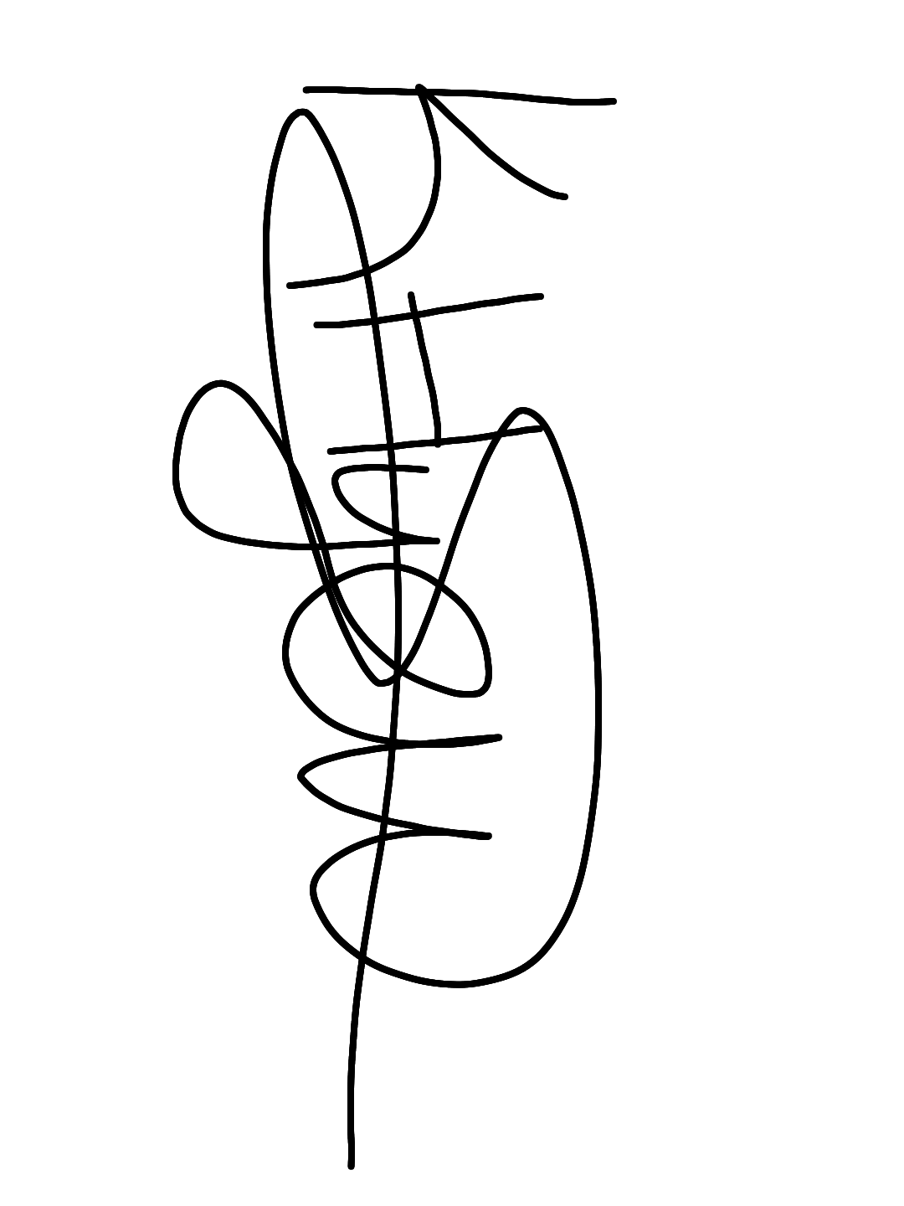 | Date: 22/10/2019

For STUDENT Submissions:
Director of Studies/Supervisor: | Dr Kate Williams | Date: 25/10/2019
Signature: |  | Date: 25/10/2019

For STAFF Submissions:
Head of School/Assistant Dean: |  | Date:
Signature: |  | Date:

Checklist: Please complete the checklist below to ensure that you have completed the form according to the guidelines and attached any required documentation:
☒ | I have read the guidance notes supplied before completing the form.
☒ | I have completed ALL RELEVANT sections of the form in full.
☒ | I confirm that the research activity has received approval in principle
☐ | I have attached a copy of final/interim approval from external organisation (where appropriate)
☐ | I have attached a full risk assessment (and have NOT completed Section H of this form) (where appropriate) ONLY TICK IF YOU HAVE ATTACHED A FULL RISK ASSESSMENT
☒ | I understand that it is my responsibility to ensure that the above named research activity will meet the University’s Research Ethics and Integrity Code of Practice.
☒ | I understand that before commencing data collection all documents aimed at respondents (including information sheets, consent forms, questionnaires, interview schedules etc.) must be confirmed by the DoS/Supervisor, module tutor or Head of School.
☒ | I have deleted the guidance notes before submitting the PG2 for consideration

RESEARCH STUDENTS AND STAFF ONLY
All communications relating to this application during its processing must be in writing and emailed to pgresearch@uwtsd.ac.uk , with the title ‘Ethical Approval’ followed by your name.
You will be informed of the outcome of your claim by email; therefore it is important that you check your University and personal email accounts regularly.

STUDENTS ON UNDERGRADUATE OR TAUGHT MASTERS PROGRAMMES should submit this form (and receive the outcome) via systems explained to you by the supervisor/module leader.

This form is available electronically from the Academic Office web pages: http://www.uwtsd.ac.uk/academic-office/

Application Process

All staff research projects and all research students must submit the Ethical Approval Form to the University Ethics Committee via the Academic Office (pgresearch@uwtsd.ac.uk). Staff research directly in relation to personal study for taught undergraduate or Masters programmes should be submitted via the Faculty procedures explained below.

Taught masters and taught undergraduate research Ethical Approval Forms are considered within Faculties. Faculties will provide details of the specific processes for this. Where the Ethical issues within any single ethical application are of particular concern the Faculty will refer these to the University Ethics Committee. Any student activity that involves the collection of primary data needs to undergo Ethical approval, this includes assignment work as well as dissertations.

.

Materials

Consent form


Academic Discipline of Psychology and Counselling
SA1 Campus
Swansea

Study Consent Form

I understand that this research study is being carried out by a 3rd year Psychology Student for their dissertation, and that taking part in this study will involve listening to a piece of music, completing a questionnaire on music ability, reading some information in regards to the piece of music played, doing a jigsaw puzzle, and then recalling the piece of music originally heard from a choice of three different options.
This study will take approximately 25 minutes to complete.
I understand that participation in this study is voluntary and I am free to withdraw participation during or at the end of the study without giving a reason. I understand that once I leave the study, I will not be able to withdraw my data, as it will be anonymized. I am aware that if I have concerns about the study, I can discuss these concerns with the researcher at any time during or after the study. I understand that I will be provided with the contact details of the research supervisor at the end of the study, should I have any concerns.
I understand that the information provided by me will be held confidentially, with a code assigned in place of my name. These data will be stored indefinitely in accordance with the Data Protection Act.
I also understand that at the end of the study I will be provided with a debrief form and the opportunity to discuss any issues with the researchers.

I, ___________________________________( NAME) consent to participate in the study conducted by Kristen Hyett, Academic Discipline of Psychology and Counselling, University of Wales Trinity Saint David, Swansea under the supervision of Dr. Kate Williams.

Participant Signature:________________________________________________
Date:___________________
Name and signature of researcher taking consent
___________________________________________________________________

Debrief form

Academic Discipline of Psychology and Counselling
SA1 Campus
Swansea

Study Debrief Sheet
The impact of musical training on susceptibility to auditory misinformation of music.

Thank you for taking part in this study.

The aim of this study was to explore the misinformation effect with music. The research specifically wanted to find out whether higher levels of musical training (captured through the Goldsmith’s Musical Sophistication Questionnaire) enabled participants to be less susceptible to the musical misinformation effect. There were two groups as part of this research. One where participants received misinformation about the inclusion of an instrument within the originally played music ensemble, and another where no misinformation was provided. Within the misinformation group, there were two counterbalancing conditions, one where the originally played piece of music contained an instrument and participants were told it was missing, and the second where the originally played music piece was missing an instrument but participants were told that it did contain the instrument. This was to test whether the misinformation would affect recall accuracy for the correct music piece heard originally. Three different musical pieces were played during the test phase: a piece with all the instruments present, a piece with one of the instruments missing, and another new random piece of music.

There was an element of deception within the study in order to examine the effect of misinformation on memory recall. The misinformation effect involves the impairment in memory from the past that arises after exposure to misleading information (Loftus 2005). It was necessary to keep this element from participants prior to conducting the study, in order to be able to accurately test for the effects of misinformation.

If you wish to withdraw your data from the study you must tell the researcher now. After this point, all of your data will remain confidential and anonymous and will not be traced back to you.

If taking part in this study has raised any questions, please speak to the researcher Kristen Hyett on 1700850@student.uwtsd.ac.uk or contact the academic supervisor Dr Kate Williams on Kate.williams@uwtsd.ac.uk.

Thank you once again for taking time to participate in this study.

Kristen Hyett

BA Counselling Studies and Psychology

University of Wales Trinity Saint David, Swansea

Questionnaire

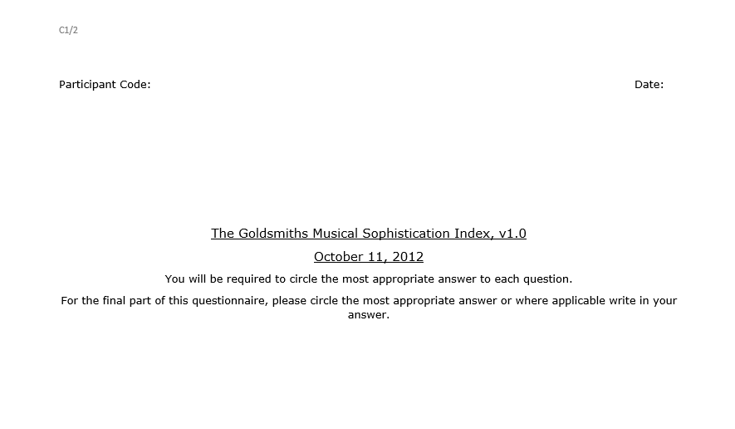

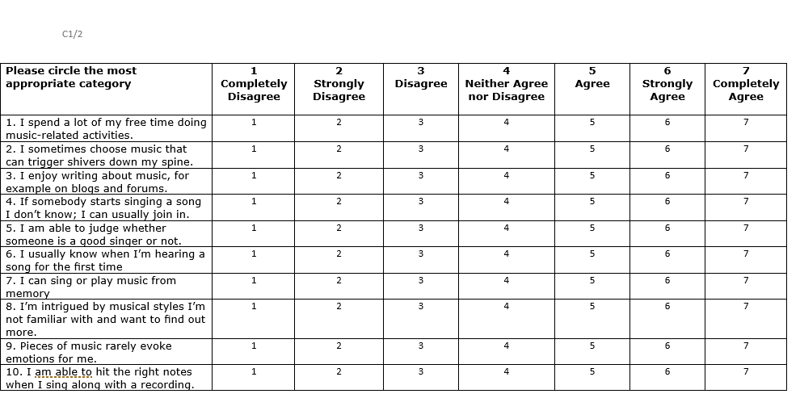

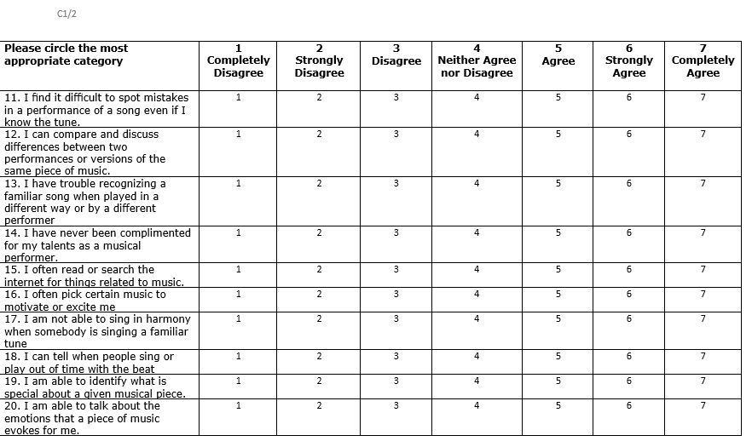

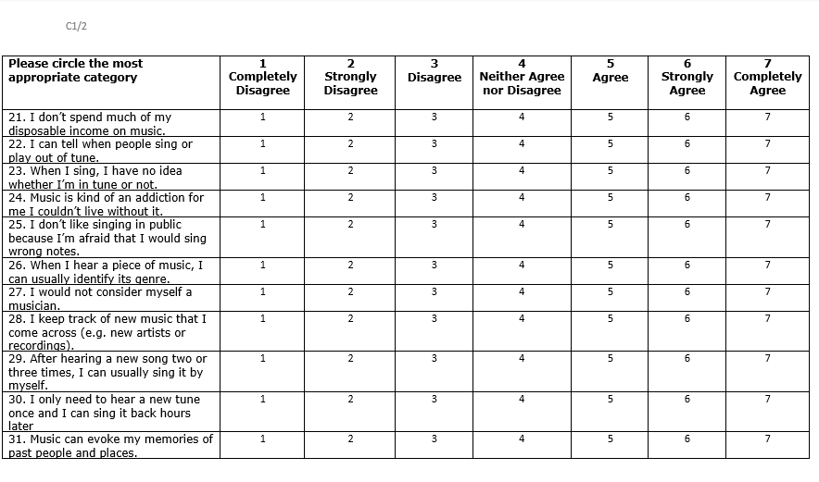

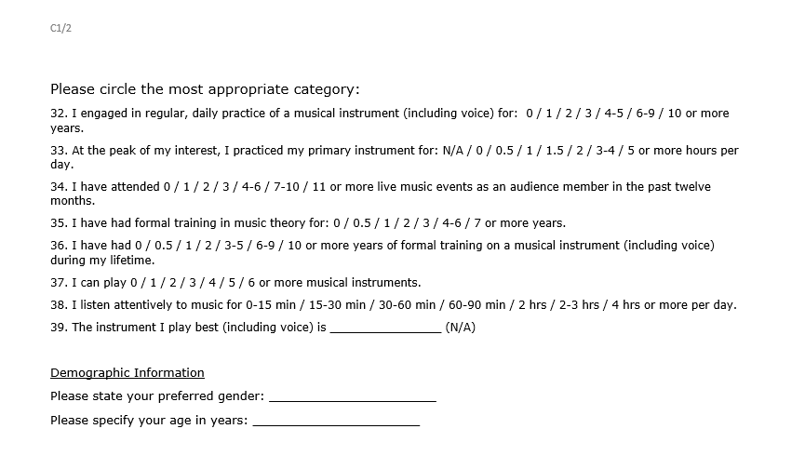

Data Table
Data Table

Participant ID | Condition (1/2) | Recall Answer (1/2/3) | Correct/Incorrect
1
2
3
4
5
6
7
8
9
10
11
12
13
14
15
16
17
18
19
20

Recall Presentation

A presentation will be used to recall the tracks. Three tracks will be presented which the participants will listen too.

Music Information

General

Academic Discipline of Psychology and Counselling
SA1 Campus
Swansea

Song - Great Balls of Fire

The song was recorded on October 8th 1957 by Jerry Lee Lewis on Sun Records and was released November 11th 1957. It was written by Otis Blackwell and Jack Hammer and falls within the category of Rock and Roll.
The Jerry Lee Lewis 1957 recording was ranked as the 96th greatest song ever by Rolling Stone. The song sold one million copies in its first 10 days of release in the United States and sold over five million copies, making it both one of the best-selling singles in the United States, as well as one of the world's best-selling singles of all time.

Including Instrument

Academic Discipline of Psychology and Counselling
SA1 Campus
Swansea

Song - Great Balls of Fire

The song was recorded on October 8th 1957 by Jerry Lee Lewis on Sun Records and was released November 11th 1957. It was written by Otis Blackwell and Jack Hammer and falls within the category of Rock and Roll.
The Jerry Lee Lewis 1957 recording was ranked as the 96th greatest song ever by Rolling Stone. The song sold one million copies in its first 10 days of release in the United States and sold over five million copies, making it both one of the best-selling singles in the United States, as well as one of the world's best-selling singles of all time.

The instruments included within the piece were:
Piano
Drums
Cymbals
Bass Guitar
Saxophone

Missing Instrument

Academic Discipline of Psychology and Counselling
SA1 Campus
Swansea

Song - Great Balls of Fire

The song was recorded on October 8th 1957 by Jerry Lee Lewis on Sun Records and was released November 11th 1957. It was written by Otis Blackwell and Jack Hammer and falls within the category of Rock and Roll.
The Jerry Lee Lewis 1957 recording was ranked as the 96th greatest song ever by Rolling Stone. The song sold one million copies in its first 10 days of release in the United States and sold over five million copies, making it both one of the best-selling singles in the United States, as well as one of the world's best-selling singles of all time.

The instruments included within the piece were:
Piano
Drums
Cymbals
Bass Guitar

Study information

Academic Discipline of Psychology and Counselling
SA1 Campus
Swansea

Information Sheet

This study will involve the following:

Firstly, you will be required to listen to a 1-minute piece of music through headphones.

You will then be required to complete the Goldsmith’s Musical Sophistication Index, which examines levels of musical training and other music related attitudes. Further instructions on how to complete this will be provided on the questionnaire.

You will then be given some information to read regarding the music piece you heard.

Then you will be given five minutes to attempt to complete a jigsaw puzzle.

Finally, you will be asked to complete a memory recall task relating to the musical piece you heard at the beginning of the experiment. This will be completed through a PowerPoint presentation. Further instructions on how to complete this will be provided at the beginning of the presentation.

Due to this research involving an auditory component, you must be capable of listening to music through headphones.

If you would like to take part in this study, please read and sign the consent form.

If you have any questions, please ask the experimenter now.

Music Tracks

There are three music tracks. One of these will be played to the participant and they will recall at the end of the study which one they originally heard out of the three.

Jigsaw

A Jigsaw will be presented to the participants.

