Project title: Smart Wallet
Module Title: ACCC5006 RESEARCH METHODS
Lecturer: Renuga Jayakumar
Student Number: 1815744
Student: Claudiu Stefan Stelian

Contents
Introduction 3
Objectives 3
Research Methodology 4
Development methodology 6
Development tools 9
References 10
Gantt Chart 11

Introduction

Smart wallet is a phone app that allow the people to store their physical documents into their phone in order to avoid of caring a physical one. Those days people are looking to virtualise everything so they can heave an easy life by not caring to many staff with them and as the wallet is a necessary item in daily use the app smart wallet will allow them to do not carry a physical one so they can have better security. Nowadays most of the countries are virtualising the money so the people don’t need to carry a physical one which helps them to do not be a victim of theft threatening. Another benefit of smart wallet is that it will help to avoid caring physical money which will help the population to avoid spreading viruses or dieses. Why this decision? Because lately the earth is at a stage that a pandemic situation will reduce the population dramatically.
Using smart wallet application to make payments the phone needs to be equipped with a device called near-field communication (NFC), which uses radio frequencies to communicate between devices. The NFC use an identification system of the user which communicate the payment data to the merchant. [4]
The Smart wallet will help you to store documents like ID, Passport and Credit/Debit/Fidelity/Business/Travel cards just by scanning or typing their details into it. it will allow the consumer to make payments and identify themselves faster. Many people will might ask why to create a mobile app, and the answer is because, the mobile is one item that is permanently in people’s hands and pockets.
The aims of the case study are to replace the physical wallet with a virtual one for a better mobility and safety. In order to create the system, we need to focus and accomplish several objectives.

Objectives
- To identify the necessary development tools
- Tools that can store personal documents;
- Tools that can store bank details;
- Tools that can help in making payments;
- Tools that can store and display the data;
- To analyse what is necessary from the wallets in human’s day use
- Analyse by interviewing some people;
- Analyse by checking people’s wallets;
- Analyse existing wallet and government ID apps;
- To design the application for an easy use
- Design functionality options for elder and young people;
- Design a login system for a high security;
- Design a database that can store and show the money flow;
- To develop a successful database
- Database that can store pictures, files and users’ details;
The application’s objective is to virtualised the physical wallet for a better money flow and safety.

Research Methodology
This research project is based on primary data sources which has been collected by interviewing people. In this case study there was no ethical approval needed. The advantage of primary source method is to analyse the subject at a bigger scale. The primary source method has proven that many people would prefer to use a virtual wallet and this has been proved by interviewing people, checking their wallets and what they would like their wallet to be like.[1]
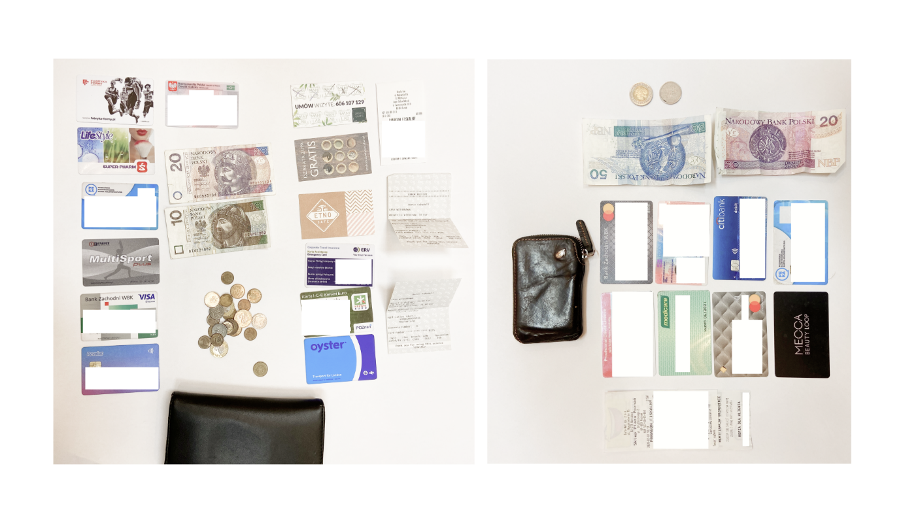
Fig 1: People’s wallets [1]

In order to identify the necessary development tools, it has been used a primary data source research method and as development software has been used Android Studio. It is a software used to develop android phone software which require few programming languages. The smart wallet is developed on an android device as the statistics made in 2017 proved that more people are using and android systems than IOS(Apple). Android studio was announced at Google I/O in May 2013. The advantage of Android studio is that it can be used on many platforms like Mac, Windows and Linux. Android studio supports all programming languages of IntelliJ like Java and C++.[2]
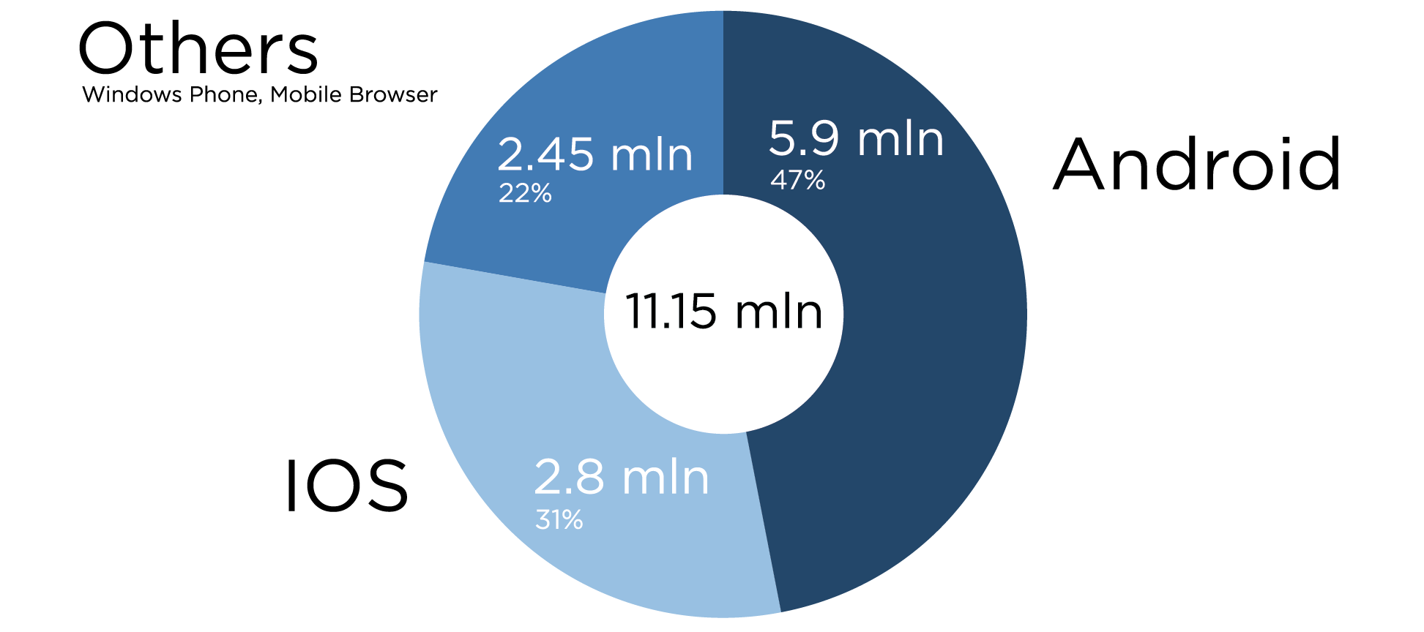
Fig 2: Android vs IOS users 2017

Some researches help out in accomplishing the objective of analysing what is necessary on a daily use from a wallet by conducting several interviews and checking people’s wallets. The researches proved that some people don’t carry any more wallet by replacing them with a smartphone feature while other have overstuffed wallets with unnecessary items. The researches released that there are two types of items which can be important, critical ID and documents, and random papers or cards related to daily life. [1]
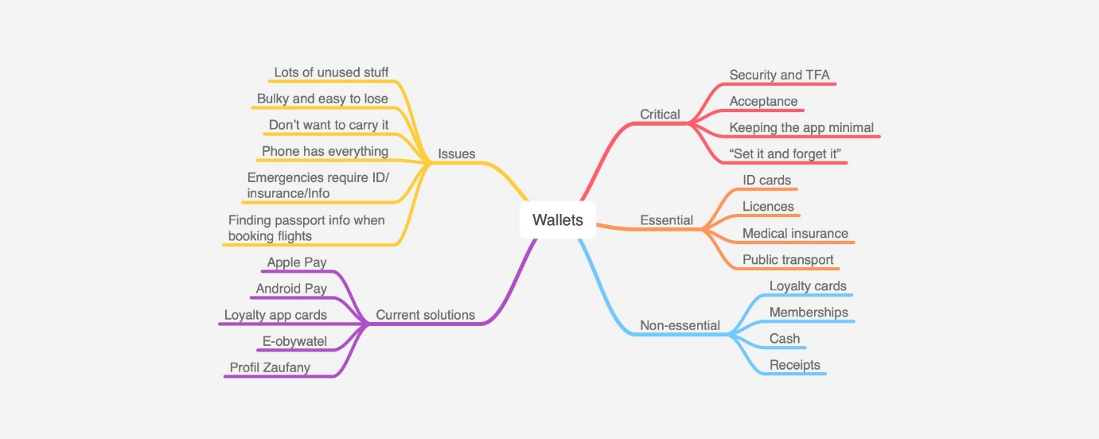
Fig 3: Mind mapping [1]

The objective to design the application has been reached by using a free UI (user interface) tools to generate mock-ups. The design is a minimalistic and clear one so it can be used by elder or younger people. With the help of the mock-ups the final design was a simple and minimal wallet that can provide personal documents and bank data’s in less than a minute.
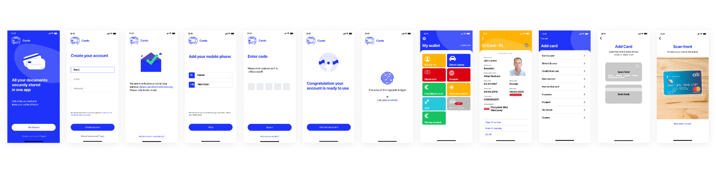Fig 4: User interface [1]

The risk of cyber-attacks is high those days and it is essential to have a good security system that’s why smart wallet is a phone software which require many credentials in order to access it like finger prints, eye recognition, facial recognition or just by entering a pin number. In case of losing the phone or stolen the access to the costumer’s data is locked just by reporting via phone call and it can be unlocked on another device.

Development methodology
For the implementation of this application, it was used an incremental model starting with a prototype as a first step and following Agile methodology. There are used sprints of 2 weeks and gaps of 2 days allocated for sprint planning and reviews.
Every stage includes six incremental steps of model:
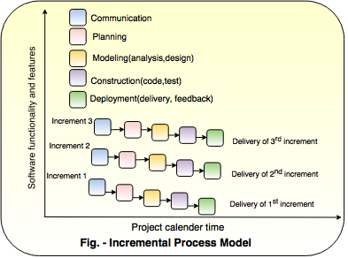
Fig 5: Incremental process’s steps

The advantage of incremental model is to deploy and develop smaller functionalities.
In the first incrementation will include only basic functionalities like:
- Manage the profile
- Check the balance of your cards
- Add/Update/Delete documents (there will be 2 different sections, one for being able to add, update or remove the personal details like ID or Passport and the other section will give you the option to add, update or remove credit/debit/locality cards)
The first increment the application will be uploaded on the Google Play Store for being downloaded and used by population. By receiving feedbacks and data stored from the users an improvement will take place. This process come with the benefits of fixing the bugs, improving the system and adding extra features while it is still in early stages.
A list of items was created into the backlog for every single version of application. The project board was created by using ClickUp tool.
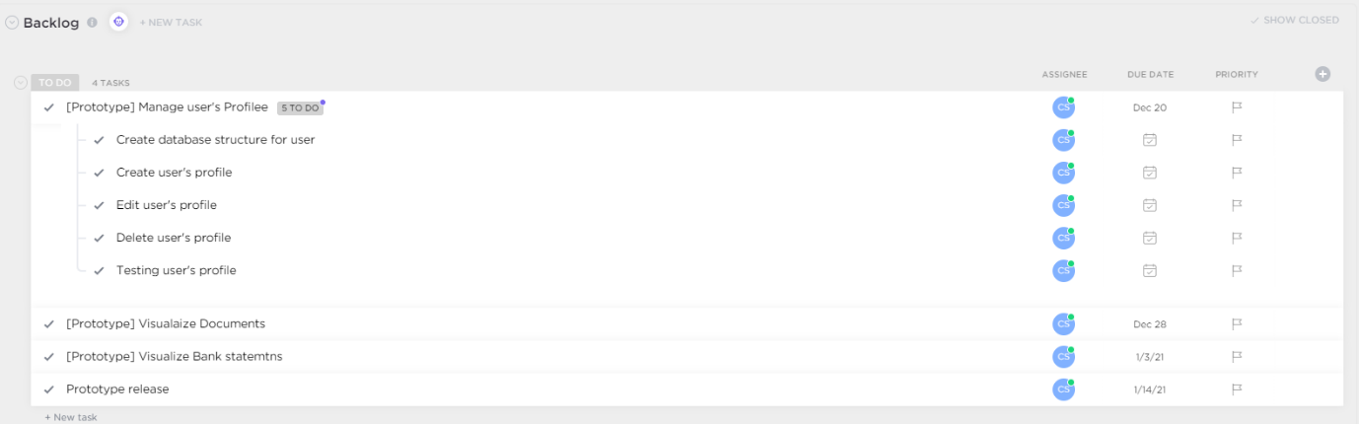
Fig 6: Project Board – Backlog items

As pe Fig 6 all the components from backlog has been spited into tasks:
The Item “Manage user’s profile” gives the information of the actions that are taking place:
- The user needs to be able to create a profile;
- The user needs to fill in the personal details like First name, Last name, Email address, Phone number, date of birth and Password;
- The user should pe able to see the personal detail;
- The user should be able to edit the personal data;
- The user should be able to delete the personal data;

Backlog item Visualize Documents is one of the main functionalities of the smart wallet prototype and includes the following user’s requirements:
- The user should be able to insert documents like personal ID, passports and business cards;
- The user should be able to scan documents like personal ID, passports and business cards;
- The user should be able to view the stored documents;
- The user should be able edit stored documents;
- The user should be able remove stored documents;
The item Visualise Bank Statements is the second main functionality and includes a couple of user’s requirements:
- The user should be able to insert the bank accounts;
- The user should be able to scan the credit/debit cards;
- The user should be able to check the balance;
- The user should be able to delete bank accounts;
- The user should be able to update bank accounts details;
- The user should be able to pay by using the phone;
The second increment includes features like:
- Searching through business/locality cards;
- Calculate the sum of all bank account expenses;
- Release bank statements for all accounts;

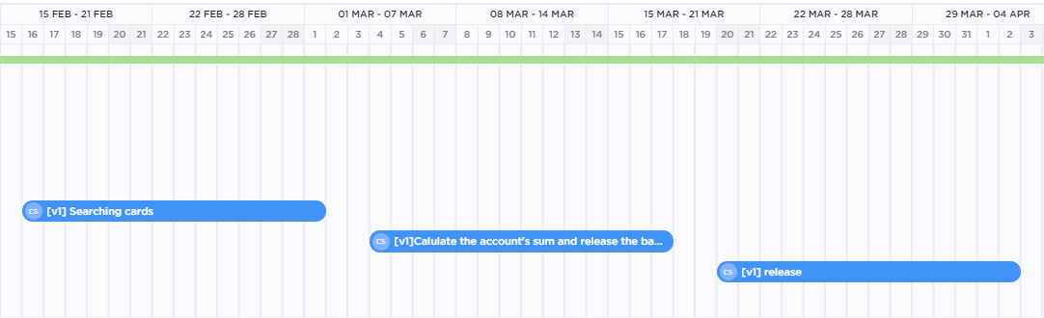
Fig 7: Second increment
The third increment will have features like:
- Receiving notification in case a card or document is about to expire;
- Transfer money from an account to another;
- Check the countries that was visited using the Passport;
- Send business cards to another user;

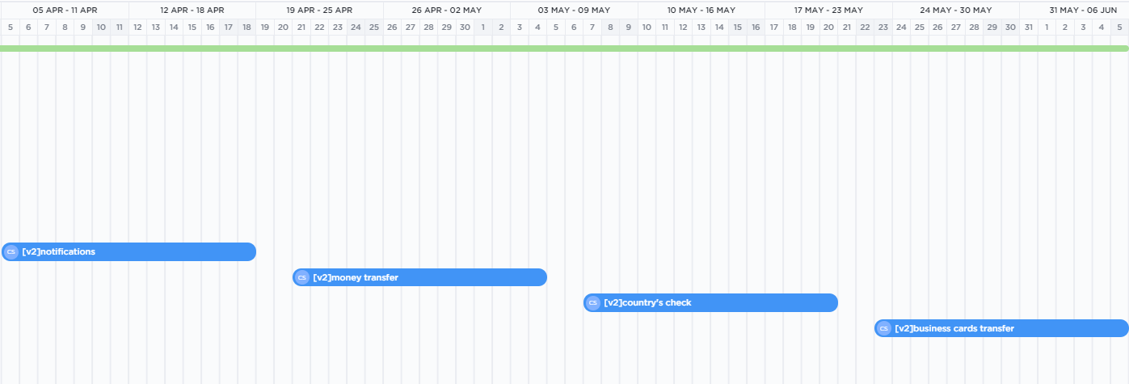
Fig 8: Third increment

Development tools
To develop the Smart wallet application, it was necessary using the following software and tools:

Software/Tools | Description | Source
Android Studio | Code editor | https://developer.android.com/studio
GitHub | Used for source control tool and project repository | https://github.com/
Java JDK | Helped in developing the application using java-based programming language | https://www.oracle.com/java/technologies/javase-downloads.html
Kotlin | Programming language used in developing the application | https://kotlinlang.org/
Jetpack | Reduce boilerplate code in the development process | https://developer.android.com/jetpack
ClickUp | Used for backlog | https://app.clickup.com
MarkDown | Used to wite file like ReadMe | https://www.markdownguide.org/
Lucidchart | Used for UML diagrams | https://www.lucidchart.com/pages/
Google Play Store | Platform to deploy the application | https://play.google.com/store
Moqups | Used for user interface mocks | https://moqups.com/
SQLite | SQL database engine | https://www.sqlite.org/index.html

References

[1] https://medium.com/snowdog-labs/snowdog-ux-challenge-wallet-app-case-study-8eacc8951c74 Wallet app case study: a Snowdog UX Challenge
[2]"Android Studio 4.1 available in the Stable channel". Android Developers. Retrieved November 13, 2020
[3] (n.d.). Retrieved from Gantt Charts: http://www.ganttchart.com/history.html
[4] IEEE Pervasive Computing (Volume: 10, Issue: 3, July-September 2011)

Gantt Chart
Grant chart is a diagram invented by Henry Gantt to illustrate schedule period during projects.[3]
For Smart Wallet application the following Grant Chart shows the schedule based on each increment which will be released with the features that are implemented:

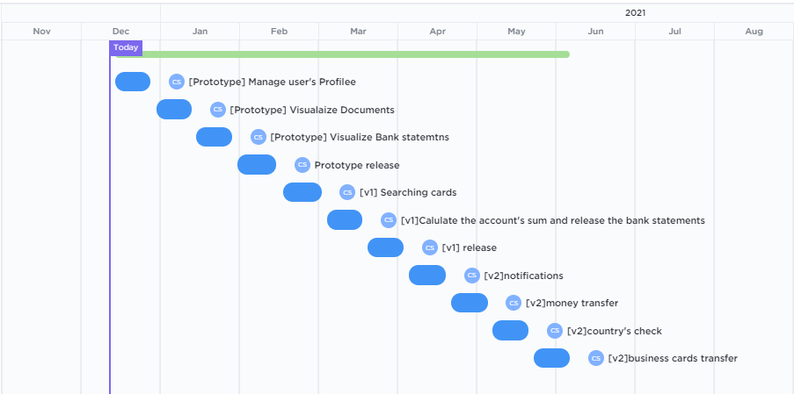
Fig 9: Gantt Chart - month level

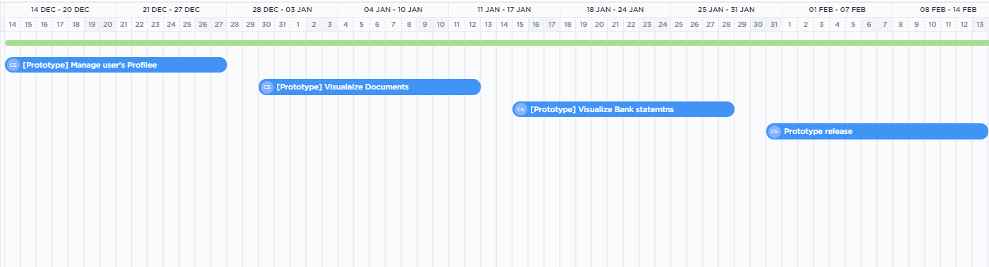
Fig 10: Gantt Chart- Prototype - week level

Fig 11: Gantt Chart- V1 - week level

Fig 12: Gantt Chart- V2 - week level

AS per Grantt Chart illustrations, the smart wallet application will have a prototype released on 13/02/2021, First version on 02/04/2021 and the last increment on 05/06/2021.

