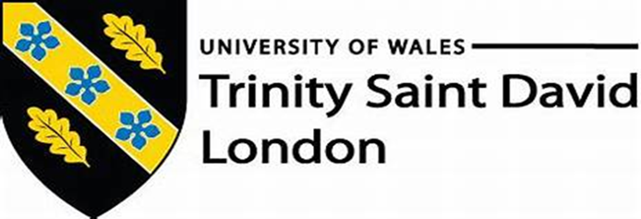
Davide Valvano (1916733)

Academic and Employability Skills
BMSW4001: Term 2 (weekend) – Assessment 2. Lecturer: Nadeem Mirza.

Contents

Intro. 3
Do you know how to “learn?”. 3
A tidy breakdown of your abilities. 4
Multiple use of the iconic language. 5
How recruiters see you. 6
Conclusion. 7
Appendix: 8
Reference list: 9

Intro.

This work wants to represent aspects of my life that have significantly changed the way I interact with the world around me. Obviously, this is a consequence connected to the important decision I made in 2020, year of the pandemic, to train widely my abilities, learn new ones through academic teaching at school. I could not be happier with this choice as, in such a short and difficult time, this updated version of myself is much brilliant and brighter than never. Hope you will enjoy reading my essay and who knows, perhaps we might agree on some aspects and have a chat face-to-face soon.

Do you know how to “learn?”.

Part of what I will share with you today begins in this second term, while we approached the subject of learning in one course lesson, particularly for one citation from Dr Kolb, 1984 (in McLeod, 2017): “Achieving is the result of innovation and evolution, co-working in order to open up new perspectives”. And this is exactly the reason of my personal motivation which drives me through studying in these days. Could not agree more than this with these words and, in reality, I highly doubt I would have the same opinion before encountering this matter, that is not an easy process, structured in four steps as this graph shows from the cycle-model described by Dr Kolb:
Dr. Kolb model, 1984.
Starting from what we know now, we should not stop questioning ourselves if there is anything we can do to improve, never stop trying to design new ideas, trying to implement them suddenly in our life. This new conscient had a clear impact on my way of approaching others straight away, positive about my new method, I understood that perhaps I could implement these academic tips into my workplace. For example, my old behaviours towards the marketing manager where we currently work, were not excellent. Sometimes I refused to meet him just because I thought he will never understand what I am doing that many hours behind the bar. Insane is not it? Back to the scholar learning, I have tried to transfer this new ability into my workplace and acknowledge the new scenarios obtained. It definitely helped me to build up a moderate way of liaising with managers from other department as, with an improved understanding of their duties and the vision of just one team glued up unite, cooperating and participating actively to weekly meetings, I started to receive good feedbacks from many of my colleagues. It was useful changing my old habits, it brought me to have better votes at campus, since my abilities on reflective writing have emerged, and definitely a better confidence within my team at work.

A tidy breakdown of your abilities.

Nowadays, to correctly write a cover letter seems to be an effective process often made when applying for a job. Following chapter 16, in Morgan (2017, p.339) we acknowledging the essence of what is the meaning of a cover letter: “It is indeed a career related statement that helps to consolidate your profession in the eyes of your recruiter”. It is highly suggested that, while applying for your future job then, you know how to write a customised accompanying statement to increase your chances to noted. Adhering to Hansen, 2017, she suggests three crucial stages on writing it that can attract right feedbacks wanted, here it the breakdown in a graph:
Hansen, K. 2017.

Examining these steps, leads us to a different perspective: elaborated first on a newly characterisation we are tending to give to ourselves, secondly on a defined structure. I did really enjoy this lesson objective, as it is pertinent closely to what is my real life. I am not used to change job quite often but when is time to walk new path, now I will have a different mindset while “selling myself”. Concept was easy to understand, however I have encountered few difficulties while taking this into practise. If we look at my first draft (Appendix 1), unfortunately we can see a deep lack of construction in here, reason why ,perhaps, instead of add some value to my job-application, was probably ignored by who was selecting people to recruit. I do consider myself very ambitious when aspiring for a new role, management position so, through some home activities, relying on the precious contents from Moodle, I was finally able to create a supportive document, distinct from my CV, that talks effectively about me. Last considerations must be attributed very positively to the importance of this module and how it gets student ready in their graduated life. I would never expect to examine this field at university for example, as the same as I was so impressed by the incessant contributions on achieving greater outcomes from the lecturer through the accurate methodology while sharing with us this concept.

Multiple use of the iconic language.

We are noticing a substantial raise of these communicative expressions, especially when: “showing expertise as our own when what said does not belong to us” (Davidson, 2015), in our conversations in these days. To be honest, it is something I would not consider with much importance before the approach with this module of study. Most of the times we tend to conceptualise what is happening around us, using some common expressions to have direct and effective communication. We should stop for a moment, and acknowledge that this, seen as an archetypal language, does not appertain to us. In first sight, facing this argument was something I underestimate a lot, thinking of owning it already. Suddenly, when introduced briefly to the four referencing styles in the academic world, I begin to have my first issues on understanding the Harvard style. Attentive and responding to class activities, it required me some practising during off time from work to really work on this technic. Lecturer assist me reviewing my works of improvements until I finally stepped up on this. It was not a basic concept as it might look like to some distracted people and for this, I am grateful to my university for achieving this new ability. It is easy-transferable into my work and, especially when scheduling, was an innovative tool that helped me consolidating teamwork. How?

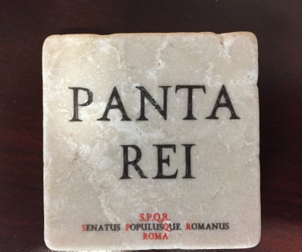
Content 1, Jones, (2017)

From the first week of March, while updating the next week rota in the share drive or via email, I started to add one of the most know, in brackets (content 1 above) for my colleagues the be inspired and work as team. Same day, few team members came over to talk to me how good was to see such a motivational citation “Panta Rei: Developments are everywhere” (cit. Kiener, 2002) in the weekly file. I repeated this experiment for the weeks ahead until I have realised, I gradually created a positive mentality about the release of the schedule, since the approach of the team in regards of it, was absolutely stretched, relaxed. All of this by simply emphasising directly with the other staff mates in a renewed and effective way. How to keep up my bar team during all this uncertainty in our hospitality sector? Well, same technic, different example this time. “We should benefit of our time now, avoiding worrying much about the future. Carpe Diem.” (Peacock 1992). This time, it was not in regards of scheduling next week shifts, felt better as an invite to participate an exclusive online event, where to improve their knowledge with fun with a detailed product masterclass. It worked incredibly well, with the attendance going over my expectations for such a training. Said this, now is time for me to note out how this work episodes they made feel so special and looked after while still carrying on my studies during pandemic. Being at my first year of education here in a foreign country, I would never expect that, decision of switching studies online with impeccable tools like for example Moodle or Microsoft Teams, was going to happen this quick and so efficiently. Basically, I almost did not reckon any changes in my tuition this year. That was my motivation, to keep unite my work colleagues with some online appointments, what was my motivation when I started following lessons online, shared with them with perhaps same great results. This course really gives you extra tools and confidence that you can easily import in your day-to-day life.

How recruiters see you.

An opposite example of what mentioned above, finds its space now, with my renewed ability to list efficiently my work experience when applying for a new opportunity. Let me say that I was more than aware about how to write this resume before, but I reckon not this accurately I am finally able now. Most encouraging part comes from the fact that I have nurtured a clear picture of the different types of skills from first term and so it was simple for me to describe mine. This is what the resume should look like in the eyes of your future employment. In addition, importing the results from crucial study cases, my CV looks much more appealable than it was before, from a visible perspective to the quality of the contents. Yet, the positive impacts received as feedback from hospitality companies, gave me room to create a consolidated personality, the professional-smart Davide you would see on the bar floor. Adhering fully with Neugebauer et al, 2016 (in Maund et al, 2017) “owning your Curriculum Vitae is derived from your inner artistic rather than your being methodical”. The precise example of my mind while recently updating the word file document of my CV. We tend to email it as primary way of sharing it, but in reality during pandemic, while furloughed and applying for some part time jobs, felt so good the walk down the square the day I went for printing it out. Starring at the well-structured pages of the document made me proud also. A little look further, cannot wait to finish my degree and use my new tool to apply perhaps, to some of my dream jobs. I do know for sure that I will playing my role accurately well, in order to succeed and swap to a premium vibrant work-life. To the university the merit of giving you the correct tools and methods, with some good teaching tending to get you ready for what is waiting you next. I really found this course the be coherent to its expectations, perhaps going over them. It is for me working in synergy with my work life to obtain an always improved stable life balance. Debatable is the matter around how many people underestimate this know-how as they might think that experience on its own gives sufficient contribute towards their future employment.

Conclusion.

What written about my experience with the University of Wales at the end wants to demonstrate how I did make mine these academic topics and suddenly shaped entirely my work life. I always had this thought inside me, especially in the recent years, of step up in my carrier affording on the best degree I would ever manage to get, transferring then the skills just gained. My soul urged to get out from the monotony of my role in the past days and really work on myself, my abilities, my potential and get out gradually from this loop. Overall, this has been a tough year for the hospitality sector where I work for the last 15 years, I discovered with the school that study is still possible, easy to access, with unlimited benefit that you can get it from it. This work wanted to give you my genuine words as inspiring for everyone to do the same thing as I have done, never give up on your studies because it is never late to restart. Motivation is endlessly alimented by the numerous positive results you will master while studying actively, sometimes I think I should have started earlier and not wait to be in my thirties to make this beautiful decision.

Appendix:

First draft in-class exercise: “how to write a cover letter”

: 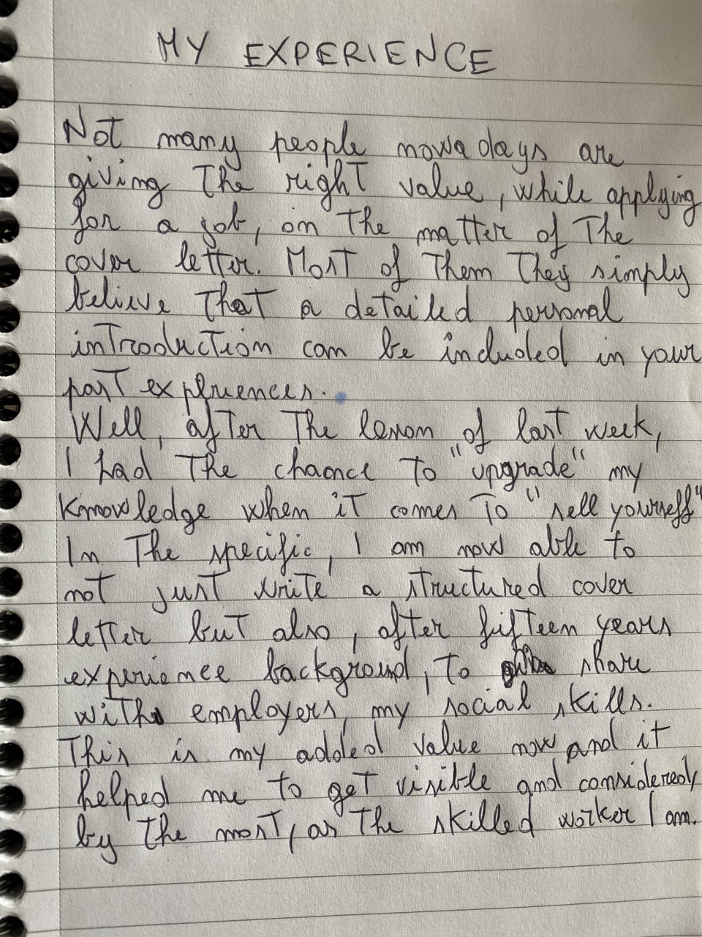

Reference list:

McLeod, S. A. (2017). Kolb - learning styles. Online, https://www.simplypsychology.org/learning-kolb.html (Accessed 18 August 2020).

Morgan, P. (2017). The business student’s guide to study and employability. 1st edn. London, SAGE publications.

Hansen, G. (2017). How to Show Off Your Transferable Skills in Your over Letter. Live career, online. Available at: https://www.livecareer.com/resources/cover-letters/how-to/write/cover-letter-transferable-skills . (Accessed 19 August 2020).

Davidson, K. (2015). Linguistics and Philosophy. 38:477. Online book. Available at: https://www-jstor-org.ezproxy.uwtsd.ac.uk/stable/24570622?seq=1#metadata_info_tab_contents (Accessed 20 August 2020).

Jones, M. S. (2017). Transform. Perform. Grow. Online. Available at: https://transformperformgrow.wordpress.com/ (accessed 20 August 2020).

Kiener, A. (2002). Panta rei: everything is changing! Online article. Available at: https://www-sciencedirect-com.ezproxy.uwtsd.ac.uk/science/article/pii/S0958166902003841 (accessed 21 August 2020).

Peacock, A. J. (1992). Transmitting Horace. Online PDF. Available at: https://rua.ua.es/dspace/bitstream/10045/5452/1/RAEI_05_10.pdf (accessed 23 August 2020).

Maund, A. Schriek, M. Tinkler, P.K. 2017. Certificate in Higher Education: Skills for the Workplace Student Yearbook. 13:315. London, SAGE publications.

