The module title: Marketing Essentials BMIH4005

Marketing Plan for Six Senses Hotel

Student’s Name: Ionel Simion
Student ID number: 2220997
Word Count: 1322

Marketing Plan for Six Senses Hotel
The marketing plan is prepared for suggesting some comprehensive strategies for the Six Senses Hotel brand. It is a reputed luxury hotel brand that operates in 16 countries around the world (Six Senses, 2019). This plan is prepared for the management team of the company for providing them with the marketing opportunities and strategies that they can utilise for achieving success in the competitive business environment. Some valuable tools such as the 4Ps of the marketing mix, Ansoff matrix, and communication mix will be used for guiding the management to develop appropriate marketing strategies that will bring the company’s marketing success.
5Cs will guide a comprehensive situational analysis (Kotler and Armstrong, 2019).
Company: SWOT analysis framework is effective for analyzing the internal and external factors affecting the company:
Strengths: It has a strong brand value as a luxury hotel brand. Properties and facilities are located at exclusive locations. Furthermore, its personalised services ensure a greater customer experience. Weaknesses: The company has limited market expansion (Six Senses, 2019). It has a low level of recognition compared to other luxury brands. Opportunities: It has opportunities to expand its market in growing economies. It also can enhance its presence on digital platforms. Threats: There is fierce competition in the tourism industry. Economic recession can affect the revenues of luxury hotels greatly.
Customer: Six Senses utilises segmentation and targeting strategies for choosing customers. The company segmented its market based on wellness seekers, luxury travellers, eco-conscious travellers, family vacationers, and honeymoon couples. The company target these segments with an exclusive, personalised, and unique experience (Michopoulou, 2020).
Competitors: Aman Resorts, Four Seasons Hotels & Resorts, Rosewood Hotels & Resorts etc serve the same market segment and so they are competitors of Six Senses Hotel (Similarweb, 2023).
Collaborators: Its collaborators are local communities, environmental organisations such as the U.S. coalition, wellness exerts, and the acquisition of IHGs.
Climate: PESTLE analysis is required for the external analysis:
Political: Negative impacts from the Russia-Ukraine war, Brexit, positive impact from government policies and political stability in the UK. Economic: Negative impacts of covid-19 pandemic, positives of the UK's economic growth and disposable income (Baum et al., 2020). Social: Shift to sustainable practices, increasing health and wellness to have positive impacts (Klemm, 2019). Technological: Increasing concern for data protection and security, the emergence of online platforms and digital media. Legal: Compliance with local and international legislation, licensing, and other intellectual property act to safeguard the business. Environmental: Climate Change and sustainable practices can influence business operations.
The Marketing Mix of the company is as follows:
Product: Luxury accommodation, personalised services, and sustainability practices. Place: Scenic and desirable destinations. Price: Premium and high-end pricing. Promotion: Digital marketing, influencers, social media. People: Experienced and capable workforce. Process: Personalised service process. Physical Evidence: Amenities, natural surroundings, sustainable materials, and sustainable practices (Six Senses, 2019).
Using the SMART framework, the marketing plan objective is summarised as " To increase the Revenue of the company by 20% within the next 12 months by targeting the wealthy market segment that has well-ness consciousness and wants premium and personalised services and it would be possible by increasing online presence, enhancing communication strategies and strategic partnership (Wood, 2019).
The issues that Six Senses is facing are the slow expansion and growth of the company. It also has some negative reviews from the guests in which they shared their poor experiences with the company's processes and pricing as they did not find the service value for money (TripAdvisor, 2023). Based on Ansoff Matrix, the company can take the following two strategies to overcome the issues:
Market Penetration: Six Senses should retain and attract new customers for the penetration strategy. It may consider improving its existing service quality and look into the reviews made by the guests and the pricing strategies can also be adjusted by evaluating the value provided to the guest (Baines, Fill and Rosengren, 2017).
Product Development: To increase the market share and revenues, it can partner with local organisations for introducing new products and services. The new product and service may be a new dining experience, expansion of wellness programs etc. (Baum et al., 2020).
The changes in the marketing mix may require introducing a new value proposition, adjusting pricing to make it more competitive, adopting enhanced communication strategies, and staff training to clean up the service quality (Dominici, 2020).
The issues identified in the situational analysis will be solved and the company will be able to improve its communication strategies if it employs RACE (Reach, Act, Convert, and Engage) framework for formulating effective communication tactics (Wood, 2019).
Reach: At first, Six Senses needs to increase its brand reach to increase the revenue within the specified time. Digital marketing campaigns such as Search Engine Optimisation (SEO), Pay Per Click (PPC) ads, and social media advertising are some examples that can be adopted for increasing the online presence (Chaffey and Ellis-Chadwick, 2019). Social media influencers can have a huge impact on achieving reach. Hence, Six Senses might consider partnering with the most eligible influencers who can attract the target audiences (Parente and Strausbaugh-Hutchinson, 2019). The company can invest in public relations efforts so that it can secure media coverage and have articles in the travel and tourism publication for attracting the wealthy market segment (Shamsudeen and Khalufi, 2018).
Act: The website of the company needs to be optimised so that it can ensure a seamless and user-friendly booking experience. Sometimes guests develop positive thoughts about the company if the websites are appealing and effective (Morrison, 2022). So, Six Senses can use analytics to understand customer needs and expectations and provide those features in their websites. The marketing manager has to develop appealing content such as videos, virtual tourism experiences, and blog posts, and engage with potential guests through social media platforms (Finne and Grönroos, 2019). Remarketing strategy is also useful for those who visited the website but left it without any booking. So they can be targeted for marketing activities.
Convert: Six Senses can convert potential customers into loyal customers by using personalised emails. These emails can contain various exclusive offers, discounts, reviews of satisfied guests and so on. The company can also introduce live chat features for instant feedback and the use of AI for customer support (Jobber and Ellis-Chadwick, 2020).
Engage: The use of social media platforms can ensure engagement with customers. The company has to develop a comprehensive customer relationship management system because it is necessary for tracking customer preferences. Hence, Six Senses will be able to deliver a personalised experience to maximise their satisfaction during the stay.

Action plan-
Company Name | Six Senses Hotel
Project Lead |  | Project Start: | July
 |  |  |  |  |  |  | July |  |  |  | August |  |  |  |  |  | September |  |  |  |  |  |  |  |  |  |  |  |  | October |  |  |  |  |  |  |  |  |  |  |  |  |  |  | November |  |  |  |  |  |  |  |  |  |  |  |  |  |  | December |  |  |  |  |  |  |  |  |  |  |  |  |  | January |  |  |  |  |  |  | February |  |  |  |  |  |  | March |  |  |  |  |  |  |  | April |  |  |  |  |  | May |  |  |  | June
TASK |  | Metrics |  | START | END
Digital Marketing Campaign
Facebook |  | 1000000 views |  | July | June
Email Marketing |  |  |  | July | June
PPC |  | 15% |  | September | April
YouTube |  | 1,000,000 views |  | October | June
SEO |  |  |  | September | February
Direct Marketing
Influencer Collaboration |  |  |  | December | June
Customer Relationship Management Software |  |  |  | January | June

The success of this marketing plan will be measured as follows:
Six Senses will observe 20% revenue growth within 12 months. The company needs to track the number of new customers during the project. The management can conduct a survey or take feedback from the guests and people to understand the success of the marketing activities. The KPIs of the promotional activities can also be evaluated for determining the success of this marketing plan. If the expected KPIs are confirmed, then the plan will be successful in achieving the goals (Wood, 2019).
Six Senses Hotel has successfully created a position in the luxury segment of the tourism industry. But its growth is very slow. The company can increase its growth and achieve success in the long term if it adopts the necessary strategies and tactics provided in this marketing plan. If there is any requirement for change in the plan, the marketing manager of the company can make the required changes for ensuring this marketing plan’s effectiveness.

References
Baines, P., Fill, C. and Rosengren, S. (2017) Marketing. Oxford University Press.
Baum, T., Mooney, S.K., Robinson, R.N. and Solnet, D. (2020) COVID-19’s impact on the hospitality workforce–new crisis or amplification of the norm?. International Journal of Contemporary Hospitality Management, 32(9), pp.2813-2829.
Chaffey, D. and Ellis-Chadwick, F. (2019) Digital Marketing: Strategy, Implementation and Practice. 8th ed. Harlow, England: Pearson.
Dominici, G. (2020) From Marketing Mix to e-Marketing Mix: a Literature Overview and Classification. International Journal of Business and Management, 4(9).
Finne, Å. and Grönroos, C. (2019) Rethinking marketing communication: From integrated marketing communication to relationship communication. Journal of Marketing Communications, 15(2-3), pp.179–195.
Jobber, D. and Ellis-Chadwick, F. (2020) Principles and practice of marketing. 9th ed. Maidenhead: Mcgraw-Hill Higher Education.
Klemm, M. (2019) The UK Travel Industry and Ethnic Minorities: Social Inclusion and Cultural Awareness. Tourism Culture & Communication, 6(1), pp.7–18.
Kotler, P. and Armstrong, G. (2019) Principles of marketing. 17th ed. Hoboken: Pearson Higher Education.
Michopoulou, E. (2020) ‘The future of global hospitality: What is going to really matter?’ – Neil Jacobs, the CEO of Six Senses Hotel Resorts Spas. International Journal of Spa and Wellness, pp.1–2.
Morrison, A.M. (2022) Hospitality and travel marketing. Taylor & Francis.
Parente, D.E. and Strausbaugh-Hutchinson, K.L. (2019) Advertising Campaign Strategy : a Guide to Marketing Communication Plans. Boston, Ma: Cengage Learning.
Shamsudeen, S. and Khalufi, N. (2018) A Study On The Determinants Of Marketing Effectiveness Of Mobile Marketing Communication On Social Media For Small And Medium Enterprises & Neighborhood Stores’ In USA. Archives of Business Research, 6(6).
Similarweb (2023) Six Senses Hotel Competitors. [online] SimilarWeb. Available at: https://www.similarweb.com/website/sixsenses.com/competitors/#:~:text=The%20other%20five%20competitors%20in,K%20visits%20in%20April%202023.
Six Senses (2019) Luxury Resorts, Five Star Hotels, Luxury Spa Resorts | Six Senses. [online] Sixsenses.com. Available at: https://www.sixsenses.com/en.
TripAdvisor (2023) SIX SENSES LAAMU - Updated 2023 Prices & Resort Reviews (Laamu Atoll, Maldives). [online] Tripadvisor. Available at: https://www.tripadvisor.com/Hotel_Review-g2050017-d2045398-Reviews-Six_Senses_Laamu-Olhuveli_Island.html [Accessed 21 May 2023].
Wood, M.B. (2019) The marketing plan handbook. Boston: Pearson.

Appendix
Slide 1
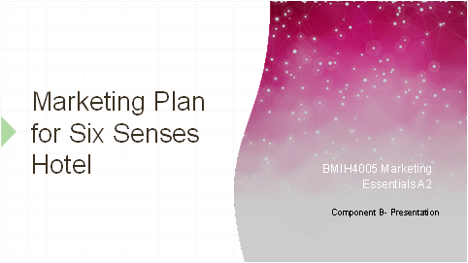
Slide 2
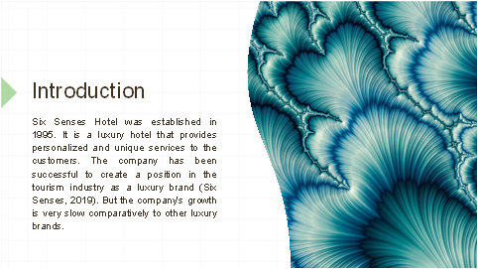

Slide 3
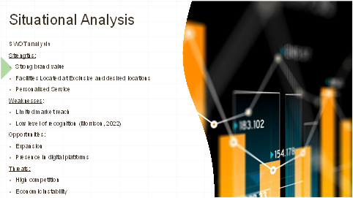

Slide 4
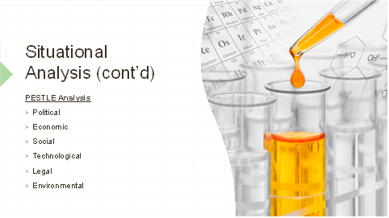
Slide 5
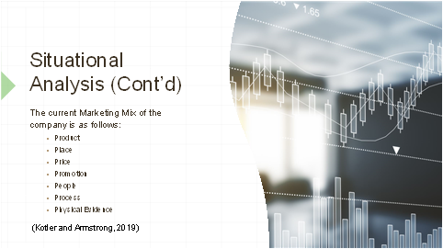

Slide 6
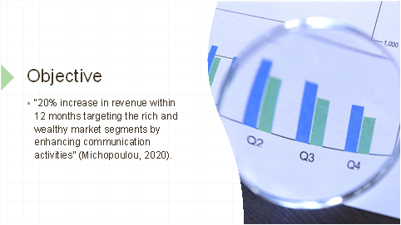
Slide 7
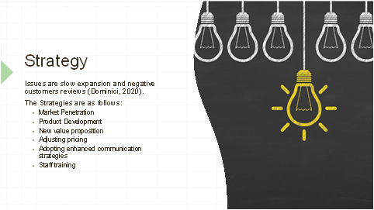

Slide 8
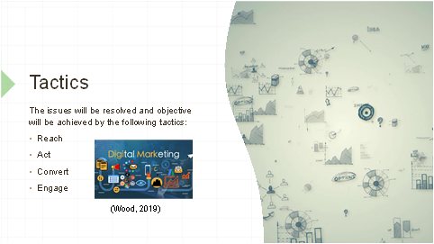
Slide 9
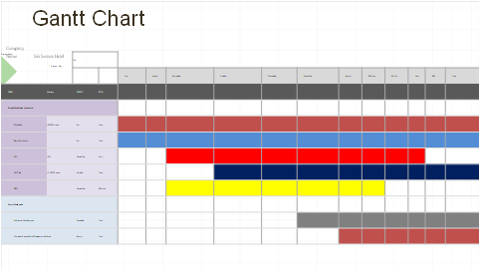

Slide 10
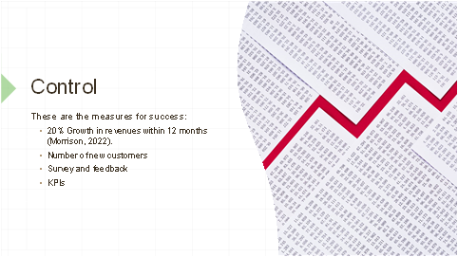
Slide 11
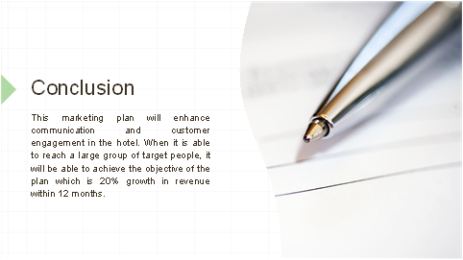

Slide 12


