
Death and Bereavement
Contents

- Introduction to death and bereavement Page 3

- Theory Page 4

  - The five-stage model Page 4 - 5

  - The four-phase theory Page 6

  - Dual process model Page 7

- Interventions

  - Group therapy Page 8

  - Dan-Joen therapy Page 9

- The Campaign Page 10

- References Page 11 - 12

Introduction to Death and Bereavement

In 2017 approximately 600,000 people died in the UK, 299,000 being male and 308,000 being female (Office of National Statistics, 2018).

Regardless of how it occurs, the death of a loved one can be painful, shocking, or difficult to accept. Individuals are often unprepared and therefore can be devastated by death. It is suggested that loss is compounded by the difficulty humans find in separation. No matter the circumstances, death is not easy (Tatelbaum, 1997).
The grief that is tied to loss is suggested to be a consequence of love and the forming of emotional bonds (Hall 2014)

Theory


The Five Stage Model
(Kübler-ross, 1973)
This model consists of five stages. These stages are linear, and the model suggests that all individuals must go through these stages in that linear motion, this means that individuals must first experience and overcome the previous stage in order to continue to the next.
The stages that this model consists of are as follows:

There are many theories which explore the process in which an individual goes through during bereavement. For this report, three theories will be explored in detail, these three being:
- The Five-Stage Model (Kübler-ross 1973)

- The Four-Stage Model of Bereavement (Parkes 1998)

- Dual Process Model (Stroebe and Schut 1999)

Denial and Isolation
The first stage of this model is denial. Denial is commonly used as a temporary defence mechanism which can help the individual survive the loss. This stage can be expressed consciously or unconsciously as a refusal of a situation (Lim 2013, Kübler-Ross 1973). Most individuals do not extensively use denial. Individuals may briefly talk about the situation; however they indicate that they do not wish to look at it any longer (Kübler-Ross 1973).

Anger
The second stage is anger. Anger is suggested to be a necessary part of the healing process. Within this stage an individual may recognise that denial is no longer a wise way to continue. Anger can typically be an indication of the intensity of love and attachment an individual has to the subject. This stage can be expressed through feelings of rebelliousness, wanting to fight back or rage (Lim 2013, Kübler-Ross 1973).

Bargaining
The third stage of this model is bargaining. This stage is where individuals can create possibilities leading to the hope that can postpone any loss. There can be negotiations which occur whether it is between themselves or with any other individuals. In some cases, individuals are willing to do anything not to feel the pain of loss and can sometimes bargain with the pain, however, this does not generally provide a sustainable solution (Lim 2013, Kübler-Ross 1973).

Depression
The fourth stage of this model is depression. Within this stage individuals may feel a state of low mood and often close themselves off from partaking within activities. This stage is where individuals typically begin to understand the loss and express this through overwhelming feelings of frustration and hopelessness. The individual may also experience feelings of numbness and lack of control (Lim 2013, Kübler-Ross 1973).

Acceptance
The fifth and final stage of this model is acceptance. Within this stage the individual experiences a state of realisation. The individual understands the loss is not their fault and may explore the good which can come from the pain of loss, such as comfort and healing (Lim 2013, Kübler-Ross 1973).

It has been suggested that Kübler-ross’ (1973) death and bereavement model describes feeling states rather than linear stages towards the resolution of grief. This model has also been criticised as it assumes that the resolution of grief is an expected endpoint of all bereaved individuals. There are also criticisms regarding how the studies were conducted, for example, Roos (2012) suggested that within the therapy sessions, the individuals were almost forced to say goodbye rather than being given alternative methods in which to relieve their distress. It is also suggested that the stages are too linear and less interpersonal, and not only do all individuals not move forwards as the model suggests, but everyone experiences grief differently and deals with experiences differently (Melnick and Roos, 2007; Roos 2012).

The four-phase model
Parkes (1998)
This model suggests phases rather than stages and proposes that grief is not a state but is rather a process which consists of phases which merge into and replace each other. This model suggests that an individual may follow these phases in a linear fashion, however each phase can be revisited either within the process of healing or later in life, such as an anniversary of a death (Parkes 1998)
The phases which this model consists of are as follows:

Numbness
The moment of death usually brings great distress; however, this is quickly repressed, which then leads to numbness which can affect the individuals for hours or even in some cases days, which is soon followed by the second phase (Parkes, 1998).

Pining
The second phase of this model is pining. This is sometimes accompanied by intense anxiety. These are mostly short episodes, rather than a long single episode. These episodes affect normal functions of the individuals which include eating and sleeping to carrying out essential tasks or responsibilities with increased anxiety.

Reorganisation
As time passes the intensity of these phases diminish. Appetite and weight return and responsibilities and tasks become easier. Although an individual’s life will become easier with time, these phases can be revisited but should this happen, the individual generally continues life as normal (Parkes, 1998).

Disorganisation and despair
Parkes (1998) suggests that appetite and weight is lost, short term memory and concentration is affected, which then leads to the third phase. This phase suggests that individuals go over the event within their mind, as if they could find out what went wrong and put it right (Parkes, 1998)

Dual Process Model
(Stroebe and Schut, 1999)
This model suggests that the bereaved individual copes with loss in everyday life, resulting in lifestyle changes which develop as a result of the loss. This model uses previous models of coping while introducing a new concept which involves moving between coping and behaviour (Stroebe and Schut, 1999).
The aspects that this model consists of are as follows:
Loss oriented process
This aspect relates to the experiences of the death. This aspect encompasses 4 factors which are:
Grief work
Intrusion to grief
Denial/avoidance of restoration changes
Breaking bonds/ties

Restoration oriented process
This aspect relates to the lifestyle changes which are related to the death. This aspect also encompasses four factors which are:
Attending to life changes
Distraction from grief
Partaking in new experiences
Establishing new roles/identities and relationships

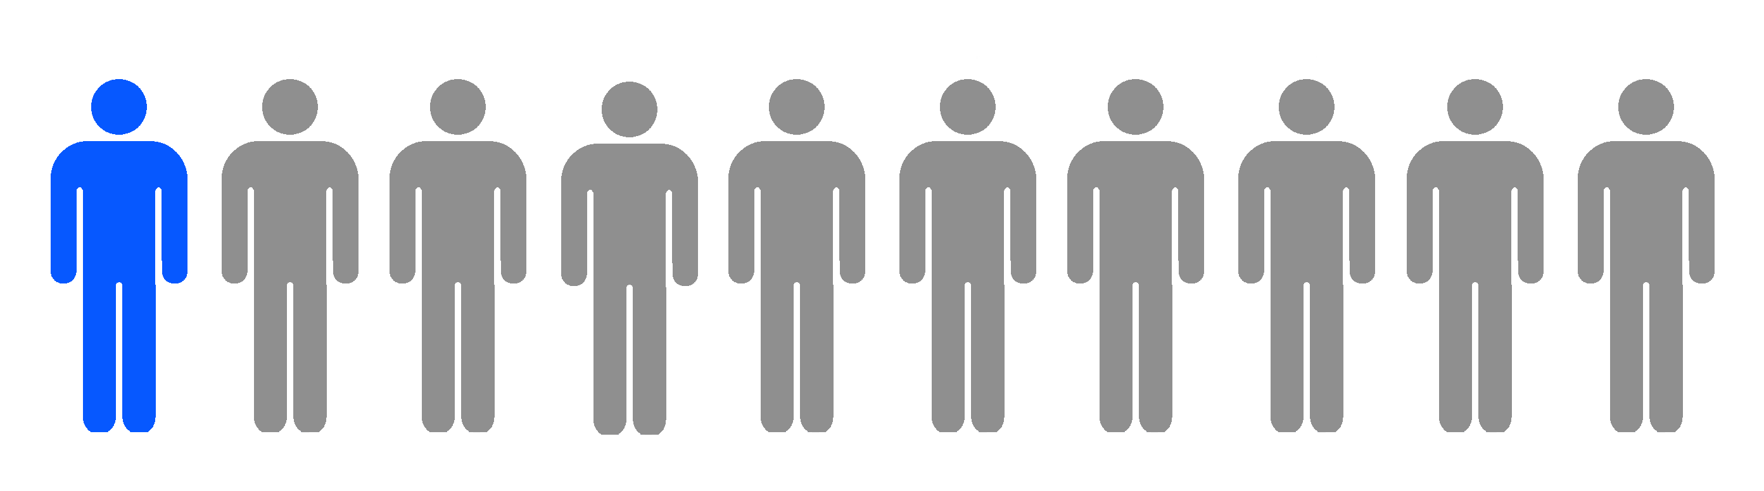

This theory is more individualistic

This model suggests that most individuals may need to move between loss oriented and restoration oriented continually in order to overcome both the cognitive effects and the impacts on the individual’s life. Although this theory suggests that all individuals move between these two aspects, it suggests that everyone will put varying degrees of emphasis on specific factors. This model can therefore be seen to be more flexible due to the interpersonal aspects of this theory (Stroebe and Schut, 1999).

Interventions

Group therapy
Group therapy is where a group of people with the same issues consult or share a session with a therapist. Group therapy is suggested to be a good intervention for individuals feeling lonely (Liu., Lin., Chen and Huang 2007).


A study conducted by Lieberman and Yalom (1992) explored group therapy with participants who were both widows and widowers. This study explored a range of behaviours that the participants experienced, for example, abuse of alcohol, depression, anxiety, focus levels etc. The evidence from this study suggested that the use of group therapy had a positive impact of the participant’s lives, reducing alcohol abuse levels and depression, and increasing focus levels, memory etc. This study provides evidence that group therapy can be a positive tool in combatting bereavement issues in the partners of the deceased.

Kealy et al. (2017) explored the role of group Psychotherapy. This study set out to explore the relationship between patients’ psychodynamic vs support group work. Participation within this study was measured via the amount of times the patients shared within the group setting, regardless of content. This study concluded that there was a positive impact of the psychodynamic work. Upon a six month follow up, patients stated that they felt that the sessions offered therapeutic relief and a reduction in grief levels. This study, however, did not find any positive impact from the supportive group sessions upon the six month follow up. The authors of this study did, however, suggest that the six month follow up was short and any further studies could provide more time before following up. The authors also suggested that the amount of time allocated to the therapy sessions may not have been long enough, and further research could provide longer sessions and a greater number of sessions.

These studies suggest that group therapy, of both psychodynamic and support types can be useful tools in assisting bereaved individuals with their grief, while maintaining the positive outcomes.
A study conducted by Liu., Lin., Chen and Huang (2007) which explored group therapy with elderly individuals living alone, found that post-therapy, individuals felt they were not alone with others feeling similar emotions to themselves. The results found positive effects of the therapy on those individuals, boosting self-esteem, reducing loneliness, reducing depression, and altogether improving life satisfaction levels.

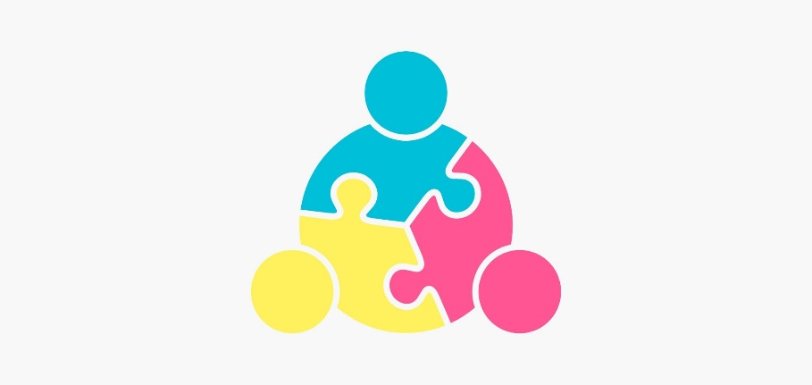

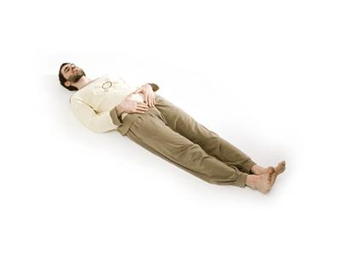
Dan-Jeon therapy
Dan-jeon is a meditation practise which encompasses both stretching and breathing exercises, which is suggested to help blood circulate around the body (Kang and Yoo, 2007).
Chicago

Yoo and Kang, (2006) conducted a study exploring the use of Dan-jeon and self-help activities on middle ages widows. All participants were widowed for less than six months and were given a depression and life-satisfaction scale before and after the sessions. The sessions ran for a ten-week period. The Dan-jeon sessions consisted of breathing and stretching exercise. Upon completion of the sessions, the participants were given the scales again. The data from the scales found that upon completing the programme there was a significant reduction in depressive levels and an increase in life satisfaction levels. This study suggests that this type of program works on middle aged individuals with immediate deaths of loved ones. Although this study found this conclusion, the study took place in Korea, where harmony and the holistic viewpoint is strong (Leung., Koch and Lu, 2002), if this study was to be replicated in the west, the results may differ as the west does not widely hold this viewpoint.

Kang and Yoo, (2007) replicated their study and explored the role of Dan-jeon on a range of ages including older adults all within the grieving process with the use of a control group who did not participate in the self-help or Dan-jeon exercise.. The study consisted of participants taking part in both self-help activities and the Dan-jeon exercises. The Dan-jeon exercises consisted of both stretching and breathing exercise while the self-help activities included group work, experience sharing and individual problem-solving activities. The self-help activities took place post Dan-jeon session and help for a period of ten weeks. This study concluded that not only did the elderly participants see a decrease is grief levels but, these positive effects where significant in all participants in accordance to the control group. This study suggests that not only does this intervention seem to work on the younger and middle-aged participants, but also for the older generation.

y



The Campaign

Much of the literature seems to suggest that a bereaved individual must go through some sort of grief work. This grief encompasses many variants of emotions and cognitive issues. Although the models used different terminologies, it seems they come from a similar standpoint, individuals must go through a process of grief to overcome it (Buglass, 2010). From the studies above into both group therapy (Liu., Lin., Chen and Huang 2007; Kealy et al. 2017), and Dan-jeon therapy (Kang and Yoo, 2007) they seem to have positive impacts on a bereaved individual, however, offering different relief. By mixing both these interventions, this may heighten these positive impacts by offering both physical and cognitive help. From this, this campaign strategy will include both Dan-jeon and group therapies in order to combat grief related issues regarding bereavement.

Campaign
- Individuals
  - This campaign is aimed towards elderly widows and widowers.

- Materials
  - Three scales will be used to gather data. these scales are
    - The Grief Rating Scale
    - The Hamilton Depression Rating Scale (HDRS)
    - The Satisfaction with Life Scale (SWL)
- A room will be located in a neutral accessible location, with a bus service provided if needed.
- Mats will be provided free of charge, as some Dan-Jeon exercises require lying on the floor
- For the group therapy, the same therapist will be used to ensure maximum comfort for the individuals, the same instructor will also be used for all Dan-Jeon sessions, for the same reason.
- Qualified manual handlers will be provided if needed.
- Refreshments will be provided free of charge.

- Procedure
- Scales will be completed pre and post intervention. They will also be completed once again after a one year period.
- Group therapy will consist of 1 hour sessions weekly. The individuals will be grouped via similar scoring patterns on the scales. The sessions will take place over a 20-week period.
- Dan-jeon sessions will also cosist of 1-hour sessions weekly. These sessions will run along side the group therapy sessions and will also take place over a 20-week period.
- All data from the scales pre, post and after the year period will be compared to explore whether the intervention has worked in reducing and managing any positive effects in regards to grief, depression and increasing life satisfaction

References

Alexander, J., & Parsons, B. V. (1982). Functional family therapy. Brooks/Cole Publishing Company
Buckley, T., Sunari, D., Marshall, A., Bartrop, R., McKinley, S., & Tofler, G. (2012). Physiological correlates of bereavement and the impact of bereavement interventions. Dialogues in clinical neuroscience, 14(2), 129.
Buglass, E. (2010). Grief and bereavement theories. Nursing Standard (through 2013), 24(41), 44.
Essa, M. (1986). Grief as a crisis: Psychotherapeutic interventions with elderly bereaved. American journal of psychotherapy, 40(2), 243-251.
Essa, M. (1986). Grief as a crisis: Psychotherapeutic interventions with elderly bereaved. American journal of psychotherapy, 40(2), 243-251.
Greenstreet, W. (2004). Why nurses need to understand the principles of bereavement theory. British Journal of Nursing, 13(10), 590-593.
Hall, C. (2014). Bereavement theory: recent developments in our understanding of grief and bereavement. Bereavement Care, 33(1), 7-12.
Jorm, A. F. (1995). The epidemiology of depressive states in the elderly: implications for recognition, intervention and prevention. Social Psychiatry and Psychiatric Epidemiology, 30(2), 53-59.
Kang, H. Y., & Yoo, Y. S. (2007). Effects of a bereavement intervention program in middle-aged widows in Korea. Archives of Psychiatric Nursing, 21(3), 132-140.
Kato, P. M., & Mann, T. (1999). A synthesis of psychological interventions for the bereaved. Clinical psychology review, 19(3), 275-296.
Kealy, D., Sierra-Hernandez, C. A., Piper, W. E., Joyce, A. S., Weideman, R., & Ogrodniczuk, J. S. (2017). Short-Term Group Therapy for Complicated Grief: The Relationship Between Patients’ In-Session Reflection and Outcome. Psychiatry, 80(2), 125-138.
Kübler-Ross, E. (1973). On death and dying. Routledge.
Leung, K., Koch, P. T., & Lu, L. (2002). A dualistic model of harmony and its implications for conflict management in Asia. Asia Pacific Journal of Management, 19(2-3), 201-220.
Lieberman, M. A., & Yalom, I. (1992). Brief group psychotherapy for the spousally bereaved: a controlled study. International journal of group psychotherapy, 42(1), 117-132.
Lim, W. M. (2013). Revisiting Kubler-Ross's five stages of grief: Some comments on the iPhone 5. Journal of Social Sciences, 9(1), 11.

Liu, S. J., Lin, C. J., Chen, Y. M., & Huang, X. Y. (2007). The effects of reminiscence group therapy on self-esteem, depression, loneliness and life satisfaction of elderly people living alone. Mid-Taiwan Journal of Medicine, 12(3), 133-142.
Lund, D. A., Dimond, M., & Juretich, M. (1985). Bereavement support groups for the elderly: Characteristics of potential participants. Death Studies, 9(3-4), 309-321.
Melnick, J., & Roos, S. (2007). The myth of closure. Gestalt Review, 11(2), 90-107.
Parkes, C. M. (1998). Coping with loss: Bereavement in adult life. Bmj, 316(7134), 856-859.
Roos, S., & Ph D, L. C. S. W. (2012). The Kubler-Ross model: an esteemed relic. Gestalt Review, 16(3), 312-315.
Schlernitzauer, M., Bierhals, A. J., Geary, M. D., Prigerson, H. G., Stack, J. A., Miller, M. D., ... & Reynolds III, C. F. (1998). Recruitment methods for intervention research in bereavement-related depression: five years' experience. The American Journal of Geriatric Psychiatry, 6(1), 67-74.
Schut, H. A., Stroebe, M. S., van den Bout, J., & De Keijser, J. (1997). Intervention for the bereaved: Gender differences in the efficacy of two counselling programmes. British Journal of Clinical Psychology, 36(1), 63-72.
Schut, M. S. H. (1999). The dual process model of coping with bereavement: Rationale and description. Death studies, 23(3), 197-224.
Shear, M. K., Ghesquiere, A., & Glickman, K. (2013). Bereavement and complicated grief. Current psychiatry reports, 15(11), 406.
Stroebe, M. S., Stroebe, W., & Hansson, R. O. (Eds.). (1993). Handbook of bereavement: Theory, research, and intervention. Cambridge University Press.
Tatelbaum, J. (1997). The courage to grieve. Random House.
van der Houwen, K., Schut, H., van den Bout, J., Stroebe, M., & Stroebe, W. (2010). The efficacy of a brief internet-based self-help intervention for the bereaved. Behaviour research and therapy, 48(5), 359-367.
Yoo, Y. S., & Kang, H. Y. (2006). Effects of a bereavement intervention program on depression and life satisfaction in middle aged widows in Korea. Journal of Korean Academy of Nursing, 36(8), 1367-1373.
The Presentation

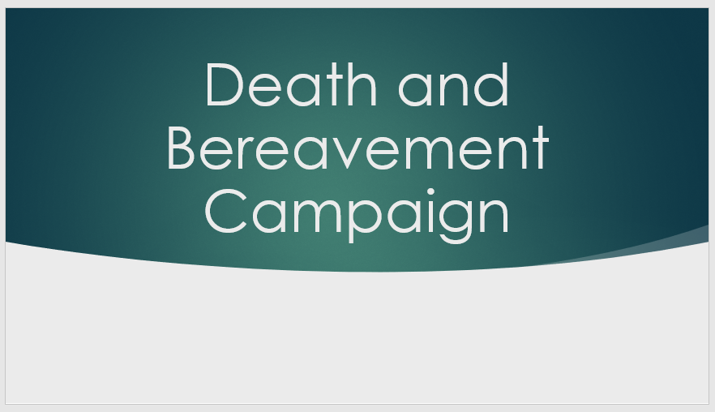
Slide 1

Presentation front page

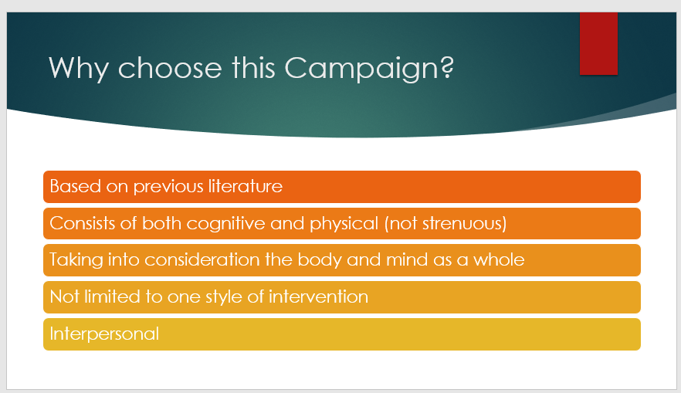
Slide 2

Slide -2 Notes
Much of the literature seems to suggest that a bereaved individual must go through some sort of grief work. This grief encompasses many variants of emotions and cognitive issues. Although the models used different terminologies, it seems they come from a similar standpoint, individuals must go through a process of grief to overcome it (Buglass, 2010). From previous studies regarding group therapy (Liu., Lin., Chen and Huang 2007; Kealy et al. 2017), and Dan-jeon therapy (Kang and Yoo, 2007) they seem to have positive impacts on a bereaved individual, however, offering different relief. By mixing both these interventions, this may heighten these positive impacts by offering both physical and cognitive help. From this, this campaign strategy will include both Dan-jeon and group therapies in order to combat grief related issues regarding bereavement.

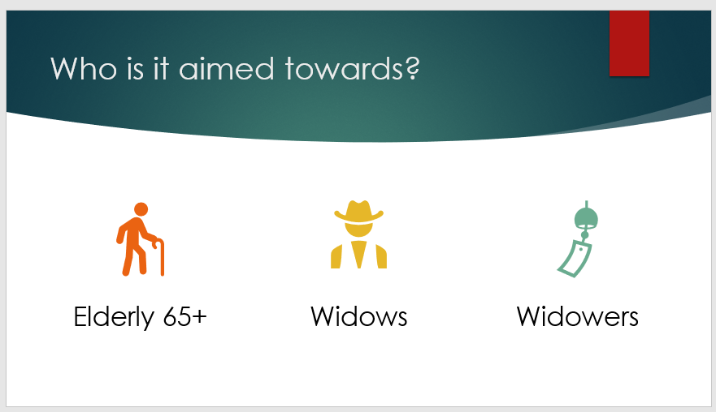
Slide 3

Slide - 3 Notes
The individuals who this intervention is aimed towards are the bereaved elderly. The age requirement will be 65+ as this is the elderly requirement in some of the previous literature for example Liu., Lin., Chen and Huang (2007). Both male and females will be welcomed into this campaign.

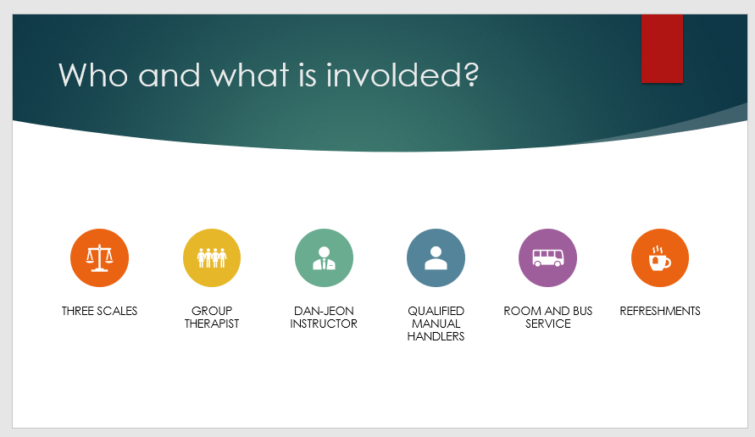

Slide 4

Slide – 4 Notes
This campaign strategy will include a total of three scales, the grief intensity scale, the Hamilton depression rating scale (HDRS) and the satisfaction with life scale (SWL). These scales will be completed by the bereaved individuals before any interventions take place. These scales will be used to measure the intensity of these aspects before and after the intervention, to explore whether the campaign works.
The sessions will be held at a neutral location chosen by the director of the campaign with both therapy sessions taking place in the same location. This is to minimise stressors that may arise from trying to find transport to the sessions. The director will also hold a bus service for any individuals who either do not drive or do not have anyone to transport them to the sessions.

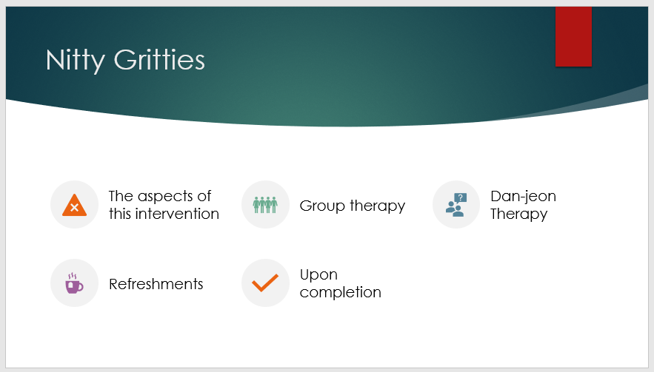
Slide 5

Slide – 5 Notes
Both aspects of the intervention will be run in parallel with each other with one session from both therapies being held weekly. The sessions will run for around sixty minutes. The time slot for the sessions will be a replication of the time slots from previous literature for example Yoo and Kang, (2006). The sessions will be held for a total of twenty weeks. This campaign will run for this length of time as some of the limitations in previous studies (Kealy et al. 2017) suggests that a larger amount of sessions may be beneficial. The sessions will be tailored as individually as possible and taking into consideration the time frame in which the individuals have been bereaved for.
The group therapy part of the campaign will attempt to group individuals who have similar scores on the scales. This is to ensure the individuals taking part will have similar feelings and will be able to communicate to others who may be experiencing the same behaviours as themselves. The group therapy will consist of one qualified therapist, who will conduct all the group therapy sessions. This is to ensure the individuals are comfortable and the sessions are more personal, with the least likelihood of repeating any information previously mentioned.
The Dan-jeon sessions will be held by a qualified individual trained in this type of therapy. Again, the director will use the same qualified person to lead the sessions to ensure maximum comfort to the participant. Mats will be provided for all participants free of charge, because sessions may require individuals lying on the floor. Qualified manual handlers will also be provided for any individuals who finds getting up and down from the floor difficult. If any individuals do not wish to do floor exercises, then they do not have to. The sessions will include both stretching and breathing exercises, however, will not be strenuous, because of the nature of the individuals partaking in the intervention. The sessions have a running time of sixty minutes as this was the time used within the studies.
As the group therapy sessions will take approximately sixty minutes, there will be a 10-minute break halfway through the session. Refreshments will be provided for all individuals free of charge. During this break, all individuals may walk around and chat freely, to ensure maximum comfort and socialization.
Upon completion of the twenty-week programme, all participants will be asked to fill the scales in again. The participants will then be asked to complete the scales once more after a one-year period to explore whether the participants have maintained any positive impacts due to the intervention. The gap will be a one-year period as some of the previous literature suggested that a six-month gap was short and a longer one may be beneficial (Kealy et al. 2017). Upon the completion of the scales after the one-year period, all scale data will be compared in order to explore whether the intervention was successful in reducing grief, depression and increasing life satisfaction levels within the bereaved elderly.

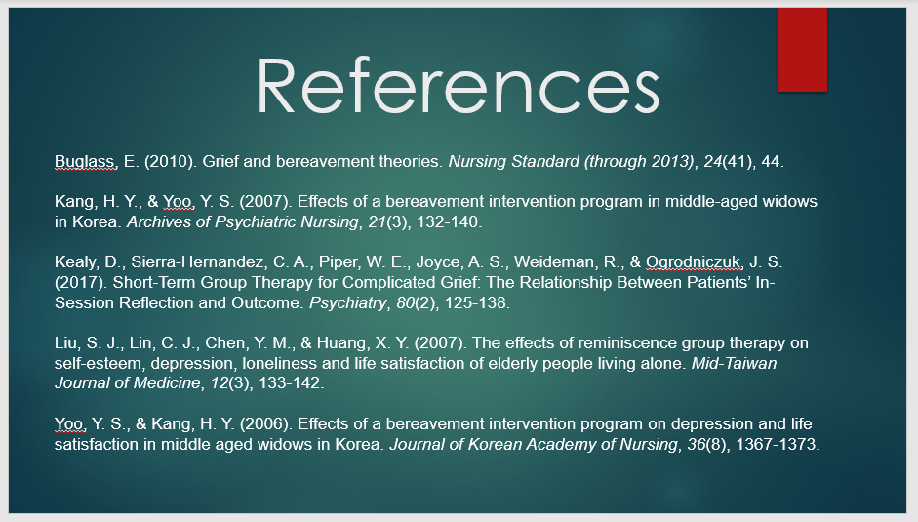
Slide - 6

Slide – 6 Notes
References for Presentation

