Developing Relationships and Workplace Achievement

Name – Moshiur Rahman
Student ID- 1814025
Programme- BA (Hons) Management and Leadership- Skills for the workplace
Module – Developing Relationships and Workplace Achievement
Module code – BMSW 5102
Lecturer- Dr. Sujeewa Herath
Submission Date- 24/11/2020

Contents
Introduction 1
Three development vehicles to the development need of individuals and organizations. 2
1. Employee Motivation 3
1.1 Application of the Theories 5
2. Employee Engagement 5
2.1 Application of the Theories 7
3. Commitment 7
3.1 Application of the Theories 8
Ways of Meeting the Development Needs from Individual’s Expectation 9
Personal Development Plan 10
Recommendation 13
Conclusion 14
References 15

List of Figures
Figure 1: Major Vehicles of Development Needs 2
Figure 2: Maslow’s Need Theory 4
Figure 3: Herzberg’s Motivation Theory 4

List of Figures
Table 1: SWOT Analysis 9

Introduction
The performance of a particular organization depends on the workforce performance or the ability of the workforces to perform their tasks efficiently. When employees got empowered and being able to take accurate and appropriate decisions can make successful in the long run (Buchanan and Huczynski, 2020). The organization must take corrective actions in the context of improving the career path for every type of employee. This report has included three parts of employee development and management context that are motivation, employee engagement, and commitment. These three aspects are significant for any organization which can lead an organization to produce a productive and efficient employee base who can make the organization to achieve its goals efficiently for gaining competitive advantages over rivals. So, these three aspects can be described as the growth drivers for any organization and this report has described these three drivers in the context of Retailing Chain Tesco. Then a detailed plan has been included which can be used to fulfil potential employees’ development needs.

Three development vehicles to the development need of individuals and organizations.
Organizational development vehicles are significant for organizational efficiency and growth because a significant role gets played by them in designing workforce skill, performance, and capabilities so that workforce can be made enable to attain the organizational and departmental goals with efficiency (Allen and Bryant, 2012). So, the organizations must pay attention to the development of the workforce need and the development drivers so that the maximum motivation of the workforce can be ensured (Singhvi et al., 2018). Organizational development vehicles include employee motivation, commitment, and engagement, performance management, reward, and compensation system, etc. So, the three significant development vehicles which enable the organization to bring improvement for today's developed and multitasker business world can be stated as:

Figure 1: Major Vehicles of Development Needs
Source: (John, 2010).

1. Employee Motivation
The strategies and ways that get adopted by the organizational managers to make an energetic, committed, and creative workforce for accomplishing organizational with a significant amount of efficiency, can be termed as the organizational motivational tools (Joseph LePla, 2013). In terms of economic downturn or the situation handling context, organizations have to apply different strategies that can make the workforce motivated and passionate about the works that they are currently doing. Organizations get engaged with the motivational incentive identification for making the employees involved and the large corporation holds a specific department named human resource management department so that it becomes easier for them to lead a huge number of workers with proper motivational incentives. But these departments try to follow some theories of motivation so that it becomes easier for them to follow those theories and models for removing inefficient from the organization. Employee motivation can be increased in many ways like the organization tend to provide direct feedback to the employees which are visible and the organization also tends to provide intangible and emotional incentives for increasing the probability of making a bunch of highly skilled employees (Lussier and Hendon, 2013). So, there is an explanation of some motivational theories which generally applied in the organizational context for making a positive impact on the organizational performance and the theories of motivation can be stated as
Maslow’s Hierarchy of Needs
The theory has been suggested by the management Guru Abraham Maslow and he stated that human beings are demanding animals and their needs can’t be satisfied by taking the significant incentives because when a stage of needs get fulfilled, humans jumped into other stage and he has made 5 division of human needs. He also stated that human has uncountable needs because they demand more and more things which are related to the things of his belonging (Cervai et al., 2014). At the first levels, employees or people expect the fulfillment of very basic needs and when basic needs get fulfilled then they demand the fulfillment of some intrinsic reward to be fulfilled. The different stages that can be aligned to the employee's needs in diverse stages can be presented as:

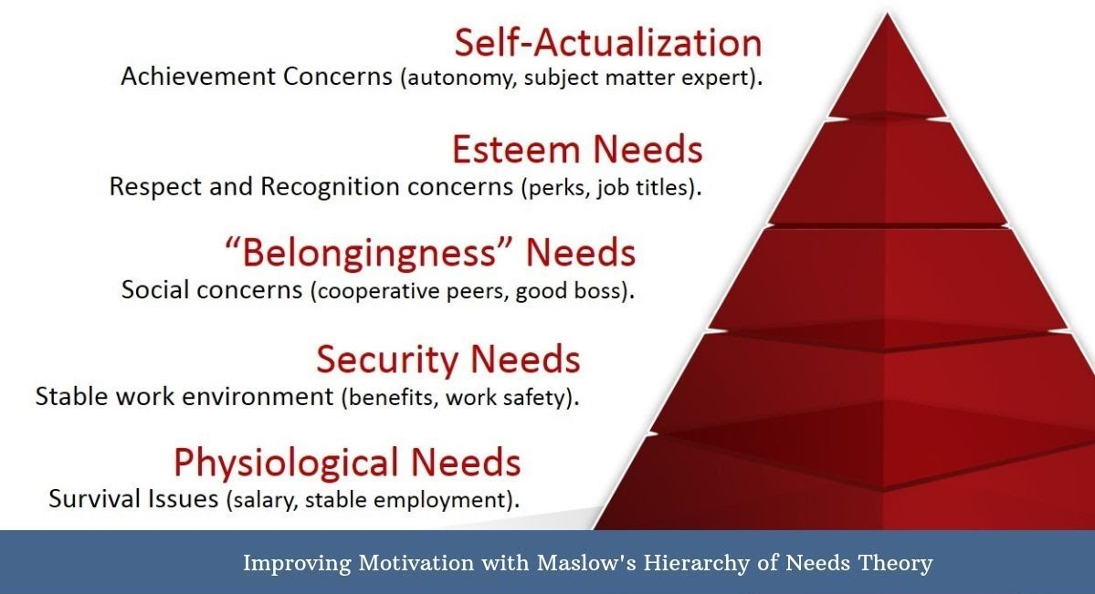
Source: (Saad, 2018)
Figure 2: Maslow’s Need Theory
Herzberg’s Theory of Motivation
This motivation theory makes managers expect better performance from the working teams by engaging two types of motivational aspects (Lussier and Hendon, 2013). The first factor is called the motivating factors and another is the hygiene factors. The motivation factors make the employees to be engaged in hard works and the factors include recognition, achievement,
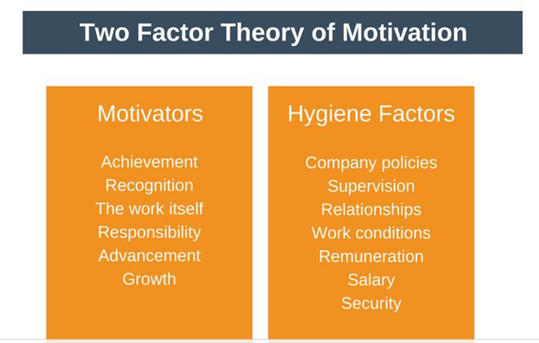
responsibility, advancement, and growth. The absence of hygiene factors makes the employees perform less while the factors don’t remain in favorable conditions and the factors include company policy, environment, security proper compensation policies, etc. So, the basic concepts of this theory are that motivational factors make the employees to get motivated in
Figure 3: Herzberg’s Motivation Theory

Source: (Lussier and Hendon, 2013)
the works, and hygiene factors must be presented in the organizational environment for ensuring an an efficient environment of work. So, these factors are not opposite rather one-factor compliments other factors.

1.1 Application of the Theories
From the business environment context, the application of motivational theories can benefit both individuals and organizations both. In a normal context, the motivation of the workforce makes the organizational executive to involve the workforce for the accomplishment of efficiency (Armstrong and Landers, 2018). Tesco stores have a great concern for the employees and employee relationships, and they motivate the workforce by engaging both intangible and expressive incentives. Tesco has been able to earn a significant amount of profitability in the retailing industry context because it has been able to impose an environment of innovation and freedom where the employees can able to fulfil esteem needs, self-actualization, and security needs (Tesco UK,2020). Also, they prioritized the employee development needs at the very first level where individuals get benefited from the best-situated responsibilities, and for the achievement of goals they get motivated with recognition and more advanced responsibility which ensures the application of ‘’Motivators’’. Departmental managers get advised with the responsibility to establish proper company policies, building relationships with the associated peers, and supervised the tasks of the teams, and recommend the proper compensation policies to the higher management which ensures the application of hygiene factors.

2. Employee Engagement
Employee engagement plays a significant role is assuming the employees’ feelings and their attachment to the job that they are currently holding and it also represents the employees’ proper employee commitment for the organizational development and related efficiencies of the workforces which helps them to reach toward a specific path (Cervai, Kekäle, and Claxton, 2014). When an organization gets engaged to take proper steps for improving the satisfaction of the employees they make the employees get positive feelings towards the management of the organization and satisfaction of the employees also gets ensured while maximum engagement initiatives get ensured from the organizational managerial context. Yet the psychology of the employees varies according to their personality. Employee engagement is the significant driver of organizational success which aids in the performance engagement of the organization. By understanding the psychology of the employees and taking proper initiatives to align with the organizational policies, executives and managers try to improve employee engagement activities by taking proper or necessary steps (Eby and Allen, 2012). The theories regarding employee engagement can be stated as:
Self-Determination Theory
The self-determination theory of employee engagement suggests that there remains a tendency on the person’s psychology to make choices on and manage their own life. And self-determination theory helps people to feel that they are having control over the activities of their own lives and choices. When people tend to work in the organizations and under the team leaders or managers they may think that their independence is getting decreased and they can feel low feeling to work for the betterment of the organization (D'Amato and Herzfeldt, 2010). But the application of the self-determination theory makes the organization to signifies on the extrinsic and intrinsic both reward system so that employees can be motivated to take the better initiatives because they may get that feeling that what they will do, it may impact the total outcomes of the organization (Woo, 2017). But it sometimes causes lower self-determination when the intrinsic reward seeking personality is giving with the extrinsic reward which may cause the reduction of the autonomy of the workforces. Sometimes people may think that their behavior is increasingly getting controlled by the external rewards and they tend to feel less because of losing control over self-behavior or dependence.
The Respect Model: The respect model sets out the fields of employee engagement. The respect models introduce the values beliefs and the sense of worth to the organizational context. The proportion of employee engagement depends on the fact of respect that they get from the organization, leaders, executives managers, and peers (Joseph LePla, 2013). So, the 7 drives of the respective model include recognition that employee gets from the organization and the managers after making better performance or brining efficiency, the proportion of empowerment that comes from the managers where the employees can find freedom while working in the organization, the tendency of the managers to provide feedback in the daily and weekly tasks of the employees, the encouragement of teamwork while accomplishing the departmental goals as well as the organizational goals and collaboration, to set out the expectation of the fairness while evaluating the performance of the employees, by considering the impact of the managerial decisions which can impact the overall wellbeing or the involvement criteria of the employees, trust that get set by the leaders on the informative decisions of the organization.

Application of the Theories
For enforcing the self-determination theory, Tesco always offers unexpected positive involvement incentives and feedbacks to the performance of the workforce for a specific task as the application of intrinsic motivation. So. These incentives help the workforce to be competent and increase its strength, which can be considered as the fulfillment of their personal needs. So, the HR executives of Tesco not only emphasize the extrinsic reward policies like the rewards or the bonus pattern as the main engagement tools rather the organizational executives make the employees feel the part of the organization by selecting the employees of the week or by reviewing the best employees’ performance on the intranet (Tesco UK,2020). The application of the Respect model can also have been seen as the employees get recognized for their works, employees get empowered with the power to contribute on managers’ decision-making process, as said earlier feedbacks of the performance are given weekly, employees get divided into teams for encouraging the goal achievement and Tesco’s HR executives always calculate the consequence of their managerial decisions by setting out the standards of equal treatment.

3. Commitment
Commitment is considered as the process to establish a specific mindset towards a specific type of behavior. In terms of business, commitment can be considered as the bond which the organizational employees share towards the working environment of the organization (Joseph LePla, 2013). So, it can be said that the committed employees of the organization generally have a strong connection with the organization because they feel fit on the organization and they have a clear understanding of what the organization intends to achieve by using the capability of the workforce. The added value of the commitment shows that employee gets determined for achieving their assigned goals, they tend to show efficiency and workforce get protective because of the fit feelings towards the attributes of the organization. Also, commitment can be stated as the mindset of the organizational employees for staying in the organization. Committed workforce tends to stay longer on the organization because they have a clear identification about the employee's goal, and are satisfied with the organizational policies (Allen and Bryant, 2012). The fear of loss also makes the employees stay in the organization because when the employees weigh up the pros and cons of leaving the organization, they may measure the loss and benefit of leaving the organization. If the perceived losses beat the benefits, employees may leave the organization
Veldman Employee Commitment Model
The employee commitment aspect of Veldman states that organizations can find a committed workforce when the employees can find an employer who matches their expected criteria or who meets all expectation of being an ideal employer (Kotzé and Roodt, 2005). Then that employer can have a big significance to look after the wellbeing of the employees and aids to build the organizational climate for arranging a satisfied employee base. So, by these processes, organizational commitment gets produced in the minds of the customers and they decide their propensity or probability to stay or leave the organization.

3.1 Application of the Theories
The theory of employee commitment gets applied in some context of the workforce management and executives of Tesco’s HR department try to make committed workforces by implementing proper HR strategies. As stated earlier the managers of the HR department tried to look after the goal of attaining the process of the organizational employees. But the tasks or goals of the department get divided by considering the skills and ability of the workforces (Tesco UK,2020). So, a climate of satisfaction gets arise when the employees see their performances on the performance management cards, and employees get satisfied with having a manager who meets up with their expectations. So, the satisfaction and favorable climate of the organization leads the organizational commitment and most of the employees find it beneficial for staying with Tesco because the turnover rate of the permanent employees of Tesco are relatively low because

Ways of Meeting the Development Needs from Individual’s Expectation
Personal development gets used in the organizational context for the enhancement of the skills of the potential employees of a particular organization which may turn into greater efficiency for the organization. Organizations get mainly responsible for the development of the skills of their current and potential workforces (Milton,2015). After taking the incentives of motivation, engagement, and commitment companies get able to develop a productive workforce.
SWOT Analysis
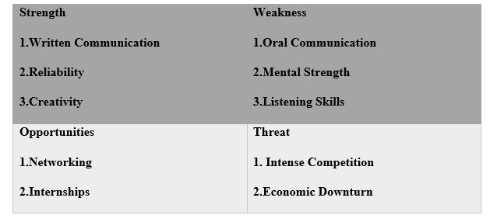
SWOT analysis makes a man identify potential characteristics of him that are required for the work environment of a particular organization. There is some observation of the personal attributes of some peers and mine which can be helpful for the identification of strengths and weakness of my personality.
Table 1: SWOT Analysis
Source: Own
Strength: As a business, students are very strong in written communication because it is the most used method of communication in student life. Also newly graduated students are also reliable in context of accomplishing their tasks and organizations can engage unique capabilities by using the talents of the new graduate students or the students of under grade. So, for applying in Tesco, written communication with reliability and creative behavior can be turned into strength because of its requirement on assessment tests.
Weakness: The method of oral communication in the business world is different from that of one in student life because of the absence of practical practices. Mental strength in times of the critical issues and weak listening skills for analysing for identifying the upcoming probability can be turned into the biggest weakness.
Opportunities: Many undergrads students have worked as part-time employees in the retailing companies which can be helpful for them to find a permanent position in the particular company and references and networks from that organization can also be turned as the opportunity.
Threat: The business environment for job seekers is getting competitive day by day (Cervai et al., 2014). Rescissions or downward economy can be turned into a problem because the employers tended to employ a minimum number of employees and excluding employees.

Personal Development Plan
This section has made a short personal development plan for the potential candidates who are willing to work with Tesco in relevance with SWOT analysis. This skilled development program has made with the relevance of the Tacos HR department so the required skills can be developed for a better career.
Required Skill | Objective | The Development  Procedure | Required Time
Communication | Developing skills for enhancing oral communication of the workforce. | Sessions will be arranged from Tesco’s aspect to make an efficient workforce with high communication skills that are required for the business environment. | Nov 2020-Dec 2020
Situation Management Expertise | Making employees capable of making efficient decisions in confusing situations | Some sessions will be arranged with the real time crisis management issues and Tesco’s authority will give training to the potential ones about the strategies of situation management. | Dec 2020 – Jan 2021
Critical Reasoning | Enhancing the ability to solve the problem of logical reasoning. | The managers will divide employees into different groups and will train them the real incident base situations which required logic and analytical skills for solving the related issues. | Dec 2020 – Feb 2021
Technical Ability | In the era of technology, employees will gain capabilities to make decisions with technology platforms. | Employees will be given chance to join online workshops for developing their skills in this sector. | Feb 2021 – April 2020
Team Works | Employees will be able to use collaborative influence for achieving any critical decisions. | Teams will be built in the departmental context and employees will be able to use their collaborative power for making something true or achieving something. | Apr 2021- May 2021
Engagement Initiatives | Employees will be motivated and engaged the employees to the organizational environment and maximum efficiency will be present in their performance | Managers will apply extrinsic and intrinsic reward management strategies for making employees motivated in their ways of developing careers. | May 2021- Aug 2021

Recommendation
In terms of motivational aspect hygiene factors and motivational factors can be applied while motivating the workforces. While applying the employee engagement strategies, Tesco can make proper application of the RESPECT model by making significance on the Trust context because the employees' engagement and commitment to the organization largely depend on the trust that gets spread by the employer and employees started to have a strong feeling towards the organizations, This leads the employee to stay on the organization and improving their efficiency by believing that the outcomes of their hard work will be evaluated with respect by the employers and the management authorities. Also, along with the application of these styles managers must make supervision the activities of the employees for improving their work styles and performance.

Conclusion
The success of any business organization depends on the ability of that organization to produce a skilled workforce and in other words by fulfilling the development needs of every individual of the organization. So, it can also be said that the overall efficiency of the organization depends on their ability to manage a fully skilled workforce and nourish them at times of need. Tesco always puts significance on the establishment of a flexible work environment that works for motivating employees, introduces employee engagement programs, and tried to develop a committed workforce so that the professional career of the employees can go through an improvement phase. Because of the organization's considerations on the employee development programs they fulfil every need of the newly recruited and currently working employees.

References
Allen, D., and Bryant, P., (2012). Managing Employee Turnover. New York: Business Expert Press.
Armstrong, M., and Landers, R. (2018). Gratification of employee training and development. International Journal of Training and Development, 22(2), pp.162-169.
Baker, H. (2008). Employee training. Chandni Chowk, Delhi: Global Media.
Buchanan, D., and Huczynski, A., (2020). Organizational Behaviour. New York: Pearson Education Limited.
Cervai, S., Kekäle, T., and Claxton, J., (2014). Employee Engagement. Bradford: Emerald Group Publishing Limited.
D'Amato, A. and Herzfeldt, R., 2010. Learning orientation, organizational commitment and talent retention across generations. Journal of Managerial Psychology, 23(8), pp.929-953.
De Silva, R. and Thilakasiri, K., 2016. Factors influencing employee motivation among non-managerial staff in hotel sector, Sri Lanka. Kelaniya Journal of Human Resource Management, 11(1), p.36.
Eby, L., and Allen, T., (2012). Personal Relationships. New York: Routledge Academic.
Hallier, J. (2009). Employers’ discovery of training: self‐development, employability and the rhetoric of partnership. Employee Relations, 21(1), pp.80-95.
Harrison, R. (2011). Employee development. London: Chartered Institute of Personnel and Development.
John, J. (2010). Relevance of Employee Development Plans in Employee Performance Management. SSRN Electronic Journal.
Joseph LePla, F., (2013). The Impact of Internal Branding on Employee Motivation and Competitive Advantage. Employment Relations Today, 40(1), pp.19-24.
Kotzé, K. and Roodt, G., 2005. Factors That Affect The Retention Of Managerial And Specialist Staff: An Exploratory Study Of An Employee Commitment Model. SA Journal of Human Resource Management, 3(3).
Li, P., (2016). The impact of the top management teams’ knowledge and experience on strategic decisions and performance. Journal of Management & Organization, 23(4), pp.504-523.
Lussier, R., and Hendon, J., (2013). Human Resource Management. Thousand Oaks: SAGE Publications.
Milton (2015). Employee Development versus Compensation: Analysis of Employee Retention Strategies on Organizational Productivity. IJARKE Business & Management Journal, 1(3).
Reid, M., and Barrington, H. (2012). Training interventions. New Delhi: Jaico Publishing.
S. Pyngavil, R., and Jindal, S., (2012). A Study on Performance Management and its Impact on Employee Motivation. Effulgence-A Management Journal, 10(2), p.19.
Saad, D., (2018). Impact of Employee Motivation on Work Performance. International Journal of Scientific and Research Publications (IJSRP), 8(3).
Singhvi, P., Dhage, N. and Sharma, P., (2018). Compensation and Its Impact on Motivation Employee‟s Satisfaction and Employee‟s Performance. International Academic Journal of Organizational Behavior and Human Resource Management, 05(02), pp.1-43.
Slattery, J., and Anderson, J. (2008). Influences of new employee development practices on temporary employee work-related attitudes. Human Resource Development Quarterly, 17(3), pp.279-303.
Tesco UK. 2020. Tesco UK. [online] Available at: <https://www.tesco uk.com/> [Accessed 30 June 2020].
Woo, H., 2017. Exploratory Study Examining the Joint Impacts of Mentoring and Managerial Coaching on Organizational Commitment. Sustainability, 9(2), p.181.

