
Smart City Technology
Thomas Evans

Web Development
Sue Maw
2000 words

Table of contents
Introduction
Background Literature
Aims and Objectives
Development Methodology

Table of Figures
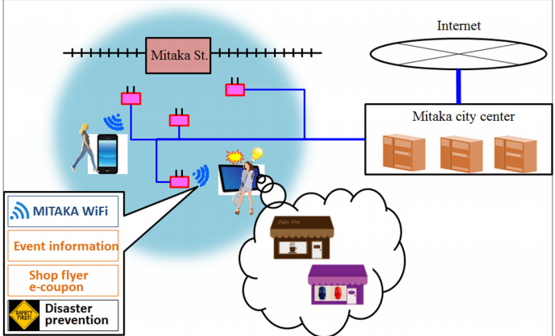
Figure 1: Network Structure of Wi-fi around station [1]
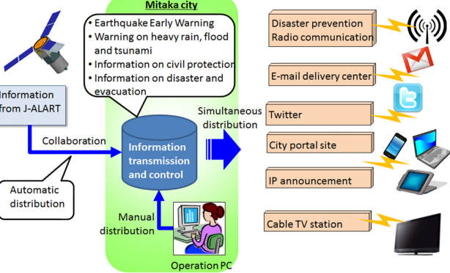
Figure 2: Concept of information transmission and control[1]
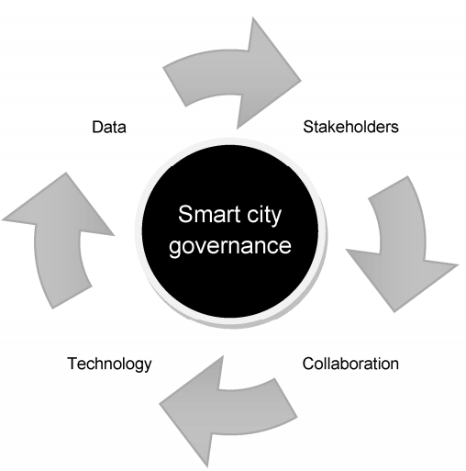
Figure 3: Key Pillars of Smart City governce[3]

Figure 4: Interest shown in smart cities

Figure 5: Reduction of UK emissions

Introduction
With cities becoming larger and more congested as the days pass the growth of smart cities continues to grow with them. With populations continuously growing smart cities enable the sharing of information with citizens and aids in the running effectiveness of government services and the welfare of all the cities citizens. Overall the intention of a smart city is to assist in the economic growth of a city as well as improving the quality of life throughout the city using smart technologies.
Smart cities integrate technology into all parts of city life to improve all parts of the cities life. Traffic lights can automatically change to help congestion, park parks can direct drivers towards a free space in real time and then enable you to pay for parking via your phone as oppose to scrambling for change. Smart lamps that dim depending on if there is traffic and get brighter when traffic is near. Smart bins can detect when they are full and notify rubbish disposal companies to empty the bins. Streets can detect incidents and notify authorities to ensure any ambulances can be deployed to ensure public safety. Smart cities are not only aimed towards improving quality of life but also aims towards the saving of resources with street lamps only being turned on when needed and directing drivers towards free space saving them from wasting fuel circling city car parks. This report proposes implementing a portion of these features into the city of Swansea to support the cities continuous growth and changes.

Background Literature
The united nations in 2014 declared that the percentage of people living in urban areas had risen from 30% to 54% and predicted a rise to 66% living in urban areas by 2050[1]. These large numbers of people living in a concentrated area can lead to high levels of congestion and pollution. A smart sustainable city should be able to tackle these problems without hassle by being able to solve traffic problems as well as many others in order to sustain a high quality of life for its residents.
To improve resident safety and state of mind [1] suggested a method of IP announcements in were vulnerable people were given access to an online shopping system with items sourced from local shops. The residents were also asked to provide conformation of resident safety to avoid solitary death in the home. They also studied an incident in Japan were in the event of a natural disaster people would flock to a network source to access information and provide conformation of safety to relatives. Figure 1 shows us a diagram of the network sources that surrounded Mitaka station after the time of the great east Japan earthquake. In the same paper they suggested these networks and access to them could be a great platform for an early warning earthquake system. Figure 2 demonstrates a way in which a city-wide network could be used to deploy information on an incoming earthquake (Or any other predictable natural disaster) by using a series of network related outputs. By using their IP announcements, they could notify vulnerable people of any upcoming disasters.
One of the first steps towards creating smart cities was in 1996 where the US government passed legislation E911[2]. This encouraged mobile networks to locate emergency callers accurately. Unfortunately, cellular technology could not fulfil these demands, so operators began to make enormous strides towards advanced positioning methods.
The Internet of things can be looked at as a form of smart cities. The internet of things essentially devices working together over a common network to complete goals.
Some claim [3] that the success of smart cities depends on the internet hook up percentage of the population of the city. For example [3] states that the Canadian city of Ottawa had 65% were as the US town of Blacksburg of 38,000 has 100% hook-up.
Figure 3 shows us the 4 main pillars for a smart city to work effectively.
Figures show [5] that the global smart city is estimated to be worth US$1.565 trillion by the year 2020. The same report also estimates a growth to 26 global smart cities by 2025 with 50% of those cities being in Europe and north America. With population in developed urban areas predicted to rise to 81% the article questions how governments will be able to maintain the high living standards that are available now.
A large portion of what makes a smart city is the cities use of resources. [7] states that the largest concern when designing and developing smart cities is the growth of eco-cities that can conserve resources using modern ICT techniques.
Figure 4 shows the peak of interest in smart cities starting in the year 2014. [7] project that the interest will continue to rise till at least 2020 as the development or smart cities increases.
[8] suggests that the smart cities are an increasingly most viable solution to urban pollution problems. Companies such as IBM, Cisco, Microsoft, Siemens and Hitachi have set their sights towards developing services and products that could explicitly help develop urban infrastructure. With the help of open data these companies are helping develop mobile apps to assist the interaction between citizens and infrastructure networks.
To ease the effect of congestion and traffic issues Google, Volvo, Uber and Tesla are working towards urban mobility services such as autonomous cars that in turn could work with public transport. These services will be aided by the newly formed Sidewalk Labs started by Alphabet Inc. in 2016. [9]
It is states [10] that over 90% of cities with over 500,000 inhabitants in the EU are considered smart cities to some degree. The same report states the global smart technology is estimated that smart technology will be worth around £40 billion by 2020.
China are making large leaps towards smart cities with 192 projects approved in 2012 which will assist in the agricultural modernization as well as the informatization and informatization of these locations.

Aims and Objectives
To outline the goals for this project it’ll be important to outline the aims for the project before beginning it. Before setting these Aims and objectives it is important to outline the type of project that is to be conducted. Whether is to be a survey-based project or a development-based project.
Aims
The aim of this project is to develop a program or application that can integrate with a smart city system and improve the quality of life of those who live in them by either reducing emissions in populated areas, reducing congestion, or improving safety in cities. The project could consist of creating an application similar to one studied in the literature section of this report now available in Japan. An application could be created to notify citizens of any disasters for example earthquakes or tsunamis or perhaps unnatural disasters. Like plane crashes or terrorist attacks. This app could use a mobile application as a platform to send notifications to warn people of an incoming danger. This application should be able to run off any network the mobile is connected to. This application could be written using the swift language for iPhone as a prototype.
Objectives
- The application should be able to access the location of the user to identify whether a user is in and area of vulnerability. The advantages of swift is that it has a built-in map feature and therefore will make it easier to find a user’s location accurately.
- The application must be able to notify the user even when the application is not running as to ensure the safety of the user.
- The application should give updates on any situation that may arise and provide safety tips for example safer places to go.
- The application should be able to provide directions out of any danger situation it might be needed for.
- The application should provide a platform for someone to contact emergency services if needed and should enable users to send warning to other users.

Development Methodology
For the purpose of this project will be to use the swift code to create a disaster awareness application similar to a project conducted in Japan. The swift language can be ideal for this project as it has a lot of easily accessible built in features that will help with the development of the application. If the project is a success it could be expanded to work on other platforms possibly a cross platform application using apache Cordova. This would an idea as an app created using swift will only be capable of running on apple devices and therefore an app created with apache Cordova will be capable of running on other devices such as android or windows.
Risks
The main risk for not reaching goals for this project would be time. Also, as the author of this report does not own hardware capable of writing the swift program it will greatly really on using facilities available from UWTSD. As far as can be seen at the current time there appears to be no ethical issues involved with this project.
Physical Resources
To complete this project, the use of the university resources will be necessary in order to write the swift code. This will be necessary as the author of this report does not have access to a device capable of writing the language on. The use of one of the universities Mac Mini’s will be necessary.

Gantt Chart
As can be seen in the below Gantt chart the projected timetable has separated the project into 4 main sections Analysis. Outline, Testing and Changeover. Separating the project into sections and planning these sections should allow for the project to run smoothly. The Gantt chart predicts that the project can be completed in advance of the end of February. The Gantt chart project finishes early to allow plenty of time in case of any sections needing extensions. This should enable the project to be amended and fixed so that no major errors can be seen in the project when it is submitted.
The Gantt chart shows that the project will begin in November and end in February although should time allow the project could begin earlier which would mean revisiting the projects Gantt chart to ensure a correct plan.


References
[1] Hara, M., Nagao, T., Hannoe, S. and Nakamura, J. (2016). New Key Performance Indicators for a Smart Sustainable City. Sustainability, 8(3), p.206.
[2] Chen Wang. Location based services and location based behavior in a smart city. Other. Université de Lyon, 2016. English. <NNT: 2016LYSEC017>. <tel-01474077>
[3] Robert G. Hollands (2008) Will the real smart city please stand up?, City, 12:3, 303-320, DOI: 10.1080/13604810802479126
[4] Paskaleva, K., Evans, J., Martin, C., Linjordet, T., Yang, D. and Karvonen, A. (2017). Data Governance in the Sustainable Smart City. Informatics, 4(4), p.41.
[5] Cambridge Journal of Regions, Economy and Society 2015, 8, 3–12 doi:10.1093/cjres/rsu034
[6] Adegboyega Ojo, Zamira Dzhusupova and Edward Curry. Exploring the Nature of the Smart Cities Research Landscape.
[7] Evelin Priscila Trindade1, Marcus Phoebe Farias Hinnig1, Eduardo Moreira da Costa1, Jamile Sabatini Marques1, Rogério Cid Bastos1 and Tan Yigitcanlar. Sustainable development of smart cities: a systematic review of the literature. DOI 10.1186/s40852-017-0063-2
[8] SMART CITY STRATEGIES A Global Review 2017. Catapult future cities.
[9] Better Planning: Smart City-Regions. Position paper (September 2017) RTPI
[10] Caird, S. Hudson, L. and Kortuem (2017). Communication on Smart City Evaluation and Reporting in UK Cities. In: First International Smart Cities in Smart Regions Conference 2016, 10-12 May 2016, A. Aalto and L. Montonen eds. Lahti Finland. pp20-28.
[11] Sihou Zhang. THE ROLE OF INFORMATION AND COMMUNICATION TECHNOLOGY FOR SMART CITY DEVELOPMENT IN CHINA. TALLINN UNIVERSITY OF TECHNOLOGY Faculty of Information Technology

