Marketing plan written for Premier Inn

Student Name
Elena Silvia Cazacu

Student ID number
2207618
___________________
Marketing Essentials BMIH4005

Lecturer
Christopher Wilkin

Table of Contents

Component 1 4

Introduction 4
Company background 5
Marketing efforts 6
Conclusion 7
References 8

Component 2 9

Introduction 9
Situation Analysis 10
Objectives 14
Strategy 15
Tactics 16
Action 17
Control 18
Conclusion 19
References 20
Appendix 22

Component 1

Introduction
The following slides presents a brief company profile of Premier Inn and its marketing efforts as per the marketing plan carried out.

Company background

Premier Inn is one of the top hotel brands based in the UK. The company was founded in 1987, since its formation the company has been consistently offering hotel services and accommodation through foods, hotel rooms and so on. The hotel brand has more than 72,000 rooms and 800 hotels (Premier Inn, 2022). However, the company is known as one of the best hotel brands across the world due to its hotel chain and operations in city centers, suburbs, airports and so on. Therefore, Premier Inn has a special and top position in the hospitality industry in the UK.

Marketing efforts

The marketing efforts fostered by the company include increasing service lines, increasing brand image, increasing website traffic and so on. Premier Inn wishes to expand into non-operating countries in order to gain more revenue (Dev et al., 2022).

Conclusion

To sum up, here it can be said that Premier Inn is one of the top existing hotel brands having large size and scope. The marketing effort of the company mainly involves promotional strategy to promote its services and brand overall.

References
Dev, C.S., the International Centre for Hotel and Resort Management at the University of West London.
Premier Inn (2022) About Us, Premier Inn. Available at: https://www.premierinn.com/gb/en/why.html (Accessed: February 21st, 2023).

Component 2

Introduction
Marketing plan refers to the systematic process of planning marketing efforts for the particular organization. It is the advertising strategy usually fostered by the company to implement to sell a product or service. The primary objective of a marketing plan is to determine the target market while focusing on all the necessary business areas inside and outside the business organization (Caob et al., 2022). The following marketing plan is being created for the UK`s top hotel brand Premier inn. In order to complete the marketing plan various theoretical analysis has been carried out such as SWOT, 4ps of marketing mix, and so on. Actions, objectives, controlling methods have been fostered as a part of marketing plan.

Situation Analysis
Company:
Strengths | Weaknesses
- High brand image  - Diverse collection of hotel services and accommodation  - Premium brand of the hotels  - Online booking facilities | - Limited global presence  - Small margins  - Outdated website
Opportunities | Threats
- Technological development  - Improved customer service  - Building brand through customer experience | - Competitions  - External business environment  - Backpackers hostels
Table 1 (SWOT analysis)
Source (created by the learner)

Customers
Premier Inn, being one of the UK`s top hotel brands, has a huge customer base who has different wants and needs, and each customer varies in terms of their purchasing behaviors. However, the customers of Premier Inn can be analyzed through the use of segmentation and targeting initiatives fostered by the company.
Segmentation: The segmentation process changed the way of understanding customers where the premier inn usually segments its customers through the use of demographic attributes of their customers (Daskalaki et al., 2022). Having done this, the company segregates its customers based on age, lifestyle, gender, income and so on.
Targeting: Premier Inn usually targets customers who belong to the millennial age group as the company believes this generation of people are mainly travelers, tourists.

Competitors:
Forces | Impact
Threats of new entrants | As the hospitality industry in UK is growing at rapid rate there are high possibilities that the premier inn can be affected by new emerging company
Bargaining power of customers | Customers demand high quality hospitality services at reasonable services which result in high bargaining power.
Bargaining power of suppliers | The supplier of the company puts high pressure by raising their price
Threat of substitute | There is a high chance of having the same hotel services in the market as offered by Premier inn.
Competitive rivalry | Leading hotel companies like Hilton and Holiday Inn can be a high competition for Premier Inn.
Table 2- Porter's 5 forces)
Source (created by the learner)

Collaborators:
Distribution partners of Premier Inn are quite vast as the company works with many Travel management companies and hotel booking agents to offer connectivity through online bookings and so on (Vinod et al., 2022). Premier Inn, being a hotel brand, partners up with tourism related companies in its operating countries.

Climate:

Factors | Impact
Political | Various rules and regulations for the trade system, tax policies affect the functioning of premier inn.
Economic | The inflation rate of the UK is expected to increase by 11.1 per cent, which makes the company be affected by it.
Social | Due to the outbreak of Covid-19 customers have developed a different purchasing perspective where they seek safety (Wang et al., 2022). Thus, this puts the company under pressure to meet the demands of their customers.
Technological | Production techniques, logistics marketing, e-commerce technologies affect the operation of the company.
Legal | Employment right Act 1996, Companies Act 2006 type of laws affects the functioning of the company.
Environment | Premier Inn considers its environmental impacts in accordance with the Environment Act fostered for the hotel companies by the UK government.
Table 3 (PESTLE analysis)
Source (created by the learner)

Objectives

Specific | Measurable | Attainable | Resources | Time
Increase service sales | Using KPI indicator to measure the increase in services of the company | It is attainable | Innovative services, implementing technology | 2 months
Increase brand awareness | Measuring social media activities | It is attainable | Content marketing, Digital marketing strategy | 2 months
Strengthening relationship with customers | Customer review and interaction with the company | It is attainable | Digital communication tools, social media platforms and so on, | 2 months
Increase traffic | Calculating lifetime value of each visitor | It is attainable | Digital marketing strategy | 2 months
Table 4 ( SMART)
Source (created by the learner)

Strategy

Value proposition refers to the statement which clearly communicates the product or service benefit to the customers. It is the statement given by the organization to its customer regarding the quality of the services being offered (Cooper et al., 2022). As in the case of Premier Inn, they have stated that they aim to provide the best quality services, affordable hotels for the guests in order to make them live positively and to positively impact the world around us. Having such a statement the organization works to fulfil this statement by offering the best quality services to its customers. The organization has set up a defined team which puts all the employees to work hard in order to deliver best quality services to its customers (Erdem et al., 2022). Since the company segments its customers in accordance with the demographic segmentation alongside targeting millennials here it can be said that the value proposition proposed by the company greatly links with its segmentation strategy.

Tactics
Product: Premier Inn offers a wide collection of hotel services and accommodation through food, hotel rooms, entertainment and so on. The unique selling point of Premier Inn is that they offer a kid family friendly, safe children’s playrooms and bike friendly image paired with free Wi-Fi. This is one of the best services offered by the company in which it makes the company have rapid increase in their product sales (Berry et al., 2022). However, the company can develop more personalized services in which they can attract more customer segments.
Price: As a part of the marketing plan, the company can make use of a competitive pricing strategy in order to develop prices for certain services offered by the company. Having done so, it will enable the company to have insights into other leading companies and accordingly can set the price for its offers. Competitive pricing method will enable the company to set the price strategically, having an advantage to gain insights of other leading companies operating in the same market (Gómez-Prado et al., 2022).
Place: The place of the products and services are to be largely available in the regional location of the company. Online bookings for the hotel company can also be fostered as it will improve customer service. Fostering online booking on the official website of the company is a great way to place the services offered as it is easily accessible to the customers (Lee et al., 2022). The services offered by the company will be sold through digital tools as the customer can have more preferences while selecting the right hotel rooms.
Promotion: The promotion of all the marketing efforts, services and brand overall can be promoted through using a digital marketing strategy. Usage of different social media channels and platforms will be used to promote the marketing efforts and the brand overall. The services and products offered by the company will be advertised through the use of social media marketing as it will enable the company to reach out to as many customers as possible (Fahmi et al., 2022). Having followed this strategy, the company can have the advantage of reaching out to wider audiences where the company can increase their brand image and so on.

Action
Activities | Start date | End date | Duration
Preparation | 21-February-2023 | 27-February-2023 | 1 week
Market research | 27-February-2023 | 5-March -2023 | 1 week
Marketing channels schedule | 5-March-2023 | 11-March-2023 | 1 week
Gathering feedback | 11-March-2023 | 17-March-2023 | 1 week
Table 5 (Gantt chart)
Source (created by the learner)

Activities | Week 1 | Week 2 | Week 3 | Week 4
Preparation
Market research
Marketing channels schedule
Gathering feedback
Table 6 (Gantt chart)
Source (created by the learner)

Control
The USP or unique selling point of the company is set to personalized hotel rooms where the customers or guests can have the advantage to demand for any type of hotel rooms they want according to their suitability (Thelen et al., 2022). The control of the marketing plan will be measured or controlled through the KPI or Key performance indicator. KPI or key performance indicator is one of the measuring techniques to measure and evaluate the performance of a certain activity. As for the marketing plan, KPI or Key performance indicator is fostered in order to critically analyze the performance of the marketing plan (Crotts et al., 2022). Generally, KPI aids in measuring the performance of certain activity over time for a specific objective.

Conclusion

To sum up the marketing plan, it can be said that the above marketing plan is for Premier Inn, one of the UK's top hotel brands. The marketing plan is carried out by using the SOSTAC model as the model refers to all the areas of marketing efforts. The ultimate objective of the marketing plan is to increase the sales of the company, increase traffic, improve brand image, to build long-term loyalty, through a combination of affordability, comfort, quality, and excellent service.
In my opinion, I may suggest, to create a partnership with other relevant businesses, a recommendation such as partnering with airlines or travel agencies by offering special promotions or discounts that could lead to more customer engagement and loyalty for Premier Inn.

References
Berry, C.T.P., 2022. Equity research-Whitbread PLC (Doctoral dissertation, Instituto Superior de Economia e Gestão).
Cao, G., Tian, N. and Blankson, C., 2022. Big data, marketing analytics, and firm marketing capabilities. Journal of Computer Information Systems, 62(3), pp.442-451.
Capability as a Competitive Advantage in the International Performance of Startups: Case of Peru. Sustainability, 14(17), p.10703.
Cooper, K., Dedehayir, O., Riverola, C., Harrington, S. and Alpert, E., 2022. Exploring consumer perceptions of the value proposition embedded in vegan food products using text analytics. Sustainability, 14(4), p.2075.
Crotts, J.C., Magnini, V.P. and Calvert, E., 2022. Key performance indicators for destination management in developed economies: A four pillar approach. Annals of Tourism Research Empirical Insights, 3(2), p.100053.
Daskalaki, E. and Hyams-Ssekasi, D., 2022. Unravelling Entrepreneurship and Innovation Within the Hospitality Industry: A Case Study of Selected Hotels in Cyprus. In Entrepreneurship and Change: Understanding Entrepreneurialism as a Driver of Transformation (pp. 239-267). Cham: Springer International Publishing.
Erdem, A. and Şeker, F., 2022. Tourist experience and digital transformation. In Handbook of Research on Digital Communications, Internet of Things, and the Future of Cultural Tourism (pp. 103-120). IGI Global.
Fahmi, K., Sihotang, M., Hadinegoro, R.H., Sulastri, E., Cahyono, Y. and Megah, S.I., 2022. Health Care SMEs Products Marketing Strategy: How the Role of Digital Marketing Technology through social media. UJoST-Universal Journal of Science and Technology, 1(1), pp.16-22.
Gómez-Prado, R., Alvarez-Risco, A., Cuya-Velásquez, B.B., Anderson-Seminario, M.D.L.M., Del-Aguila-Arcentales, S. and Yáñez, J.A., 2022. Product Innovation, Market Intelligence and Pricing
Lee, S.H., Deale, C.S. and Lee, J., 2022. Does it pay to book direct? Customers’ perceptions of online channel distributors, price, and loyalty membership on brand dimensions. Journal of Revenue and Pricing Management, 21(6), pp.657-667.
Morrison, A.M., 2022. Hospitality and travel marketing. Taylor & Francis.
Thelen, A.E., 2022. The Challenges and Benefits of Implementing Virtual Reality and Augmented Reality in the Hotel Industry.
Vinod, B., 2022. Revenue Management in the Lodging Industry: Origins to the Last Frontier. Springer Nature.
Wang, S., Cheah, J.H., Lim, X.J., Leong, Y.C. and Choo, W.C., 2022. Thanks, COVID-19, I'll reconsider my purchase: Can fear appeal reduce online shopping cart abandonment? Journal of Retailing and Consumer Services, 64, p.102843.

Appendix
Slide 1
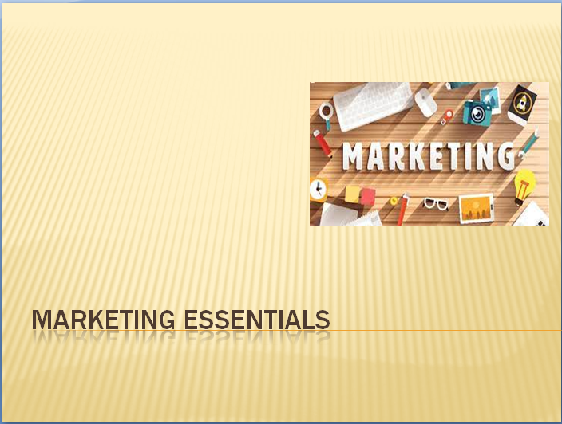

Slide 2
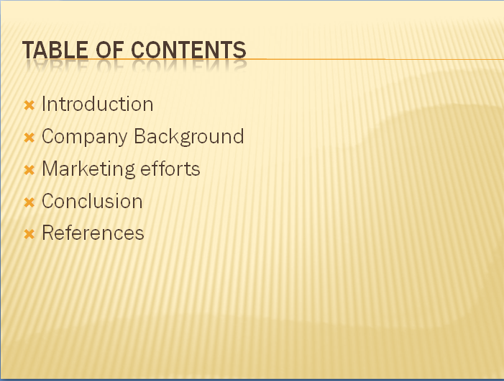

Slide 3
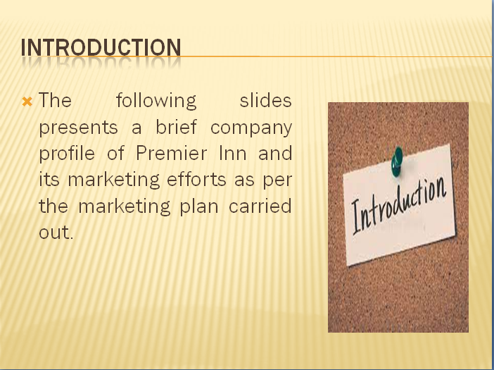

Slide 4
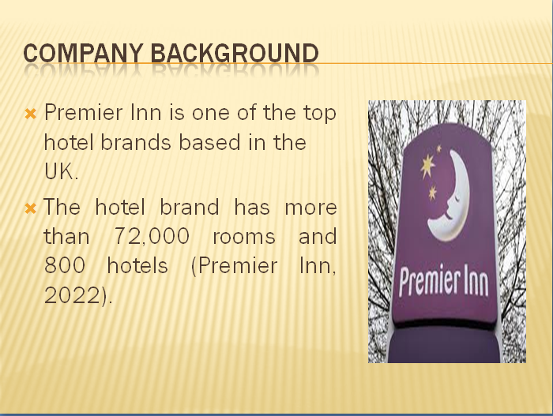

Slide 5
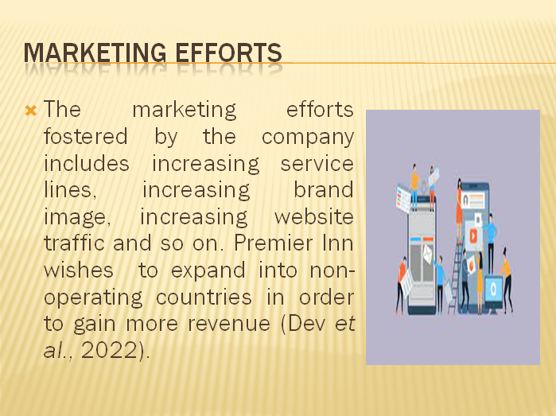

Slide 6
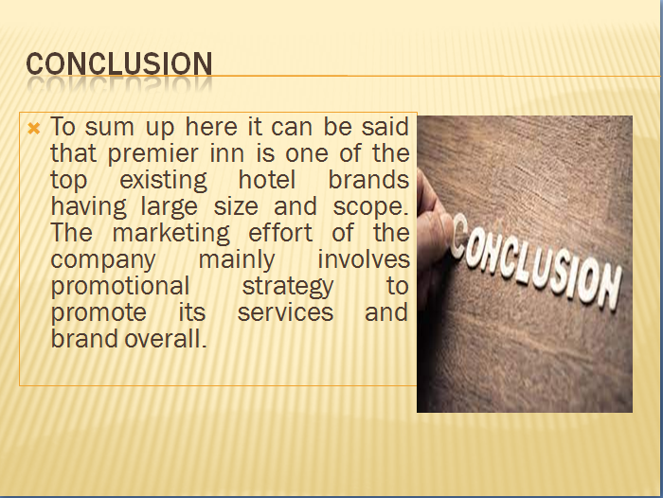

Slide 7

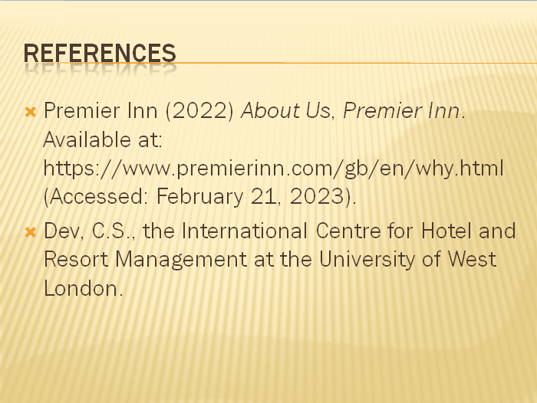

Slide 8


