Building of Eumachia (Eumachia’s building)
Task 1: identify two to three pieces of scholarship you can use which relate to your building / location. These can be chapters or subsections in monographs, chapters in edited books, journal articles (or segments within journal articles), and excavation reports. [Do not include online blogs]
Moeller, Walter O. “The Building of Eumachia: A Reconsideration.” American Journal of Archaeology, vol. 76, no. 3, 1972, pp. 323–27. JSTOR, https://doi.org/10.2307/503926. Accessed 4 Dec. 2025.
Longfellow, Brenda. “FEMALE PATRONS AND HONORIFIC STATUES IN POMPEII.” Memoirs of the American Academy in Rome, vol. 59/60, 2014, pp. 81–101. JSTOR, http://www.jstor.org/stable/44981973. Accessed 4 Dec. 2025.
Curtis, Robert I. “ARCHAEOLOGICAL EVIDENCE FOR ECONOMIC LIFE AT POMPEII: A SURVEY.” The Classical Outlook, vol. 57, no. 5, 1980, pp. 98–102. JSTOR, http://www.jstor.org/stable/43934163. Accessed 4 Dec. 2025.

Task 2: try and locate a structural/architectural plan for your building (or a topographic layout of an area if you picked, for example, the Necropolis outside the Nuceria Gate).
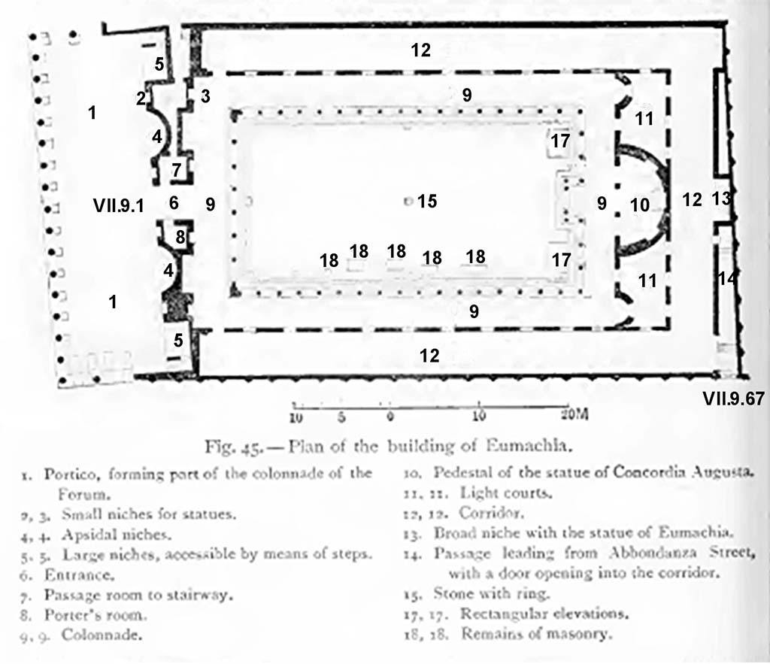
Task 3: on a topographic map, identify where your structure (or series of structures) is located and pick out any relevant buildings in the vicinity. Is your building part of a particular district?
The building is located on the forum, with its portico forming part of the forum’s colonnade. (see building circled in blue)
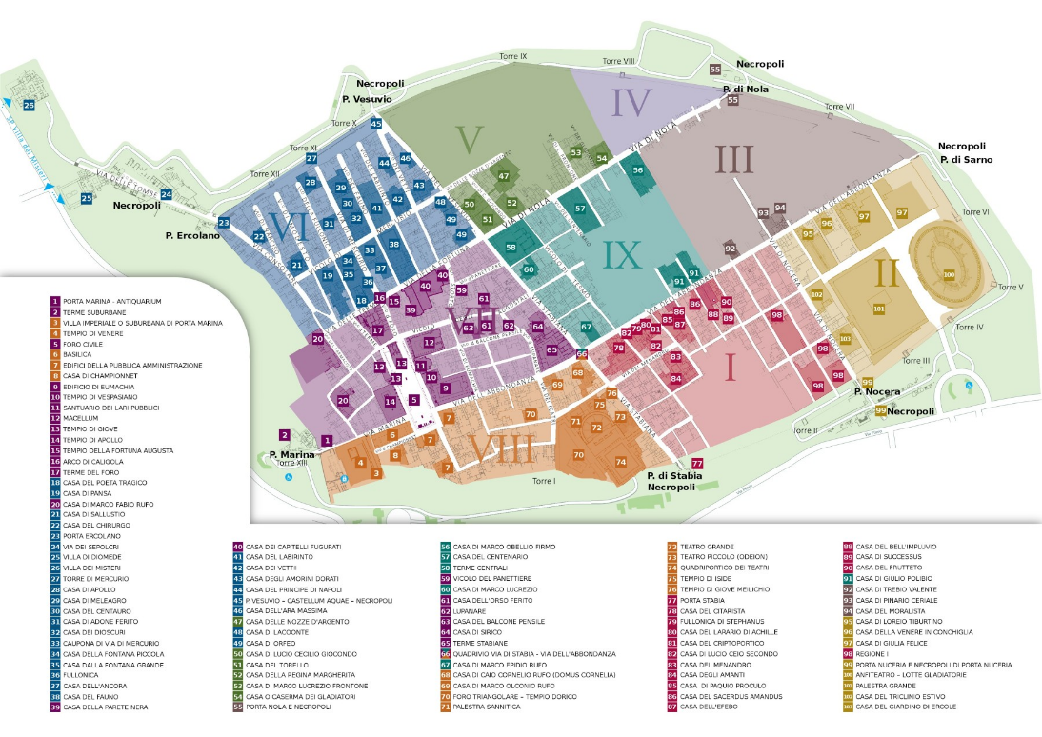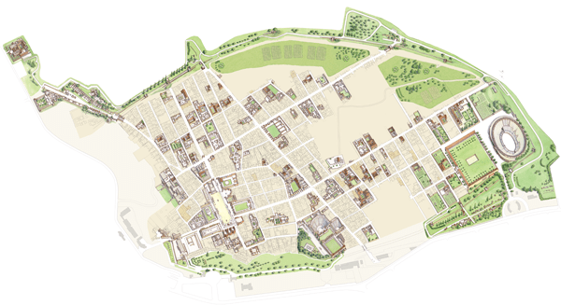
Task 4: Identify any iconographic imagery (e.g., wall-paintings, etched (graffiti) images, statuary, mosaics, funerary reliefs, etc.). The goal is to identify material that you may find useful for your study.
- The entrance has a decorative marble relief depicting vegetation
- Graffiti: “The gladiatorial troop of Aulus Suettius Certus, aedile, will fight at Pompeii on the 31 May. There will be a hunt and awnings” (From a wall of the Eumachia Building, Via dell Abbondanza, Pompeii)
- lack of graffiti (or at least record of graffiti) seems attributable to much of the outside of the building being covered with plaster, which has deteriorated or been destroyed since the excavation in the 19th century. (see below for example)
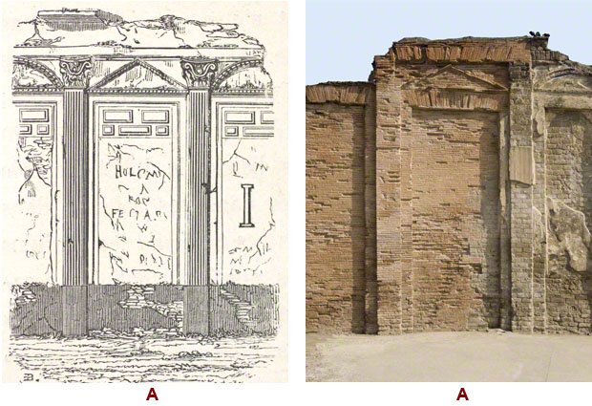
( https://www.pompeiiperspectives.org/index.php/condition-assessment-analysis/north-side-regio-vii-insula-9)

Task 5: Identify a few items of material culture (physical objects), organic material (e.g., skeletal remains, archaeobotanical material, zooarchaeological material, etc.) or epigraphs evidence (e.g., inscriptions and graffiti) that have been discovered in connection with your building / site. The goal is to identify material that you may find useful for your study.
- An immured terracotta jar was found in a small room, likely used as a urinal
- Initial descriptions mention the remains of cistern mouths, vats, basins and stone tables, though these are no longer present.
- The statue of Eumachia is found inside the building, it is a well-preserved statue of the priestess Eumachia, it bears a dedication to the fullers of the city. The statue is 5 foot 4 inches tall, and is made of marble.
- The inscription below is found above the colonnade. 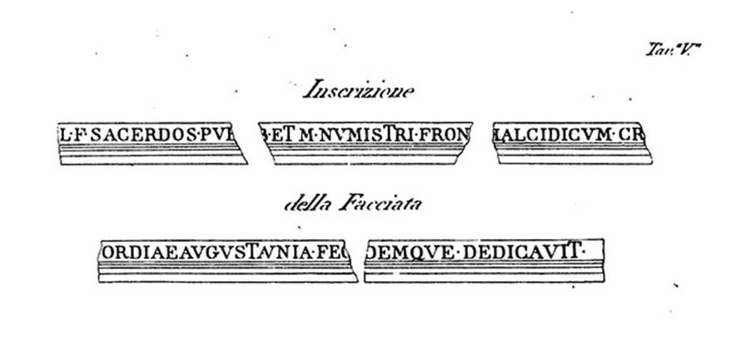
- There are plaques dedicated to Romulus and Mars
- A statue of Concordia with a cornucopia was found there (now in naples archaeological museum
- There is an inscription displaying the patron of the building being the priestess Eumachia

