- Powerpoint Link - ASSIGNMENT 2 DIGITAL.pptx
- Video Link https://drive.google.com/file/d/1OgTby6Q9mzfgYKRdllaQ_ueUsWCYgxIx/view?usp=sharing

- Screenshot of Slide 1 Introduction

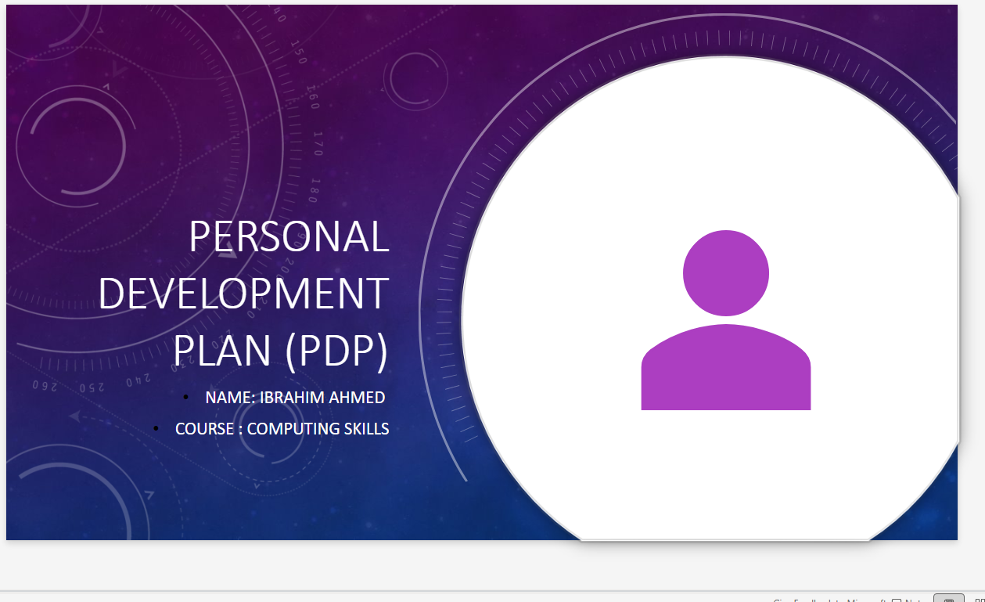
- Screenshot of Self Evaluation
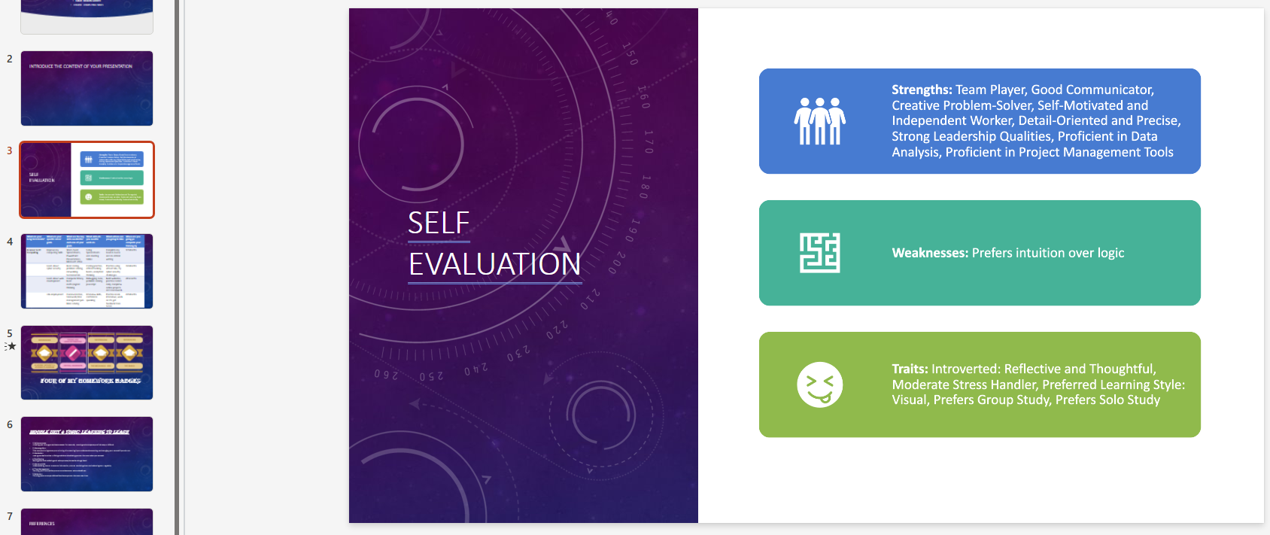

- Screenshot of Introduction

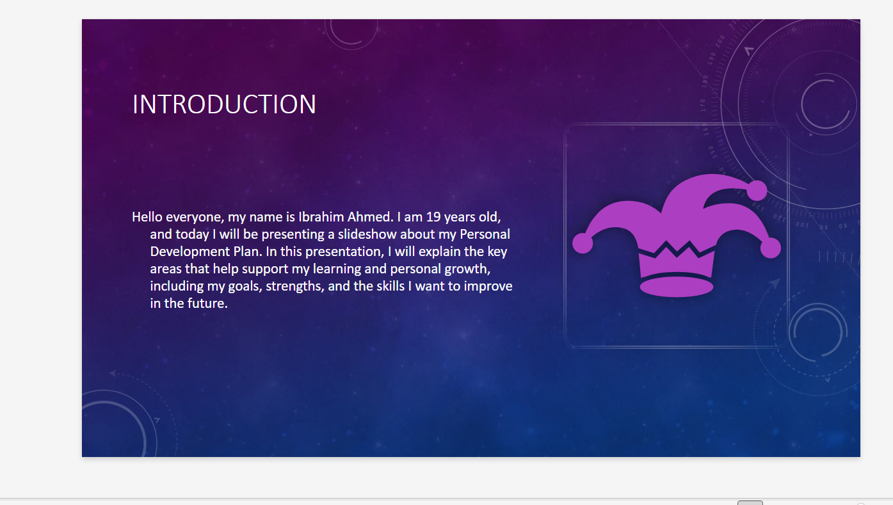
- Screenshot of My Career Table
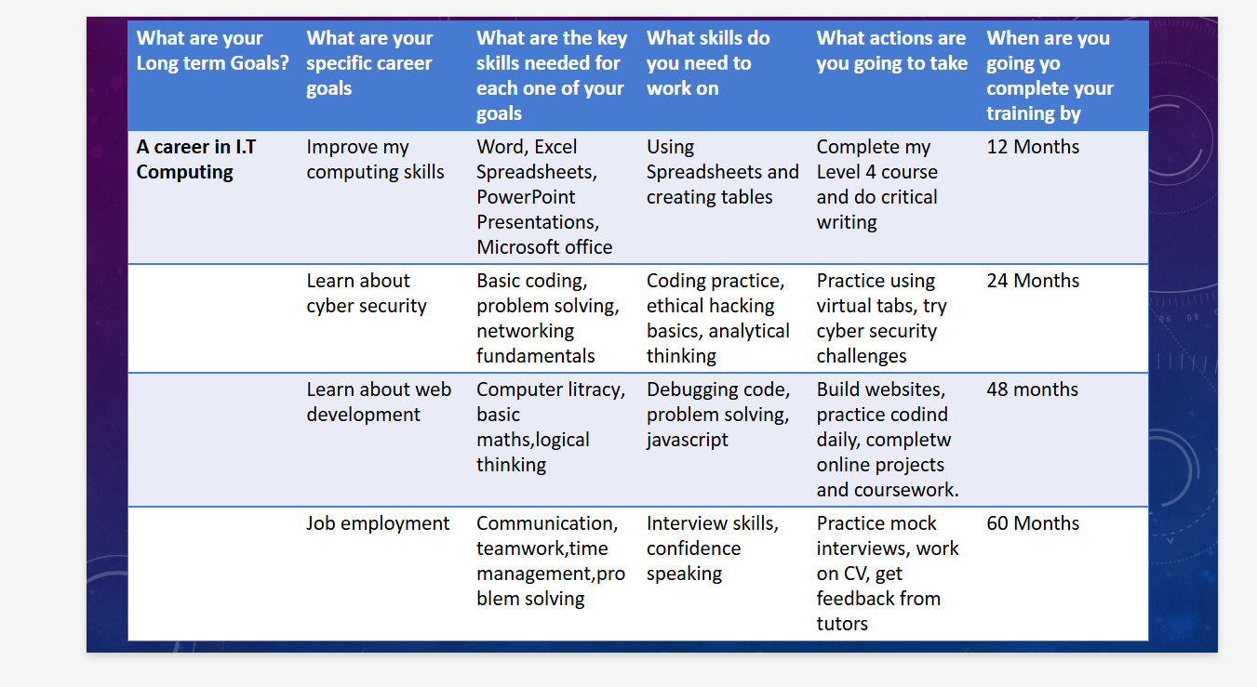
Screenshot of My Unit 4 Topic Learning to Learn
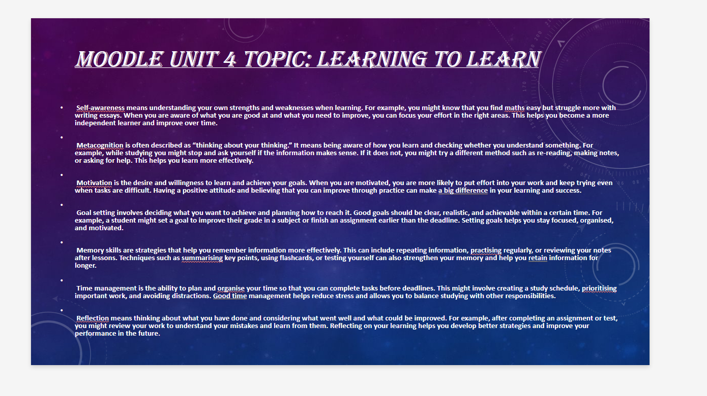

- Screenshot of My Four Rewards
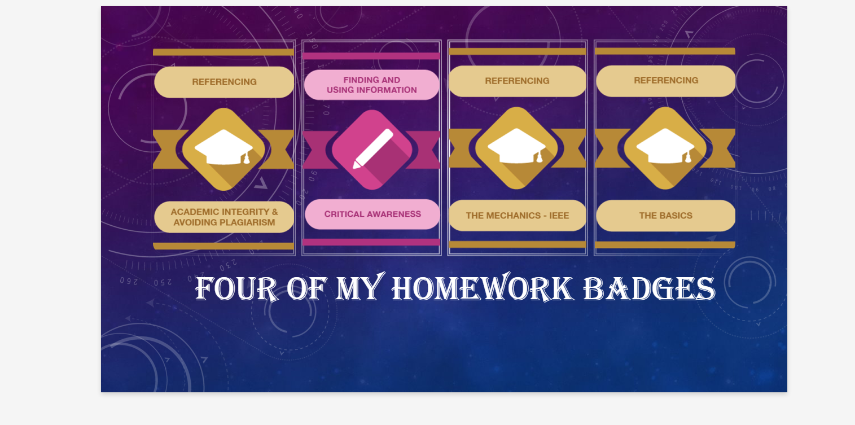
Screenshot of Conclusion
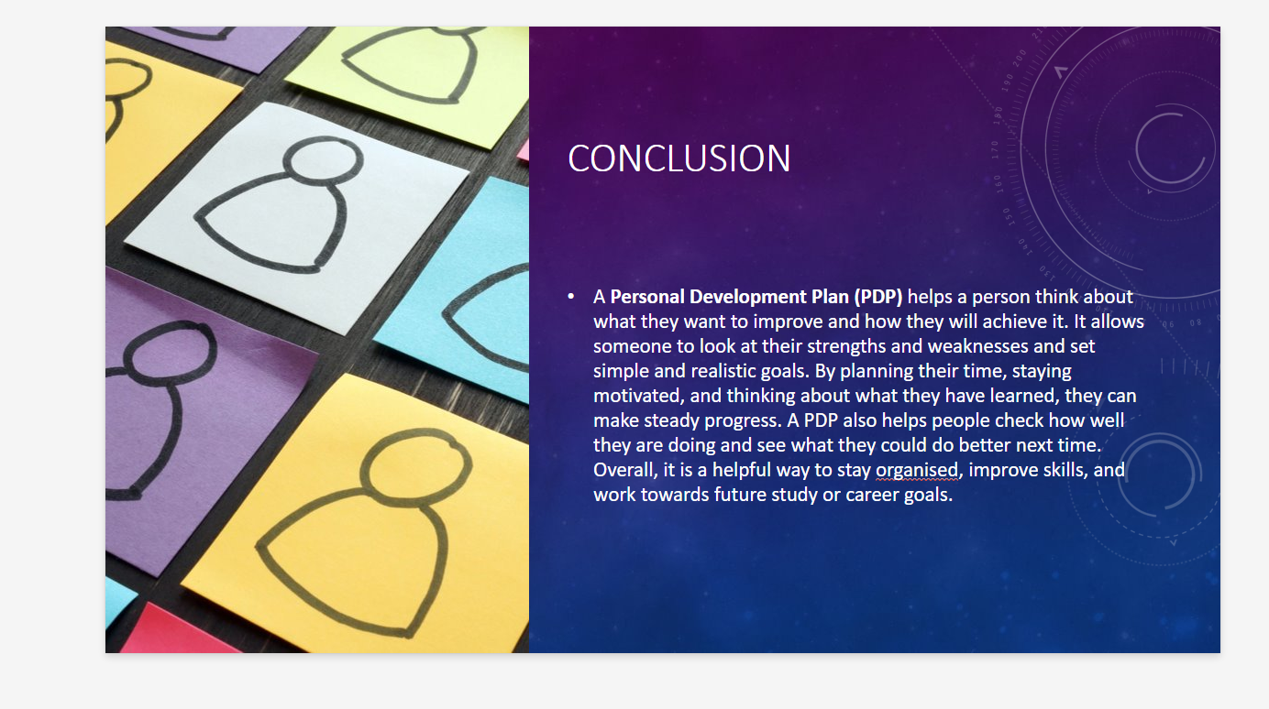
Screenshot of References


