

Student Name: Mitali Bhanderi

Student ID: 2436026

Module Name: Strategic Management

Module Code: LCMB7003

Lecturer’s Name: Amare Desta

Work Count: 5193

Term 2

Table of Content
1. Selection of Organisation and Target Market 6
1.1 Organisation selection: Walmart 6
1.1.1 Strategic profile and capability fit 6
1.1.2 Scale, financial strength, and execution capacity 6
1.1.3 International readiness and learning advantage 8
1.2 Target market selection: France 9
1.2.1 Market attractiveness and strategic relevance 9
1.2.2 Demand conditions and timing logic 11
1.2.3 Digital and “smart retail” upside 12
1.2.4 Risk considerations and feasibility 13
1.2.5 Summary justification 13
2. Comprehensive Strategic Analysis 14
2.1 Strategic context 14
2.2 PESTLE Analysis of France 14
2.2.1 Political factors 14
2.2.2 Economic factors 15
2.2.3 Social factors 16
2.2.4 Technological factors 17
2.2.5 Legal factors 18
2.2.6 Environmental factors 19
2.3 Competitive Landscape Analysis 21
2.3.1 Porter’s Five Forces 21
2.3.2 Competitor analysis 23
2.4 Effectiveness and limitations of analytical tools 24
3. Strategy Development and Formulation 25
3.1 Strategic Objectives and Rationale 25
3.2 Market Entry Strategy: Mode of Entry 25
3.3 Competitive Advantage through Porter’s Generic Strategies 27
3.4 Resource-Based View (RBV) and Capability Leverage 28
3.5 Ansoff Matrix and Growth Path 29
3.6 Risk Mitigation and Institutional Alignment 30
3.7 Strategic Fit with Corporate Performance Objectives 31
3.8 Strategic Synthesis 32
4. Performance Evaluation Framework 32
4.1 Rationale for the Performance Evaluation Framework 32
4.2 Overview of the Balanced Scorecard Approach 33
4.3 Financial Perspective 35
4.4 Customer Perspective 36
4.5 Internal Business Process Perspective 37
4.6 Learning and Growth Perspective 38
4.7 Integrating Sustainability and the Triple Bottom Line 39
4.8 Strategic Control and Continuous Improvement 40
4.9 Summary 41
References 42

List of Tables
Table 1: PESTLE Summary – France (Walmart Expansion Context) 20
Table 2: Porter’s Five Forces 21
Table 3: Competitor Analysis – Walmart vs. Key French Retail Competitors 24
Table 4: Resource-Based View (RBV) 29
Table 5: Balanced Scorecard Walmart’s Expansion into France 34

List of Figures
Figure 1: Walmart Logo 6
Figure 2: Walmart International net sales 7
Figure 3: Omni-channel marketing 10
Figure 4: Change in volumes invested in France 11
Figure 5: E commerce share of total retail sales 12
Figure 6: Risk considerations and feasibility 13
Figure 7: France’s Economic Resilience Amid Political 15
Figure 8: Eurozone Inflation Converging Toward the ECB 2% Target 16
Figure 9: Consumer Preference for Omnichannel Retail over Online-Only Shopping 17
Figure 10: Growth of E-Commerce Turnover in France (2005–2023) 18
Figure 11: Stringent Labour Law and Employment Cost Framework in France 19
Figure 12: EU Sustainability Regulation and Environmental Compliance Pressures in France 19
Figure 13: Managing Risk for Your Market Entry Strategy 26
Figure 14: Partnership-led approach 26
Figure 15: Porter’s Generic Strategies 28
Figure 16: Ansoff Matrix 29
Figure 17: Stakeholder-oriented strategy 30
Figure 18: 5 Corporate Performance Objectives 31
Figure 19: Corporate Performance Objectives 32
Figure 20: Balanced Scorecard 33
Figure 21: Financial Perspective 35
Figure 22: Customer Perspective 36
Figure 23: Walmart's Company Structure 37
Figure 24: Learning and Growth Perspective 38
Figure 25: Triple Bottom Line 39
Figure 26: Integrating Triple Bottom Line (TBL) into Walmart’s Balanced Scorecard 40

1. Selection of Organisation and Target Market

1.1 Organisation selection: Walmart

1.1.1 Strategic profile and capability fit
Walmart is an appropriate organization for international expansion thanks to its fundamental model, an amalgamation of economy of scale and technology-enabled omni-channel proposition. Its latest annual report describes itself as a "people-paced, technology-enabled omni-channel retailer" that brings together brick-and-mortar format stores and eCommerce platforms so as to help customers experience cost savings and improved well-being (Walmart Inc., 2024).
Walmart Inc. (2024) outlines that this model is strategically useful in full-fledged retail markets in that it aids in cost leadership, i.e. keeping everyday low prices and everyday low costs and also in fulfilling the emerging demand of convenience through offering pickup, delivery, and online platforms.

Figure 1: Walmart Logo

1.1.2 Scale, financial strength, and execution capacity
Walmart's scale delivers economic power in terms of lower per unit costs, negotiating power of suppliers, and the ability to make upfront, long-term investments in logistics and digital capabilities, which are crucial factors in the success of a retail merchant operating in highly competitive international retail markets (Miao, 2023; Greenspan, 2024).
Operationally, Walmart reports serving about 255 million customers every week, carrying out over 10,500 stores and e-commerce websites in nineteen countries; hence, proving its operational experience and replication ability globally (Walmart Inc. 24).
In the fiscal year 2024, Walmart had total revenues of 648.1 billion, which gives the company the cash-flow capacity needed to fund an initial entry such as supply-chain establishment, compliance measures, diversification of retail format, and localisation of technology and enable it to sustain the margin compression usually experienced in early-stage operations.
This scale advantage supports a defensible rationale for expansion in line with current advancement theory in the international market, where resource strength and capabilities that can be transferred simultaneously counter a risk of entry (Lubis et al., 2024; Zif, 2025).
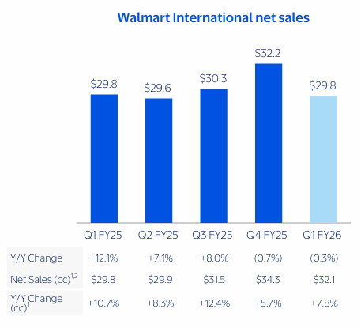
Figure 2: Walmart International net sales

1.1.3 International readiness and learning advantage
As Walmart International demonstrates, the company can adapt its performance to the specifics of the local market, which is required in such controlled and culturally unique European markets. In its annual report, Walmart International is specified as having presence in 18 countries, with a variety of formats of its business, which include supercenters, cash-and-carry, and e-commerce and digital services, which include marketplaces and payment platforms (Walmart Inc., 2024).
Importantly, Walmart International had net sales of $114.36 billion during fiscal year 2024 (about 18% of total consolidated net sales), which suggests that its international activities are substantial and well strategically managed rather than peripheral (Walmart Inc., 2024).
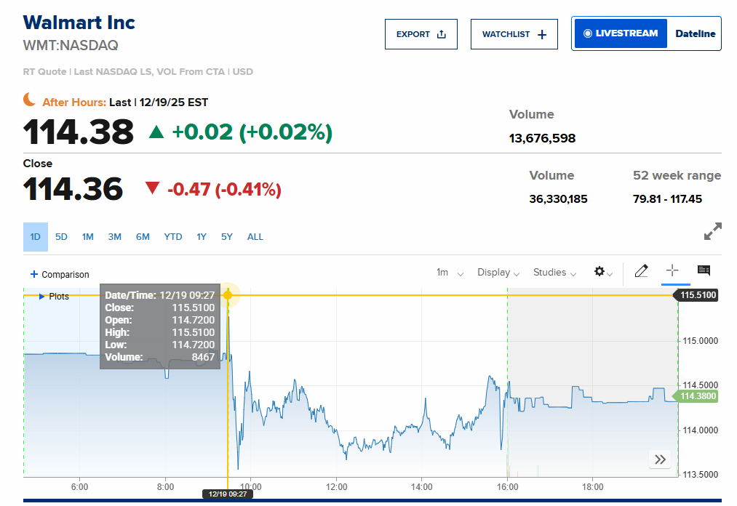
The applicability to France is the possibility to build strong local businesses supported by Walmart, which implies the need to localise assortment, create own labels, channel strategies, and partnership structures, which are associated with high performance in market entry contexts marked by strong institutional and consumer heterogeneity (Walmart Inc., 2024; da Silva et al., 2023).
In light of Walmart strategic positioning which includes value as well as convenience, its tried and tested omni-channel framework of operations, and a substantial financial depth, choosing Walmart as the vehicle for expansion is logical (Walmart Inc., 2025; Shvartsman, 2025; Fang, 2025).

1.2 Target market selection: France

1.2.1 Market attractiveness and strategic relevance
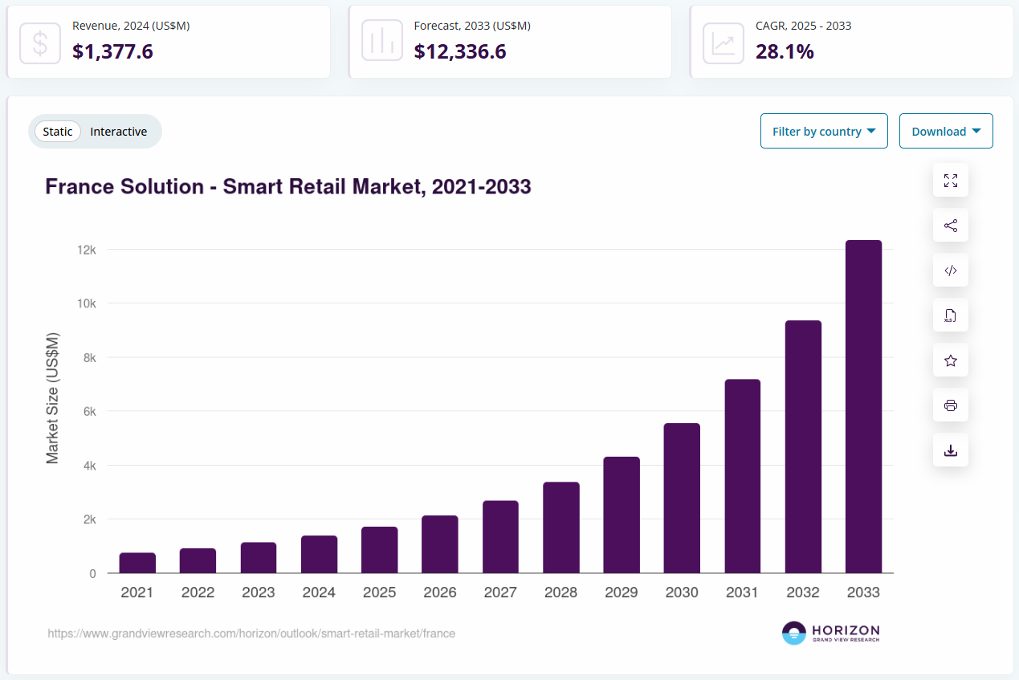
France is a potential and unique foreign country in which Walmart should expand, as it is quite large in terms of size, per capita income and strategic position in the European Union, thus affording both the large-scale demand and as a scheme to expand regions. The population of France goes above 68 to 9 million based on the Business Climate Survey, and it is the second-largest economy in the EU, further strengthening the background market-size indicators related to retail growth (Business Sweden, 2025).
Furthermore, France has been the top European destination over several consecutive years for foreign direct investment initiatives, indicating that despite prevailing uncertainty, multinational enterprises continue to view France as an attractive venue for investment initiatives, especially into foreign investments within sectors supported by innovation and infrastructure (Business Sweden, 2025).

Figure 3: Omni-channel marketing
In the view of the retail strategy, the modern consumer market in France enables the application of the omni-channel proposition developed by Walmart: value-based retailing is still attractive in terms of long-term price sensitivity in the French consumer market, but high convenience expectations put pressure on the retailers to consider models of store-delivery formats with the involvement of digital integration (Jayarat, 2025; Dewi et al., 2025). According to the Savills report, the current short term environment is characterized by low confidence and cautious consumption. Nevertheless, the report recognizes that retailing is accelerating rapidly, influenced by technological enhancements, the growth of e-Commerce, and network rationalization. In such a context, scale operators with technical competencies in strong logistics and data will have a high chance to gain ground (Savills, 2025).

1.2.2 Demand conditions and timing logic
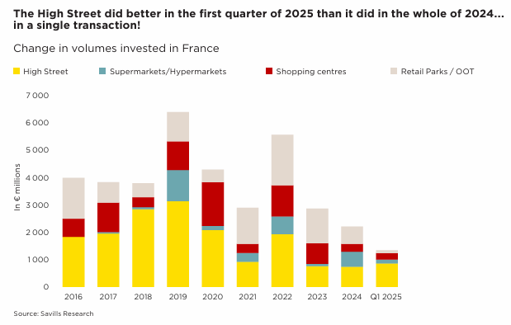
Figure 4: Change in volumes invested in France
Although the French consumer confidence has been declining on a low profile and actually posted 92 in March 2025 versus the 100 long run equilibrium, such a macro environment presents the opportunity to cement Walmart value proposition as households are starting to focus more on basic spending and price efficiency (Savills, 2025).
Strategically, to enter the market at a time of mitigated demand may have advantages, if the new entrant can bring reduced price points and more operational efficiency bringing in situ and partnerships on more rational grounds than heated cycles (Pangarkar and Prabhudesai, 2024). Savills also demonstrates that the prime yields of the main retail formats remained flat in early 2025 (e.g., 4.00 % high street, 6.00 % retail parks, 5.50 % shopping centers), which implies enhanced price discovery and better understanding of where to invest in the retail real-estate decisions (Savills, 2025).

1.2.3 Digital and “smart retail” upside
France's relevance is reflected in the increasing impact of retail technological adoption in the market. Grand View Research says there will be strong growth in the smart retail market in France through 2033, with growing opportunities for data-driven merchandising, customer-less interactions and digitalized store operations (Grand View Research, 2025). The observation aligns with the strategic goal of Walmart to make the enhancements in digital integration and face physical retail stores with e-commerce operations, simultaneously broadening ancilio ecosystems to include delivery, fulfillment, and ads (Walmart Inc., 2024; Walmart Inc., 2025).
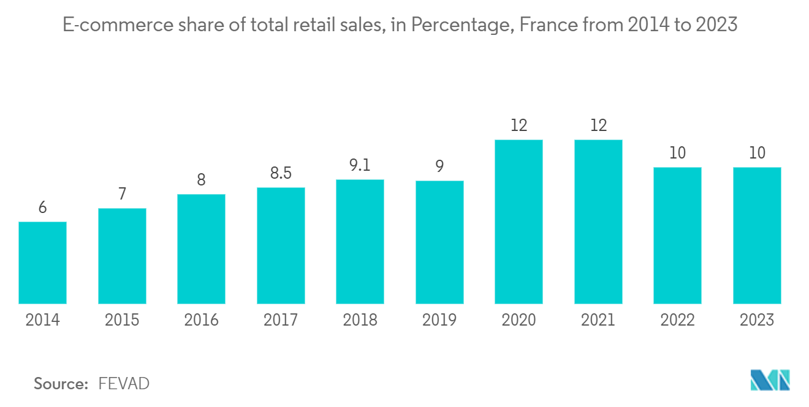
Figure 5: E commerce share of total retail sales
In addition, sector forecasts and channel analyses relevant to France, including online retail, provide a basis for the methodological choice of the formats and the order of entry (i.e. starting with e-commence or through marketplaces with some selective physical formats) compared to a monolithic deployment of a single format (GlobalData, 2023).

1.2.4 Risk considerations and feasibility
France is also characterized by noticeable risks that support the soundness of the choice. The Business Climate Survey points to institutional challenges, including the inflexibility of labour policies, complex processes of hiring and firing employees, and the disruptive effect of labour strike (Business Sweden, 2025).
Political uncertainty and overall geopolitical tensions have the potential to delay investment decisions and create worse supply chain risk uncertainty, something that is of strong importance to high volume retailers (Business Sweden, 2025).
However, these risks can be managed by Walmart, as its business model is supported by stringent cost-control measures and a strong system of supply chains, and the company has already proven itself able to reorganize portfolios in foreign markets and adapt retail formats to local conditions (Walmart Inc., 2024).
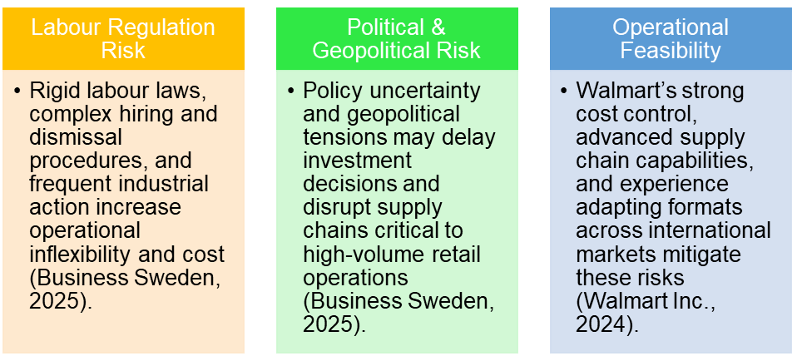
Figure 6: Risk considerations and feasibility

1.2.5 Summary justification
The choice of Walmart is justified by the well documented omni-channel scalability of the company as well as the financial capacity and the evidence of competence in setting up contextually relevant international operations (Walmart Inc., 2024; Shvartsman, 2025).
The choice of France can be explained by the size of the market, the strategic role within the European Union, investability indicators, and the transition to digitally enabled retail in the long run, despite the short-term fluctuations of demand and regulatory challenges (Business Sweden, 2025; Savils, 2025; Grand View Research, 2025).

2. Comprehensive Strategic Analysis

2.1 Strategic context
The extension of Walmart into France demands appraising it in a multifaceted macro-economic environment and a highly competitive retail sector. Walmart is a people-centric, technology-enabled, omnichannel retailer, whose competitive advantage is found in its everyday low price (EDLP) strategy, efficiency in its supply chains, and growing digital integration (Walmart Inc., 2025). The size, logistics skills and financial capability are a strong foundation to going global, but France presents unique challenges in political, regulatory, and competitors, and it requires careful strategic alignment (Walmart Inc., 2024; Business Sweden, 2025).

2.2 PESTLE Analysis of France

2.2.1 Political factors
France offers institutional stability typical of a key European Union economy; but more recent political volatility and social unrest have taken a toll on investor confidence. The Business Climate Survey shows that policy uncertainty, frequent reforms, and strike activities especially in the transport and public service sectors might affect business operations and delay investment decisions (Business Sweden, 2025). In the case of Walmart, where predictable logistic and long-term capital efficiency, to achieve its cost-leadership strategy, the mentioned political risks would negate a quick direct country launch and, thus, require a gradual and adaptable strategy on entry.
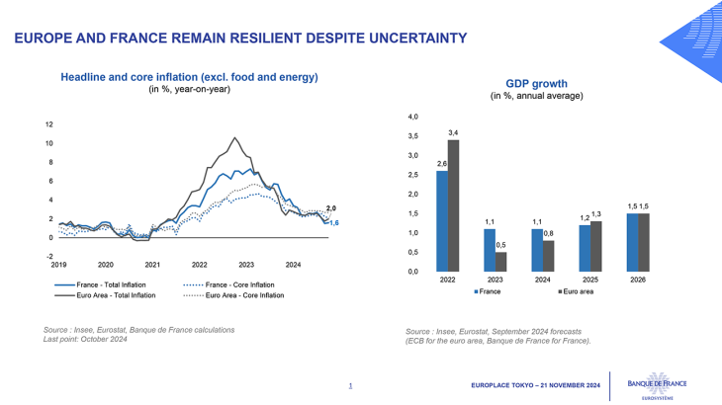
Figure 7: France’s Economic Resilience Amid Political

2.2.2 Economic factors
France remains one of Europe's largest consumer markets; however, the overall state of recent economics is marked by limited consumer spending and high household savings rates (Savills, 2025). Inflationary dynamics have calmed down to the ECB 2% target element hence better predictability of cost of wages and prices (Business Sweden,2025). The current landscape seems to be promoting the retailers that focus on value; hence the Everyday Low Pricing (EDLP) offer by Walmart, especially during the times when the population is inclined towards the so-called trade-down, especially in time of economic insecurity (Shvartsman, 2025). However, low form of discretionary expenditure can initially put the break on margins beyond basic grocery products.
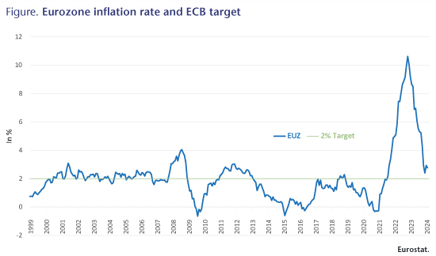
Figure 8: Eurozone Inflation Converging Toward the ECB 2% Target

2.2.3 Social factors
French consumers are very sensitive to price and at the same time demand convenience, quality, and business practices that are ethical. Societal expectations regarding fair wages, employment stability, and contributions to society are rather strong in France thereby making corporate legitimacy a key determinant for foreign entrants to the market (Business Sweden, 2025). The people-based story of Walmart must be operationalized, thus, based on plausible employment relations and supplier relations on a local level in the context of low prices (Pandey et al., 2021). Any failure to conform to these social boundaries can attract challenging consumers, unions and regulators.
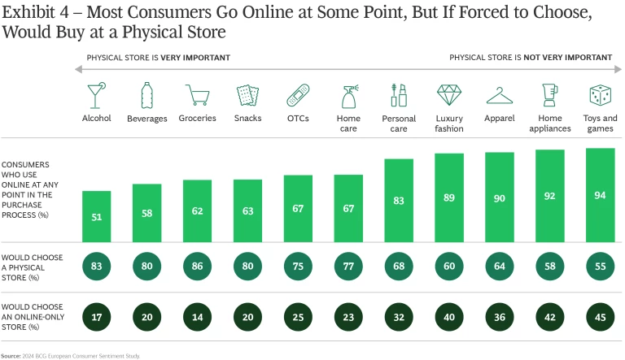
Figure 9: Consumer Preference for Omnichannel Retail over Online-Only Shopping

2.2.4 Technological factors
France's retail industry is undergoing a digital revolution. The smart retail market is expected to show strong growth until 2033, indicating a higher level of data analytics, automation, and omnichannel retail technologies (Grand View Research, 2025). The global investments of Walmart in digital solutions, fulfilment automation, and data-driven merchandising put the corporation in a better position to seize this trend (Gomes, 2024). However, an isolated technological advantage is not enough, the effectiveness of the initiative depends on the adjustment of digital tools to the French consumer behavior and meeting regulatory requirements, in particular, data protection and competition requirements (Kung, 2023).
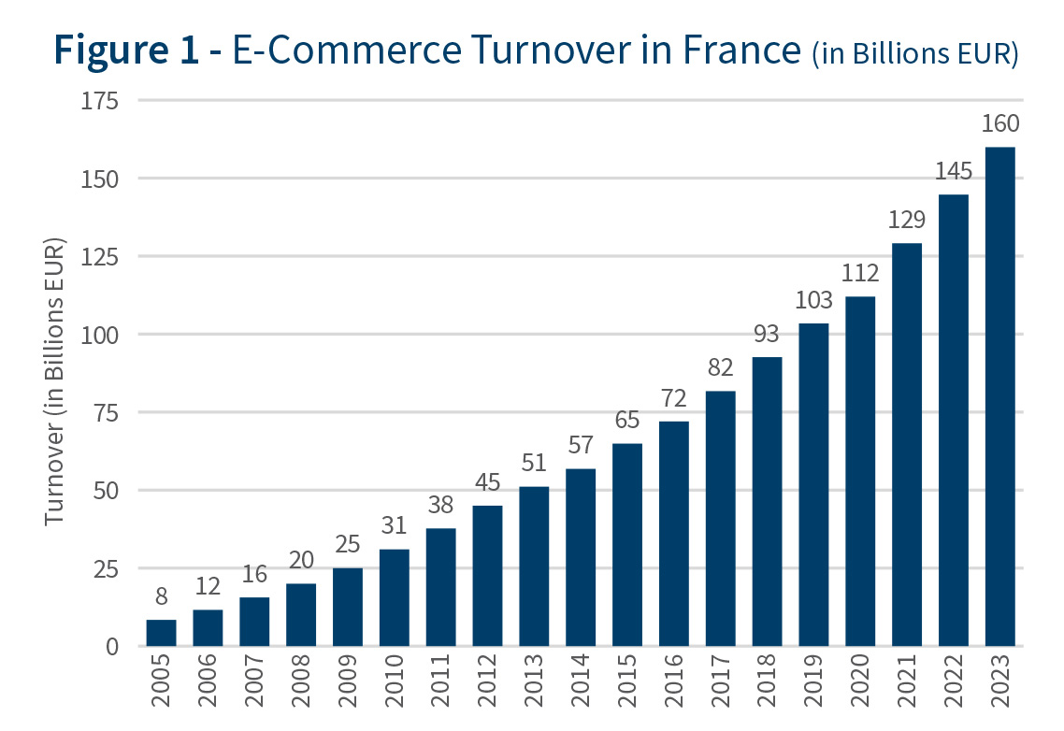
Figure 10: Growth of E-Commerce Turnover in France (2005–2023)

2.2.5 Legal factors
The legal situation in France is a feature barrier in entering the markets. Labor rules can be described as stringent enforcement, strict rules on both hiring and dismissing, high social security contributions, and significant union power (Business Sweden, 2025). These limitations compound operational risk of labor-intensive retail formats, which limits the flexibility of Walmart in changing the staffing level. Also, there are compliance requirements such as food safety, consumer protection, and competition law, which significantly increase the cost of entry (Rowland, 2024). Thus, Walmart needs to focus on compliance-by-design, implement automation wherever possible, and maintain positive labour relations to moderately reduce legal liability.
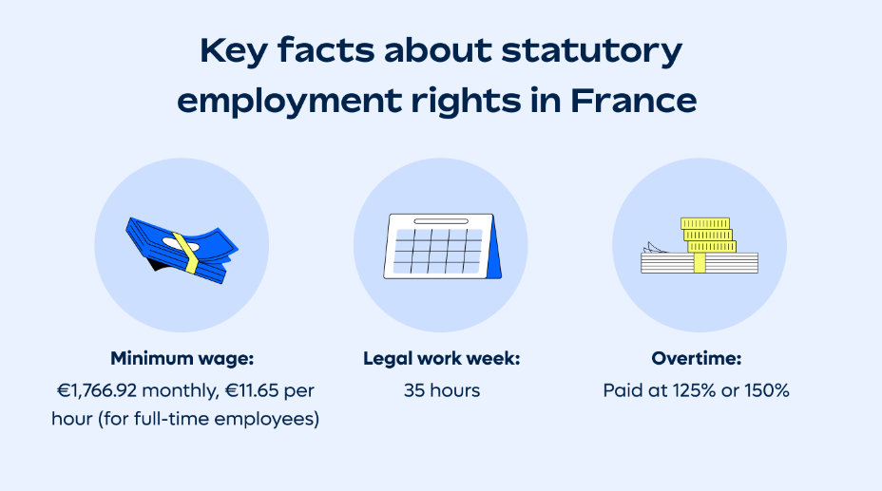
Figure 11: Stringent Labour Law and Employment Cost Framework in France

2.2.6 Environmental factors
Environmental sustainability forms a major issue in France where growing regulatory measures and consumer demands exert pressure on retailers to reduce emissions, waste and supply chain implications. Although the stringency of these environmental standards is high, the two are simultaneously in resonance with Walmart's own avowed commitment to emission abatement and renewable energy (Walmart Inc., 2024). The strategic dilemma is to balance the environment campaigns with social demands since most of the French stakeholders focus on employment and local sourcing and environmental performance (Ch Das, Bora, and Das, 2025).

Figure 12: EU Sustainability Regulation and Environmental Compliance Pressures in France
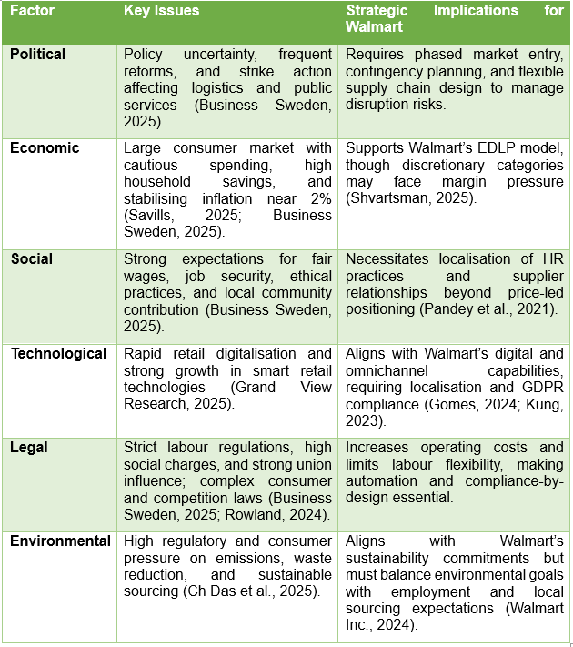
Table 1: PESTLE Summary – France (Walmart Expansion Context)

2.3 Competitive Landscape Analysis

2.3.1 Porter’s Five Forces
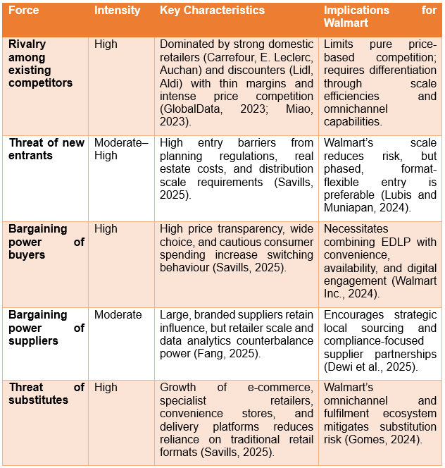
Table 2: Porter’s Five Forces

Rivalry among existing competitors – High
The French retail sector is highly competitive, with major domestic players dominating the market (Carrefour, E.Leclerc, Intermarches and Auchan), as well as aggressive discount retailers (Lidl and Aldi) being present (GlobalData, 2023). These enterprises have the benefits of commanding vast knowledge of local markets and being able to develop strong local supplier ties and loyal consumer bases. Such factors as low profit margins and frequent price wars contribute to the enhancement of the competitive rivalry and limit the ability of Walmart to keep up with its pricing mechanisms based on the cost efficiency only (Miao, 2023).

Threat of new entrants – Moderate to High
Entry barriers in the retail industry are high, and can be explained by prohibitive planning regulations, high real estate costs, and the required high scale of distribution. Savills (2025) shows that retail yields vary significantly between retail formats affecting the economic analysis of location and format decisions. Although these barriers provide protection for incumbents, Walmart scale and capital resources reduce but not eliminate the risk of entry. Accordingly, a selective and flexible strategy in terms of formats is more feasible than the establishment of large-scale hypermarkets (Lubis et al., 2024).

Bargaining power of buyers – High
The consumers in France have an abundance of substitutes and also have high levels of price transparency thus causing a crust of purchasing power to them. Expressive switching behavior is also enhanced by high rate of savings as a result of cautious spending patterns (Savills, 2025). In turn, in a bid to build consumer loyalty, Walmart needs to supplement its Everyday Low Price (EDLP) concept with high-quality product supply, convenience and omnichannel value (Walmart Inc., 2024).

Bargaining power of suppliers – Moderate
Large, branded suppliers still have significant market power but may be surpassed by Walmart's buying power in the market scale and its vast data analysis capabilities (Fang, 2025). Furthermore, the imperatives of sustainability, traceability, and labor compliance in France may limit flexibility on the part of suppliers and increase the costs of their services, making local sourcing partnerships of key strategic importance (Dewi et al., 2025).
Threat of substitutes – High
Potential substitutes include convenience stores, specialty stores, electronic commerce and delivery restaurants. The shift to service-oriented and web-based modes of consumption reduces the preference to traditional big-basket stores of consumption (Savills, 2025). The future omnichannel ecosystem, the conglomeration of physical stores, online platforms and delivery systems Walmart operates, consequently, serves as a container defense against substitution pressures (Gomes, 2024).

2.3.2 Competitor analysis
Domestic competitors like E.Leclerc and Carrefour at the same time realize price competitiveness and have excellent local legitimacy. On the other hand, Amazon promotes non-store competition using speedy logistics and digital ecosystems (Kumar, 2025). Relative to these incumbents, Walmart enjoys the advantages of being on a global scale and having an efficient supply chain architecture; however, there is a major weakness due to the lack of brand recognition in France that requires a staged entry hierarchy and localization.

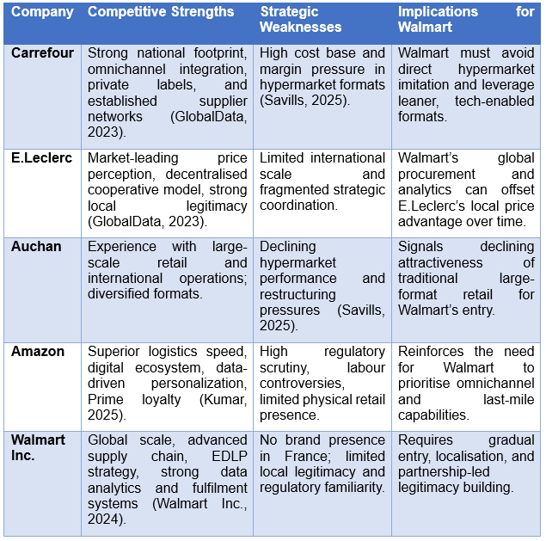
Table 3: Competitor Analysis – Walmart vs. Key French Retail Competitors

2.4 Effectiveness and limitations of analytical tools
PESTLE analysis is a scientific method of recording macro environmental risks and opportunities in the context of Walmart entering France especially in explaining regulatory, social, and economic limitations (Karadzhov et al., 2025). However, it is necessarily descriptive and inertial and can give little guidance on prioritization, or interaction between the different factors involved. Moreover, Porter's Five Forces is a well-defined analytic tool for evaluating competitive intensity and pressures on profits (Pangarkar and Prabhudesai, 2024); however, it assumes fairly stable industry boundaries and therefore underestimates the disruptive potential of digital platforms and ecosystems. Competitive analysis is good to scale up market realism, but you need regular data updates, which becomes useful in a rapidly evolving omnichannel retail segment (Gandrita, 2023). Accordingly, maximum efficacy of these instruments can be achieved when they are supplemented by dynamic capabilities and scenario based strategic planning.

3. Strategy Development and Formulation

3.1 Strategic Objectives and Rationale
The major strategic vision of the Walmart Inc. when entering France is focused on the possibility to sustainably and long-term develop due to the leverage of its global scale, the efficiency of its supply chain, and its digital facilities and simultaneously adjusting operations to the complex of strict regulatory framework and highly competitive French retail. Walmart corporate purpose of helping consumers achieve cost savings while improving quality of life is in accordance with increased price sensitivity among French consumers in the current economic climate. However, the success of the company's efficacy depends on the localization of its commercial strategies, not on wholesale transplantation of its United States model (Walmart Inc., 2025; Shvartsman, 2025). Accordingly, the proposed strategy needs to balance cost leadership goals with legitimacy, regulatory compliance, and differentiation in an omnichannel setup.

3.2 Market Entry Strategy: Mode of Entry
The entry theory best matched to the entry of the French retail in the international market is a gradual and risked based entry strategy. Instead of engaging in greenfield hypermarket investment, Walmart ought to adopt a hybrid entry mode, which incorporates strategic alliances, minority equity stakes, and digital-led market testing. Numerous empirical investigations of international expansion assert that highly competitive and regulated markets support incremental entry modes that maintain flexibility and limit sunk costs (Lubis 2024 25).
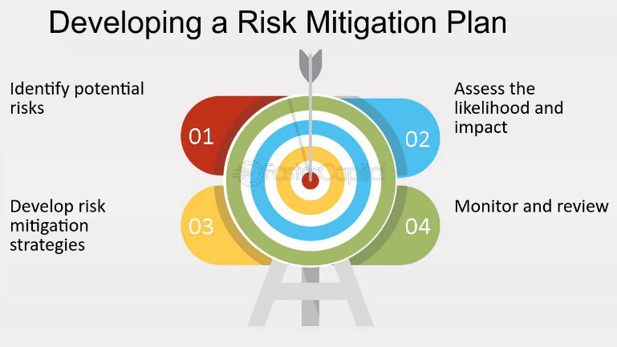
Figure 13: Managing Risk for Your Market Entry Strategy
Entry theory best fit to entry of the French retail in the international market is a gradual and risk based entry strategy. Instead of pursuing investment in greenfield hypermarket, Walmart should pursue a hybrid mode of entry, which includes strategic alliances, minority equity investments, and the digital-led market testing. Numerous empirical explorations of international expansion claim that highly competitive and regulated markets provide for incremental entry modes that provide flexibility and limit sunk costs (Lubis 2024: 25).
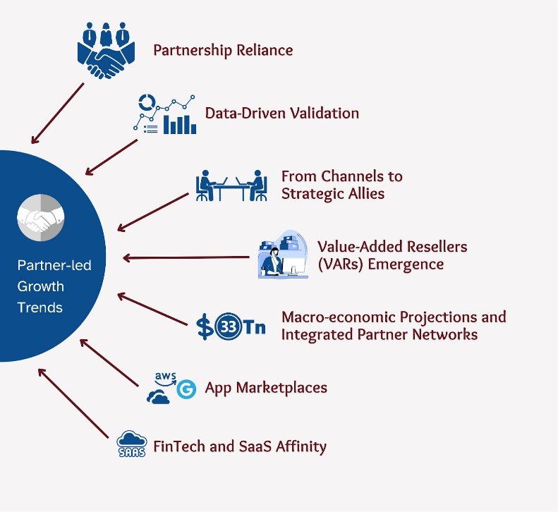
Figure 14: Partnership-led approach

3.3 Competitive Advantage through Porter’s Generic Strategies
The strategic competitive edge that Walmart will be able to establish in France could be best drawn upon the model of the Generic Strategies introduced by Porter, with the specific focus on a hybrid model of cost-leadership and differentiation. Limitations to pure cost-leadership strategy entail French labour laws, elevated social charges, and stiff rivalry on the prices of competing retailers like E.Leclerc and Lidl (Miao, 2023; GlobalData, 2023). Nevertheless, there is still a chance that Walmart may consider relative cost efficiency by sourcing globally, using sophisticated analytics, and automation, eliminating the need to cut wages.
Differentiation should be achieved through omnichannel convenience, availability and data-driven personalization but not through breadth of assortment. Walmart strategic investments in fulfilment automation, inventory optimization and digital platforms support an improved in stock performance and faster last mile delivery to offset logistical advantage of Amazon's fast delivery while strengthening price competitiveness (Gomes, 2024; Fang, 2025). This type of hybrid positioning helps to overcome the risk of a price war and at the same time helps to sustain margins.
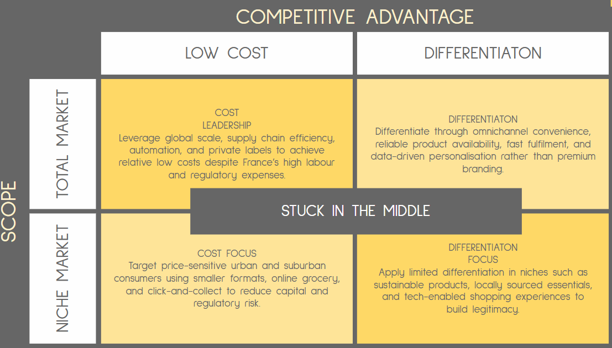
Figure 15: Porter’s Generic Strategies

3.4 Resource-Based View (RBV) and Capability Leverage
Regarding the Resource-Based View, the sustainable advantage of Walmart is based on the capabilities that are potentially valued, rare and difficult to imitate, the greatest of which are its global supply-chain orchestration, buying power, and data-analytics infrastructure (Abdulwase et al., 2020; Zhang, 2024). The extent to which these resources can be transferred to France, however, depends on the alignment and localization of organizations so as to ensure effectiveness of the same.
To benefit from these capabilities effectively, Walmart should spend its efforts on operating tech-enabled processes (demand forecasting, automated replenishment, AI-based pricing, etc.) on one hand, while on the other hand also integrating local suppliers to meet expectations for sustainable and traceable operations. Empirical research suggests that digital capabilities improve competitive advantage only when they are embedded in local organizational processes and regulatory contexts (Hoang, Hien, and Duong, 2025). Consequently, Walmart's resource-based view derived strategy needs to stress on contextual adaptation and not standardization.
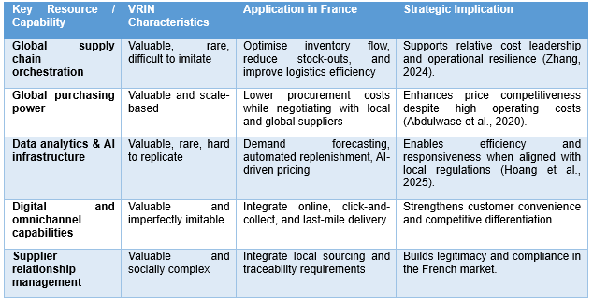
Table 4: Resource-Based View (RBV)

3.5 Ansoff Matrix and Growth Path
In the framework of the Ansoff Matrix, the expansion of Walmart to France represents a market development strategy, in accordance with which the current retail and online capabilities will be applied to a new geographic location. However, the possible threats can be avoided through incorporation of market expansion with specific product and format changes, including launching smaller city stores, own-brand basic products, and online-only groceries.
According to Savills (2025), the footfalls of traditional large format retail in France are decreasing, while the convenience and omnichannel models are more resilient. Consequently, Walmart should not replicate hypermarkets, rather target urban and digitally integrated formats backed by centralized fulfilment. This approach will enable slow brand-building while connecting with evolving French consumer behavior (Jayaraj, 2025).
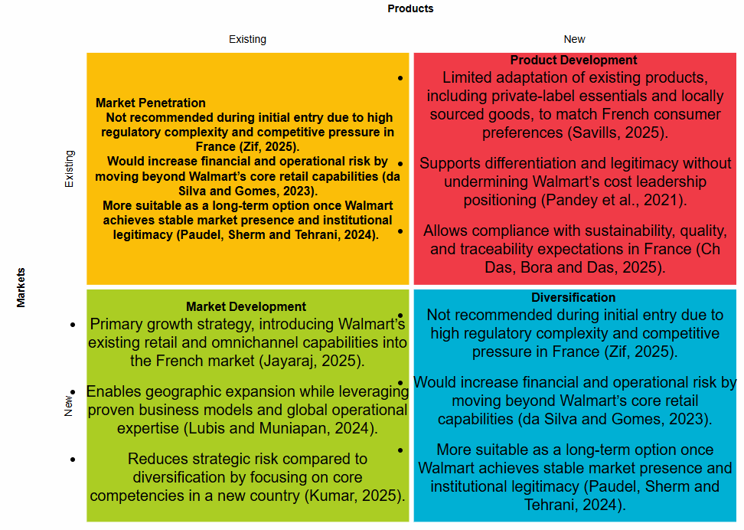
Figure 16: Ansoff Matrix

3.6 Risk Mitigation and Institutional Alignment
The strategic risk management is of utmost importance in the framework of the complicated legal and socio-economic environment in France. Stagnation in labour rigidity, the strength of trade union powers, and increased regulatory controls are all elements of operations risk that can worsen the cost effectiveness of Walmart without proper control (Business Sweden, 2025). Reacting to this, Walmart should seek a stakeholder-based approach where they will be in touch with the regulatory agencies, labour unions, and local constituencies.
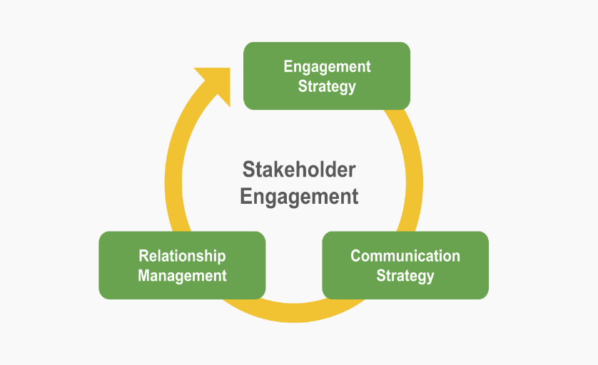
Figure 17: Stakeholder-oriented strategy
Institutional theory holds that legitimacy is equally important as efficiency in order to succeed on foreign markets. Consequently, Walmart needs to focus on fair employment practices, transparent governance, and local sourcing which strengthens the people-centric story by taking tangible action (Pandey et al., 2021; Gandrita, 2023). Environmental commitments in particular emissions reduction and waste minimization should be systematically incorporated into supplier selection and logistics design to satisfy French expectations of sustainability (Ch Das et al., 2025).

3.7 Strategic Fit with Corporate Performance Objectives
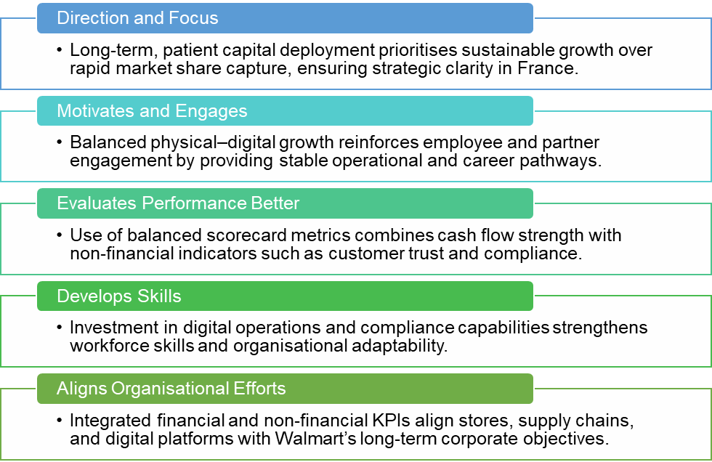
Figure 18: 5 Corporate Performance Objectives
According to a financial analysis, strong cash-flow generation and profitability of Walmart provide the company with the opportunity to invest in patient capital and ensure the long-term character of the increasing growth curve, instead of focusing on the short-term market-share improvement (Walmart Inc., 2024; Fang, 2025). The given strategy is aligned with the vision of Walmart to attain balanced development in both physical and online sources as highlighted in recent earnings statements (Walmart Inc., 2025).
Performance measurement should bring together non-financial measures such as customer trust and compliance with regulations, or operational resilience with traditional financial measures. This is a balanced framework to drive strategic oversight amid market volatility and institutional complexity (Madsen, 2025).
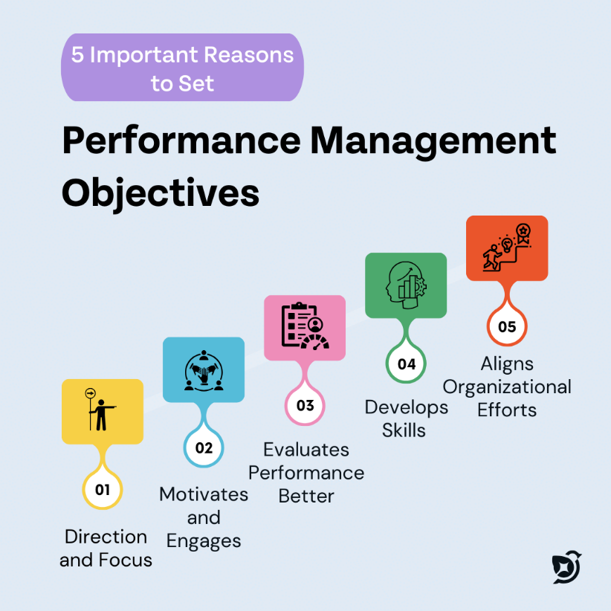
Figure 19: Corporate Performance Objectives

3.8 Strategic Synthesis
Therefore, the entry of Walmart in France should be guided by a gradual, relational, omnichannel model that leverages the global economies of scale and digital capabilities and considers institutional limitations of the regions. Walmart can gain a defensible competitive position by combining hybrid cost leadership, derived capability via resources-based-view, and sequencing market development. In essence, this competitive advantage will not depend on marginal cost cutting only, but instead its ability to integrate operational effectiveness, technological solution, and institutional legitimacy in an operating environment that is quite demanding in the European continent.

4. Performance Evaluation Framework

4.1 Rationale for the Performance Evaluation Framework
For Walmart's strategic expansion into the market of France, the establishment and implementation of a robust and thorough performance evaluation architecture is paramount in order to track the strategic progress, reduce risk and maintain synchronicity with corporate goals. Given the complexity involved in international expansion, it would be inadequate to look exclusively at purely financial metrics. Thus, Balanced Scorecard (BSC) has been implemented as the key performance measure framework due to its ability to combine financial and non-financial metrics representing various performance dimensions (Madsen, 2025). The BSC suits the application to Walmart, in particular, as it aligns operational implementation with the strategic goals, capabilities it to create value in the long term, and responds to the regulatory, social, sustainability demands that are common in the French marketplace (Abi-Farah, 2020; Owais et al., 2025).
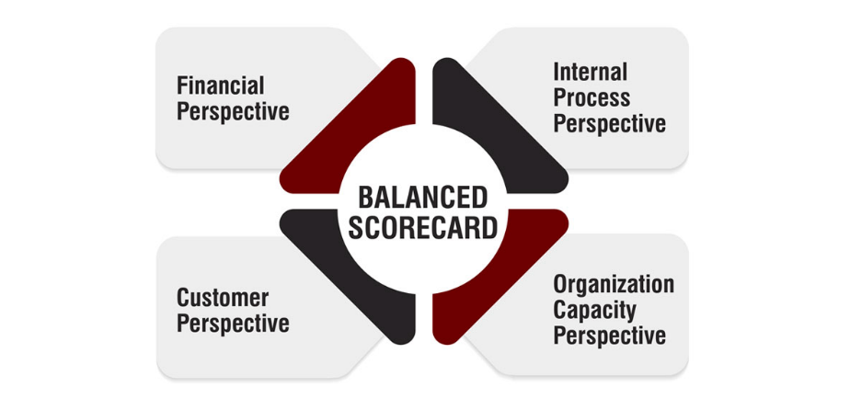
Figure 20: Balanced Scorecard

4.2 Overview of the Balanced Scorecard Approach
The Balanced Scorecard measures the organisational performance on the basis of 4 perspectives: Financial, Customer, Internal Business Processes, and Learning and Growth. This multidimensional approach allows Walmart to measure not only the profit in the short term, but the acceptance of the customer, efficiency of operation, and development of capability required for sustainable expansion (Alharbi et al., 2025 The Business Strategy Canvas (BSC) using the regulatory compliance, labour relations, and digital transformation priorities in the French setting might be seen as an opportunity to guarantee that the strategic coherence of all the expansion activities (Gandrita, 2023).
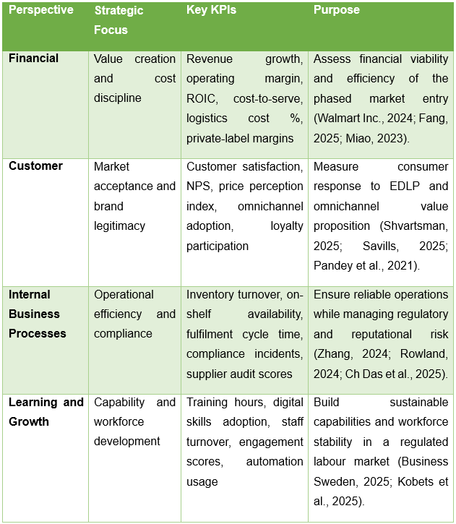
Table 5: Balanced Scorecard Walmart’s Expansion into France

4.3 Financial Perspective
The financial approach focuses on an analysis of whether Walmart's expansion into France adds value to its shareholders while maintaining financial discipline. Critical financial KPIs are revenue growth for the French market, operating margin and return of invested capital (ROIC). These metrics are used to assess whether the phased entry approach taken by Walmart offers acceptable returns given high labour costs and regulation bound in France (Walmart Inc., 2024; Fang, 2025).
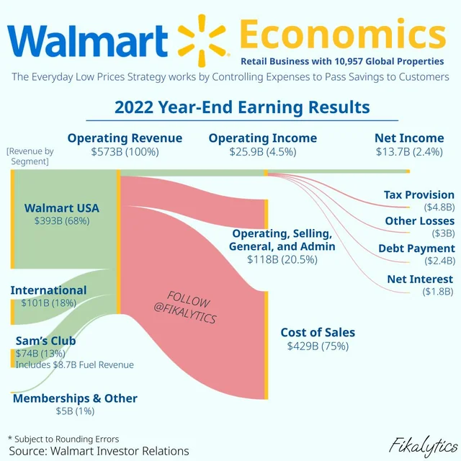
Figure 21: Financial Perspective
Other indicators like cost-to-serve, the ratio of logistics costs to sales, and margin contribution provided by the own label are also especially relevant, as the competitive advantage of Walmart is based on the efficiency of operations, rather than exceptional prices (Miao, 2023). Time series measurement of these key performance indicators means that the management can identify cost pressure at an early stage and revaluate sourcing, automation, or price strategies, respectively. The level of financial discipline will also be of increased concern in the first stages of market entry when economies of scale are yet to be entirely realised (Zif, 2025).

4.4 Customer Perspective
The customer perspective explores how French consumers understand and value the value proposition presented by Walmart. In light of extreme domestic competition and limited brand recognition, customer-centric KPIs become crucial. Such metrics should include indices of customer satisfaction, net promoter score (NPS), price perception indices and rates of adoption of omnichannel initiatives such as click and collect services or online grocery transactions (Shvartsman 2025; Savills 2025).
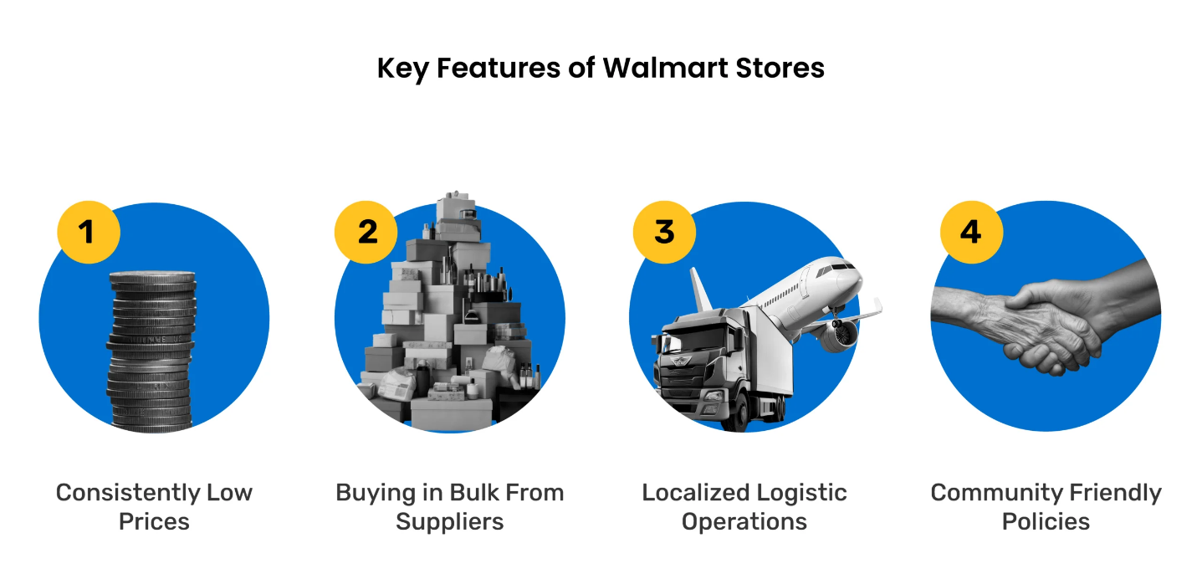
Figure 22: Customer Perspective
With these metrics, it becomes easier to assess whether the strategy of the French subsidiary Everyday Low Price (EDLP) concept, coupled with convenience and digital services can be implemented by Walmart across the tastes of French consumers. Furthermore, the indicators of customer trust and brand acceptance, such as complaints and service ratings, the use of loyalty programs, etc. are also unavoidable to evaluate the legitimacy in such a socially sensitive market (Pandey et al., 2021). Robust performance on key customer performance indicators, as an indicator of progress to sustainable market penetration, rather than transient transactional sales.

4.5 Internal Business Process Perspective
The internal process perspective determines the effectiveness of how Walmart is exercising its strategic objectives in the French market. Due to the importance of the logistical reliability level and the compliance with the regulatory framework, some of the key performance indicators (KPIs) are inventory turnover, stock in place, order fulfillment time, and the frequency of supply chain interruptions (Zhang, 2024; Gomes, 2024). These metrics help to shed light on the ability of Walmart to leverage its international supply chain resources at the same time, overcoming the localized conditions of operation.
Compliance-related KPIs are highlighted as crucial, which include labour law compliance related incidents, food safety audit score, and supplier sustainability compliance score (Rowland, 2024; Ch Das, Bora and Das, 2025). Monitoring these metrics helps to mitigate the legal and reputational risk and strengthens Walmart's commitment to their responsible operations. As a result of this, internal process informs the link between operational efficiency and institutional legitimacy that is crucial to the long term success of France (Business Sweden, 2025).
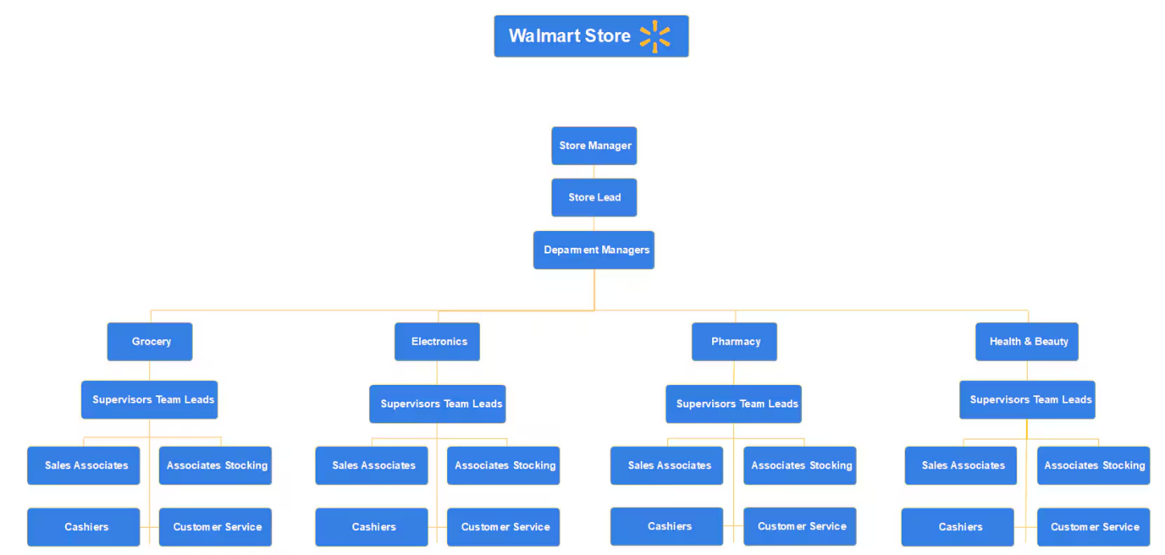
Figure 23: Walmart's Company Structure

4.6 Learning and Growth Perspective
The learning and growth approach highlights the ability of Walmart to create competencies that can make it remain competitive. The KPIs must be training hours of employees, their digital skill level, their levels of staff turnover, and employee engagement levels. These indicators are especially pertinent in France, where the labour relations and the labour force stability have a huge impact on the continuation of the operations (Business Sweden, 2025).
Furthermore, technology capability metrics, such as data analytics tool adoption rates, automation systems, etc., must be tracked to ensure that Walmart's investments in technology translate to operational improvements that can be measured (Kobets et al., 2025). Empirical evidence suggests that digital capabilities are only conducive to better performance when embedded as part of local organizational processes, and thus learning-focused KPIs are key to the monitoring of strategic alignment (Hoang et al., 2025).
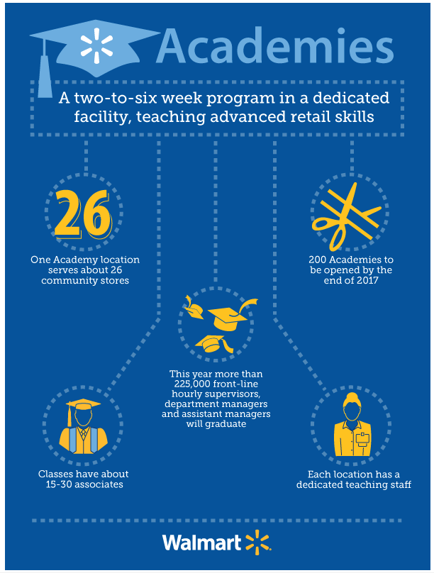
Figure 24: Learning and Growth Perspective

4.7 Integrating Sustainability and the Triple Bottom Line
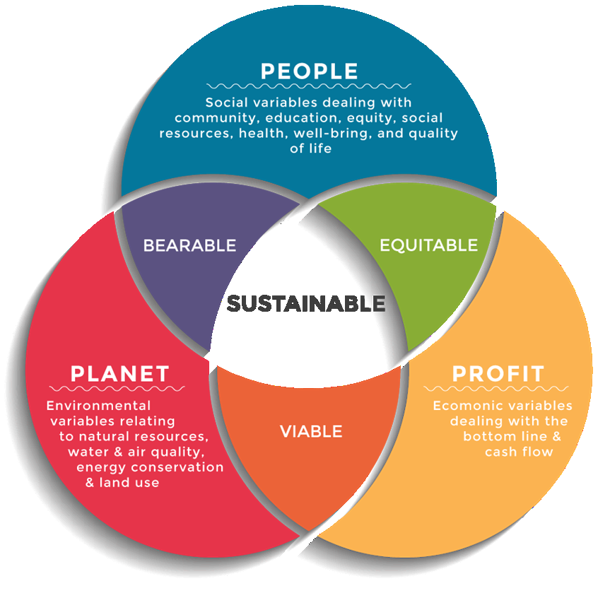
Figure 25: Triple Bottom Line
Although the Balanced Scorecard continues to be the leading framework, it is urgent that sustainability concerns that are aligned with the Triple Bottom Line (TBL) be systematically incorporated in all perspectives. In France, the environmental key performance indicators which include carbon emissions per delivery, rates of waste reduction, as well as the use of renewable energy, are both regulator friendly and consumer friendly (Ch Das et al., 2025). Social key performance indicators such as percentage of local suppliers and fair employment are used to support legitimacy and trust and thus complement financial performance. With the active inclusion of TBL in the BSC, the expansion of Walmart is set to create long-term economic, social, and environmental value (de Araaujo et al., 2024).
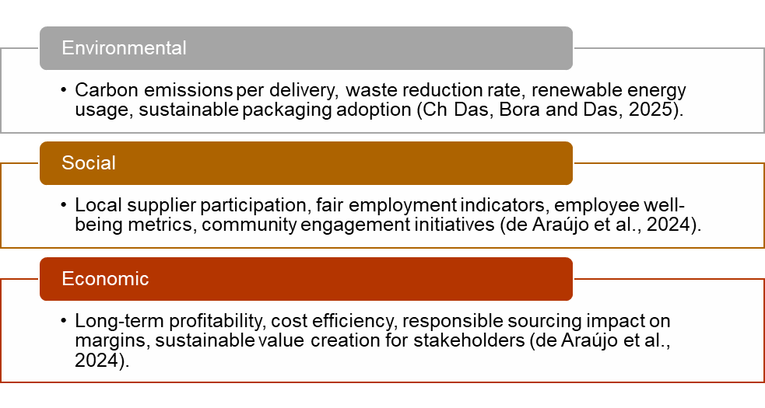
Figure 26: Integrating Triple Bottom Line (TBL) into Walmart’s Balanced Scorecard

4.8 Strategic Control and Continuous Improvement
The Balanced scorecard also serves as a strategic control system mechanism that would allow Walmart to continually measure its progress and adjust its expansion strategy. The mishaps in shaping up strategy vs execution can be highlighted through regular performance review using BSC metrics data, specifically in a volatile and regulated market (Madsen, 2025). This dynamism in using performance measurement supports adaptive decision-making that lessens the risk of losing the way in expansion process (Gandrita, 2023).

4.9 Summary
In summary, the Balanced Scorecard provides holistic, performance-levied performance-assessment to Walmart expansion into France. The framework enables comprehensive evaluation of the progress and impact by balancing financial, customer, internal processes, and learning perspectives and introducing aspects of sustainability. This methodological strategy thus favors the aim of Walmart to achieve sustainable growth, operational efficiency and institutional legitimacy in one of the most competitive European retail markets.

References
Abdulwase, R., Ahmed, F.A.A., Nasr, F. and Al-yousofi, A. (2020) ‘The role of business strategy to create a competitive advantage in the organization’, Open Access Journal of Science, 4(4), pp. 135–138. https://doi.org/10.15406/oajs.2020.04.00162
Abi-Farah, B. (2020) Strategy management balanced scorecards example – Wal-Mart. July. Concordia University.
Ahmed, N., Arshad, M.N. and Qidra, A. (2020) Strategic analysis of Walmart’s market entry strategies and growth prospects in Africa. July. https://doi.org/10.13140/RG.2.2.11596.73608
Alharbi, M.A. and Abdulaziz, J.O.E. (2025) ‘The impact of using the balanced scorecard on improving the quality of accounting information in Saudi commercial banks: a field study’, International Journal of Innovative Research and Scientific Studies, 8(3), pp. 1733–1744. https://doi.org/10.53894/ijirss.v8i3.6880
Business Sweden (2025) Business Climate Survey France 2025. Available at: https://www.business-sweden.com/49d6ec/contentassets/1ae8f1156bca4f44a9dd5e2b3e124c67/business-climate-survey-2025-france.pdf
Ch Das, T., Bora, P.K. and Das, J. (2025) ‘Corporate sustainability, ESG, and the triple bottom line: a review of key challenges’, International Review of Management and Marketing, 15(5), pp. 345–355. https://doi.org/10.32479/irmm.19768
CNBC (2025) WMT: Walmart Inc Stock Quote. Available at: https://www.cnbc.com/quotes/WMT (Accessed: 21 December 2025). DOI: https://www.cnbc.com/quotes/WMT
da Silva, L. and Gomes, J. (2023) ‘Internationalization strategies: a theoretical approach to the input mode choices in the foreign market and the inclusion of real options modeling for decision making’, Open Journal of Business and Management, 11, pp. 2144–2160. https://doi.org/10.4236/ojbm.2023.115118
de Araújo, M.L., Caldas, L.S., Barreto, B.S., Menezes, P.P.M., Silvério, J.C.S., Rodrigues, L.C., Serrano, A.L.M., Neumann, C. and Mendes, N. (2024) ‘How to evaluate the effectiveness of performance management systems? An overview of the literature and a proposed integrative model’, Administrative Sciences, 14(6), 117. https://doi.org/10.3390/admsci14060117
Dewi, R.A., Gustomo, A., Anggoro, Y. and Herliana, S. (2025) ‘The influence of macro and micro environmental factors on bamboo-based SMEs’ organizational learning ambidexterity’, Journal of the International Council for Small Business. https://doi.org/10.1080/26437015.2025.2480599
Fang, K. (2025) ‘Walmart’s financial performance and strategic growth analysis’, Advances in Economics, Management and Political Sciences, 181(1), pp. 167–173. https://doi.org/10.54254/2754-1169/2025.23251
Ferguson, E. (2024) Walmart’s mission statement, vision statement & strategies. Panmore Institute, 22 October. Available at: https://panmore.com/walmart-vision-mission-statement-intensive-generic-strategies
Gandrita, D.M. (2023) ‘Improving strategic planning: the crucial role of enhancing relationships between management levels’, Administrative Sciences, 13(10), 211. https://doi.org/10.3390/admsci13100211
GlobalData (2023) France retail market size by sector and channel including online retail, key players and forecast to 2027. GlobalData, 25 July. Available at: https://www.globaldata.com/store/report/france-retail-market-analysis/
Gomes, G. (2024) Digital transformation: a Walmart case study on retail innovation. CTO Magazine, 5 August. Available at: https://ctomagazine.com/walmart-case-study-digitalization/
Grand View Research (2025) France smart retail market size & outlook, 2025-2033. Available at: https://www.grandviewresearch.com/horizon/outlook/smart-retail-market/france
Greenspan, R. (2024) Walmart Five Forces analysis & recommendations (Porter’s model). Panmore Institute, 21 October. Available at: https://panmore.com/walmart-five-forces-analysis-porters-model-case-study
Hoang, D.V., Hien, N.T. and Duong, T.T.-T. (2025) ‘Digital capabilities and sustainable competitive advantages: the case of emerging market manufacturing SMEs’, SAGE Open. https://doi.org/10.1177/21582440251329967
Jayaraj, P. (2025) ‘A study on the influence of external factors on consumer decision-making factors in the digital era with reference to macro environment’, International Journal of Engineering Technologies and Management Research, 12(4SE). https://doi.org/10.29121/ijetmr.v12.i(4SE).2025.1582
Karadzhov, V. and Patarchanova, E. (2025) ‘How to create the best PESTEL analysis’, International Journal of Digital Research, 1(3), pp. 8–20. https://doi.org/10.63711/ijdr.net20250301
Kobets, D., Kovalska, K., Zozulia, N. and Lozynska, T. (2025) ‘The effectiveness of data analytics tools in the implementation of human resource management strategies’, International Review of Management and Marketing, 15(2), pp. 310–316. https://doi.org/10.32479/irmm.17925
Kumar, N. (2025) ‘Amazon versus Walmart: clash or strategic complementarity?’, Management and Business Review, 5(2). https://doi.org/10.1177/2694104X251359810
Kumar, P. (2025) Market entry strategies for international expansion. SSRN Working Paper, 12 June. Available at: https://ssrn.com/abstract=5296592
Kung, W. (2023) ‘Using the PESTEL analysis to determine the effectiveness of new digital media strategies’, Advances in Economics, Management and Political Sciences, 5(1), pp. 19–25. https://doi.org/10.54254/2754-1169/5/20220054
Kushariyadi, K., Wahid, D.A., Albashori, M.F. and Rustiawan, I. (2025) ‘Performance management based on key performance indicators (KPI) to improve organizational effectiveness’, Maneggio, 2(1), pp. 90–102. https://doi.org/10.62872/7yx54j15
Lubis, M. and Muniapan, B. (2024) ‘International market development strategies for enhancing global expansion in the export industry’, Involvement International Journal of Business, 1(1), pp. 14–27. https://doi.org/10.62569/iijb.v1i1.3
Madsen, D.Ø. (2025) ‘Balanced scorecard: history, implementation, and impact’, Encyclopedia, 5(1), p. 39. https://doi.org/10.3390/encyclopedia5010039
Maganti, S. (2025) ‘From annual reviews to continuous feedback: evolving performance appraisal systems in 2025’, International Journal of Research in Management, 7(1). https://doi.org/10.33545/26648792.2025.v7.i1k.528
Mccall, A. (2024) Strategic management and competitive advantage. November. Ladoke Akintola University of Technology.
Miao, H. (2023) ‘Walmart’s business strategy and financial analysis based on Porter’s Five Forces analysis model and SWOT’, Highlights in Business Economics and Management, 23, pp. 1156–1163. https://doi.org/10.54097/4k10qb18
MyStudies (2021) PESTEL analysis, an example of a country – France. Available at: https://www.mystudies.com/en-ca/blog/our-tips/pestel-analysis-example-country-france-28-07-2021.html
Owais, L.Q. and Kiss, J.T. (2025) ‘Examining the impact of performance measurement systems (PMSs) on the performance of the Jordanian industrial estates’ companies’, Administrative Sciences, 15(9), 341. https://doi.org/10.3390/admsci15090341
Pandey, R., Dillip, D., Jayant, J. and Vashishth, K. (2021) ‘Factors influencing organization success: a case study of Walmart’, International Journal of Tourism and Hospitality in Asia Pacific, 4(2), pp. 112–123. https://doi.org/10.32535/ijthap.v4i2.1059
Pangarkar, N. and Prabhudesai, R. (2024) ‘Using Porter’s Five Forces analysis to drive strategy’, Global Business and Organizational Excellence, 43(1). https://doi.org/10.1002/joe.22250
Paudel, R., Sherm, A. and Tehrani, S. (2024) ‘Strategic for direct investment: market entry dynamics and policy implications for multinational corporations’, Jurnal Ilmiah Multidisiplin Indonesia (JIM-ID), 3(02), pp. 89–102. https://doi.org/10.58471/esaprom.v3i02.4602
Rowland, C. (2024) Walmart PESTEL/PESTLE analysis & recommendations. Panmore Institute, 22 October. Available at: https://panmore.com/walmart-pestel-analysis-recommendations-case-study
Savills (2025) Spotlight retail market in France Q1 2025. Savills Research. Available at: https://pdf.euro.savills.co.uk/france/fre-eng/spotlight-retail-france-q1-2025-eng(1).pdf
Setiawan, I. and Purba, H.H. (2020) ‘A systematic literature review of key performance indicators (KPIs) implementation’, Journal of Industrial Engineering and Management, 1(3), pp. 200–208. https://doi.org/10.7777/jiemar.v1i3.79
Shvartsman, D. (2025) Walmart: A formidable player in the retail industry. Investing.com Academy, 31 October. Available at: https://www.investing.com/academy/statistics/walmart-facts/
The Strategy Story (2025) Walmart PESTEL analysis. Available at: https://thestrategystory.com/blog/walmart-pestel-analysis/
Varha, V. and Varha, V. (2025) Market analysis tools for scaling small business under resource constraints: the strategic approach of an innovative entrepreneur. SSRN Working Paper, 20 August. Available at: https://ssrn.com/abstract=5475308
Walmart Inc. (2024) Walmart 2024 annual report (Form 10-K) for the fiscal year ended January 31, 2024. Available at: https://stock.walmart.com/_assets/_1bb8710bd2d32b8416cdfd68dd533e16/walmart/db/950/9651/annual_report/Walmart_2024-AR-10K_Searchable.pdf
Walmart Inc. (2025) About Walmart: People-Led, Tech-Powered Retail. Available at: https://corporate.walmart.com/about
Walmart Inc. (2025) Purpose. Available at: https://corporate.walmart.com/purpose
Walmart Inc. (2025) Q1 FY26 earnings presentation. Available at: https://corporate.walmart.com/content/dam/corporate/documents/newsroom/2025/05/15/walmart-releases-q1-fy26-earnings/q1-fy26-earnings-presentation.pdf
Wu, Z. (2024) ‘The analysis of the effect of compensation strategy on corporate performance: an example from Walmart’, Highlights in Business Economics and Management, 24, pp. 511–515. https://doi.org/10.54097/jcemes64
Zhang, W. (2024) ‘An analysis of Walmart based on its internal and external environment’, Advances in Economics, Management and Political Sciences, 77(1), pp. 142–147. https://doi.org/10.54254/2754-1169/77/20241609
Zif, J. (2025) ‘The startup dilemma of international market expansion’, Journal of Entrepreneurship and Business Innovation, 12(1), p. 1. https://doi.org/10.5296/jebi.v12i1.22668

