Box 24.1 Strategic Trade Theory
The case of Airbus
Supporters of strategic trade theory hold that comparative advantage need not be the result of Luck or circumstance, but may in fact be created by government. By diverting resources into selective industries, usually high tech and high skilled, a comparative advantage can be created through intervention.
An example of such intervention was the European aircraft industry, and in particular the creation of the European Airbus Consortium.
The European Airbus Consortium was established in the late 1960s, its four members being Aerospatiale (France), British Aerospace (now BAE Systems) (UK), CASA (Spain) and DASA (Germany). The setting up of this consortium was seen as essential for the future of the European aircraft industry for three reasons:
- to share high R&D costs;
- to generate economies of scale;
- to compete successfully with the market's major players in the USA — Boeing and McDonnell Douglas (which have since merged).
The consortium, although privately owned, was sponsored by government and received state aid, especially in its early years when the company failed to make a profit. Then, in 2000, the French, German and Spanish partners merged to form the European Aeronautic Defence and Space Company (EADS), which had an 80 per cent share of Airbus (BAE Systems having the remaining 20 per cent share). Shortly afterwards, it was announced that enough orders had been secured for the new 550+ seater A380 for production to go ahead. This new jumbo, which had its maiden flight in April 2005, is a serious competitor to the long-established Boeing 747. In 2006, BAE Systems announced that it was planning to sell its 20 per cent stake in Airbus to EADS to concentrate on its core transatlantic defence and aerospace business.
By the early 2000s, Airbus had become very successful and in 2003 for the first time it delivered more passenger aircraft than Boeing (305 compared with 281 for Boeing). This lead continued up to 2012, when Boeing overtook Airbus and delivered 22 more aircraft than its rival (see chart). Boeing continued to deliver more in 2013 and 2014.
In the light of Airbus's growth, it should come as no surprise to find that the Americans, and Boeing in particular, have brought accusations that Airbus is founded upon unfair trading practices and ought not to receive the level of governmental support that it does.
Aside from the Legal wrangles, other issues were becoming apparent. Considerable delays (up to two years) and cost overruns were being experienced with the new superjumbo, the A380. With falling profitability and falling orders, in February 2007 Airbus announced plans to cut 10 000 jobs from its 57 000 workforce.
The development of the A380 put significant financial strains on Airbus. Its Launch was 21/2 years Late and 50 per cent over budget. Airbus sought to avoid such problems with its new A350, which is seen as competing with Boeing's 787 Dreamliner and 777 series. As of May 2015, it had received 780 orders from 40 customers. But the A350 has also experienced delays and in June 2014, Emirates cancelled an order for 70 of the aircraft, citing frustrations with its development.
So does the experience of Airbus support the arguments of the strategic trade theorists? Essentially three kinds of benefits were expected to flow from Airbus and its presence in the aircraft market: lower prices, economic spillovers and profits.
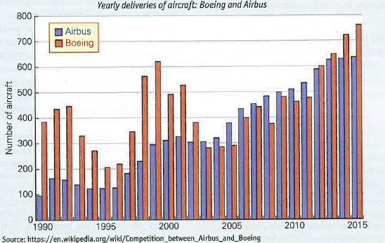
- Without Airbus and the civil aircraft market would have been dominated by two American firms, Boeing and McDonnell Douglas (and possibly one, if the 1997 merger had stilt gone ahead if Airbus had not existed). The only other significant competitors, and only in the small civil aircraft market, are Embraer of Brazil and Bombardier of Canada. Therefore the presence of Airbus would be expected to promote competition and thereby keep prices down. Studies in the 1980s and 1990s tended to support this view, suggesting that consumers have seen significant gains from Lower prices. One survey estimated that without Airbus commercial aircraft prices would have been 3.5 per cent higher than they currently are, and without both Airbus and McDonnell Douglas they would have been 15 per cent higher.
- Economic spillovers from the Airbus Consortium, such as skills and technology developments, might be expected to benefit other industries. Findings are inconclusive on this point. It is clear, however, that although aggregate R&D in the whole aircraft industry has risen, so has the Level of R&D duplication.

On balance it appears that Airbus has had many positive effects and that the strategic trade theory that has underpinned state aid, in this instance, has been Largely vindicated. Boeing has a genuine competitor in Airbus and passengers worldwide have benefited from this competition.
Questions
- In what other industries could the setting up of a consortium, backed by government aid, be justified as a means of exploiting a potential comparative advantage?
- Is it only in industries that could be characterised as world oligopolies that strategic trade theory is relevant?

