 | Targed/target | Yr hyn yr wyf wedi'i wneud yn yr aseiniad hwn  What I have done in this assignment...
Targed/Target 1 | Darllen yn eang a beirniadu'r llenyddiaeth rwyt yn cyfeirio atynt. | Due to the nature of this assignment and it only being 2500 words I have really tried to focus on the literature I have read.
Targed/Target 2 | Defnyddio arddull mwy academiadd wrth ysgrifennu. | I have made sure that the format of my work is to an academic standard.
Targed/Target 3 | Adolygu canllawiau cyfeirnodi - angen rhoi teitl llyfr mewn italig yn yr rhestr gyfeirnodi; cynnwys man cyhoeddi (e.e. London: Sage.) | Made sure that I look at the Harvard referencing guide to ensure that they are all correct.

How a school develops one aspect of its SDP: a report that critically reflects on the actions, impact and evidence base.

The area I have chosen to critically reflect upon within the SDP is the area of ‘iechyd a lles’ with the main focus being ‘Galluodi pawb I gydweithio mewn awyrgylch gynhyrchiol a phositif, gyda’r disgyblion yn datblygu yn unigolion iach, hyderus a pharchus.’ This assignment will focus on how my chosen school works on these development points and the process of implementing and evaluating each target. The evaluation of literature will also be looked at and how the SDP process works on a school wide approach. A SDP is a document that is put in place to plan and implement strategies for school improvement (Gov(A) 2014). The SDP for this school was developed with the input from teachers, governors, student voice and ESTYN recommendations. (ESTYN(A) 2019) The school discussed within this assignment is a three to nineteen Welsh language school within The Vale of Glamorgan. The school is a mixed gender school and has a lower than national average for children having free school meals across the primary and secondary side of the school. Due to The Additional Learning Needs Code for Wales 2021 (Gov 2021) the data shown for the number of ALN learners is lower than what is in the school due to the system making sure that everyone involved has enough time to discuss, plan and support the plans for these learners. This had a role to play in the area of the SDP discussed within this assignment.

The Welsh Government put in place in 2015 that all maintained schools in Wales were required to ensure that they had a SDP in place that was in line with the Education Regulations 2014 (Gov, 2016). Each school will have a set of priorities and within these they will have targets that they need to achieve over a three year stretch (Gov(A) 2014).
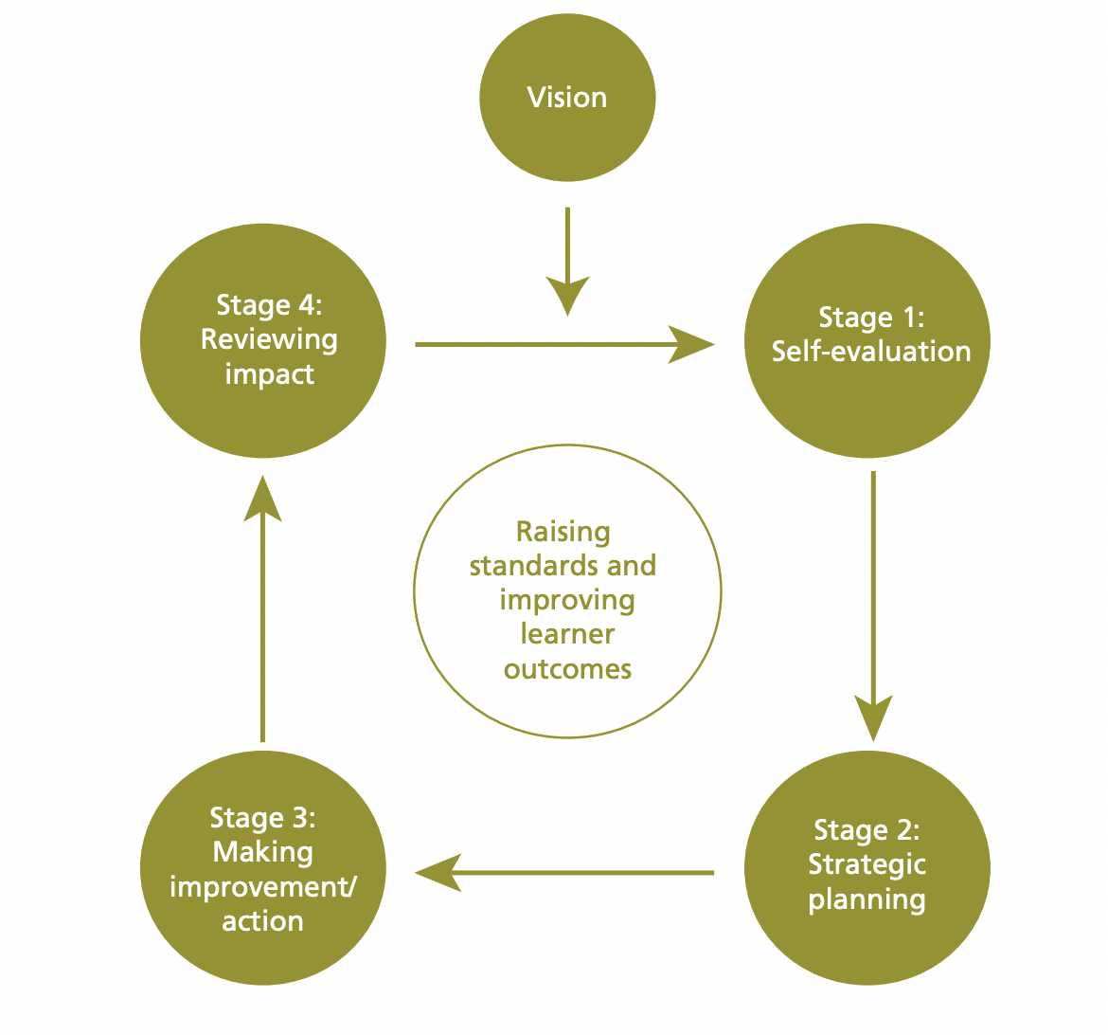
As shown in this diagram there are four stages to a SDP. Each school follows this format to evaluate, plan, implement and review the targets they have set. Once the schools have a clear vision of the areas of improvement they will self evaluate. Chapman & Sammons, (2013) noted that a schools self evaluation is ‘by which members of staff in the school reflect on their practice and identify areas to stimulate improvement in areas of pupil and professional learning.’ In short this is where the school will be critical of their own practices, polices and procedures and delve into how they can improve these areas. Goldstone (2022) found that collaborative work is a fundamental aspect to a strong SDP as this enables everyone involved to feel a sense of value and pride in the SDP.

Gov(A) 2014
Once schools have evaluated and concluded on the areas they need to improve they then need to plan how these targets will be met. For these plans to achieve their goals everyone needs to be committed and have involvement in the plan. The Welsh Government (2014) stated that the planning stage needs to go through a number of people from the governing body, the school staff, learners, guardians, local authorities, other school within their network and so on. The reason for this is to ensure that the collaboration is there and that schools are able to move forward in a way that everyone involved is happy with. Once these priorities have bet discussed and agreed upon the school will then research these and look at how they will be able to implement them within the next stage.

The aspect chosen to discuss from the SDP is the area of health and wellbeing. Therefore the school would need to look at Government Acts and legislation, theory and current research to inform how they would tackle this priority. The Social Services and Well-being (Wales) Act 2014 would have played a part in this priority. This Act ensures that learners who need care and support are able to gain access to that support (Gov(B) 2014). This is important due to the number of ALN learners within the school and also looked after children. Looking at the legislation and embedding that into the schools priorities gives a level of importance to this aspect as this is also the largest area within this schools SDP. The Additional Learning Needs Code for Wales (2021) also discusses the importance of health and wellbeing to a learners and cites The Social Services and Well-being (Wales) Act 2014 as a Act that needs to be followed to ensure that the learners are getting the support they need within education. The Curriculum for Wales has played a part in the planning of the SDP and specifically the area of learning and experience ‘Health and Well-being’. One of the What Matters statements for Health and Well-being is ‘Developing physical health and well-being has lifelong benefits’ (Gov 2022). Within this statement is talks about respect this is a word used in the school target for this area.

Once the school has identified the priorities and planned them they then need to move to stage three which is to put these plans into action. The SDP for the chosen school has set out the plans from 2022 - 2024 and therefore have been able to identify the immediate target and then how they are going to build on that. The target discussed here is the need to let the learners work in a safe, positive environment that is going to help them grow and develop into confident respectful individuals. Humanism theory can be linked to this target to a degree as the school wants learners to feel fulfilled and happy, confident individuals. This is the idea behind Humanism theory and learners strive for that fulfilment where they are satisfied physically, cognitively and emotionally (Gandhi, 2022). This idea is strengthened by the views of Maslow (1970) where he argued that having a humanistic education would as this schools SDP intends develop strong, healthy, confident learners who would have a clear set of values.

The last stage of a SDP is reviewing the impact that the planning has had on the school and the learners. The SDP is a working document and as with the chosen school it gets reviewed every six months. The reviewing of a document can be sooner if the school feels that a target isn’t working or they need to amend or adapt the planning. Gov (2014) also noted that a review of the SDP will also happen after a ESTYN inspection to ensure that the plans and strategies are still relevant and working for the school.

As noted above there is a number of people involved in a SDP. Critically speaking the number of people involved in the chosen schools SDP could be considered a lot. The school has input from schools within their network. While this could be seen as a good form of collaboration, each school is different and needs to ensure that while they work with their feeder schools they do not take on the same priorities as they could not be relevant or beneficial to the school. Gov (2014) states that Governing bodies have a responsibility to ensure that schools are meeting the high educational standards. Working with a number of people to embed these priorities is crucial to them having a positive impact on the learners and the school.

One example of this is a case study from Ysgol Gynradd Pencarnisiog. ESTYN(B) (2019) wrote a report on this school and the impact that a number of stakeholders had on improving the health and well being at this school. Ysgol Gynradd Pencarnisiog had an issue with the health and well being of the learners and with the support of the headteacher, staff, parents and learners they evaluated the issue and put a plan in place to support the learners. This is similar to the chosen school. They have found from their self evaluation that learners seemed happier when the classrooms had a clam environment. The school target for this year is to improve the behaviour of the learners in a fair and supportive way. Therefore the school with the support of the stakeholders have implemented a protocol to follow in regard to praising and giving sanctions to learners. Cowley (2002) found that putting too many sanctions on learners can have a negative impact and can actually lead to an escalation of the behaviour and a negative classroom atmosphere. This is something that the chosen school is trying to avoid not only to keep the school a positive learning environment but also to ensure the health and well being of the learners. Therefore the chosen school has implemented a system where the learners get three verbal warnings before the situation is escalated to a negative point on classroom charts (the system the school uses).

From observation and staff meetings within the school this system is working and the teachers feel that the learners are responding well to the system of green points from positive behaviour and then warnings and a red point for negative behaviour. Looking at this system critically it is important that this is a consistent practice by all member of staff to ensure learners understand the system. Focusing on the SDP and the health and well being of the learners this system has taken into account there well being as it gives the learners a chance to change their behaviour before they are given a sanction of a red point.

Measuring the impact of these priorities is something that the chosen school does weekly at their staff meeting. While not all are discussed they will pick an aspect of the SDP to discuss. Drucker (1992) noted that keeping the goals simple you will be able to focus your attention on them and engage everyone involved. The data involved in measuring the impact could be viewed as difficult in regard to health and well-being. The school however will use a number of different methods to collect the data that is linked to their SDP. One of the methods used to gauge the health and well being of the learners if from classroom observations. Schildkamp and Poortman (2015) found that it is best to use a number of different methods to gain an insight into the target. Heitink et al. (2016) found that using less formal ways of collecting data such as informal discussions also produced very strong data. During staff meetings it is clear that the chosen school are using classcharts, observations and discussions to collect data relevant to health and wellbeing. Reflecting on this the school should look into an educational research project to really dig deep into this priority and gain a valuable insight. Veldkamp et al. (2017) supports this idea of big data and even suggests that the findings could benefit education as a whole as it could lead to new findings. As discussed above self evaluation plays a crucial part in a SDP.

Gov(B) (2021) understands the importance of schools being able to evaluate their practices and therefore are developing a national evaluation and improvement resource that can be used to used to support schools. This is a positive way of ensuring that schools are able to get the best support when completing this document and in turn this will produce a strong and clear pathway for all involved.

Donaldson (2015) highlighted in Successful Futures that the well being of learners in Wales was something that needed to be celebrated and ensure that it is being developed and supported within schools. On reflection what the chosen school is doing to support the well being of the learners is very positive. The school has just developed a dark den where learners can go and have a time out in a dark room where they have sensory equipment to support in calming them down. While this is a positive step forward there are some challenges to this. There are a number of learners who will need to use this den and if their is a learner in the den then they will have to wait. Practically this is not beneficially to the well being of the children if they cannot use it as much as they might need.

The school in question has a large communal area that realistically could house more of these dens to be able to support more than one child at a time. The NCSE (2021) has also noted ways that schools can create a sensory space within a classroom this could be a route that the chosen school could go down to ensure that they are able to support the well being of all the learners who need this support. An area that the chosen school has focused on in regard to the health and well being SDP priority is making the schools communal area a space where the learners feel safe and comfortable. While this is not a sensory space the atmosphere is a calming environment. Champage (2006) found that having these spaces can promote a number of different areas within a learner. It can give them a space to develop skills, empowerment, self care and recovery. Reflecting on this area while it does promote a number of these things it also can have the opposite affect on learners as there is a lot going on in this area as it is used as a space where learners can go for extra support, if they need time out of the class or when a teacher or teaching assistant is doing a focused task. In my opinion this area can become an area of sensory overload so the need for the school to develop the target discussed is very important. One area of the SDP that has not been discussed under this target is staff training. The National Autistic Society (2023) found that this is where a great deal of problems arise. While it is a brilliant resource to have in a school if the staff using it do not know how to engage the learners and promote that sense of well being within the den the outcome is not doing to be what the learner or staff want. Moving forward staff training in how to support and incorporate these sensory dens into every day school life will be needed if the school want to see an improvement in the learners well being.

In conclusion, therefore this assignment has discussed what a school development plan is, and the importance of having a clear vision of what priorities you want your school to focus on. Brighouse and Woods (1999) discuss an interesting idea that will influence my professional practice in the future. The idea of a ‘critical friend’. This theory looks at the idea that you need someone who understands the topic and is sympathetic to its purposes discussed within the SDP. This is linking back to the ideas discussed within this assignment with the amount of people needed to complete and have an input on a SDP. Going forward having a support group or network of people to call upon for support much like the stakeholders involved in a SDP is something that will be beneficial professionally in my career. Barber (1996) sums up the importance of SDP and the information collected and evaluated within this assignment. The key to having a successful SDP is to ensure that you are self evaluating and searching for the improvements that need to be made. This whole assignment has taught me the importance of having these plans in place to ensure that not only the school is running as it should be but as the chosen school has highlighted that the learners are at the centre of these plans and each area focuses on ensuring that they are developing at a holistic level.

Reference

- Barber, M. (1996) The learning game: arguments for an education revolution (London, Victor Gol-lanz).
- Brighouse and Woods (1999) Stakeholders and Partners.Their contribution to school improvement. Available at: https://padlet.com/jessicaroberts4/school-improvement-e04tfqe8jmln73vb/wish/1489220928. Accessed on: 4/4/23
- Champagne, T. (2006). Creating sensory rooms: Environmental enhancements for acute inpatient mental health settings. Mental Health Special Interest Section Quarterly, 29(4), 1-4.
- Chapman, C., & Sammons, P. (2013). ‘School self-evaluation for school improvement: What works and why?’. Education Development Trust.
- Cowley, S (2002) Guerilla Guide to Teaching. London. Continuum International Publishing Group Ltd
- Donaldson (2015)Successful futures. Available at: https://www.gov.wales/sites/default/files/publications/2018-03/successful-futures.pdf. Accessed on: 6/4/23
- Drucker, P. (1992). Managing for the future: The 1990s and beyond. New York: Truman Talley Books.
- ESTYN (A) 2019 School inspection report. Available at: https://www.estyn.gov.wales/system/files/2021-08/Inspection%20report%20Ysgol%20%20%20%202019.pdf. Accessed on:15/3/23
- ESTYN(B) 2019. Healthy and happy. School impact on pupils’ health and wellbeing. Available at: https://www.estyn.gov.wales/system/files/2022-01/Healthy%2520and%2520Happy%2520report%2520En_0.pdf. Accessed on: 4/4/23
- Gandhi MH, Mukherji P. Learning Theories. [Updated 2022 Jul 19]. In: StatPearls [Internet]. Treasure Island (FL): StatPearls Publishing; 2023 Jan-. Available from: https://www.ncbi.nlm.nih.gov/books/NBK562189/. Accessed on: 4/4/23
- Goldstone 2022. School self evaluation for school improvement: Principles of effective practice. Available at: https://www.bera.ac.uk/blog/school-self-evaluation-for-school-improvement-principles-of-effective-practice. Accessed on: 2/3/23
- Gov 2022. Area of learning and experience. Health and well-being. Available at: https://hwb.gov.wales/curriculum-for-wales/health-and-well-being/statements-of-what-matters/. Accessed on: 6/4/23
- Gov(B) 2021. Framwork on embedding a whole school approach to emotional and mental well being. Available at: https://www.gov.wales/sites/default/files/publications/2021-03/framework-on-embedding-a-whole-school-approach-to-emotional-and-mental-well-being.pdf. Accessed on: 5/4/23
- Gov 2016. Leadership for a self improving system. Available at: https://padlet.com/jessicaroberts4/school-improvement-e04tfqe8jmln73vb/wish/1449335376. Accessed on 5/4/23
- Gov (A) 2014. School development plans. Available at: https://www.gov.wales/sites/default/files/publications/2018-03/school-development-plans.pdf. Accessed on 5/4/23
- Gov (B) 2014. Social services and well being (Wales) Act 2014. Available at: https://www.legislation.gov.uk/anaw/2014/4/pdfs/anaw_20140004_en.pdf. Accessed on: 3/4/23
- Gov 2021. The Additional Learning Needs Code for Wales 2021. Available at: https://www.gov.wales/sites/default/files/publications/2022-06/220622-the-additional-learning-needs-code-for-wales-2021.pdf. Accessed on: 1/4/23
- Heitink, M. C., F. M. Van der Kleij, B. P. Veldkamp, K. Schildkamp, and W. B. Kippers. 2016. “A Systematic Review of Prerequisites for Implementing Assessment for Learning in Classroom Practice.” Educational Research Review 17: 50–62. doi:10.1016/j.edurev.2015.12.002
- Maslow, A. H. (1970). Motivation and personality. New York: Harper & Row.
- NCSE 2021. Sensory space in school. Available at: https://ncse.ie/wp-content/uploads/2021/10/NCSE-Sensory-Spaces-in-Schools-2021.pdf. Accessed on: 4/4/23
- Schildkamp, K., and C. L. Poortman. (April, 2019). “Characteristics of effective professional development in the use of data.” Paper presented at the annual American Educational Research Association conference, Toronto, Canada.
- Veldkamp, B. P., K. Schildkamp, M. Keijsers, A. J. Visscher, and A. J. M. De Jong. 2017. “Rapport: Verkenning Data-Gedreven Onderwijsonderzoek in Nederland.” In [Report: Exploration of Big Data in Education in the Netherlands]. Enschede: Pubished by Universiteit Twente.

