Course: BA Business Management

Module name: Blogging to communicate

Module code: LCBB4004

Lecture name: Afzal Munna

Title of report: APPLE INC.
Student name: Daniela Krasteva

Student number: 2124368
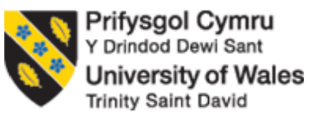
Apple Inc.
Apple is an “American multinational technology-based company” and has expertise in manufacturing consumer electronics, and software and offering online services. Its head quarter is in Cupertino, California, United States. Apple is considered to be the second largest producer of mobile phones, fourth in terms of unit sales of personal computers and biggest in terms of market capitalization. Apple is among the Big Five American IT companies which include “Alphabet”, “Amazon”, “Meta” and “Microsoft”. Apple was founded by “Steve Jobs”, “Steve Wozniak” and “Ronald Wayne” in 1976 as “Apple Computer Company”. Apple launched products like the iMac, iPod, iPhone and iPad through different advertising campaigns. Various Apple stores are opened and several companies are acquired by apple to make the portfolio of the products broader (Thabit and Raewf, 2018).
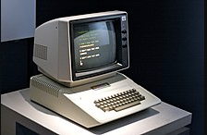
Logo of Apple Inc
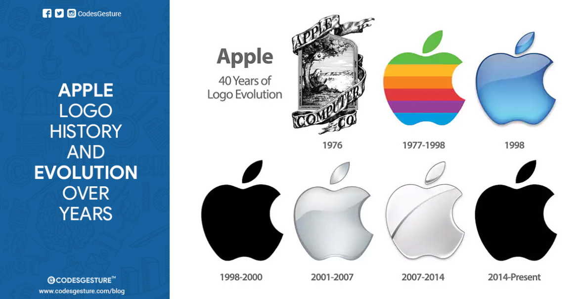
The first logo of Apple was designed by Roy Wayne which was based on Sir Isaac Newton’s laws. The first design was replaced by “Rob Janoff’s” designed “Rainbow Apple” with a bite taken out of it. Different themes of the “bitten” Apple logo were presented by Janoff to Steve Job and thus Job preferred that the logo need to be coloured to show the organisation as humanized. In 1999, Apple dropped the idea of the rainbow apple and switch to the monochromatic logo. Aqua-themed logo was used by Apple from 1998-2003 and then a Glass-themed logo came into use in 2007 and continued till 2013 (Nir, 2018).
Mission and Vision of Apple Inc
The strategies to achieve success in global markets are defined in the “mission and vision statements of Apple Inc”. Apple was considered to be the most innovative and elegant company in terms of its designs. The mission and vision of the company encourage the employees to contribute to the success and innovations of the company for gaining a competitive advantage. Apple regularly makes efficient changes in its vision and mission statements which show the participation of the company in business opportunities in the field of computer technology, consumer electronics, and digital content distribution services, etc (Mohamed and Ahmad Murad, 2021).
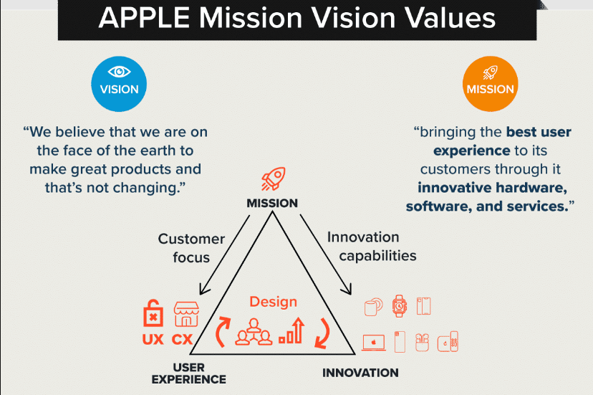
The corporate mission of Apple is “to bring the best personal computing products and supports to students, educators, designers, scientists, engineers, businesspersons and consumers in over 140 countries around the world”. According to this statement, Apple considers the possibilities that can influence its performance as it focuses on making products as organisational outputs that meet the requirements of the consumers of different market segments (Koberg and Longoni, 2019). The mission statement also focuses on increasing the reach of the company’s operations by targeting consumer electronics and online services across the globe. The corporate vision of Apple is “to make the best products on earth, and to leave the world better than we found it”. The corporate vision of Apple is based on Apple’s strategy of corporate social responsibility which highlights the “sustainability”, “environmental conservation”, and “ecological impact of the business”. The “best products” in vision statements refer to the technology of the company as a leader in product designs and development. The vision of the best products encourages the company to produce innovative products of high quality (Addison and Adelaide, 2022).

Marketing Mix of Apple Inc
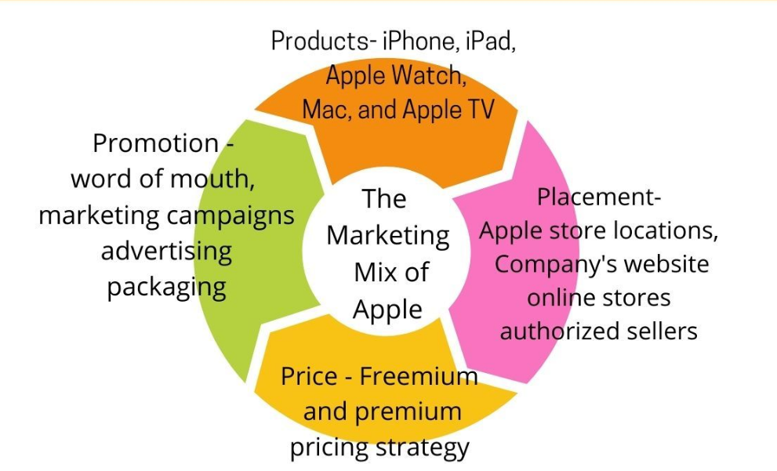
Apple is a famous brand for technology with a reputation in the whole world. Apple gained this position in the market through a consistent focus on innovations, maintaining high-quality products, and marketing. Apple’s marketing mix includes the methods and strategies which are involved in the implementation of a marketing plan. There are mainly 4Ps in the marketing mix of Apple Inc. which includes the “product, price, place and promotion”. For the creation of a “marketing mix”, a strategy named premium branding is used by Apple. The main objective of this strategy is to focus on premium brands and assure that all the variables of the marketing mix are supporting the image of the brand (Addison and Adelaide, 2022).
Product Strategy of Apple
Apple is famous for the production of innovative products over the past years. The product line of Apple is good for the fulfilment of global consumers’ requirements as it includes both goods and services. The product variable of “Apple’s marketing mix” depicts the business of consumer electronics. A variety of products are offered by Apple which includes, “Mac, iPad, iPhone, Apple Watch, and Apple TV” and services offered by Apple include “Apple Music, iCloud, Apple news, Apple books, Apple arcade, and Apple podcasts, and Apple fitness+”. The product mix of this company considers quality over quantity and works on enhancing the quality of chosen products (Wieland, 2021).
Pricing Strategy of Apple
Apple is a premium brand as they follow a premium pricing policy which has high-end products only. The company has a targeted audience that has high affordability. The products of Apple are costly and thus considered to be a symbol of status. Apple never lowers its price to compete and never offers any product at the sale as the low sale price leads to dilution of brand image. Also, Apple Company uses superior quality products with high-end technology which maintains the brand's image and thus the prices never go down (Thabit and Raewf, 2018).
Place Strategy of Apple
Apple has various distribution channels which allow them to increase its products’ reach at the global level. Apple has set up numerous outlets at different locations to ensure that consumers of different places can access the premium products directly. There are also different websites available online and other online portals like Amazon, Flipkart, etc., where consumers can directly purchase Apple products. Apple is connected with some corporate resellers who can sell Apple products for the company. As the company has a premium image, the stores are preferred according to their size, monthly sales, etc. The product's reach at an international level offers the company a wider customer base and thus creates awareness for the brand at the global level (Nir, 2018).
Apple Promotion Strategy
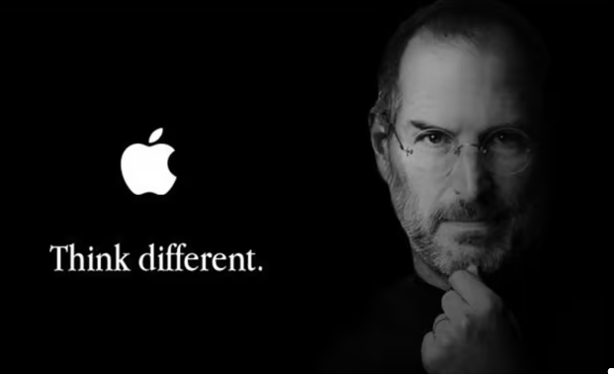
Apple promotes its products using various mediums like “TV, billboards, online ads, etc”. Apple use websites and other digital platforms to promote its products. A campaign like “Think Different” was run by the founder of Apple to encourage the audience to be confident of and proud of themselves. The target of Apple is a specific segment of society and thus produces the products in a unique way which makes them better than their competitors. This element of the marketing mix makes use of public relations to attract consumers (Mohamed and Ahmad Murad, 2021).
Supply chain strategy of Apple
Apple’s network is much broader which offers special long-term agreements with its main suppliers and ensures high productivity. It has diversified the supply chain which includes China and Taiwan as manufacturing partners. The main function of Apple’s supply chain is the development of a product. Apple uses other businesses too for the development of a product by ensuring that the other business has unique raw materials for the development of new products. Apple also works for engaging more and more manufacturing partners to develop products. This will help in reducing the risk of the vendor and also reduce the shortage of raw materials (Liu, 2022).
STP of Apple Inc
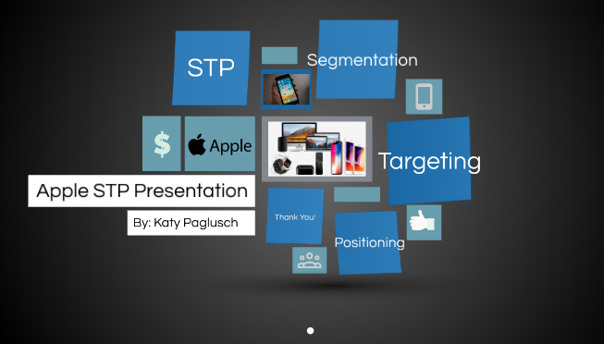
Segmentation
Segmentation refers to the division of the population into various groups based on various characteristics like age, gender, profession, and other preferences. Apple develops its merchandising stores using geographical segmentation at the international level. The products of Apple are manufactured according to the family size and age group of 18-45years. Apple products mainly have an audience of high income who are generally at the bachelor stage. Apple included the behavioural variables in the market segment to the target market. The behavioural variables consist of attitudes, responses, and knowledge of a product (Koberg and Longoni, 2019).
Targeting
In targeting, the most favourable segments are identified for selling the products. MNCs like Apple offer technology products and target the segment of consumers who are willing to pay more. Apple is a premium brand which offers products with advanced features and updated technology. Apple offers its consumers innovative designs and supports the requirement of consumers for speed and service, efficiency and advanced features along with tools. The customers of Apple eventually become loyal when they start using a product of Apple (Bahador, 2019).
Positioning
Positioning means the selection of the products and services which are appealing in every segment. This is considered to be the last stage for a company to link their products and services with the preferences of customers. This creates a pattern of competition in the market of a specific industry. Market research plays an important role in producing an innovative product. The product of high quality thus offers a good position to a brand in the competitive market. Emotional relationships are also important to maintain with the consumers as it makes the survival of the company easy (Addison and Adelaide, 2022).

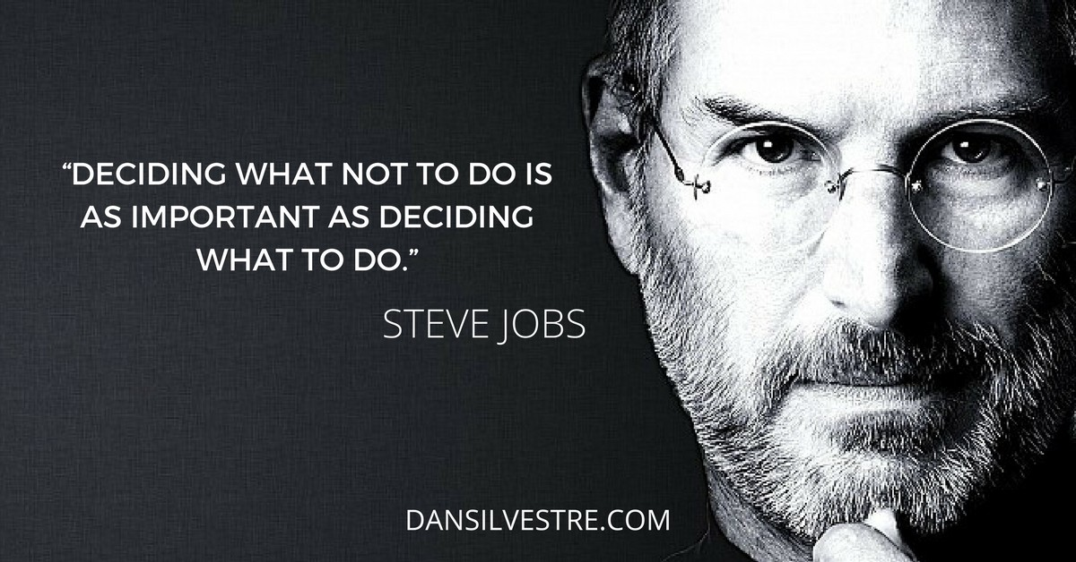

References
- Addison, M. and Adelaide, V., 2022. Brand Development and Marketing Strategies in USA: A Case of Apple Inc. Journal of Marketing and Communication, 5(1).
- Bahador, M.H.H., 2019. The effect of marketing mix on organizations performance. In 1st Strategic Management Conference 2019.
- Koberg, E. and Longoni, A., 2019. A systematic review of sustainable supply chain management in global supply chains. Journal of cleaner production, 207, pp.1084-1098.
- Liu, Z., 2022. Promotional Strategies on Online Platforms (Doctoral dissertation).
- Mohamed, B. and Ahmad Murad, N.A., 2021. Mission and vision in industry development. FBM INSIGHTS: Universiti Teknologi MARA Cawangan Kedah, 3, pp.47-50.
- Nir, M., 2018. Define and Communicate the Mission and Vision. In The Pragmatist's Guide to Corporate Lean Strategy (pp. 21-31). Apress, Berkeley, CA.
- Thabit, T. and Raewf, M., 2018. The evaluation of marketing mix elements: A case study. International Journal of Social Sciences & Educational Studies, 4(4).
- Wieland, A., 2021. Dancing the supply chain: Toward transformative supply chain management. Journal of Supply Chain Management, 57(1), pp.58-73.

