
STUDENT NAME: CLAUDIA REBECA GORGAN
STUDENT ID: 2209748
MODULE CODE: LCLM6001
COMPONENT 1
INDIVIDUAL REPORT
WORDS: 3000

Table of Contents
Executive Summary 3
Introduction to Innocent Drinks 3
PESTEL Analysis 5
SWOT Analysis 8
Strategic Growth Options and Proposed Strategy 9
Evaluation of Strategic Growth Options 10
Stakeholder Analysis 14
Strategic Objective 1: Develop and Launch Innovative Sustainable Products 16
Conclusion 18
Reference List (Harvard Style) 19

Executive Summary
In this document, I will identify the growth prospects for Innocent Drinks in the context of a competitive and sustainability-driven space. A certified B Corporation, who are in the health and wellness beverage sector Innocent Brand Capital has a strong brand equity based on ethical brand position, focus on environmental responsibility and branding. But the company is increasingly challenged by intensifying competition, supply chain volatility, the increasing cost of inputs and greater consumer demands around transparency and sustainability. Three key strategic perspectives based on an analysis are found to be priority priorities in the analysis. First, there is substantial opportunity for market development to open international geographic entry in high-growth markets in regions in which demand for plant-based and functional beverages is growing. Second, product development and innovation should shift to functional health drinks and alternative low sugar formulations, environmental packaging options and sustainable packaging options that are competitive differentiation and cater to the changing requirements and consumer preference. Thirdly, there is the need for operations to ‘be resilient to shocks’ through sustainable procurement partnerships, supply chain diversification and ongoing investment in carbon emission saving programmes to remain within science-based targets. To sustain growth and its ethical obligations, the report advises to consider a sustainable growth strategy based on stakeholder theory and shared value creation. This will involve further increasing Innocent’s B Corp status, improved transparency via quantifiable sustainability measures and leveraging the extent of Innocent’s credibility in marketing communications. Not only that, but Innocent Drinks also looks set in a good position for a continued growth. “We can focus on the growth strategy of the business without cutting corners from its key mission and vision. However, strategic expansion will only be sustainable if growth is congruent with its foundational mission, vision and principles and ethical and environmental stewardship.

Introduction to Innocent Drinks
Innocent Drinks is a British beverage company, established in 1999, that makes smoothies, juices, and plant-based drinks. Once set up, the company established itself as a conscious organization serving the health and wellness community. Innocent’s mission is to “make natural, delicious food and drink that helps people live well and die old,” reiterating focus on health, quality, and natural ingredients (Innocent Drinks, 2024). Based on such mission statement, its product design and marketing communications are heavily rooted in this mission statement, providing a brand identity that is rooted in ethical and consumer behaviour. The organisation’s vision and philosophy that it wants to “leave things better than we found them “indicates a long term effort in environmental sustainability and social responsibility (Innocent Drinks, 2024). This is consistent with the perspective of stakeholder theory that value creation is to benefit a wide market segment of people, not just shareholders only (Freeman 1984). Certification as a B Corporation at Innocent, the most recent incarnation of a B Corporation, is additional evidence of Innocent’s commitment to achieving profit with integrity and verifying its performance standards in terms of social and environmental performance as well as in terms of transparency and accountability (B Lab, 2023). Altogether, Innocent’s mission, vision and values make the company a mission focused organisation that aims to have sustainable growth with a commitment to ethical and environmental responsibilities.
Evaluation of the Current Market Situation
A comprehensive evaluation of Innocent Drinks’ current market situation requires an integrated analysis of the macro-environment (PESTEL), industry structure (Porter’s Five Forces), and internal capabilities (SWOT). Together, these frameworks provide a holistic assessment of the strategic context in which the company operates (Johnson, Scholes and Whittington, 2017).

PESTEL Analysis
Political and Legal Factors.

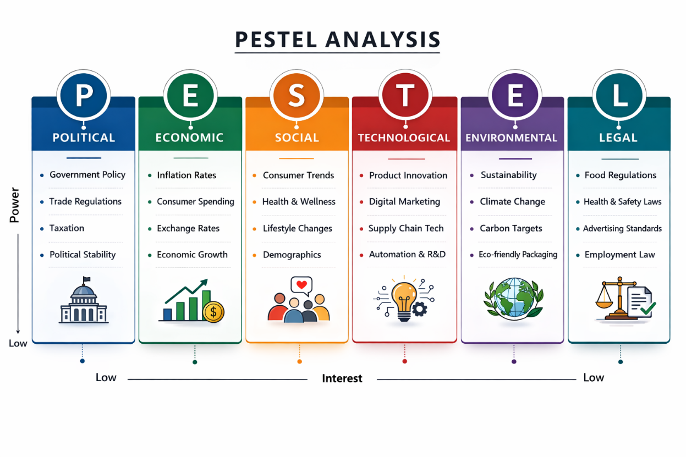
The soft drink industry in the UK is heavily regulated. In 2018 the Soft Drinks Industry Levy (SDIL) was introduced, which incentivised manufacturers to reduce sugar content, reshaping product formulations across the sector (HM Government, 2018). Although Innocent’s smoothies often contain naturally occurring sugars, regulatory scrutiny around sugar labelling and health claims remains significant. Additionally, post-Brexit trade arrangements have increased administrative burdens and supply chain complexity for companies sourcing fruit globally (CBI, 2023). Environmental regulations, including the UK’s net-zero commitment by 2050, further pressure firms to decarbonise operations and packaging.

Economic Factors.
Inflation and rising cost-of-living pressures in the UK and Europe have impacted consumer purchasing habits and thus price sensitivity (ONS, 2023). Meanwhile, there have been global supply-chain disruptions and climate-related agricultural volatility, which have increased input costs for fruits, packaging and logistics. While the premium health beverage segment remains robust, the economic uncertainty can squeeze discretionary spending on the more expensive smoothies.
Social Factors
Health is a strong motivator for natural, plant-based, and functional beverages. Consumers are looking for products that look like minimally processed goods bought and sourced from the most ethical sources (Mintel, 2023). But knowledge of sugar in smoothies is risky for reputation. In addition, sustainability expectations are rising Consumers now call on brands that show they have measurable environmental and social commitments.
Technological Factors
Sustainable packaging, digital marketing and data analytics offers opportunities for innovation. Automation and better cold chain logistics optimize operations; digital channels drive direct and interactive customer experiences and brand storytelling.
Environmental Factors. Climate change in these regions has a major impact on fruit supply chains as it causes volatile sourcing and price fluctuations. Innocent’s science-based carbon reduction goals and renewable energy investments are in line with increasing environmental accountability benchmarks (Innocent Drinks, 2024). Nonetheless, environmental risks are stubbornly structurally embedded in the agricultural supply base.

Porter’s Five Forces Analysis
Porter’s (1980) framework highlights the competitive intensity of the health beverage industry.

Competitive Rivalry – High.
The UK smoothie and juice market is a competitive field with multinational forces like The Coca-Cola Company (the key shareholder in Innocent), PepsiCo and a few niche cold-pressed juice brands. There’s intense price competition from supermarket private labels. Product differentiation is moderate with strong drivers in branding, sustainability credentials and innovation.
Threat of New Entrants – Moderate.
Small-scale production is relatively low in terms of barriers to entry but achieving national distribution, brand recognition and compliance with sustainability standards require large capital investments. Incumbent advantages come from economies of scale and retailer relationships.
Bargaining Power of Suppliers – Moderate to High.
Fruit sourcing is exposed to climate conditions and fluctuations in global trade. In addition, the limited certified sustainable suppliers drive the dependency. Suppliers’ power is strengthened by price volatility of agricultural commodities.
Bargaining Power of Buyers – High. Big supermarket chains like Tesco and Sainsbury's have great power over pricing, shelf placement, marketing and promotion. End consumers also have low switching costs between brands.
Threat of Substitutes – High
Substitutes are bottled water, carbonated soft drinks, energy drinks, homemade smoothies and plant-based beverages. There is also the expansion of functional drinks and kombucha products and it is becoming increasingly diversified. The industry structure indicates intense market competition, which demands both consistent innovation and distinct branding.

SWOT Analysis

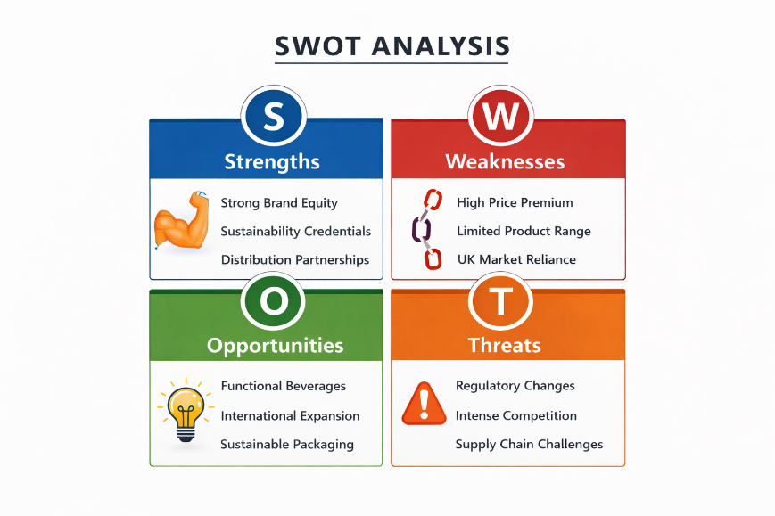

Strengths.
Innocent has good brand equity through ethical positioning and unique marketing communications. Its B Corp status adds reputational authenticity and strengthens trust of stakeholders. The corporation enjoys The Coca-Cola Company-supported delivery networks that offer scale benefits. The commitment to sustainability and transparent reporting will strengthen brand loyalty in the long term.
Weaknesses
Premium pricing may reduce competitiveness during economic downturns. The dependence on agricultural supply chains makes it vulnerable to environmental volatility. Smoothies’ natural sugar content may conflict with public health narratives as well.
Opportunities
Plant-based diets and functional beverages are growing and should create diversification potential. There are opportunities for scale with the increase to international markets, notably Europe and Asia. Sustainable packaging innovation could drive further differentiation of the brand.
Threats
Competition from private-label and multinational companies is growing and poses a threat to market share. Consumer perceptions may be influenced by regulatory tightening surrounding sugar labelling. Long-term raw-material availability and cost stability risks are being raised by climate change.
According to the analysis, Innocent is exposed to a mature yet evolving market with a lot of competition and growing regulatory and sustainability challenges. Notwithstanding enormous macro-environmental risks and competitive pressures, the organisation’s strong brand identity, stakeholder orientation, and sustainability credentials underpin competitive advantage. The future-oriented global strategic choices must improve innovation, enhance operational resilience, and maintain brand authenticity and ethical credibility.

Strategic Growth Options and Proposed Strategy

Market Penetration
Market penetration is the increase in share within existing markets through existing products and is understood as “to increase the market share of an existing brand” (Ansoff, 1957). Innocent would do well to improve promotional campaigns, retailer partnerships and brand loyalty through intensified digital interaction in the UK and European markets. Although lower risk, such a strategy only promises a small amount of long-term growth because the market is mature and there are high levels of competitive rivalry. Margin expansion is hampered by private-label supermarket alternatives and multinational beverage companies.
Market Development
Market development is expanding current products into new geographies. Growing global appetite for plant-based and functional beverages also allows for market opportunities in a few selected cities in the Asia-Pacific and North American regions. Innocent’s rich brand equity and sustainability credentials might appeal to the international eco-friendly consumer base. However, international expansion creates regulatory, cultural, and supply chain challenges that need careful market selection along with phased entry.
Product Development
Developing the product is an attractive strategy. Consumer needs are trending towards functional health beverages, reduced sugar products and plant-based protein beverages (Mintel, 2023). Innovation matching wellness trends could further differentiate, and counter regulatory expectations associated with sugar consumption. Moreover, sustainability investments in recyclable and low-carbon packaging further strengthen environmental leadership and brand authenticity.
Diversification
Adding other unrelated food categories would raise risks and, likely, undermine Innocent’s brand identity. Its association with healthy beverages means unrelated diversification is not strategically coherent.
To sustain competitive advantage within the increasingly saturated health beverage market, Innocent Drinks must pursue a growth strategy that balances commercial expansion with its ethical and environmental commitments. Strategic options can be evaluated using Ansoff’s (1957) growth matrix and Porter’s (1985) Generic Strategies framework to ensure both directional clarity and competitive positioning.

Evaluation of Strategic Growth Options
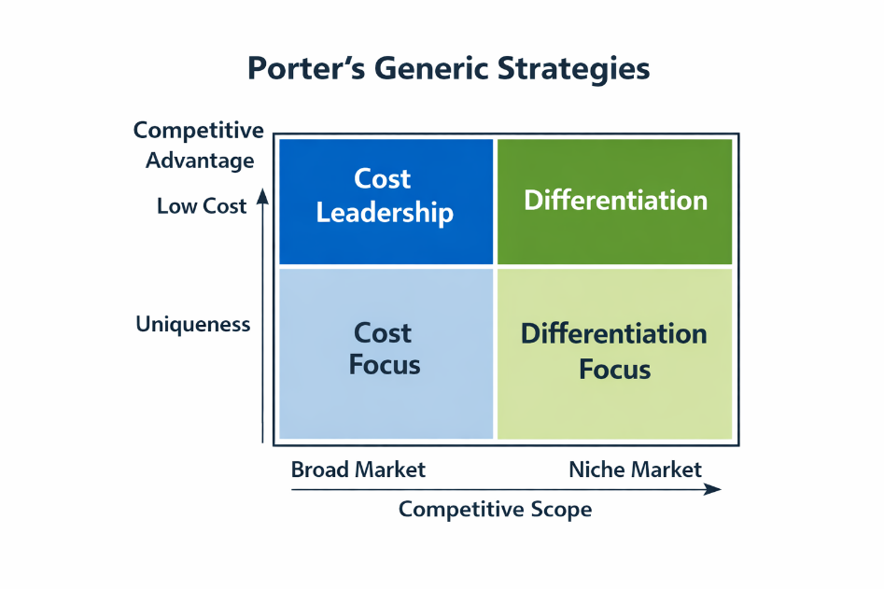
Recommended Strategy: Differentiation through Sustainable Product Development with Selective Market Expansion

It is Innocent should use a differentiation strategy (Porter, 1985) that is supported mostly by building products and supplemented with developing the market selectively. Such a hybrid method allows for both growth and strategic alignment with organisational values. According to Porter's (1985) theory, Innocent has traditionally competed via differentiation rather than by becoming a cheaper player. That premium positioning, ethical sourcing commitment, and B Corp certification make it known as a more unique brand. Price battles would be detrimental to sustainability investments and brand equity. Thus, innovation that further strengthens differentiation is strategically consistent. All product development efforts should focus on three key areas:
Functional and fortified beverages (e.g., vitamin-enriched smoothies or gut-health products).
Low-sugar and reformulated options in line with public health and regulatory trends.
Innovative sustainable packaging options with increased recycled content and carbon-neutral production facilities.
And by doing so, they provide consumers with their health benefits without the detriment of the environment (Porter and Kramer, 2011). This strategy is perfectly consistent with Innocent’s stated ambition to “make natural, delicious food and drink that helps people live well and die old” and its intention to “leave things better than we found them” (Innocent Drinks, 2024).
Targeted market development ought to focus on demographically appropriate urban areas where there may be a large disposable income and strong awareness of sustainability. Expansion should maintain ethical sourcing practices and transparency in supply chain operations to mitigate reputational risks. It also maintains the strategic advantage of phased internationalisation by minimizing risk of operational volatility and still using existing distribution partners.

Strategic Justification and Alignment with Organisational Values
Based on stakeholder theory (Freeman, 1984), this suggested strategy acknowledges that long-term value creation is associated with the trade-off between shareholder returns and societal and environmental responsibilities. This, combined with Innocent’s commitment to sustainability embedded in product innovation and not as an add-on, supports the creation of greater legitimacy and longer-lasting resilience. In addition, sustainable innovation and differentiation reduces competitive rivalry highlighted by Porter’s Five Forces analysis, as distinct value propositions mitigate price sensitivity and substitution threats. It also responds to macro-environmental pressures such as sugar regulation and carbon reduction targets. We conclude that, a differentiation-based growth strategy of sustainable product development and selective market expansion will bring to bear a balancing of risk, competitive position and mission harmonization. This model enables profitable growth, maintains Innocent’s ethical integrity, and strengthens its position as a purpose-driven market leader.

Strategy Evaluation
To assess the robustness of the offered differentiation-led product development and selective market expansion strategy, the SFA framework (Suitability, Feasibility, and Acceptability) presented by Johnson, Scholes and Whittington (2017) is used in this section. This assessment validates that the proposed approach is consistent with Innocent Drinks’ external surroundings, inner capacities, and stakeholder expectations.
Suitability
Evaluates if the strategy responds to the major opportunities and threats evident in the external analysis. Given the growing consumer demand for functional health beverages, reduced-sugar alternatives, and more sustainable products, the suggested strategy has good relevance across the beverage market (Mintel, 2023). Through its commitment to product innovation in the health and wellness space, Innocent directly responds to social and regulatory challenges such as sugar reduction initiatives and environmental transparency commitments. In addition, sustainable innovation (differentiation) boosts competitive position in high-rivalry sectors (Porter, 1985). Expanding selectively in international markets with highly health-demanding consumers provides solutions for growth limitations of the mature UK market. So the strategy is fit into macro-environmental conditions and industry dynamics.
Feasibility
Indicates whether the organisation has the resources required to deliver the strategy. Innocent enjoys brand equity, relationship and distribution support of retailer The Coca-Cola Company. Such functionality increases operational scalability and access to international markets. In addition, Innocent’s B Corp certification and sustainability expertise provide organisational skills in responsible sourcing and environmental reporting. Yet making it work is going to take a lot more investment in R&D, providing a more diverse supply chain, and packaging innovation.
Assumptions:
These considerations are based on the premise that Innocent remains financially strong and can receive funding for R&D investment. We also expect that current partner relationships will be scalable and sustainable yet do not violate ethical standards for sourcing. Overall, the strategy is feasible to implement at current operations levels and with current partners.
Acceptability
Measures stakeholder responses in terms of the risk, return, and conformity of corporate values. The proposed strategy will be closely in line with Innocent’s mission to advance health and its quest to “leave things better than we found them” (Innocent Drinks, 2024). By integrating sustainability into innovation, the company solidifies stakeholders’ trust and brand legitimacy. From the standpoint of shareholders, product development and selective expansion represents a moderate-risk strategy than unrelated diversification (Ansoff, 1957). International expansion may lead to operational risk, but a phased approach limits exposure. Expected returns include higher brand differentiation, keeping premium pricing, and long-term market growth. The strategy also resonates with stakeholder theory (Freeman, 1984), as it combines economic performance with ethical and social responsibilities.

Stakeholder Analysis
The strategy of differentiation proposed that will be implemented based on sustainable product development and selective internationalisation will have different consequences when employed toward the main key stakeholders of Innocent Drinks. Underlines the concept of stakeholder theory (Freeman, 1984), organisations will add long run value to their interests balance the balance of stakeholders groups instead of meeting only shareholders’ needs. Mendelow’s Matrix (1991) offers a way to assess the power and interests of stakeholders to help frame strategies for engagement.
Stakeholder Impact Analysis
High Power, High Interest (Key Players)

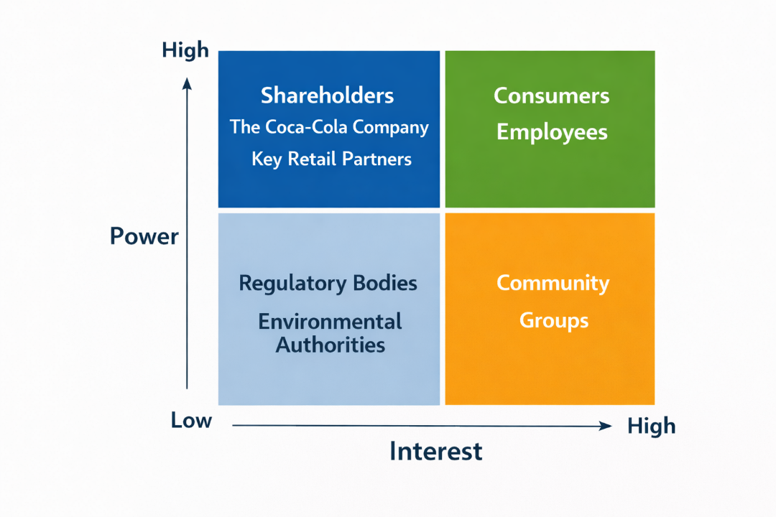
Shareholders and majority-owner The Coca-Cola Company are in this quadrant. While suggesting long-term growth potential through innovation and geographic expansion, the strategy will take some urgent attention, especially near-term R&D and sustainable sourcing expenditure. You will need transparent performance reporting and clear financial projections, to retain confidence. High power of distribution control means that major retail partners (Tesco, for example) also have high power. Product innovation and sustainability differentiation could support collaboration and premium shelf positioning.
High Power, Low Interest
Regulatory authorities and environmental leaders are very powerful players but have low direct control over how the business is run in the real world. The strategy's proximity with carbon reduction and sugar reformulation policies limits regulatory risk.
Low Power, High Interest
Ethical business practices and innovation are of great interest to consumers and employees. Improved sustainable packaging, functional beverages, and transparency in sourcing strengthen brand loyalty and employee involvement. Preserving authenticity will be essential so as not to create perceptions of “greenwashing.”
Low Power, Low Interest
Community groups, whose community networks extend in various directions. They may indirectly influence it, but the continued charitable initiatives would not be directly applicable at community scale, and the environmental commitment would be offset.
Stakeholder Engagement Plan
According to Mendelow’s (1991) matrix:
Manage Closely (High Power/High Interest): Continuous financial updates, sustainability reports and business performance profiles, regular financial updates to investors and critical retail associates.
Keep Satisfied (High Power/Low Interest): Proactive compliance reporting and environmental disclosures to regulators.
Keep Informed (Low Power/High Interest): Transparent marketing communication, sustainability storytelling, and internal engagement programmes for employees.
Monitor (Low Power/Low Interest): Ongoing community engagement initiatives.
Taken all together, infusing sustainability in innovation builds stakeholder confidence and strengthens Innocent’s mission-driven identity and demonstrates that strategic growth will be commercially sustainable and socially responsible.
Implementation and Monitoring
Implementation of the proposed differentiation-led product development and selective market expansion strategy must be based on a formalized implementation framework and be accompanied by empirical and operational performance metrics. As stated in Kaplan and Norton (1996), the success of a strategy is reliant on converting strategic objectives to operational performance monitored by well understood Key Performance Indicators (KPIs). Below is an implementation plan with strategic priorities, actions taken, and metrics for monitoring.

Strategic Objective 1: Develop and Launch Innovative Sustainable Products

Actions: Invest in research and development to develop low-sugar drinks and functional drinks (e.g., vitamin-enriched and plant-protein drinks). Reformulate some of the current products to reduce sugar content in line with regulatory guidance. Use more recycled and plant-based packaging materials, Establish supplier relationships that promote responsible sourcing.
KPIs:
Percentage reduction in added or total sugar per product line, New product launches per year, Percentage of packaging made from recycled or renewable materials, Scope 1, 2 and 3 carbon emission reductions aligned with science-based targets.
Strategic Objective 2: Focus on Selective International Market Expansion.
Actions:
Market and risk analysis for focused areas, Develop distribution partners in some cities, Tailored regional marketing communication using cultural context and brand authenticity, Implement pilot product launches prior to full-scale roll-out.
KPIs:
Growth rate of revenue in new markets, % market share within first three years of entry, Return on investment (ROI) for expansion activities, New regions’ brand awareness metrics.
Strategic Objective 3: Increase Brand Differentiation and Stakeholder Trust.
Actions:
Transparency in sustainability reporting can be improved, Launch combined marketing efforts focused on ethical sourcing and health advantages, Educate its employees regarding sustainability.
KPIs:
Customer trust and brand satisfaction, Employee engagement index,B Corp recertification scores.
Monitoring and Control Mechanisms
Quarterly strategic performance reviews at the board level should be made, as well as balanced scorecard reporting (Kaplan and Norton, 1996). The variance analysis will also enable corrective action when targets are not achieved. Supply chain volatility, regulatory developments, and reputational risk should be monitored through risk management frameworks. This allows to balance our growth ambitions with our sustainability commitments, hence enabling sustainable long-term performance being measured and accountable (KPIs) as it helps with its structured implementation and execution.

Conclusion
This report has undertaken a critical analysis on Innocent Drinks’ strategic positioning in a very cutthroat and sustainability-oriented beverage industry. Analysis of external factors also showed growing competition, regulatory pressure around sugar reduction, and increased consumer awareness of health-conscious and environmentally conscious products. Through this internal analysis, we identified Innocent’s strong brand equity, B Corp certification and ethical positioning as core competitive strengths. By analyzing this, it is recommended that a differentiation-oriented approach focused on maintaining a sustainable product development model supported by selective global market diversification is supported by this assessment. These approaches follow Ansoff’s (1957) growth framework and Porter’s (1985) Generic Strategies, reinforcing competitive advantage through innovation instead of cost leadership. The strategy was cross assessed using the SFA framework and was considered appropriate, feasible, and acceptable in Innocent’s organisational environment. Ultimately integrating sustainability into innovation supports Innocent's long-term growth so that Innocent can reach sustainable growth that remains consistent with the company mission to promote health and its vision to “leave things better than we found them.”

Reference List (Harvard Style)
Ansoff, H.I. (1957) ‘Strategies for diversification’, Harvard Business Review, 35(5), pp. 113–124.
CBI (2023) UK trade and supply chain report. London: Confederation of British Industry.
Freeman, R.E. (1984) Strategic Management: A Stakeholder Approach. Boston: Pitman.
HM Government (2018) Soft Drinks Industry Levy. London: HM Treasury.
Innocent Drinks (2024) A bit about us. Available at: https://www.innocentdrinks.co.uk
Johnson, G., Scholes, R. and Whittington, R. (2017) Exploring Strategy. 11th edn. Harlow: Pearson.
Kaplan, R.S. and Norton, D.P. (1996) The Balanced Scorecard. Boston: Harvard Business School Press.
Mendelow, A. (1991) ‘Stakeholder mapping’, Proceedings of the 2nd International Conference on Information Systems, Cambridge.
Mintel (2023) UK Juice and Smoothie Market Report. London: Mintel.
ONS (2023) Consumer price inflation, UK. London: Office for National Statistics.
Porter, M.E. (1980) Competitive Strategy. New York: Free Press.
Porter, M.E. (1985) Competitive Advantage. New York: Free Press.
Porter, M.E. and Kramer, M.R. (2011) ‘Creating shared value’, Harvard Business Review, 89(1/2), pp. 62–77.

