Understanding the Importance of Effective Communication within Early Years Settings.

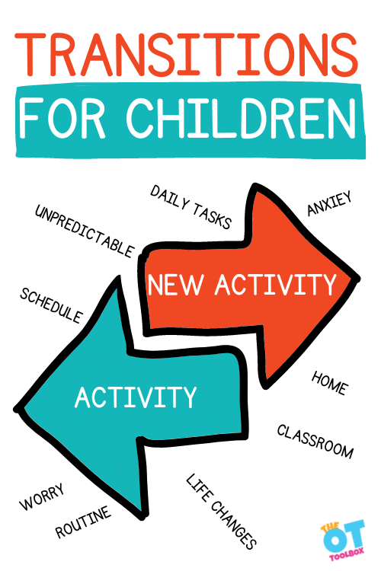
Figure 1:The Tool Box (2023)

A handbook that aims to promote and support practitioners within early years through transitions to encourage a child’s learning and development.

Contents

Introduction

What is a Transition?

Roles of an Adult

Needs of a child

Theories

Partnership

Intervention

Possible outcomes

Introduction
Early years in the curriculum is commonly known as the foundation phase and is supported by early years practitioners in settings encouraging and supporting development for three- to seven-year-olds (Foundation Phase Framework 2015).
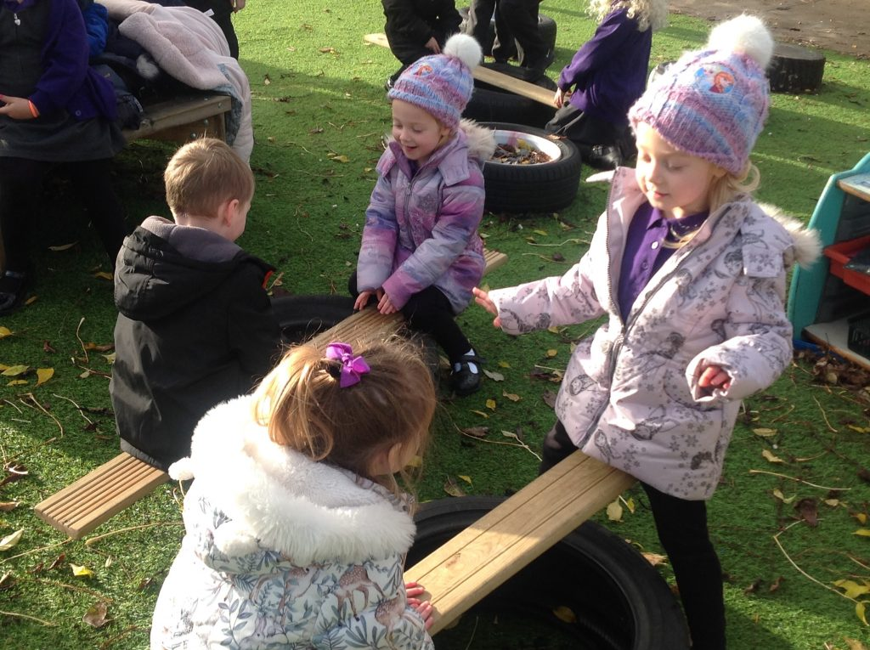
Figure 2: Birth to 5 Matters (2023)
This handbook has been developed to support practitioners’ awareness working with children in early year setting in preparation for of them taking the important step from home to Nursery. This type of transition is described as a vertical transition through a child’s key stages of development (Flying Start 2017). The information within this handbook is predominantly aimed towards supporting major transitions however, it can help support early years practitioners with more horizonal transitions known as daily routine transitions such as lunchtime to play time to home and repeat (Lindon 2012).
These are backed up by theorists and popular authors that have researched into the development of a child and how they explore the world through the early year’s development.
Early Years Practitioners work actively to support a child to ‘fit in’ and research suggests that children’s experiences are enhanced when staff support an induction period to help smoother transition’s (Flying Start 2017).
What are Transitions?

Birth to 5 matters (2023) detail transitions as a process not an event that should be planned. They also detail the key need to ensure a high-quality experience for children in Early years. A child should have continuity between home and school and the people within all those settings. The movement of transitions is described as ‘horizontally’ by Birth to 5 Matters (2023). This can be for a child moving from one room to another whilst in an early year setting, a child moving forward in more structured focused tasks such as lunchtime or going home with a care provider, and back to nursery again all in the same day.
Figure 3: Wakeup-World)
Flying start (2017) describe major events a child experience as vertical transitions. An example of this is a child starting school for the first time resulting in a major change in a child’s everyday routine. In practise Trodd (2012) supports this and explains that transitions tend to focus on the changes of children’s experiences such as from one key stage to another or into a new setting.
Brooker (2008) suggests that in early education in the UK are in urgent need of an environment this is high in opportunities for them to explore. Therefore, the transitions into new environments shaped by adults in early years settings may shape the direction of their learning journey.
The Role of the Adult
Child development does not just include the expected brain development as babies and children grow, it also tries to explain why and hope the development of the child unfolds Lindon (2012). An adult’s behaviour in temperament and personality will affect the way in which a child will explore the opportunities given to them. Such opportunities to be given through play, first sight high engagement of a child, risky play that gives a rough and tumble approach (Lindon 2016).


The adults responsible of the care and support of a child need to ensure they are fully engaging through the assessment period of the transition to starting a care setting (Flying start 2017). The purpose of the assessments initially takes place to build a picture to understand the needs of the child, their capacity and identify how practitioners can work effectively with the child to achieve the best possible outcomes (Flying Start 2017). Strengthening these relationships can benefit from home visits from the practitioner outside of the nursery setting and informal face to face visits of parents spending time within the environment the child is to attend (Brooker 2008).
Figure 4: Clip Art
The Welsh Government (2014) highlight that it is important for those involved with child, a care provider and in education, that families are the centre on the interaction. Brooker (2008) finds that through watching, waiting and allowing autonomous decisions allows good outcomes for the child development in different transitions.
The Needs of the Child
Lindon (2012) suggests that children within early years are better supported by adults who are compassionate and care about the well fair and well-being of a child. A Practitioner and parent should have a good baseline knowledge of child development theories that can build accurate expectation of a child Lindon (2012).
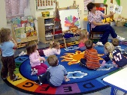

Indoors
Outdoors
Figure4: Clip art
Figure 5: Clip art
Development for a child is through indoor and outdoor environments that are stimulating, exciting, fun and safe. This is to fundamentally allow the child to learn being curious to explore through first hand experiences (Foundation Phase Framework 2015). Fredrich Frobel saw children as curious and creative learners who learn to their best ability through activities, play, talk and self-reflection (Tovey 2020). Practitioners should encourage a child to explore the environment autonomously to allow the child to be more independent within their play to pursue their own interests and talents (Tovey 2010). The Welsh Government (2014) formally recognise this and have embedded this into the Framework for children saying that children should identify their own personal interests to achieve the best outcomes.
Friends

A child will have the freedom to not only explore different opportunities but build relationship with peers. The United Nations Convention Rights of a Child in article 15 encourages a child to meet other children and join in groups that are accessible.
Participation

Children and young people need to have the voice heard when adults supporting them so that they are taking park in the decisions that affect the lives (Children and Young People’s Participation in Wales - Good Practice 2016).
Communication

The child needs to know that the practitioner working closely with them is supporting the above needs of the child. A practitioner needs to have effective communication skill and ensure the child is listened to, you are giving them your full attention, being honest with them and understand their body language (Early Learning HQ). A theorist John Bowlby build research on that communication through being a responsive adult can build a foundation of secure attachment of their needs being met therefore, the child forms a bond of trust and recurrent serve and return in future activities (Very Well Mind 2023).

Theorist
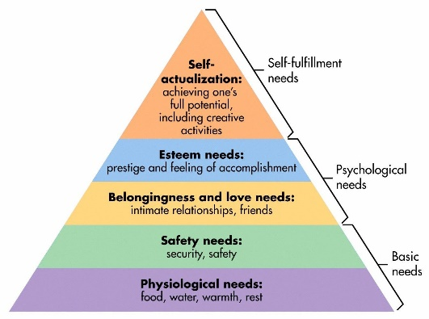
Maslow (1943) builds a pyramid that begins with building a foundation base for child to develop. Maslow starts by illustrating the basic needs of a child followed by the psychological and self-fulfilment needs. The basic needs outlines that every child has food, water, a place to feel safe and be well rested. The United Nations Convention Rights of Child (UNRCR) in article 27 states that a child has a right to adequate standard of living. In detail this means a child must have access to food and housing to meet their physical and social needs to support their development. This then allows the child psychological needs to develop through relationships with peers and other adults support them. Their self- esteem needs are then fed through to feeling more accomplishment and positive impact on their well-being. Self-fulfilment helps a child achieve their potential and to be creative (World of Work Project 2023). The foundation phase framework (2015) also links in with Maslow (1943) pyramid and lists in the curriculum they aim to ensure every child and young person has a safe home and wider community to support their physical and emotional well-being.
Figure 6: Simplypsychology 2020
John Bowlby’s (1958) attachment theory demonstrated that children in the early years’ are likely to form secure emotional attachments by having consistency through familiar adults when they are responsive and sensitive to a child expressing a need (Verywellmind 2023). Therefore, if the foundation of the pyramid within the Maslow theory is strongly built up through a child’s development it can strengthen a smooth process of transitions.
Bronfenbrenner’s explains that children’s experiences are so varied, and we live and grow through these (Brooker 2008). It is described by Bronfenbrenner as an ecological theory of human development of a child as they participate in a range of interests that all of which impact the direction of their development (Brooker 2008). Flying start (2017) outline that their staff adopt these types of approaches by building graded equal opportunities for children that may develop at different stages still maintaining their own direction of development. Furthermore, by adapting approaches that are led with the rights of the child at the centre of the service delivery can back up the theory Bronfenbrenner suggests a range of interests which is led by the child’s choice in decision making (Children’s Rights Approach Framework 2017).
Fabian and Dunlop, 2002 and Vogler et al, 2008 two studies that investigated the experience from home to early years setting within early years childhood (Flying Start 2017). These studies show that after the initial settling in period when the child has a lack of absorbing the necessary information about the rules and structure of their day, that they quickly learn and switch to and have high engagement and levels of social interaction (Flying Start 2017).

Partnership
A partnership is a close ongoing relationship between the Early years practitioner’s and the parent (Kirklees Council). Within this partnership it is especially important that communication is robust to ensure that the sharing of information regarding the child is up to date. To ensure that communication is continuous regular meeting, planning reviews and sharing of practise needs to be shared amongst the partnership (Kirklees Council).
Whilst the transition to reception can be well prepared and planned the emotional attachment can become a barrier to a successful transition. When building the partnership is good to have an understanding the different ways in which children form attachments and that relationship building of trust and finding comforts can help the process (Children’s Workforce Development Council).
The Welsh Government (2014) use a multi-agency approach model called ‘Team Around the Family’ which ensures that a broad range of support can be delivered to children, young people and their families in ways that suit them and not solely to the child. The multi-agency teams are advised to co-ordinate, target and tailor provision and intervention to their needs in the hope for the greatest impact to keep families working together.
The Children’s Workforce Development Council advise that it is vital for multiagency and parents working with children and young people they acknowledge their role in transitions.

- Listen to children and young people concerns.
- Manage the process in a timely manner.
- Support Children and young people in the development of confidence in their own decision making.
Figure 7:VectorStock
Multiagency working is built up of a large proportion of different services, agencies a wider team of professionals working together to provide a service that meets the needs of a child, young person, and their families (Children’s Workforce Development Council).
The Social Services and Well-being (Wales) Act 2014 focuses on bringing together multi – agency working to help improve the well – being of children that will be cared for and that may need support in doing so. In addition, the Childrens Commissioner for Wales (2017) created a Children’s Rights Approach framework aimed to for those working with children. The Children’s Rights Approach Framework (2017) embeds The United Nations Conventions Right of a Child within the core of directing integrated practitioners understand the rights of child in all decision making, policy and practise.
When there is no consistency how transitions are managed it is likely to create some difficulties when multi agencies are trying to work with children and their families (Trodd 2012).

Interventions
Whilst interventions are effective it is important that a holistic approach is enforced for the best possible outcomes (Welsh Government 2014).
Meet and Greet

Trodd (2012) recommends that the early years practitioners should consider contacting the parents of the child and welcome them into the setting and arrange re-visits for them to explore. Early Years Practitioners work actively to support a child to ‘fit in’ and research suggests that children’s experiences are enhanced when staff support an induction period to help smoother transition’s (Flying Start 2017). This will build a secure attachment between adult and child and allow a relationship as illustrated by Bowlby (Verywellmind 2023). This stands alongside the Maslow foundation of basic needs of a child building the trust, safety, and security (World of Work Project 2023).
Enabling Environment

Through meet and greet opportunities preparing your setting in an enabling environment that offers stimulating resources. The practitioners can benefit from key observations opportunities to allow a clear understanding of the child’s current development, interaction and begin to build a plan for potential next steps for the child (Birth to 5 Matters). In reflection Bronfenbrenner’s (1979) approach to learning opportunity and the environment feeling safe and secure (Maslow 1943) can impact a secure attachment with the new environment allowing supporting smoother transition lowering anxiety (Bowlby1958).
Story Telling

A child’s communication is hugely led by spoken language, therefore, support a story telling approach regarding the transition through Nursery to Reception (Lindon 2016). This can involve showing visual prompts of new environments they will see. Supporting the explanation of events through a story of what the child experience in that environment can help their expectations of what’s been observed already through adult’s experience (Lindon 2016). In the 1970s Jerome Bruner took a roll in a big research model based in Oxford which created a target method of observation. The observational data was analysed from the information from categories within adult behaviours and child’s play. Following the studies, they adopted approaches that are more narrative, this aims at story telling a child’s experience (Lindon 2016).

Photograph Book

Kirklees Council suggest making a photograph book of the new classroom. These can be key pictures of the toilets, coat pegs, lunch area and the routine staff members with their names. This can support the child’s confidence and awareness ahead of the transition and a material that can be taken home with parents to keep revisiting before the expected start date. The principle of this is to allow the parents to have resources at home to reinforce familiarities to the child in preparation of the vertical transition from home to nursery (Flying Start 2017).
One Page Profile

Information regarding the child should be collated on a document format described as a one page profile or a all about me information care (Flying Start 2017). These tools are in place to gather a range of key information person centred focused. The types of questions that need to be answered in the first person are aimed at what the child feels they are good at or important to them as well as how best to support me when I may be feeling upset or worried (Flying Start 2017).

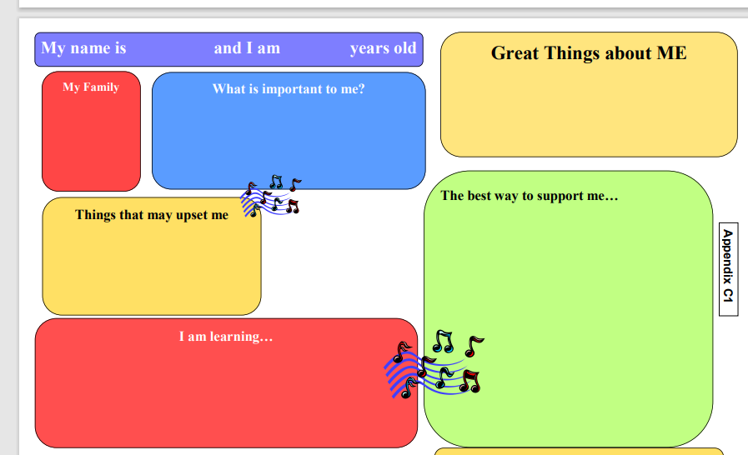
Figure 8: Flying Start (2017 p71)

Proposed outcomes
Lindon (2016) explains that communication in forms of spoken language is what children absorb most information from. The language directed to them to explain changes in their day by parents, practitioners and other care provider need to be clear and consistent.
Positive intervention measures such as use of photograph books of the setting with small explanations will help the child become more familiar with what they will expect when leaving parents to attend nursery (Flying Start 2017). Flying start (2017) continue to set out that robust communication such as telephone calls, written communication slips and producing routine reviews with opportunities to meet with practitioners can form better relationships.
The curriculum set out in the Foundation Phase Framework (2015) expects that with appropriate structed and planned opportunities in the learning environment children should enhance their progression developmentally. Equally the learning environment gives opportunity for children to explore being the unique children they are and freely explore through their curiosity and play (Tovey 2010).
Multi-agency practitioners need to share information positively and accurately in a timely manner. Of course, this is deemed best practise to do so and in some case it can save lives (Childrens Workforce Development Council). The information that is shared must remain confidential and at the same time respond to the rights of the child (UNCRC). The outcome of working within the above guidelines gives the child a good foundation of advocates to maintain their basic needs (Maslow 1943) whilst maintaining their rights as a child (Welsh Government 2014).
To conclude it is widely evidenced within this handbook that all theories, research and policies focus the need on the centre of the child. Flying Start (2017) really support face to face interactions in the first steps of the transition process along side Kirklees Council being keen drivers of visual resources for home to familiarise the child of the coming changes of environment and adults taking care of them. Through out all the theorist research showed they all highlight basic needs and a baseline of needs being met (Maslow and Frobel). In addition Bowlby explains that having secure attachments with a parent or care giver gaining trust and a sense of security helps lower the anxiety share by both parent and child when leaving each other in the early stages of a vertical transition process (Verywellmind 2023).

Referance list Module 3 – Human Development
Birth to 5 Matters is published by Early Education on behalf of the Early Years Coalition Transitions – Birth To 5 Matters (Accessed: 29th November 2023)
Brooker, Liz. (2008) Supporting Transitions in the Early Years [electronic resource]. Maidenhead :, McGraw-Hill Education.
Children's rights in Wales | GOV.WALES (Accessed: 29th November 2023)
(Children’s Workforce Development Council). https://moodle.uwtsd.ac.uk/mod/resource/view.php?id=514249 (Accessed: 29th November 2023)
Early Learning Resources Effective communication in early years settings (earlylearninghq.org.uk) (Accessed: 29th November2023)
Flying Start Transition Guide (2017) https://moodle.uwtsd.ac.uk/mod/resource/view.php?id=514247 (Accessed: 27th November 2023)
foundation-phase-framework-revised-2015.pdf (gov.wales) (Accessed: 27th November 2023)
Frobel Principles and practice today https://moodle.uwtsd.ac.uk/mod/resource/view.php?id=514237 Helen Tovey 2010 Clarence Lodge, Clarence Lane, Roehampton, London SW15 5JW Registered Charity No.1145128
good-practice-guide.pdf (gov.wales) (Accessed 29th November)
Jennie Lindon and Kathy Brodie (2016) Understanding Child Development 0-8 Years 4th Edition: Linking Theory and Practice. London: Hodder Education Group (Linking Theory and Practice). Available at: https://search-ebscohost-com.ezproxy.uwtsd.ac.uk/login.aspx?direct=true&db=nlebk&AN=1483002&site=ehost-live (Accessed: 27 November 2023).
John Bowlby: His Life and Theory of Attachment (verywellmind.com) (Accessed: 27th November 2023)
Kirklees Council https://moodle.uwtsd.ac.uk/mod/resource/view.php?id=514250
Lindon, Jennie. (2012) Understanding child development 0-8 years [electronic resource] . 3rd ed. London :, Hodder Education.
Maslow's Hierarchy of Needs: A Simple Summary - The World of Work Project (Accessed: 27th November 2023)
"Now What?" – The Energy Behind Your Next Big Transition | Wake Up World (wakeup-world.com) (Accessed: 26th November 2023)
Nutbrown, Cathy. (2008) Early childhood education [electronic resource] : history, philosophy and experience . Los Angeles :, SAGE.
Social Services and Well-being (Wales) Act 2014: children's rights impact assessments | GOV.WALES (Accessed: 29th November 2023)
The open University Early childhood transitions research: A review of concepts, theory, and practice
(2023) Vogler, Pia; Crivello, Gina and Woodhead, Martin (2008). Early childhood transitions research: A review of concepts, theory, and practice’ Working Paper 48. Bern
The-Right-Way.pdf (childcomwales.org.uk) (Accessed: 29th November 2023)
Transitions for Children - The OT Toolbox (Accessed: 17th November 2023)
L. Trodd (ed.) (2013) Transitions in the early years : working with children and families . Los Angeles :, SAGE.
United Nations Conventions on the Rights of the Child UN Convention on the Rights of the Child - UNICEF UK (Accessed: 28th November 2023)
4 piece puzzle image - Search Images (bing.com) (Accessed: 27th November 2023)

