Advanced Industry 4.0
Assignment 1 – Written Report
MSc Industry 4.0 Advanced Manufacturing
Module Code: ACPA7000
Supervisor: Mahesh Kannath

A review of business models and forms of operations that lead to new sources of value using Industry 4.0 technologies.

16th September 2022
Student: Christopher O’Connor
Email: christopher.oconnor@hanson.biz





Contents
Summary 3
Introduction 4
What is Industry 4.0? 4
What is a Business Model? 4
Key business models implemented in Industry 4.0 5
Traditional Business Models and their Industry 4.0 adoption 5
Retailer model 5
Manufacturer model 7
Subscription model 8
Conclusions and recommendations 9
Table of Figures 10
Bibliography 11

Summary
With the Fourth Industrial Revolution gathering momentum across all industries and organisations, it is important that the technologies and their ability to add value are imbedded in any business model. This report looks to briefly explain what Industry 4.0 and a Business Models (BM) are, before looking at how the former is impacting the traditional BM type and creating new avenues for value. The report looks at three well known organisations BM’s and what Industry 4.0 technology has been implemented and what value it has added. Finally, it discusses the hurdles that businesses as well as society itself faces to successfully implement and leverage Industry 4.0 technologies.

Introduction

What is Industry 4.0?
Industry 4.0 is a term that was coined in 2011 at the Hannover Fair in Germany. At the time it referred to changes directly linked to automation fields integrated with information technology (Epicor, 2022). Eleven years later it encompasses far more and can be interpreted as a comprehensive digitalisation and wide-ranging interconnection of industrial value creation promising potentials for both individual companies and entire supply chains (Veile, et al., 2022).
Technologies that are synonymous with the term Industry 4.0 are:
- Internet of Things (IoT)
- Additive Manufacturing
- Advanced Robotics
- Artificial Intelligence
- Cyber-physical systems
Industry 4.0 technologies on their own may offer some value add, but generally they are not enough to obtain substantial, long-lasting gains within a business. Therefore, it is essential that not only should businesses consider the adoption of said technologies, but they must also imbed them in their business strategies and subsequent business models to ensure maximum leverage and value are gained (Bittencourt, et al., 2021).
The main advantages that Industry 4.0 technologies offer are:
- Increased efficiencies (work and economic)
- Reduction in production costs
- Increased flexibility
- Increased return on investment (ROI)

What is a Business Model?
A Business Model (BM) can simply be described as the “how” the business goes about achieving its business strategy goals. Business model innovation outlines the rationale of how value within a business is created, delivered, and captured, as opposed to it being gained through new producer service creation (Kriss & R, 2022).
Firstly, it is important to see what the key components of a typical BM are before we look at how Industry 4.0 technologies are influencing them. Below is an example of a Business Model Canvas (template) showing each component:

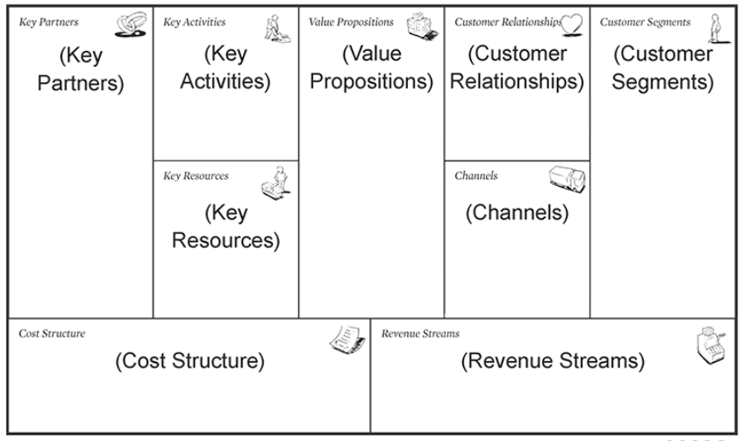
Figure 1 - Business Model Canvas Example – Toyota - (Cowan, A, 2022)
Industry 4.0 can be retrospectively applied holistically or to individual components of existing traditional types of business plans. However, the advancement of Industry 4.0 and its technologies has seen the emergence of a new disruptive type of business models based specifically on the industry 4.0 concept, appropriately named Digital Business Models (DBM). A DBM can be defined as a model that leverages digital technologies to improve several aspects of an organisation from how it acquires customers to what product/service it provides (Cuofano, 2022).
Another interesting and disruptive innovation model is that businesses accept that they are a part of a larger business eco-system, as opposed to a standalone “firm”, that find themselves digitally connected all along the value-stream lines to both traditional suppliers and customers. Industry 4.0 technologies such as the IoT are a particular driver in these eco-system models as it offers real time, almost 24/7 connectivity and huge amounts of data access to all stakeholders (Hakanen & Rajala, 2018).

Key business models implemented in Industry 4.0
Using traditional business model types as reference, the author will now explain how industry 4.0 technologies are being integrated into the BM’s and how they are contributing to increased value in existing and new sources.

Traditional Business Models and their Industry 4.0 adoption

Retailer model
The Retailer model is perhaps one of the oldest and most well-established types of business models, even if it has not always been named so. Typically, it consists of buying goods from a manufacturer and then selling them on to a customer for more than they were purchased for. With the introduction of the internet and subsequent advancements in mobile phone technology, retail models are being driven to a more e-commerce type, with global online sales expected to grow to 22% in 2023 from 14.1% in 2019 (Big Commerce, 2022).
Amazon originally operated under such a model, it has significantly evolved however since being founded in 1994 by Jeff Bezos to a more eco-system-based model that synthesises many different models under one umbrella, such as retailer, subscription, and distribution for example. Industry 4.0 and the implementation of its technologies have significantly contributed towards the success of this synthesised eco-system, some of examples of which will be given next.
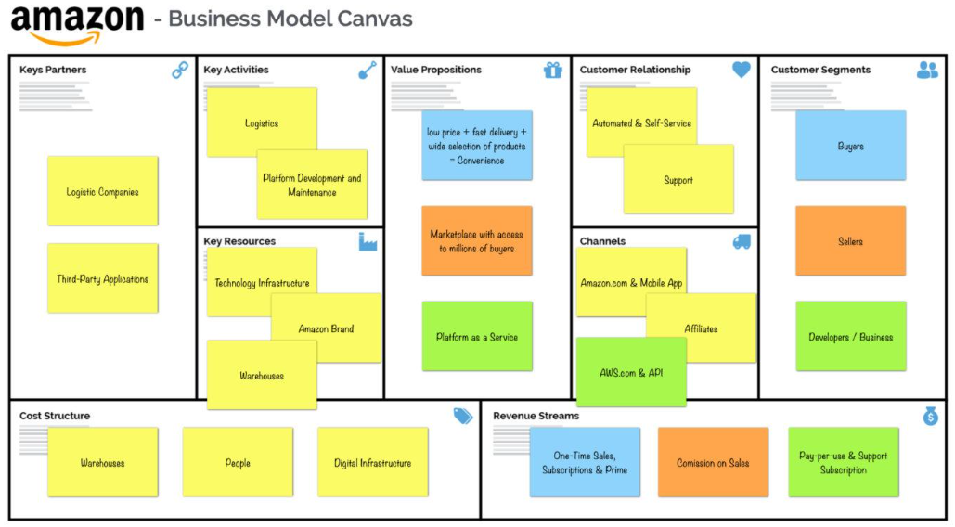
Figure 2 - Amazon Business Model Canvas - (Pereria, 2022)

Advanced robotics and the IoT for inventory management
What is Advanced Robotics? Advanced robotics are programmable machines that are digitally integrated into business systems using wired or wireless connectivity and sensors that allow them to interact with the real world that surrounds them (RGBSI, 2022).
What is the Internet of Things (IoT)? The Internet of Things is connectivity of machinery or products to servers in a closed loop system using sensors and readers. Typically, the information contained or received is then analysed by IoT analytics and which determine the actions of the human, machine, or software outputs (Marquez, 2021).
Amazon have seen such value in the automation of specific business steps through advanced robotics that have a business line that contributes to the R&D of the technology and its development. Amazon combines the above technologies to offer solution into the sorting, transport, and packaging of their products. Products are identified with technologies such as radio frequency identification tags or QR codes which allows them to be traced from receipt of delivery to dispatch (Hakanen & Rajala, 2018). This allows an excellent understanding of inventory movements to allow maximum utilisation of storage space and inventory management.

Manufacturer model
The manufacturing model is based around a business turning a raw material into a product that is considered of value to a customer based on predetermined specifications. Car manufacturers are an excellent version of such a model. At a basic level, they design a product based on available consumer preferences, purchase base parts of manufacture them from new, then assemble them together to give the final useable product. There are several value-add steps that take place in a car manufacturing work stream, for example when raw materials are made into useable parts, or useable parts are assembled to form working equipment/machinery.
Your traditional manufacturing business model may typically look like the below diagram:
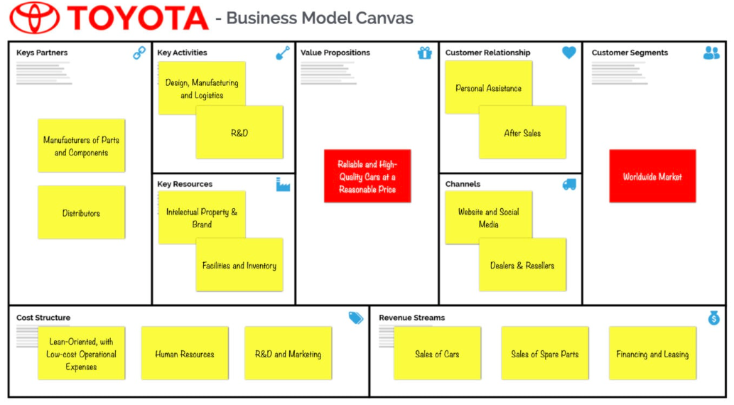
Figure 3 - Toyota Business Model Canvas (Pereria, 2022)

The use of Digital Twins in Process Optimisation
What is a Digital Twin? A digital twin is essentially an approximate imitation of a process or system that can span its lifecycle, can be updated in real time, and uses machine learning to aid in decision making (Monti, et al., 2020).
They can be applied to an entire production process, from the buildings, the machinery and all the way down to the individual product components. They are being used at the design stage of factory lay out to ensure the space and process flows are optimised to reduce transport times and increase productivity, for example. On a more granular level they can be used to create simulations of products that can then be rigorously (virtually) tested under specific conditions to understand full product life cycle and predict failure patterns. This enables the business to either design out the issues that lead to premature failure or provide customers with accurate life cycle times so that pre-emptive procurement of parts can be more accurately estimated (Tao, et al., 2019).

Subscription model
This model is based on the concept of a customer paying a reoccurring fee for continued access to a product or service. It is based on customers continued value in what is being provided, which can be a challenge particularly now with customer preferences changing frequently (Campbell, 2021). The opportunity to know and then continuously update your service to suit these needs is where real value can be gained, this value can be added using Industry 4.0 technologies. Netflix is a good example of a subscription model that is using Industry 4.0 to leverage its market position and value creation.
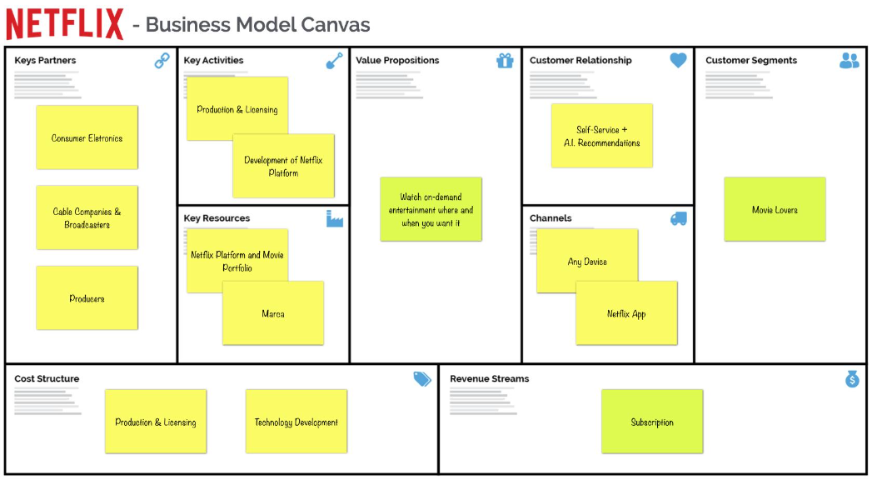
Figure 4 - Netflix Business Model Canvas (Pereria, 2022)

Big Data, Artificial Intelligence, and their use by Netflix in adding value to its business model
What is Big Data? It can be expressed as a combination of data managing technologies that enable organisations to store, manage and manipulate large quantities of data in a time frame suitable to be able to use it to improve a process, product, or service (Hurwitz, 2013). Technologies such as Cloud Storage, Artificial Intelligence, IoT and sophisticated modelling programmes such as Trident (Apache Storm, 2022) are allowing leverage such data to improve numerous components of their business models.
What is Artificial Intelligence? At its purest form it can be described as a field that amalgamates computer science with robust datasets with the aim of solving problems independent from human participation (IBM, 2020). Typical benefits that AI offers are
- Improved customer service through better response time
- Reduced errors through automated tasks and services
- Improved decision-making accuracy and time
- Tackling of complex problems
A worked example of the combination of AI and Big Data in relation to Netflix is targeted content. Instead of people scrolling through lists of TV programmes or films, A.I. targets specific content to the user based on assumptions made from Big Data analytics carried out on watching patterns of other similar uses to ensure engagement is kept up and subsequent subscription fees are renewed (Arti, 2022). Value creation is also seen in the Production component of the business model as it allows Netflix to make new content based on the preferences of its customers.

Conclusions and recommendations
Industry 4.0 technologies have caused a wave of disruptive innovation to traditional business models, by way of how value is created but also by opening new avenues of value add without significantly changing the overall business strategy. The challenges for business will be how they implement such technologies whilst satisfying other components of their business such as security, resource, training and development and socio-economic factors. Opening a business in terms of connectivity to a global platform of data information present serious security problems that must be considered and mitigated before any success implementation of technologies can be made. Block chain technologies and cyber security development are some answers to the security problem; however, these can be costly if your business is not adequality equipped in terms of knowledge and training to best utilise them. Conversely cyber security itself is becoming a more appealing business model when you consider that in the UK alone the industry was valued at £8.3 billion and has increased 44% from 2017 – 2020 (Gov, 2020). Socio-economic impacts on workers and subsequent communities are significant concern not just for organisations, but for governments themselves if you consider that tasks normally carried out by people will be filled by robots and machinery. Drastic steps such as trials of universal income, which gives a nominal amount of money of all persons of a certain based on living needs data, are being carried out to try and mitigate this problem in the future (Stone, 2022).

Table of Figures
Figure 1 - Business Model Canvas Example – Toyota - (Cowan, A, 2022) 5
Figure 2 - Amazon Business Model Canvas - (Pereria, 2022) 6
Figure 3 - Toyota Business Model Canvas (Pereria, 2022) 7
Figure 4 - Netflix Business Model Canvas (Pereria, 2022) 8

Bibliography
Apache Storm, 2022. Trident Tutorial. [Online]
Available at: https://storm.apache.org/releases/current/Trident-tutorial.html
[Accessed September 2022].
Arti, 2022. Analytics Insight. [Online]
Available at: https://www.analyticsinsight.net/top-10-ways-netflix-is-using-artificial-intelligence-in-2022/#:~:text=Netflix%20uses%20artificial%20intelligence%20and,Artificial%20Intelligence%20effectively%20in%202022.
[Accessed September 2022].
Big Commerce, 2022. Ecommerce 101: The History and Future of Online Shopping. [Online]
Available at: https://www.bigcommerce.co.uk/articles/ecommerce/
[Accessed Sept 2022].
Bittencourt, V. L., Alves, A. C. & Leao, C. P., 2021. Industry 4.0 triggered by Lean Thinking: insights from a systematic literature review. International Journal of Production Research, 59(5), pp. 1496-1510.
Campbell, P., 2021. Price Intelligently. [Online]
Available at: https://www.priceintelligently.com/blog/subscription-business-model
[Accessed September 2022].
Cowan, A, 2022. Cowan +. [Online]
Available at: https://www.alexandercowan.com/business-model-canvas-templates/
[Accessed Sept 2022].
Cuofano, G., 2022. FourWeekMBA - Digital Business Models Map: Digital Business Model Types in 2022. [Online]
Available at: https://fourweekmba.com/digital-business-models/#:~:text=A%20digital%20business%20model%20might,helps%20enhance%20its%20value%20proposition.
[Accessed September 2022].
Epicor, 2022. What is Industry 4.0 - the Industrial Internet of Things (IIoT)?. [Online]
Available at: https://www.epicor.com/en-uk/blog/learn/what-is-industry-4-0/
[Accessed September 2022].
Gov, 2020. Business and Industry. [Online]
Available at: https://www.gov.uk/government/news/uks-booming-cyber-security-sector-worth-83-billion
[Accessed September 2022].
Hakanen, E. & Rajala, R., 2018. Material Intelligence as a driver for value creation in IoT-enabled business ecosystems. Journal of Business and Industrial Mining, 33(6), pp. 857-867.
Hurwitz, J., 2013. Big Data for Dummies. New Jersey: John Wiley @ Sons, Inc.
IBM, 2020. What is Artificial Intelligence. [Online]
Available at: https://www.ibm.com/cloud/learn/what-is-artificial-intelligence
[Accessed September 2022].
Kriss, R. & R, M., 2022. Nerdwallet - Business Models: Types, Examples and How to Design One. [Online]
Available at: https://www.nerdwallet.com/article/small-business/what-is-a-business-model
[Accessed September 2022].
Marquez, F., 2021. Internet of Things. London: IntechOpen.
Monti, A., Corti, D. & Pietraroia, D., 2020. A Simulation Model Supporting the Production Optimisation for High-Precision Machines Assembly. Novi Sad, SUPSI.
Pereria, D., 2022. Business Model Analyst. [Online]
Available at: https://businessmodelanalyst.com/business-model-canvas-examples/page/4/
[Accessed Sept 2022].
RGBSI, 2022. The Impact of Advanced Robotics on Manufacturing. [Online]
Available at: https://blog.rgbsi.com/impact-of-advanced-robotics-on-manufacturing#:~:text=What%20are%20advanced%20robotics%3F,the%20real%20world%20around%20it.
[Accessed September 2022].
Stone, J., 2022. Independent. [Online]
Available at: https://www.independent.co.uk/news/uk/politics/universal-basic-income-wales-pilot-b2031819.html
[Accessed September 2022].
Strategyzer, 2022. Business Models. [Online]
Available at: https://www.strategyzer.com/expertise/business-models
[Accessed September 2022].
Tao, F., Qi, Q., Wang, L. & C, N. A. Y., 2019. Digital Twins and Cyber-physical Systems toward Smart Manufacturing and Industry 4.0: Correlation and Comparison. Elsevier, Volume 5, pp. 653-661.
Veile, W. J., Schmidt, M. & Voigt, K., 2022. Toward a new era of cooperation: How industrial digital platforms transform business models in Industry 4.0. Journal of Business Research, Volume 143, pp. 387-405.

