Operating Systems and Command-Line Interfaces
Name-Jahvon Genus
Student number 2532390
Modula lecture-Anum Paracha
Course Name-Computer Architecture and Operating Systems
Module code-ACCA4022

There are many popular operating systems which phone and computer use to manage all software and hardware resources such as chrome OS and Microsoft window, which are designed for computers and Apple macs OS and android OS which are for phone.
CPU
Operating systems manages many things in your device to help it keep stable and run efficiently without your device crashing and having delay and one of the way an operating system prevent this issue from accruing is to manage all the programs running in your computer and decides which one gets to use the CPU. This is so multiple programs can run at the same time without the risk of your device crashing because the operating systems control’s which program get processing time and when. This is called CPU scheduling, and it determines which program get priority over other than swiftly switches it to another program allowing the CPU to operate without any issues.
Memory management
The operating system also manages your devices memory to prevent any of your programmes that are running from clashing and deleting each other data which could cause your device to crash and have major delays. It prevents this by giving a program a separate portion of the RAM to stop it from accessing and changing other programs data and if the portion of RAM is full it will then be saved in the Hard drive or the SSD. then once you close the program the operating system releases the memory to allow a new program to use that portion of RAM. The operating system also constantly watches and manages how much memory each program is using and prioritise the important programs to prevent the system from running out of memory.
File and Storage Management
The operating system also manages files and storage by organising, storing and retrieving your data while also protecting it so that know but the user can access it.it does this by allowing the user to create new files and move, copy, save, rename, delete or move files to another folder or area and no matter where you save it the Operating system will keep track of how much storage space you have.
Device & Peripheral Management
Not only do the operating system control and manage the software and data it also communicate with the Device & Peripheral, it’s able to do this because the operating system is like a universal translator between your software application and hardware so when the user their keyboard, mouse or printer it goes through the steps of using device drivers, interrupt handlining and buffering. This is so the so programs don't need to understand the complex, low-level mechanics of every specific mouse, keyboard, or printer.
User Interface
The operating system acts as a bridge for user and the hardware and with its help it allows the user to use two main interface which are graphical user interface and command line interface. An example graphical user interface are menus, icons and windows operating system which are used to issue commands and are easy to learn.as for command line interface it is harder to learn and memorise and example of it are DOS and Unix.
Security and Access Control
The operating system also protects your data and information from any malware and unauthorized users by managing your accounts and passwords and will only allow access to the user.

Windows task manager Windows file explorer
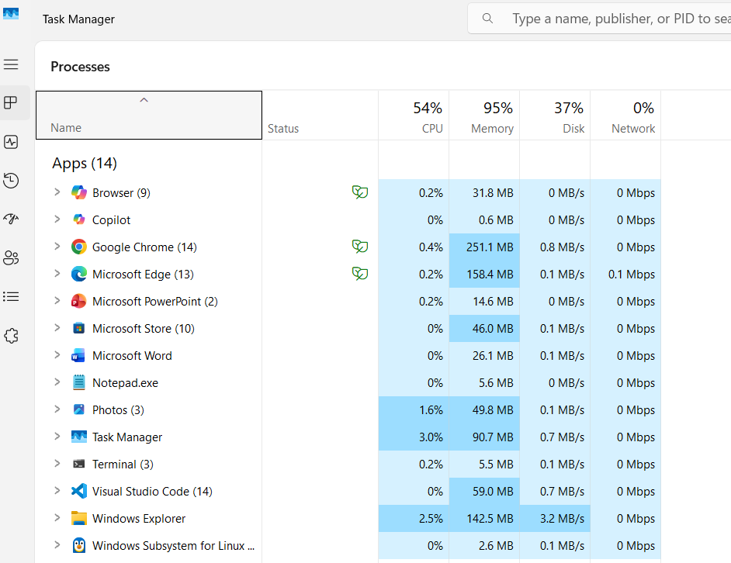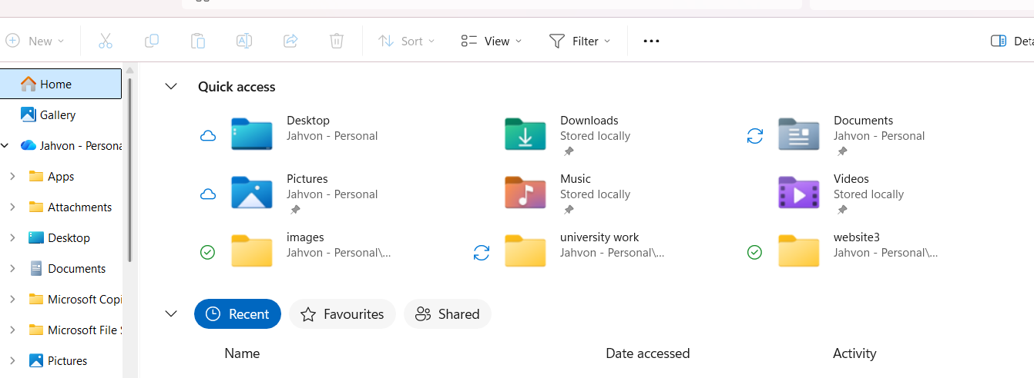

Device manager Window account

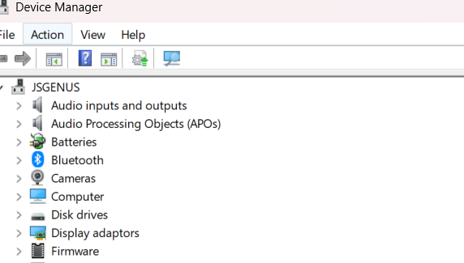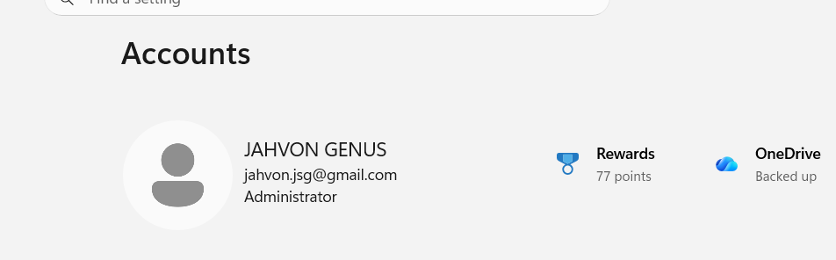

Windows security
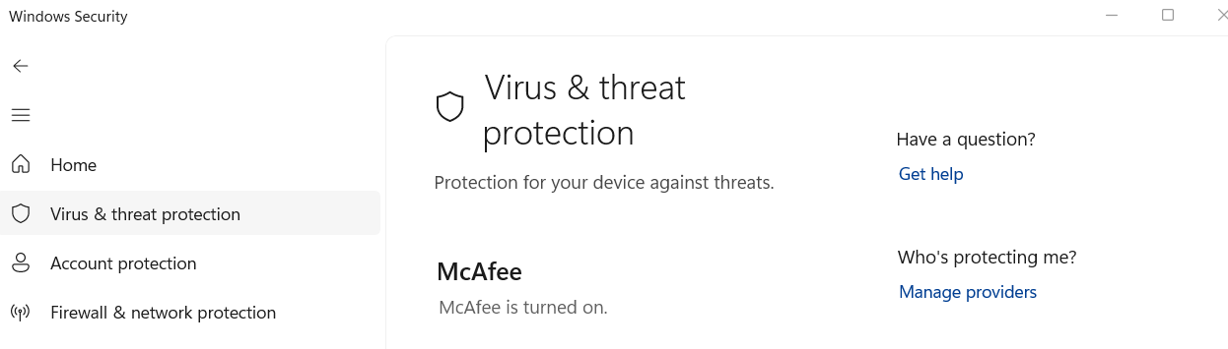

2) windows commands
Process management
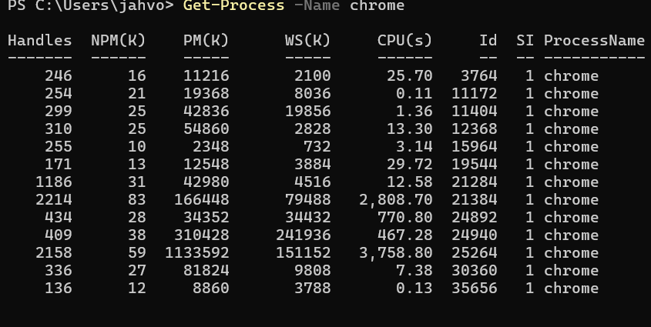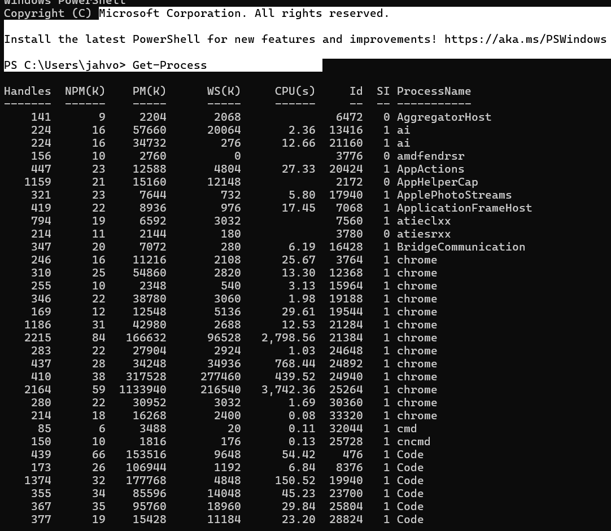
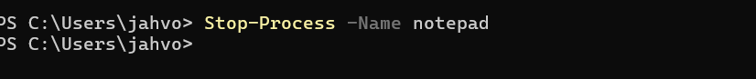T

The Get-Process command displays the processes currently running on the Windows operating system. The -Name chrome option filters the results so that only Google Chrome processes are shown. Information such as the process ID and CPU time can be used to monitor resource use. The Stop-Process -Name notepad command terminates Notepad.

File & directory management

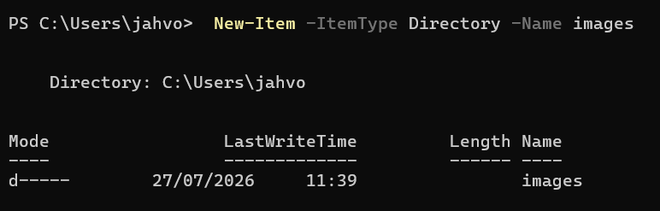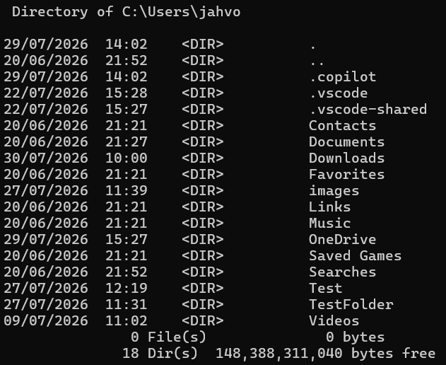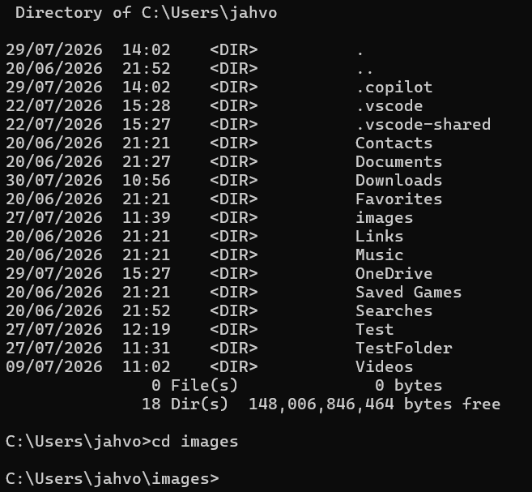 This PowerShell command creates a new folder called images
- New-Item — creates something new.
- -ItemType Directory — specifies that it should be a folder.
- -Name images — names the new folder “images.”
This command creates a new directory named “images” in the current location. It can be used to organise image files for a project.
This command displays all files and folders in the current location.
<DIR> means that the listed item is a directory or folder.

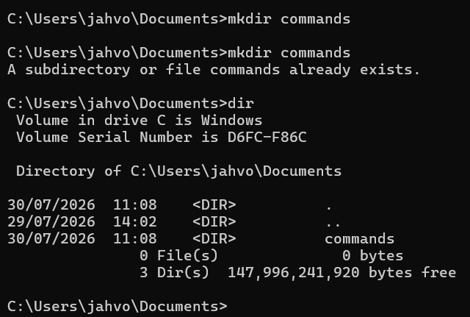this command creates a new folder for you to user to use.MKDIR mean make directory

Network

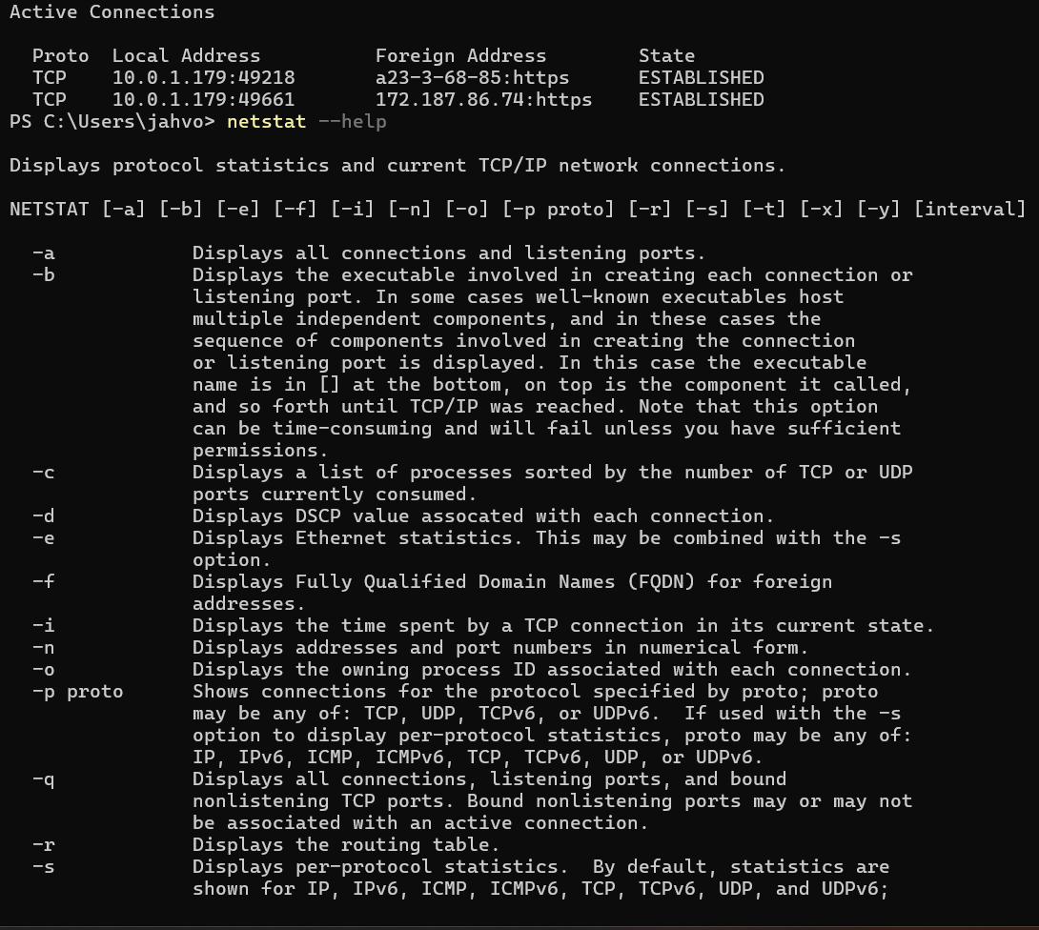
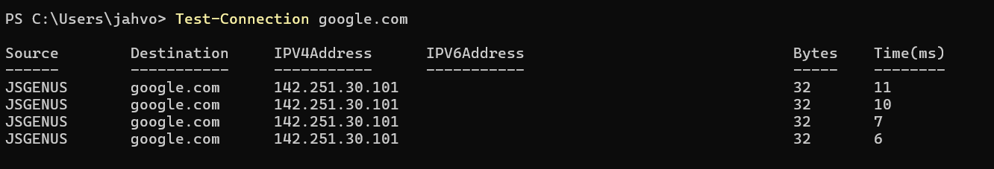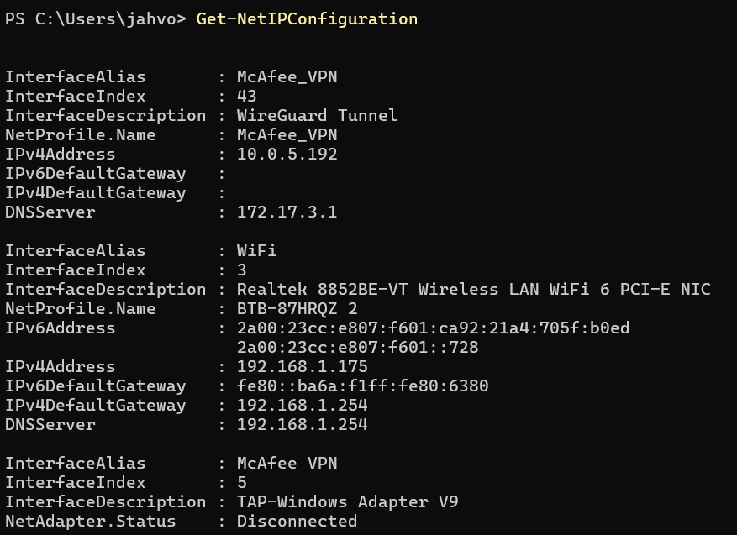
The netstat command displays active network connections on the computer. It shows local and remote addresses, port numbers and the status of each connection. It is useful for monitoring network activity and identifying connections currently in use.
The netstat --help command displays instructions and available options for using netstat. This helps the user select suitable options for examining network connections and statistics
The Test-Connection google.com command sends test packets to Google’s server to check network connectivity
The Get Net IP configuration -This PowerShell command displays the computer’s network configuration, including Wi-Fi, VPN and other network adapters.
.
User management

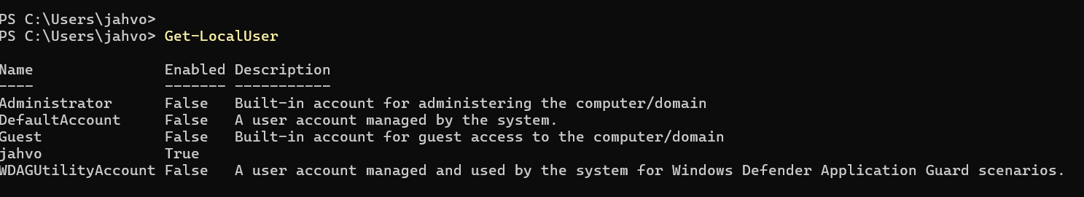
This PowerShell command displays all local user accounts stored on the Windows computer.
Task management

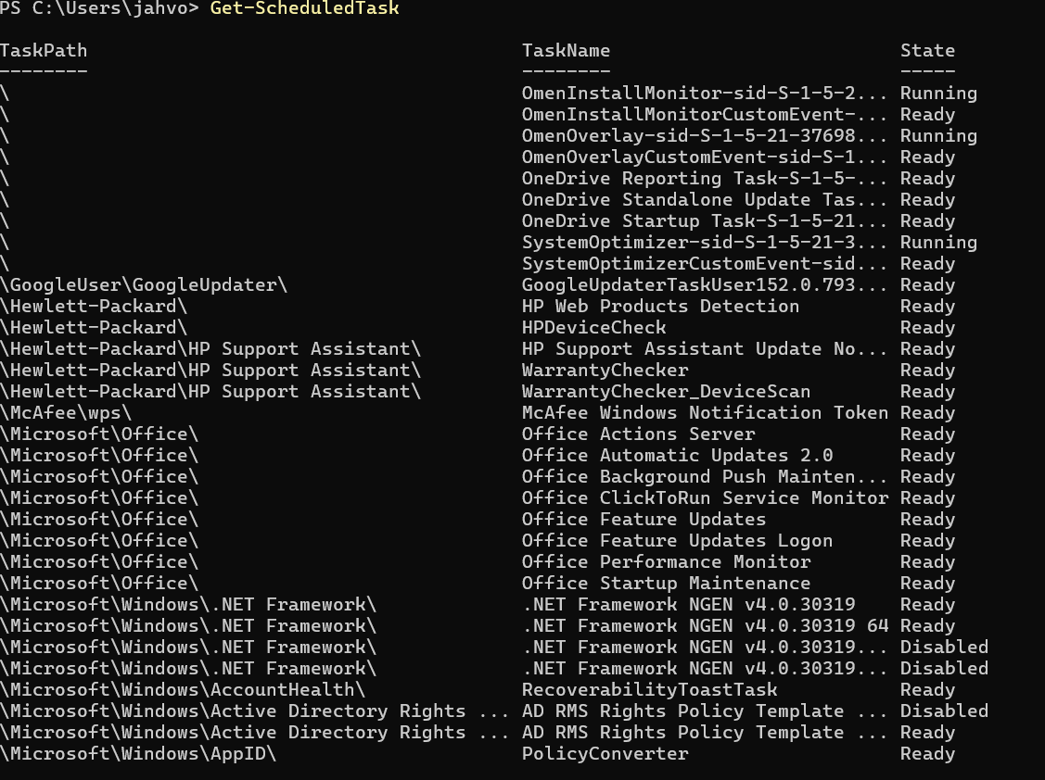This PowerShell command displays the scheduled tasks saved on the Windows computer. Scheduled tasks are programs or actions that Windows runs automatically at a particular time or when a specific event happens.

Linux command
Process management
. Display running processes
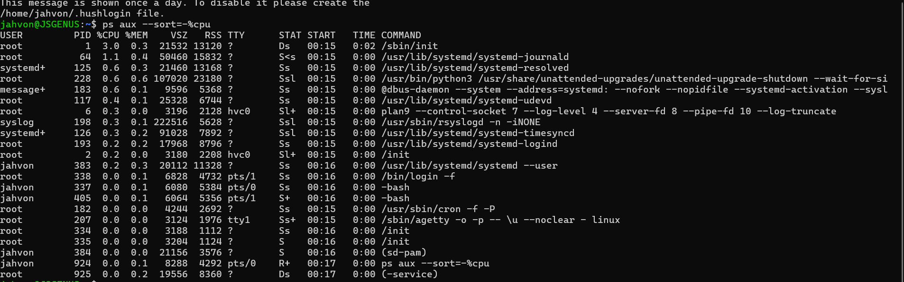The command displays detailed information about running processes and sorts them by CPU usage. It helps administrators identify processes consuming system resources.
Monitor processes
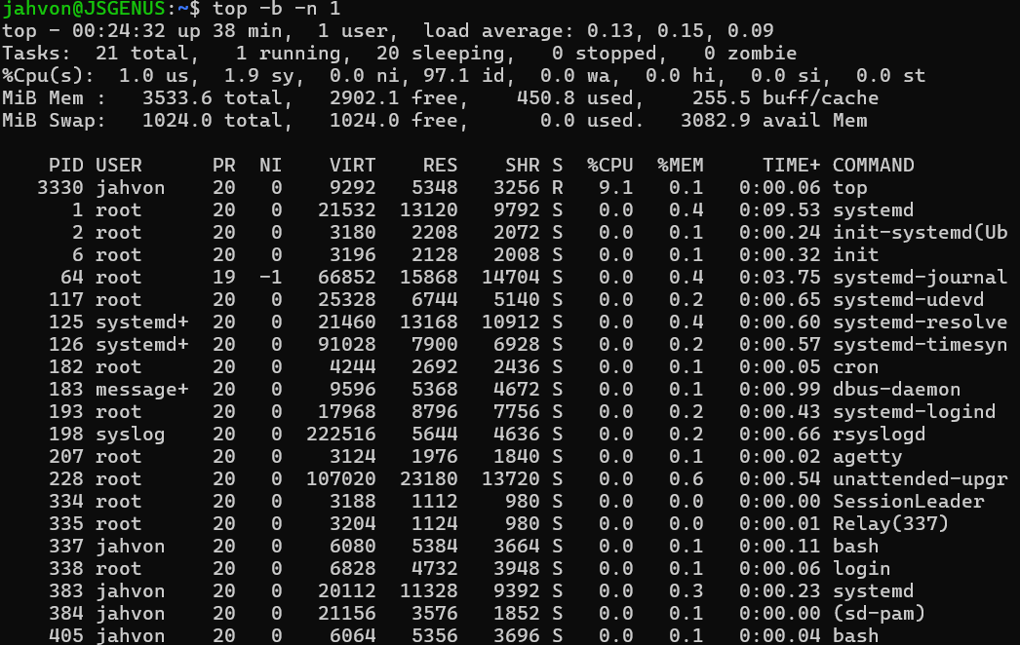This command provides a snapshot of running processes, CPU activity and memory consumption. It is useful for monitoring system performance.

File and directory management
Create a directory
Create a file
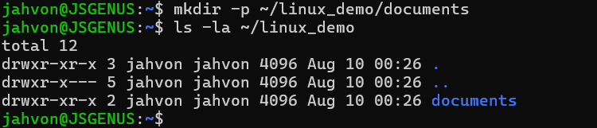The mkdir -p ~/linux_demo/documents command created a directory and its required parent directory. The ls -la ~/linux_demo command was then used to confirm its creation. The -l option displayed detailed information, including permissions and ownership, while -a included all directory entries.
List files

This copies original.txt into the documents directory and displays confirmation.
. Copy a file
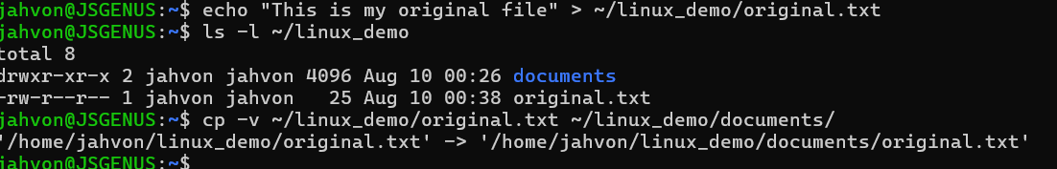

Network testing and monitoring
Test internet connectivity
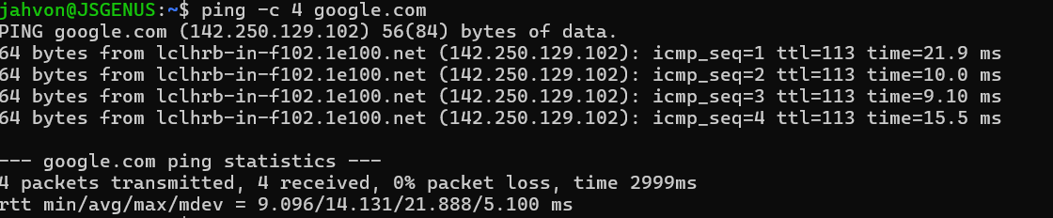 This tests whether the computer can communicate with Google and displays packet loss and response times.
Display network addresses
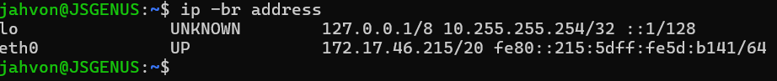 This displays the computer’s network interfaces, connection states and IP addresses. The ip utility can inspect network devices, addresses, routes and tunnels.
User management
Display the current username
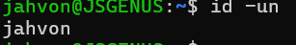 This identifies the user account currently operating the terminal.
. Task scheduling
Display cron jobs
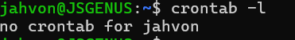
This displays tasks scheduled to run automatically for the current user. “No crontab” simply means that no tasks have been created yet.

Windows Batch scripts
calculator
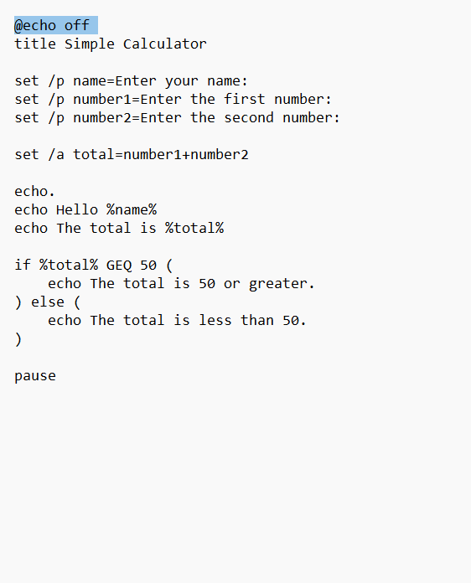 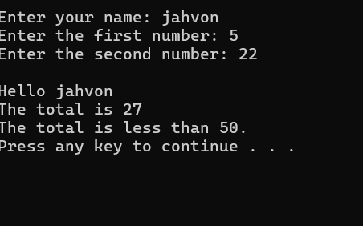 This Batch script asks the user to enter their name and two numbers. It adds the numbers using set /a and stores the answer in a variable. An if statement checks whether the total is at least 50 and displays the appropriate message
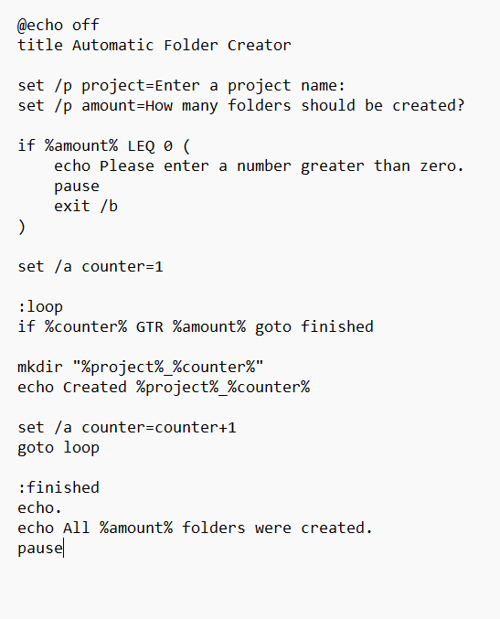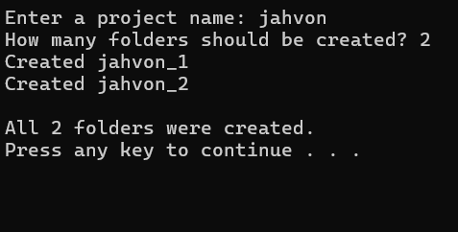this automacilly creates a folder for you

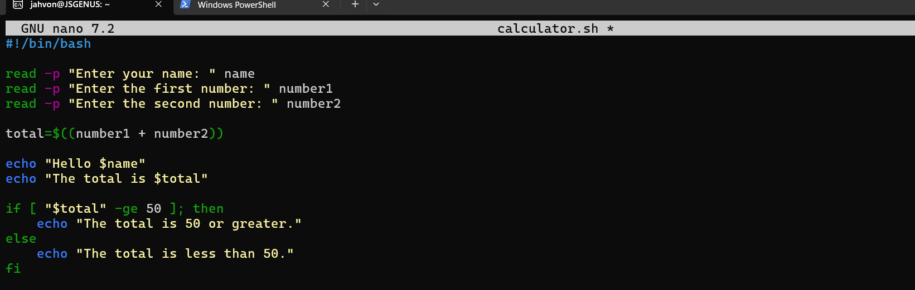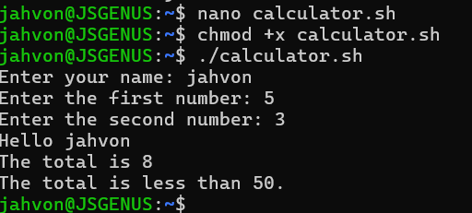this is a simple calulator that you can use any number apart from when its greater than 50



