

Programme: Master of Business Administration
Module: Marketing Management

Assignment Title: Marketing Strategies Portfolio
Portfolio (All Elements)
Student Name: Omkar Jalindar Shinde
Student ID: 2526513
Group:3
Lecturer: Dr. Tola Odugbesan
Word Count: 2650

Table of Contents
Element 1: Brand Extension Poster Presentation 3
Element 3: Marketing Mix (7Ps) 7
Element 4: Reflection 12
Harvard Reference 14

Element 1: Brand Extension Poster Presentation
Appendix A: Poster
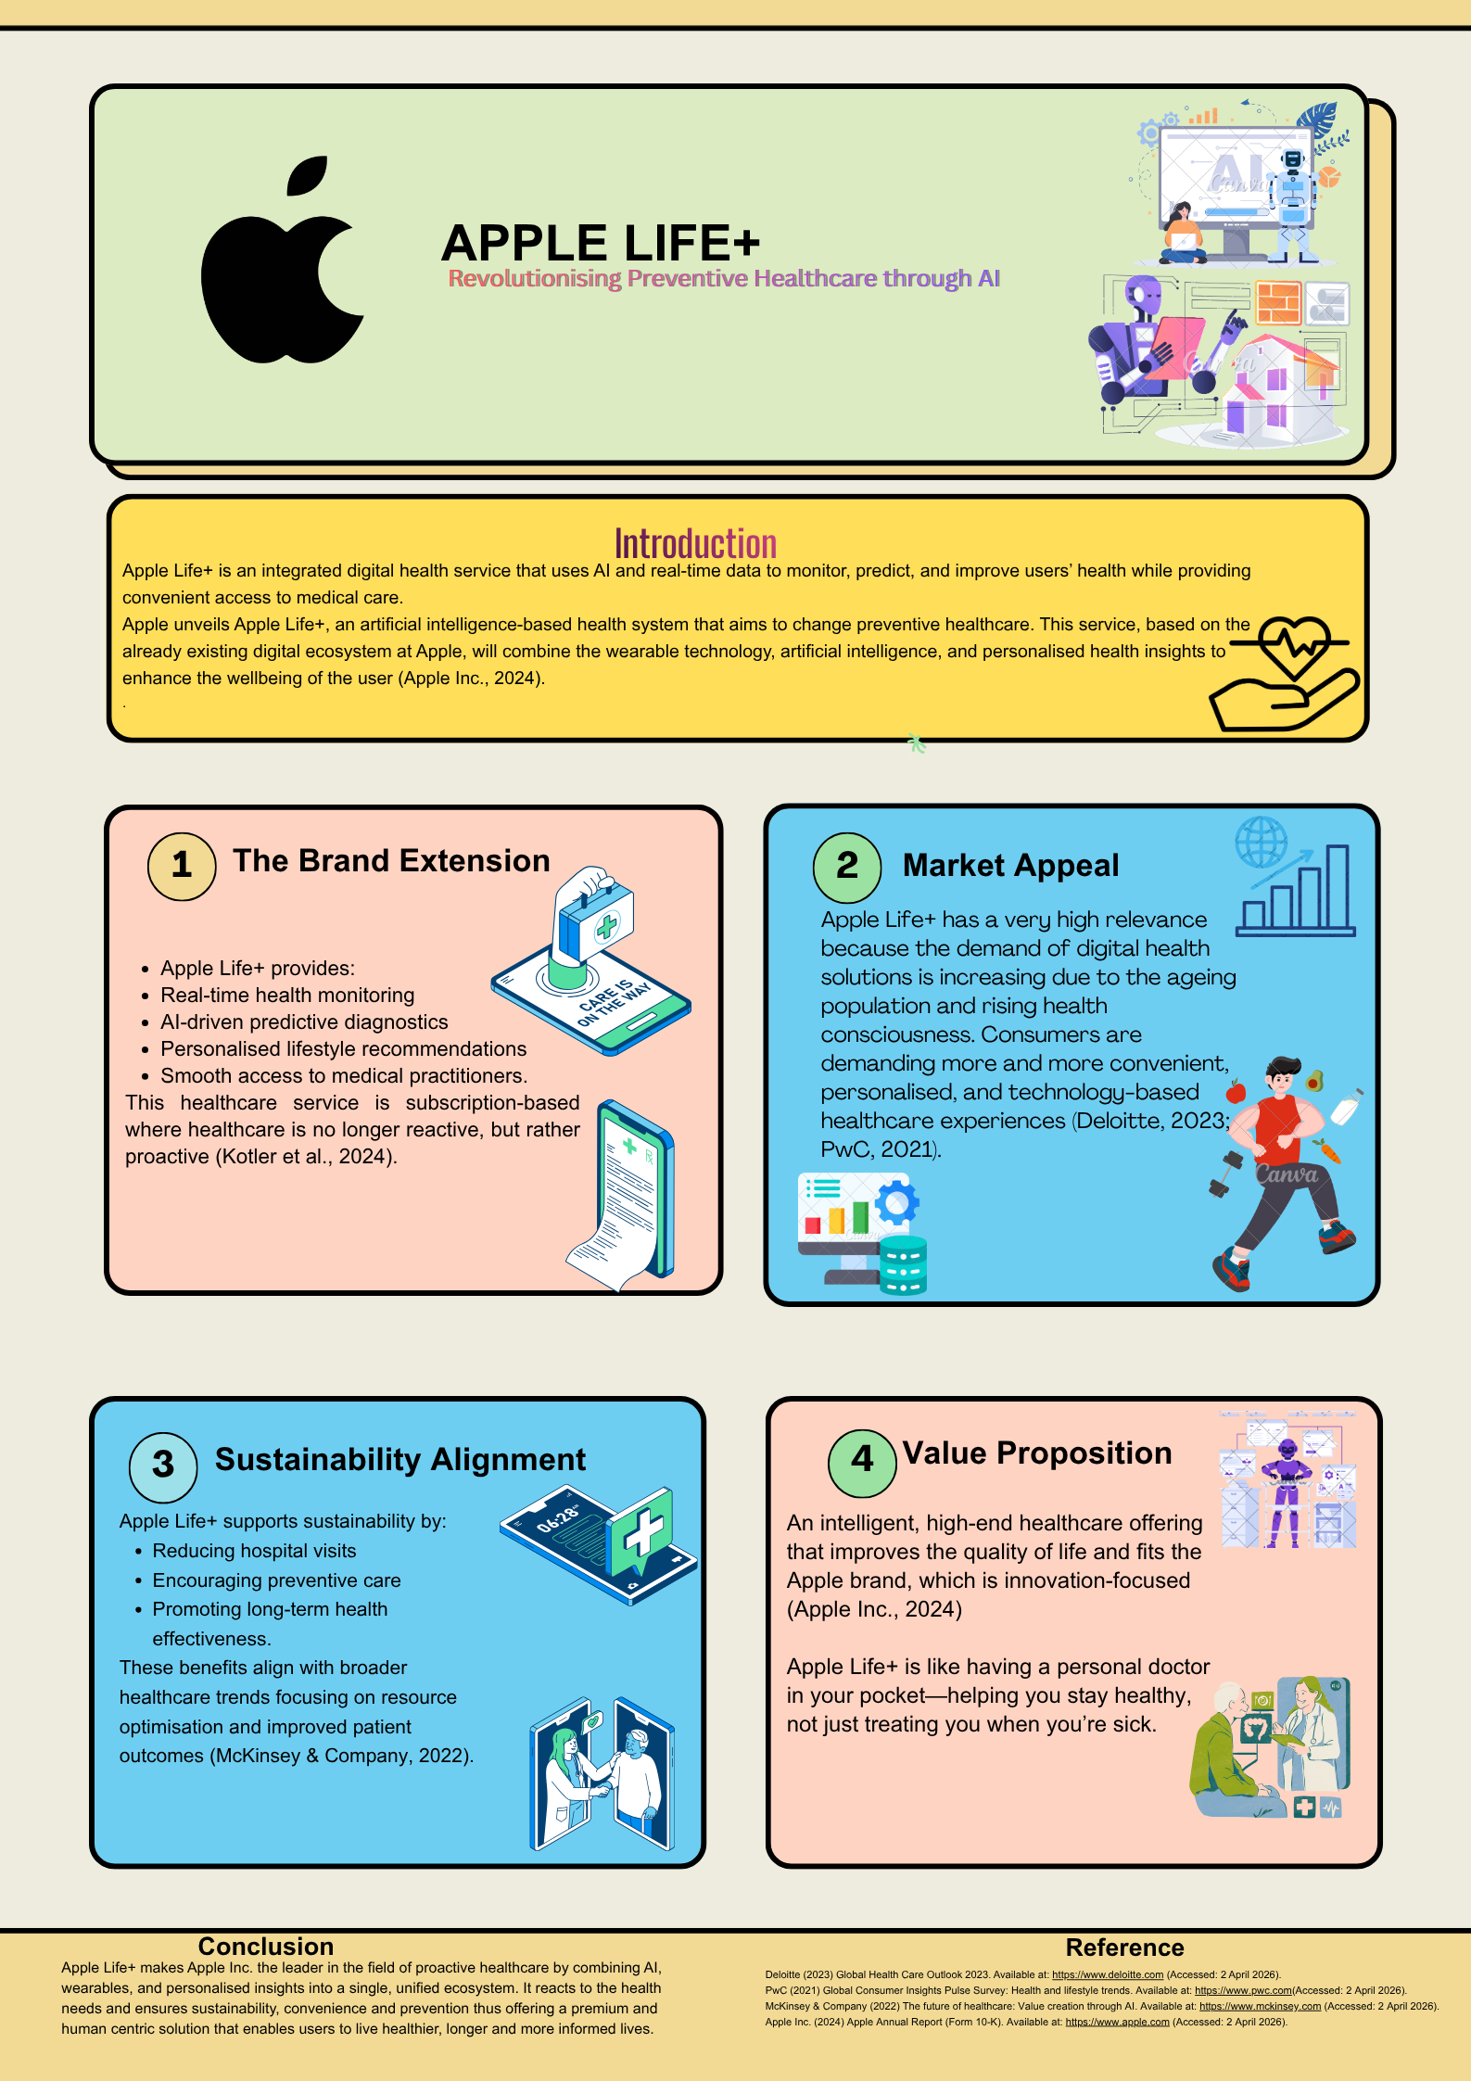
Figure A1: Poster

Element 2: STDP Analysis

Apple Life+ is a new brand extension created by Apple Inc. that is strategically important in the fast-growing digital health market. Targeting, Differentiation, and Positioning (STDP) approach that is in line with the changing market conditions and Apple main strengths in the innovation, integration, and high-end branding.
Segmentation
Apple Life+ uses a multi-dimensional segmentation approach, combining geographic, demographic, psychographic, and behavioural variables to embrace the intricacies of modern healthcare consumption (Kotler et al., 2024). The given approach represents the transition to the personalised and data-driven health solutions with consumer needs becoming more numerous and context-specific.
Geographically, the platform focuses on the developed markets like North America, Western Europe and the developed Asian economies. The areas have good digital infrastructure, high spending on healthcare, and extensive usage of wearable technologies, which would favour digital health platforms (Deloitte, 2023; McKinsey and Company, 2023). Yet, this emphasis indicates some strategic conservatism as well. Digital health is increasing more rapidly in emerging markets due to the increasing number of smartphones and the growing access to healthcare (WHO, 2023; Statista, 2024). This underservicing of these areas would expose Apple to the risk of missing out on early-stage growth opportunities and limit its long-term global scalability. Demographically, Apple Life+ is focused on people who have a medium to high income and are highly digital and have an age of 25-55. This group is close to the premium positioning of Apple and covers professionals who can afford and are willing to invest in preventive solutions to healthcare (PwC, 2023). The ageing demographic, especially the ageing of the population and the growing need in health monitoring technologies, can be seen in the addition of older adults as a secondary segment (OECD, 2023). However, the fact that the young consumers, in particular Generation Z, are relatively excluded can be viewed as a strategic flaw. This generation is very active in digital wellness and self-tracking devices and will probably shape the market dynamics in the future (Deloitte, 2024).
Apple Life + is psychographically targeted to people who are health-conscious and technology-oriented and are concerned with efficiency, control, and self-optimisation. This is in line with the quantified self movement, whereby people actively monitor and process personal health data to enhance wellbeing (Lupton, 2022). Such a segmentation has the potential to enhance the degree of emotional engagement and customer loyalty. Nevertheless, psychographic variables are dynamic and hard to operationalise in nature, which makes them less predictable when it comes to long-term strategic planning (Hollensen, 2023).
On the behavioural front, the platform targets users who are already involved in the wearable technologies and subscriptions-based digital services. This is a strategically beneficial solution, because it helps to use the existing Apple ecosystem to minimize the cost of acquisition and maximize customer retention (Cusumano et al., 2022). Nevertheless, it also poses a structural constraint: this dependence on ecosystems limits the access of non-Apple users and can decrease the interoperability in an increasingly open digital health ecosystem (Gawer, 2022).
Targeting
Apple has a differentiated targeting approach as it targets mainly technology-conscious professionals between the age of 25 and 45, but it also targets older people who can find preventive healthcare solutions. This two-pronged strategy strikes a balance between short-term profitability and long-term demographic changes, especially the increase in the need to monitor health among ageing populations (OECD, 2023).
The main segment is strategically appealing because of its high disposable income, digital use, and innovativeness. This is in line with the premium subscription model offered by Apple and helps in the generation of revenues. Nevertheless, the targeting approach is still mostly consumer oriented. The growth into business-to-business (B2B) categories, such as employers, insurers, and healthcare providers, can greatly improve the scalability and network effects in the digital health ecosystem (McKinsey & Company, 2023).
Additionally, the approach seems to be overly dependent on the brand trust as an adoption driver. Even though Apple is a high brand equity, other factors such as clinical validation, regulatory compliance, and perceived reliability are involved in healthcare decision making (Jiang et al., 2022). In this way, a more detailed targeting strategy incorporating institutional stakeholders should be implemented to increase credibility and legitimacy.
Differentiation
Apple Life+ will be differentiated in terms of ecosystem integration, AI-powered predictive features, premium branding, and personalisation. All these factors make up a strong and unique value proposition in the digital health market.
Ecosystem integration will enable all Apple devices to communicate with one another without any issues, which will not only make the user experience more fulfilling but also make it harder to shift to a new ecosystem (Gawer, 2022). This increase in customer loyalty but can also limit interoperability and make it less accommodating to non-apple system users.
The application of AI-powered predictive analytics on the platform marks a major transition to proactive healthcare, with the ability to detect issues early and take customised actions (Topol, 2023).Nevertheless, AI-based technologies also come with possible threats, such as algorithmic bias, inaccuracy of data, and ethical issues, which can cause a lack of trust without appropriate management (Jiang et al., 2022).
Apple brand equity is also a part of the differentiation, particularly, the privacy and reliability (Keller, 2023). Nevertheless, with healthcare, trust must be built on transparency and evidence-based outcomes, and brand perception cannot be the only aspect (Rust, 2022). Personalisation will increase user involvement and value creation but pose serious questions on the issues of data privacy and monitoring. Since digital health platforms deal with sensitive personal information, strong governance frameworks are needed to ensure that users can trust them and comply with the regulations (WHO, 2023).
Positioning
Apple Life+ will be positioned as a high-end, AI-based preventive health platform that enables users to actively maintain their health. This stance aligns with the brand identity of Apple that is built around innovation and is aligned with the growing consumer demand of personalised and continuous health management solutions (Keller, 2023; Deloitte, 2023).
This high end positioning however, poses a strategic conflict. While it adds to the perceived value and exclusivity, it can reduce accessibility and inclusivity in the price-sensitive markets. This raises the issue of a significant compromise between brand exclusivity and market coverage.
STDP Conclusion
Altogether, Apple Life+ shows a highly integrated STDP strategy that is in line with market trends as well as with the core capabilities of Apple. Nonetheless, its success in the long-term will relies on the ability to overcome such major constraints as reliance on the ecosystem, lack of accessibility, and ethical issues related to AI-driven healthcare.

Element 3: Marketing Mix (7Ps)

Product

Apple Life+ is a service-dominant product, created by Apple Inc., which combines wearable, artificial intelligence (AI) analytics, and healthcare services to form a single digital ecosystem. This is consistent with the service-dominant logic approach to value creation wherein the value is co-created during ongoing interaction between the user and the platform instead of being delivered as a fixed product (Vargo and Lusch, 2021). The main value proposal of the platform, which is preventive healthcare based on real-time monitoring and predictive insights, is a direct consequence of the larger movements towards personalised and proactive health management (Topol, 2023).
Strategically, the product goes a long way in supporting the Apple ecosystem advantage through seamless integration with other devices like the Apple Watch and iPhone. This enhances user experience and creates high switching costs, strengthening customer retention (Cusumano et al., 2022). Nonetheless, such integration is a structural constraint as well. Apple hardware dependency limits access to non-Apple users, which limits market penetration and poses questions about interoperability in an environment of healthcare that is becoming more cross-platform-friendly (Gawer, 2022).
Moreover, as the AI capabilities of the platform have great advantages, they also create issues of data accuracy, bias in the algorithms, and clinical reliability, which need to be resolved to guarantee trust in the long term (Jiang et al., 2022).

Price

Apple Life+ follows a premium subscription pricing strategy, which is based on perceived value and brand positioning of Apple (Kotler et al., 2024). It may enhance the value proposition and exclusivity of the product but lower the reach and inclusion in price-sensitive markets. This brings up the question of a trade-off between exclusivity and market share. However, high prices are a significant barrier to adoption, particularly in price-sensitive markets. This approach can restrict the adoption of the strategy by a large population and go against the societal objectives of inclusive healthcare in the context of healthcare, where accessibility is a key issue (WHO, 2023). It has been proposed that digital health pricing should be about both value perception and affordability to maximize adoption (Deloitte, 2023).
The tiered pricing model would provide a more adaptable strategy to enable users to use more basic features at a lower price without losing high-tier services (Hollensen, 2023). This approach would help Apple increase the number of users without diluting its brand equity, thus resolving the exclusivity and inclusivity tension found in the STDP analysis.

Place

Apple Life+ is mainly distributed digitally, which builds on the ecosystem established by Apple, such as the App Store and in-built device interfaces. This guarantees a smooth experience, makes the user experience more convenient and enables Apple to fully control the customer experience (Chaffey and Ellis-Chadwick, 2022).
Moreover, Apple has physical retail outlets, which also offer a complementary channel, where demonstrations and personalised support are offered. Such an omnichannel strategy enhances customer interaction and credibility. Nevertheless, the dependency on the digital distribution can omit some user groups, especially elderly people or digitally illiterate people (OECD, 2023).
Apple will be able to address this weakness by enhancing partnerships with insurance companies, hospitals, and healthcare providers. Such alliances would be more available and more plausible since they would turn the platform into a component of the current healthcare systems (McKinsey & Company, 2023). This would also enable wider integration into the ecosystem than the proprietary Apple environment.

Promotion

The promotional strategy of Apple is defined by integrated marketing communications, high level of concentration on storytelling, lifestyle branding, and engagement of emotions. This strategy is successful in conveying the two-fold worth of Apple Life+ as a technological solution and a change in lifestyle (Chaffey and Ellis-Chadwick, 2022).
Nonetheless, there is further complexity when it comes to marketing products that are related to healthcare. In contrast to consumer electronics, health services demand evidence-based communication to be credible and not to raise ethical issues. Exaggerated or unconfirmed statements may also lead to mistrust and put the brand at risk of being regulated (Kaplan and Haenlein, 2022).
Thus, Apple Life+ promotional strategies should consider transparency, clinical validation, and data security as a priority. Adding the recommendation of medical experts and the clinical research data might make it more credible and facilitate its adoption. This change of a strictly emotional branding to evidence-based communication is a crucial development in the marketing strategy of Apple in the healthcare sector.

People
The aspect of people is especially crucial in terms of healthcare services, and trust and human contact become the key aspects. Apple Life+ is a service that engages both users and healthcare professionals to form a hybrid model of service, which is technology and human expertise merged.
The involvement of healthcare professionals increases credibility and corresponds to research that revealed the significance of trust in the use of digital health (Reddy et al., 2020). It also helps in the incorporation of Apple Life+ in larger healthcare systems.
Nevertheless, over-dependence on AI-based interactions can be a possible risk that can lessen the perceived human aspect of care. Healthcare is a very personal sphere, and users might not want to use only automated recommendations (Jiang et al., 2022).
To overcome this, Apple should make sure that its platform does not substitute human expertise but complements it; there must be a balance between technological effectiveness and human touch.

Process
Apple Life+ provides extremely automated and streamlined processes, providing real-time health insights and personalised recommendations. This makes it more convenient, less frictional, and easier to use, which is consistent with the modern trends of digital services (Chaffey and Ellis-Chadwick, 2022).
Nonetheless, the need to make use of constant data collection and analysis comes with a considerable number of issues associated with data privacy, security, and governance. Digital health is directly related to the management and security of user data (Reddy et al., 2020).
Regulatory compliance, particularly in terms of laws on data protection, is required to ensure legitimacy and confidence of users. Clear data policies and high-quality security measures are thus important elements of the process strategy (WHO, 2023).

Physical Evidence
Physical evidence can be used to strengthen the premium brand image of Apple. The Apple device design, user interfaces, and retail space offer a uniform and quality experience that mitigate perceived risk and boost customer trust (Keller, 2023).
Physical evidence in the case of Apple Life+ can be seen not just in hardware, but in the digital interface, data visualisation and the experience of the user. These factors add to the perceived reliability and professionalism which are especially significant in healthcare services.
Nevertheless, the focus on high-end design and looks can also support the exclusivity images, which might make it less accessible to more users. A major strategic challenge is balancing a premium branding and inclusivity.

Marketing Mix Conclusion
Overall, the marketing mix of Apple Life+, which is based on the 7Ps, has a high level of consistency with the STDP approach, which supports the high-quality positioning and integration of the platform into the ecosystem. All these elements contribute to a single and differentiated value proposition grounded on preventive and personalised healthcare.
However, some significant challenges still exist. High costs and reliance on ecosystems could limit access and ethical implications of AI and data privacy need to be carefully handled. It will be necessary to address these concerns and make it sustainable in the long term and more widely adopted in an increasingly competitive and regulated digital health market.

Element 4: Reflection

The development of Apple Life+ was a great opportunity to apply the theoretical marketing concepts to a contemporary and real-life context. One of the strengths of the project was that the proposed brand extension was in line with the core competencies of the Apple Inc. specifically its emphasis on innovation, ecosystem integration, and premium positioning (Keller, 2023). This fit helped in the strategic coherence of the concept and helped to consolidate the importance of leveraging brand equity to access adjacent markets. It also revealed the application of frameworks like STDP and the marketing mix in an integrated and practical way (Kotler et al., 2024).
The development and presentation of the poster helped me develop my skills of communicating complicated strategic messages succinctly and visually significantly. To reduce the information on the complicated scholarly ideas to a simple form, prioritisation and clarity of thought was essential. It is reflective of the importance of communication in managing decisions where complex insights must be translated into actionable plans (Chaffey and Ellis-Chadwick, 2022). Another thing that instilled confidence in me was the presentation of the concept that I could argue out strategic points.
Nevertheless, several limitations were found. The secondary data employed in the analysis was also rather significant, which might cause bias and limit the number of insights (Hollensen, 2023). The absence of a primary study meant that the hypotheses concerning the consumer behaviour were not experimentally proved, which is particularly important in the digital health markets (McKinsey & Company, 2023). In addition, the details of such aspects of ethics as data privacy, algorithmic bias, and regulatory compliance were not delved into (Jiang et al., 2022; WHO, 2023). The other weakness of the project was that it was mainly consumer oriented without considering the potential B2B opportunities.

Overall, the project has enhanced my thinking and strategic analysis and my communication abilities and demonstrated to me the importance of the balance between innovation and ethical responsibility in the digital health (Rust, 2022).

Harvard Reference

Chaffey, D. and Ellis-Chadwick, F. (2022) Digital Marketing. 8th edn. Harlow: Pearson.
Cusumano, M.A., Gawer, A. and Yoffie, D.B. (2022) The Business of Platforms. New York: Harper Business.
Hollensen, S. (2023) Marketing Management: A Relationship Approach. 4th edn. Harlow: Pearson.
Keller, K.L. (2023) Strategic Brand Management. 5th edn. Harlow: Pearson.
Kotler, P., Keller, K.L., Chernev, A. et al. (2024) Marketing Management. 17th edn. Harlow: Pearson.
Lupton, D. (2022) The Quantified Self: A Sociology of Self-Tracking. Cambridge: Polity Press.

Gawer, A. (2022) ‘Digital platforms and ecosystems: Remarks on the dominant organizational forms of the digital age’, Research Policy, 51(1), pp. 1–13. https://doi.org/10.1016/j.respol.2021.104394
Jiang, F., Jiang, Y., Zhi, H. et al. (2022) ‘Artificial intelligence in healthcare: past, present and future’, Stroke and Vascular Neurology, 7(2), pp. 230–243. https://doi.org/10.1136/svn-2021-001259
Kaplan, A.M. and Haenlein, M. (2022) ‘Artificial intelligence in marketing: Opportunities and challenges’, Business Horizons, 65(1), pp. 37–50. https://doi.org/10.1016/j.bushor.2021.10.006
Rust, R.T. (2022) ‘The future of marketing’, International Journal of Research in Marketing, 39(1), pp. 15–26. https://doi.org/10.1016/j.ijresmar.2021.10.002
Vargo, S.L. and Lusch, R.F. (2021) ‘Service-dominant logic 2025’, International Journal of Research in Marketing, 38(1), pp. 1–14.

Deloitte (2023) Global Health Care Outlook 2023. Available at: https://www.deloitte.com
Deloitte (2024) Digital Health Trends 2024. Available at: https://www.deloitte.com
McKinsey & Company (2023) The Future of Digital Health Ecosystems. Available at: https://www.mckinsey.com
OECD (2023) Health at a Glance 2023. Paris: OECD Publishing. Available at: https://www.oecd.org
PwC (2023) Emerging Trends in Digital Health. Available at: https://www.pwc.com
Statista (2024) Digital Health Market Outlook. Available at: https://www.statista.com
World Health Organization (WHO) (2023) Global Strategy on Digital Health 2020–2025. Available at: https://www.who.int

