How Power is created and used in the World
(Leveling Mechanism, Egalitarianism)

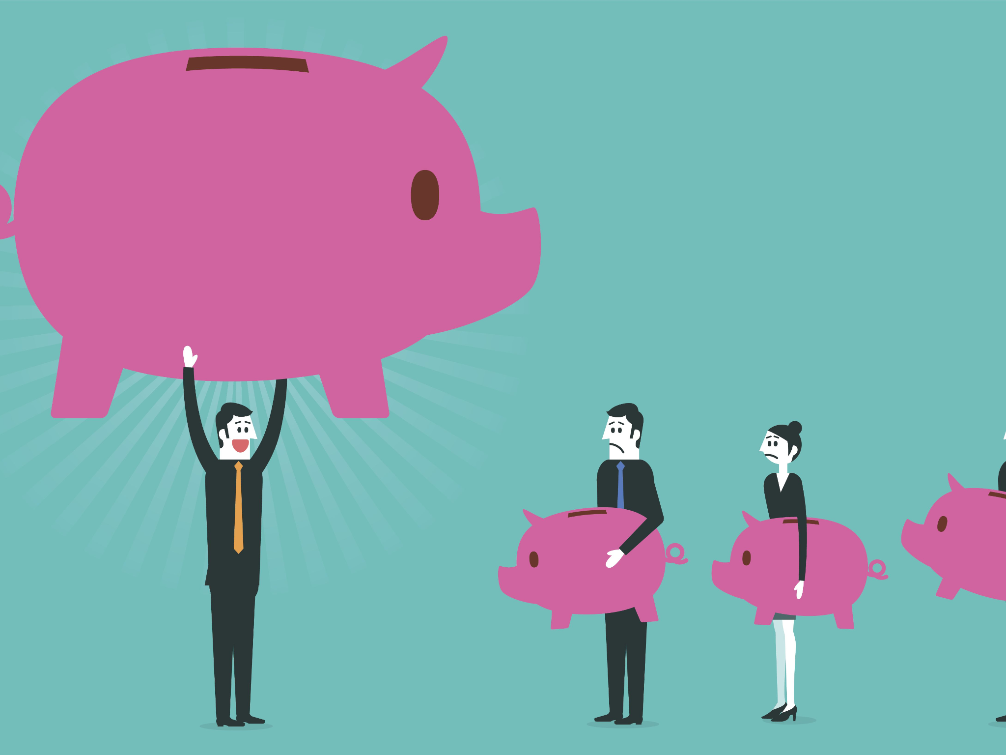

Name: Dru Sutherland
Modul: Exploring The Humanities
Lecturer: Luci Attala
Date: 02/10/2022
“The power to do good is also the power to harm those; those who control the power today may not tomorrow, what one man regards as good, another may regard as harm” Milton Friedman. In my opinion power is the capacity to instruct guidance on others or a predestination. Power is created to implement control over a particular group or country. Without control there may be the occurrence of chaos and corruption. According to Granite State College, and I quote “Another way to view power is as a resource that people use in relationships. When a leader influences subordinates, it is called downward power. On the other hand subordinates can also exercise upward power by trying to influence the decisions of their leaders” end of quote. Power can bring about equality and inequality, depending on the leadership, Leveling Mechanism and Egalitarianism explains more in depth. Power is created and used in the world and may be seen as equality and inequality due to the different perspectives.
Upward Power refers to that form of communication where you have a bottom to top approach. Whereas Downward Power is the opposite where they have a top to bottom approach. Nature between upward and downward power; upward power have a participative and appealative approach meaning members of society can interact with their leaders or citizens, can interact with their Prime ministers/Presidents while downward approach is quite the opposite, Authoritative and Direct approach, meaning everything, all decisions or information comes directly from the leader to members of society or Prime minister/ Presidents to Citizens. Upward power purpose is to make complaints or appeal, give feedback and suggestion while downward is to give orders, instructions and advice or assign responsibilities. The point has been recognised, I hope. Here we have an equality and inequality approach. Upward power poses equality among their members/citizens and that is something we as a society/citizens need to encourage among our nations, and of course the inequality approach would be the downward power, all the decisions and ideas comes directly from the leader, unwillingly to hear about what the others have to say/contribute. Inequality!

“ When equality of minority fails, inequality of majority arises” Val Wiseman. In this modern age we hear about these hashtags, mostly on social media such as; Twitter, Instagram, Facebook and so much more. So now our hashtags against inequality are; #enoughisenough, #equality, and #changeyourthoughts. Leveling Mechanism is a standard that is set in place to ensure equality, which prevents members of society from endeavoring putting themselves above others. According to 123helpme, an example of Leveling Mechanism is when a member brings an animal back from their hunt, others don’t praise him, but instead telling them what’s wrong with it, to prevent that member from gaining prestige (Monroe, 2015- Subsistence Systems Leveling). Equality is something we experience everyday, not just gender inequality, race inequality. But to stop inequality, everyone has to work together, to put laws in place, enhance laws, equality among society, among citizens, among gender and race is possible. Leveling encourages resolution of conflict, avoiding violence, coming to a settlement amongst themselves by negotiating, apologizing when one party is wrong, oaths and deals.

When I look at a person , I see a person not a rank. Not a class. Not a title” Criss Jami- Just a person. According to the Stanford Encyclopedia of Philosophy I quote “ Egalitarianism is a trend of thought in political philosophy. An Egalitarian favors equality of some sort; people should get the same, or be treated the same, or be treated as equals in some sort” end of quote. Egalitarianism was started by Karly Marx, as a starting point in creation of his Marist philosophy and John Locke considered egalitarianism when he proposed that individuals had natural rights. Equality has a dramatic impact on all our lives, whether we believe it or not, whether we see it in our everyday lives or not. Working from a political point of view egalitarianism has both an impact on the way people are treated and with distributive justice. According to the Internet Encyclopedia of Philosophy “ Distribution justice is another form of egalitarianism that addresses life outcomes and the allocation of valuable things such as income, wealth, and other goods other than Leveling Mechanism, Egalitarianism is the equality of; welfare, Resources Capabilities, Democratic/Social Equality Primary goods and Luck Egalitarianism. Until you treat everyone as equal, you have no right to complain about the treatment you receive from anyone.

“ Take a method and try it. If it fails, admit it frankly, and try another, but by all means, try something” Franklin D. Roosevelt. Life is full of inequality and to get equality in society, everyone has to work together, we need an upward approach, it is definitely possible. Once everyone is involved and willing to come together to work as one equality is possible. Equality is a wonderful concept in life, it is important in our daily lives, which helps to reduce crime and keep society balanced, not only that but it helps to create fairness, justice for all, and reduce social inequality among members of society. There are two different equality; equality in our social and professional lives. Equality in our social lives; with the rich and wealthy and the poor, the rich and wealthy as known would most likely have the upper hand or the downward power, more powerful, while the poor would be powerless, not only is this unfair, but it is also unstable. Equality is a keystone of democracy. It guarantees that everyone in society/citizens is given an equivalent moment of success, as mentioned before, we should all strive together for equality both in our personal and professional lifestyle. “Justice is about making sure that being polite is not the same thing as being quiet. In fact, oftentimes the most righteous thing you can do is shake the table.

References
26 inspiring quotes on Gender Equality (women): Gender Equality Quotes, gender equality, equality quotes. Pinterest. (2020, October 22). Retrieved October 2, 2022, from https://www.pinterest.com/pin/516999232229557303/
35 motivational dare to try quotes (Keep Trying): Try Quotes, Roosevelt Quotes, Theodore Roosevelt quotes. Pinterest. (2022, June 8). Retrieved October 2, 2022, from https://www.pinterest.com/pin/634796509991268132/
Arneson, R. (2013, April 24). Egalitarianism. Stanford Encyclopedia of Philosophy. Retrieved October 2, 2022, from https://plato.stanford.edu/entries/egalitarianism/
DSpace JSPUI. eGyanKosh. (n.d.). Retrieved October 2, 2022, from https://egyankosh.ac.in/
Examples of leveling mechanism. Examples Of Leveling Mechanism - 1102 Words | 123 Help Me. (n.d.). Retrieved October 2, 2022, from https://www.123helpme.com/essay/Examples-Of-Leveling-Mechanism-662919
Graduate Studies, G. S. C. (n.d.). Power and influence. Cultivating Your Leadership Capabilities. Retrieved October 2, 2022, from https://granite.pressbooks.pub/ld820/chapter/4/
Internet encyclopedia of philosophy. (n.d.). Retrieved October 2, 2022, from https://iep.utm.edu/egalitarianism/
LMS transition. LMS Transition Home Comments. (n.d.). Retrieved October 2, 2022, from https://lms.wsu.edu/
Milton Friedman quote about power from capitalism and freedom: Political quotes, life quotes, quotable quotes. Pinterest. (2020, August 21). Retrieved October 2, 2022, from https://www.pinterest.com/pin/240942648803097636/
Pin on feminism. Pinterest. (2022, June 23). Retrieved October 2, 2022, from https://www.pinterest.com/pin/721561171563183190/
S, S., Says, F., Fodrey, says, A. Z., Zinyowera, A., says, P. O., Obuekezie, P., Says, Z., Zidane, says, V. K., & Kumar, V. (2017, July 14). Difference between upward and downward communication (with comparison chart). Key Differences. Retrieved October 2, 2022, from https://keydifferences.com/difference-between-upward-and-downward-communication.html
Épinglé sur quotes. Pinterest. (2021, May 20). Retrieved October 2, 2022, from https://www.pinterest.com/pin/495044184049684136/

