Module: Professional Career Development
Module code: BMSW4005

Assignment Title: Professional Career Development Report and Role-play (Task-2)
Stefanel Lazar 2132344
Lecter : Sukhpreet Grewal

Table of Contents
Contents
Introduction 3
A personal reflection on role-playing 3
Description 4
Feelings 5
Evaluation 5
Analysis 5
Conclusion 6
Action Plan 6
Personal Development Plan 6
Short-term goal 6
Mid-term Goal 7
Long-term Goal 8
Self-evaluation Plan 9
Distinctive leadership style: 9
Motivating Power: 9
Explanation of prior experiences: 10
SWOT Analysis 10
Strength 11
Weakness 12
Opportunities 12
Threats 12
Action steps 12
Conclusion 13
References 15
Journals 15
Appendix 1 17
Appendix 2 19

Introduction
The report is here to explain all the data collected and collated by the people in a short time. The presentation of this report is quite good for anyone to understand the things it has to explain to the readers. The questions that are asked in a job interview have been answered properly to bestow that theatrical ambience for the audience to focus on the roleplaying session. This will omit the negative feelings that irk an interviewee when they appear for a job interview. Personal insights are delivered in this report which is further explained with the help of the model given by Gibbs (Adeani, Febriani and Syafryadin, 2020).

A personal reflection on role-playing
The list which holds the benefits of role-playing is a long one as they help the interviewee to acclimatise to the simulated environment. The person gets to hone the skills necessary to crack an interview. This is where they get the treatment which is necessary to understand the way an interview session operates all the time. I am here as a plumber who is describing the work position and roles in a given company. This is a job done by Gibb’s Cycle of Reflection which shows that higher education is necessary to nurture the capabilities necessary to reflect upon something (Yaacob et.al 2021). All of this comes into play when the students understand the ways interview is conducted everywhere in the world.
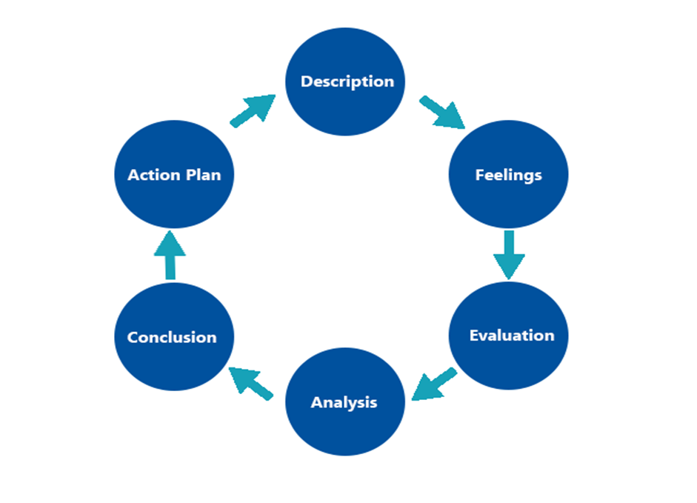\
Figure 1: Gibb’s Cycle of Reflection
(Source: Yaacob et.al 2021)

Description
The ambient vibe that I got from the interview was relatively fair and acceptable for a first-time interviewee. The knowledgeable insights that I received during the interview were really good for me

Feelings
The entire process of this interview was very relaxed and interactive. Even with that being said there were sudden jerks of discomfort that made shivers run down the spine due to a lack of proper public speaking skills (Marinho et.al 2019). Yes, being scared to talk to someone new for the first time is a trait which defines me in the best way possible. The panel was very friendly and supportive which was the reason I was able to overcome this fear in a short time.

Evaluation
The overall procedure of this system was very unique and helpful for me. I discovered a side of my personality which was completely unknown to me. The reason for this is the help that I got from the interviewer. I could ensure my level of confidence was at a higher spot as they develop properly under pressure. This is why I was able to keep myself calm and composed for the maximum part of the interview.

Analysis
The analysis of the report is to show the degree of crucially it was for the people. This is the reason why I could develop a sense of confidence and self-respect for myself. The benefit is that the development of these traits helps me to foster a personality which is good for me as a human being.

Conclusion
I was able to see the places where I used to lack as a human being. These are the holes that were left in my personality. This aided and assisted me to the extent that I started to feel confident and faced all of my shortcomings with courage. By implementing this strategy I am sure that a time will come in the future when I will grow into a fine person.

Action Plan
The environment where I learnt my loopholes is nothing but a simulation. Thus, I have enough time before I face the real world to improve myself in a way which is respected by everyone. All the soft skills that I lack at the moment will be treated with care until helps me develop into a fine person.

Personal Development Plan
I will rely upon the SMART objectives to show my goals in order to develop myself on a personal note. These goals are divided into three stages the first being short-term, the second being the middle-term and the last one is long-term goal. They are as follows:

Short-term goal
Specific | I hope to develop my skills in a way which helps me to speak properly
Measurable | This feat will be achieved by constant practice and more roleplays in a simulated environment to test the progress that is made.
Agreed | The power to collaborate with peers in order to practice these skills is the best way to solidify the necessary means.
Realistic | The development must come not only from the simulated environment but also from the real world.
Time-bound | 5 to 7 months

Mid-term Goal
Specific | This is the stage where the soft skills must be diversified for a wider scope of awareness.
Measurable | By gathering the basic skills I can set my journey to be a fine person in no time.
Agreed | The benefit that I enjoy from these skills always helps me to earn more of this standard to maintain the personality I develop
Realistic | The aim is to make myself turn into a pad which helps me to be well-groomed in achieving my long term goals.
Time-bound | 3 years

Long-term Goal
Specific | I want to see myself become a mentor for my peers and subordinates after a couple of years.
Measurable | I aim to go by the books as a means to gain as much knowledge as a person can over a course of time.
Agreed | The target that I chose must not go beyond human expectations as it may force me to veer off the path to success.
Realistic | I believe constant practice and implementation of these skills will help me to be the person I want to be in the future.
Time-bound | 7 years.

Self-evaluation Plan

Distinctive leadership style:
I always prefer to have a democratic approach with a slight touch of authoritarian style in order to manage my subordinates. This is a tool to keep the workers in line while helping them to be creative and bring their best talent to the front (Hilton, Arkorful and Martins, 2021). Once this technique is adopted my personal profession which is to lead my people towards the path of success is well-covered with this style of leadership. The leaders gain extreme knowledge about the things they will do in his/her professional sphere which can be used as a power to encourage the team in doing something phenomenal every time. The goals can be attained in this way to keep the workers motivated in the process until it comes to an end.

Motivating Power:
I believe in the desire to do something at all costs for a specific set of achievements is the meaning of motivation. This is the most important skill that has to be a possession by a team leader. They need this quality is it means an awful lot to the team when they are inspired to do a job which is considered to be pretty hard (Lorincová et.al 2019). The important qualities, in this case, are our integrity and devotion to the team which help the workers to look up to the leader.

Explanation of prior experiences:
I have been the leader of a group for quite some time now which is enough to gather a good chunk of experience. I learnt the responsibilities that are given to me is the key to boosting my motivation skills that drive team member to do something good.

SWOT Analysis
The analysis is here to talk about the strengths, weaknesses, opportunities and threats that I have as a after I learnt these skills. They are given under this section in the form of points to help everyone understand the way this analysis is done.
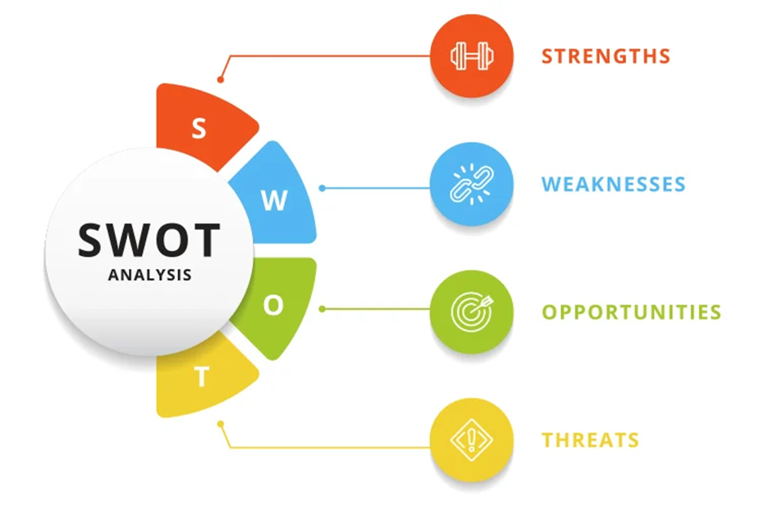
Figure 2: SWOT Analysis
(Source: Thitisuda, S., 2019)

Strength
I can be very precise in my job a. This is the reason why preciseness is very important in this line of work. The other strength that I have for myself is that I am very hard working. I can influence others to learn .

Weakness
Due to the long hours of work and constant change of trends I lose my focus at times. This is the reason why I struggle to be precise at times as my eyes hurt due to constant concentration and focus for a long period of time. The constant variation of trends is the reason why I brainstorm a lot in my free time to find out some good designs which are not a trend as of now.

Opportunities
I have room to brainstorm new ideas that can be ahead of the trend and be unique in their own way. This is the reason why it is necessary to keep myself in this state of mind which helps me to develop smarter and sharper than the rest of the team (Bérubé and Demers, 2019). The presence of people who are smart is another opportunity which can be obtained after they are hired into the team.

Threats
There is a constant threat of poor health condition which will force me to call in sick quite often. Thus, a time may come frequently which will force me to pass out an opportunity to learn something new and practice the skills that I have gained over some time.

Action steps
The weaknesses can be solved by following this plan of action. They are as follows -
Weaknesses | How to deal with the defect | Time Limit
Long work hours | This can be solved by restricting the time one works for the company | 1 month
Health problem and stress | The issue can be solved by seeking medical help quite often | 12 months
Poor motivation skills | This problem can be resolved by motivating people frequently. | 3 months

Conclusion
All the interviews that are conducted at the moment barely inform the status of the interviewee in a matter of minutes. Now that this is a roleplay, the results will be delivered in no time as the evaluation is done quite swiftly for the participants. As per the details that I had received from the conversation is that the importance of team leaders is always quintessential to a person. This is the reason why I have made sure of the fact that my subordinates are always independent of the job they want to do. Therefore, a path is forged which helps the workers to set a target which can be easily achieved in no time. By making sure of this fact they are able to look for a source of confidence within themselves. This is the road to trust and faith in the ability to do something unique in a short period of time. This is the conclusion that I have reached after assessing the roleplay that is mentioned above in the report.

References

Journals
Adeani, I.S., Febriani, R.B. and Syafryadin, S., 2020. USING GIBBS’REFLECTIVE CYCLE IN MAKING REFLECTIONS OF LITERARY ANALYSIS. Indonesian EFL Journal, 6(2), pp.139-148.
Bérubé, J. and Demers, C., 2019. Creative organizations: when management fosters creative work. Creative Industries Journal, 12(3), pp.314-340.
Hilton, S.K., Arkorful, H. and Martins, A., 2021. Democratic leadership and organizational performance: the moderating effect of contingent reward. Management Research Review.
Lorincová, S., Štarchoň, P., Weberová, D., Hitka, M. and Lipoldová, M., 2019. Employee motivation as a tool to achieve sustainability of business processes. Sustainability, 11(13), p.3509.
Marinho, A.C.F., Medeiros, A.M.D., Lima, E.D.P., Pantuza, J.J. and Teixeira, L.C., 2019, October. Prevalence and factors associated with fear of public speaking. In CoDAS (Vol. 31). Sociedade Brasileira de Fonoaudiologia.
Thitisuda, S., 2019. A STUDY OF BUSINESS PLAN DEVELOPMENT OF NAIL SALON IN BANGKOK (Doctoral dissertation, Mahidol University).
Yaacob, A., Mohd Asraf, R., Hussain, R.M.R. and Ismail, S.N., 2021. Empowering Learners' Reflective Thinking through Collaborative Reflective Learning. International Journal of Instruction, 14(1), pp.709-726.

Appendix 1
Job application form
Application for [job title] – plumber ENGINEER
Your details:
Name: Stefanel Lazar
Education and training
High school - romania
Qualifications:
Please give details: LEVEL 2,SSTS
Employment history:
Name of employer: MARIAN VOINEA
Job title: PLUMBER
Length of time with employer: 5 YEARS
Reason for leaving: Heavy work conditions
Duties: INSTALLATION OF PIPES
Previous employers
Please tell us about other jobs you have done and about the skills you used or learned in those jobs.
I have learned different skills in my previous job and most importantly, I have learned communication skills,WORK UNDER PRESSURE,and also with 220 water pressure, in my previous job.
Supporting statement
Please tell us why you applied for this job and why you think you are the best person for the job.
I applied for this job as it has good oppurtunity to explore new standards. I am fit for this job as I have good communication skills and I m hard working. Good body conditions,strong
Right to work in the UK
Do you need a work permit to work in the UK?
Yes I have the permit to work in the country.
References
Please give the names and contact details of 2 people who we can ask to give you a reference. We may ask them before an employment offer is made. We will not ask your current employer until we get your permission.
Marian Voinea, Nele Dumitrescu
Declaration
I confirm that to the best of my knowledge the information I have provided on this form is correct and I accept that providing deliberately false information could result in my dismissal.
Name: Stefanel lazar
Signature: SLAZ
Date: 28/04/2023

Appendix 2
1. How did you hear about this position?
2. what was your reason for leaving your previous job?
3. how many years of plumbing experience do you have?
4. what training have you completed and what certification do you hold?
5. do you have any questions about the role or the organisation?

