

Student name: Onyemaechi Christian Meregini
Student ID: 2413001
Module name: Introduction to Physiology
Module code: BMHP5023
Lecturer name: Shaila Hussain

Assessment: 1
Case Study Report

Date Submitted: 05th December 2025

Table of Content

- Introduction……………………………………………….……. 3
  - What is Asthma……………………………………….……….… 3
  - Risk Factors for Asthma…………………………………………….. 3
- The Respiratory System…………………………………………….. 4
  - Structures……………………………………………….………… 4
  - Mechanical Respiration………………………………………...… 6
- Gaseous exchange in the Lungs ………………...………….……..7
- Irritants in the Respiratory System……………………………….. 8
- Recording and Tracking………………………………………….. 8
- Recommendation…………………………………………………. 9
- Conclusion……………………………………………………….. 11
- References……………………………………………………….. 12

1. Introduction

This report aims to discuss Asthma as a health condition that affects breathing and the lungs, and to talk about the risk factors of asthma. The report will analyse the health condition and look at the respiratory system, and the gaseous exchange in the alveoli
The report will analyse the causes of swelling in the lung tissues, a major disease that impacts the lungs is known as Asthma. This report will discuss the management of asthma using technology to record and monitor daily trajectory of the health condition in a patient and using this study to make evidence-based recommendations on best practices to managing the condition. - Let begin with the basics, - what is asthma? What is a definition of asthma?

What Is Asthma
This is a chronic respiratory health condition of the lungs that makes breathing difficult. The level of difficulty experienced by the patient largely depends on the severity of the condition (GINA 2024).

Risk Factors for Asthma
Human Science has not yet discovered the definitive causes of Asthma, but there are several known causes or factors that trigger the condition. These are known as the risk factors of asthma as follows:
Family History: Studies confirm that families with history of atopy are prone to asthma and other related conditions such as eczema, nasal polyps etc (GINA 2024)
Sex: Records show that cases of asthma is recorded more in boys and girls, whilst in adults is the opposite, there are more women with the condition than men (NHS Digital, 2019).
Smoking: All forms of smoking both directly as well as passive smoke involve the inhalation of polluted air into the lungs. This is unhealthy to the lungs, and these are potential triggers for asthma (GINA 2024)
Overweight: Overweight and obesity is a common health condition often associated with breathing problems and more often than not asthma is a major health problem associated with people who are overweight (GINA 2024)
Environmental Factors: Explains different categories of exposure to air pollution both indoors and outdoors. Caused by harmful chemicals, moulds, house mites, food allergies, grass, flowers, pollen etc (GINA 2024)
Occupational Factors: Similar to environmental factors, some categories of work exposes people to the pollutants that cause different levels of irritation that triggers breathing problems. Some may take years to manifest. Examples are mine workers, workers in the auto-industry, building and construction workers etc. Some workers only begin to manifest health conditions long after they had stopped working on the polluted sites. The pollutants they inhaled during their years of exposure begins into manifest into asthma as well as other respiratory conditions

2. Respiratory System
The respiratory system is made up of two sections that perform two distinct functions. The transportation of air in and out of the lungs is known as breathing, whilst the processing of oxygen and glucose to produce heat and energy for the body is called respiration (Connor J, Harwood-Pearce V, Morgan K, 2006),

Structure of the Respiratory System

Structure (Waugh, 2018):
- Upper Airways: Air enters through the nose or mouth, where it is warmed and humidified. It then passes through the pharynx and larynx.
- Lower Airways: Air enters the trachea (windpipe), a tube supported by C-shaped cartilage rings that keep it open. The trachea divides into two bronchi, one for each lung.
- Lungs: Within the lungs, the bronchi branch into smaller and smaller tubes called bronchioles, resembling an inverted tree (the tracheobronchial tree).
- Alveoli: The smallest bronchioles end in millions of tiny air sacs called alveoli, which are surrounded by a dense network of capillaries. The thin walls of the alveoli and capillaries form the respiratory membrane, facilitating gas exchange. See figure 3
- Muscles of Respiration: The lungs are enclosed in the thoracic cavity, protected by the ribs and intercostal muscles. The diaphragm is a large, dome-shaped muscle located below the lungs. See figure 1, below.

Respiratory Organs
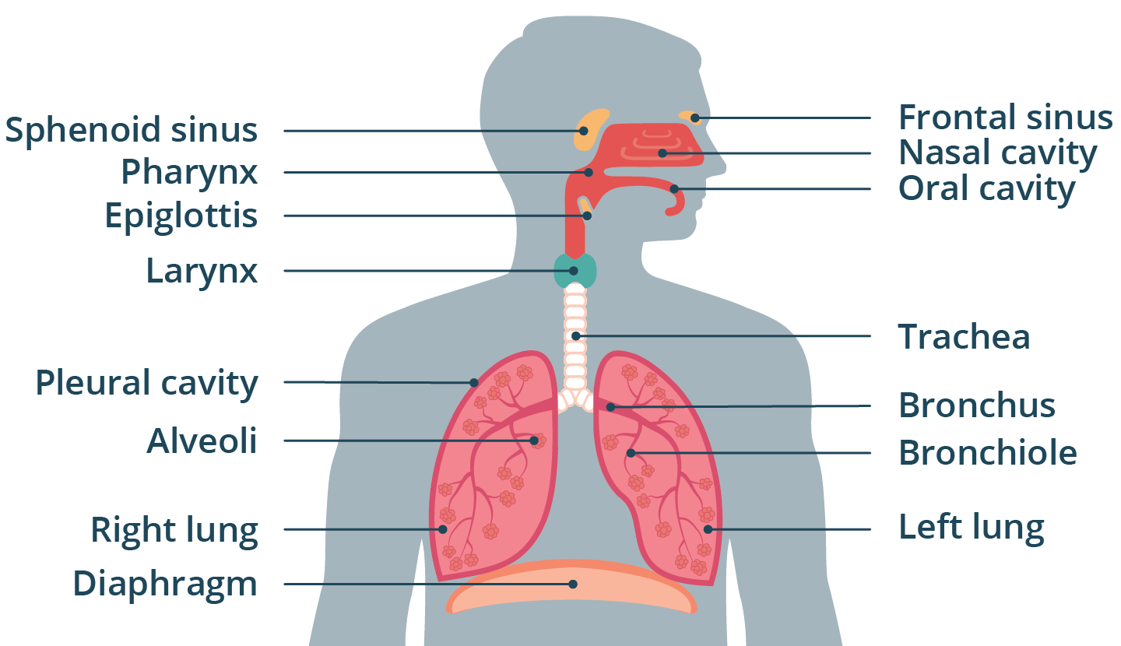
                - Figure 1 Source: Healthdirect.gov.au

- Mechanical Respiration

- 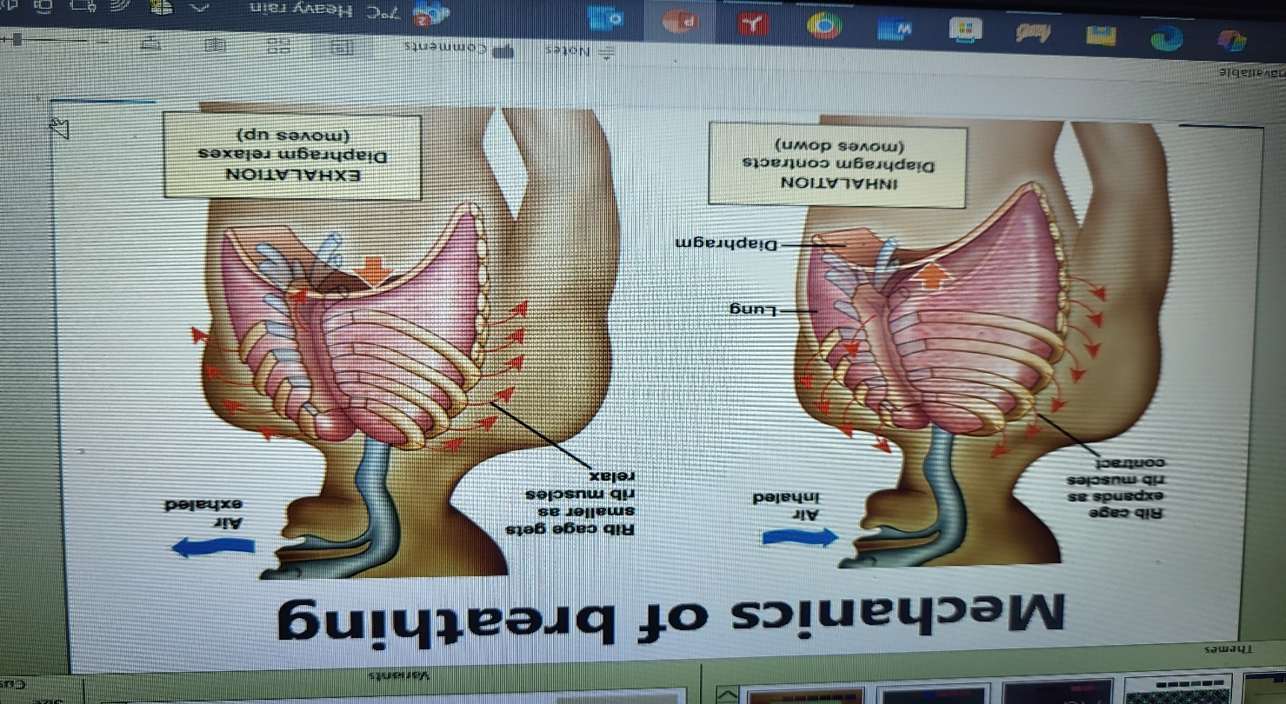
- Figure 2, Source: UWTSD Lesson Notes (2025)

Mechanical Respiration (Breathing):
The process of mechanical respiration, or ventilation, describes the actual passage of air in and out of the lungs through changes in pressure and volume within the thoracic cavity.
- Inhalation: The diaphragm muscle contracts and moves downwards to let in air from outside. See figure 2, above.
- Exhalation: Conversely, the muscles relax for the diaphragm to move upwards to expel air outwards. See figure 2, above.

3. Gas Exchange In Lungs

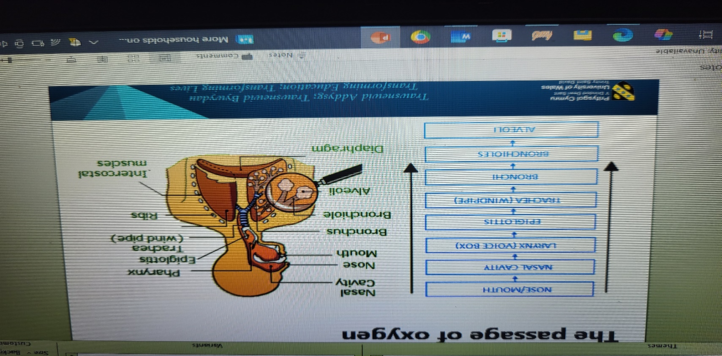
Figure 3 Source: UWTSD Lesson Notes (2025)

Gas exchange is the process where oxygen from the inhaled air is absorbed into the bloodstream, and carbon dioxide from respiration is released from the blood into the alveoli to be exhaled.

- Oxygen Absorption: Inhaled air fills the alveoli with oxygen-rich air. Due to a concentration gradient, oxygen diffuses from the high-concentration area in the alveoli into the adjacent capillaries, where the oxygen concentration is lower. Once in the blood, oxygen binds to haemoglobin in red blood cells for transport to body tissues.

- Carbon Dioxide Release: Simultaneously, carbon dioxide that is returned back to the body tissue has a higher concentration in the capillaries than in the alveoli

4. Irritants in the Respiratory System
When increased levels of irritants (e.g., pollen, smoke, strong chemicals, air pollutants) enter the respiratory system, the body initiates an immune response, leading to inflammation.
According to information consistent with (BiologyInsights.com, 2025 - inferred source information), this response causes the following changes:
- Inflammation and Swelling: Inflammatory cells, such as mast cells and eosinophils, are activated and release chemical mediators like histamine. These mediators cause the airway walls to become inflamed and swollen (edema).
- Excess Mucus Production: Goblet cells in the airway lining produce excess mucus, which thickens and can form mucus plugs, further obstructing airflow.
- Bronchoconstriction: The smooth muscles surrounding the airways contract and tighten (bronchospasm), narrowing the diameter of the airways.
Impact on Respiration: The combination of swelling, excess mucus, and bronchoconstriction significantly reduces the diameter of the airways, increasing airway resistance and making it difficult to breath.

5. Recording and tracking respiratory functions
Recording and tracking respiratory functions, such as peak flow readings, provides essential data that empowers individuals to monitor and safely manage their asthma. This practice is crucial for several key reasons:
- Early Warning System: Regular tracking helps individuals recognise subtle changes in their respiratory function, which often precede a full-blown asthma attack. A gradual drop in peak flow readings can serve as an early warning sign, allowing them to intervene with medication or other management strategies before symptoms become severe.
- Identification of Triggers: Consistent logging of peak flow measurements alongside activities, exposure to allergens, and symptoms helps patients and their doctors identify specific triggers (e.g., pollen, dust, exercise, cold air). Avoiding these triggers is a key part of asthma management.
- Assessment of Medication Effectiveness: Tracking peak flow readings provides objective data on how well current asthma medications are working. If readings improve or stabilise after starting a new treatment, it indicates the medication is effective. Conversely, persistent low readings may signal the need to adjust the treatment plan.
- Informed Decision Making and Action Plans: The data collected allows healthcare providers to create a personalised asthma action plan, which outlines specific steps to take based on peak flow readings (e.g., "Green Zone" for good control, "Yellow Zone" for caution, "Red Zone" for medical alert). This enables individuals to make informed decisions about their health in consultation with medical professionals.
- Objective Communication with Doctors: Rather than relying solely on subjective descriptions of symptoms (e.g., "I felt tight-chested"), individuals can present objective data through their peak flow records. This ensures more accurate and efficient communication with their healthcare team, leading to better-informed medical advice and adjustments to care.
By regularly monitoring these functions, individuals gain a proactive approach to managing their condition, enhancing their quality of life and preventing potentially serious exacerbations.

6. Recommendations

Lifestyle changes like a balanced diet, regular physical activity, adequate sleep, and stress management can significantly improve various health conditions. Adopting a nutrient-dense, whole-food, plant-predominant diet, incorporating moderate-intensity aerobic exercise (150–300 minutes per week), ensuring quality sleep, managing stress through techniques like meditation, and avoiding smoking and excessive alcohol consumption are all evidence-based recommendations. Building social connections also positively impacts both physical and mental health.
Diet and nutrition
- Prioritise whole foods: Eat a diet rich in fruits, vegetables, and whole grains, and limit processed foods, red and processed meat, and sugary drinks.
- Manage carbohydrates: Be mindful of carbohydrate intake, as excess can increase insulin resistance. A lower glycemic index diet can be beneficial, especially for conditions like type 2 diabetes.
- Eat a healthy breakfast: Make time for a filling breakfast, and prepare it ahead of time if needed.
- Mindful eating: Keep a food diary to track what, when, and how much you eat to identify patterns and areas for improvement.
Physical activity
- Aim for regular exercise: Engage in at least 150–300 minutes of moderate-intensity aerobic activity per week.
- Make it a routine: Incorporate enjoyable activities like walking, cycling, or swimming into your daily life.
- Minimise sedentary behaviour: Take the stairs, walk during your lunch break, and avoid sitting for long periods.
- Focus on functional balance: For older adults, include exercises that focus on balance and strength to prevent falls.

Sleep and stress management
- Prioritize restorative sleep: Adequate, high-quality sleep is crucial for overall health and can be a powerful tool in managing chronic conditions.
- Manage stress: Practice relaxation techniques like meditation to lower anxiety and improve mental well-being.

Other important lifestyle factors
- Quit smoking and limit alcohol: Avoid tobacco and reduce alcohol consumption.
- Strengthen social connections: Spend time with people and foster positive social relationships, as this is linked to better mental and physical health.
- Seek professional guidance: Talk to a healthcare provider to develop a personalized plan tailored to your specific needs. They can provide guidance and support to help you make changes and set realistic goals.

7.Conclusion
Asthma is a complex, chronic respiratory condition of the airways with no definitive cause, involving interactions between genetic predisposition and environmental triggers. Understanding the structure and mechanics of the respiratory system helps elucidate how inflammation and smooth muscle constriction impede airflow during an asthma attack. Proactive management, including the consistent tracking of respiratory functions like peak flow readings, is essential for monitoring the condition and preventing severe exacerbations. By combining vigilant monitoring, adherence to prescribed medication, and evidence-based lifestyle modifications, individuals with asthma can effectively manage their condition and lead a normal, active life.

8. References

1. Healthline (2023) Available at: https://www.healthline.com/health/understanding-idiopathic-pulmonary- fibrosis/ways-to-keep-your-lungs-healthy-and-whole#5.-Breathe-deeply
2. NHS (2017) Available at: https://www.longtermplan.nhs.uk/online-version/chapter-3-further-progress-on
care-quality-and-outcomes/better-care-for-major-health-conditions/respiratory-disease/
3. NHS (2023) Available at: Ethical considerations - NHS Providers
4. GINA (2024) Global strategy for asthma management and prevention. Global Initiative for Asthma. https://ginasthma.org
5. Mukherjee, M., Stoddart, A., Gupta, R.P., et al. (2016) The epidemiology, healthcare and societal burden and costs of asthma in the UK and its member nations: analyses of standalone and linked national databases. BMC Medicine 14(1), 113.
6. Connor J, Harwood-Pearce V, Morgan K, ( 2006) anatomy and physiology for therapists. Heinemann pp 111.
7. NHS Digital (2019) Health survey for England 2018. NHS Digital. https://digital.nhs.uk
8. NHS England (2025) Quality and Outcomes Framework guidance for 2025/26. NHS England. https://www.england.nhs.uk
9. NICE (2018) Asthma (Quality Standard). National Institute for Health and Care Excellence. https://www.nice.org.uk
10. Phelan, P.D., Robertson, C.F. and and Olinsky, A. (2002) The Melbourne asthma study: 1964-1999. Journal of Allergy and Clinical Immunology 109(2), 189-194.
11. RCP (2014) Why asthma still kills. The National Review of Asthma Deaths (NRAD). Confidential enquiry report. Royal College of Physicians. https://www.rcp.ac.uk

