Demonstrate how cross curricular teaching and learning can influence indepth skills and understanding. Underpin this with reference to relevant research, a detailed lesson plan and an enhanced provision material.

Targets

Targets | What have I done in this assignment?
To follow Harvard referencing closer | Used the Harvard referencing booklet
To introduce more critically within your response | Used more counter arguments when talking about the topic
Have a more academic tone | Tried to watch how I was writing

Intro

Cross-curricular learning in Wales refers to an educational approach that tries to connect different AoLES between others, while also having its very own framework. There are also two different frameworks one for Digital competence and one for literacy and numeracy. “How these skills are developed are all decided at a local level and will fit with the individual schools’ approaches” Welsh Government (2019). This means that even though the frameworks are mandatory it is completely up to the schools on how they want to go about developing them for their learners. The two frameworks as mentioned in the overview of cross-curricular skills frameworks are to support the schools with providing opportunities to progress and applying these skills. In Professor Donaldsons (2015) successful futures report he mentioned that he recommended the three cross-curricular skills must be the responsibility for all teachers and people who work with children. In Barnes chapter (2015) on cross-curricular leaning he said that the world outside the classroom is cross curricular, how he sees it everyone has different views of the world and the way we see it, he also believes that cross-curricular learning understands these differences and builds on them.

During my enrichment days in my placement school, I was able to see a variety of lessons that showed cross-curricular teaching. For example, was when the teacher read to the whole class about a dragon, this was due to the theme being Wales at the time, after the book was finished the LSA took small groups of learners and used the Chromebook to paint their own Welsh dragons, this lesson brought in literacy, digital competence and art all in one. This was the best example I have seen of the cross-curricular skills. However, in my placement school they use a phonics scheme called phonics play this uses a website that has multiple games included that is used daily. This way they are having digital competence and literacy cross-curricular skills being developed on the daily.

Of course, as good as cross-curricular learning can be there are plenty of obstacles that hinder this technique. One for example could be the time constraints, the curriculum is already large enough and take up a significant amount of time therefore having to include these cross-curricular skills could add even more things to cover in such little time. Of course, these skills can be added into the lessons that are already being planned. One other problem could be trying to keep the children’s attention, or their engagement. It can be difficult for teachers to successfully. Plan lessons that are creative and engaging that includes the cross-curricular skills without them being too convoluted. If the lessons do become too crowded and full then the learners could become disinterested which would mean they won’t be learning to their full potential.

Main body

The twelve pedological principles are an important part of the curriculum for Wales they work hand in hand with the four purposes, on the Welsh Government website they describe the pedological principles as the “heart of the curriculum” (Welsh Government,2023). These twelve principles are what the Welsh government makes good learning and teaching. The four purposes are what the Welsh government hope to help the learners achieve with their curriculum. They are the ‘starting point and aspiration for schools’ (Welsh Government,2023). Using the curriculum, they hope the learners are helped to aspire and developed into these four different characteristics.

The curriculum has six different AoLEs and each of these AoLEs have statements of what matters. These statements provide the teachers and learners guidance in what is important in each area of learning. As an example, if you were to investigate the science and technology AoLE one of the statements is,

‘Being curious and searching for answers is essential to understanding and predicting phenomena’ (Welsh Government, 2019). This statement shows you need to try and think outside the box and ask questions to be able to succeed in this AoLE.

While talking about any curriculum that has its learners take the lead in their own learning talking about Vygotsky’s concept of more knowledgeable other. This goes hand in hand with his zone of proximal development theory, this theory is best shown with a diagram where you can see the learner is placed into the middle circle where they can do the task without help, with a circle just around that where the learner can do the task with guidance and one more circle where they cannot do it even with guidance. The zone of proximal development is where the learner needs slight help and guidance to do the task as it is not too hard to complete or too easy for them where they don’t struggle at all. The person who gives the learner guidance is called an MKO or a more knowledgeable other. The MKO can be anyone it does not have to be the teacher it can also be a peer.

There are four strands that make up the literacy framework these being listening, reading, speaking and writing. Each of these strands have elements included in them. As seen in the 2022 pdf by the Welsh government each element has a Responsibility for learning (rfl) route map. Along with that they have three steps labelled step a, b and c where it tells the learners what they need to be doing to achieve these steps. On a separate document it further breaks down the elements into progression steps, on this other document there is an additional strand called translanguaging which would most likely be used when thinking about Welsh. This framework is used throughout the children’s educational life going from primary age all the way to a-level. One thing to consider is a learner can be a progression step one in one element and progression step two or three in another as not all our skills develop at the same rate. The progression steps have no coloration to age however there are rough guidelines to where a child could be placed at certain ages, for example foundation phase are more likely going to be in the lower progression steps however they can be placed in higher progression steps if they meet the criteria. For example, in the listening strand one of the outcomes for progression step one is ‘I can listen to others with growing attention’ (Welsh Government,2019). Like how you can be at different progression steps in different strands the same can be said for elements as you may be a progression step two in the listening for meaning element but only a progression step one in developing vocabulary. The numeracy framework works in the exact same way that the literacy framework does it just has different strands and elements. For example, one of the strands is developing mathematical proficiency, and an element is conceptual understanding. In my opinion I am more likely going to find it harder to include numeracy into my teaching than literacy or digital competence. In foundation phase the cross-curricular skills are most likely going to be taught at a basic level to not throw too much at the learners too quick, for example using the Chromebook to do their phonics like my placement school do. Or even using small incidental Welsh to the learners in hopes that they pick up on some of language.

To further talk about some of the challenges of cross-curricular teaching you must talk about the budget of schools. The digital competence cross-curricular skills are an incredibly important skills to develop in these times as everything is quickly becoming electronics heavy. This however comes with expenses; some schools may not have the budget to be able to afford a Chromebook or iPad for each student. The average cost according for a Chromebook ranged between £100 to £250, this price for 320 plus students in each class is an increasingly high amount. Even with how expensive they are once they have been paid for you do have them for as long as they last so it can be seen as an investment. Obviously, some schools will already have these devices and maybe even more, for example a bee-bot or a more advanced sphero. It’s only the budget that could affect cross-curricular learning but the training that the teachers have, if a teacher had done their course many years ago, they are not fully up to date with this concept and require extra training which takes class time away from the learners and would again likely affect the budget. A large amount of the problems with anything to do school can be traced back to some kind of budget problem.

In the lesson plan I created I showed the cross-curricular skills. I did this by first using a set of snap cards that I created myself to have my group play a game or two of snap where they would be looking for matching colours and once that is done, they would then pronounce the colour they matched in Welsh. After this game they would move on to creating their own snap card, this would be a card that matches the current theme that the school is teaching, this could be the weather or animals. I would have them create the snap cards by drawing a picture of the subject then putting it on a template I already created for them. In this lesson I attempted to introduce all three of the cross-curricular skills without having the lesson being too crowded which is why the numeracy takes a more supporting role in where I will ask the learners how many cards they have at a random point in the game. Whereas literacy and digital competence takes a more main role in where we are learning or going back over Welsh words then using a computer to create their own snap cards. Of course, the expressive arts are a huge part of the lesson as it takes up most of the lesson.

Conclusion

throughout my research I have come to learn that the cross-curricular skills are incredibly valuable skills to develop. They are some of the most basic skills that hopefully with the introduction of cross-curricular teaching should become second nature with how often they are used. Like I mentioned before being electronically inclined may give you an advantage later in life as some children who didn’t get this type of teaching may not have the basic skills that you already do. The frameworks influence the way teachers go about teaching in a mostly positive sense as they try to be more creative to include the cross curricular skills however this does also mean the lessons can at times become too crowded and harder to explain to the younger children.

How I see cross-curricular learning influencing me in how I am going to teach is simple, I will try my best to include them as often as possible without cramming them into the lesson. Making sure that the lesson is still simple enough for the learners to understand while adding in cross-curricular learning is an important thing for me.

Target 1- attempt to cross between AoLEs as often as possible.

Target 2- Bring in digital competence to as many lessons as possible.

Target 3- use cross-curricular teaching while also outdoor teaching.

References

Barnes, J. (2015) The creative primary curriculum. 2nd edn. Canterbury: sage

Welsh Government (2019) ‘Cross- curricular skills framework’
Available at: https://hwb.gov.wales/curriculum-for-wales/cross-curricular-skills-frameworks

Welsh Government (2015) ‘successful Futures’
Available at : https://www.gov.wales/sites/default/files/publications/2018-03/successful-futures.pdf

Welsh Government (2019) ‘Literacy and numeracy framework’
Available at: https://hwb.gov.wales/curriculum-for-wales/cross-curricular-skills-frameworks/literacy-and-numeracy-framework/

Welsh Government (2023) ‘Developing a vision for curriculum design’.
Available at: https://hwb.gov.wales/curriculum-for-wales/designing-your-curriculum/developing-a-vision-for-curriculum-design/#curriculum-design-and-the-four-purposes

Welsh Government (2019) ‘Science and technology, statements of what matters’
Available at: https://hwb.gov.wales/curriculum-for-wales/science-and-technology/statements-of-what-matters/

Appendix

Resources

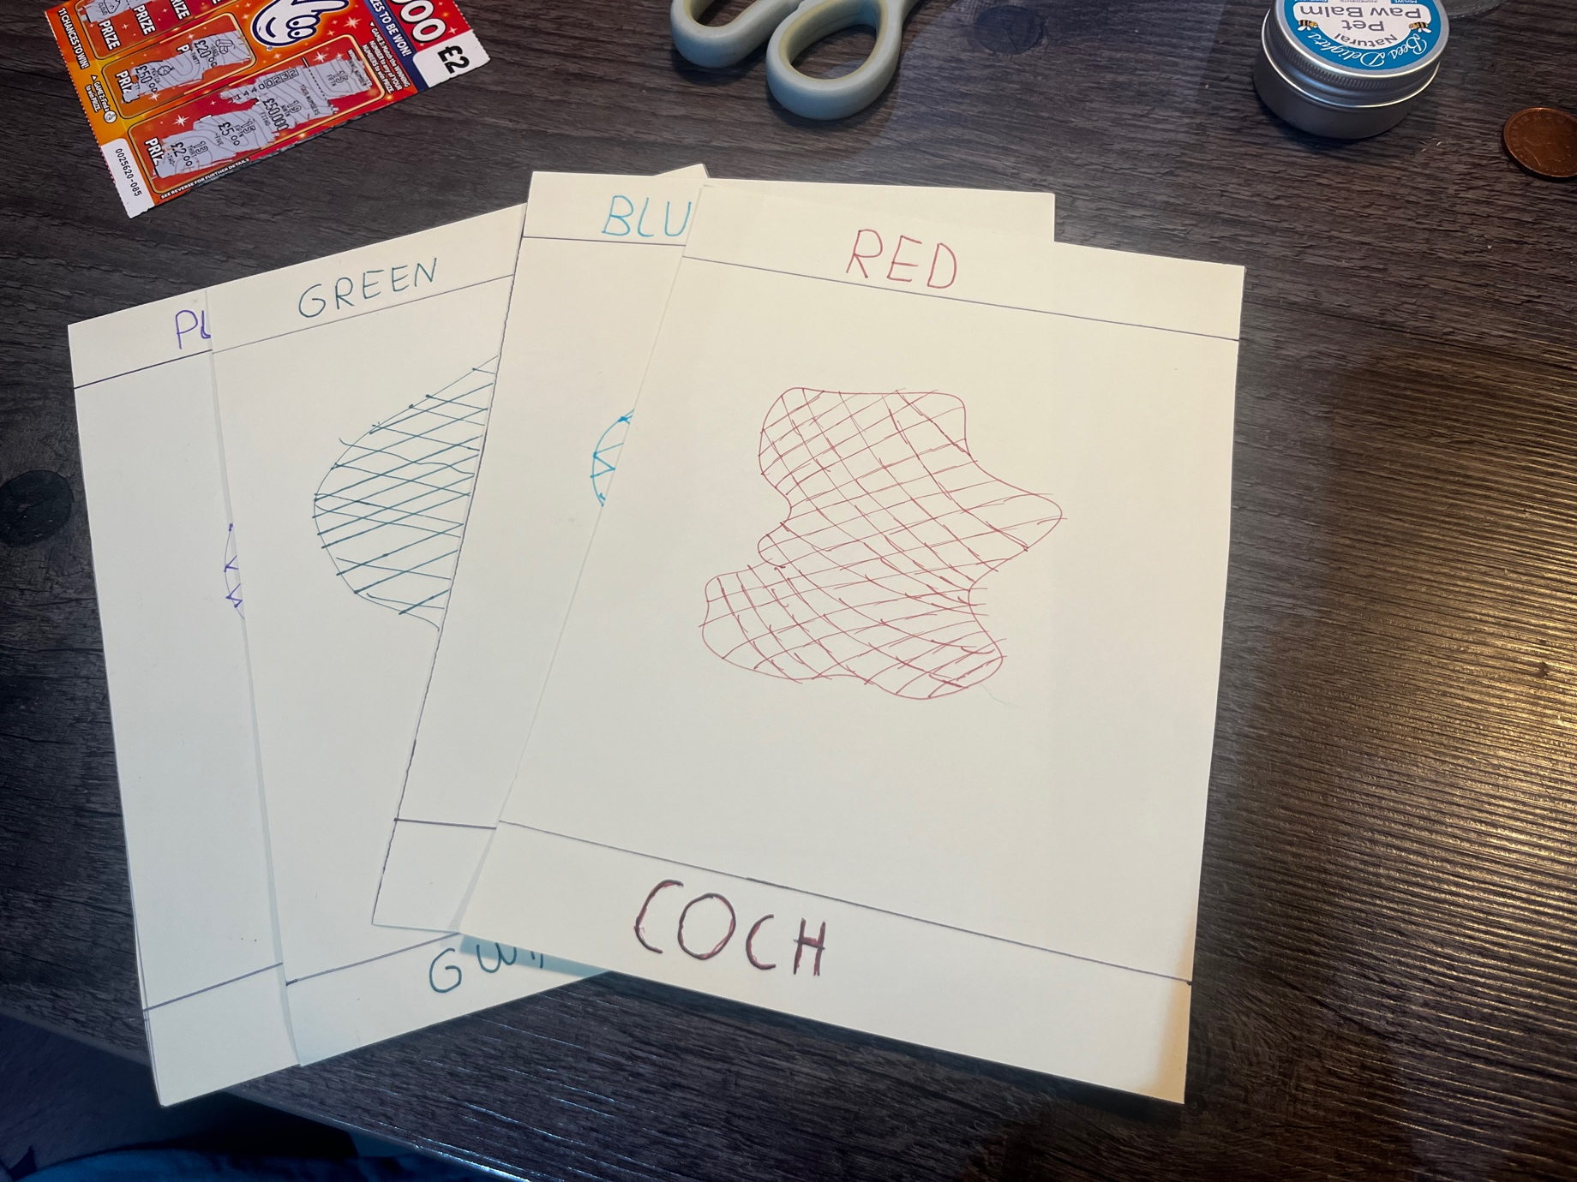

Lesson Plan



