Food & Beverage Operations
BMIH4002

Assignment 2 Menu Engineering (Practical Task)
Lecturer name: Jaliya De Silva
Student name: Petruta Roxana Toma
Student id: 2232075
Word count: 400

The new restaurant idea at the Hotel Trinity in Doncaster will be a Farm to Table style. This approach focuses on acquiring products directly from farms that are locally grown, organic, and sustainably produced. It promotes the use of fresh, local, and organically produced food and is based on the ideas of seasonality, sustainability, and quality. Moreover, this concept emphasises the relationship between farmers, chefs, and consumers, and it promotes responsible, ethical, and sustainable food consumption (Cousins, 2020). Additionally, by adopting this concept, the local economy can be helped, the carbon footprint will be minimised, and give a one-of-a-kind culinary experience that reveals the origin story of the food (Davis et al., 2018).
Furthermore, this concept's target audience will be health-minded, environmentally conscious consumers, food enthusiasts who respect quality ingredients, and customers who value food traceability. The audience would typically consist of millennials and Generation Z, as these generations are known for their strong environmental conscience and love for fresh, organic, and local cuisine.
The menu is designed to reflect seasonal vegetable availability, highlighting the finest that local farmers have to offer. This technique is consistent with the farm to table philosophy of supporting local agriculture and sustainability. The menu will include appetisers, main courses, desserts, and beverages crafted from the finest, freshest ingredients. For instance, desserts would make use of seasonal fruits, local dairy, and sweets such as honey from local apiaries. Local breweries, distilleries, and vineyards would be highlighted in the beverage option (Johnston, 2012). Additionally, the menu options also reflect the growing desire for healthy dining options, which Cousins et al. (2011) noted. The restaurant can appeal to the health-conscious consumer category by offering menu items that are not only tasty but also sustainably sourced and nutritious. Furthermore, as mentioned by Motarjemi and Lelieveld (2014), this strategy will enable the restaurant to efficiently keep food safety regulations because partnering with local suppliers helps maintain a clear traceability chain and assures the integrity of the items used in the kitchen. This idea highlights the growing importance of sustainable, local, and organic dining options in the modern hospitality business ( Walker, 2017). Also, The Farm to Table idea enhances the dining experience by including an educational component. Customers are not only dining, but also learning about the origins of their food, how it is cultivated, and the path it takes from the farm to their plate. This educational aspect of dining may boost consumer engagement, provide a unique selling proposition, and help customers form a more profound connection with food (Brown, TotalBoox, and TBX, 2013). This approach also complements the values of transparency and trust. It enables customers to make informed decisions about what they eat, resulting in a trusting connection between the restaurant and its customers. As a result, this method will aid in nurturing loyal consumers and promoting an enhanced dining experience, enhancing the Hotel Trinity chain's reputation and status in the hospitality business (Foskett et al., 2021).

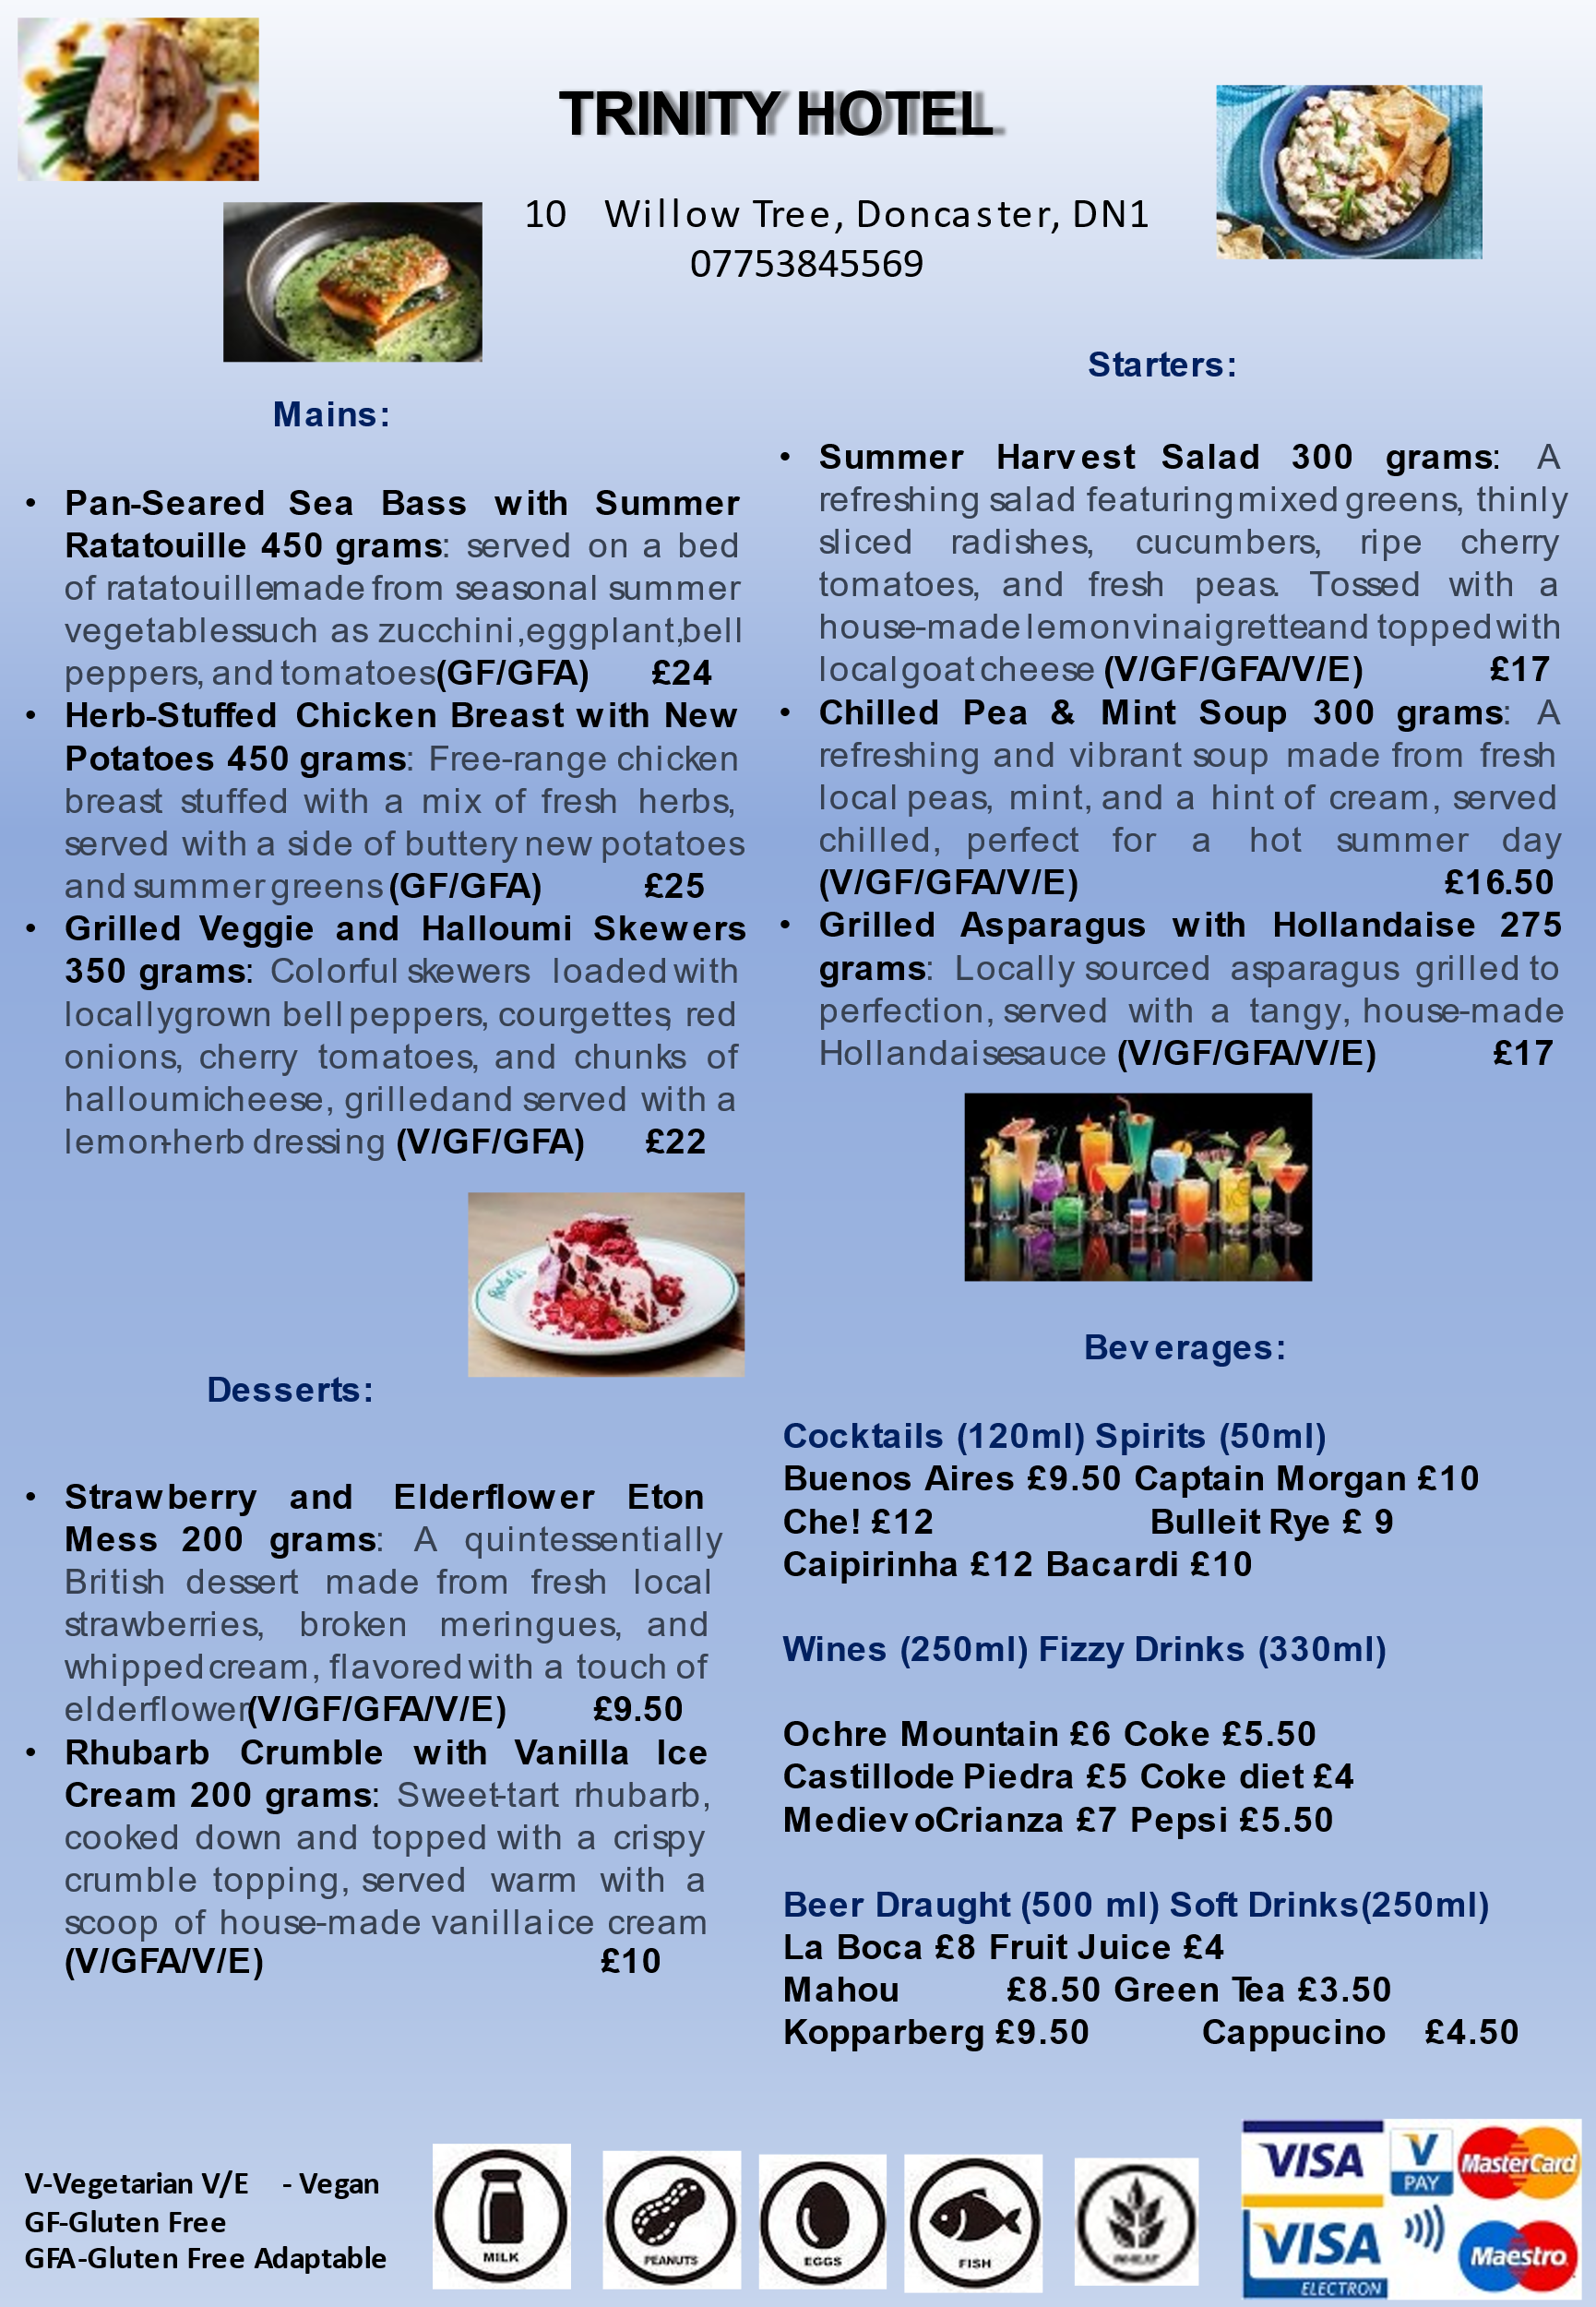
References

Brown, D. R., TotalBoox and TBX (2013) The Restaurant Manager’s Handbook : How to Set Up, Operate, and Manage a Financially Successful Food Service Operation. 4th Edition. Atlantic Publishing Group
Cousins, J. (2020) Food and beverage service. 9 th ed. London: Hodder Education Group.
Cousins et al. (2011) Food and beverage management: For the hospitality, tourism and event industries. 3rd edn. Oxford: Goodfellow
Davis, B et al. (2018) Food and Beverage Management. 6 edn London: Routledge
Foskett, D. et al. (2021) The Theory of Hospitality and Catering. 14th Edition. London: Hodder Education Group
Johnston, R. (2012) Service operations management : improving service delivery. 4th ed. Harlow, England: Pearson.
Motarjemi, Y and Lelieveld, H (2014) Food safety management : a practical guide for the food industry. Illustrated edition. Amsterdam: Academic Press.
Walker, J (2017) Introduction to Hospitality. Harlow: Pearson Education Limited.

