An analysis into the decline of Ford
By
Bilkis Hussain (1816043)

University 0f Wales Trinity Saint David
Date: 21st November 2019

Table of Contents
1. Introduction 3
2. Findings 4
2.1. The Ford Motor Company 4
3. Conclusion 10
4. Recommendations 11
5. Appendix A – SWOT Analysis 12
6. Appendix B – PESTLE Analysis 14
7. References 16

- Introduction
This report was requested by Laura James on November 14, 2019. This report will be compiled by the researcher, Bilkis Hussain, and needs to be completed by the January 10, 2020. The purpose of this report is to investigate and analyses the decline of Ford Motor Company. Ford Motor Company is an American multinational car manufacturer whose main headquarter is in Michigan, USA. Ford Motor Company has seen a significant decline of its share prices over recent years.

The report will look into the problems associated with Ford, who these problems affect, and how it affects them. A SWOT analysis would be carried out to assess the current situation Ford is at. A PESTLE analysis will be carried out to establish the external macro environment which Ford has to deal with.

Recommendations of possible solutions will be made from the information gained through the SWOT and PESTLE analysis. Suggestions will also be made as to how these solutions can be monitored and reviewed and how they will be communicated.

- Findings
  - The Ford Motor Company

The Ford Motor Company was established by Henry Ford in 1903. It is one of the largest automotive producers who supply vehicles to most parts of the world. They manufacture a huge array of automobiles which include passenger cars, tractors, and trucks as well as producing majority of their parts.

The Ford Motor Company produced just under 6 million cars world-wide in 2018. They generated around $160 billion worth of sales during that time (Wagner I, 2019).

The world-wide distribution of their cars from 2010 to 2018 can be seen in the graph below:

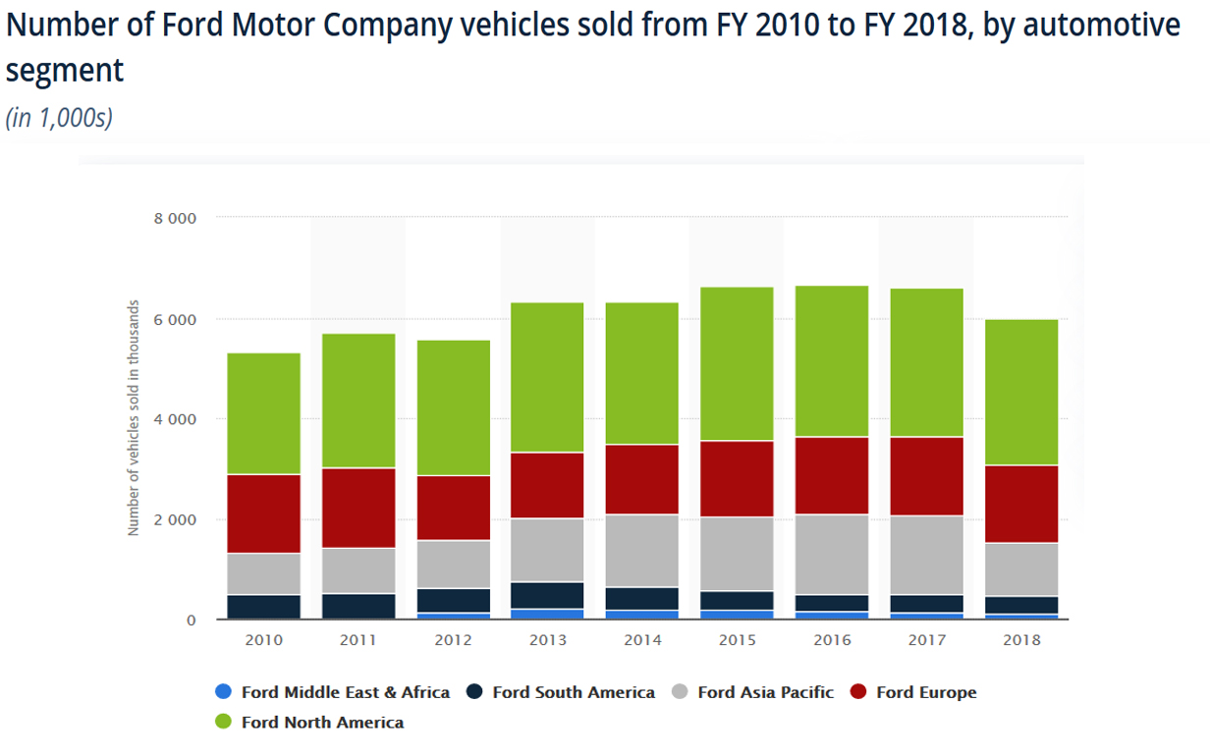

Graph 1.1 Ford Vehicles sold by location, (Source: Statista.com, 2019)

The key points to acknowledge from the graph are that the graph clearly shows that in 2017 and 2018, Ford has sold lower number of vehicles globally. It also indicates a significant decrease in sales in Asia Pacific region. It is also clear that North America is its most lucrative market.

Nature

It is clear from the last two years of sales figures that Ford is facing difficult challenges in the market within which it operates.

The demand for Ford automotive has declined. Ford has recently struggled in the Chinese market. According to a recent CNBC article, Fords sales in china in the third quarter of 2019 had dropped by 37.7 % (CNBC, 2019). As a global automotive producer Ford cannot ignore such drop in sales as it will have a significant impact on its balance sheets. According to the same article the market share for German and Japanese automotives have increased while American automotive (GM and Ford) have declined. This clearly indicates that other manufacturers have got thing right and Ford is struggling.

Fords struggles can be due to many issues which may include pricing of end product, brand image, product reliability, quality of product, and the range of products available to the consumer as well as efficiency in production.

Scope

Fords decline in sales will have significant impact on many fronts. These may include the following sectors: employees, Customers, CEO, community, suppliers, and shareholders.

Impact
Some of the Ford plants across the Europe are shutting down; Bridgend is one of them in the UK. There will be a massive lay off employees as the plant is not economically viable. The jobs cut will have an impact on employees and their families; as people won’t have enough money to buy the basic necessity, for example, foods, pay rent, bills etc. There will be stress on relationships. People with less qualification or manual workers will find it hard to get a job elsewhere.

- Employees – if sales decline then Ford may have to lay off staff and shut down factories. This would have a significant impact on the lives of these employees as their source of income would no longer be there.
- Customers – Ford has to restructure their production in order to get their sales up and that may affect some customers who don’t prepare the new innovation/ hybrid cars. Also the customer who had easy access to go down to the local ford plant for viewing when buying a car has no longer had the facilities to do that as many plants are closing down.
- CEO- decline on the sales putting pressure on the company’s CEO, as they are trying hard to find the solution for sales decline and get the sales back up.
- Community- as shutting down ford’s plant in many areas will affect the community for example the areas were used for ford’s plant will be no longer be used by them as a result some other company may want to relocate in this area and that may not be suitable for community and will cause tension in the community.
- Suppliers – the supply chain would be hit. For example orders for steel from Tata Steel would decline or come to a halt. This may then affect Tata Steels ability to ensure job security of their employees.
- Shareholders – As the business is facing difficulties and making losses it had an impact on the company’s share price. Shareholders get a lower return on their investment as fords profits have gone down dramatically in recent years.

  - SWOT Analysis

A full SWOT Analysis of Ford can be found in Appendix A. It is essential to carry out a SWOT Analysis of a given problem to identity its current position and potential. The following have been derived from the SWOT Analysis:

First, it’s important to note that Ford is a globally recognised brand with an extensive network for production and sales around the world. This can only be beneficial to the company.

However, as the company seems to be on the slide (as per recent sales figures), it’s essential to look into why that may be and how it can possibly be rectified.

As more and more people are becoming more conscious about the environmental impact they have on the planet they also start looking into the type of car they drive. They are also becoming budget savvy i.e. look for cars with low or no road tax. Ford has been slow to join the market of hybrid / electrical cars.

A typical example of Fords inability in this sector can be seen by looking into an article by Auto Express (Holding J, 2020), where they discuss the best tax free cars on the market in the UK. Brands such as BMW, Renault, Nissan, Hyundai, Kia, and VW get a mention but Ford are nowhere to be seen on the list. Articles like this will have an impact on people’s decisions as to which car they purchase and Ford need to produce the relevant cars to be mentioned on these articles in order to be more successful in the future.

According to The Telegraph (English A, 2019), Ford has finally decided to bring out electrical cars from the end of 2019. Though this is good news, it is a rather late entrance into the market. They will have to put a lot of energy and effort into this sector to try and catch up with other major electrical car manufacturers such as Tesla (American company) and BYD Co (worlds largest electrical car manufacturer based in China).

The fact that Ford sales are declining in China could be partly due to the fact that China has the world’s largest electrical car manufacturer at its doorstep (BYD Co) and Ford has only entered the market a few weeks ago.

Another factor to take into account is that fact that Fords sales figures in different parts of the world. Ford seem to be very reliant on the US and Europe for majority of its sales as per chart below.

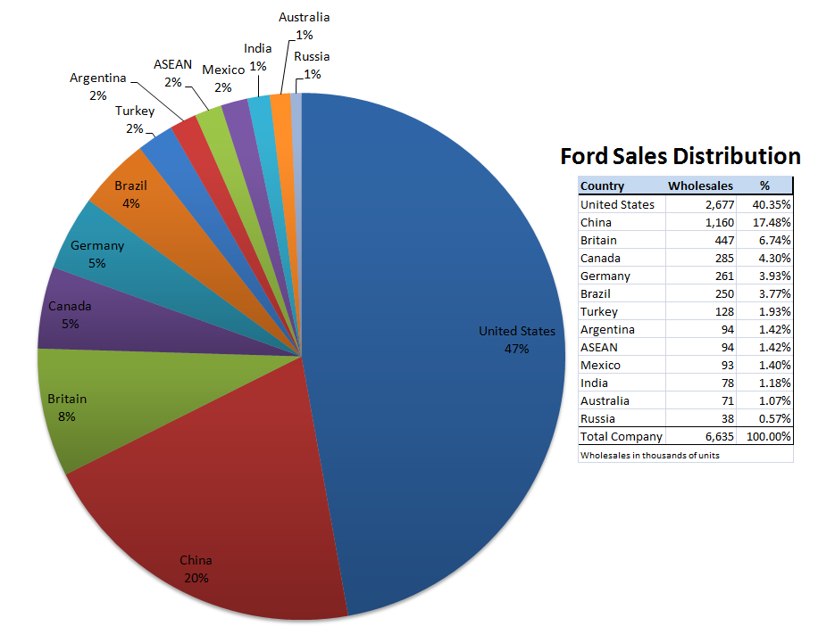
Figure 1.2. Fords sales Distribution, (source: Seeking Alpha, 2016)

It is critical Ford invests further in markets such as India and China as the population of these two countries alone is about one third of the world’s population. If Ford is able to establish a base on these two countries and thrives then they will remain a dominant force in the global car market otherwise they may struggle as a global brand.

It is clear ford is a fairly established brand in China, but its sales figures have been dropping year on year. China is a great opportunity for Ford. One of their problems in China is that they were slow at producing different models of their cars and the quality is not the same as their Japanese and German counterparts.

Ford must address this issue by being innovative, streamlining their production, and cutting costs so that the cars can be produced in that quickly without compromising on quality.

  - PESTLE Analysis

A PESTLE Analysis provides an insight into the external factors that could influence companies’ products. A full analysis is given in Appendix B.

There are many factors to consider, however, the following can be regarded as the most influential in the current climate (also taking into account the SWOT Analysis).

Ford has an issue when it comes to reliability of their cars. They are not considered to be a brand where their cars can be trusted to be reliable. According to some JD Power surveys some of their cars have ratings as low as 2 out of 5 (OSV, 2019), which can be considered damning to some extent.

However, one can argue that Jaguar whom is considered to be a luxury car is also not reliable. In the JD Power survey in the US Jaguar came one from bottom of the list for reliability (Automotive News, 2019). This did not affect the reputation of Jaguar on a global scale as they are seen as a luxury brand and that can often soften the blow.

Ford need to produce cars of such high quality especially in China, where there is a boom of millionaires. People there have more disposable income and can afford better cars but they want quality.

Another important element to consider is Artificial Intelligence in a car. Things such as automatic parking should become a norm in the future. Ford currently offers this and it’s called Active Park Assist (Ford, 2020). It would be a huge trump if they could offer this as standard on most models.

Ford should also look into driverless cars as this seems to be the future of the car industry.

- Conclusion

It is evident from the research that Fords sales have declined year on year for the past two years. Some of this is due to the fact that there has been a loss of sales in China.

China is a market with vast potential and Ford cannot afford to lose market share there. It seems that they are losing out there due to lack of newer models and the speed at which they are introduced. They also need to look deeper into the Indian market as both these countries represent 1/3 of the world’s population. Improving Fords record on reliability will also help its global brand image.

Ford has entered the Hybrid and electric car market at a late stage. But this venture must be continued and improved if Ford is to be successful as people are becoming more environmentally ethical and they care about the emissions they produce. Electrical cars are the future of the automotive industry.

Recommendations

- Ford should increase its spending on Research and development for Electric cars as these are seen as the cars of the future. Ford has entered the market late and is playing catch up.

- Ford should concentrate more on China and India as they represent 33 percent of the world population. A concentrated effort should help them regain market in China and establish a stronger market in India.

- Ford can partner up with Uber and other app-based vehicle services to grow its revenue and customer base. Uber is also interested on driverless cars, a partnership may be possible.

Appendix A – SWOT Analysis

SWOT analysis

STRENGTH  - Big Brand Multi- national Company – The Ford brand is recognized globally.  - Company’s restructuring to keep up with competitive market  - Huge network and world wide presence – Ford has factories at large number of countires around the world. Their sales team are also based extensively around the world.  - Large product range to support different markets around the world.  - Adaptability and Research & Development – Ford invest a lot of money on R&D to ensure it is being constantly innovative with new technology and car designs.  - Biggest market is the US which is doing well financially therefore its revenue from the US market should be safe. | WEAKNESSES  - Poor reputation –compared to the German and Japanese manufacturers Fords reptutaion is a lot weaker. This can be due to quality of the product and its overall reliability.  - Product recall – ford has had many product recalls to fix issues with cars. This can have an impact on customer confidence.  - Ford is currelty in the process of making a lot of people redudndant and closing many of its factories around the world including one in Bridgend.  - Slow process of restructuring the company.  - Ford hasn’t taken to the Hybrid / Electric car market quickly enough.  - Largely dependant on US and European markets
OPPORTUNITY  - Volunteer redundancies  - Promote new model - invest more on marketing new models and engaging with customers.  - Acquire new customers by focusing more on Asia i.e. China and India. These two nations will have huge demands for transportation needs in the near future.  - Self driving car – possibly invest in self driving cars as they may possible be the future of transportation.  - Eco-friendly – hybrid or all electric cars are the future of the motor industry. Ford must play a leading role in order to survive in this industry. | THREATS  - Loose experience and qualified staff  - Ford plant closure – can be seen as a negative to branding  - Highly competitive market – the Japanese and Germans are in a much better position than Ford. Toyota is the largest car manufacturer in the world. Tesla is leading  - Potential Economic slowdown can have a major impact on demand for cars.  - CEO Cancelled meeting with analyst, could impact company’s reputation.  - Less people wanting to drive now in order to save the planet

Appendix B – PESTLE Analysis

PESTLE Analysis

- Political Factors
Brexit – may have established uncertainty in many parts of the world. This can have an impact on future production and sales of cars.
Government incentives are given for lower emission cars such as no road tax which can appealing to the buyer.

- Environmental Factors
Low emission cars now are an essential part of future automotive industry. Hybrid and electrical cars will form the backbone of all car manufacturers. Ford have just entered this market.

- Social Factors
Different communities have different needs. For example, a country where they have more members in a family may require a larger car such as a MPV.
A Country where most people are wealthy may require more high end luxury cars.
Ford does provide some high end cars such as their Lincoln range. They may need to focus more on those ranges for those high end markets.

- Economical Factors
The ability to be able to sell cars abroad make a significant difference to a company growth. Ford has access to huge markets like China and India which it can capitalise on. The demands for cars from these countries will be huge.
However, in order to be successful Ford must produce a variety of reliable and high quality cars which are targeted at different markets.

- Legal Factors

Laws and regulations are different from country to country and they must be followed. These laws include car emissions laws, employee rights laws, consumer rights laws etc.
Faulty parts which are dangerous must be replaced by law in most countries. Accidents arising from faulty parts can also lead to compensation claims which can also lead to loss of reputation. Ford has had a fair share of its problem in this department.

- Technological Factors

People are now higly involved in technology. Everybody uses the internet. Cars now need to be connected to the internet. This can be for security reasons i.e. tracking a car. Perhaps you can have amazon echo installed in your car and it can communicate with your home and turn lights and the heating on while youre driving back from work.
Driverless cars are also a thing of the near future. Ford is behind in this sector and may need to up its game.
Other car technology may include parking cameras, automated parking, automated phone connection etc.
Ford needs to be at the forefront of these technologies.

References

Bynon.H, Working for ford, Pelican books 1984, Middlesex England.

Automotive news (2019), Genesis, Kia, Hyundai again rank highest in J.D. Power quality scorecard, available at: https://www.autonews.com/sales/genesis-kia-hyundai-again-rank-highest-jd-power-quality-scorecard (accessed on 31/12/2019)

CNBC (2019), Ford’s China sales decline again despite new models, Available at: https://www.cnbc.com/2019/10/11/fords-china-sales-decline-again-despite-new-models.html (Accessed on 02/01/2020)

English A (2019), The Telegraph, ford finally embraces electrification, Available at: https://www.telegraph.co.uk/cars/news/ford-finally-embraces-electrification/ (Accessed on 03/01/2020)

Ford (2020), Active Park Assist, https://www.ford.co.uk/shop/research/technology/driving-experience/active-park-assist, Accessed on 06/01/2020

Holding J (2020), Autoexpress, Best Tax Free Cars 2020, Available at: https://www.autoexpress.co.uk/best-cars/89081/best-tax-free-cars (accessed on 02/01/2020)

Seeking Alpha (2016), Fords Global struggles, Available at: https://seekingalpha.com/article/3958149-fords-global-struggles (accessed on 31/01/2019)

Statista.com (2019), Number of Ford Motor Company vehicles sold from FY 2010 to FY 2018, by automotive segment, Available at: https://www.statista.com/statistics/239738/vehicle-sales-of-the-ford-motor-company (Accessed on 02/01/2020)

Osv (2019), is ford reliable?, https://www.osv.ltd.uk/are-ford-reliable/, Available on: https://www.osv.ltd.uk/are-ford-reliable/ (accessed on 02/01/2020)

Wagner I (2019), Ford Statistics and Facts, Available at: https://www.statista.com/topics/1886/ford (Accessed 01/01/2020)

Wisdomjobs.com (2019), Management Roles in Management. Available at: https://www.wisdomjobs.com/e-university/principles-of-management-tutorial-293/managerial-roles-9220.html (Accessed on 11 June 2019).

MindTools (2019),Mintzberg’s Management Roles. Available at: https://www.mindtools.com/pages/article/management-roles.htm (Accessed 11 June 2019).

Gomadthinking (2019), Better results start with better thinking. Available at: https://www.gomadthinking.com/ (Accessed 8th June 2019)

