Electrical & Electronic Engineering

Critical evaluation of braun’s multiplier & wallace tree multiplier using vhdl
Electronics 2
ACDA6001
Rebecca Coles
2218001
Table of Contents
Table of Figures 3
Introduction 5
Background Research 5
Applications & Advantages of Multipliers 6
Flowchart 7
Braun’s Multiplier 7
Wallace Tree Multiplier 7
Methodologies 8
VHDL Codes 9
8x8 Braun’s VHDL Code 9
8x8 Wallace VHDL Code 15
Timing Diagrams & Schematics of Design 20
Braun’s Multiplier – Timing diagrams 20
Timing 1 20
Timing 2 21
Timing 3 22
Timing 4 23
Timing Constraints – Longest delay 24
Timing Summary 24
Schematic 28
Wallace Tree Multiplier – Timing diagrams 29
Diagram 1 29
Diagram 2 29
Diagram 3 30
Diagram 4 31
Timing Constraints – Longest delay 32
Timing Summary 32
Schematic 36
FPGA Design & Pin Allocation 37
Braun’s Multiplier Pin Allocation 37
Wallace Tree Multiplier Pin Allocation 38
Results 39
Braun’s Multiplier 39
Battery Summary 39
RTL Analysis 40
LUT’s 40
Wallace Tree Multiplier 41
Battery Summary 41
RTL Analysis 41
LUT’s 42
Recommendations 43
Conclusion 43
References 44

Table of Figures

Figure 1 – Braun’s Multiplier 8
Figure 2 - Wallace Tree Multiplier 8
Figure 3 - Dot Diagram 9
Figure 4 - Braun’s VHDL - 1 10
Figure 5 - Braun’s VHDL - 2 10
Figure 6 - Braun’s VHDL - 3 10
Figure 7 - Braun’s VHDL - 4 11
Figure 8 - Braun’s VHDL – 5 11
Figure 9 - Braun’s VHDL - 6 11
Figure 10 - Braun’s VHDL – 7 12
Figure 11 - Braun’s VHDL – 8 12
Figure 12 - Braun's VHDL – 9 12
Figure 13 - Braun's VHDL – 10 13
Figure 14 - Braun's VHDL – 11 13
Figure 15 - Braun's VHDL – 12 13
Figure 16 - Braun's VHDL – 13 14
Figure 17 - Braun's VHDL – 14 14
Figure 18 - Braun's VHDL - 15 15
Figure 19 - Wallace VHDL - 1 16
Figure 20 - Wallace VHDL - 2 16
Figure 21 - Wallace VHDL - 3 17
Figure 22 - Wallace VHDL - 4 17
Figure 23 - Wallace VHDL – 5 18
Figure 24 - Wallace VHDL - 6 18
Figure 25 - Wallace VHDL - 7 19
Figure 26 - Wallace VHDL - 8 19
Figure 27 - Wallace VHDL - 9 20
Figure 28 - Braun's simulation timing 1 (Max value) 21
Figure 29 - Braun's simulation timing 2 (Min Value) 22
Figure 30 - Braun's simulation timing 3 (Midd Value 1) 23
Figure 31 - Braun's simulation timing 4 (Midd Value 2) 24
Figure 32 - Braun's longest delay diagram 25
Figure 33 - Braun's timing summary & device 25
Figure 34 - Braun's time delays - 1 26
Figure 35 - Braun's time delays - 2 26
Figure 36 - Braun's time delays - 3 27
Figure 37 - Braun's time delays - 4 27
Figure 38 - Braun's time delays - 5 27
Figure 39 - Braun's time delays - 6 28
Figure 40 - Braun's time delays – 7 28
Figure 41 - Braun's Schematic 29
Figure 42 - Wallace simulation timing 1 (Max Value) 30
Figure 43 - Wallace simulation timing 2 (Min Value) 30
Figure 44 - Wallace simulation timing 3 (Midd Value 1) 31
Figure 45 - Wallace simulation timing 4 (Midd Value 2) 32
Figure 46 - Wallace longest delay diagram 33
Figure 47 - Wallace timing summary & device 33
Figure 48 - Wallace timing delay - 1 34
Figure 49 - Wallace timing delay - 2 34
Figure 50 - Wallace timing delay - 3 35
Figure 51 - Wallace timing delay - 4 35
Figure 52 - Wallace timing delay - 5 36
Figure 53 - Wallace timing delay - 6 36
Figure 54 - Wallace timing delay - 7 37
Figure 55 - Wallace Schematic 37
Figure 56 - Braun's pin allocation 38
Figure 57 - Braun's device 38
Figure 58 - Wallace pin allocation 39
Figure 59 - Wallace device 39
Figure 60 - Braun's power summary 40
Figure 61 - Braun's set power value 40
Figure 62 - Braun's RTL analysis 41
Figure 63 - Braun's LUT's 41
Figure 64 - Wallace power summary 42
Figure 65 - Wallace RTL analysis 42
Figure 66 - Wallace LUT's 43

Introduction

This report looks at both the theory and practical use of Braun and Wallace multipliers using VHDL. It starts with background research on where and how multipliers are used, and explains the features, benefits, and working methods of Braun and Wallace multiplier designs. The report then moves on to show how each multiplier is built and tested in practice. Both types of multipliers are compared based on their speed, complexity, and power use, highlighting the strengths of each design. [1]

Background Research

Multipliers play an important part of digital systems, they are used in many areas like signal processing, image processing and computer systems where fast calculations are needed. The Braun’s and Wallace Trees are two common types of multipliers, each with their own advantages and disadvantages. The Braun’s multiplier is known for its simple and regular design, which makes it easier to build. However, the Wallace Tree multiplier is designed to be faster, this is due to the reduction of steps needed to complete the process.
Choosing the right type of multiplier depends on the needs of the application. Things to be considered would be speed, size and power. As signal processing tasks are becoming more demanding, the need for faster and more efficient multipliers has increased. In real-time systems, it’s important to reduce any delays and power usage to meet performance requirements. By using the application VHDL to design and test these multipliers, we are able to compare how they perform and understand which one works better on different tasks. The choice of multiplier depends on the specific needs of the system and can be categorised as ‘signed’ or ‘unsigned’. This is based on how fast they can handle the values inputted into the system.

The Braun’s and Wallace Tree multipliers each have their own strengths and weaknesses. The Braun’s multiplier is known for its simple and regular design, making it easy to understand and implement in any software. It is a good option to choose when the design needs to be straightforward and easy to implement. However, there are disadvantages to using the Braun’s Multiplier, this includes slower processing and the use of more power due to longer delays in the system. On the other hand, the Wallace Tree multiplier is designed for speed, it does this by reducing the number of steps it takes to process the data, making it faster and more efficient for high-performance tasks. While it offers better speed and is more suitable for larger operations, its structure is more complex, which can make it harder to design and implement.
In comparison, when choosing between the two multipliers, it would really depends on the needs of the application, whether simplicity or speed is more important. [1] [2]

VHDL is used as it allows us to describe, simulate and test systems before they are built on a software. VHDL makes it easier to design complex systems, detect errors throughout the simulation and make changes without physically rebuilding the circuit.
One key advantage of using VHDL is its public availability, as it is defined by the IEEE as an industry standard language. This standardisation ensures that VHDL is both machine readable and human readable, which helps improve the design, synthesis and testing of the software. VHDL follows a common structure and format, it also simplifies the process of sharing, maintaining and modifying any software designs. This is especially useful in long term projects, where updates or repairs may be needed, as it ensures that the data remains accessible and useable over time.

Applications & Advantages of Multipliers

Braun’s multiplier is commonly used in digital systems where simplicity and regular designs are important. It is mostly used for applications such as image processing, signal processing and embedded systems that require basic, unsigned multiplication. One of the main advantages of Braun’s multiplier is it’s simple structured layout, which makes it easy to design and implement on any software. Especially when used on FPGAs (Field Programmable Gate Array). Its structure allows for easy scaling when working with larger bit-widths. While it may not be the fastest , Braun’s Multiplier is reliable, efficient for smaller systems and is a straight forward logic that makes testing and fault finding easier. This makes the Braun’s multiplier a good choice for simple projects, low power designs and systems where speed isn’t as critical.

FPGAs (Field Programmable Gate Arrays) are types of an integrated circuits that can be programmed to perform different tasks after they are manufactured. They are commonly used in custom software design, prototyping, high-performance computing and digital signal processing. FPGAs are flexible, allowing engineers to test and modify designs quickly, making them ideal for tasks that require high speed processing or real time data handling. [3]

The Wallace Tree multiplier is widely used in applications that require high speed operations. These include digital signal processing (DSP), microprocessors and image processing. The Wallace Multiplier is particularly useful for large bit multiplications where speed and efficiency are critical. One of the main advantages of the Wallace Tree multiplier is its ability to reduce the number of stages, speeding up the multiplication process. By using carry and sum adders in a tree-like structure, it minimises delays and improves performance. However, the increased complexity in both the design and software may demand more resources, which may affect speed. [4]

Flowchart

Braun’s Multiplier

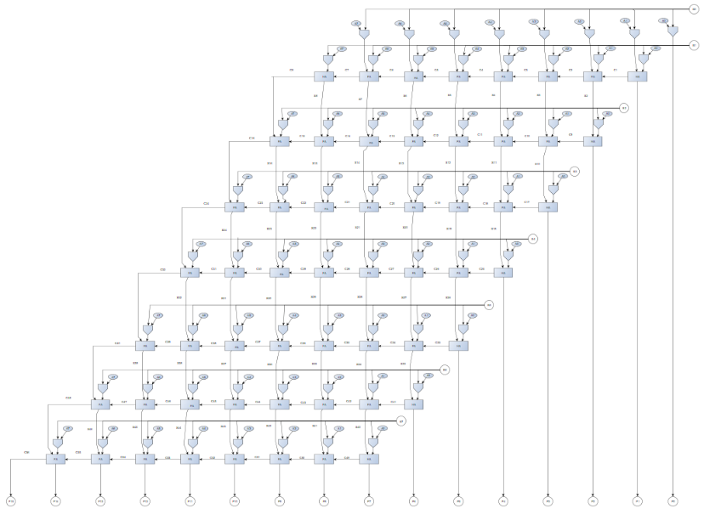
Figure 1 – Braun’s Multiplier

Wallace Tree Multiplier

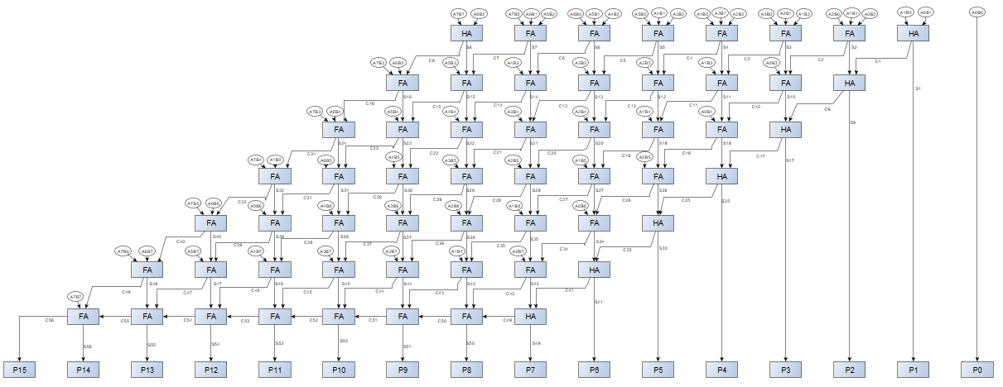
Figure 2 - Wallace Tree Multiplier

Methodologies

In this project we were required to design two 8x8 multipliers. One being the Braun’s Multiplier and the other the Wallace Tree Multiplier. Both multiplier were designed, implemented and compared using VHDL and the Vivado software. The Braun’s multiplier was built using AND gates and then adding them using either full or half adders, this was dependant on the inputs into each gate. Each component was written in VHDL and connected using port maps to build the complete multiplier, which was then simulated and tested on FPGA. For the Wallace Tree multiplier, the design focused on reducing multiple stages using a structured tree of adders to achieve faster performance. A dot diagram below is used to calculate half or full adders in the multiplier. As shown below, anything grouped as a three is a full adder, showing 3 inputs, where as anything grouped as a 2 is a half adder with only 2 inputs, refer to figure.3 below. It is also then followed by VHDL implementation, simulation and FPGA synthesis. . In the final step, both multipliers were compared by calculating delays, finding the critical path and checking power use. This helped to understand which design worked better in terms of speed and efficiency.

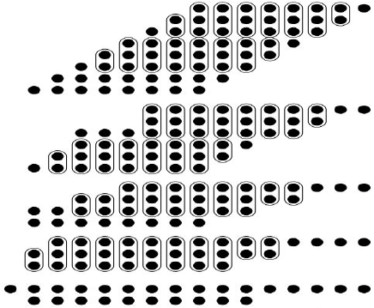

Stage 0

Stage 1

Stage 2

Stage 3

Stage 4

Figure 3 - Dot Diagram

VHDL Codes

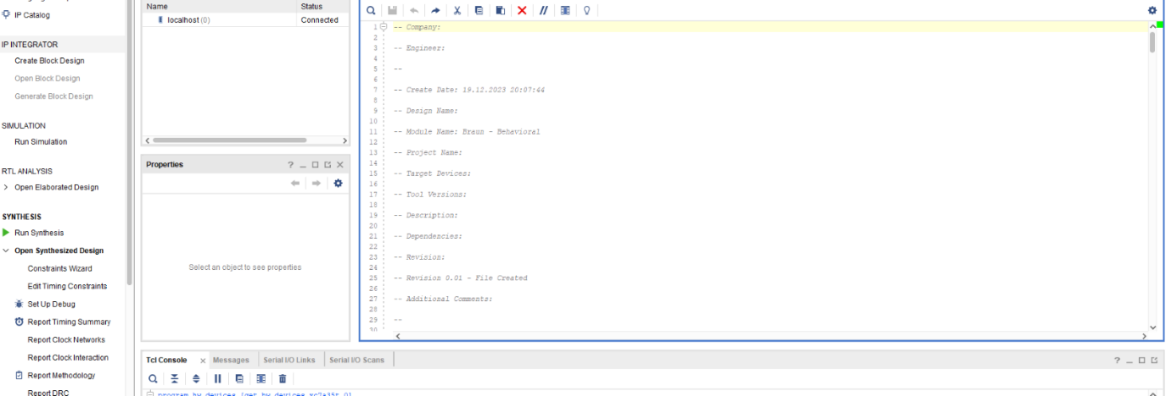
8x8 Braun’s VHDL Code
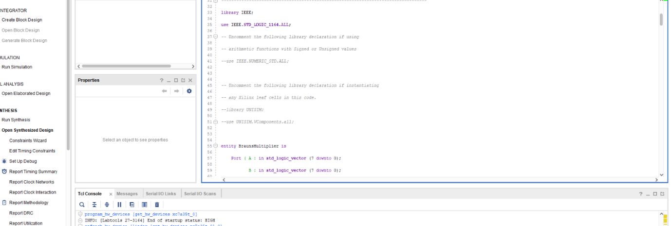
Figure 4 - Braun’s VHDL - 1
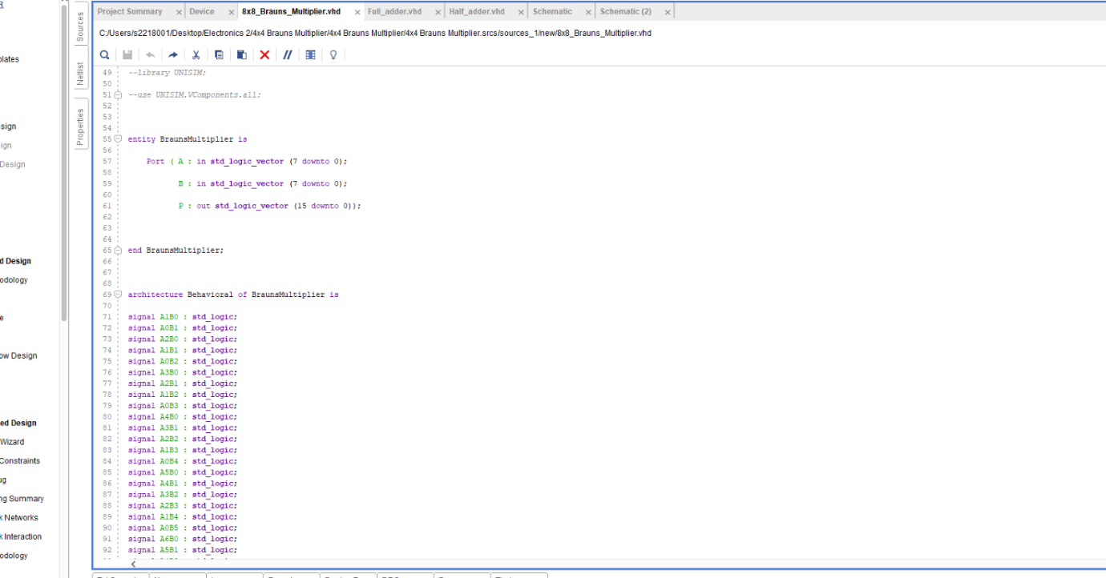
Figure 5 - Braun’s VHDL - 2
Figure 6 - Braun’s VHDL - 3
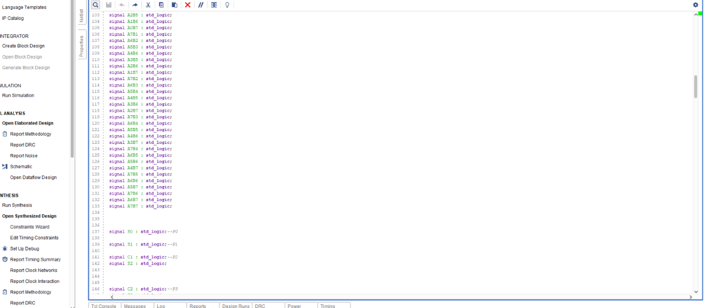
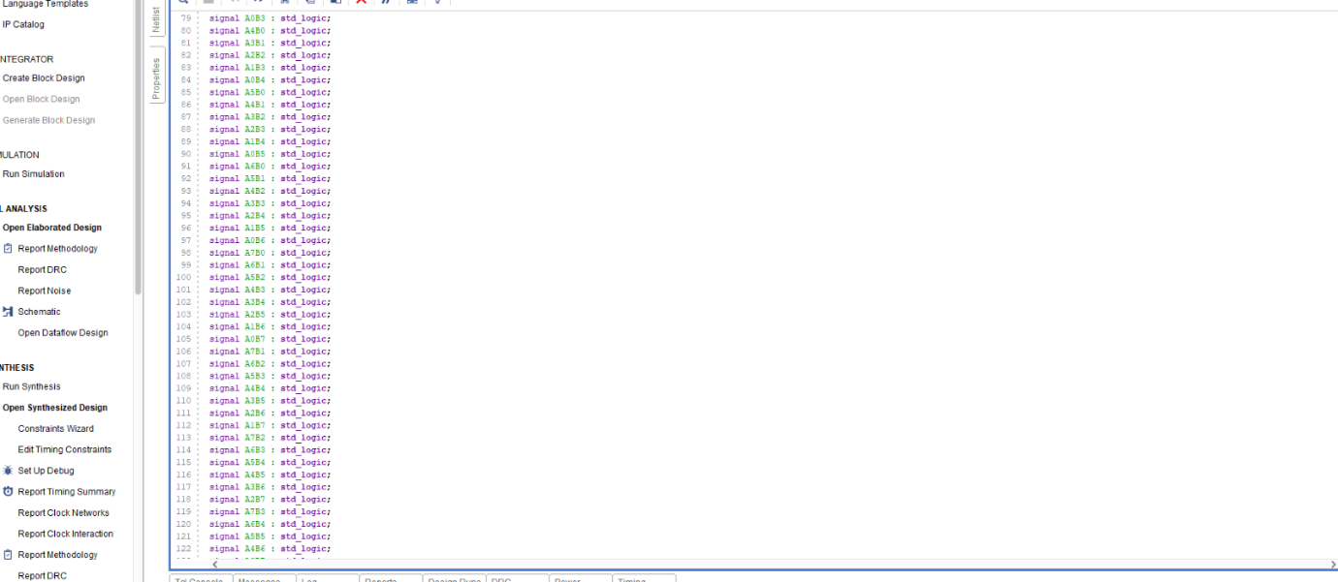
Figure 7 - Braun’s VHDL - 4
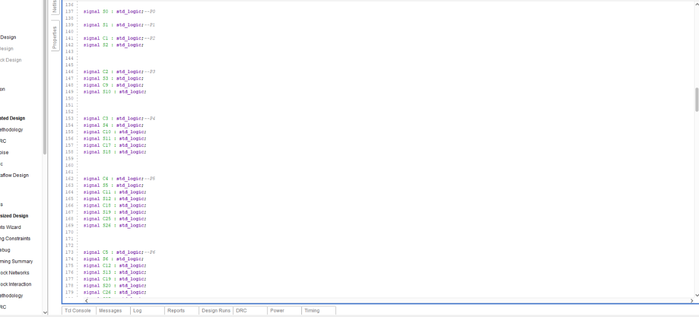
Figure 8 - Braun’s VHDL – 5
Figure 9 - Braun’s VHDL - 6

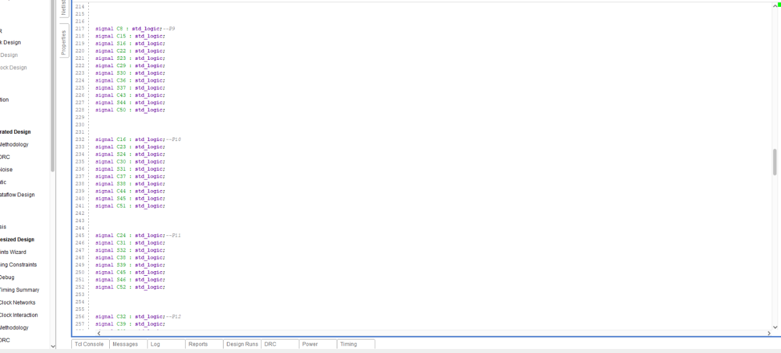
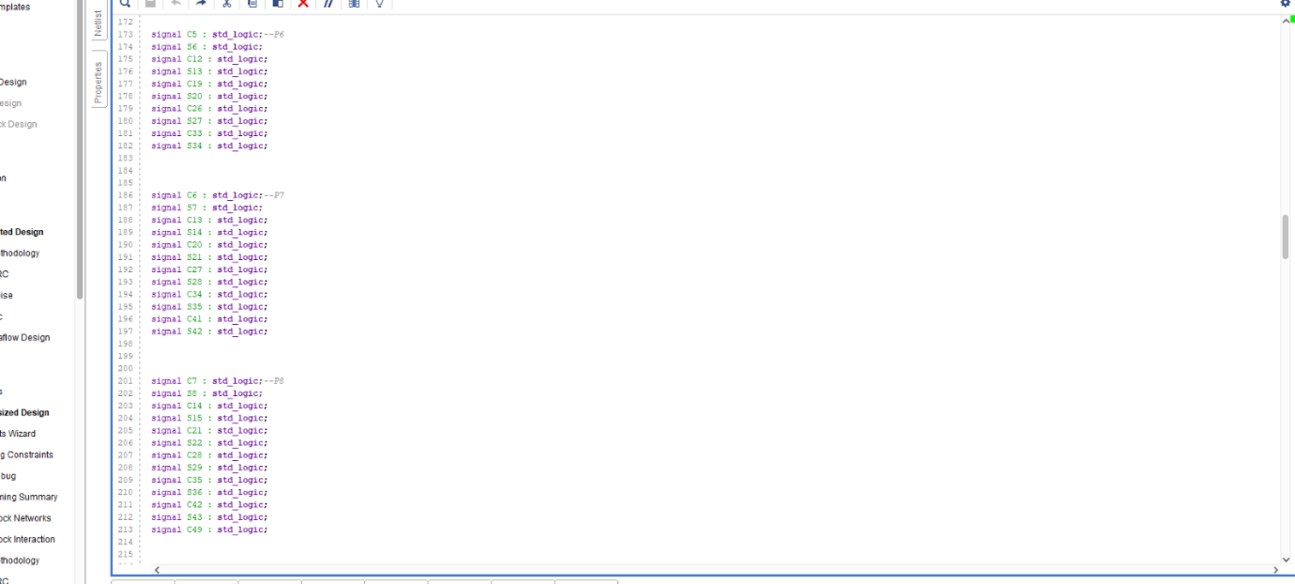
Figure 10 - Braun’s VHDL – 7
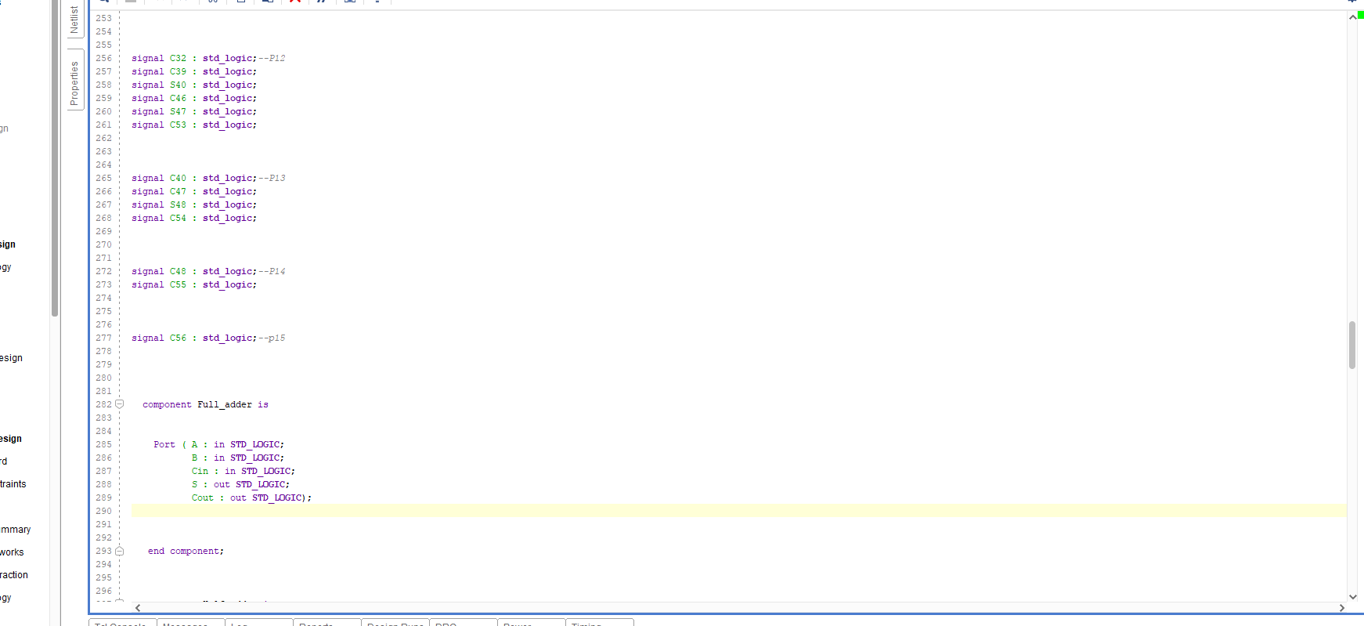
Figure 11 - Braun’s VHDL – 8
Figure 12 - Braun's VHDL – 9

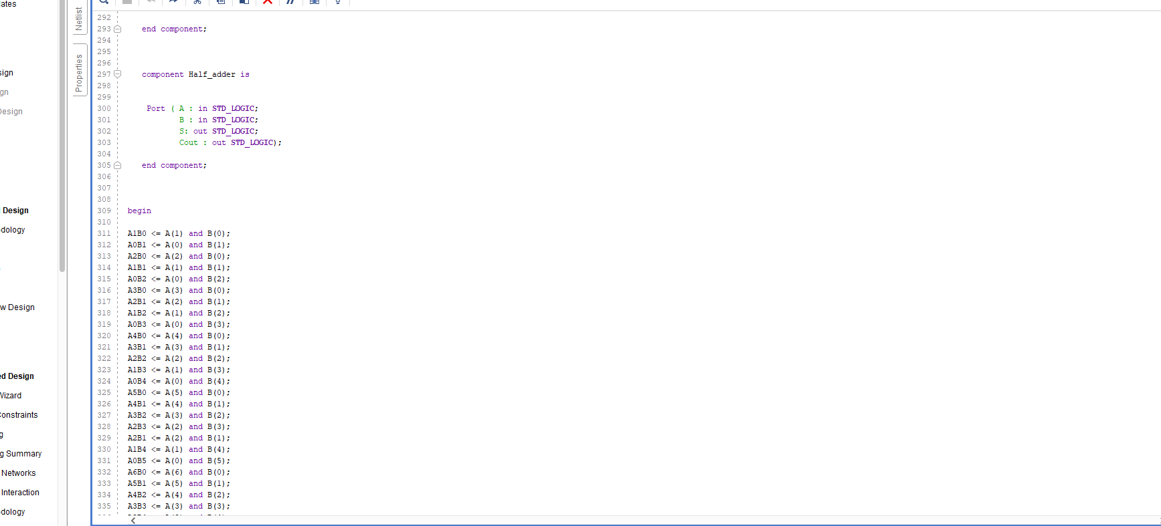
Figure 13 - Braun's VHDL – 10
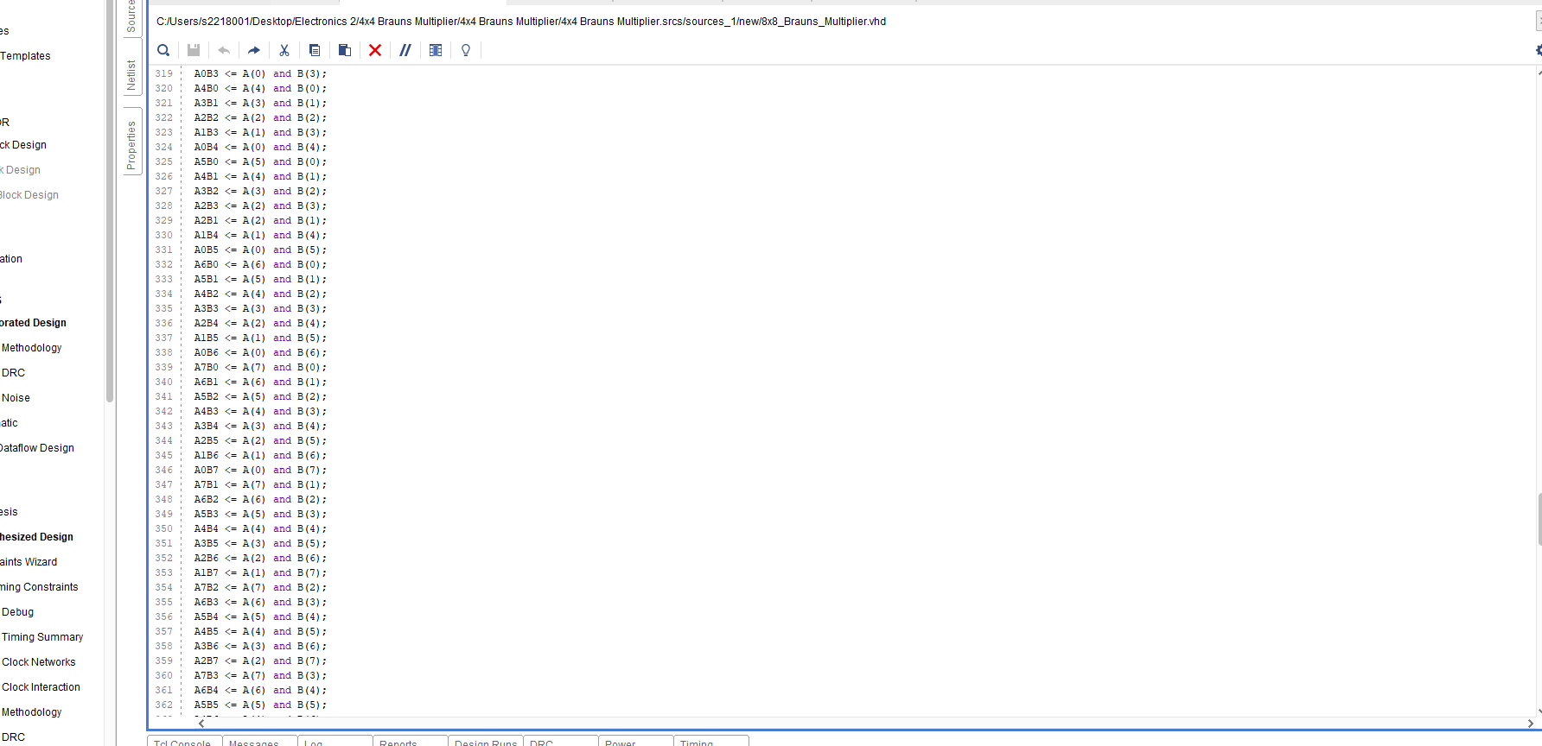
Figure 14 - Braun's VHDL – 11
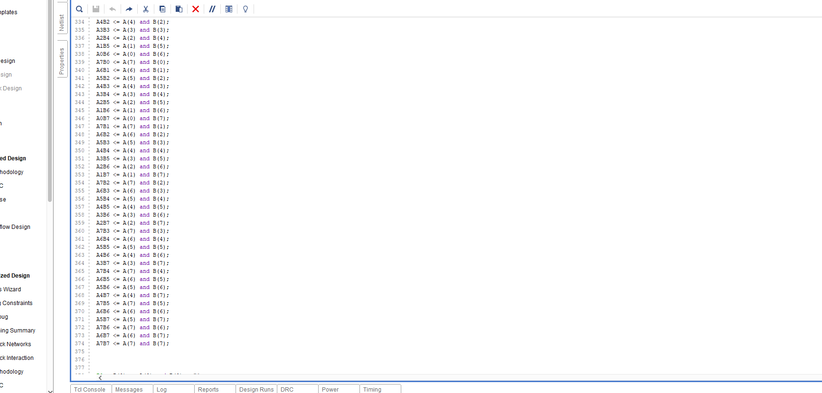
Figure 15 - Braun's VHDL – 12
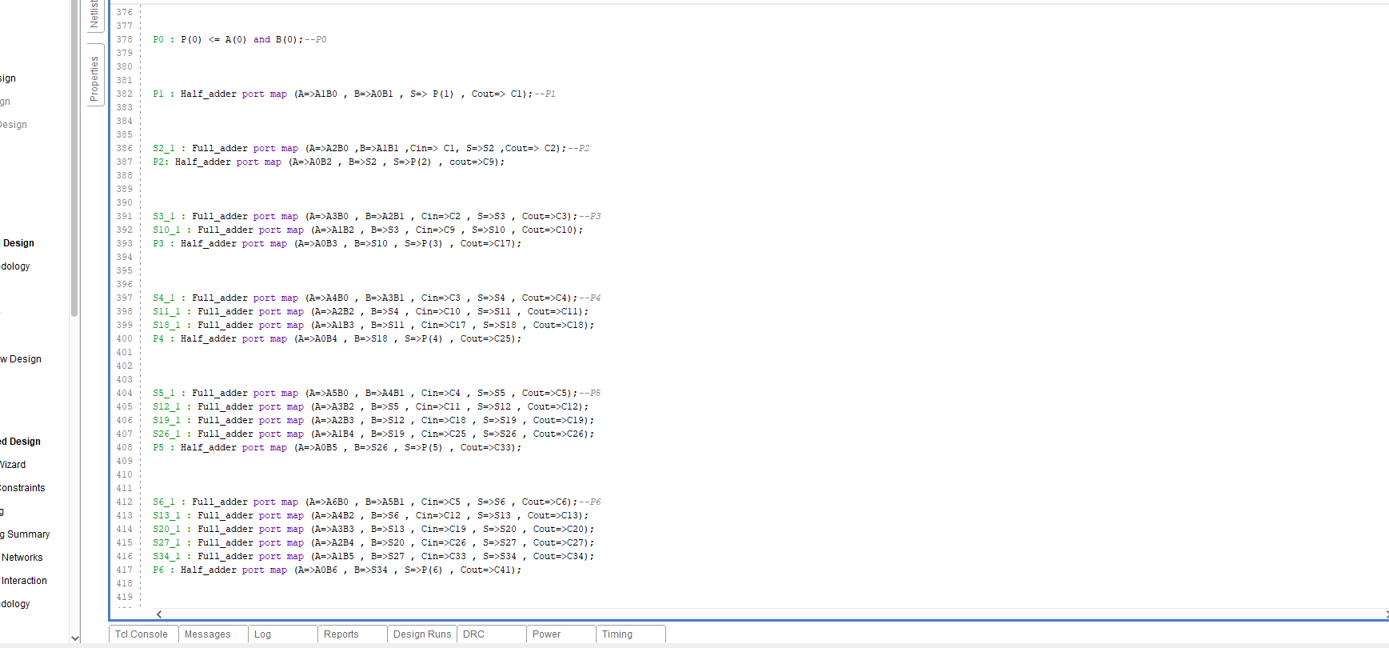
Figure 16 - Braun's VHDL – 13
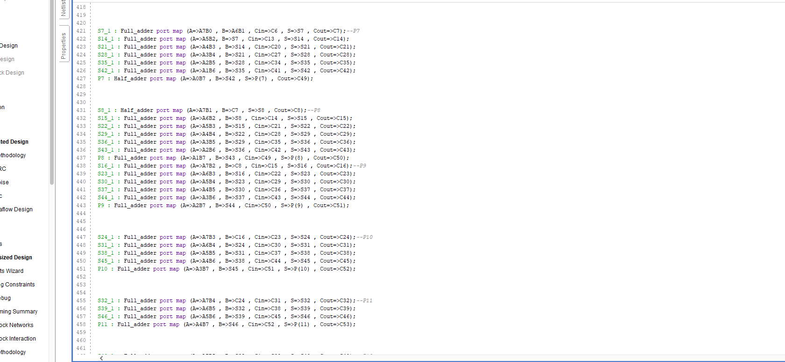
Figure 17 - Braun's VHDL – 14
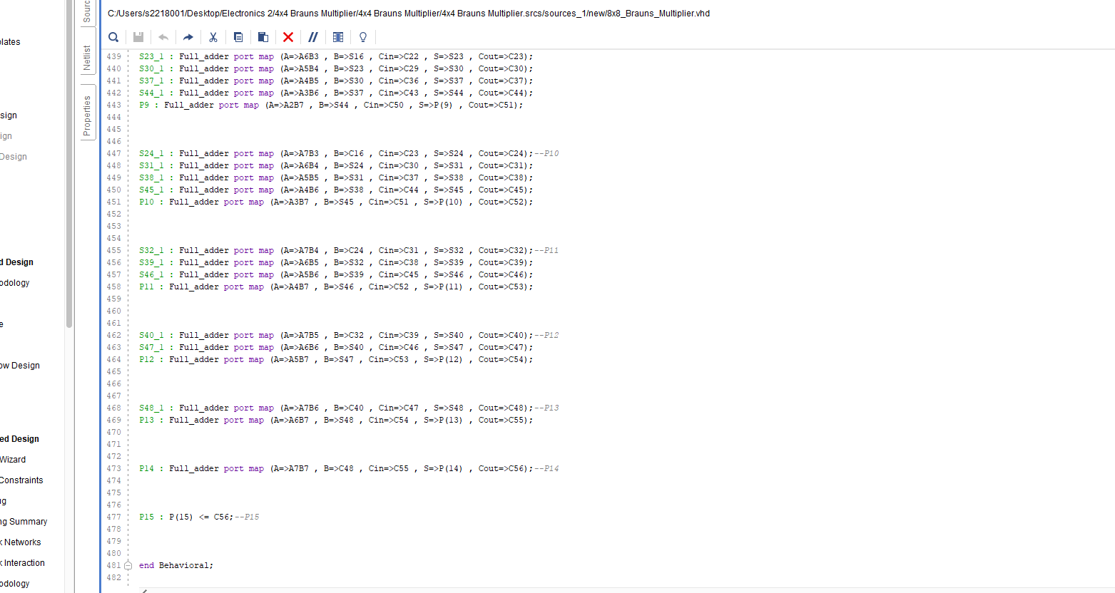
Figure 18 - Braun's VHDL - 15

8x8 Wallace VHDL Code
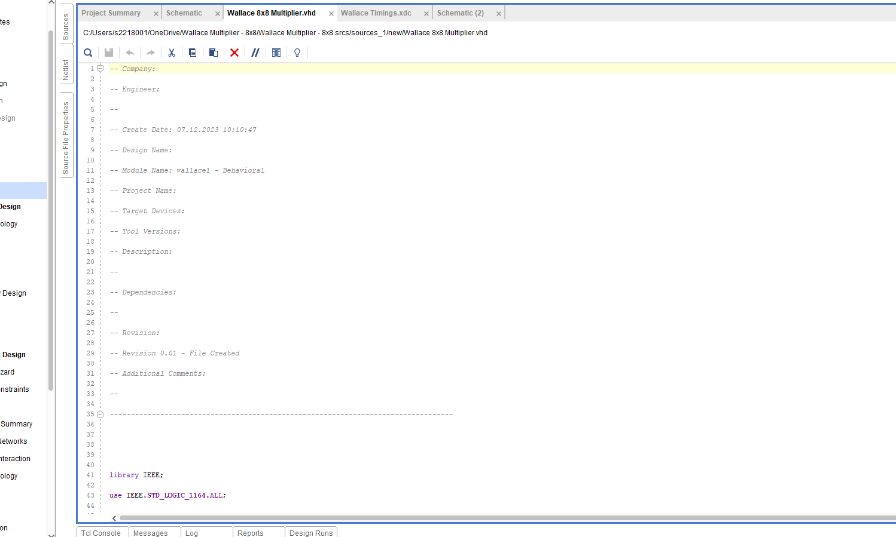
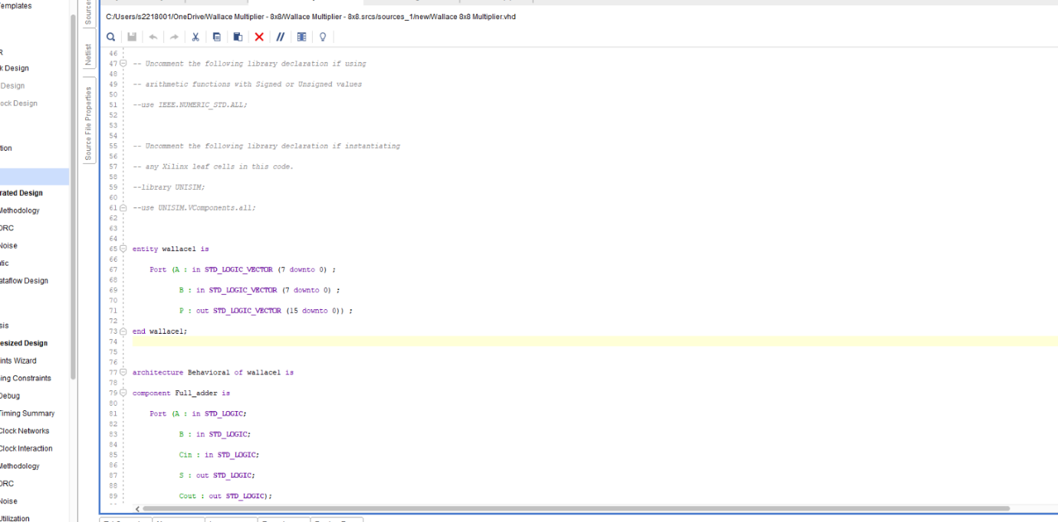
Figure 19 - Wallace VHDL - 1
Figure 20 - Wallace VHDL - 2

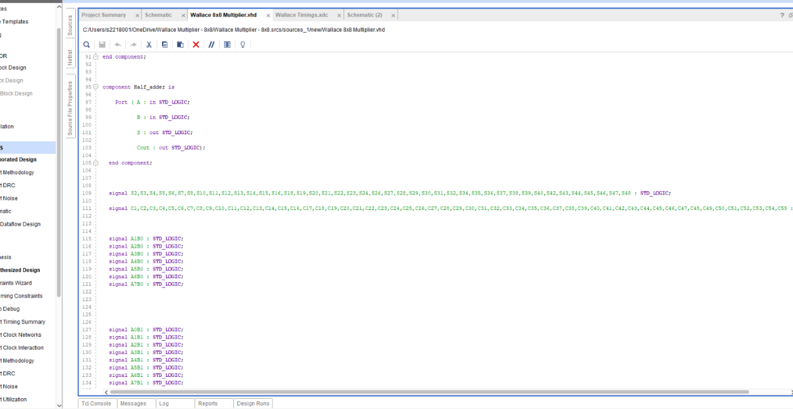
Figure 21 - Wallace VHDL - 3

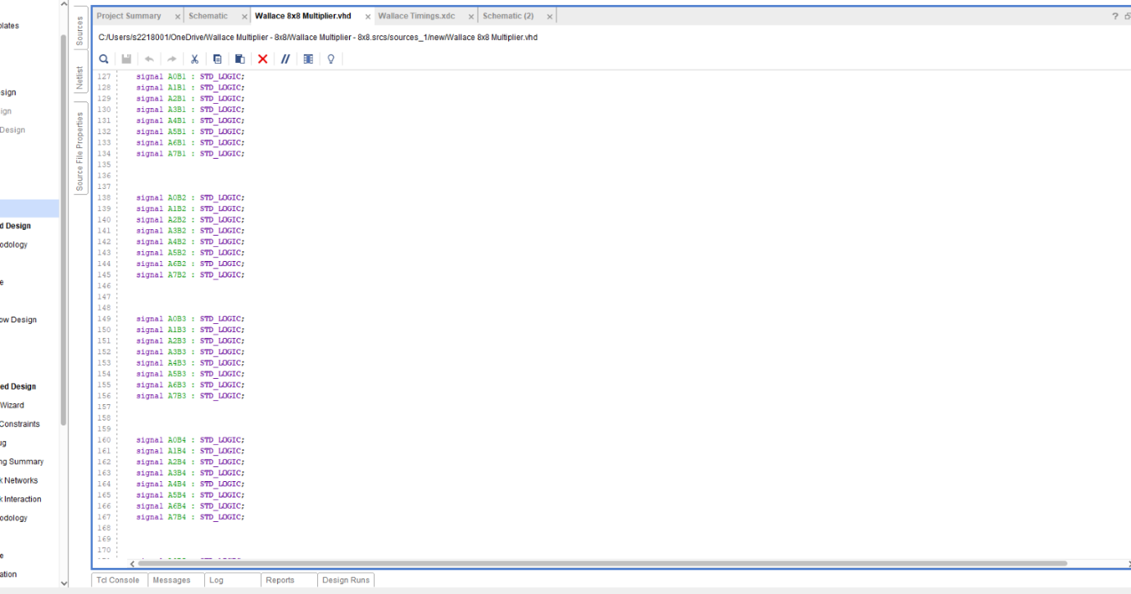
Figure 22 - Wallace VHDL - 4

Figure 23 - Wallace VHDL – 5
Figure 24 - Wallace VHDL - 6

Figure 25 - Wallace VHDL - 7
Figure 26 - Wallace VHDL - 8

Figure 27 - Wallace VHDL - 9

Timing Diagrams & Schematics of Design

Braun’s Multiplier – Timing diagrams

The figures below show different timing constants applied to the Braun’s simulation. There has been 4 timing constraints applied. Each simulation has a forced clock on A & B with the leading edge value of 1 and the trailing edge value of 0. The constants for each simulation has then been set to max, min and two middle values.

Timing 1
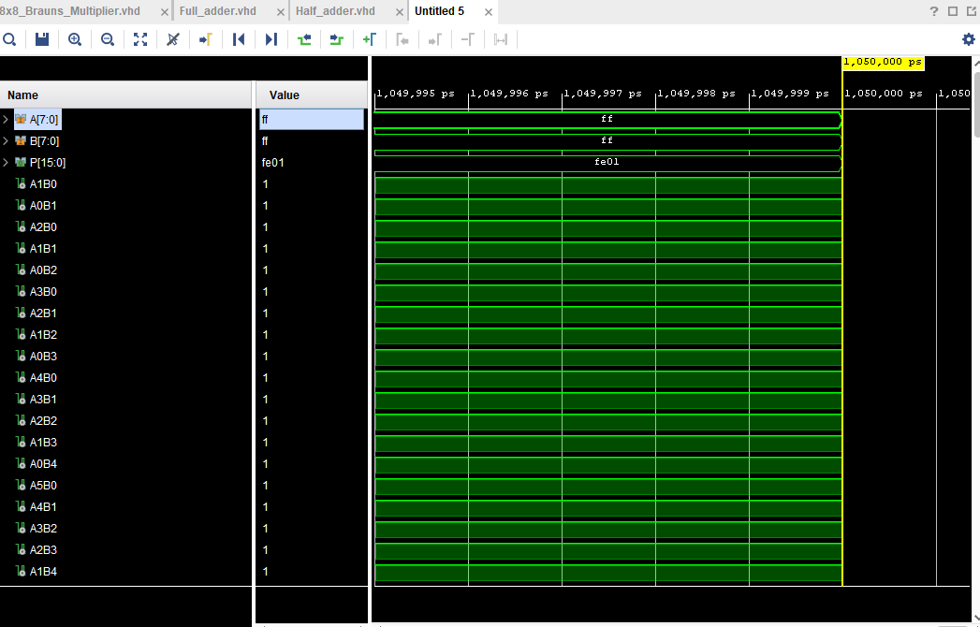
Figure 28 - Braun's simulation timing 1 (Max value)

Figure 28 shows the simulation being run and the different behaviours. This figure shows the maximum value that can be simulated on the multiplier.

A x B = P

Hex-
ff x ff = fe01

Binary-
1111 1111 x 1111 1111 = 1111 1110 0000 0001

Timing 2
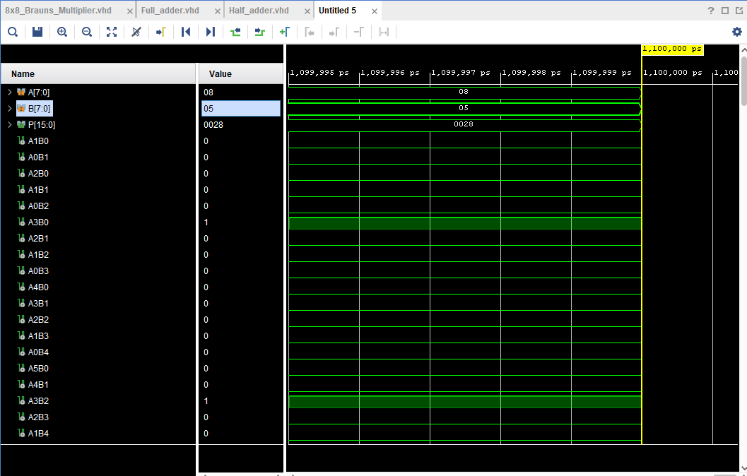
Figure 29 - Braun's simulation timing 2 (Min Value)

Figure 29 shows the minimum value input into this simulation.

A x B = P

Hex-
08 x 05 = 0028

Binary-
0000 1000 x 0000 0101 = 0000 0000 0010 1000

Timing 3
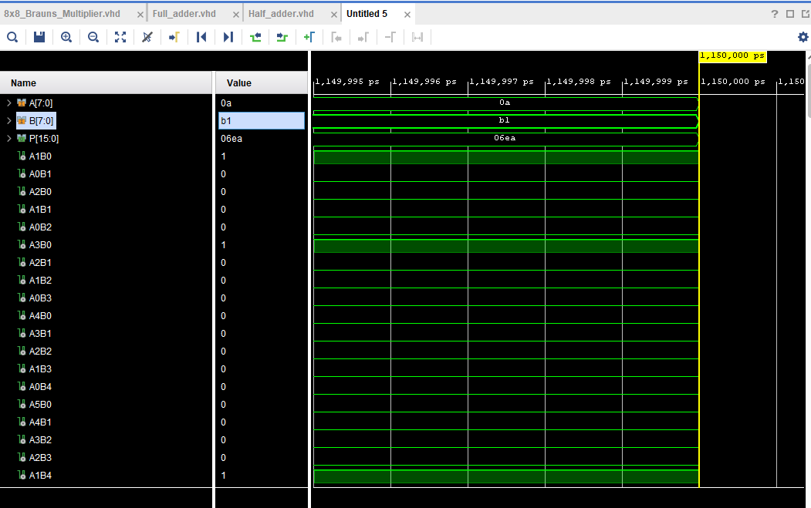
Figure 30 - Braun's simulation timing 3 (Midd Value 1)

Figure 30 shows the first middle value input into this simulation.

A x B = P

Hex-
0a x b1 = 06ea

Binary-
0000 1010 x 1011 0001 = 0000 0110 1110 1010

Timing 4
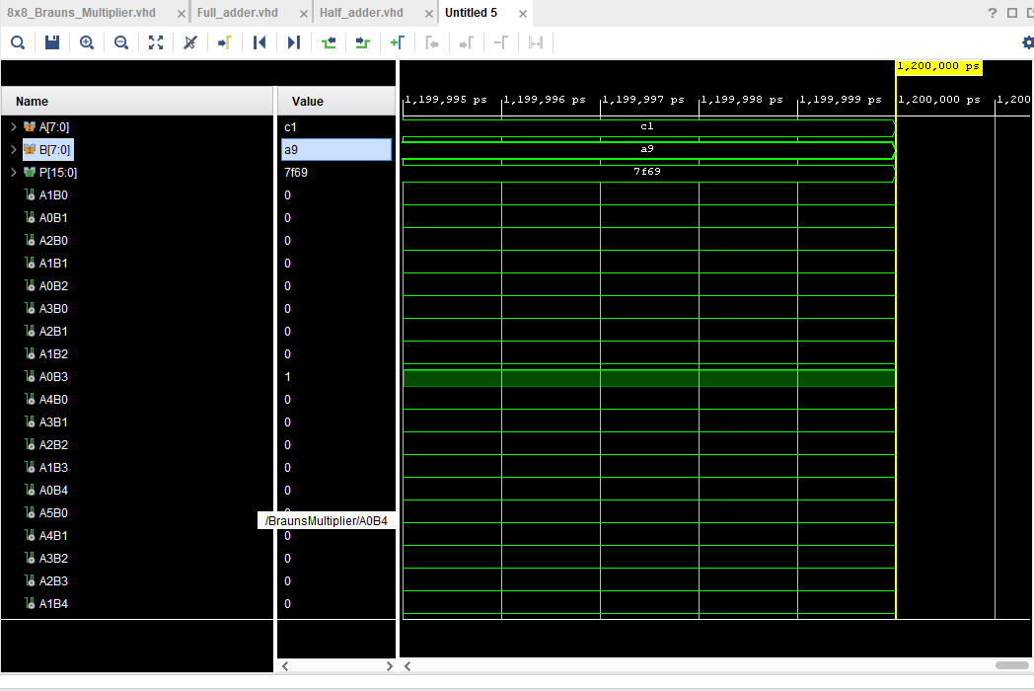
Figure 31 - Braun's simulation timing 4 (Midd Value 2)

Figure 31 shows the second middle value input into this simulation.

A x B = P

Hex-
c1 x a9 = 7f69

Binary-
1100 0001 x 1010 1001 = 0111 1111 0110 1001

As demonstrated throughout each simulation each input has given the correct value output. This proves both coding and simulation are working correctly.

Timing Constraints – Longest delay

Given that AND gate delay = 1ns
Full adder/half adder delay = 2ns

Longest delay = 1ns + 14* (2ns) = 29ns
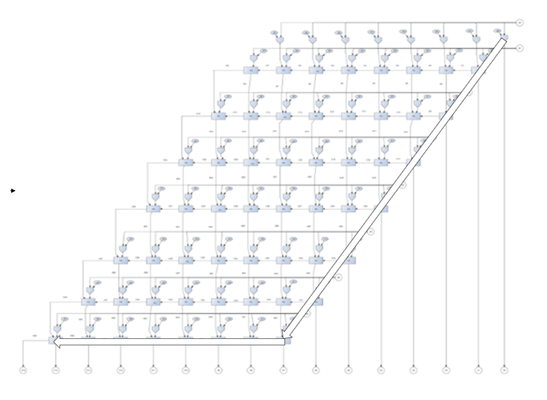

Figure 32 - Braun's longest delay diagram

Timing Summary
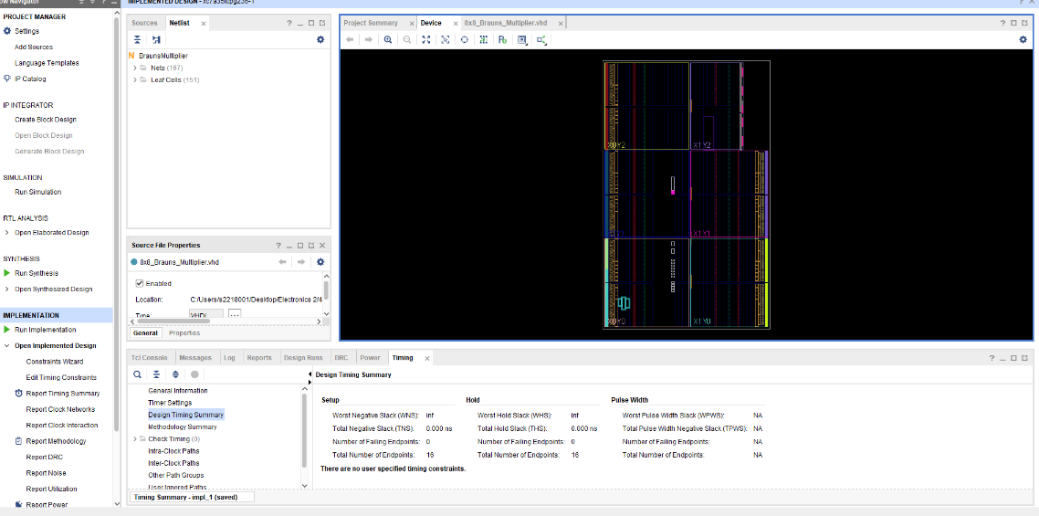
Figure 33 - Braun's timing summary & device
The figure shows the timing summary for the Braun’s multiplier. It indicates that there are no timing violations, with zero negative slack and zero failing endpoints, meaning the design meets the required timing constraints. This confirms that the multiplier operates correctly within the expected timing, making it reliable for FPGA implementation.

The next figures show the time delays of all signals in the Braun’s Multiplier.

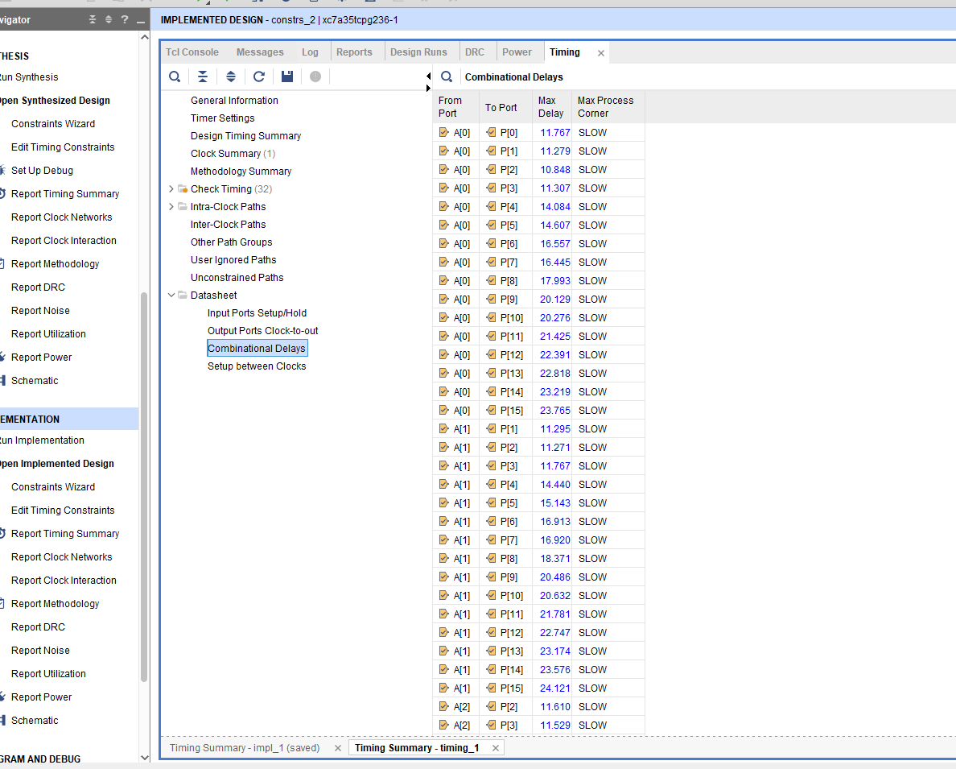
Figure 34 - Braun's time delays - 1
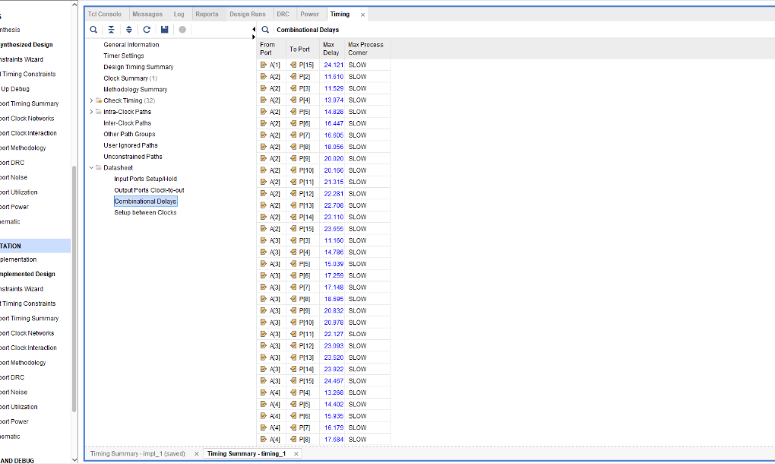
Figure 35 - Braun's time delays - 2
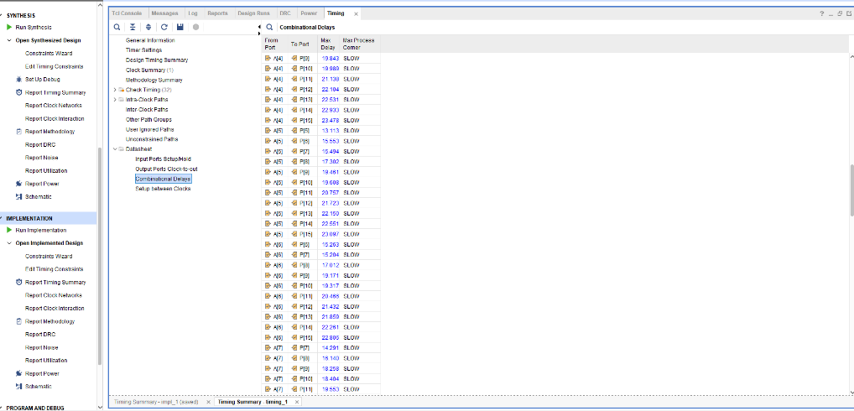
Figure 36 - Braun's time delays - 3
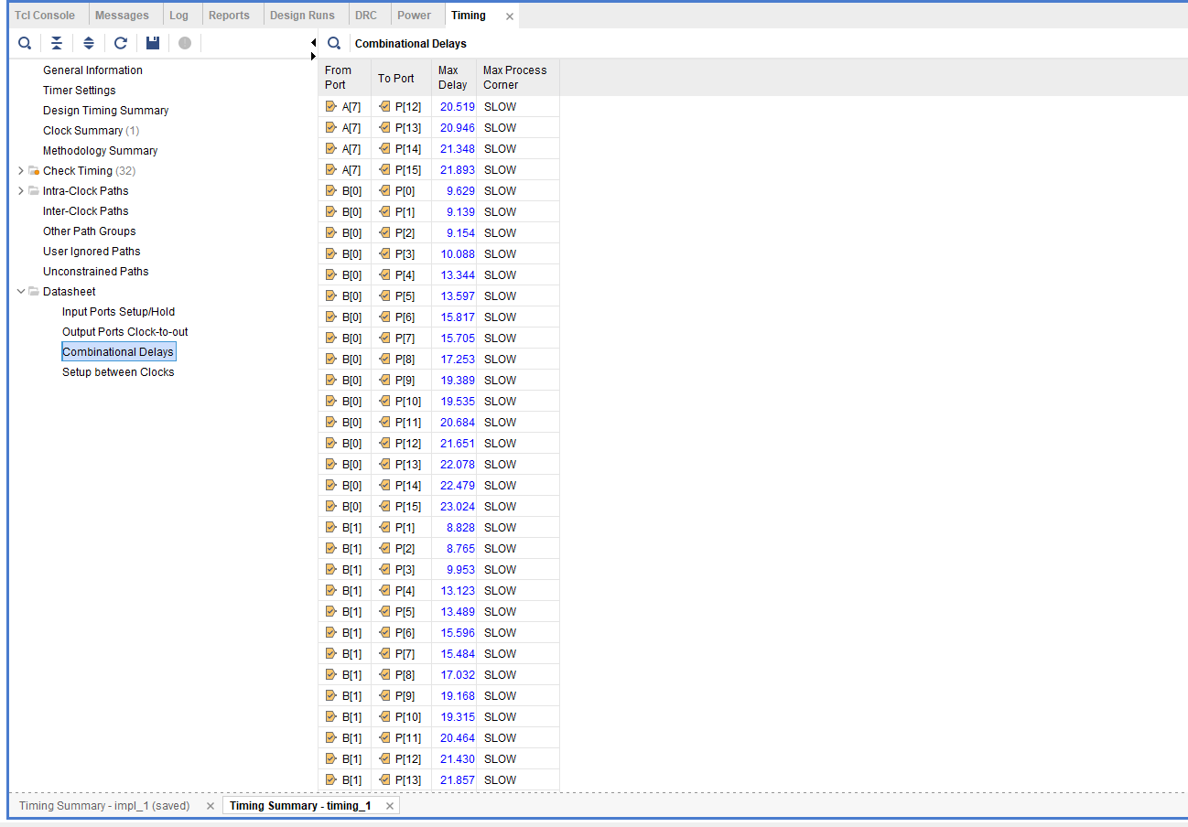
Figure 37 - Braun's time delays - 4
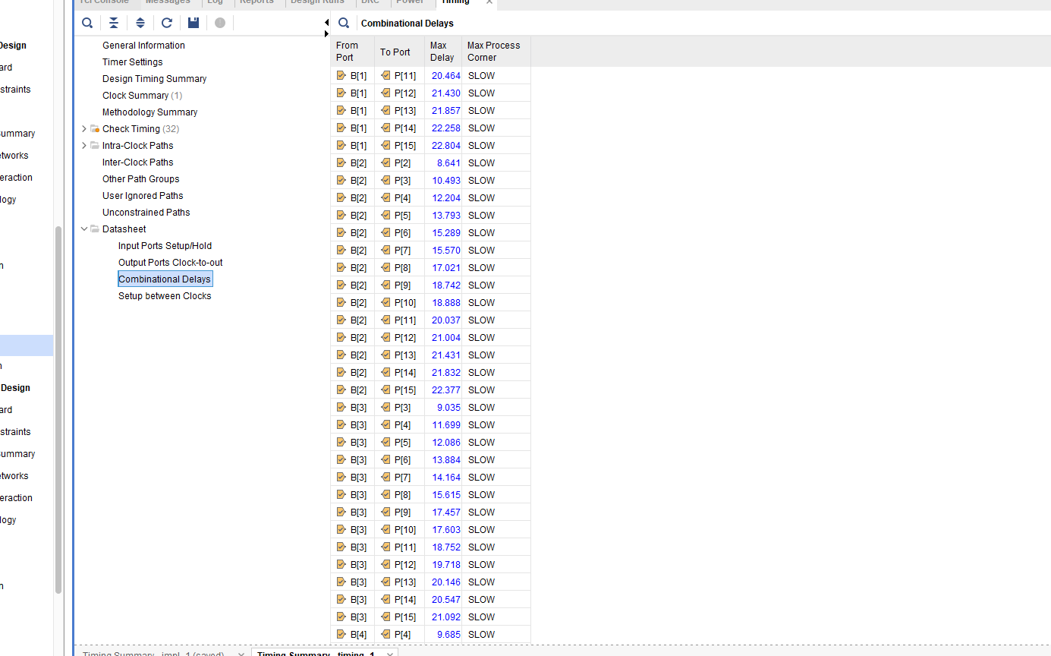
Figure 38 - Braun's time delays - 5
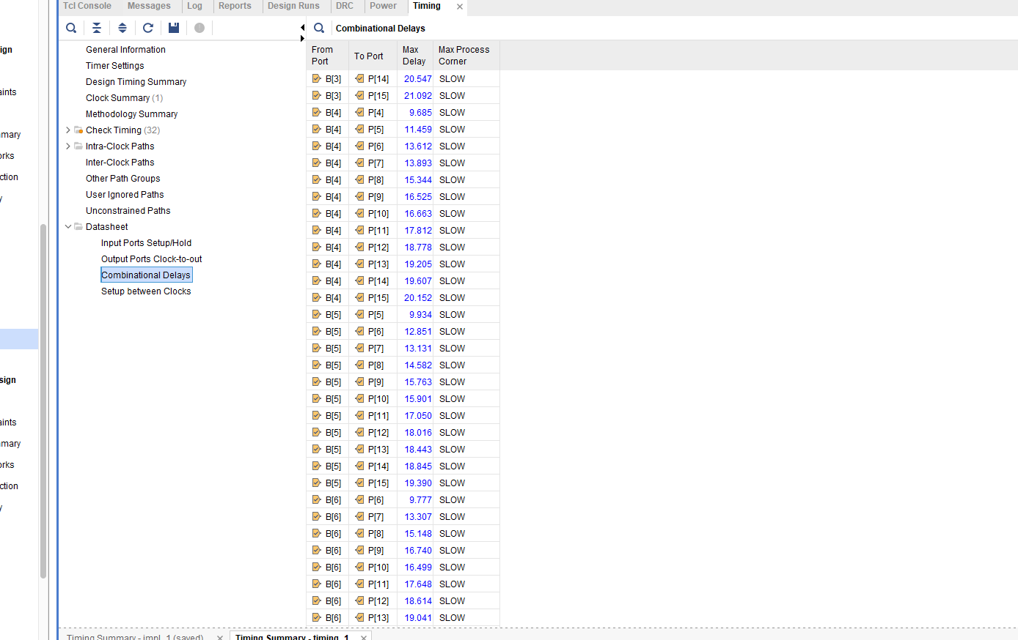
Figure 39 - Braun's time delays - 6
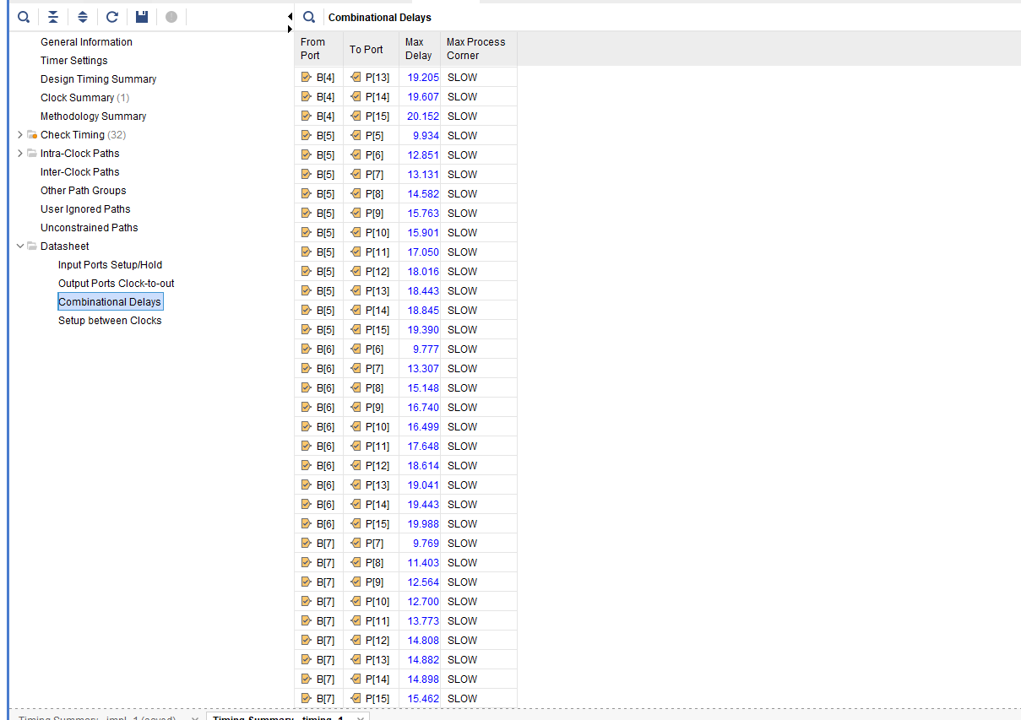
Figure 40 - Braun's time delays – 7

Schematic
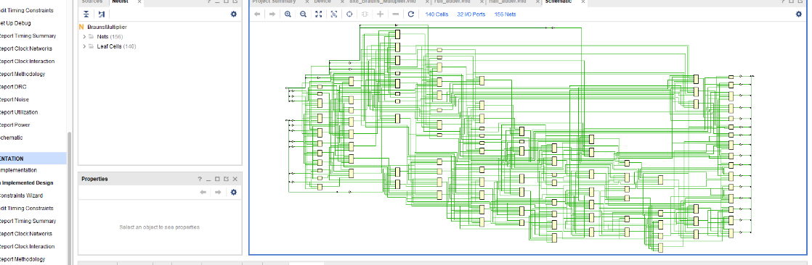
Figure 41 - Braun's Schematic
Figure 40 shows the Schematic layout for the Braun’s multiplier designed in Vivado. The green lines represent the interconnections between components in the circuit, which also include components like AND gates and adders. This diagram help understand, test and improve the circuit.

Wallace Tree Multiplier – Timing diagrams

The same timing constant were applied on the Wallace Multiplier. See below figures of all 4 simulations.

Diagram 1
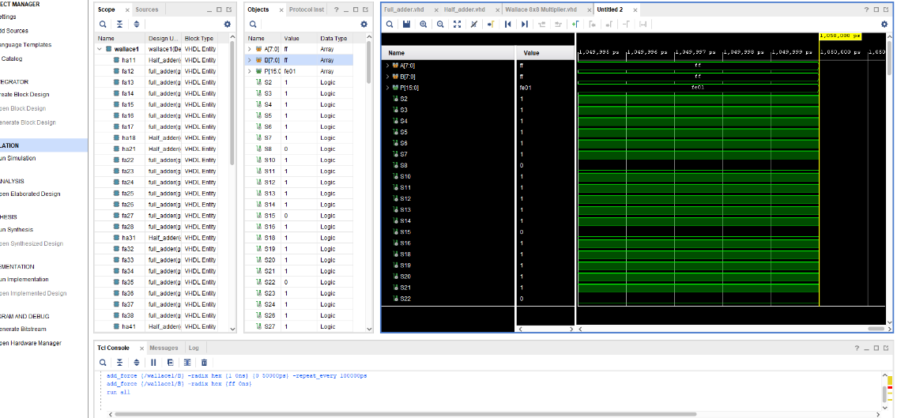
Figure 42 - Wallace simulation timing 1 (Max Value)

A x B = P

Hex-
ff x ff = fe01

Binary-
1111 1111 x 1111 1111 = 1111 1110 0000 0001

Diagram 2
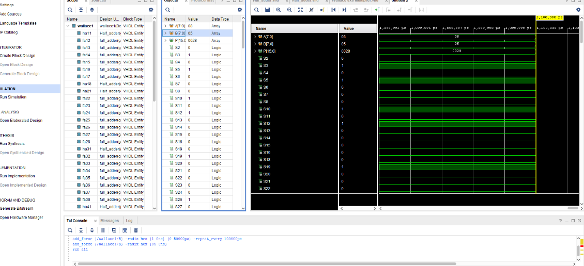
Figure 43 - Wallace simulation timing 2 (Min Value)

A x B = P

Hex-
08 x 05 = 0028

Binary-
0000 1000 x 0000 0101 = 0000 0000 0010 1000

Diagram 3
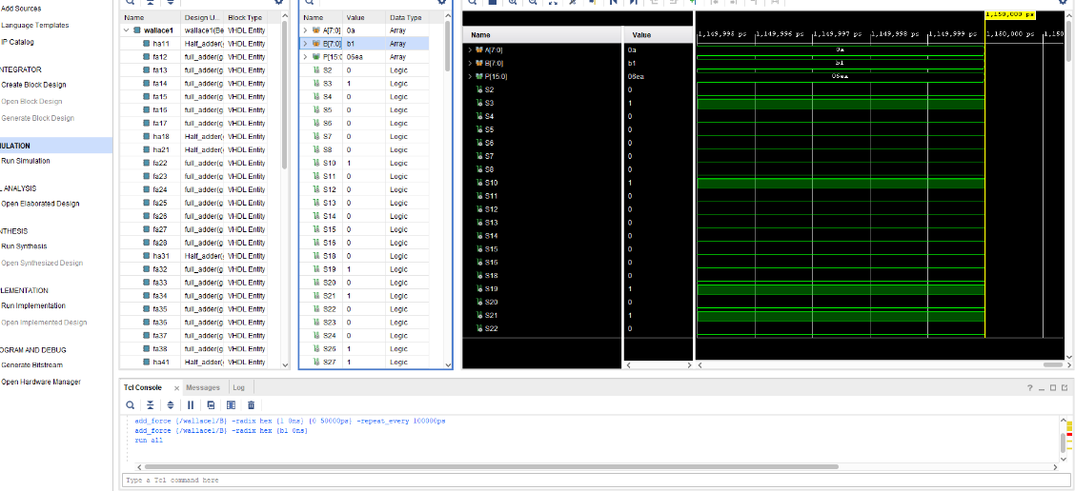
Figure 44 - Wallace simulation timing 3 (Midd Value 1)

A x B = P

Hex-
0a x b1 = 06ea

Binary-
0000 1010 x 1011 0001 = 0000 0110 1110 1010

Diagram 4
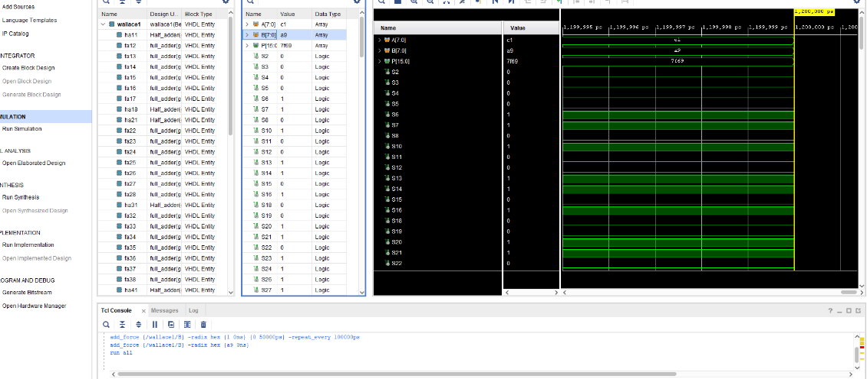
Figure 45 - Wallace simulation timing 4 (Midd Value 2)
A x B = P

Hex-
c1 x a9 = 7f69

Binary-
1100 0001 x 1010 1001 = 0111 1111 0110 1001

As shown in all 4 simulations, each input has given the correct value output again using the Wallace Tree multiplier. This proves both coding and simulation are working correctly.

Timing Constraints – Longest delay

Given that AND gate delay = 1ns
Full adder/half adder delay = 2ns

Longest delay = 1ns + 20* (2ns) = 41ns
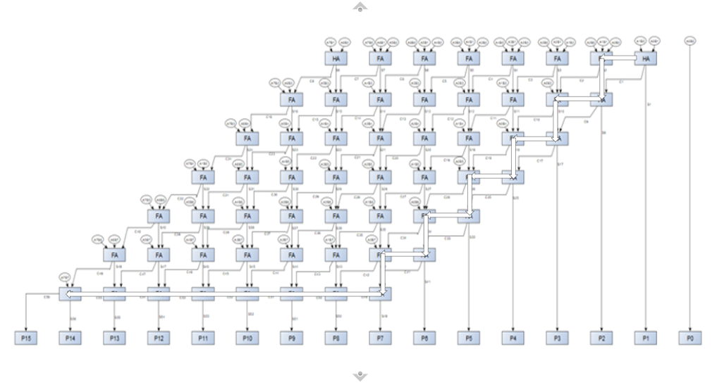
Figure 46 - Wallace longest delay diagram

Timing Summary
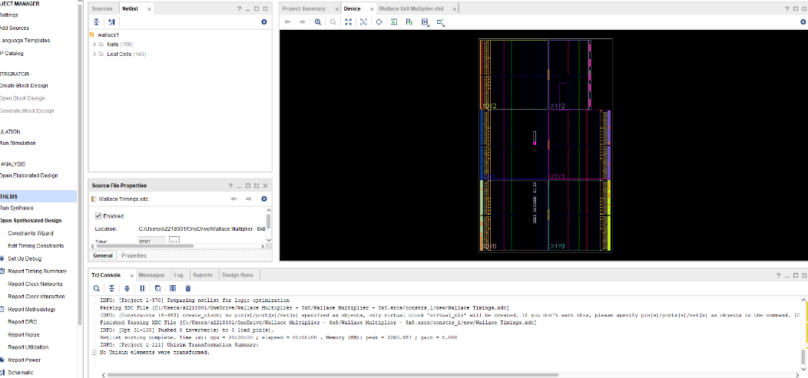
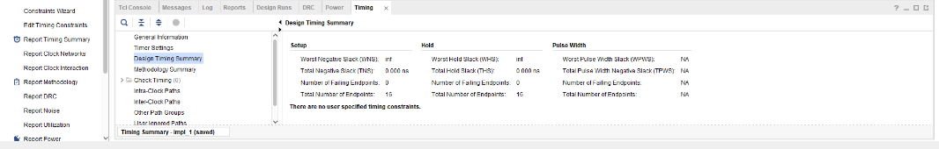
Figure 47 - Wallace timing summary & device
The timing summary for the Wallace Tree multiplier indicates that there are no timing violations, with zero negative slack and zero failing endpoints, meaning the design meets the required timing constraints. This again confirms that the multiplier operates correctly within the expected timing, making it reliable for FPGA implementation. As it stands, using the same inputs with either multiplier’s, we are receiving the same output.

The next figures show the time delays of all signals in the Wallace Tree Multiplier.

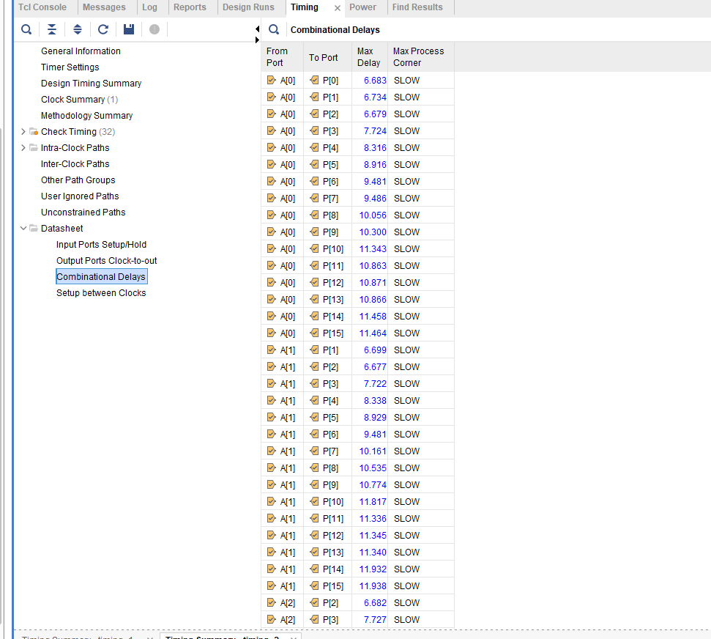
Figure 48 - Wallace timing delay - 1
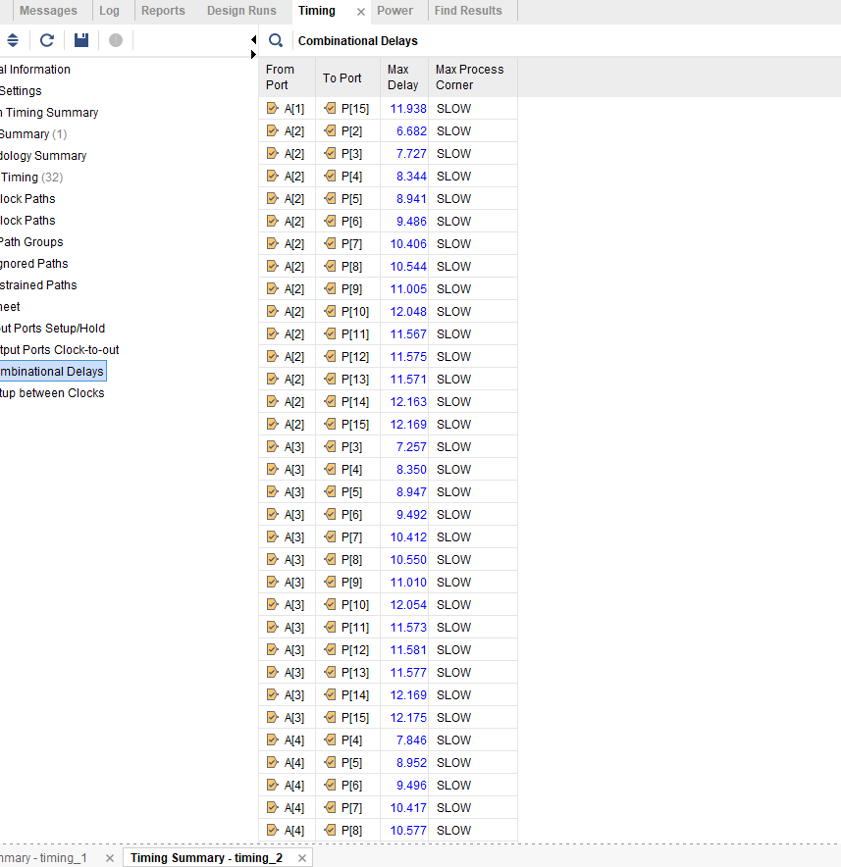
Figure 49 - Wallace timing delay - 2
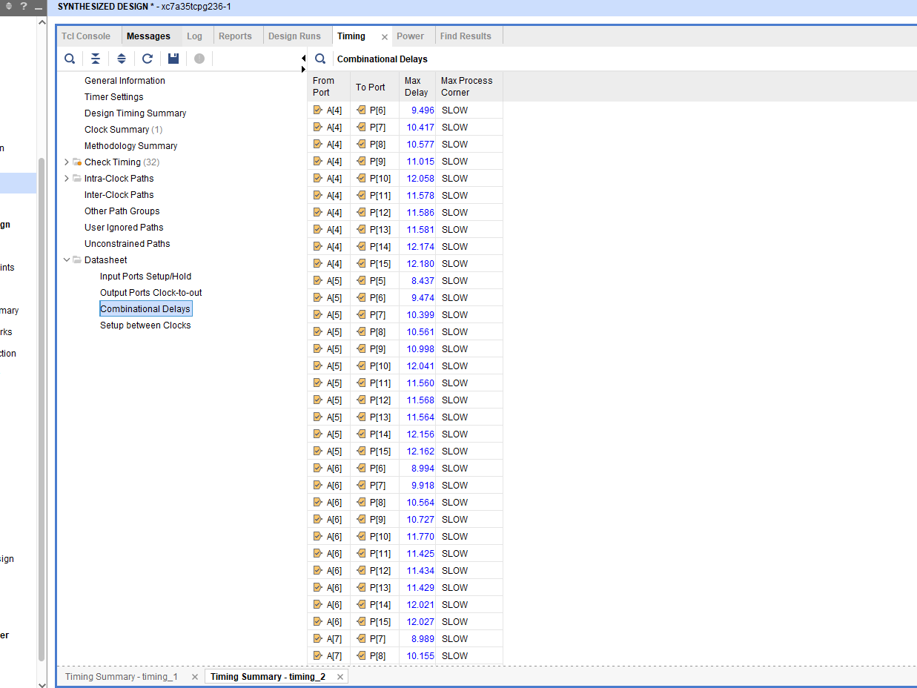
Figure 50 - Wallace timing delay - 3
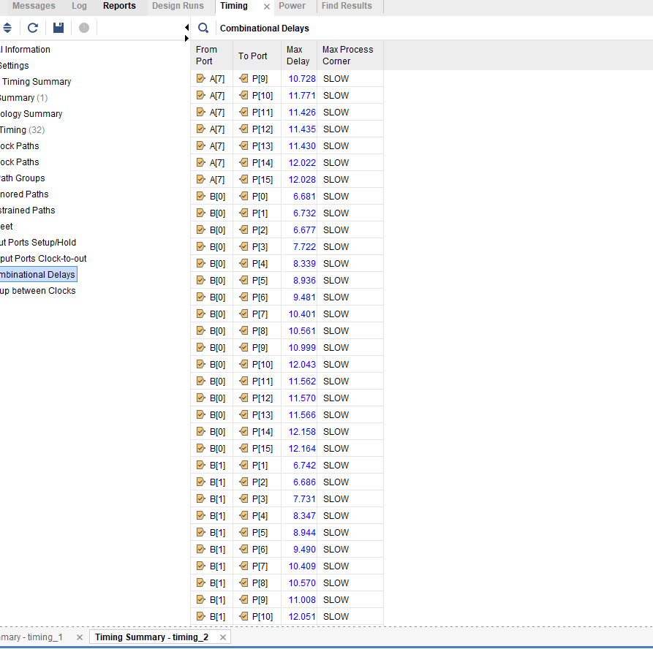
Figure 51 - Wallace timing delay - 4
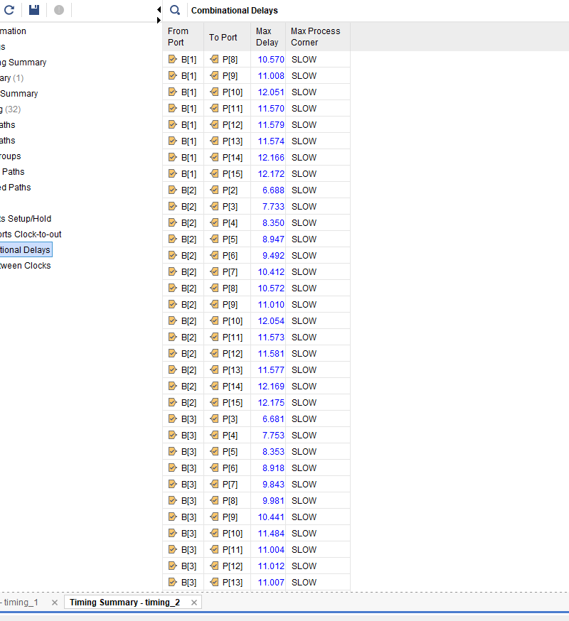
Figure 52 - Wallace timing delay - 5
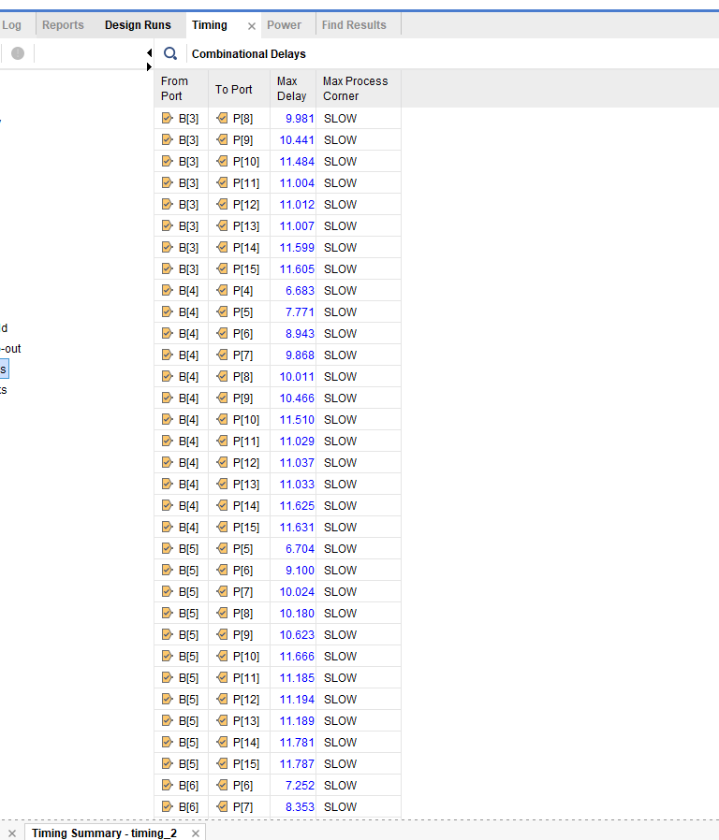
Figure 53 - Wallace timing delay - 6
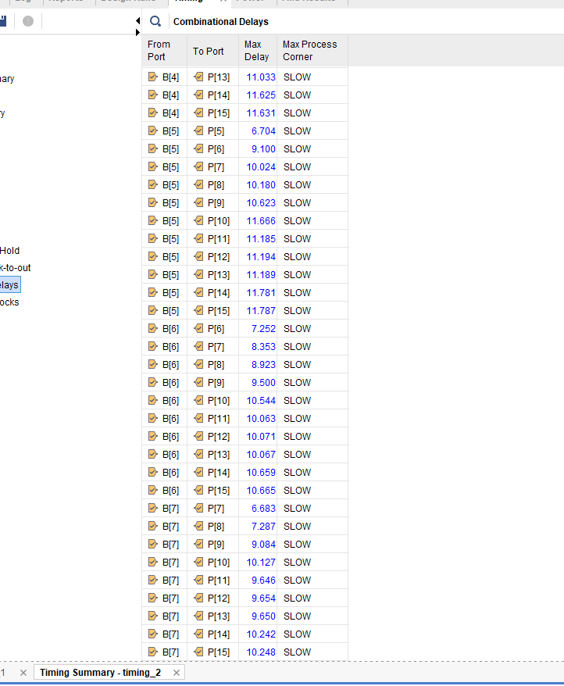
Figure 54 - Wallace timing delay - 7

Schematic
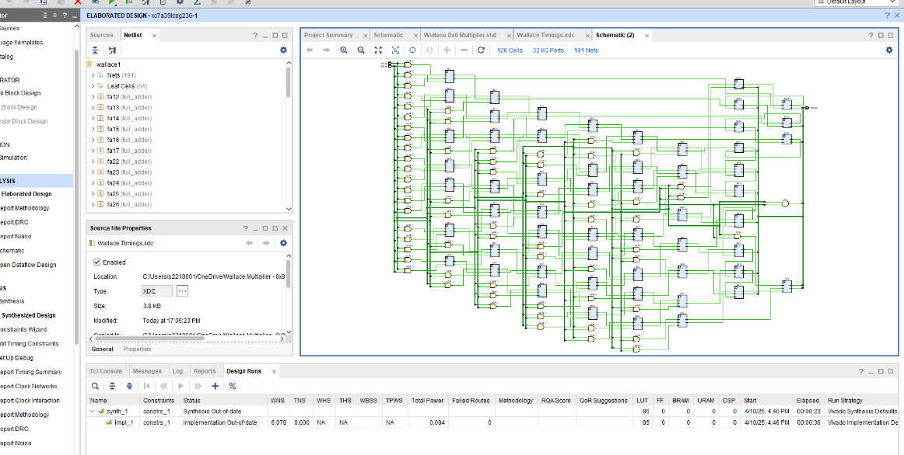
Figure 55 - Wallace Schematic

FPGA Design & Pin Allocation

Allocation of port is an important part in the system. The input ports receive data, such as the numbers to be multiplied, while the output ports deliver the result of the operation. Without properly assigned I/O ports, the design cannot interact and provide any signals.

Braun’s Multiplier Pin Allocation
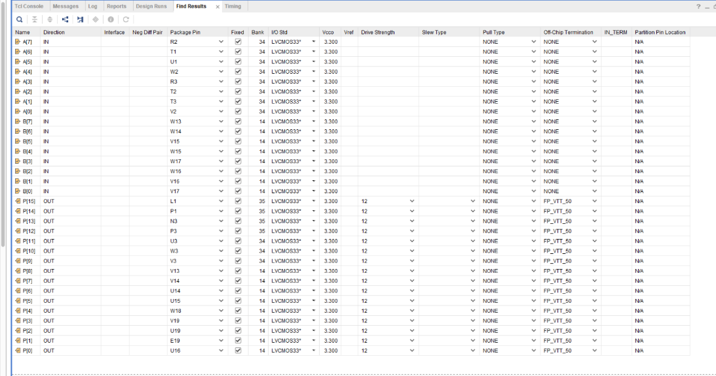
Figure 56 - Braun's pin allocation
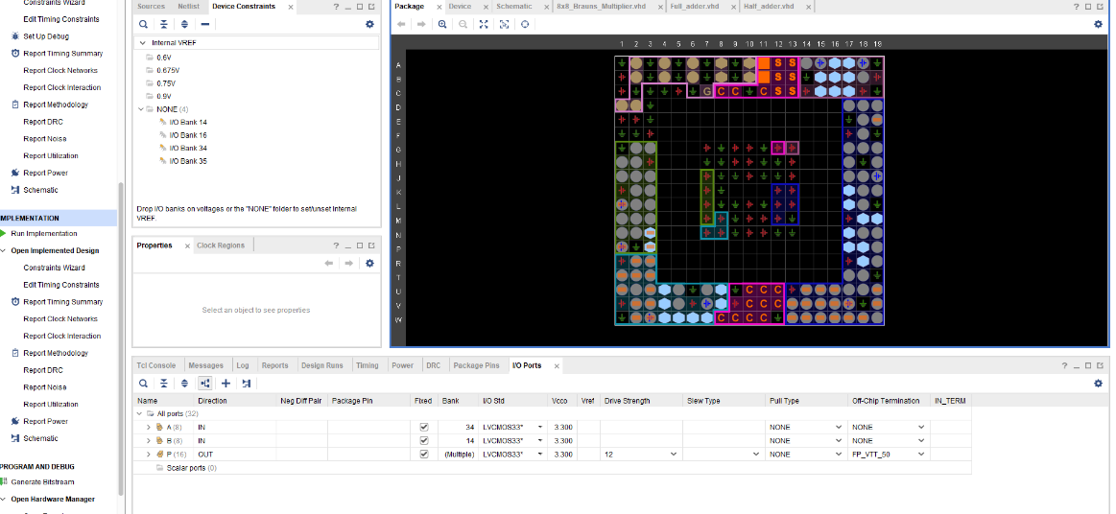
Figure 57 - Braun's device

Wallace Tree Multiplier Pin Allocation
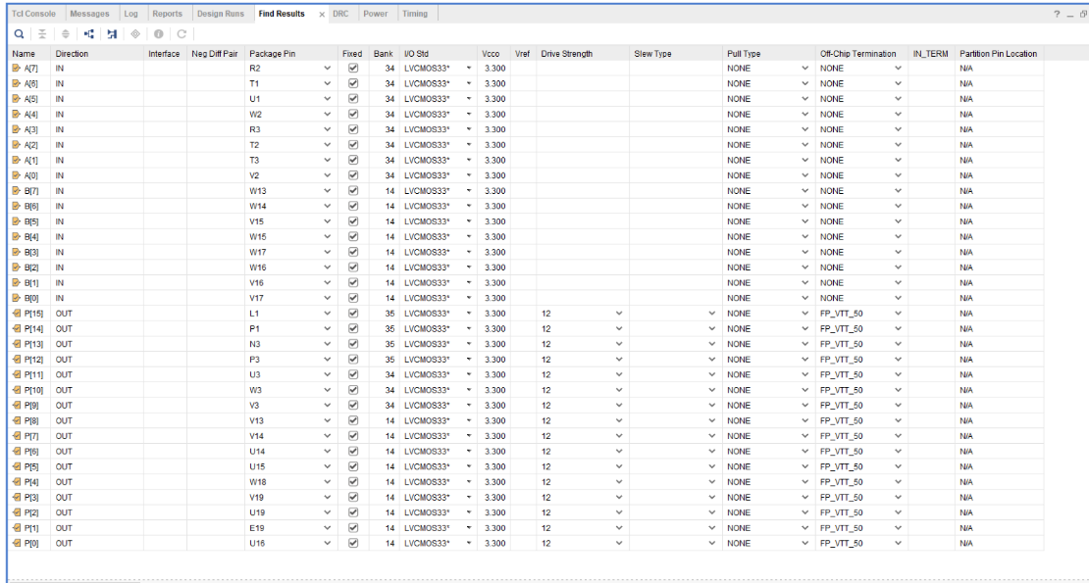
Figure 58 - Wallace pin allocation
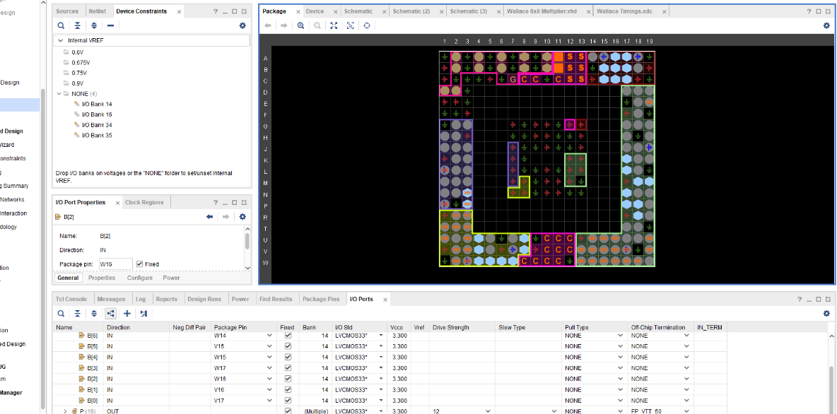
Figure 59 - Wallace device

Results

Braun’s Multiplier

Battery Summary

The figure below shows the power summary of the Braun’s Multiplier.

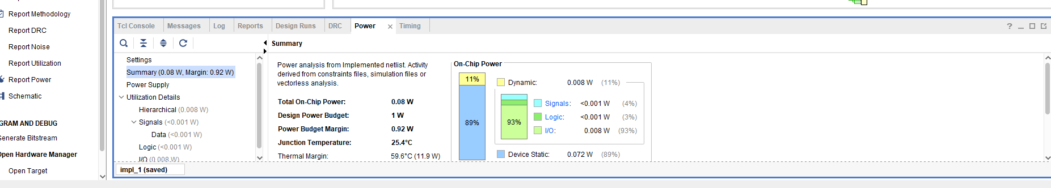
Figure 60 - Braun's power summary
By knowing the power summary of the Braun’s multiplier it tells us how much power the circuit uses when running. This helps in understanding if the design is energy efficient and suitable for use in real software’s such as FPGAs. If the power is too high, it can cause heating issues or reduce battery life in portable devices. By checking the power summary, we are able to make changes to improve performance and save energy.

The figure below shows what design power value we set, which is 1W.

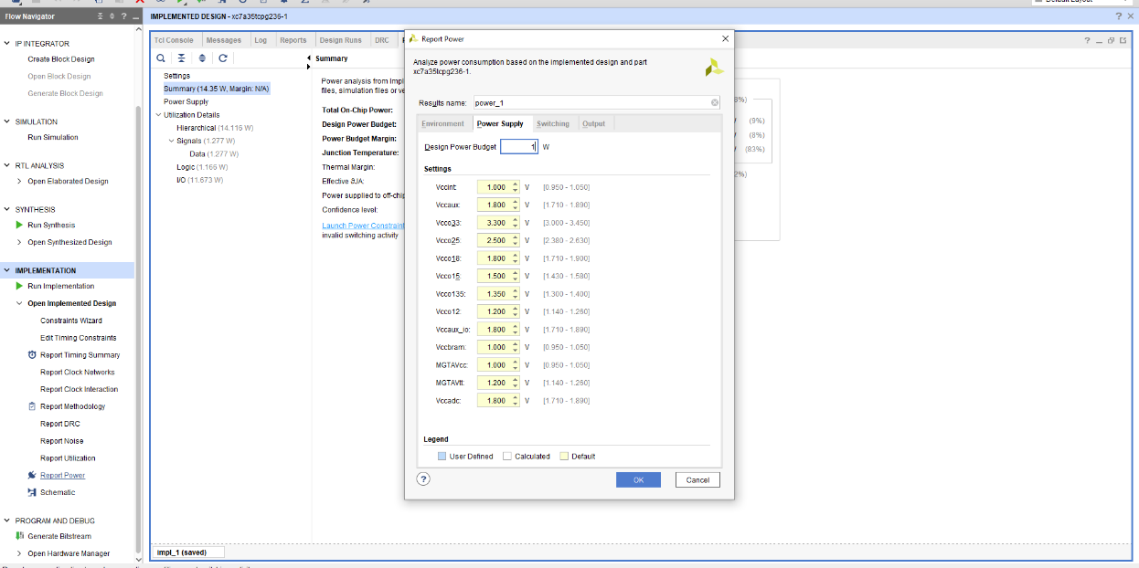
Figure 61 - Braun's set power value

RTL Analysis

The following figure demonstrates the RTL analysis of the design.

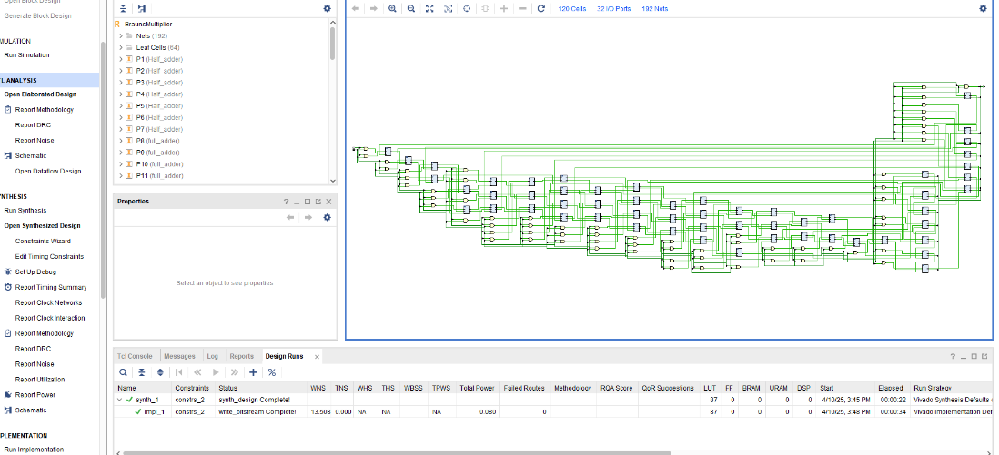
Figure 62 - Braun's RTL analysis
RTL (Register Transfer Level) analysis is important because it shows how data moves between registers and logic in a digital circuit. By checking the RTL, we can make sure the logic is correct, identify errors, and improve the design before moving to implementation.

LUT’s
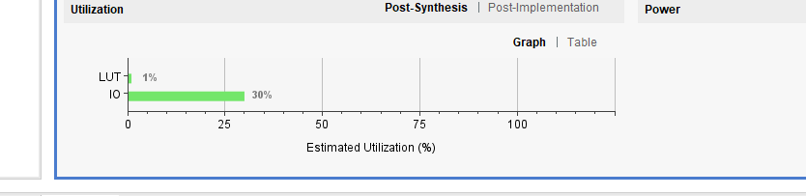
Figure 63 - Braun's LUT's
Utilization in the multiplier refers to how efficiently the software resources of an FPGA, such as LUT’s, etc that are used to implement the design. It provides information on how much of the available FPGA capacity is consumed by the multiplier. Monitoring utilization helps designers understand the complexity and size of the design. High utilization may indicate a need to simplify the design, while low utilization shows that more resources are available for other components. [5]

Wallace Tree Multiplier

Battery Summary

The figure below shows the power summary of the Wallace Tree Multiplier.

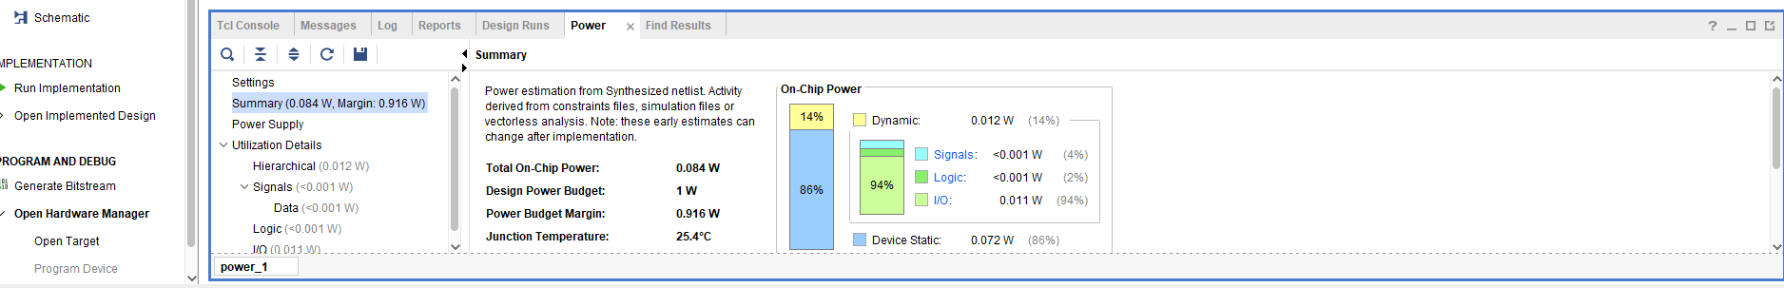
Figure 64 - Wallace power summary
Both Multiplier’s were given a design power value of 1W. Both values were kept the same for comparison.

RTL Analysis

The following figure demonstrates the RTL analysis of the design on the Wallace.

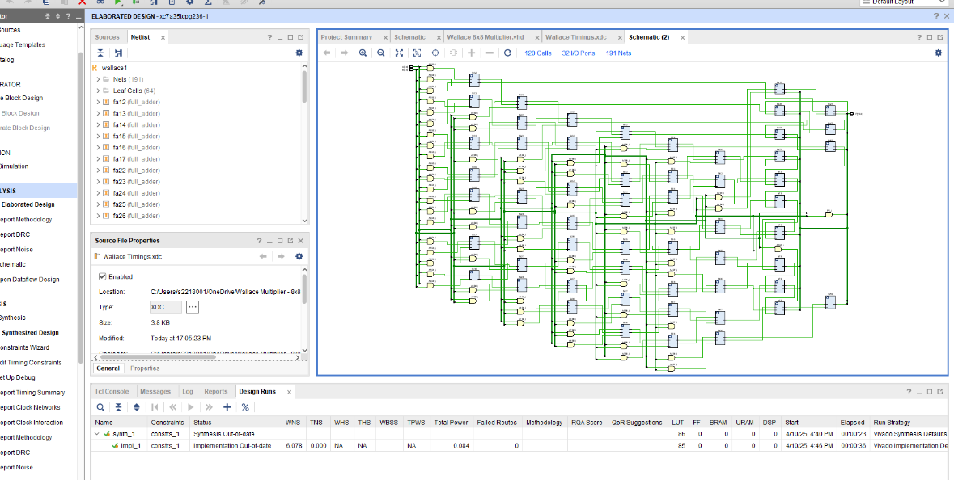
Figure 65 - Wallace RTL analysis

LUT’s
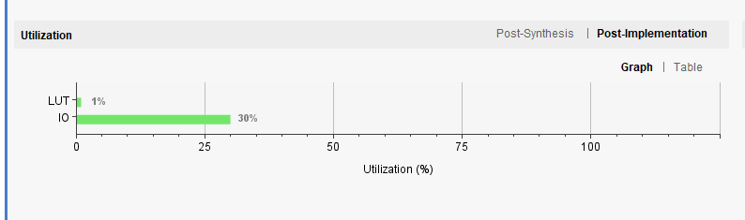
Figure 66 - Wallace LUT's

Recommendations

Recommendations for the design and analysis of the Braun’s and Wallace Tree Multiplier are listed below. Firstly design selection based on application, if the application requires a more simple and lower resource usage, then the Braun’s multiplier would be suitable. This is due to its smaller systems where power efficiency and ease of implementation are more important than speed.
Secondly optimisation for speed. For high speed or performance critical tasks like real time processing, the Wallace Tree multiplier is more suited to the task. It is quicker due to reduction in stages, despite its complexity and slightly higher power consumption.
Next would be the FPGA’s. Although both designs use FPGA’s, monitoring LUT’s and power consumption in detail and would help identify any design issue’s throughout the system.
Another recommendation would be power efficiency. When designing and choosing what multiplier to use, considerations like low power design techniques to further enhance energy efficiency.
Finally simulation and testing. Additional testing and verification could be included to improve the design, especially when implementing into real world applications.

Conclusion

In conclusion, this project implemented, analysed and compared two multiplier’s, one being Braun’s and the other the Wallace Tree Multiplier. The Braun’s multiplier and the Wallace Tree multipliers, both use VHDL and FPGA. As shown throughout the report, both simulations, including timings constraints, power usage, input power, etc, have performed and worked correctly when tested.

The Braun’s multiplier demonstrated a simpler and more structured design, making it easier to use and suitable for low complexity applications. However, the Wallace Tree multiplier, even though it is a more complex design, it has proved to be more of an efficient system in regards to speed due to its reduction process on the stages.

Both designs met the required timing constraints and power use, making them both suitable options for software implementation. Overall, when choosing between both designs, it would really depend on the requirements of the application, whether it’s simplicity and ease of implementation or speed and performance. [6]

References

[1] | in Computer Arcitchture, John.L.Hennesy & David.A.Patterson, 2019.
[2] | “Ripublication,” 11 04 2025. [Online]. Available: https://www.ripublication.com/acst17/acstv10n5_54.pdf.
[3] | “AMD,” 12 04 2025. [Online]. Available: https://www.amd.com/en/products/adaptive-socs-and-fpgas/fpga.html.
[4] | “IEEE Explore,” 04 04 2025. [Online]. Available: https://ieeexplore.ieee.org/abstract/document/8605173.
[5] | “iaENG,” 09 04 2025. [Online]. Available: https://www.iaeng.org/publication/IMECS2012/IMECS2012_pp275-277.pdf.
[6] | “Academia,” 02 04 2025. [Online]. Available: https://www.academia.edu/114227557/FPGA_Based_High_Performance_Double_Precision_Matrix_Multiplication?uc-sb-sw=7975393.

