Module Name: International Meetings Management for the Hotel Industry
Module Code: BMIH6007
Assignment 2: Event Strategic Planning and Delivery Considerations for an International Meeting.
Event Theme: World Festive Food Festival

Student Name: Khalilur Rahman
Student ID: 2211971
Lecturer Name: Kathryn Flynn

Declaration
I confirm that I have not used any AI tools in the research and creation of this assignment. I confirm that I have not presented any AI-generated materials as my own work. I confirm I have copies of my drafts, notes, and other resources I used, which I may be asked to provide in evidence.

Executive Summary
Birmingham's New Bingley Hall will host the World Festive Food Festival, which will promote food industry diversity and inclusion. International food merchants, famous chefs, and cultural ambassadors network and engage in this event. The Festival promotes foreign cuisine and community connection with the culinary and hotel sectors. Festival success requires financial, stakeholder, and logistical planning. The festival chose New Bingley Hall for its accessibility, large capacity, and customisable event space to promote diversity and cultural representation. This infrastructure can accommodate numerous guests, vendors, and entertainers and provide transit and accessibility. According to the previous assignment's (A1) feasibility analysis, the event is logistically and financially feasible with a £3,000 net profit (A1). Sales of tickets, sponsorships, and products benefit stakeholders. The operational plan boosts event effect with smart marketing, vendor coordination, and cultural organisation engagement. Event strategy includes internet marketing, experiential event demand, and sustainable event administration. Event planners satisfy guests' physiological, safety, social, and self-actualization demands using Maslow's hierarchy. This study describes event management strategy as planning, marketing, budgeting, and execution. Understanding the food industry, involving stakeholders, and managing well can help the festival promote ethnic diversity, inclusivity, and quality.

Table of Contents
Executive Summary 2
Introduction 4
The Event Cycle 5
Event Concept 7
Aim and Objectives of the Event 9
Event Management 10
Event Budget 13
Industry Trends / Issues / Impacts 15
Situational and Cultural Considerations 17
Conclusion and Recommendations 19
References 20
Appendix 23
Gantt chart 23

Introduction
The World Festive Food Festival will promote food industry cultural diversity and inclusivity through MICE. In Birmingham's New Bingley Hall, global cuisine and cross-cultural understanding are interactive. The event, "Equality, Diversity, and Inclusion within Industry," highlighted business and society's growing focus on diversity and inclusion. Participants will try African, Asian, Middle Eastern, South American, and European foods. Projections of logistical, financial, and market demand determined event viability in Assessment 1. The feasibility research indicated the event is financially sustainable with customer interest, sponsorship, vendor, and cultural group support. The study preferred Birmingham's New Bingley Hall due to its central position, public transit accessibility, and large event capacity. Continuous operation fosters cultural interchange, corporate networking, and community engagement. This Assessment 1-based event management strategy covers strategic planning, operational execution, and financial considerations for event success.

The Event Cycle
The event cycle includes planning, execution, and closure. Every stage is vital to event organisation, efficiency, and success. Start, Plan, Execute, Close is the event cycle. EMBOK guidelines assure success at each event cycle step (Getz and Page, 2019). This section links World Festive Food Festival stage-specific event management best practices to event planning and execution.
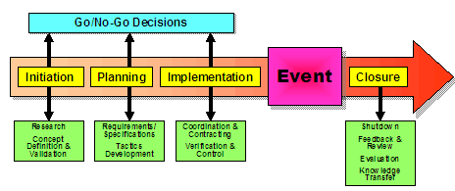
Figure 1: EMBOK
Source: (Bladen et al., 2023)
Initiation: Initiation sets event cycle goals, scope, and purpose. This phase sets World Festive Food Festival ethnic diversity and food industry inclusivity targets. Festival food vendors from outside promote cultural interaction (Bowdin et al., 2023). Which festival goals are discussed? Goal audience? What logistics are needed for events? Identify sponsors, cultural ambassadors, suppliers, and participants now. Each group is crucial to the festival's success. Plan attendees, food vendors, and event items early. Set these variables to align festival choices with aims.
Planning: Event cycles require an execution strategy. EMBOK covers project, resource, financial, and risk management. World Festive Food Festival planning begins with venue selection. Birmingham's new Bingley Hall holds visitors and food vendors. Planning requires vendor collaboration. Food safety and health must be met when serving international cuisines. Plans include festival promotion (Seraphin, 2020). Internet marketing, local outreach, and cultural alliances boost event attendance and excitement. Promote ethnic diversity and inclusion in festival marketing. Staffing, catering, technical equipment, and contingencies are planned. Event team duties must be outlined for stakeholder communication. Event success requires a venue, food, beverage, promotion, and technical fees. Each work has a deadline to avoid event day delays.
Execution: Plan implementation brings them to life. Here, event execution counts. This time, EMBOK emphasises event success through operational management. The World Festive Food Festival starts with venue setup. Set up merchant stations, booths, and vendor sites before the event. Protect health and safety. Technical operations cooperation is critical next. Sound, lights and other audio-visual equipment must work (Holmes et al., 2015). Festivalgoers need crowd management to move. Monitoring all actions throughout execution is essential. Technical concerns, crowd management, and vendor shortages need rapid attention. Collaboration speeds problem-solving events. Here, event staff must verify all aspects meet expectations. To overcome unexpected problems, execution requires agility and real-time decision-making. This stage relies on suppliers, guests, and volunteers and on-time operations.
Closure: Final evaluations assess event success and improvements. Plans should include post-event evaluation, per EMBOK. Last phase sponsors, vendors, and participants evaluate the World Festive Food Festival's success. Strengths and weaknesses may be revealed by execution feedback. A detailed financial investigation is needed for closure. Check ticket, sponsorship, and food and beverage sales to see if the event budget was met (Schmidheiny and Siegloch, 2023). Report abnormalities and cost overruns to budgeting. Post-event reports should highlight successes and improvements. Closure includes thanking vendors, volunteers, and stakeholders and honouring agreements including payments and comments. Results analysis improves future festivals. Event performance review and management practice improvement must end.

Event Concept
The World Festive Food Festival immerses guests in gastronomic culture. This event will feature many international cuisines. It celebrates international cuisine and culture. The event will serve African, Asian, Middle Eastern, South American, and European meals (Kesgin, Murthy and Lagiewski, 2021). Cultural awareness and pleasure increase with variety. International cuisine lets tourists try new foods and culinary methods. Besides dining, cultural ambassadors will share stories, cooking techniques, and cuisine perspectives. Food tours, not bazaars, will be the vibe.
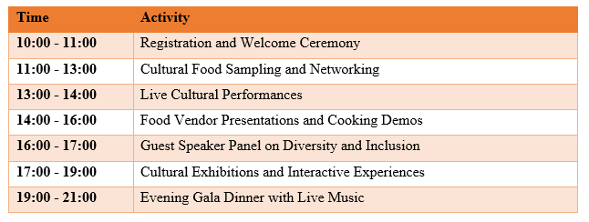
The Event will be comprehensive. A 10:00–11:00 registration and welcoming ceremony will set the festival's tone and explain event details. Visitors can network from 11:00–13:00 food vendors while sampling cultural treats. This initiative helps like-minded people try new foods and interact. From 13:00 to 14:00, live performances will reinforce the festival's cultural focus. These performances will feature international traditional music, dance, and art. Food vendors and cooks will perform during the festival from 14:00 to 16:00. Sellers will prepare authentic dishes live (Dimitrovski, Starčević and Marinković, 2021). Understanding diverse cuisines' ingredients and preparation increases the experience. From 16:00 to 17:00, experts will discuss the benefits of cultural diversity, especially through gastronomy, in a diversity and inclusion guest speaker panel. Discussions about how food fosters community are encouraged.
From 17:00 to 19:00, cultural exhibitions and interactive encounters conclude the day. Cultural exhibitions, art installations, and hands-on activities teach festivalgoers about civilisations. Immersive events will reveal our cuisine's civilisations (Getz, 2024). The events 19:00 to 21:00 Evening Gala Dinner will have live music and a huge meal. Participants will rest, eat, and reflect on the day's cultural diversity in the last session. Live music at the World Festive Food Festival will boost holiday cheer.

Aim and Objectives of the Event
Aim
- The World Festive Food Festival aims to celebrate cultural diversity and inclusion by showcasing diverse cuisines and promoting global exchange.
SMART Objectives
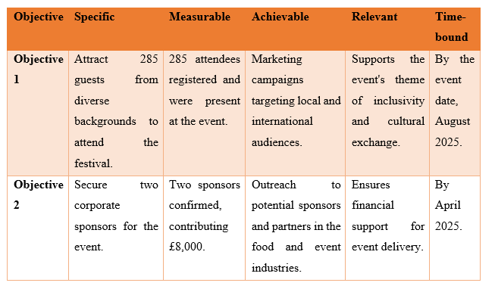
World Festive Food Festival aims for success and impact. Inclusion and cultural exchange require 285 people. Event registration data will track 285 confirmed guests, making the goal clear and measurable. It can be done via social media, targeted marketing, cultural collaborations, and community involvement (Kesgin, Murthy and Lagiewski, 2021). It promotes festival diversity and engagement. Promotion and outreach must match the August 2025 event date.
Finding two £8,000 business sponsors is key. For this, we need two sponsors and their money. Success grows with industry networks, sponsorship opportunities, and targeted marketing to food and event sponsors (Holmes et al., 2015). Relevant because it secures venue, marketing, and logistics funds. April 2025 is the deadline for festival financial planning and sponsorship.

Event Management
World Festive Food Festivals need planning, execution, and promotion. Event management requires planning, resource allocation, and promotion throughout.
Operational skills and resources: Events require logistics, vendor management, food, technology, and security. Logistics moves commodities, equipment, and food efficiently. Organise food vendors, booths, and stages (Bladen et al., 2023). Management of goods, timelines, and vendors requires event coordinating skills and technology. Crowd control, patron safety, and vendor health require security (Wickham, Donnelly and French, 2020). Concert, speech, and cultural installation technicians control video, lighting, and sound. These resources must cooperate to entertain.
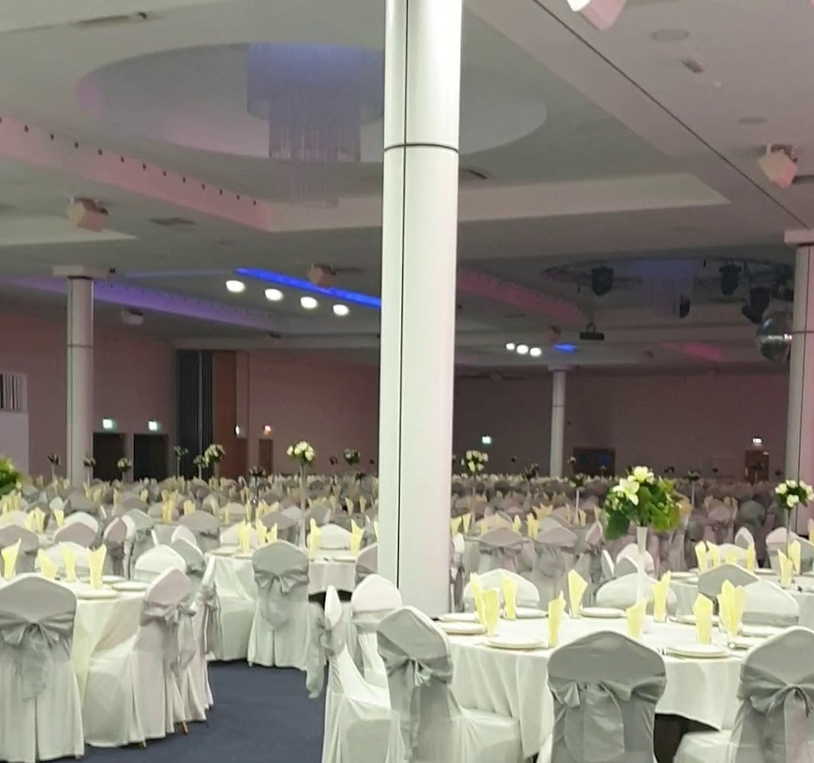
Figure 2: The New Bingley Hall
Source: (Getz, 2024)
Planning skills and resources: Strategy and goals are needed for World Festive Food Festival planning. Experienced staff will plan and budget the event. These planners need stakeholder collaboration, risk assessment, and large-scale event site experience (Jarman, 2020). To accommodate all visitors, multinational event planners must overcome language barriers, cultural sensitivities, and various perspectives. Event planning includes a clear timetable, backup plans for delays, and a staff for last-minute changes. Event planners must communicate with sponsors, vendors, and speakers. According to Maslow's Hierarchy, planners must address participants' physiological and social needs for food, comfort, networking, and culture (Zou et al., 2021). Meeting these expectations at festivals promotes self-actualization and cultural variety.
Marketing Activities: Promote the World Festive Food Festival to draw people. A comprehensive marketing plan boosts ticket sales and awareness. This phase requires digital, social, PR, and branding expertise. Marketing should target foodies, culture explorers, and community members. Content, visuals, social media, and market research will constitute marketing. Promote with local media and influencers to boost attendance and buzz (Tran et al., 2022). This phase will determine the event's product, pricing, place, promotion, staff, process, and physical evidence using the marketing mix (7Ps). Marketing 7Ps attached in the appendix examined and presented a good marketing plan. World Festive Food Festival marketing should emphasise cultural diversity. Effective marketing can enhance attendance.

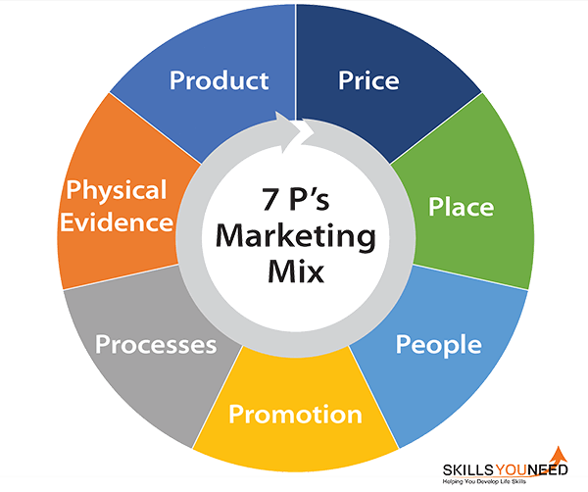
Figure 3: Marketing 7Ps
Source: (Tran et al., 2022)

7Ps | Description
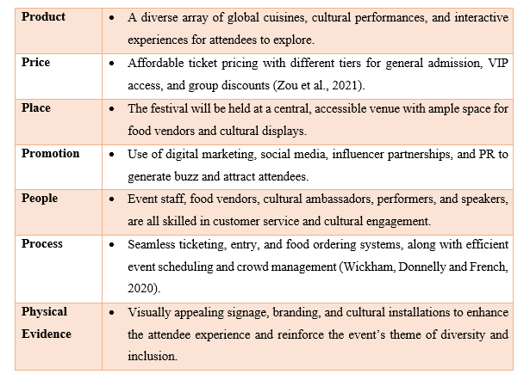
A successful World Festive Food Festival requires planning, marketing, and operations experience and resources. To ensure the event succeeds meets goals, and provides an inclusive, engaging experience, every phase is critical (Janiszewska and Ossowska, 2021). Maslow's Hierarchy of Needs will help the event management team make smart decisions to satisfy festivalgoers' diverse needs and produce a great experience.

Event Budget
Budgets will support the World Festive Food Festival. Breaking down revenue and spending helps limit spending and make money. The greatest profit is £20,000 from 285 £70 tickets. Two sponsors contribute £4,000, totalling £8,000. Event-branded clothing and culture should sell for £4,000. These sources make £32,000. The highest event location rental fee is £6,000. It hosts food sellers, performers, and guests (Dowson and Bassett, 2022). The event's £12,000 catering budget covers food and prep. Event organisers and helpers get £5,000. Digital and traditional advertising will cost £2,000 to draw visitors. Stage, video, and other gear cost £2,000. £2,000 miscellaneous funds pay unforeseen bills. It cost £29,000. Net profit is income less expenses. With £32,000 income and £29,000 costs, the event should make £3,000. Operating costs and event continuation demand profit. The festival can grow by investing in future activities and promotions. As budgeted, financial planning promotes event growth. Making money will fund the festival and consider expansion.
Income | Amount (£)
Ticket Sales (285 guests x £70) | £20,000
Sponsorship (2 sponsors x £4,000) | £8,000
Merchandise Sales | £4,000
Total Income | £32,000
Expenditure | Amount (£)
Venue Hire | £6,000
Catering Costs | £12,000
Staff Salaries | £5,000
Marketing and Promotion | £2,000
Equipment and Supplies | £2,000
Miscellaneous | £2,000
Total Expenditure | £29,000
Net Profit/Loss | Amount (£)
Total Income | £32,000
Total Expenditure | £29,000
Net Profit | £3,000

Industry Trends / Issues / Impacts
Trends, difficulties, and consequences define the events industry, especially large festivals like the World Festive Food Festival. Four trends will affect this event.

Figure 4: Industry Trends
Source: (Richards et al., 2022)
Sustainability and Eco-Friendly Practices: Event firms go green. 60% of event organisers are sustainable and 51% of guests prefer green events, according to Akinsowon (2023). The World Festive Food Festival can benefit from plastic reduction and biodegradable food containers and utensils. Sell more plant-based food to reduce CO2. Festival marketing and operations must please attendees and meet industry standards.
Digital and Hybrid Events: Digital and hybrid events increased during COVID-19 and continue. Sanchez (2024) reports that 77% of event organisers utilise virtual or hybrid forms more. This may affect the World Festive Food Festival in person. Live-streamed cultural performances, gastronomy demos, and guest speaker panels could increase event attendance and sponsorship. Social media, event apps, and virtual experiences can engage consumers away from the location.
Diversity and Inclusion: More (68%) event planners respect diversity and inclusion (AMR, 2023). This trend matters because of the World Festive Food Festival's multicultural food. Diversity in merchants, musicians, and festival staff satisfies industry standards and attracts inclusive attendees. Catering, art, music, and cultural exhibits help events. These efforts can increase event attendance by recruiting socially conscientious and inclusive people.
Health and Wellness: Growing wellness concerns impact events. The Global Wellness Institute estimated a £4.5 trillion food, exercise, and mental health wellness market in 2018 (Excel. London, 2022). Low-calorie, gluten-free, vegan meals at the World Festive Meals Festival oppose this tendency. Health-conscious folks may attend fitness, mindfulness, and cookery classes. An inviting environment for mental and physical health would attract health-conscious people.
Competition: Many festivals offer distinct cultural and culinary experiences, making the event industry competitive. The World Festive Food Festival must follow Experience Theory and delight guests (Dowson and Bassett, 2022). Birmingham International Cuisine Fair and Taste of London draw huge crowds with food and entertainment. Competitive events must have sensory engagement, customisation, and interactive elements like live cooking demos, cultural performances, and chef and cultural ambassador networking. Quality service, logistics, and attendee engagement build emotional bonds that boost satisfaction and retention. Interactive event apps, digital payments, and social media enhance the experience. These qualities make the festival a top cultural gastronomy event.
These five trends affect World Festive Food Festival planning and execution. Sustainability impacts operations, vendor selection, and waste management. Digital and mixed media interaction may increase event attendance. Event organisations will reflect cultures through diversity and inclusion (Richards et al., 2022). The event will include healthy food and activities. Event management should consider these trends and concerns and align the World Festive Food Festival with industry standards to attract current audiences and boost its chances of success. These issues will demonstrate the festival's creativity, social responsibility, and audience appeal in a competitive festival scene.

Situational and Cultural Considerations
Cultural Sensitivity and Diversity: Cultural diversity makes the World Festive Food Festival successful. Event planning and food vendor selection must be culturally aware. SWOT promotes multiculturalism. International food and ethnic diversity will distinguish you in events. Avoid miscommunication and offence by being culturally sensitive (Randall, 2024). This could damage the event's reputation and alienate nations. In a multicultural society, PESTEL evolves. To compete, the World Festive Food event should gently and engagingly promote cultural experiences like "Taste of London" with international food (Tastefestivals.com, 2020).
Health and Safety Regulations: Events must include health and safety with food, large audiences, and many activities. The legal issues were examined using PESTEL. The World Festive Food Festival must obey local food safety, crowd control, and emergency response legislation. Failure to comply can lead to legal troubles, licence revocation, or event reputation loss. The "BBC Good Food Show" and its rivals offer safe and healthy food (Seraphin, 2023). Food festivals and outdoor events highlight food safety, therefore the World Festive Food Festival must follow strict health and safety requirements. Not following these rules can harm health and attendance.
Economic Climate and Attendee Spending Behaviour: Economics affect consumer spending and event participation. PESTEL analyses economics. Recession and inflation may affect ticket, food, and merchandise sales. If the local economy tanks, ticket and retail sales may fall, hurting event profitability. To compete with "Festival", competitors may offer cheaper or tiered tickets for different income levels. To reduce consumer spending losses, the World Festive Food Festival must consider affordable admittance, discount packages, and sponsorships (Salih and Ingram, 2021). An economic slump may reduce attendance and revenue, while variable prices may entice people.
Technological Advancements in Event Management: Technology is increasingly needed at events. The technology offered SOAR growth and differentiation. Social media, online tickets, live streaming, and event apps boost attendance (Ramsden, 2021). Digital involvement, real-time information, and easy navigation may help the World Festive Food Festival. Smartphone apps track food vendors, bands, and entertainment at "The Big Festival" and "Glastonbury Festival" for better events (Bigfeastival.com, 2025). The World Festive Food Festival may attract tech-savvy attendees and improve the experience by investing in such technologies. Virtual ticketing, contactless transactions, and kitchen demos may appeal to modern audiences.
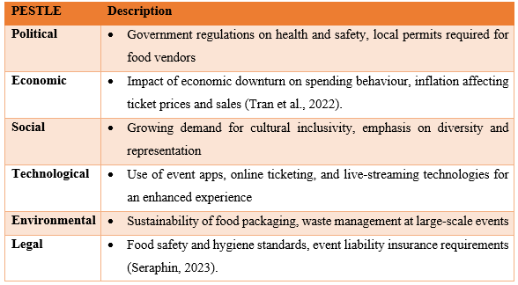
SOAR | Description
Strengths | - Strong cultural diversity, immersive food experience, community engagement
Opportunities | - Use of technology to enhance the event experience, expanding global brand recognition (Schmidheiny and Siegloch, 2023).
Aspirations | - Become a premier international food festival, known for cultural inclusivity and high-quality food.
Results | - Increased attendance, higher sponsorship opportunities, and stronger social media engagement (Sanchez, 2024).

Cultural awareness, health and safety, economic conditions, and technology are needed for the World Festive Food Festival (Brown, 2021). Event planners can follow best practices and compete in the ever-changing event market using these characteristics. SWOT, PESTEL, and SOAR assessments help events adapt and increase attendance.

Conclusion and Recommendations
In conclusion, the World Festive Food Festival will encourage food industry cultural diversity and inclusivity. Events' strategic design meets industry changes and audience expectations, from operational planning to stakeholder interaction. Full programming promotes international cuisine and exchange at the festival. Prioritise social media, food, and cultural influencers for festival success. Eco-friendly food and waste management can enhance event attendance. Finally, virtual and hybrid events may attract more individuals, especially those who cannot attend. Such changes would increase festival attendance and global appeal. Global culture and food will benefit from the World Festive Food Festival. A strong foundation and these suggestions will position the event for long-term success and influence.

References
Akinsowon, V. (2023). 9 Event Industry Trends You Should Know in 2023 | Cvent Blog. [online] www.cvent.com. Available at: https://www.cvent.com/uk/blog/events/event-trends [Accessed 16 Feb. 2025].
AMR (2023). UK Events Industry Share , Size , statistics Growth analysis 2032. [online] Allied Market Research. Available at: https://www.alliedmarketresearch.com/uk-events-industry-market-A169718.
Bigfeastival.com (2025). Big Feastival. [online] Bigfeastival.com. Available at: https://bigfeastival.com/ [Accessed 14 Feb. 2025].
Bladen, C., Kennell, J., Abson, E. and Wilde, N. (2023). Events Management : an Introduction. 3rd ed. Abingdon, Oxon ; New York, Ny: Routledge.
Bowdin, G., Allen, J., O’toole, W., Harris, R. and Mcdonnell, I. (2023). Events management. Oxford: Butterworth-Heinemann.
Brown, A.E. (2021). Co-creation and Engagement: What Festivalgoers Want in the UK Rock Festival Experience. Event Management, 27(2). doi:https://doi.org/10.3727/152599521x16367300695690.
Dimitrovski, D., Starčević, S. and Marinković, V. (2021). Which Attributes Are the Most Important in the Context of the Slow Food Festival? Leisure Sciences, pp.1–19. doi:https://doi.org/10.1080/01490400.2021.1967234.
Dowson, R. and Bassett, D. (2022). Event planning and management : principles, planning and practice. 2nd ed. London, Uk ; New York: Kogan Page.
Excel.london (2022). Insight: the top five food trends in the events industry | Excel London. [online] Excel.london. Available at: https://www.excel.london/insight-the-top-five-food-trends-in-the-events-industry [Accessed 13 Feb. 2025].
Getz, D. (2024). Festival and Event Tourism. pp.391–395. doi:https://doi.org/10.1007/978-3-030-74923-1_84.
Getz, D. and Page, S.J. (2019). Event Studies : theory, Research and Policy for Planned Events. 4th ed. London: Routledge.
Holmes, K., Hughes, M., Mair, J. and Carlsen, J. (2015). Events and sustainability. London ; New York: Routledge.
Janiszewska, D. and Ossowska, L. (2021). Food Festival Exhibitors’ Business Motivation. Sustainability, 13(9), p.4920. doi:https://doi.org/10.3390/su13094920.
Jarman, D. (2020). FESTIVAL TO FESTIVAL: NETWORKED RELATIONSHIPS BETWEEN FRINGE FESTIVALS. Event Management. doi:https://doi.org/10.3727/152599520x15894679115510.
Kesgin, M., Murthy, R. and Lagiewski, R. (2021). Profiling food festivals by type, name and descriptive content: a population level study. British Food Journal, 124(2), pp.530–549. doi:https://doi.org/10.1108/bfj-04-2021-0412.
Ramsden, S. (2021). ‘It’s one of the few things that … pulls us together when the outside world is really tough.’ Exploring the outcomes and challenges of a charity-led community garden in a disadvantaged English city. Local Environment, 26(2), pp.283–296. doi:https://doi.org/10.1080/13549839.2021.1886067.
Randall, J. (2024). Post-Pandemic Transformations: Rethinking Employability in Event Management Education - White Rose eTheses Online. Whiterose.ac.uk. [online] doi:https://etheses.whiterose.ac.uk/id/eprint/36128/1/JRandall%20EdD%20Thesis%20.pdf.
Richards, G., Censon, D., Gračan, D., Haressy, M., Kiráľová, A., Marulc, E., Rossetti, G., Barkiđija Sotošek, M. and Sterchele, D. (2022). Event management literature: exploring the missing body of knowledge. Journal of Policy Research in Tourism, Leisure and Events, [online] pp.1–22. doi:https://doi.org/10.1080/19407963.2022.2128810.
Salih, A. and Ingram, B. (2021). Adaptive and Sustainable Leadership for Event Management Learning outcomes. [online] Available at: https://www.goodfellowpublishers.com/free_files/Chapter%208-03e6ae2161455389b9636a952ff00f69.pdf.
Sanchez, C. (2024). 5 Event Industry Trends You Need to Know in 2024. [online] ISH Venues. Available at: https://www.ishvenues.uk/5-event-industry-trends-you-need-to-know-in-2024/ [Accessed 14 Feb. 2025].
Schmidheiny, K. and Siegloch, S. (2023). On Event Studies and Distributed‐Lags in Two‐Way Fixed Effects Models: Identification, Equivalence, and Generalization. Journal of Applied Econometrics. doi:https://doi.org/10.1002/jae.2971.
Seraphin, H. (2020). COVID-19: an Opportunity to Review Existing Grounded Theories in Event Studies. Journal of Convention & Event Tourism, 22(1), pp.1–33.
Seraphin, H. (2023). Speed dating events: Introducing ‘Special interest and meso-adultainment events’ as a new type of event to existing Literature. Journal of Enterprising Communities: People and Places in the Global Economy, 15, pp.1–9. doi:https://doi.org/10.1080/15470148.2023.2209341.
Tastefestivals.com (2020). The World’s Greatest Food Festival in London | Taste of London. [online] Tastefestivals.com. Available at: https://london.tastefestivals.com/ [Accessed 16 Feb. 2025].
Tran, A.T.T., Le, A.D., Bui L.A., P., Le, V.V. and Vu, L.T. (2022). Food festival research review in contemporary tourism. International Journal of Tourism Cities, 9(2). doi:https://doi.org/10.1108/ijtc-01-2022-0009.
Wickham, M., Donnelly, T. and French, L. (2020). STRATEGIC SUSTAINABILITY MANAGEMENT IN THE EVENT SECTOR. Event Management, 25(3). doi:https://doi.org/10.3727/152599519x15506259856318.
Zou, Y., Meng, F., Bi, J. and Zhang, Q. (2021). Evaluating sustainability of cultural festival tourism: From the perspective of ecological niche. Journal of Hospitality and Tourism Management, [online] 48, pp.191–199. doi:https://doi.org/10.1016/j.jhtm.2021.06.009.

Appendix

Gantt chart
Task | Jan | Feb | Mar | Apr | May | Jun | Jul | Aug (Event)
Event Concept & Planning
Venue Booking
Sponsorship & Partnerships
Vendor & Performer Selection
Marketing & Promotions
Ticket Sales
Logistics & Setup
Final Preparations & Rehearsals
Event Execution
Post-Event Evaluation

