Alexander Wright (1701086)

Abstract
Vehicle Safety is a major factor in automotive design and development. From the early days of Anti-Lock Braking Systems up until the present day, developments have come a long way, in both technology and vehicle braking performance. The following report will outline the basic operational principles of an Anti-Lock Braking System, as well as the system components, diagnostic procedures when fault finding, what the effects on passenger safety are, as well as the legislation surrounding ABS in modern passenger vehicles.
Anti-Lock Braking Systems
Emissions Control & Diagnosis

Table of Contents
1 Literature Review 2
1.1 Historical Overview 2
1.2 Operational Overview 3
1.3 ABS Components 3
1.3.1 Pressure Modulator 3
1.3.2 Control Module/ECU 4
1.3.3 Wheel Speed Sensors 4
1.4 Relationship with On-Board Diagnostics 5
1.4.1 OBD Overview 5
1.4.2 E-OBD 6
1.4.3 Legislation and Law 6
2 Methodology 7
2.1 Diagnostic Procedures & Practical Testing 7
3 Operational Overview, Differences & Summary 8
Phases of solenoid operation: 8
3.1.1 Engineering Protocols 8
3.1.2 Pros and Cons of both Systems 8
3.2 Bosch 2-EH 9
3.2.1 2-EH Pin Numbers 9
3.3 Teves MkIV ATE 10
3.3.1 MkIV Pin Numbers 10
4 References 11
5 Appendix & Additional Data 12
5.1 Teves MkIV Test Data 12
5.2 Bosch 2-EH Test Data 13
5.3 Oscilloscope Readings 14
5.3.1 Pin 2 + 19 (Teves MkIV) 14
5.3.2 Pin 4 + 2 (Bosch 2-EH) 14
5.3.3 Pin 9 (Bosch 2-EH) 15
5.4 Generic OBD-2 ABS Fault Codes 15
5.5 Bosch 2-EH Wiring Diagram 17

Literature Review

Historical Overview

Anti-lock braking systems, in a more basic form, were first introduced and patented back in the early to mid-20th century, a notable early patent being by Robert Bosch GmbH, commonly known as ‘anti-skid,’ chiefly used in the aviation industry. The first widespread system to see production was developed and built by Dunlop, known as ‘Maxaret,’ which was widely adopted throughout the 1950’s on various aircraft, vastly reducing stopping distances and preventing total lock-up when slowing rapidly on landing. Dunlop Maxaret never saw wide use outside of the aviation industry (with exception to experimental use on road vehicles including motorbikes) however in 1966, British automaker Jensen utilised the system on their newly developed FF; the world’s first production road car to feature both four-wheel drive and an anti-lock braking system, which at the time was considered highly innovative.
Throughout the 1970’s, many high profile automobile manufactures involved themselves in anti-lock braking system development, and subsequently a number of production cars throughout the decade were fitted with said systems, all with varying levels of complexity. The most significant of this period being Mercedes-Benz, who together with Bosch, introduced a fully electronic four-wheel multi-channel anti-lock braking system on the W116 S-Class.
(Golub, 2012)
Fig 1: W116 S- Class at the MB Stuttgart test track. The ABS equipped vehicle (top), maintaining a controlled state of deceleration while enabling steerability, while the non ABS vehicle (bottom) locks up, preventing any controlled directional change under hard braking.
Over the years, anti-lock braking systems became evermore advanced and effective in their operation, leading to systems such as Bosch 2-EH and Teves Mk4, examples of more modern systems that are compatible with the earlier generations of on-board diagnostics. On more recent systems, TCS (Traction control systems) has been incorporated into ABS operation, allowing wheel slip to be controlled under acceleration, whereby an increase in wheel speed will trigger this mode of operation (indicating wheel-spin and a subsequent loss in traction).

Operational Overview
(Certain points of operation will be covered in ABS Components, 1.3)
The primary function of ABS when used in an automotive application is to allow steerability under heavy braking conditions, thereby granting the operator/driver the ability to avoid any possible collisions or accidents while under hard braking. ABS modulates braking pressure to allow for the maximum retardation (deceleration), utilising all of the available coefficient of friction between the tyre contact patch and the road to prevent lockup and minimise braking distance. The effects of ABS operation can replicate threshold or cadence braking, albeit at a significantly faster rate, allowing the braking performance to be maximised.
As stated by (Robert Bosch GmbH, 1995) “Under normal operating conditions these systems can provide fast and effective braking for the vehicle. Braking under more critical conditions, such as those encountered with wet or slippery road conditions, driver panic reaction (unanticipated obstacle), and mistakes committed by other drivers and pedestrians can lead to wheel lock when braking.”
To prevent wheel lockup and maintain steerability, the system modulates brake pressure (in most modern systems, this can be performed many times per second), this is the manipulated variable within the ABS control loop (The controlled system being the vehicles braking ability, and friction between the tyre and road surface). The controlled variables within the loop relate to driver input, such as the applied brake pressure and wheel speed. Disturbances can include factors such as the road surface quality, braking conditions (such as temperature), vehicle load and also multiple tyre characteristics such as tread depth, pressure, contact patch, etc.

ABS Components

Pressure Modulator
Brake pressure control is achieved through the use of a number of solenoids within the pressure modulator unit. “It forms the hydraulic link between the brake master cylinder and the wheel-brake cylinders.” - (Robert Bosch GmbH, 1995)
The 3 main components incorporated into the modulator assembly are the solenoids, pump and accumulator. The pump is responsible for returning any excess fluid from the system back to the master cylinder / reservoir, engaging during ABS operation. During a brake system service, whereby a brake fluid change is being performed, it is critical to run the pump and cycle the solenoids after the bleeding process is complete on the brake circuit. This can be performed on vehicles equipped with on-board diagnostics via use of a scan tool.
The modulator also incorporates an accumulator that can account for any fluid surge that occurs during the pressure release phase during ABS operation. Fluid is drawn from the accumulator by the pump during ABS operation.
Pressure modulation is achieved by use of the solenoid valves, controlling the brake pressure at the wheel cylinders, which occurs during ABS intervention / operation. Solenoid layouts are typically either 3 or 4-channel (3 -channel layouts modulating front brakes individually and the rears as a pair, with 4-channel having independent modulation of all brakes). Different systems will have varying operating phases, with the most common being 3 phase.

The 3 phases of operation are as follows:
- Pressure build-up – When the solenoid is at its base position, allowing an unrestricted build-up of pressure during normal braking conditions, or under specific conditions under ABS operation.
- Pressure holding – Once imminent lockup is detected, the solenoids are held at 50% (by having a proportional amount of current applied to the solenoid winding), maintaining a pressure that is sufficient to avert lockup. The control module/ECU closes the return valve to maintain the pressure.
- Pressure reduction – Once the wheel speed sensors receive a lower frequency signal, indicating a reduction in wheel speed (or lockup when the signal stops), the input valve will then shutoff, in addition to the opening of the return. Pressure in that specific brake cylinder will then reduce, allowing fluid to be bled off and re-circulated back to the master cylinder. In this position, maximum current is applied to the winding, allowing the solenoid to be fully opened.

Control Module/ECU
“The electronic control unit receives, amplifies and filters the sensor signals to determine velocities, which serve as the basis for calculations of reference speed, brake slip and the wheels’ peripheral rates of acceleration and deceleration.” - (Robert Bosch GmbH, 1995)
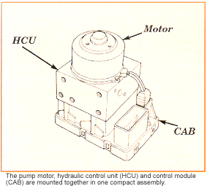
On many systems throughout the past 20 years, the ABS control module is incorporated into the pressure modulator assembly; such is the case with Teves Mk20. Primarily this is for packaging reasons, which is a big consideration for manufacturers in production passenger vehicles.
“At the time ABS was introduced into production, it was technically feasible to integrate the hydraulics and electronics into one unit.” - (Muller & Maier, 1995)

Teves Mk20, a system that incorporates the control module/ECU (CAB) and hydraulic assembly (HCU) into one complete unit.
- (AA1Car, 2005)

Wheel Speed Sensors
The function of the wheel speed sensors is to generate a speed signal input to the ABS control module / ECU. Typically, the sensors are located on the vehicles hub assembly, picking up off a toothed reluctor ring mounted on the driveshaft or wheel bearing unit.
The sensor consists of an external coil winding, a permanent magnet and a pole. The permanent magnet within the sensor creates a magnetic field between the pole and the reluctor ring. As each tooth on the reluctor ring passes the pole, the magnetic field modulates. The sensor registers this fluctuation in the magnetic field and generates an A/C (alternating current) signal.

As the reluctor rings are typically externally mounted rather than forming a part of an encased unit, they are exposed to atmospheric and road conditions such as debris, dirt and various forms of weather. This can contribute towards possible damage and/or wear, which in turn can affect the signal generation from the sensor if (for example) a tooth is broken or worn, disrupting the signal and providing inconsistent and incorrect readings for the control module to read.
“The gap between the wheel speed sensor and the sensor ring is only about 1mm; and precise tolerances must be maintained to ensure reliable signal generation.”- (Robert Bosch GmbH, 1995)

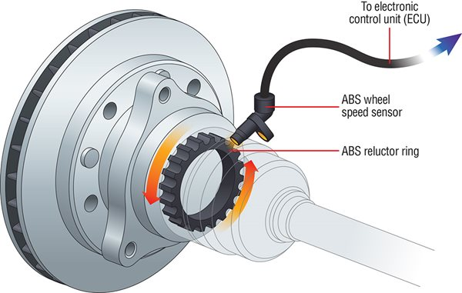
A typical ABS wheel speed sensor setup, with the reluctor ring located on the driveshaft/wheel bearing unit.

(Apec Braking, 2017)

Relationship with On-Board Diagnostics

OBD Overview
On-board diagnostics (OBD) has become a standardized form of self-diagnostic and reporting capability in modern vehicles, with the primary function being to allow greater levels of communication between various vehicle systems and scanning equipment. The demand for OBD was also made for greater emissions control in passenger vehicles.
Code: | Item:
12 | Initiation of diagnosis.
16 | LH Front Solenoid
17 | RH Front Solenoid
18 | Rear Solenoid
19 | Solenoid Relay Circuit
25 | Faulty Sensor toothed Ring
35 | Pump Relay Circuits
37 | Stop Lamp Switch
39 | LH Front Speed Sensor
41 | LH Front Speed Sensor
42 | RH Front Speed Sensor
43 | RH Front Speed Sensor
44 | LH Rear Speed Sensor
45 | LH Rear Speed Sensor
46 | RH Rear Speed Sensor
47 | RH Rear Speed Sensor
48 | System Voltage High/Low
55 | Faulty ABS ECU
Basic fault codes from a Bosch 2-EH system, commonly found in 2 wheel drive Vauxhall production cars from the early 1990`s, such as the Mk3 Cavalier and Calibra. This illustrates a very primitive form of early OBD, before the introduction of OBD-2 with standardised connectors and generic fault codes.

While the first generation of OBD allowed for these functions, there was no standardisation for connectors and DTC’s (diagnostic trouble codes), therefore almost every manufacturer ran a different system with various connectors and specific scanning equipment. Because of this, the push for a standardized on-board diagnostics system was made by the Society of Automotive Engineers during the late 1980’s, who desired a universal connector to enable greater OBD capability for road vehicles, in addition to greater emissions control, thus the introduction of OBD-2 shortly followed.
OBD-2 introduced standardized fault codes, in addition to having better signalling protocols and messaging formats over the first generation of OBD, making it easier for the user to read and operate. With regards to OBD-2, ABS faults (diagnostic trouble codes, DTC’s) are displayed as ‘C’ codes, which remains in today’s systems.
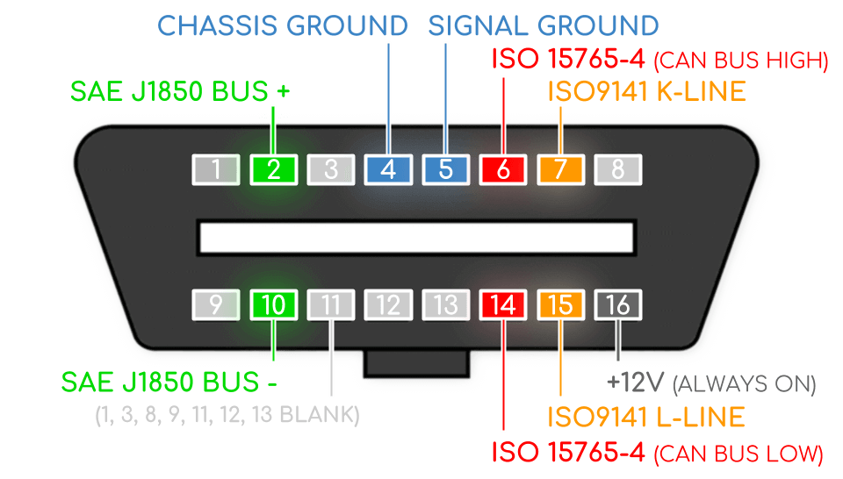
(Refer to Appendix for list of OBD-2 ABS generic fault codes)
OBD-2 port configuration, showing the standardised pin layouts. (SAE – Society of Automotive Engineers, ISO – International Organisation for Standardisation)

(Jacobs, 2020)

E-OBD
European on-board diagnostics (E-OBD) was mandated on all petrol cars sold within Europe from the 1st of January 2001, and diesel cars manufactured from the 1st of January 2003; as a requirement primarily for emissions control, which fell in with directive 98/69/EC of the European Parliament and of the Council of 13 October 1998; relating to measures to be taken against air pollution by emissions from motor vehicles.

Legislation and Law
One thing widely recognised within industry, and even by many consumers, is the ability of ABS to maximise braking performance in certain conditions, something which even an experienced driver could not replicate in a similar situation. In many studies conducted over the years, ABS stopping distances on high traction surfaces have shown to be lower on average than non-ABS equipped vehicles, consequently reducing accident and fatality rates in some cases.
Various high profile governments and councils recognised these effects, and subsequently mandated ABS to be fitted on all new passenger cars sold. In the EU (European Union), this was mandated in 2004, while in the US, the National Highway Traffic Safety Administration (NHTSA) made ESC mandatory under the Federal Motor Vehicle Safety Standard (FMVSS) No. 126, which additionally implements ABS due to their relationship.
The executive summary of FMVSS 126; (NHTSA (National Highway Traffic Safety Administration), 2007) - “This Final Regulatory Impact Analysis examines the impact of Federal Motor Vehicle Safety Standard (FMVSS) No. 126, Electronic Stability Control Systems (ESC). ESC has been found to be highly effective in preventing single vehicle loss of control, run off the road crashes, of which a significant portion are rollover crashes. ESC has also been found to reduce some multivehicle crashes. Based on this analysis, the final rule is highly cost-effective.”

Methodology

Diagnostic Procedures & Practical Testing
PPE – Before tackling the task, the appropriate personal protective equipment was worm, including a dust coat, steel toe capped boots and safety goggles where necessary.
On both systems, the initial testing procedure began with understanding the system layout by referring to the documents provided, including the schematics, wiring diagrams and pin layouts. Using any system information is critical to not just this specific test, but to any diagnostic procedure and repair work on a vehicle system, particularly one with a complexity level similar of that to an ABS system.
- Battery voltage check to ensure system has sufficient power.
- Systems switched on to check for basic operation (ignition on). During this phase, the pump can be heard running, as the system performs a brief self diagnostic process, during which any faults will trigger an ABS warning light.
- Multi pin plugs on both systems then checked with the multimeter, using a finer probe or paper clip to contact the pins without causing damage to the multi plug, as the connectors and pins can be relatively delicate if probed. This was performed with ignition off and on (test data contained within appendix for both Teves MkIV and Bosch 2-EH).
- Following the pin testing, the solenoid voltages were also measured (ignition on), as well as on the 4 pin multi plug (Bosch system only).
- Finally, we performed some tests on the Bosch system during ABS operation, using the universal oscilloscope to analyse waveforms. This was achieved by using the test rigs functions to allow variation in braking pressure, enabling the operator to replicate ABS operation similar to an on road situation.
- From this, all data from the test was cumulated in various tables to allow for easy interpretation.
(Testing on the Teves MkIV system was limited due to the design of the control module, as it is integrated with the hydraulics as one complete unit, with no external wires).

Operational Overview, Differences & Summary
Both systems are very similar with regards to layout, utilising a 3-channel configuration (2 solenoids for front brakes, 1 for rears). 2-EH and MkIV also adopt 4 passive wheel speed sensors, generating an A/C signal that is sent to the control module/ECU.

Phases of solenoid operation:
- Pressure maintenance (both inlet and outlet valve closed to maintain current system pressure).
- Pressure reduction (inlet valve closed, outlet valve opened to allow any excess pressure to bleed off and circulate back to the brake master cylinder/reservoir).
- There is also the passive operation, whereby the inlet valve is opened and outlet is closed to attain regular braking pressure increases (Teves system only).

Engineering Protocols
Being a safety system, it is critical that ABS operation is always maintained. In the circumstance of ABS failure or system faults, the driver must be made aware of this. Many high-profile governments and councils have governed legislation on the ability to inform the driver of faults, at minimum, this will be an ABS warning light.
Strict protocols surround ABS legislation, some of which can be viewed in section 1.4.3.

Pros and Cons of both Systems
Bosch 2-EH
Pros:
- Simplicity of its layout and operation, allowing easy diagnostic capabilities.
- 3 channel operation allows relatively effective ABS operation on 2-wheel drive passenger vehicles.
Cons:
- No TCS capabilities (only possible on 4 channel systems).
- Compatible only with first generation OBD, which does not provide a large scope of diagnostic capability compared to more modern iterations.
Teves MkIV
Pros:
- TCS capability in 4 channel configuration (system tested was 3 channel)
- The complete assembly is more compact than the Bosch system as the electronics and hydraulics are integrated.
- OBD-2 compatibility, granting the use of standardised DTC’s, which can greatly assist the fault finding process.
Cons:
- The complete unit being integrated means there are no external wires, making multimeter and oscilloscope testing far more difficult, and would possibly require specialist work to disassemble and rebuild.

Bosch 2-EH
- 4 wheel speed sensors
- 3 channel system
- 2 phase operation
- Compatible with the first generation of OBD
- Hydraulics and Electronic control units are separate assemblies
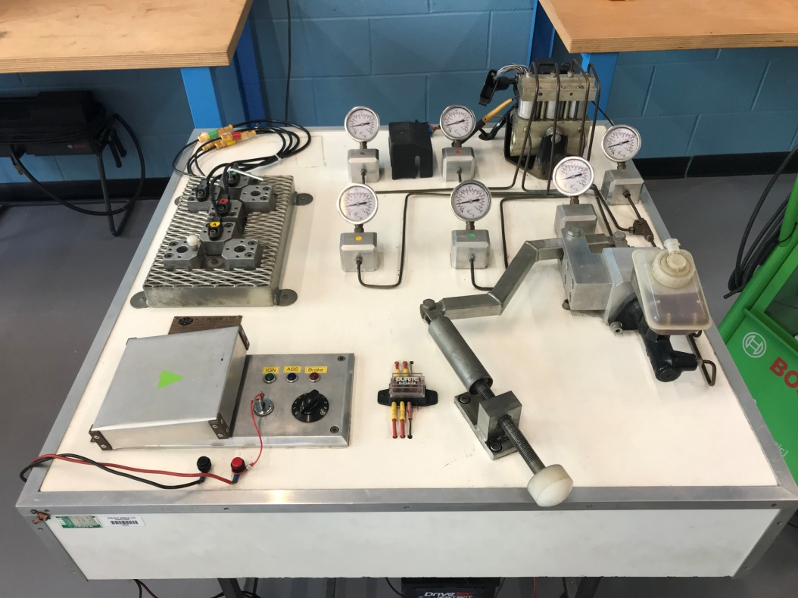
- Therefore allows ease of testing, as wires and connectors are external

-Bosch 2-EH test rig.

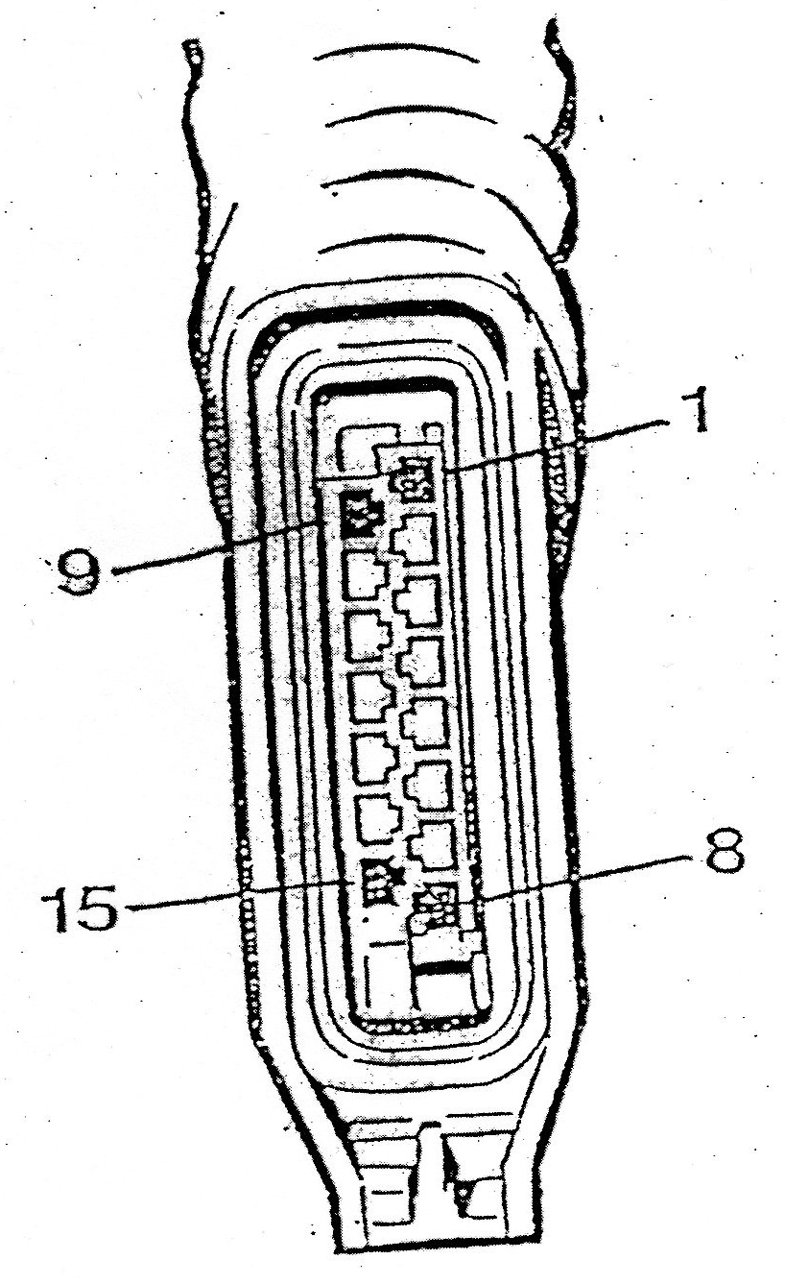
2-EH Pin Numbers
- ABS warning lamp actuation
- N/S/R wheel speed sensor (ground)
- N/A
- N/S/R wheel speed sensor (signal)
- O/S/F wheel speed sensor (ground)
- O/S/R wheel speed sensor (signal)
- N/S/F wheel speed sensor (ground)
- N/A
- Brake light switch feed
- O/S/F wheel speed sensor (signal)
- N/A
- Serial data wire
- N/S/F wheel speed sensor (signal)
- O/S/R wheel speed sensor (ground)
- Diagnostic excitation lead

Teves MkIV ATE
- 4 wheel speed sensors
- 3 channel system
- Compatible with OBD-2
- Hydraulics and Electronic control units are integrated into a single assembly
- Therefore no external wires from controller to solenoid valves or pump body
- It is a non-integral ABS system that can be configured for either 3 or 4 channel operation on front or rear wheel drive vehicles
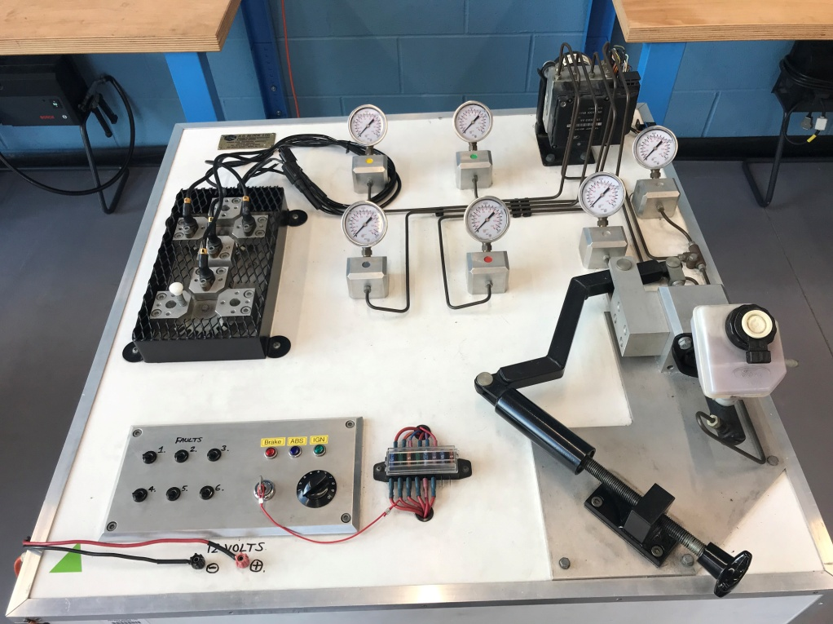

-Teves MkIV test rig

With regards to the solenoid valves: “Each pair consists of one inlet valve and one outlet valve. An inlet valve is positioned between the main brake cylinder and a wheel cylinder. It is opened when the ABS-system is passive and closed during the pressure maintenance and reduction phases. An outlet valve is sited between a wheel cylinder and the brake fluid reservoir. This only opens during the pressure reduction phase." (Eric R, 2005)

MkIV Pin Numbers
1. | O/S/R wheel speed sensor (signal) | 14.
2. | O/S/F wheel speed sensor (signal) | 15.
3. |  | 16. | Comms Line
4. |  | 17. | O/S/R wheel speed sensor (ground)
5. |  | 18. | N/S/R wheel speed sensor (ground)
6. |  | 19. | O/S/F wheel speed sensor (ground)
7. | Permanent Live | 20. | N/S/F wheel speed sensor (ground)
8. | Ground | 21.
9. | Ignition Live | 22.
10. | N/S/R wheel speed sensor (signal) | 23.
11. | N/S/F wheel speed sensor (signal) | 24. | Ground
12. | Ground | 25. | Permanent Live
13. | OBD signal

References
AA1Car. (2005). Teves Mark 20 Anti-lock Brakes. Retrieved from AA1Car, Automotive Repair Help: https://www.aa1car.com/library/abs_teves_mk20.htm
Apec Braking. (2017, April 24). Technicians Guides - ABS Sensors. Retrieved from https://www.apecbraking.co.uk/Resources/TechniciansGuides/ABS-Sensors.aspx
Eric R. (2005, March 3). Trouble Shooting - ABS Teves MkIV. Retrieved from ATSS Planet: http://www.atss.planet.ee/kolaladu/ford/Scorpio/veakoodid/teves.pdf
Golub, B. R. (2012, September 3). 40 Years Model Series: Luxury Class in Top Form. Retrieved from The World of MB-AMG: https://theworldofmbamg.wordpress.com/2012/09/03/40-years-model-series-116-luxury-class-in-top-form/besser-bremsen-mercedes-benz-s-klasse-limousinen-der-baureihe-116-auf-der-einfahrbahn-in-stuttgart-unterta%C2%BCrkheim-1978-das-obere-fahrzeug-mit-anti-blo
Jacobs, A. R. (2020, January 2). OBD2 Pin Numbers. Retrieved from http://10.indulge.danis-schreibwelt.de/obd2-pin-numbers.html
Limpert, R. (1992). Elements of Braking Performance, Design and Safety. In R. Limpert, Brake Design and Safety (pp. 1-31). Warrandale: Society of Automotive Engineers, Inc.
Muller, K., & Maier, M. (1995). ABS 5.3: The New and Compact ABS5 Unit for Passenger Cars. In SAE, Advancements in ABS/TCS and Brake Technology (pp. 1-9). Warrandale: Society of Automotive Engineers, Inc.
NHTSA (National Highway Traffic Safety Administration). (2007, March). FMVSS No.126 Electronic Stability Control Systems. Retrieved from NHTSA: https://www.nhtsa.gov/sites/nhtsa.dot.gov/files/fmvss/ESC_FRIA_%252003_2007.pdf
Robert Bosch GmbH. (1995). ABS anti-lock braking system. In Bosch, Automotive Brake systems (pp. 38-63). Stuttgart: Robert Bentley Publishers.

Appendix & Additional Data

Teves MkIV Test Data
Teves MkIV
Pin | Voltage (V) - Ignition off | Voltage (V) - Ignition on
1 | 2.31 | 2.32
2 | 2.35 | 2.36
3 | 0 | 0
4 | 0 | 0
5 | 0 | 0
6 | 0 | 0
7 | 12.77 | 12.75
8 | 0 | 0.01
9 | 0 | 12.7
10 | ✓ | ✓
11 | ✓ | ✓
12 | 2.32 | 2.33
13 | 10.9 | 10.97
14 | 0 | 0
15 | 0 | 0
16 | 0 | 12.69
17 | ✓ | ✓
18 | ✓ | ✓
19 | 2.33 | 2.34
20 | ✓ | ✓
21 | 0 | 0
22 | 0 | 0
23 | 0 | 0
24 | 0 | 0
25 | 12.7 | 12.7

Bosch 2-EH Test Data
Bosch 2-EH
Pin | (V) - Ignition off | (V) - Ignition on | (V) - Operation
1 | 0 | 12.32 | 12.12
2 | 0 | 0.22
3 | 0 | 0
4 | 0 | 0.33
5 | 0 | 0.22
6 | 0 | 0.33
7 | 0 | 0.22
8 | N/A | N/A
9 | 0 | 12.29 | 12.16 (See scope)
10 | 0 | 0.33
11 | N/A | N/A
12 | 0 | 11.09
13 | 0 | 0.33
14 | 0 | 0.22
15 | 0 | 0
4 Pin Plug | (V) - Ignition off | (V) - Ignition on
1 | 0 | 12.49
2 | 0 | 12.08
3 | 0 | 12.1
4 | 0 | 0
Solenoids | (V) - Ignition off | (V) - Ignition on
1 |  | 12.47
2 |  | 12.47
3 |  | 12.47

Oscilloscope Readings

Pin 2 + 19 (Teves MkIV)
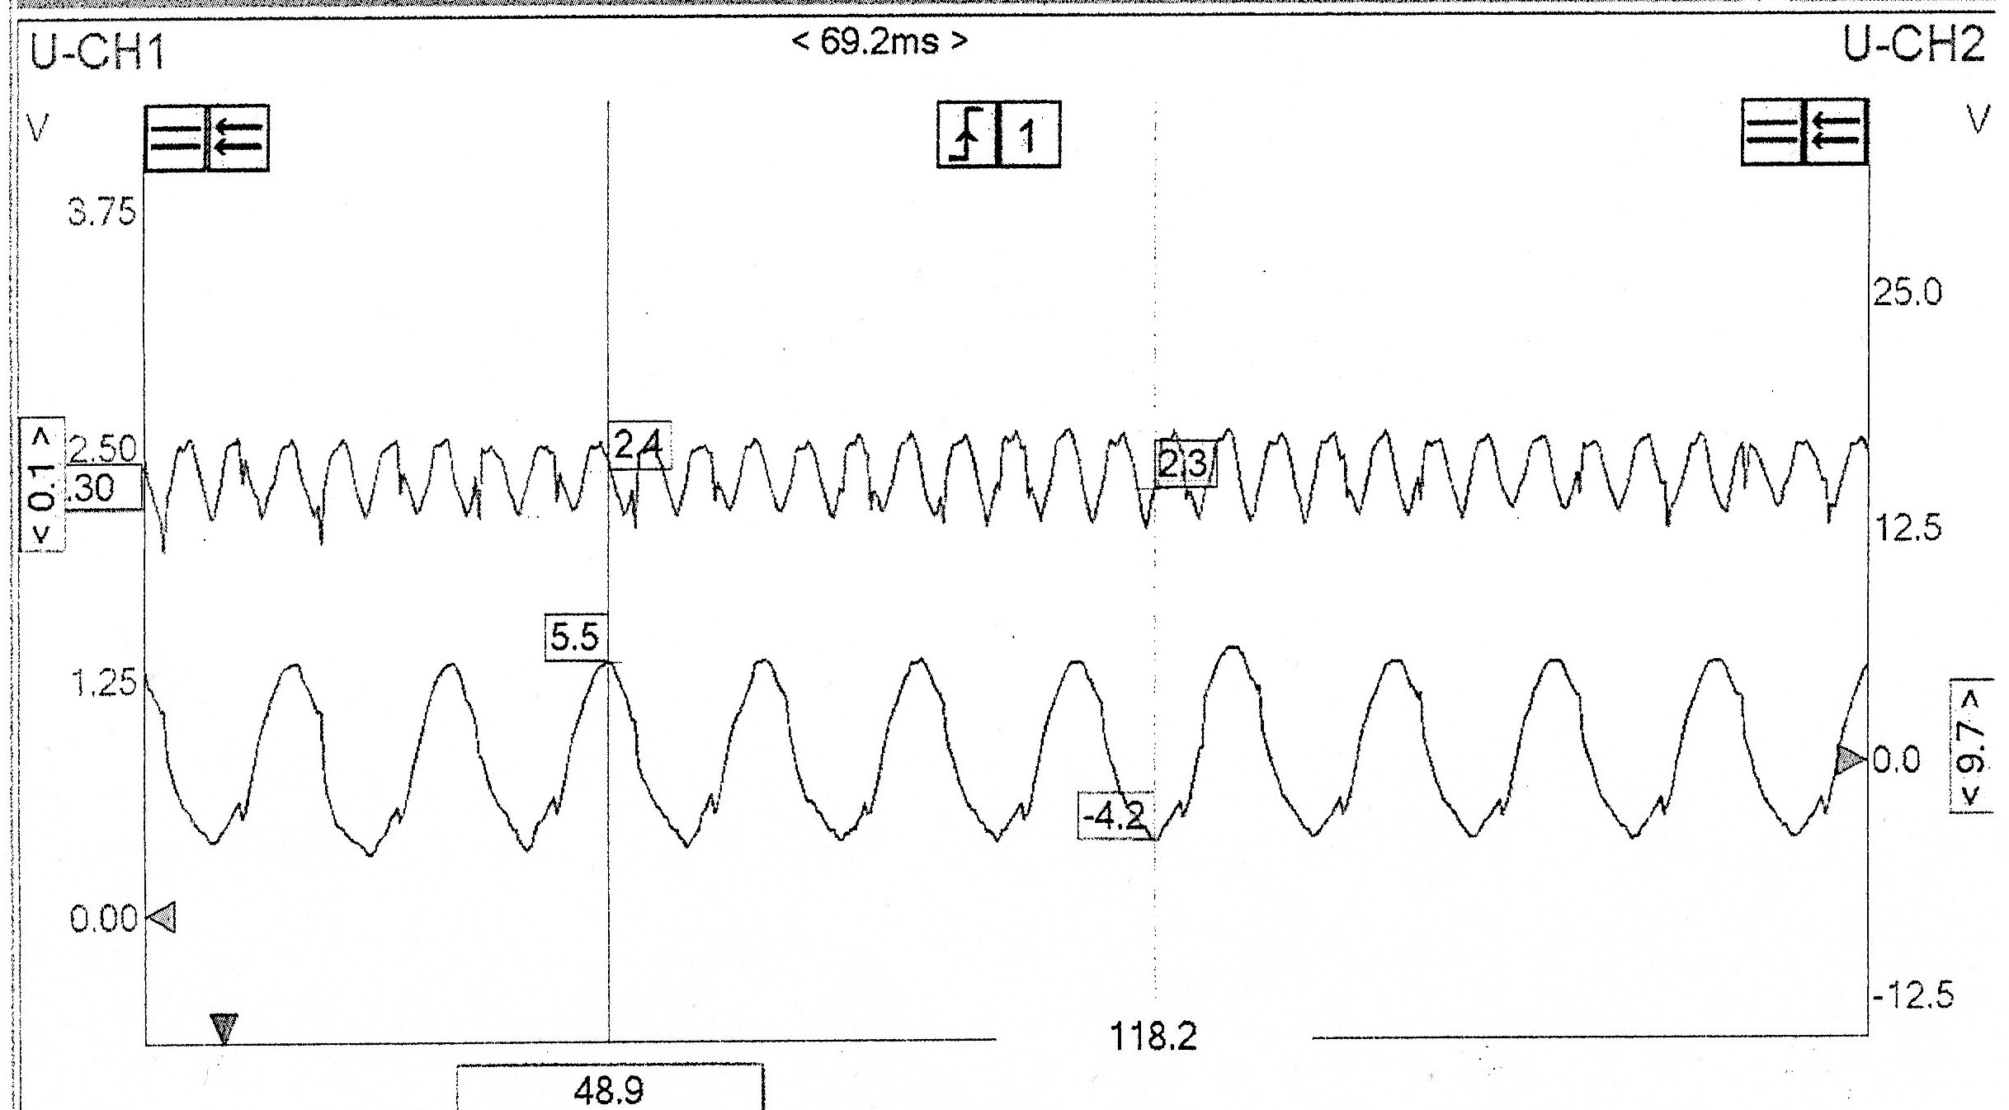

O/S/F Wheel speed sensor signal and ground. An A/C waveform produced by the pulse generator (69.2ms period). The ground signal (U-CH1) shows a far lower amplitude of around 0.1V, with an increased frequency, while the signal waveform has a significantly larger amplitude and reduced frequency
The somewhat rough waveform can indicate damage on the reluctor ring teeth, providing a less consistent waveform and in some extreme cases, causing an ABS fault, as the control module will not be receiving the correct signal, therefore affecting ABS operation on that specific wheel/axle (depending on the system layout).

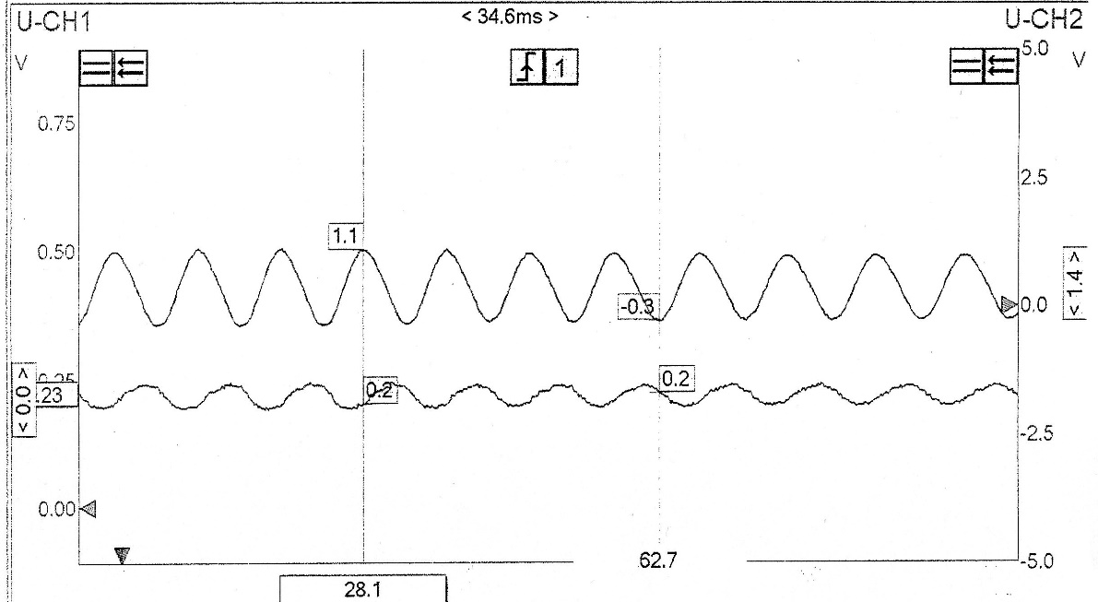
Pin 4 + 2 (Bosch 2-EH)

N/S/R Wheel Speed Sensor (4) and ground (2), displaying an A/C waveform that is produced by the pulse generator. (34.6ms period). U-CH2 displays the ground signal, producing a very similar waveform, albeit with a lower voltage (V) value.

Pin 9 (Bosch 2-EH)
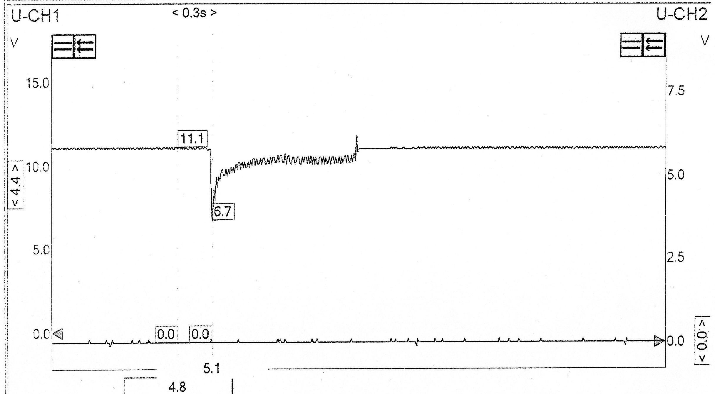

Pin 9 (brake light switch feed) displaying an 11V signal (0.3s period), before experiencing a sudden voltage drop, before climbing back up to regular operational voltage. As the brakes are engaged, its clear to see that the voltage drop is caused by the engagement of the ABS pump, drawing excessive current, and causing a negative initial spike for the brake switch feed.
Judging by the timescale, this happens for around 0.1s, and therefore would not be particularly noticeable for other motorists, as the brake lights would flicker for a very brief time period.

Generic OBD-2 ABS Fault Codes
C0035 - Left Front Wheel Speed Circuit Malfunction
C0040 - Right Front Wheel Speed Circuit Malfunction
C0041 - Right Front Wheel Speed Sensor Circuit Range/Performance (EBCM)
C0045 - Left Rear Wheel Speed Circuit Malfunction
C0046 - Left Rear Wheel Speed Sensor Circuit Range/Performance (EBCM)
C0050 - Right Rear Wheel Speed Circuit Malfunction
C0051 - LF Wheel Speed Sensor Circuit Range/Performance (EBCM)
C0060 - Left Front ABS Solenoid #1 Circuit Malfunction
C0065 - Left Front ABS Solenoid #2 Circuit Malfunction
C0070 - Right Front ABS Solenoid #1 Circuit Malfunction
C0075 - Right Front ABS Solenoid #2 Circuit Malfunction
C0080 - Left Rear ABS Solenoid #1 Circuit Malfunction
C0085 - Left Rear ABS Solenoid #2 Circuit Malfunction
C0090 - Right Rear ABS Solenoid #1 Circuit Malfunction
C0095 - Right Rear ABS Solenoid #2 Circuit Malfunction
C0110 - Pump Motor Circuit Malfunction
C0121 - Valve Relay Circuit Malfunction
C0128 - Low Brake Fluid Circuit Low
C0141 - Left TCS Solenoid #1 Circuit Malfunction
C0146 - Left TCS Solenoid #2 Circuit Malfunction
C0151 - Right TCS Solenoid #1 Circuit Malfunction
C0156 - Right TCS Solenoid #2 Circuit Malfunction
C0161 - ABS/TCS Brake Switch Circuit Malfunction
C0221 - Right Front Wheel Speed Sensor Circuit Open
C0222 - Right Front Wheel Speed Signal Missing
C0223 - Right Front Wheel Speed Signal Erratic
C0225 - Left Front Wheel Speed Sensor Circuit Open
C0226 - Left Front Wheel Speed Signal Missing
C0227 - Left Front Wheel Speed Signal Erratic
C0229 - Drop Out of Front Wheel Speed Signals
C0235 - Rear Wheel Speed Signal Circuit Open
C0236 - Rear Wheel Speed Signal Circuit Missing
C0237 - Rear Wheel Speed Signal Erratic
C0238 - Wheel Speed Mismatch
C0241 - EBCM Control Valve Circuit
C0245 - Wheel Speed Sensor Frequency Error
C0254 - EBCM Control Valve Circuit
C0265 - EBCM Relay Circuit
C0266 - EBCM Relay Circuit
C0267 - Pump Motor Circuit Open/Shorted
C0268 - Pump Motor Circuit Open/Shorted
C0269 - Excessive Dump/Isolation Time
C0271 - EBCM Malfunction
C0272 - EBCM Malfunction
C0273 - EBCM Malfunction
C0274 - Excessive Dump/Isolation Time
C0279 - Powertrain Configuration Not Valid
C0281 - Brake Switch Circuit
C0283 - Traction Switch Shorted to Ground
C0284 - EBCM Malfunction
C0286 - ABS Indicator Lamp Circuit Shorted to B+
C0287 - Delivered Torque Circuit
C0288 - Brake Warning Lamp Circuit Shorted to B+
C0290 - Lost Communications With PCM
C0292 - Lost Communications With PCM
C0291 - Lost Communications With BCM
C0297 - Powertrain Configuration Data Not Received
C0298 - Powertrain Indicated Traction Control Malfunction
C0300 - Rear Speed Sensor Malfunction
C0305 - Front Speed Sensor Malfunction
C0306 - Motor A or B Circuit
C0308 - Motor A/B Circuit Low
C0309 - Motor A/B Circuit High
C0310 - Motor A/B Circuit Open
C0315 - Motor Ground Circuit Open

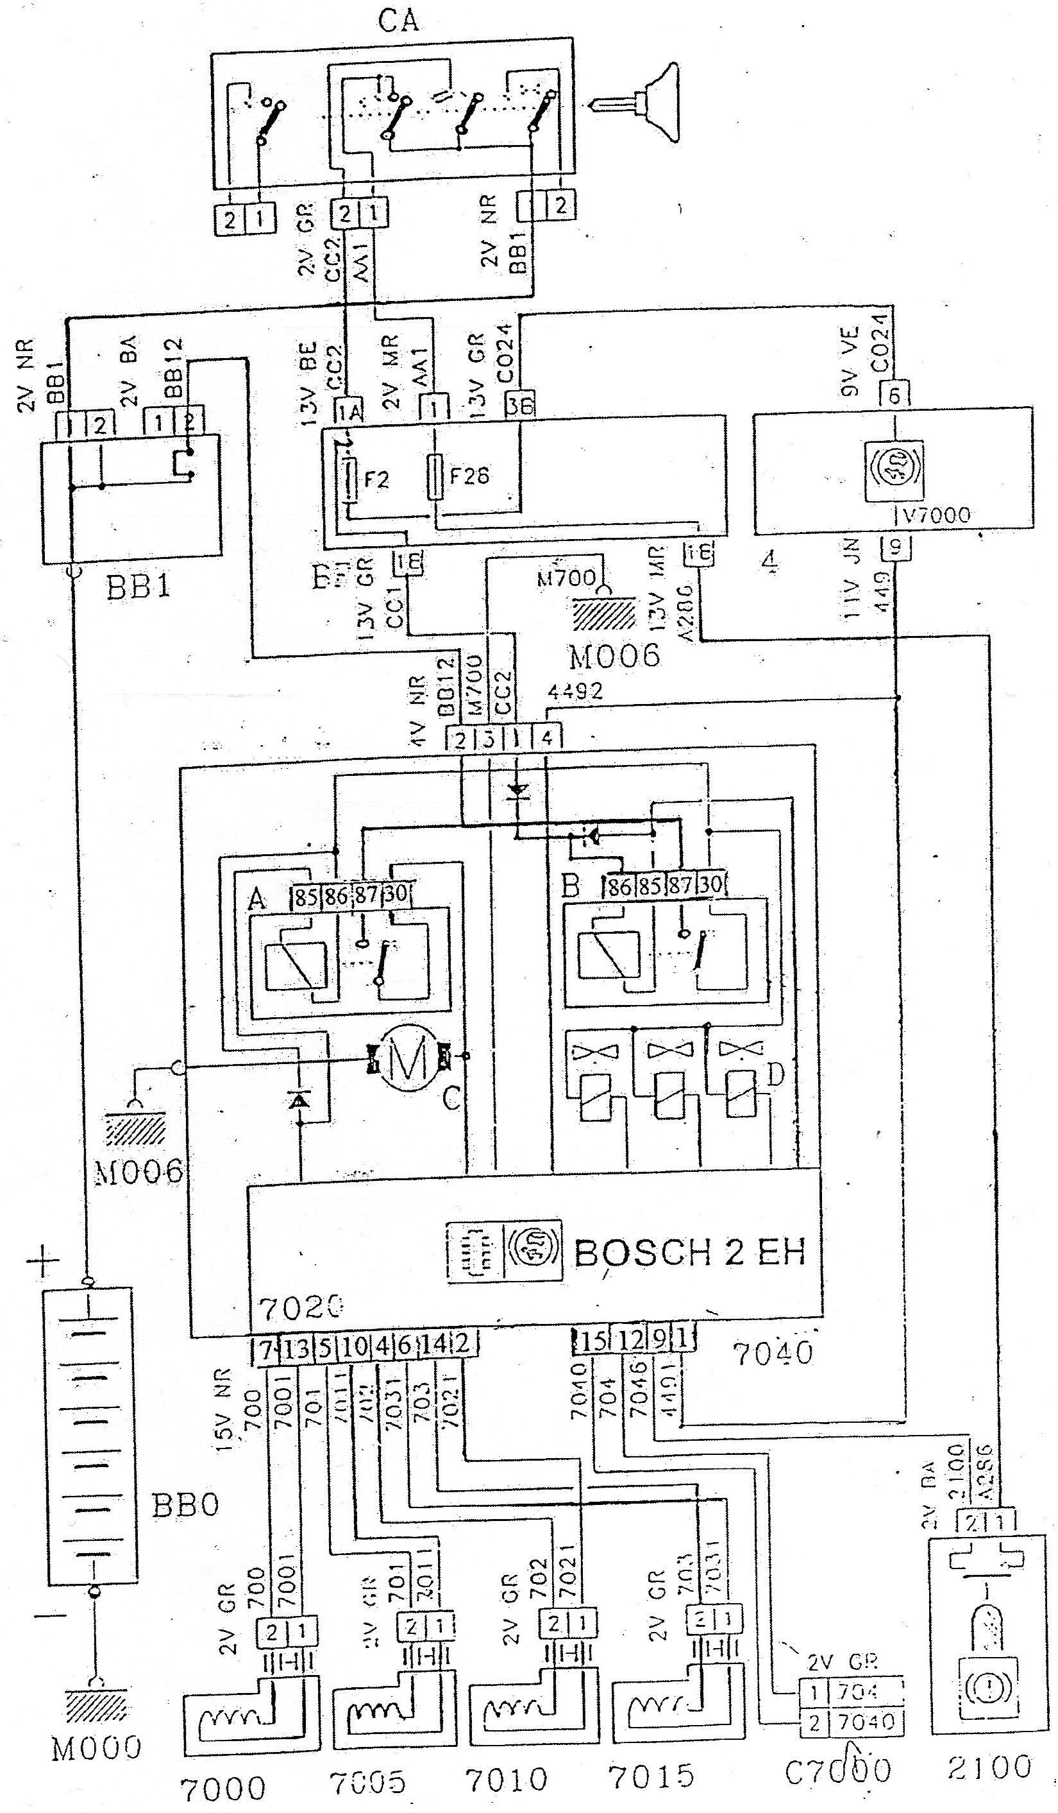
Bosch 2-EH Wiring Diagram

Magnetic Pulse Generators (Wheel Speed Sensors):
- 7000
- 7005
- 7010
- 7015
ABS Control Module with 15-pin connection: 7020
CA: Ignition switch
BB0: Battery

