University of Wales Trinity Saint David
The ethical issues of sweatshops
Unit Name: | Global Ethics
Module code: | BMBM6008
Written by: | Yunhao Wang
Student ID: | 2300618
Date submitted: | 12th January 2024

Executive Summary
This report explores cultural differences in business ethics, discusses the ways in which management positions in enterprises deal with different ethical challenges, and discusses the application of three types of ethics in different places, as well as the different ways in which enterprises face cultural, political, and social environments. Finally, it introduces some of the shortcomings of the three types of ethics. This article provides some academic information to support these viewpoints.
Content

1.0 Introduction 3
2.0 Main Findings 4
2.1 Ethical relativism 4
2.2 Ethical Universalism 6
2.3 Ethical pluralism 8
2.4 Some Disadvantages of Three Cultures 9
2.4.1 The Disadvantages of Ethical Relativism 9
2.4.2 The Disadvantages of Ethical Universalism 9
2.4.3 The Disadvantages of Ethical pluralism 9
3.0 Conclusion 10
4.0 Reference 11

Introduction
This report will mainly explore cultural differences in business ethics. Firstly, it will introduce ethical relativism, ethical absolutism or universalism, and ethical pluralism, and analyze the different practices of different companies under these three ideologies. It will explore the response of management functions to moral challenges and the different ideologies adopted by enterprises under different social environments and government constraints, And ultimately, we will analyze the reasons for these situations and how to avoid them.

2.0 Main Findings

2.1 Ethical relativism
Ethical relativism holds that there is no absolute truth in ethics, and moral right and wrong vary from person to person or from society to society. The Greek historian Herodotus of the 5th century BC proposed this viewpoint, observing that different societies have different customs, and everyone believes that the customs of their own society are the best. However, Herodotus said that there is no social custom that is truly better or worse than any other custom. Some contemporary sociologists and anthropologists also believe that morality is a social product, so it develops differently in different cultures. Every society has established standards for people to distinguish between acceptable and unacceptable behaviors, and every right or wrong judgment is based on one or another of these standards. (Ladd, 1985)
Taking India as an example, in Indian society, women are considered to hold secondary positions in the family and workplace, which means that male status is higher than female status in the workplace. However, in most countries around the world today, the concept of gender equality is emphasized, which is a model of ethical relativism. Each country's society has its own social customs, as stated in a research report by McCarthy, Enterprises with more female employees often possess higher levels of innovation, creativity, and productivity, resulting in higher profits. However, it seems that Indian companies are not too concerned about this issue, especially in the IT dominated technology sector. Although occasional voices about improving women's employment and benefits can be heard from the media or government officials, they always end up becoming empty slogans. "By analyzing all Indian companies, it was found that the proportion of women in the Indian technology industry is only 34%; the proportion of women at the executive level is even rarer, only 7%; and the proportion of women in professional and technical positions is 26%, with a male to female ratio of 3:1." This is the conclusion of a recent report released by the career agency Belong.

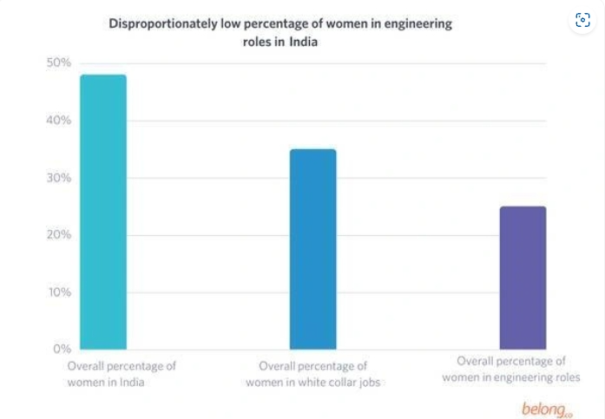
Figure 1 (Belong 2017)

This phenomenon is very common in India, and it is not an unethical thing for Indian people because it is a local custom. Moral standards can also change in different cultures. Although according to McCarthy's report, companies with more female employees often have higher corporate profits, local companies will still make decisions to recruit more male employees due to social customs. My opinion is that although recognizing religion and local customs can make more local people recognize the company, sometimes companies should pay more attention to their own profits. At these times, they can make some correct decisions. If Indian companies can recruit more female employees, it may bring more new vitality to the company.

Taking Japan as an example, it has a unique island culture. Historically, Japanese women were expected to be subordinate to men and limited to family affairs. However, in 1947, a new legal framework was established to grant gender equality, providing women with more education, employment opportunities, and career development opportunities. However, the changes in gender gap, equal pay for equal work, and education level are progressing slowly, and the concept of complete equality is still an "ideal" rather than the norm. The idea of male superiority and female inferiority has always been a social norm in Japan, which is not only reflected in daily life, but also a very common phenomenon within enterprises. In April 2016, Japan's "Women's Activity Promotion Law" was fully implemented, proposing a hard target: "By 2020, the proportion of female leaders in various fields of society should be increased to at least 30%", which has attracted widespread attention from enterprises, The atmosphere of promoting female members has further expanded. In 2020, out of 1593 listed companies listed in the CSR Company Directory, 1352 disclosed the proportion of female executives.

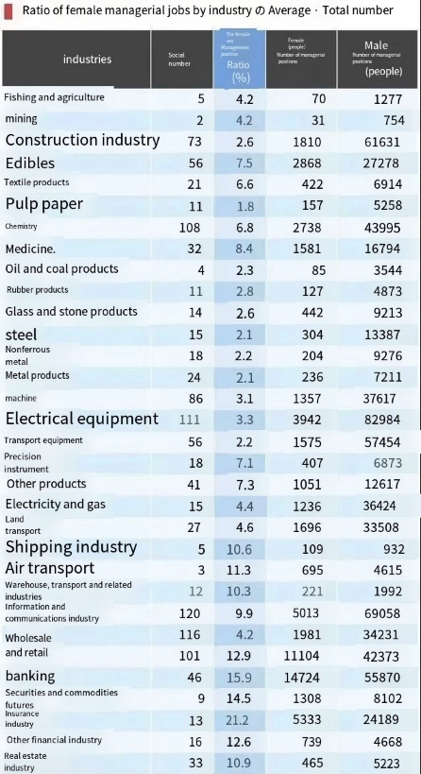
Figure2 (CSR Company Directory 2020)

In most industries, the proportion of female managers is very low in Japan, but due to Japanese cultural customs, this has become a habit. Many managers believe that women's work efficiency is not as good as men's, but this idea is actually due to the long-standing Japanese concept of male superiority and female inferiority, which is a mistaken idea. It is actually very difficult to avoid this situation in Japanese society, and can only be adjusted slowly through a gradual change in social thinking.

2.2 Ethical Universalism
Ethical universalism is a philosophical and ethical concept rooted in the belief that fundamental rights, values, and principles should be universally applicable to all individuals, regardless of their nationality, race, religion, or social status. Moral universalism is a meta ethical stance where certain ethical systems are universally applicable to all individuals, regardless of culture, race, gender, religion, nationality, sexual orientation, or any other prominent characteristics. Universalism in ethics may be consistent with the assertion of the form, scope, or content of ethical principles, or with the idea that ethical judgments rely on principles rather than specific cases. (Ethical Universalism, Ethical Nationalism and Beyond, 1998) Ethical universalism believes that there are fundamental rights, values, and principles that apply to all individuals regardless of their nationality, race, religion, or social status. A very typical example of ethical universalism is the prohibition of theft, and this moral principle is universally applicable because it is based on common human values and basic needs. Taking several Asian countries as examples, China, Japan, and South Korea, although there are many similarities in the values of the entire Asia, the corporate philosophies of these three countries are fundamentally different. Taking state-owned enterprises as an example, China's state-owned enterprises are tools of the state, and there is obvious government support for strong support. Japan's state-owned enterprises serve society and still maintain lifelong positions. South Korea's state-owned enterprises work purely for profit. Although the state-owned enterprises of the three countries are fundamentally different, due to some ethical universalism, the three countries still have some common values in their enterprises, which are the prohibition of plagiarism and the theft of the labor results of others. Taking the Chinese Criminal Law as an example, Article 217 of the Criminal Law of the People's Republic of China stipulates that for the purpose of profit, If any of the following constitutes a copyright infringement and the illicit earnings are substantial or there are other grave conditions, the offender faces a maximum penalty of three years in jail or criminal detention in addition to a fine. In the event of significant illicit earnings or other extremely serious circumstances, he will get a fixed-term prison sentence of no less than three years nor more than seven years, along with a fine.. (China, 2000). Although the cultures, religions, and social forms of the three countries are different, a unified consciousness is still formed in the face of moral standards that are applicable to all humanity. This is the best explanation and example of ethical universalism.

Taking the East and West as examples, Asian values tend to respect social interests, have strong family values, and businesses are relatively conservative in all aspects and respect seniority. Western values tend to emphasize political and economic freedom, with a greater emphasis on individual achievements. Generations are far less convincing than power. Despite the significant differences in values between the East and the West, the same concept is always upheld in the common survival of all humanity. For example, in the perspective of protecting the environment, all countries around the world share the same concept. This moral code is universally applicable because it is formed by the basic rights and principles shared by humanity. Taking the recent hot Fukushima nuclear wastewater incident as an example, with authority from the International Atomic Energy Agency, Japan is progressively releasing wastewater into the ocean (IAEA). There will be four iterations of this version between now and the end of March 2024. This is version one. It takes at least 30 years to complete the process. Not all scientists agree with the impact that the release will have, despite some specialists saying it is harmless. In December 2022, the National Oceanic Laboratory Association of the United States released a statement in which it declared its lack of confidence in Japan's data. University of Hawaii marine biologist Robert Richmond told the BBC: "We see insufficient assessments of radioactivity and ecological impacts, which makes us very concerned that Japan not only cannot detect substances, sediments, and organisms entering the water, but if detected, it will not be able to remove them." Shaun Burnie, senior nuclear expert at Greenpeace East Asia It is stated that if tritium is ingested, it will have a "direct negative impact" on plants and animals, including "reduced fertility" and "damage to cellular structure (including DNA)" (The science behind the Fukushima waste water release, 2023). The act of discharging nuclear wastewater into the Pacific is undoubtedly not in line with ethical universalism, and it is a serious violation of all human values. Therefore, in such an event, all humanity should take the same resistance measures.

2.3 Ethical pluralism
A theory known as ethical pluralism holds that the pursuit of values or commodities by humans is what makes human moral existence really moral. The most basic version of moral pluralism maintains that there are many, incomparable values or commodities that people can rightfully pursue. In other words, there are a lot of real human values that just cannot be summed up or encompassed by one dominant value or set of values. This is due to the fact that some human values inherently clash with other equally potent human values. Individual freedom, for instance, could clash with equality, public order, or technical effectiveness; a just court system with empathy and compassion; or a scientific finding with practical applications in society. (Hinman 2012) Ethical pluralism requires us to listen to the opinions of other cultures towards us, and cultures can be mutually evaluated. Taking Indian culture as an example, India has a very strong caste system, and the caste structure divides people into four main groups: Brahmins, Chadilis, Vedas, and Sudras. Moreover, castes are determined by birth and cannot be changed in the later stages. This is one of the oldest cultures in India, In the current mainstream value system that emphasizes equality for all, this system will definitely be discussed by other cultures. Many people believe that this system is not fair, and some people with lower birth caste are unable to exert their abilities. Many companies have requirements for caste, which leads to many talented people being unable to exert their abilities and will also reduce the profits of the company. Taking Dutch culture as an example, when it comes to egalitarianism, it is necessary to mention Dutch culture. This egalitarian perspective continues to the workplace, even in hierarchical organizations where everyone has the right to express their opinions and be heard. This culture of equality for all is highly in line with today's mainstream values, which leads to many cultures discussing Dutch culture and hoping to learn from it, However, a highly equal plan will increase the tax pressure on local workers, which is the only drawback. The main concept of ethical pluralism is that cultures can be mutually evaluated. Two completely different cultures, Indian culture and Dutch culture, can still be evaluated and borrowed from each other. Any culture has its own value, so cultures can be evaluated and discussed with each other, even though the gap between the two is huge.

2.4 Some Disadvantages of Three Cultures

2.4.1 The Disadvantages of Ethical Relativism
Cultural conflicts are one of ethical relativism's most evident disadvantages. Every culture has its own set of traditions and beliefs. For instance, continual monogamy served as the foundation for the original establishment of the institution of marriage in Western civilization. Consequently, it can be deemed adultery if a guy marries a second woman to become his second wife. On the other side, the idea of Koryak women inviting their husbands to marry other women. They appreciate having a second wife at home and think it is selfish to deny their husband the chance to love someone else (Ruggiero, 2011). Therefore, we can conclude that an individual's moral standards strictly depend on culture, which is the cultural conflict between two cultures, and this is the most obvious drawback of ethical relativism.

2.4.2 The Disadvantages of Ethical Universalism
The disadvantage lies in the flexibility and rigidity of the adherence pattern to values and rules. Defenders of universalism have been accused of ignoring cultural differences and promoting Western values, indicating a racially centered attitude (Benhabib, 1994; Donnelly, 2003; Marko, 2012; Namli, 2018; Vattimo, 2007). In today's society, although mainstream values advocate equality for all, and in enterprises, status should be determined by ability, in Eastern culture, seniority is also very important, which is related to politeness, The disadvantage of ethical universalism is that it may overlook cultural differences between the East and the West and overly lean towards Western values.

2.4.3 The Disadvantages of Ethical pluralism
The disadvantage of ethical pluralism is low social trust. In a diversified society, social trust is relatively low. Everyone is different in various aspects, so it may not be possible to gain social trust in their coexistence. Due to ethical pluralism, cultures can evaluate each other, which can lead to some people believing that others evaluating their own culture is an offensive behavior. This can make it difficult for society to form a unified idea, which is reflected in the lack of mutual recognition and trust among employees in enterprises, making it difficult to manage.

3.0 Conclusion
This report mainly introduces ethical universalism, ethical relativism, and ethical pluralism. Ethical universalism means that people believe in a common value that is in line with morality and the most basic human needs. Ethical relativism means that all moral standards are different in different cultural environments, and each culture has its own moral principles. Ethical pluralism means that different cultures can evaluate each other and there can be multiple cultures. After introducing the three cultures and their applications in the current world, this article also analyzes the shortcomings of the three cultures. Ethical universalism can lead to smaller cultural differences, and some supporters of universalism tend to lean too much towards Western values. The disadvantage of ethical relativism is that there are inevitably cultural differences between different cultures, which may lead to cultural conflicts. Ethical pluralism can lead to mutual evaluation among people, which may lead to a decrease in social trust.

4.0 Reference
Ladd, J. (1985). Ethical Relativism.
‌
International, India). (2002). NASSCOM-McKinsey Report, 2002.
‌
Rachels, J. (2015). Ethical Relativism. In: Encyclopædia Britannica. [online] Available at: https://www.britannica.com/topic/ethical-relativism.
‌
Ethical Universalism, Ethical Nationalism and Beyond. (1998).
‌
China (2000). Criminal Law of the People's Republic of China = Criminal law of the People’s Republic of China. Zhonghua Renmin Gongheguo xing fa = Criminal law of the People’s Republic of China. China Legal Publishing House: Distribution of Xinhua Bookstore, Beijing.
‌
The science behind the Fukushima waste water release. (2023). BBC News. [online] 26 Aug. Available at: https://www.bbc.co.uk/news/world-asia-66610977.
‌
Hinman, L.M. (2012). Ethics: A Pluralistic Approach to Moral Theory. Cengage Learning.
‌
Sumi Madhok (2021). Vernacular rights cultures : the politics of origins, human rights, and gendered struggles for justice. New York: Cambridge University Press.
‌
Donnelly, J. and Cornell University Press (2006). Universal human rights in theory and practice. Ithaca ; London: Cornell University Press, [Post.
‌
studybounty.com. (n.d.). Ethical Relativism: Definition, Examples & Pros and Cons Free Essay Example. [online] Available at: https://studybounty.com/ethical-relativism-definition-examples-and-pros-and-cons-essay.
‌
The Editors of Encyclopedia Britannica (2019). Universalism | Christianity. In: Encyclopædia Britannica. [online] Available at: https://www.britannica.com/topic/Universalism.
‌
Emily (2023). Ethics in Business: Navigating Cultural Differences and Challenges. [online] Aaron Hall. Available at: https://aaronhall.com/insights/ethics-in-business-navigating-cultural-differences-and-challenges/#Key_Takeaways [Accessed 12 Jan. 2024].
‌
Shomali, M.A. (2002). Ethical relativism : an analysis of the foundations of morality. London: Islamic College For Advanced Studies Press ; London.
‌
Shomali, M.A. and University Of Manchester. Government Department (2000). Ethical Relativism. Manchester: University Of Manchester.
‌
Ethical Universalism, Ethical Nationalism and Beyond. (1998).
‌
Saral Jhingran (2001). Ethical relativism and universalism. Delhi: Motilal Banarsidass Publishers.
‌
Browning, D. (2006). Universalism vs. relativism : making moral judgments in a changing, pluralistic, and threatening world. Lanham, Md.: Rowman & Littlefield Publishers.
‌
Madsen, R. and Strong, T.B. (2003). The many and the one : religious and secular perspectives on ethical pluralism in the modern world. Princeton, N.J.: Princeton University Press.

‌ Gill, M.B. (2014). Humean moral pluralism. Oxford: Oxford University Press.
‌
Commisceo-global.com. (2019). Netherlands (Holland) - Language, Culture, Customs and Etiquette. [online] Available at: https://www.commisceo-global.com/resources/country-guides/netherlands-guide.
‌
Commisceo-global.com. (2016). Japan - Language, Culture, Customs and Etiquette | global-etiquette | resources. [online] Available at: https://www.commisceo-global.com/resources/country-guides/japan-guide#c4.

‌ Commisceo-global.com. (2019). India - Language, Culture, Customs and Etiquette. [online] Available at: https://www.commisceo-global.com/resources/country-guides/india-guide#C3.
‌
The science behind the Fukushima waste water release. (2023). BBC News. [online] 26 Aug. Available at: https://www.bbc.co.uk/news/world-asia-66610977.
‌
Fukushima nuclear disaster: Japan to release treated water in 48 hours. (2023). BBC News. [online] 22 Aug. Available at: https://www.bbc.co.uk/news/world-asia-66578158.
‌
Linda Trinkaus Zagzebski (2004). Divine Motivation Theory. Cambridge University Press.
‌

