Ford Cooper (P148308)
Fcooper.148308@student.awtsdac.uk
Abstract
This report discusses two various modern-day manufacturing which include laser cutting and water jet cutting. Both processes are compared and contrasted taking into account the technology used, cost and benefit to the company. The main objective of this paper is to select the best modern-day technology for cutting metal.
Advanced processes and materials
Critical evaluation of non-traditional machining equipment for manufacturing industry

Table of Contents
Introduction 3
Laser 4
Theory of laser technology 4
Components of a laser 4
Spontaneous and stimulated emission principle 6
Types of lasers 7
Application of lasers 8
Laser cutting 8
Process 8
Advantages and disadvantages of laser cutting 9
Abbrasive Water Jet 10
Theory of water jet 10
Components of an abrasive water jet 10
Applications of water jet 11
Abrasive water jet cutting 11
Process 11
Advantages and disadvantes of abrasive water jet cutting 12
Contrast 13
Concluesion 15
Appendices 16
References 19

Introduction
This report compares and contrasts two different non-traditional manufacturing methods. This report will investigate the scientific principles behind both methods as well as comparing and contrasting various areas such as physical attributes, cost implications, health and safety impacts, environmental impacts.
The modernised manufacturing methods, which the author analyses are, laser cutting and abrasive water jet cutting.
These two methods will be compared on these given factors and a conclusion will be drawn on which method would be most suited to the company for the manufacturing of the variety of components such as fastenings, fixings and springs.

Laser

Theory of laser technology
According Bromberg (1991) the word ‘laser’ is an acronym for light amplification by stimulated emission of radiation.
The main properties of laser light are as follows:
- Monochromatic – The light emitted from the laser is of one wavelength (colour).
- Directional – Lasers emit light that is highly direction, it is emitted in a narrow beam in a specific direction.
- Coherent – The wavelengths if the laser light is all in phase.

Components of a laser
A laser must have the following three basic components according to Steen (2010):
- An active medium, which is used to serve the purpose to amplify light. This may be any material that is solid, liquid or gas. Most common mediums include ruby, argon or CO2.
- Pumping source, which is a means to excite the active medium to the amplifying state. Any energy source can be used for pumping including flash lamps, electrons or chemical reactions.
- Optical resonator, which is a means to provide optical feedback. An optical resonator causes the light generated by the active medium, to be reflected back and forth through the medium. One end of the cavity will have a mirror of 100% reflection whereas the other side of the x-axis plane will have a mirror of 99% reflective. Therefore, only part of the light is released each pass through the partially transmitting mirror.
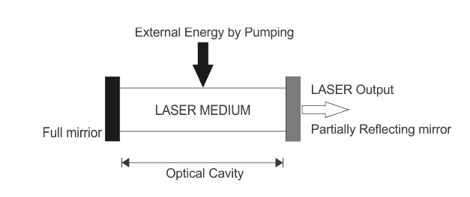
[Figure 1: Showing basic components and function of a laser] (Electrical4u.com)
It can be seen that the laser output is accomplished by the interaction of atoms within the active medium due to the excitation produced via the external energy by pumping. The laser output is through the partially reflecting mirror, which emits a beam of which is monochromatic and in phase.
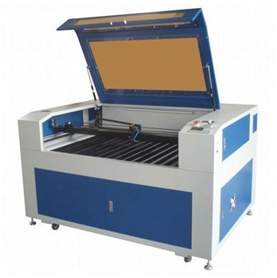
[Figure 2: Showing a laser cutting machine] (Indiamart (2018))

Spontaneous and stimulated emission principle
Steen (2003) wrote that Arthur Schawlow and Charles Towns first published the concept of the laser in 1958, then followed Theodore Harold who in 1960 invented the first working ruby laser from following on from Einstein’s papers (1916) and (1917) which showed the occurrence called ‘Stimulated emission’.
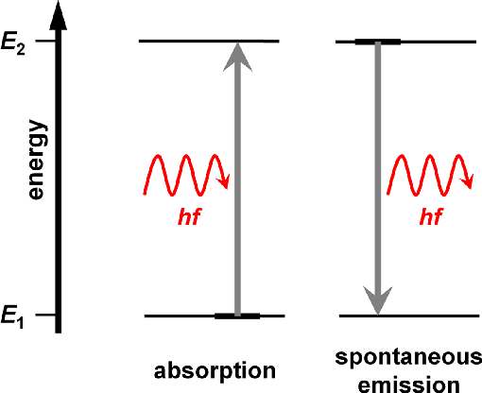
According to Paschotta (2008) a laser gain medium has active ions/ atoms which have different energy levels. If an atom is at ground state and is exited to a higher energy level it will need to absorb a packet of exactly that of the difference between both energy levels in the form of a photon, this process is called absorption.
If an atom is in an exited state it may spontaneously decay into a lower energy level releasing its energy in the form of a photon in a random direction and phase, this is called spontaneous emission.

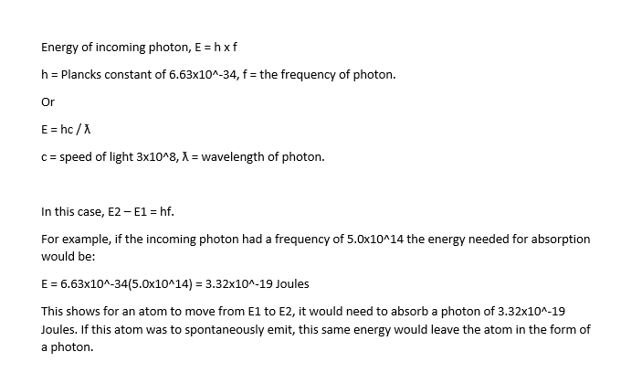
[Figure 3: Showing absorption and spontaneous emission] (Gomes, N (2017))

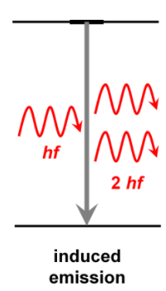
Paschotta (2008) also wrote that it is possible for the emission to be stimulated by incoming photons, which is called stimulated emission. An incident photon causes an upper level atom to decay, emitting a “stimulated” photon whose properties are identical to those of the incident photon. The emission then goes into the same direction as the incoming photon. In effect, the incoming radiation is amplified. This being the basics of how the laser functions. One condition needed for a laser to funtion and stimulated emission to take place is that population inversion must be present. This is when the number of atoms on energy level two are greater than that of one. If population inversion is not present absorption dominates and light is not amplified.

[Figure 4: Showing stimulated emission] (Gomes (2017))

Types of lasers
According to Steen (2010), for manufacturing, the most common systems are CO2, Nd:YAG (neodymium-doped yttrium aluminium garnet) and fibre lasers. Each laser type has different performance characteristics so are suitable for various tasks, but it is also possible to manipulate a single laser to perform different tasks by adjusting power density, which is a main reason for popularity of lasers within manufacturing.
With reference to table 1 and 2, it is possible to see the various characteristics given by each form of common laser. It can be seen that for laser cutting purposes within manufacturing then most suitable lasers are either Nd:Yag or CO2 (axial flow), (transverse flow) or (slow flow). This is due to the high-power output/ Watts, which is needed to cut through a metal material.

Application of lasers
It is written by Steen (2010), that laser have many modern-day applications within the manufacturing industry. These include: cutting, drilling, welding, cladding, alloying, heat treating and cleaning. Outside of manufacturing lasers are used within other industries including military, scientific, medical and commercial. The applications include laser printing, light display, CD player, eye/ cosmetic surgery, spectroscopy and nuclear fusion.

Laser cutting

Process
Steen (2010) describes the process of laser cutting as initially a precise and focused laser beam will pierce the material which is to be cut with a hole at the edge, the beam is then continued along from there. The laser will essentially melt away any material it passes over. It is described to be more of a melting process which results in in accurate and smooth cut.
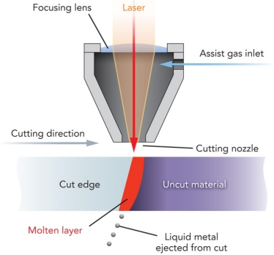
[Fig 5: showing illustrated process on laser cutting] (Shannon (2011))

Advantages and disadvantages of laser cutting
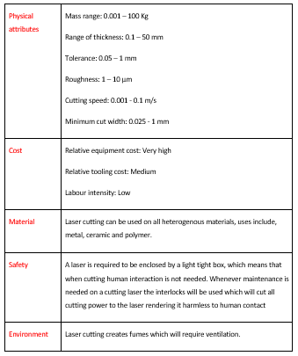
According to Ion (2005) there are many various advantages of using laser cutting within a manufacturing sector appose to various traditional methods, with these in mind cross referenced with CES software a table can be produced below:

Abbrasive Water Jet

Theory of water jet
According to Krajcarz (2014) the technique with using high pressure water for cutting materials was first time patented in 1968 by researcher in USA, but fast development of water jet cut method was starting in early ‘80s. It is now the most rapidly developing cutting technology, that is used in industry for processing variety of engineering materials.

Components of an abrasive water jet
A water just must have the following basic components according to Momber (2012) are
- High-pressure pump: used to pump water from the inlet supply to the intensifier.
- Intensifier: used to increase the supplied water pressure to a specific pressure need to cut through the material.
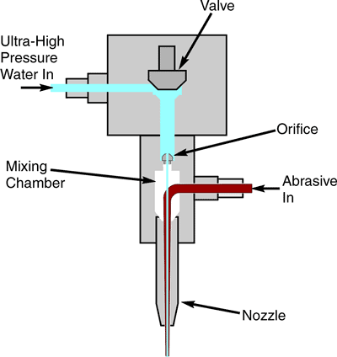
- Actuator: This is comprised of a cutting nozzle as well as the specific orifice needed to meet specification.
The components necessary can be identified in figure 4. It shows how the high-pressure water enters the machine, then passes through the orifice, abrasive mixture is then added to the steam to aid cutting.

[Figure 6: Showing abrasive water jet] (Kong (2014))

Applications of water jet
According to Momber (2012), water jets are used in nearly all areas of modern industry chemical, industrial, aerospace and construction. Applications include surface preparation; paint stripping, decontamination, recycling and manufacturing. In the purpose of manufacturing abrasive water jet cutting technique can be used for material cutting, deburring, cutting materials which machine cannot, polishing, piercing and surface peening.

Abrasive water jet cutting

Process
Momber (2012) describes water jet cutting as the method of passing pumped high-pressure water (up to 400MPa) through an oracle (sapphire) producing a stream with a diameter of 0.1 to 0.3mm. Grit is then added to the steam to produce a mixture at a velocity of 850 m/s and using this to erode a narrow line in the stock material. It is the fastest growing machining process and one of the most versatile.
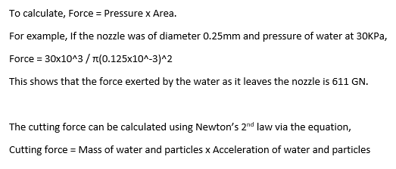
When a material is chosen it is important to ensure the water-jet cutting machine can produce enough force to erode the material, this is calculated as followed:
To keep the cutting force high enough to pierce the material, it is vital to either increase velocity or the mass of the stream. By increasing either there would now be an increase of momentum.

Advantages and disadvantes of abrasive water jet cutting
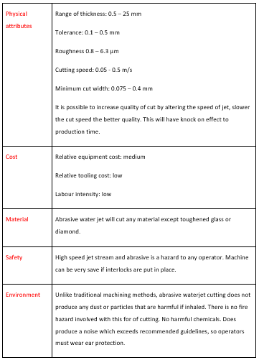
Cross-referencing CES software with Ion (2005) a table shown below can summarise the benefits and negatives related to abrasive water jet cutting as well as some characteristics:

Contrast
Versatility: Water jet appose to laser cutting is primarily more versatile. Water jet can cut virtually all materials, but laser is restricted to all homogenous materials which do not reflect light. Both manufacturing methods can be used to produce complicated designs if programmed effectively. Both cutting methods can cut thin and thick materials, but laser jet is able to cut that 25mm bit deeper according to CES software.
Thermal deformation: Water Jet has the advantage of not producing any thermal deformation, which laser cutting may suffer due to it cold cutting quality as stated by Krajcarz (2014).
Quality: According to Ion (2005) both methods are of high quality giving a smooth and square finish. If the product being made is needed to be of top quality, laser would be the method of manufacturing because it gives the smallest kerf width and the least edge roughness.
Environment: Abrasive waterjet cutting is regarded as the most environmentally friendly according to Kong (2014), it does not produce any harmful particles when manufacturing a product unlike laser cutting. Laser cutting can produce fumes which will need to be extracted safely. Another difference is that laser cutting is relatively quite compared to jet cutting, this will mean in accordance with guidelines operators will be required to wear ear protection when carrying out water jet cutting. Laser cutting does not require any input materials to carry out the process, whereas abrasive water jet cutting requires water and also the garnet used as an abrasive.
Cost: Laser cutting is the more expensive method of manufacturing with a greater labour, tooling and equipment cost.
Productivity: According to ion (2005), laser cutting has a greater productivity to abrasive water jet cutting. This does not agree with data shown via CES software that states that abrasive waterjet cutting has a greater cutting speed. Waterjet may have greater cutting speed due to the fact speeds can be altered via the program at hand, making cutting speed faster at the cost of reducing quality of parts, which could result in some material needing rework thus reducing productivity.
The comparison between both methods can be summarised below:
[Table 6: Showing a summary of comparisons between both methods]
Blue: Good, Green: Same, Red: Bad

Concluesion
The issue discussed in this report was to look in detail at two possible non-traditional methods which could be used to cut a variety of components. To identify which method would best be suited for company to use, background research was undertaken as well as a direct comparison of both methods. The comparison has been shown in a summarised form in table 6. Both methods seem a reasonable investment to the company in order to cut these variety of components but after closely analysing both methods, the most suited method the author believes would be abrasive water jet cutting. The reasoning for this decision is supported by the following points. Abrasive water jet can cut through a wider range of materials. If the components which are being cut are made from a metal, there will be zero thermal deformation. Water jet cutting has a lower equipment cost and is also the most environmentally friendly method.
The author believe further information is required before definitively saying that abrasive water jet cutting is the method of choice. Information needed would include what materials are being used and also batch quantity. As laser cutting has he greatest productivity, if batch quantity is high, then this could be the method of choice.

Appendices
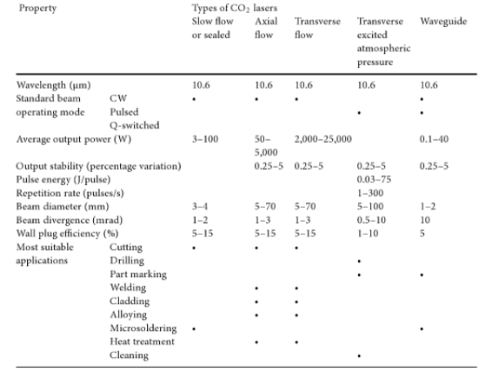

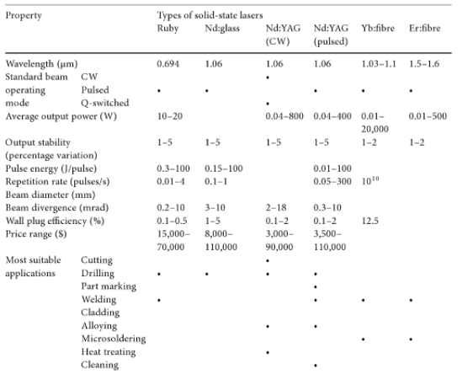
[Table 1: Showing performance characteristics of solid-state lasers] Steen (2010)

[Table 2: Showing performance characteristics of gas lasers] Steen (2010)
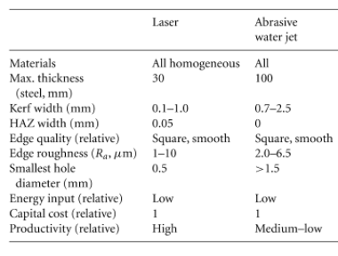
[Table 3: Showing technical features of cutting processes] Ion (2005)
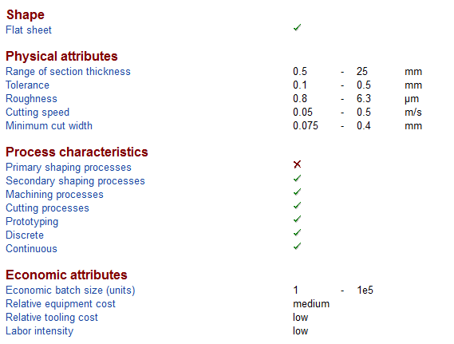
[Table 4: Showing properties of abrasive water jet cutting] CES (2018)

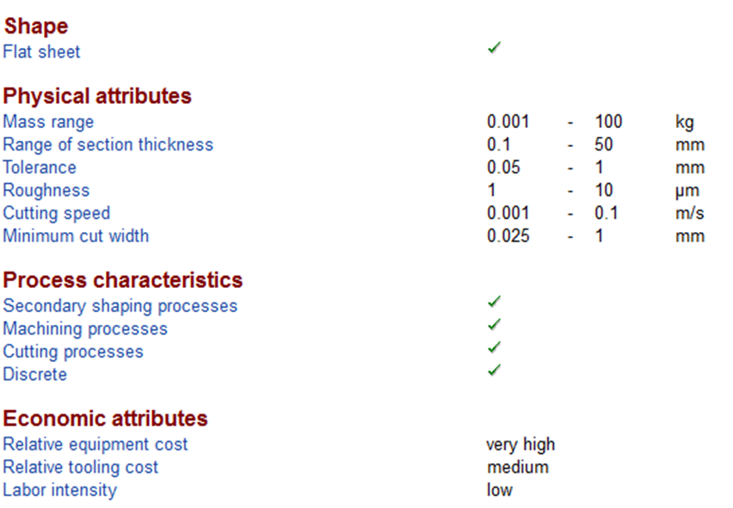
[Table 5: Showing properties of laser cutting] CES (2018)

References
- Bromberg, JL (1991). ‘The laser in America 1950-1970’. MIT Press: Cambridge.
- Ctrlasers (2018) [Online]. Running cost of lasers. http://www.ctrlasers.co.uk/running-costs [Accessed 28/03/18].
- Einstein, A (1917). ‘Zur quantentheorie der strahlung’. pp.121-128.
- Einstein, A (2016). ‘On the Quantum Theory of Radíationf’. The Old Quantum Theory: The Commonwealth and International Library: Selected Readings in Physics, pp 167.
- Electrical4u (2018) [Online]. Basic components and function of a laser. http://www.Electrical4u.com [Accessed 26/03/18].
- Gomes, N (2017). ‘Laser cooling techniques: Standard and alternated optical molasses’, pp 12- 400
- Indiamart.com (2018) [Online]. Laser cutting machine. https://dir.indiamart.com/impcat/fiber-laser-cutting-machine.html [Accessed 20/03/18].
- Ion, J (2005). ‘Laser processing of engineering materials: principles, procedure and industrial application’, pp 44-207
- Kong, C (2014). ‘Water-jet cutting’. CIRP encyclopaedia of production engineering (pp. 1297-1301). Springer Berlin Heidelberg.
- Krajcarz, D (2014). ‘Comparison metal water jet cutting with laser and plasma cutting’. Procedia Engineering 69, 838-843.
- Momber, A.W (2012). ‘Principles of abrasive water jet machining’. Springer Science & Business Media, pp 2-40.
- Paschotta, R (2008). ‘Field Guide to Lasers’. SPIE Press: Bellingham
- Shannon, G (2011) [Online]. ‘Fine laser cutting’. https://www.industrial-lasers.com/articles/print/volume-26/issue-2/features/fine-laser-cutting.html [Accessed 25/03/18]
- Steen, W.M (2003). ‘Laser material processing—an overview’. Journal of Optics A: Pure and Applied Optics, 5(4), pp 33-249.
- Steen, W.M and Mazumder, J (2010). ‘Laser material processing. Springer Science & Business Media’, pp 345.
- Yablonovitch, E (1987). ‘Inhibited spontaneous emission in solid-state physics and electronics’. 58(20), pp 2059.

