Research Methodology and Planning
Introduction
This chapter aims to identify the most appropriate research approach required to conduct the research project on county lines and their exploitation of vulnerable individuals.
Typically, there are two main types of research: primary and secondary. Bryman (2016) describes primary research as information that is collected by an individual for a specific purpose. Secondary information is that which is obtained from previous studies by another researcher for their own intent and purposes. To further build on available literature and contribute to existing debates, primary research will be the most effective.
The Research Onion
One of the most popular methods used in academic research is that of “The Research Onion” by Saunders et al, (2016).
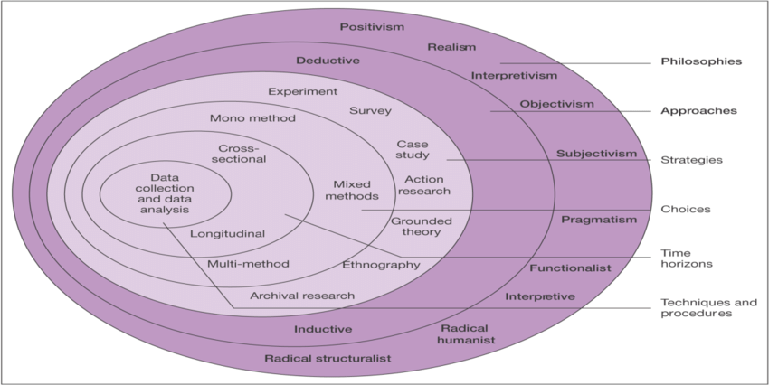
(Saunders, et al., 2016)
Research Philosophies
The first “layer” covers research philosophies. The approach that will be taken for this project is “Interpretive” as Saunders et al, (2019), states that this is a good method in enhancing an already existing academic understanding of a subject.
Approaches
The next “layer” is the approaches. An inductive approach will be used for this research project. Bryman (2016), states that this method involves the researcher basing their theory on their findings and observations, whereas a deductive approach does the opposite, with the researcher looing for specific findings that will either prove or disprove their theory.
Strategies
The third “layer” is one for strategies. Questionnaires/surveys will be created via GoogleDoc and subsequently shared via social medica platforms such as Facebook and Instagram in order to have a wide and diverse sample range, which Dewaele (2018), states strengthen the ecological legitimacy of the resulting database.
Choices
The next “layer” is choices. This study will use a mixed method design. This combination method allows for a more complete analysis of the research subject as the qualitative and quantitative methods complement one another (Migiro & Magangi, 2011).
Time Horizon
The last “layer” helps the researcher to identify how long their research is going to take to collect. There are 2 different types of research designs, longitudinal and cross-sectional (Kesmodel, 2018) . Since the questionnaires will be distributed over a short period of time, a cross-sectional study is the most appropriate time horizon.
Techniques: Data collection and data analysis
Data collection
Primary data can be carried out in multiple different ways, such as in the form of surveys and questionnaires. There are many advantages as well as disadvantages to using questionnaires as a form of primary data collection. Advantages include the collection of high quality data if planned properly, as well as getting more honest answers from the general public due to the barrier of anonymity. However, disadvantages can include confusion to participants caused by the questions, resulting in subpar answers as well as barriers such as language and poor literacy skills (Marshall, 2005).
Survey Design
The online questionnaire will contain a mix of both open-ended and closed questions. This is to ensure a more diverse range of data. Whilst closed-ended questions are seen as the better option for online surveys as they are seen as less cognitively demanding, they can be more biased. Whereas open-ended questions, whilst more complicated to use for online surveys, can provide more detailed and informative responses (Connor Desai & Reimers, 2018).
Sample & Data Analysis
Ghauri & Gronhaug (2005), highlight the importance of not having too large of a sample size as it does not allow for comparison. The target sample size for this project is between 50-75. The questionnaire will be distributed on social media for views on the general public, as well as sent to colleagues and other individuals known to the researcher. The gathered data will then be analysed through the GoogleDocs survery tool as this will allow for several advantages.
Reliability and Validity
Valid data is that which is accurate and peer-reviewed, with reliability coming from consistent results from obtained from data being consistently collected (Fitzner, 2007). As stated above, questionnaires are found to be dependable sources of
Limitations
Due to the nature and sensitivity surround the topic of county lines, it is inevitable that there will be limitations experienced by the researcher. One such limitation will be the lack of participation from young, vulnerable individuals who are seen to be the ones most commonly exploited by county lines gangs due to the university’s ethics policies.
The short time frame in which the questionnaire will be live on social media could also be a limitation. This is due to the researchers own time limitations as well as deadlines for university work.
Another such limitation could be the general populations lack of knowledge on county lines gangs and how they operate. This will hopefully be combated by the inclusion of a small brief on county lines gangs at the start of the questionnaires.
Ethical Considerations
Prior to undertaking this research project, an in-depth ethics form was completed and submitted. As stated in the ethics form, all primary research gathered will be voluntary with the participants right to withdraw their consent at any time clearly stated within the questionnaires. All participants will also be informed on the nature of the research as well as how their data will be used for the dissertation project. Anonymity and confidentiality of participants will be kept throughout, and all information will be stored on a password protected device.
Conclusion
This chapter of the dissertation has outlined the most suitable form of research methodology appropriate for this dissertation as well as achieved the second objective for this dissertation. The next chapter will present these findings, analysing the data in order to further explore county lines and their exploitation of vulnerable individuals.

References
Bryman, A., 2016. Social Research Methods. 5th ed. London: Oxford University Press.
Connor Desai, S. & Reimers, S., 2018. Comparing the use of open and closed questions for Web-based measures of the continued-influence effect. Behavior Research Methods, 51(1), pp. 1426-1440.
Dewaele, J.-M., 2018. The Palgrave Handbook of Applied Linguistics Research Methodology. 1st ed. London: Palgrave Macmillan.
Fitzner, K., 2007. Reliability and Validity A Quick Review. The Science of Diabetes Self-Management and Care, 33(5), pp. 775-780.
Ghauri, P. N. & Gronhaug, K., 2005. Research Methods in Business Studies: A Practical Guide. 3rd ed. London: Pearson Education.
Kesmodel, U., 2018. Cross-sectional studies - what are they good for?. Methodology in Clinical Epidemiological Research in Obstetrics and Gynecology, 97(4), pp. 388-393.
Marshall, G., 2005. The purpose, design and administration of a questionnaire for data collection. Radiography, 11(2), pp. 131-136.
Migiro, S. & Magangi, B., 2011. Mixed methods: A review of literature and the future of the new research paradigm. African Journal of Business Management, 5(10), pp. 3757-3764.
Saunders, M., Lewis, P. & Thornhill, A., 2016. Research Methods for Business Students. 7th ed. Essex: Pearson Education.
Saunders, M., Lewis, P. & Thornhill, A., 2019. Research Methods for Business Students. 8th ed. London: Pearson Education.

