  - Vehicle Systems M4X02198

Suspension Investigation
Subith Joseph 1902458

(n/a, 2019)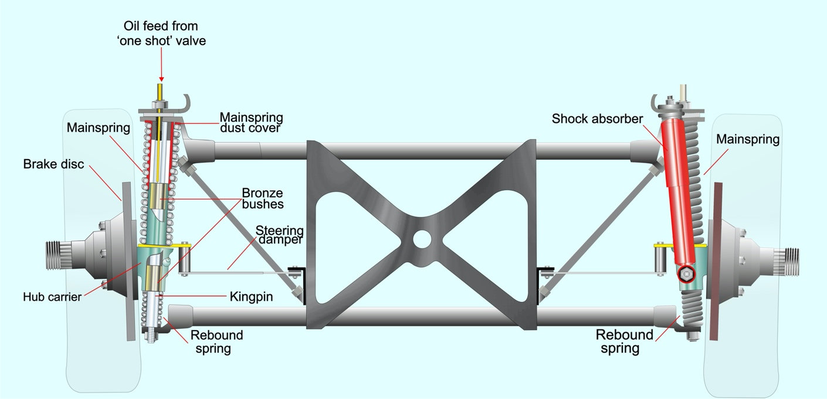

Table of Contents
Introduction 3
Equipment 4
Vernier Calliper 4
Steel Ruler 5
Engineers Square 6
Height gauge 6
Digital protractor (inclinometer) 7
DTI gauge (Dial Test Indicator) 8
Methodology 8
Results 9
Conclusion 10
Recommendation for further study 11
Bibliography 12

Introduction

The Purpose of this Investigation is to review how the suspension system of a vehicle behaves under forces and reacting to forces e.g. Compression, Rebound

Suspension geometry

Toe –in/out
The angle of the wheel between a longitudinal axis.
Rear wheel drive vehicles, front toe in 5-20 minutes – This is to provide straight line stability
Front when drive, front toe out 0-20 minutes – This is to compensate all the different types of forces the wheel has to endure e.g. acceleration, braking and steering
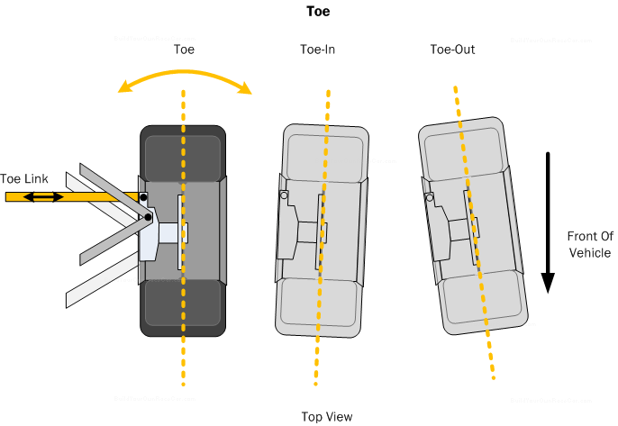
(N/A, race car suspension basics and design, 2019)

Camber
Camber angle is the angle of the wheel vertically upwards
Camber is mainly used to enhance cornering performance, for maximum straight-line performance 0$°$ Camber is used but when it come to cornering running 0.8 – 1.3$°$ negative camber gives the vehicle less change to loos traction.
This is caused by how the camber changes in a vehicle as is goes down its suspension travel the wheel the camber values changes, when setting a vehicle up for cornering then having negative camber will be useful, this is so when the vehicle is turning the camber would move to a neutral position also causing the tyres to have more contact area to the ground which also means more grip. Doing this can affect straight line performance

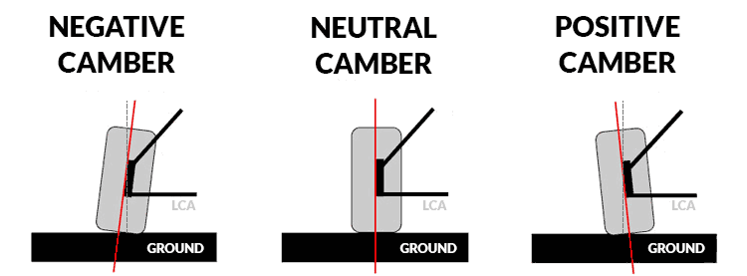
(N/A, learn Camber, Caster, and toe, 2019)

Caster
Caster angle is the angle position where the steering axis would be placed
Positive caster is normally used in motorsports applications, this is to improve the stability of the vehicle and get sharper handling dynamics, doing this would increase negative camber but for motorsports application that’s great form cornering grip. Also doing this would have some drawback as steering would get heavier (cars without power steering) but for modern vehicle that is no problem since it is electronically controlled
Negative Caster is normally found in older vehicles. This is not common anymore due to less accurate steering dynamics, but doing this will lighten the steering wheel but will not be sharp and accurate as having positive caster

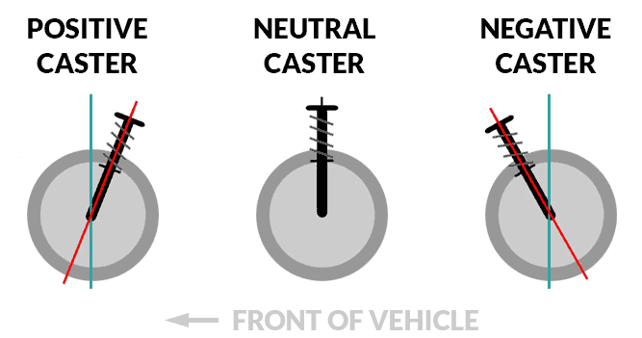

(N/A, learn Camber, Caster, and Toe, 2019)

Equipment

Vernier Calliper
The Vernier Calliper was used on the first and second Lab session when measuring points. This was used due to its accuracy and precision. The Vernier Calliper has a sliding jaw which moves across a scale where all the measurements are read. The Internal jaws are can be used to measure the inner diameter of a rod when the External Jaws can be used to measure the diameter of anything e.g. tube. The Depth Measuring Blade can measure the depth e.g. measuring clearance. An alternative to the Vernier Calliper would be a Digital Vernier calliper or a Steel ruler.

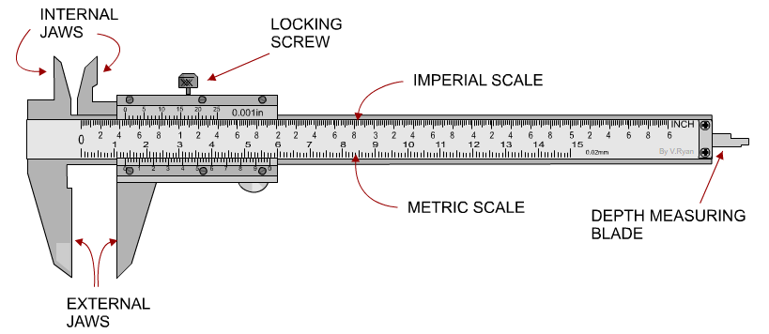
(N/A, Vernier Calliper, 2019)

Steel Ruler
The steel ruler is for measurement and also drawing straight lines, due to the non-flexibility of the usage it wasn’t the first equipment of choice.

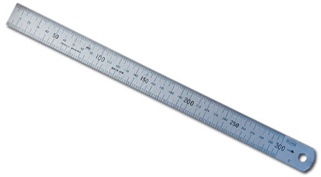 (N/A, Measurement & marking out, 2019)

Engineers Square
The Engineers square was used to mark out a straight line from the edge of the base for an accurate 90$°$ representation to show that what your measure is straight and in level
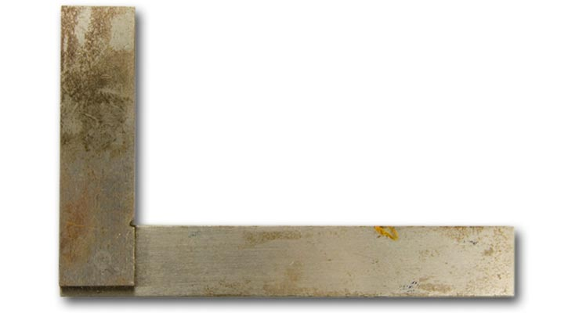

(N/A, Measurement & marking out, 2019)

Height gauge
The height gauge was used to measure the Z axis of each point of the suspension points. To use a height gauge, a level surface is needed, or else the data which it reads will not be accurate. An alternative to a height gauge would be a steel ruler which would give a less accurate reading but more compact.

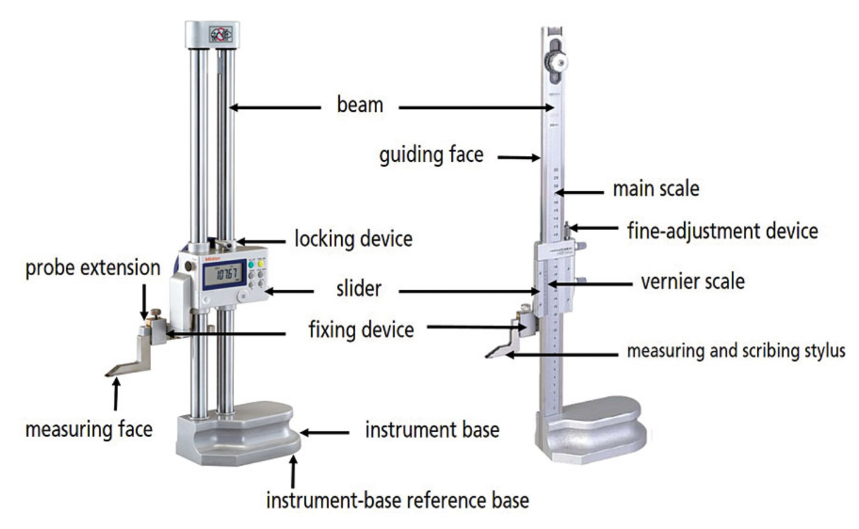

(Grosenbach, 2016)

Digital protractor (inclinometer)
The Inclinometer is used to measure the angle of a surface compared to a horizontal axis. The Inclinometer is used during the second session when working out the kingpin angle and also the angle of the brake disc. When using the Inclinometer zeroing the gauge is important on a flat surface for an accurate reading
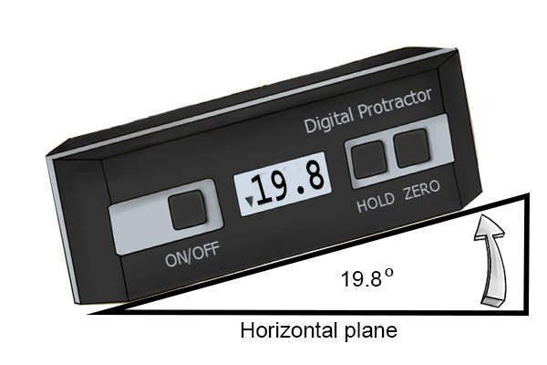 (How to use a digital angle gauge (digital protractor), 2019)

DTI gauge (Dial Test Indicator)
The DTI gauge is very precise measurement tool. This is used for doing disc runout to check for warped brake disc. The DTI gauge was used on the second session when working out toe while changing the length of the tracking rod.
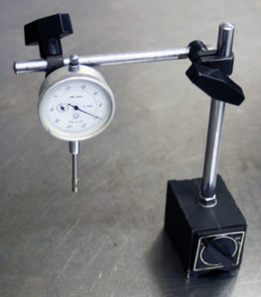 (N/A, How to Use a Dial Indicator, 2019)

Methodology:

Session one
Session one was to find the 3-axis dimensional space for the outer and inner tie rod ends. The following presentation as a set of instruction to find the specification points of the outer tie rod. The chassis used on this from a 1996 Diemen Formula Ford

Setting up the session
- Firstly, making the steering rod in the central to the chassis by equalizing the distance of the steering rack on the steering box. This is achieved by using a Vernier calliper and measuring the two distance of both sides of the steering rack. After this then lock the steering rack so the data which will be produced will be accurate
- A sheet of paper is placed underneath the flat bed surface where the chassis is on, this is used to plot the various points of the tie rod.

Taking the measurement:
- Using an Engineers square, placing it on the side on the work bed which has been calibrated to 90$°$
- draw a perpendicular line from the centreline of the chassis and the disk brake a small distance beside the hub. This will then show the x, y axis of the chassis which will be worked on.

Finding the x axis
- To get the x axis, finding the midpoint of the wheel hub is essential
- Find the diameter of the brake disc using a Vernier Calliper (138.9mm) and then halving it to get the midpoint of the wheel hub (69.45mm)
- Using the engineers square, draw a horizontal line from the centre point of the wheel hub across the sheet of paper

Finding Y axis
- The y axis is the 2-dimensional vertical line which runs through the chassis from front to back
- For this session It will be a basic line just a small distance away from the wheel hub to make it simple.

Inner Tie Rod:

Plotting x axis
- To find the outer tie rod point, finding the midpoint of the bolt head is needed
- Using the Vernier calliper the diameter of the bolt $(9.31mm$) and halving it to get the midpoint ($4.65mm$)
- Using the Vernier calliper measured the blade of right angle ($38.3mm$)
- Using the Vernier calliper measure the diameter of the boss ($30.12mm$) and halving it to get the midpoint ($15.06mm$)
- Then adding the two recent measurements together ($38.3 + 15.06 = 53.36mm$)
- On the sheet of paper plotted down ($53.36mm$) as a reference
- Using a steel ruler, measure the line across the x axis (151.84mm)

Plotting y axis
- On the midpoint of the bolt head on the outer tie rod ($4.65mm$)
- Using that point plotted the y axis which then measure to ($187mm$)
- $y=187mm$

Plotting z axis
- To measure the height since the height gauge isn’t tall enough, using an engineer block for the extra height was needed
- Using a Vernier calliper used to measure the height of the engineer block ($50.8mm$)
- Then placing the height gauge on top of the block to measure distance the top of the outer tie rod bold to the bottom of the height gauge$(264.69mm$)
- To measure the total height including the engineers block ($50.8 + 264.69 = 315.49mm$), ($315.49-4.65=310.84mm)$
- $z=310.84mm$

Outer Tie Rod:

Plotting x axis
- Using the Vernier Calliper measure the distance from the centre of the bolt to the straight edge (12.15mm)
- Then plot the point on the sheet of paper 12.15mm from the straight edge
- Using the steel ruler measure the point from x axis $(-65.8mm)$
- $x= -65.8mm$

Plotting y axis
- Using the Vernier calliper measure the distance from the bolt to the straight edge $(26.7+4.65=31.38mm)$
- Then plotting $31.38mm$ on the sheet of paper
- Using the steel ruler measure the point from y axis ($740.5mm$)
- $y=740.5mm$

Plotting z axis
- Using an engineer block ($50.8mm$) for extra height reachability because the height gauge is not high enough
- Measure the height of the bolt with the engineer block ($262.39+50.8=313.19mm$)
- $z=313.19mm$

Session two
This session was to understand the suspension system with suspension travel, Camber and bump steer during suspension travel of the chosen chassis (1996 Van Diemen Formula Ford).

Setting up the session
- Removed the damper located in the front midsection of the chassis and replaced it with an adjustable rod in a fully extended setting
- Fitted an inclinometer to the brake disc perpendicular to the floor and set as zero
- Find a flat surface and place the height gauge on the wheel hub and set it as zero
- Attach a measuring plate on the wheel hub a tighten till no movement is seen
- Place a pair of DTI gauge on both ends of the measuring plate on the hub
- Last of all ensure all measuring equipment is set as zero

Taking measurement
- Using the Vernier Calliper to measure the distance between the adjusting nut by turning 2 revolutions clock wise to screw inwards, this represents the suspension travel
- While changing the length of the suspension travel observe the Inclinometer and the DTI gauge to the nearest 0.001”
- Repeat 10 times

Weighing the un-sprung mass
- Disconnect all points below the dampers (wishbones and tracking rod) from the chassis as one unit
- Place on a scale and record the data shown

Measuring the spring natural rebound
- Remove the coil spring from the damper
- Using a Vernier calliper measure the total length of the spring ($6 inches$)
- Using a scale measure the total weight of the coil spring (26.5kg)
- Place the spring on the coil spring tester
- Zero the scale
- Compress the spring with the tester and take the readings

WinGeo3
WinGeo3 is a software used to simulate suspension movement on the computer, this can be used to predict certain outcomes which can be used in motorsports application when tuning a vehicle to behave a certain way in certain scenarios.

Set up:
- Unit of measurement - Metric
- Motion ratio - Velocity ratio
- Toe steer - Degree
- Ackerman - Both
- Edit check sums or incline angle: Check sums
- Track or half track measurement - full track
- Steering box - Rack travel
- Names - Road racing

Toe, Ride and Camber Results
- Open table, doing this will bring up a table
- On the top left corner on ride change the ride height from +25mm to 0mm then down to -25mm in 5mm increments
- Input recorded data

Measured Results

Travel (mm) | Damper(mm) | Camber (deg)
0 | 51.5 | -1.54
6.36 | 48.6 | -1.62
13.06 | 45.2 | -1.7
19.59 | 42.6 | -1.78
26.02 | 38.4 | -1.86
32.46 | 36.6 | -1.94
38.94 | 33.7 | -2.03
45.39 | 30.5 | -2.11
51.62 | 27.3 | -2.21
57.94 | 24.8 | -2.3

The chart above shows how the camber changes due to suspension travel.

Travel (mm) | Damper(mm)
0 | 51.5
6.36 | 48.6
13.06 | 45.2
19.59 | 42.6
26.02 | 38.4
32.46 | 36.6
38.94 | 33.7
45.39 | 30.5
51.62 | 27.3
57.94 | 24.8

Suspension leverage (SL)
26.7 = change In coil spring length from start position = 51.5 – 24.8
$$\frac{57.94}{26.7}=2.17$$

Spring rate
Spring rate is the amount of force needed to compress the coil spring alone by one inch or any other chosen unit
To work out the spring rate changing the units from Ibs/in to N/m is important for an accurate and reliable data
$$\frac{397}{25.4}=15.62 Ibs/mm$$
$$\frac{15.62}{2.2}=7.1Kg/mm$$
$$7.10*9.81=69.69N/mm$$
$$69.69*1000=69695.23 N/m$$
Spring rate = 69695.23 N/m

Bibliography
Grosenbach, M. (2016, July 1). Ins and Outs of Height Gages. Retrieved from Quality Magazine: https://www.qualitymag.com/ext/resources/Issues/2016/July/height/QM0716-DEPT-101-p6-height_gage.jpg
How to use a digital angle gauge (digital protractor). (2019, 12 6). Retrieved from Wonkee Donkee Tools: https://www.wonkeedonkeetools.co.uk/protractor-sets/how-to-use-a-digital-angle-gauge-digital-protractor
N/A. (2019, 12 6). How to Use a Dial Indicator. Retrieved from Hot Rod Engine Tech: https://hotrodenginetech.com/wp-content/uploads/2012/06/Magbase_sm-263x300.jpg
N/A. (2019, 12 6). learn Camber, Caster, and toe. Retrieved from Come and Drive it : https://dnpp98jra4k9j.cloudfront.net/images/camber.png
N/A. (2019, 12 6). learn Camber, Caster, and Toe. Retrieved from Come and Drive it: https://dnpp98jra4k9j.cloudfront.net/images/caster.png
N/A. (2019, 12 6). Measurement & marking out. Retrieved from Electrotech resources: https://emedia.rmit.edu.au/dlsweb/Toolbox/electrotech/toolbox1204/resources/03workshop/04measuring/images/steel_ruler.jpg
N/A. (2019, 12 6). Measurement & marking out. Retrieved from Electrotech resources: https://emedia.rmit.edu.au/dlsweb/Toolbox/electrotech/toolbox1204/resources/03workshop/04measuring/images/square.jpg
N/A. (2019, 12 6). race car suspension basics and design. Retrieved from Build your own race car: www.buildyourownracecar.com%2Frace-car-suspension-basics-and-design%2F3%2F&psig=AOvVaw0V59P2ypjO1h-rFDNPNtae&ust=1576297147968000&source=images&cd=vfe&ved=0CAIQjRxqFwoTCIi9hdHiseYCFQAAAAAdAAAAABAD
n/a. (2019, 12 2). Suspension geometry. Retrieved from Morgan Rebuild : http://morganrebuild.co.uk/images/SuspensionLayout.jpg
N/A. (2019, 12 4). Vernier Calliper. Retrieved from Technology student: http://www.technologystudent.com/equip1/caliper1a.png

