

Module Name: Entrepreneurial Innovation
Module Code: BMBM4011
Assignment Name: Developing a Venture Plan for Sustainable Delivery and Longevity
Topic: Business plan
Student Name: Finlay Catling
Student Number: 250183
Lecturer: Robyn Griffiths
Deadline: 24/04/2026

Focused Financial Consulting

Executive Summary
Focused Financial Consulting is a Business-to-Business financial advisory consulting business that is designed to help startups, small and medium-sized businesses, maximise value out of their surplus cash.
We will be advising on where to store funds to ensure businesses are maximising potential earnings, rather than letting cash sit aside. We also focus on long-term investments for these businesses. Providing financial planning and looking to optimise businesses for the future.
We have built a strategy for long term success focused on delivering a high-quality service for our clients. Our main objective for this is to maximise customer retention, and prioritize transitioning out clients onto retainer agreements, to ensure guaranteed monthly income.
To achieve this, we are committed to consistently providing an excellent standard of service. In addition, we are focused on referrals from clients to new potential clients in order to expand the business organically.
Focused Financial Consulting is designed to operate with low overhead and high profit margins. As we are a knowledge-based business, we require little startup cost and can maintain these costs low during operation of the business. In the first year, we are looking to have 12 clients on retainer. With an initial audit costing around £1500 and an ongoing retainer fee of £350 a month. This will give us a turnover of around £22200 in the first year. We will be looking to double this in year two.

Project Overview and Context
Focused Financial Consulting is able to provide solutions to the lack of financial experts and provide financial planning to help small and medium size businesses plan for the future and get the returns and their money that they deserve.
We offer consulting for businesses that have a history of being underserved by the financial services industry. Unlike large wealth management firms, we have the ability to offer a more hands on approach, which is personalised to every client at a low cost. We have multiple packages that we offer at every price point. The packages range from a treasury audit with a deep dive into the business finance, to where we offer strategic future planning and how to maximise wealth in the current financial climate. This comes with ongoing financial support to safely navigate through the upcoming years.
According to Allica Bank (2023), a significant amount of small and medium-sized businesses hold surplus funds in low yield current accounts, with businesses suffering from an annual interest deficit that is equivalent to more than £7.5 billion. In addition to this, small and medium sized enterprise (SMEs) have £273 billion sitting in bank accounts, with £149 billion of that earning zero interest. This is down to factors such as a lack of expert knowledge about short term investment instruments and high yield saving accounts, and the lack of financial planning from SMEs. This represents a distinct gap in the market, where businesses are unknowingly losing out, and unknowingly leaving potential returns on the table. Traditional financial advisors are typically focused on individuals of high net worth, where profit is easily made, rather than the smaller businesses.
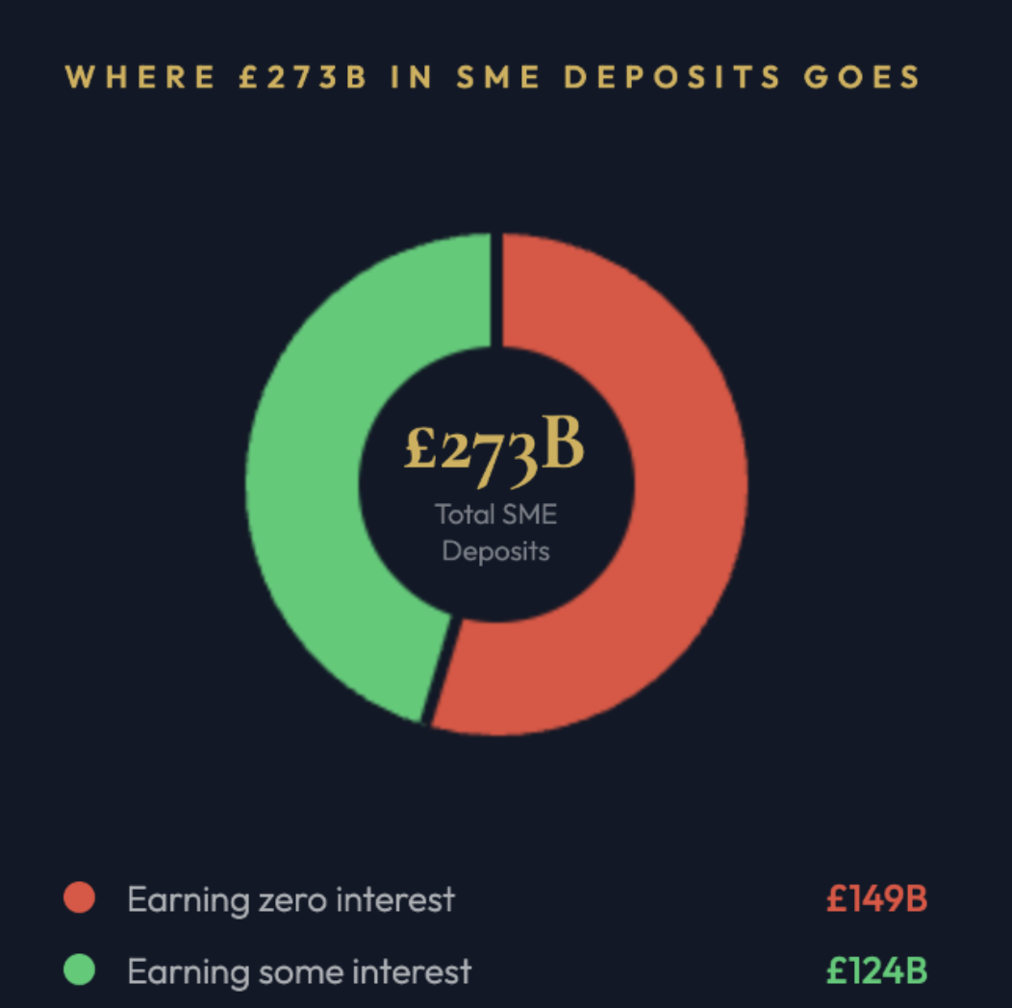
Value is created for our clients by analysing an organisation’s financial situation and improving financial returns on surplus cash, strong financial governance and creating long term financial plans to ensure future financial success. The business itself is able to create value through a stable, knowledge driven service model that has the capability to grow through building a strong presence and a great reputation in the industry. By positioning the business in its current way, it is difficult for large organisations to replicate this.
With the number of new businesses growing exponentially, NatWest (2024) states that over 468,000 new businesses were set up in the first half of the year in 2024. This provides a large number of potential clients. With the creation of new businesses, and the lack of financial knowledge of most new business owners, as it is not their strong suit and are focusing on the business itself. With an increase in the number of potential clients and mainstream financial firms focused on large corporate clients, this creates a well-timed entry point for Focussed Financial Consulting.

Strategy for Longevity
For Focused Financial Consulting to be a viable business long term, it must have the ability to continuously create and demonstrate value for clients, this is critical for any business, Pepper & Rogers (2010) attests to this. Anderson & Narus (1998) support the importance of the value that is provided through the time working with the client, and not just at the point of sale, it must be reinforced to maintain a great client relationship. We will achieve this by structuring engagement models in which each client will receive an initial treasury audit, a bespoke investment strategy and an ongoing quarterly review session. This will give us the opportunity to discuss with the client new savings and respond to any changes in market conditions. This will allow us to deepen our relationship with the client and build trust, which Sutton (2025) agrees with. With interest rates ever changing, Focused Financial Consulting will proactively update clients' strategies, ensuring the advice we are providing clients remains relevant. We believe that this is what differentiates us from one off consultancy firms, as we provide ongoing support.
To ensure that Focused Financial Consulting is a successful business over the next 2 years, a road map has been created. Focusing on the two years separately. Years one will focus on establishing credibility in the industry, providing the best quality of services possible to maximise client retention and obtain great client recommendations, Monfort et al (2025) suggest this is key. The primary goal of the first year being to convert the pilot clients into an ongoing retainer relationship. The goal for year one is to secure 12 clients on retainer. To achieve 12 clients, it is essential that we provide quality services with results for our clients. In exchange, we will be recommended by our clients to other businesses.
Year two looks at shifting focus to scaling the business. With a base of 12 clients on retainer from the first year, it is now time to grow as a company. We will aim to introduce a tiered pricing structure that reflects the depth of ongoing engagement. This will allow us to secure larger clients and provide a more premium service level. After collecting data from year one, our marketing will be more targeted based on the client profiles that generated the strongest outcomes and highest retention. The aim of year two is to double the number of clients, aiming to get to around 24 clients on retainer.
It’s important that we react to any changes that involve internal and external factors in a proactive way and respond accordingly, Neck et al (2020) support this. Potential threats over the next two years that put this plan at risk are the regulatory changes. All financial services in the UK must be authorised by the Financial Conduct Authority (FCA). We are not yet FCA registered but are in the process. It takes between 3 and 6 months.
With the FCA constantly updating their regulations, FCA (2026), it is important that focused financial consulting complies with these changes. In addition, any expansion of regulated activity would require appropriate authorisation.
There are several political factors that affect small businesses, Gupta (2021) supports this. With governmental decisions and regulations constantly changing, it’s a challenging time to have a small business. Roper et al (2024) state that Brexit was a major struggle for small businesses. Small businesses must remain viable, as this is our main client base. O’Neil (2023) states that it is important that we monitor any large political decision and aim to plan ahead in the event that something similar to Brexit happens again.
Another potential risk we could face is the loss of key clients in the early stages of business due to changes in economic stability and potential social factors. In addition, Amankwah-Amoah & Wang (2019) state that this could lead to the failure of the business. To ensure we mitigate this risk, we will ensure to provide the best services possible for each client, to ensure that no client is unhappy with the service. We will also ensure that we diversify the client base across multiple institutions, and ensure that no single client represents more than 20% of our total income. Yankanich (2025) supports this by stating that having a diversified client base is essential for protecting against economic downturns. You are able to mitigate the impact of economic fluctuations, while one sector may see economic instability, another may see strong growth, thereby providing us with a buffer against potential loss.

Business Model Canvas

Key partners  A team that has the essential financial skills that can be used to provide a great service.  A great customer services teams to deal with any enquires and questions our clients may have and respond accordingly to ensure that they customers are happy and kept up to data.  Financial software designed to securely store and manage data with accuracy, presenting it in a clear and user-friendly way for clients to easily understand (Excel). | Key Activities  Is to generate income for the businesses that we are working for that is greater than they were orgiginally, and to beat the current market conditions.  Treasury audits for small business with surplus cash.  Bespoke cash investment strategy design for long term success.  Ongoing finical advice to react to everchanging finical conditions. | Value Proposition  We are looking to target small business with surplus cash that is sitting in current accounts and earing nothing for business. Businesses are lossing out massively by earing no interest.  We offer an accessible hassle-free solution to improve business finances.  We look to maximise the amount of money that can be made on cash. An audit, looking at the business current finical position, offering a solution, then continually work with the business through any economic changes and help them to navigate it as effective as possible.  This type of expertise has previously only been available to large corporations, we are looking to change this. |  | customer Relationships  To retain customers, we have the option for the customer to be put on retainer, were we works continually with the business to ensure their financial success. This always us to upsell the initial offer we provide. To attain customer, we are focused on getting great customer recommendations and review which intern allows us to provide positive testimonials to potential clients.  We will have a dedicated point of contact for each client to ensure that they feel well looked after and are receiving the services they paid for. This is a top priority for us. | Customer Segments  We are focused on small business and startups.  Looking for businesses with heavy cash flow and surplus cash flow.  Businesses without in houses financial departments.  Owner managed businesses, with lack of finical knowledge.
 | key Resources  The knowledge on the correct finical topics, such as interest rates, politics and policy based finical thinking and long-term finical planning skills. To ensure we provide the client with the correct and relevant information, allowing us to ensure we provide the service we are offering.  Financial software to store client data.  Financial market data subscriptions to get the most up to date information and prediction on what the market might do. |  |  | Channels  Word of mouth and client referrals as we have provided a good service, we hope that clients will recommend us to potential clients.  Social media, we will set up our own social media account across multipe planforms such as, Instagram, X, Facebook, LinkedIn and TikTok to help promote our business and reach a wider audience at a lower cost than trainload paid marketing.
Cost Structure  Paying a team to be able to advise clients on the correct finical advice, maintaining customer relationships, providing a good service.  Paying people to generate surveys and to analyse the data.  Marketing fees, paying a videographer to film content.  Finical software and finical market data subscriptions. |  |  | Revenue Streams  We will be charging the businesses a flat fee for the initial audit and the work that follows. Following on from this, we have the option of the clients paying us a retainer, so we are able to continually work with the business through any economic changes and help them to navigate it as effective. The goal is to have multiple business on retainer, this will be taken monthly for ongoing advisory.

Viability and Finances
The objective with Focused Financial Consulting is to be a low overhead, high profit margin business. We are a knowledge-based consulting business. Beach et al (2011) state that consulting businesses require significantly less upfront investment to launch in comparison to a product based or manufacturing business and can be started with virtually no capital. This allows us to keep overhead low and maintain a high profit margin.
Our current overheads consist of paying our current teams, paying people to generate surveys and to analyse data, marketing fees (videographer) and financial software and financial marketing data subscriptions.
We currently operate without a dedicated office space. However, to enhance our professionalism and provide a suitable environment for meeting clients, we believe securing an office is a crucial step for the business. We are actively searching for an office space, which will add to our overhead substantially, but we feel like it will definitely be worth it. Despite the estimated expense of this costing around £1000 per month, we are confident that this is an investment that will deliver strong long-term value and support the growth of the business.
To ensure financial sustainability for Focused Financial Consulting, it’s essential that we prioritise retainer revenue, Zipursky (2023) agrees with this, stating that it provides predictability to income. The initial pilot phase will generate some initial income, but it’s important that we convert those early clients into ongoing retainer clients. Each successful client on retainer reduces potential financial worries and improves predictable cash flow.
To ensure that we are pricing our services correctly, Dublino (2026) recommends carrying out market research, comparing other companies conducting similar services. It was difficult to find a business providing the exact service we are providing. JCWT Consulting charges £399 plus VAT for their start-up success packages. Woods (2024) suggests that a one off finical plan can cost between £1000 and £3000, depending on the complexity of the situation. After reviewing market pricing, focused financial consulting will charge £1500 for the initial audit and the accompanying advisory service. This will be followed by an ongoing retainer of £350 per month. We believe that this pricing structure is fair and represents excellent value for the quality of service we are providing.
The image below represents projected revenue and profit for Focused Financial Consulting over the next 5 years. With estimated revenue of around £500,000 and £300,000 in profit, this will be a steady rate of growth that we hope to achieve over the next 5 years.
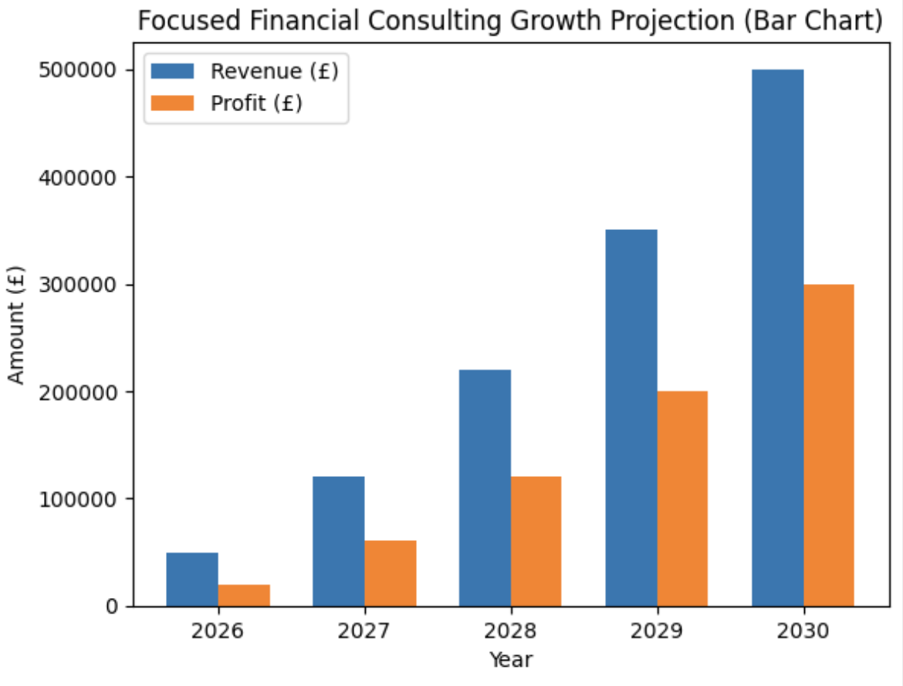

Implementation and learning loop
At Focused Financial Consulting, we take our approach in the same way we approach out client's investments. We believe that decisions should be backed by evidence. For the first six months of business, we will be operating in a structured pilot phase. Bogenschultz (2025) suggest that the pilot phase is useful for gathering data, identifying and mitigating risks and optimising processes. Aiming to take on a small group of around five SME clients at a reduced rate in exchange for detailed feedback, Bryant (2022). We will create surveys for our clients to complete, which will allow us to collect data on our service. This will allow us to continuously refine our systems and, in the long run, provide a better service for our clients. We will be looking at what went well, what didn't go so well, and why. We will then aim to improve this for our next client. This will be a constant ongoing process that we will do with every client.
We will be measuring the outcomes for each client. These include yield improvement achieved or surplus cash, client’s satisfaction scores, and the time it took from the initial audit to implementing the strategy. The data that is collected will be used as proof of concept and a basis for refining the service and improving any areas of potential weakness.
When the pilot is concluded, an in depth review will be carried out. Points where friction was created on the client's end will be assessed, whether it was accurate, and whether we provided enough value for the cost. Champagne (2025) believes that feedback loops are great to implement. Feedback loops will be formalised through client surveys and comparing client financial outcomes to those of industry averages, in order to obtain as much data as possible to ensure what we are doing is correct, and we are able to use client testimonials to obtain future clients.
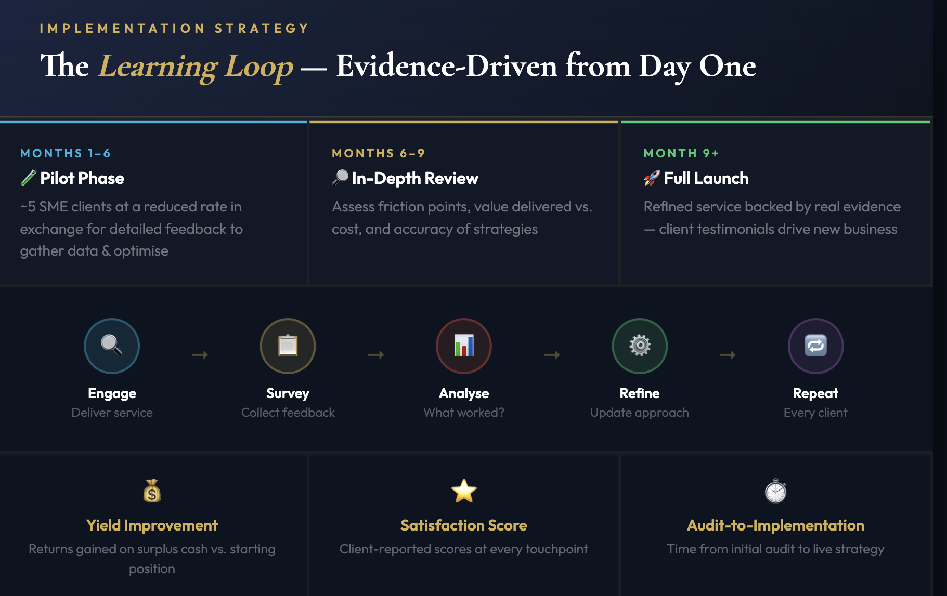

Conclusion
Focused Financial Consulting aims to address underserved market needs. With low cost, evidence-based service model and a strong retention strategy, the business is viable with the ability to scale long term. With the correct execution, by looking to prioritise client relationships and execute on client feedback, Focused Financial Consulting has the opportunity to fill a gap in the market and succeed as a company.

‌
‌Reference List
Allica Bank, (2023). The Great British Savings Squeeze A report into the state of the SME business savings market. Available at: https://www.allica.bank/hubfs/pdf/Allica_Bank-Great_British_Savings_Squeeze.pdf.

Amankwah-Amoah, J. and Wang, X. (2019). Opening Editorial: Contemporary Business Risks: An Overview and New Research Agenda. Journal of Business Research, [online] 97, pp.208–211. doi:https://doi.org/10.1016/j.jbusres.2019.01.036.

Anderson, J. and Narus, J. (1998). Business Marketing: Understand What Customers Value.Harvard Business Review. Available at: https://hbr.org/1998/11/business-marketing-understand-what-customers-value.
Beach, J, Beach ,J. Hanks, C. and Beasley, D. (2011). School for Startups: The Breakthrough Course for Guaranteeing Small Business Success in 90 Days or Less. McGraw Hill Professional.

Bogenshultz, F. (2025). Understanding Pilot Projects: Types and Implementation. [online] Available at: https://www.wayra.de/blog/understanding-pilot-projects-types-and-implementation.

Bryant, A. (2022). The Significance Of Pilots In A Rapidly Changing Business World. Forbes. Available at: https://www.forbes.com/councils/forbestechcouncil/2022/06/08/the-significance-of-pilots-in-a-rapidly-changing-business-world/.

Champagne, J. (2025). The Business Analyst’s Career Master Plan. Packt Publishing.

Dublino, J. (2026). How to Set a Price for Your Service. Business.com. Available at: https://www.business.com/articles/set-price-services

FCA. (2026). FCA confirms new incident and third party rules to bolster resilience. [online] Available at: https://www.fca.org.uk/news/news-stories/fca-confirms-new-incident-and-third-party-rules-bolster-resilience.

JCWT Consulting (2026). JCWT Consulting. [online] JCWT Consulting. Available at: https://jcwtconsulting.com/business-services
Monfort, A., López-Vázquez, B. and Sebastián-Morillas, A. (2025). Building Trust in Sustainable Brands: Revisiting Perceived Value, Satisfaction, Customer Service, and Brand Image. Sustainable Technology and Entrepreneurship, 4(3), p.100105. doi:https://doi.org/10.1016/j.stae.2025.100105.

Natwest.com. (2024). Record number of UK companies launched in first half of 2024 | NatWest Business. Available at: https://www.natwest.com/business/insights/business-management/business-strategy/record-number-of-uk-companies-launched-in-first-half-of-2024.html.

Neck, C.P., Houghton, J.D. and Murray, E.L. (2020). Managment. SAGE Publications.

O’Neill, J. (2023). What is political monitoring? ] Available at: https://dehavilland.co.uk/2023/09/27/what-is-political-monitoring/

Peppers, D. and Rogers, M. (2010). Managing Customer Relationships. John Wiley & Sons.

Roper,S. Belt,V. Hart, M. (2024). Growing pains: How to help small businesses scale | News | Warwick Business School. [online] Warwick Business School. Available at: https://www.wbs.ac.uk/news/help-small-businesses-scale/.

Sutton, R. (2025). Clients Retention Cycle. Epubli.

Woods, K. (2024). How much does a financial adviser cost? [online] Available at: https://www.lucentfinancialplanning.co.uk/blog/how-much-does-a-financial-adviser-cost

Yankanich, T. (2025). 6 Reasons Why Customer Diversification is Important. [online] Kreischer Miller. Available at: https://www.kmco.com/insights/6-reasons-why-customer-diversification-is-important/.

Zipursky, M. (2025). Consulting Retainer Guide in 2025: From One-Off Projects To Recurring Revenue | Consulting Success®. Available at: https://www.consultingsuccess.com/consulting-retainer.
‌

