University of Wales Trinity Saint David
School of Engineering

Engine Performance Characteristics
Vehicle Technology (M4X00394)

Iwan Williams
1901752
07/01/2020

Contents
1. Introduction ii
2. Experimental Procedure iii
3. Results and observations iii
4. Research vii
5. Conclusion vii
6. Evaluation viii
7. References viii

Introduction
This report is about the observation of the performance characteristics of an engine. The aims of this report is to successfully conduct an experiment in order to record raw data on the performance of the engine, to calculate more engine performance statistics based off the raw data from this experiment and to identify and evaluate the trends and characteristics in the performance of the engine shown by the overall results.

Experimental Procedure
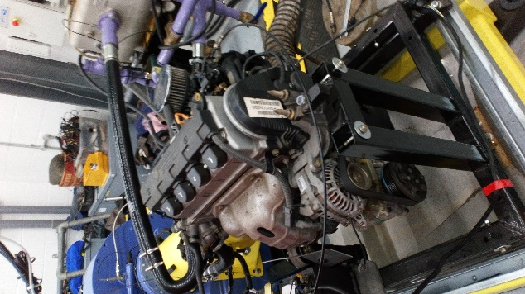
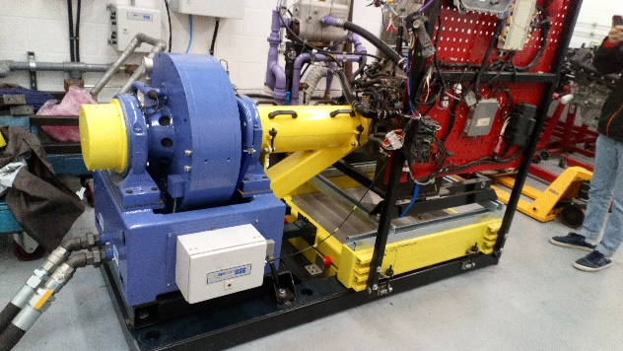
In order to observe the performance characteristics of an engine, it would be essential for an engine to be connected to a dynamometer to collect the raw data required. Once the engine is connected, it can be started and controlled from a computer linked up to the dyno. With all the relevant apparatus set up correctly, the engine dynamometer test can begin.
Figures 1 and 2:
Shows the dynamometer used and the engine attached to the dyno

The test involves setting a 100% throttle opening on the engine and then running it on the dyno from an idle speed up to a much higher (but not too high) speed. Running the engine from 1000rpm up to about 5500rpm should produce a suitable range of results. As the engine is ran on the dyno, the computer linked up to the dyno records the engine speed as well as some other useful data required for many of the relevant calculations.

Results and observations
These were the results that were obtained following the experiment:
Figure 3:
Results table
The results for the load, engine/dyno speed, fuel flow and lambda were recorded using the dyno during the experiment, as well as the figures for pressure (1027.86 mBar), humidity (31.38%) and room temperature (25˚C). All the remaining results obtained were mostly calculated from the recorded data (along with some other figures which were researched externally) using the appropriate equations. Initial observations from the data produced by the dyno are that the fuel flow rate increases with the engine speed, where the lowest speed requires the least fuel and the highest requires the most. The load however increases with engine speed up to about 3500rpm at which speed the load begins to decrease with engine speed. The lambda values meanwhile decreased with engine speed up until 4800rpm at which point the values began to increase again.
After entering the raw test data into a spreadsheet, the varied figures for the torque, power, BMEP, SFC and overall thermal efficiency of the engine could be calculated. Using a spreadsheet can be very useful for equations such as =A3*0.65 (to calculate torque) make it a lot quicker and easier to calculate the figures as all of the calculations (using equations like this) down the table can be done at once. The first figures to be calculated were that of the torque. After using the equation and generating a set of results, the torque could be easily compared with the engine speed by creating a graph, such as this one:
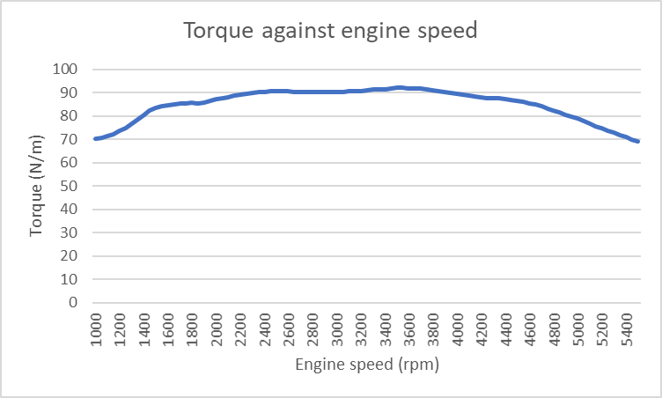
Figure 4:
Graph comparing torque output with engine speed
The graph clearly shows that the torque begins to increase with the engine speed at first, but then starts to decrease at around the 3400rpm mark until the torque produced at the highest rpm on the dyno was similar to that of the torque produced at idle speed.
After calculating the torque, the engine power can be calculated using the figures calculated for torque. The data for power can also be represented in a graph against the engine speed.
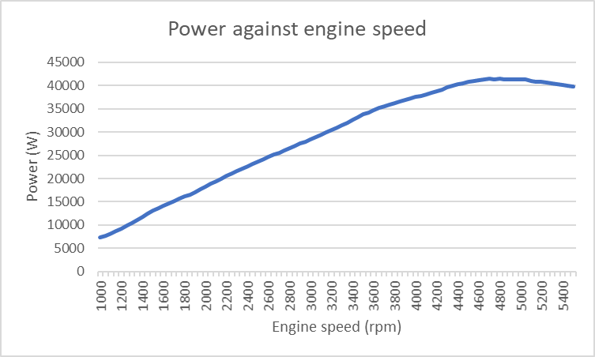
Figure 5:
Graph comparing power output with engine speed
As the graph shows, the power increases progressively up to about 4800rpm (in contrast to lambda which decreased up until this point) before decreasing with engine speed leading up to 5500rpm. As theses graphs show, there are few similarities between the trends shown by the power and torque against engine speed. One similarity however would be that neither show a consistent increase/decrease from idle to full speed, with the power/torque increasing up to a point before decreasing again. The reason for the decrease in power and torque at high engine speeds could be due to the decrease in load on the dyno after 3500rpm. A decrease in power after 4800rpm may also be due to the lambda values starting to increase after this engine speed is reached.
With the results for both power and torque recorded, one of the next sets of results to obtain was the S.F.C. Once this has been calculated, a graph can also be produced to show the results of S.F.C in order to compare it to the power and torque produced.
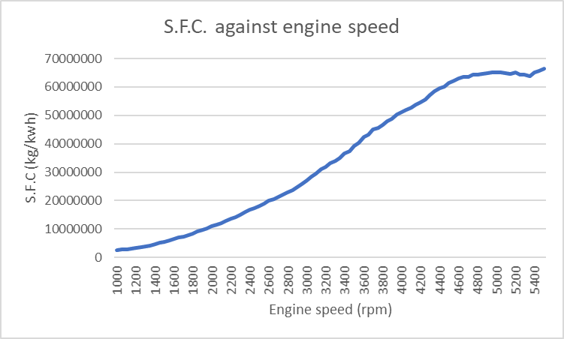
Figure 6:
Graph comparing S.F.C with engine speed
The results for S.F.C show a rather different pattern compared to the engine torque and a more similar (but still different) trend to that of the power when placed on the graph. It shows a (roughly) consistent increase in S.F.C with engine speed, with the highest figure being recorded at the highest rpm. The slope of the curve on the graph does however decrease significantly towards the higher engine speeds, likely due to a decrease in power over 4800rpm. On the graph, the S.F.C appears to begin to decrease at about 4800rpm-5000rpm but then rises again after 5200rpm, which could suggest the presence of some anomalous results at the highest engine speeds. I also recorded data for the B.M.E.P and overall thermal efficiency of the engine, which appeared to follow similar trends to that of the power and torque.

Research
Before making all the necessary calculations needed to obtain all the results for the experiment, Some of the figures required for these calculations were not provided and were therefore obtained externally. For instance, the calorific value of petrol as well as the specific gravity value of it were both required. After conducting research into the petrol used, the calorific value was found to be 43 Mj/kg (Stopford Energy & Environment, 2018) and the specific gravity value was recorded as 0.739 (Engineering ToolBox, 2003). Another figure required for equations was the radius of the torque arm on the dynamometer. This turned out to be 0.65m (Shenck, 2001). The bore and stroke of the engine were also required for calculations, these were found as 81.0mmx77.4mm (Honda Motor Co., 1990).
With these figures recorded, the next thing to find was the peak power and torque figures for the engine. These were found to be 160hp (119.312kw) at 7600rpm and 150N/m at 7000rpm respectively (Wikimotors, 2018). Obtaining these figures allows the comparison between peak power and torque outputs recorded with the peak outputs of the engine itself. The peak engine power and torque figures are noticeably higher than the maximum outputs achieved (92.13N/m of torque and 41.45Kw of power). This however could be due to the amount of load on the dyno and/or the fact that the peak outputs are at higher engine speeds than achieved in the test. The condition of the engine used could also be a reason as to why the outputs are noticeably lower.

Conclusion
In conclusion, the results of the experiment show that although both power and torque increase with engine speed, neither produce the highest outputs at the highest speeds. The torque follows a similar trend to the load on the dyno against the engine speed, with both the load and the torque beginning to decrease after 3500rpm. The power on the other hand shows a similar but contrasting pattern to the lambda values recorded, as one decreases when the other is increasing (with each switching directions at roughly 4800rpm). It is also likely that the S.F.C of the engine is influenced by the power output, as both show similar trends on the graph, only with the S.F.C continuing to increase at a shallower gradient after 4800rpm whereas the power begins to decrease.

Evaluation
Overall, I am satisfied with the way I have handled the experiment, recorded and calculated the results I required and compared/contrasted my results with each other. However, I feel that both my performance and the experiment could be improved. As for my personal performance, I could have spent more time on researching some of the values required so that I could get a more accurate representation of these values, therefore leading to more accurate calculations. I also think the experiment could be improved by taking more time and repeating the experiment so that a more accurate average of the raw data obtained could be calculated for better results.

References
- Stopford Energy & Environment (2018) Examining the Variability in the Carbon Factor of Petrol for Road Use. Available at: https://uk-air.defra.gov.uk/assets/documents/reports/cat07/1811161339_Carbon_Factors_Petrol_Final_report.pdf (Accessed 7th January 2020)
- Wikimotors (2018) Honda B16A engine (B16B). Available at: http://mywikimotors.com/honda-b16a-b16b/ (Accessed 7th January 2020)
- Engineering ToolBox (2003) Liquids - Specific Gravities. Available at: https://www.engineeringtoolbox.com/specific-gravity-liquids-d_336.html (Accessed 14th January 2020)
- Honda Motor Co. (1990) Shop Manual Honda Civic coupe CRX. Service publication office
- Shenck (2001) Technical Specification Eddy-Current Dynamometer W Series. D-64293 Darmstadt

