
APPENDIX GA36d

LEVEL 7 ASSESSMENT SPECIFICATION

Student name: | Lars Jandt | Student ID number: | 2124399
Programme: | DBA
Module: | Visions for the Future – Theoretical Perspectives on Management
Module code: | HKBM7006 | Contribution to Overall Module Assessment (%): | 100%
Lecturer: | Prof Eddie Yu (PhD) | Internal Verifier:
Assignment Title: | Germany’s staggered pandemic strategy on containing the coronavirus: An analysis utilizing the 3h framework | Word count (or equivalent): | 7,636 words
Submission deadline: | 15 August 2022 | Return date of provisional marks & written feedback: | 19 September 2022
Submission method:
Academic honesty / referencing:

Lars Jandt
Prof Eddie Yu
HKBM7006
12th of August 2022

Germany’s staggered pandemic strategy on containing the coronavirus:

An analysis utilizing the 3H framework
Lars Jandt
Introduction, Background and Contextual Factors
In Germany, in the state of Bavaria, the first local case of the coronavirus was identified on the 27th of January 2020. In a corresponding press release from the health section of the state ministry it was stated that a male employee from Starnberg got infected with the new coronavirus. This marked the beginning of the pandemic in Germany. The patient was accordingly directly isolated and monitored, surveyed by key medical teams under a newly created governmental taskforce “infectiology”. Close contact persons were consequently informed and briefed about potential symptoms, required hygiene concepts and the virus’s means of transmission. The state of Bavaria further stated that: “the risk for the general population in Bavaria, to get infected with the newly discovered coronavirus is limited” (STMGP, 2020).
The discovered first identified infection occurred at the premises of Webasto, an automobile parts supplier in Stockdorf, who operates various subsidies in Wuhan, China, and actively engaged in business travel in between the plants. According to the company’s CEO Holger Engelmann subsequent cases have been detected a day later and immediate remediation actions were implemented: “We have currently notice of three further employees who tested positive and at the moment we are investigating the colleagues who were in contact with them," (Webasto Group, 2020). The company further took first response actions internally which comprised the temporary closure of the site in Germany, the starting of systematic testing of employees and travel suspension for 2 weeks. Consequently, the German authorities were instantaneously informed and acted alongside with the company; doctors from the public health department were put on stand-bye.

A devastating pandemic, such as the Covid-19 situation, puts not only pressure on a government’s leadership and its skills but also health systems and the larger society alike. This research paper focuses on the senior leadership in the German government and how a staggered approach was utilized to fight the pandemic and contain its outcome. The paper attempts to not only analyse the effectiveness of the German governments’ strategy but also its acceptance within the society and “buy-in” of the population.

Certain key constraints, as well as success and failure factors, of Germany’s strategy will be examined. The corresponding research method to be applied will be the 3H framework (Yu, 2020). Specifically, the holistic inevitability of three domains (head, heart, and hand) will be the guiding parameters for the research to describe identified lack in action and alleged shortfalls of the government. This paper aims to later conclude unbiased that an ubiquitous application of all 3H components, for achieving corresponding containment outcomes, would have resulted in a more favourable result of the overarching German pandemic strategy. The paper will first focus on Germany’s immediate response strategy in early 2020 and further evaluate in phases the staggered approach, and its lack of holistically applying the 3H, until the second quarter of 2022.

Germany’s first response strategy trying to contain the virus
On the 27th of January the German Health Minister – Jens Spahn stated: “We have expected that the virus ultimately will also reach Germany. The case in Bavaria however shows, that we are well prepared. The general danger arising out of the respiratory disease from China for the German population’s health remains, according to the current evaluation of the RKI (Robert Koch Institute), low” (Federal Ministry of Health, 2020).

At the very early phase of the pandemic in January 2020 neither vaccinations nor a clear picture of the etiopathology was available to the government’s portfolio of potential actions, therefore often resulting in rushed uncoordinated actions being taken by various states and governing bodies. According to the WHO – SARS, in the years 2002/2003, only caused 9 infections in Germany with no recorded deaths, whereas Covid-19 caused, from the 3rd of January 2020 to the 21st of June 2022 already 140,358 deaths with further cases spiralling up in June and July 2022 adding to the count. There have been further 27,334,993 confirmed Covid-19 positive cases in Germany despite a total of 179,952,194 vaccine doses administered (WHO, 2022).

This paper aims to analyse and investigate, in the research method analytics section, if the overarching case load in Germany could have been contained at lower levels with a more unified leadership approach. Key strategic management and leadership actions will be analysed and their respective effectiveness in the following paragraphs.
Germany’s staggered approach
Germany over generations was well prepared in managing pandemics with special isolation wards being readily available to instantly treat patients, e.g., with Ebola. The German cabinet, as well as the chief virologist of Berlin’s Charite University Hospital were therefore at the beginning of 2020 optimistic to contain the virus without assuming a larger further spreading throughout the population. Chief Physician Wendter stated: "If you had told me then that we would treat more than 5,000 corona patients in our hospital network over the next two years, I would have said you were crazy” (Der Spiegel International, 2022). Germany’ officials therefore didn’t expect that the virus will hit the country hard as the baseline conditions were given. Chancellor Merkel and her cabinet remained rather quiet and in a holding pattern over the first weeks of the pandemic analysing the situation through various expert groups rather than immediately going into a full lock-down as seen in Wuhan, China.

Two and a half years into the pandemic the German staggered strategy didn’t proof to play out as anticipated.

A) Hesitating decision making from central government bodies vs. a federal state-system,
B) Irresolute communication strategies to actively reach the most vulnerable population group
and winning them for vaccination drives,
C) Planning and Strategizing an ubiquitously thought through deployment strategy over the entire
country putting the safety and health of the population first rather than harmonizing actions
with multiple parties, institutions, and expert groups with contradicting views and
D) an undetermined execution with uncoordinated activities and actions led to more than 140k
deaths.

The Chronology of a Staggered Approach
The chronology will describe shortfalls being made supporting the verdict that Germany could have done better managing the pandemic. Germany, by chance at the beginning, decided on a rather uncoordinated phased random approach with various cautious state-wide and nationwide lockdowns, followed by eased and desultory “lock-down-light” initiatives and infection rate linked corona tightening measures. An often, by the general population, perceived “back and forth strategy” led, over the course of the pandemic, to ultimately lower acceptance rates of the measures imposed by the government. Even though 70% of all Germans have received a primary vaccination in early 2022 the omicron wave causes an eightfold spike of infections in the first quarter of 2022, which can be seen in Figure 1.
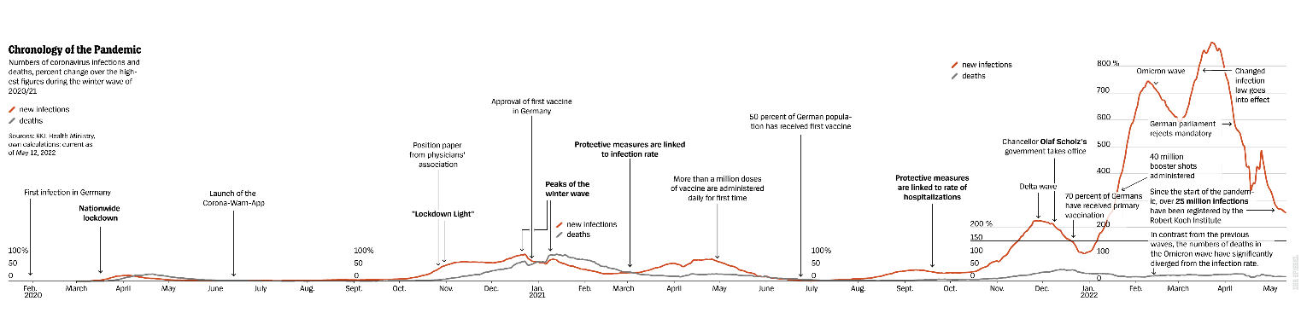
Figure 1: Chronology of the Pandemic – Numbers of coronavirus infections and deaths, percent change over the highest figures during the winter wave of 2020/2021. Sources: (Robert Koch Institute - RKI, German Health Ministry, 2022)

Germany followed a liberal lock-down, opening, light-lock-down, full lockdown approach strategy, which was for the public difficult to understand as different measures were applied at different times and regions. Continuous new regulations since early 2020, overworked administration bodies, short-staffed health and medical offices caused a regulatory and enforcement clutter. According to current Corona regulations in the State of Berlin: If a recovered corona infected person from Berlin travels by train to Munich he would arrive as a non-vaccinated traveller not being allowed to enter a restaurant in a different state as in Munich different vaccination rules apply. Another example states that if a person got vaccinated twice with Johnson & Johnson and receives a booster vaccination the corresponding booster vaccination would be counted as invalid. Another regulation reads that only those persons who have tested positive after a rapid test, self-test or pooling test using nucleic acid detection are now entitled to a free PCR test. PCR follow-up testing is offered in numerous pharmacies in Berlin as well as in other places (Governing Mayor of Berlin, 2022).

The German problem lies in its federalism. 16 states made a larger problem visible, a unified central German government strategy was difficult getting rolled out, as each of the 16 states is differently construing the respective legislations, often being governed by opposite and contrary political parties. Driven by multilateral party conflicts, in different states, opposition parties often challenged the current governing body. Ursula Muench, political scientist said: “The federal state system proofed to be efficient in the past, but the central government body could work more efficiently as the empowerment and actionability of the Republic of Germany was indeed not to convincing in the pandemic” (BNN, 2021).

As visible in Figure 1 Germany went through the first phase of the pandemic relatively well with few deaths. In April 2020 most of the German government bodies assumed that the situation eased and was fully under control. As one example, Melanie Brinkmann from the Helmholtz Centre for Infection Research in Braunschweig stated: “We managed it well and it didn’t end in a disaster” (Helmholtz, 2020).

The German Government made complacent major mistakes in autumn 2020, before the winter spike, as it was not stringent enough in its conducted lockdown measures applying only light-lockdowns, curfews and non-ubiquitous measures as event closures, public appearances cancellations, school-closures, fitness centre closures not being harmonized across the republic. This uncoordinated strategy ultimately resulted in a further severe spike of cases and deaths in the winter of 2020.

The pandemic caseload only eased in the summer of 2021. Similar oversights however have been made again in the winter of 2021 when Delta hit Germany. Ultimately a new German Government was elected and became active, and Merkel’s party’s (Christian Democratic Union) area ended in the voting out of office. Even though a new health minister was elected to office in late 2021, up to June 2022 manifold lock-down and corona measures did not proof to be as effective as desired to fully containing the situation.

Figure 2 shows that the active 28 days caseload remains high with 1,870 related deaths in Germany and more than 1.5million active cases in the last month of June 2022.
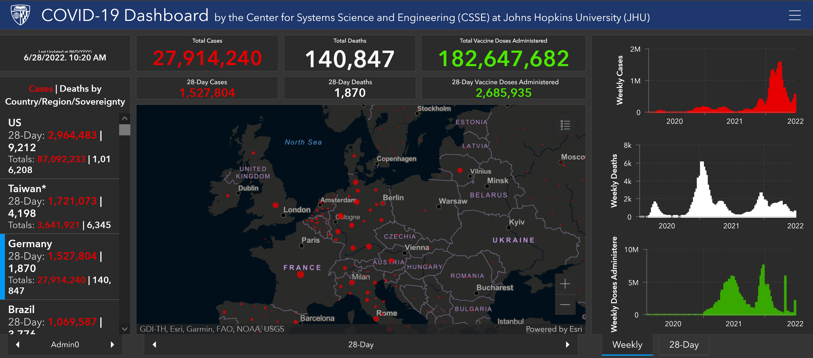
Figure 2: Covid 19 Dashboard June 2022. Source: (Johns Hopkins University (JHU), Centre for Systems Science and Engineering, 2022)

Germany’s Government Leaders Management
Phase 1 – The early stages 2020: As laid out Germany, like many other European countries, achieved in mid-2020 a low incidence rate after going through major struggles but failed to maintain its strategy in the long run. Various waves were accompanied by uncoordinated central government measures. Chancellor Merkel addressed the citizens of Germany in a speech as one of the first leadership messages only in early March 2020. "It is serious. Since German reunification, no, since the Second World War, there has not been a challenge to our country that depends so much on our joint solidarity," the Chancellor emphasized (Deutschland.de, 2020). At the first phase of the pandemic in early 2020 various opposed contrary statements were made without clear actions as the Chancellor three weeks later counter-stated at the end of March that “On Tuesday after Easter, the situation will be reassessed to decide on how to proceed. The benchmark will be the assessment of the Robert Koch Institute and the epidemiologists” (The Federal Chancellor, 2020). Valuable time was lost in this phase 1.

Table 1 gives a first overview on immediately launched “fire-fighting activities” at the early stage of the pandemic addressing a wide range of measures:

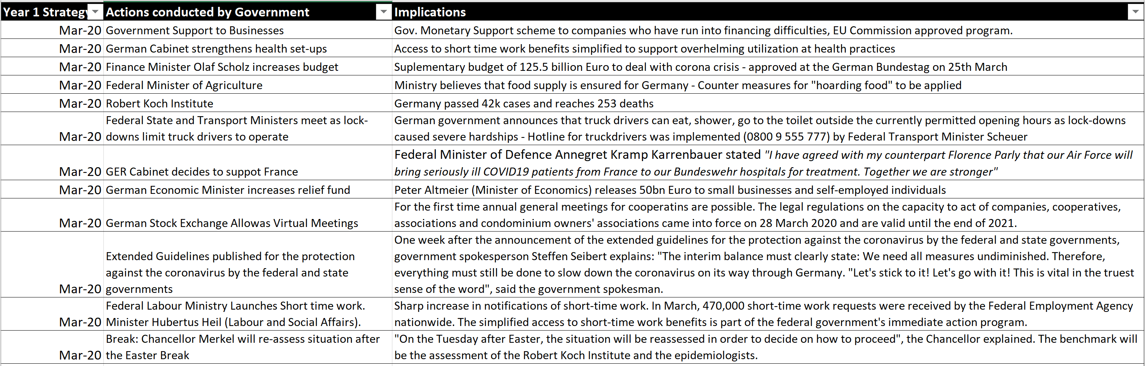
Table 1: Variety of Wide Instant Measures Launched by the German Government.
Sources: Self-created table with utilized information sources from a) The Federal Ministry for Labour and Social Affairs, b) The Federal Ministry for Economic Affairs and Climate Action, c) The Federal Ministry for Digital and Transport, d) Germany Chancellery,

Phase 2 – The winter spike October 2020 to May/June 2021
The summer of 2020 was not utilized well, and valuable time was lost, due to negligence of a perceived safety by low Covid case numbers, to prepare for the first bigger wave in winter 2020. The government did not hit hard, instantaneously and with a clear aligned strategy. Major shutdowns were delayed by 3 weeks in late summer and autumn and the government experimented with lock-down light scenarios. These delays ultimately resulted in more than 50,000 deaths in phase 2.
The government caused the winter spike 2020/2021 as it took the cabinet’s decision maker more than 2 months to realize that the winter spike-wave couldn’t be neither controlled nor contained. Mistakes were being made by not taking full responsibility for measures as larger groups of scientists and institutes had calculated scenarios and modelled predicted outcomes by providing expected infection and death scenario modelling numbers accordingly.

On the 14th of October 2020the well-known Michael Meyer-Herman from the Helmholtz Centre for Infection Research presented to the chancellor Angela Merkel his scenario calculations (a – imposing a strict and direct full lock-down, b - a time-lagged delayed lock-down would be considered and c – only light contact restrictions would be applied) and corresponding impact on Germany. No action was taken by the Government for another 2 weeks. Meyer-Herman (2020) stated “Germany would have had a good chance of fully preventing the second wave, when the government would have reacted earlier”.

The German Cabinet around Chancellor Merkel was not convinced that lockdowns are the only alternative. On the 28th of October, the day Chancellor Merkel announced few measures, Germany's National Association of Statutory Health Insurance Physicians presented a strategy paper arguing against a lockdown. The associations head Gassen stated (2020): "We cannot put the entire country, or even a continent, into an induced coma for weeks or months”. The ultimate increase in the winter spike cases 2020/2021 can be seen in figure 1 and 2. From October 2020 until June 2021 ultimately 80,000 people died in Germany by the coronavirus, alone in the December Christmas week more than 5800 people died.

Phase 3 – The staggered relaxation, recovery mode in summer June 2021 to November 2021
Over the course of the summer 2021 case numbers significantly dropped and more than 50% of the population got vaccinated. New infections and death levels were significantly lower and restriction measures in certain states were only linked to communal rates of hospitalization ratios. Until November it was perceived that the pandemic is under control before, in phase 4, the delta variant hit in Dec. 2021 and Omicron in March 2022 with further mutations in April and June 2022.

Phase 4 – The underestimated omicron wave = Factor 8 case-load Nov 2021 to April 2022:
In contrast to previous waves the death count of the omicron variant significantly diverged from the infection rates. Here specifically depending to the fact that more than 70% of the German population was vaccinated by January 2022. Further, February 2022 already 40mio “booster shots” were administered reducing the fatality rate of the virus further.
The ongoing high case load put an immense pressure on testing capacities, general practitioners, and employers alike as self-isolation and (home) quarantine requirements stayed in place with an ongoing “patchwork-quilt” of regulations over Germany. Germany’s changed infection law came only into place in late March 2022 despite consistently high, in certain jurisdictions even rising, infection numbers.

The German government further significantly eased COVID-19 protection measures on the 19th of March 2022. With this change, and implementation, specific regulations of Germany’s former Infection Protection Actare expiring. As described in the earlier chapter, due to the federalism of Germany, the respective states do need to either adopt or adjust the infection law, which caused non-harmonized regulations. This resulted in the situation that the obligation of all 16 individually governed federal states to conduct 3G screenings only applied to restaurants, hotels, public places, and beauty services (e.g., hairdressing, nail saloons). For all other businesses, which are not open to public major containment regulations no longer apply. From 3rd of April 2022, all 3G regulations are dropped allowing free movement without identification of testing, vaccination or recovery status.

Phase 5 – Desired Containment – Summer 2022
It is not expected that a full containment with above relaxation strategy will take place in the summer of 2022. The previous 2 summers in 2020 and 2021 were rather virus-free, with eased measures and reduced regulations. It can be anticipated that the current wave will see higher infection rates. Eckerle (2022), a virologist from the Geneva centre of Emerging Viral diseases states “I don’t think we will have another largely virus-free window this summer like the last 2 as Omicron is simply too good at infecting people”. As currently the German Government does not impose lockdowns nor larger corona related containment measures anymore it can be assumed that new variants and sub-variants will hit Germany again in late 2022 as also a decline in vaccination efficiency and protection durability is expected in the coming months. If the German Government wants to ultimately contain it is crucial to learn from earlier mistakes and utilize a holistic model of various domains to achieve positive results. This paper in the following paragraph, utilizing the 3H holistic management framework, strategizes and analyses accordingly and discusses respective findings.

Introducing Professor Eddie Yu’s 3H holistic management framework
What is the 3H holistic management framework?
According to Yu (2019), “a good management is an art and science of applying 3H framework to holistically manage people and organization effectively and efficiently.” Describing the conducted German government initiatives to fight the Coronavirus the framework can be used accordingly to analyse the Covid-19 response-management shortfalls being made by the German Government and correspondingly utilizing the framework beyond corporations or industry bodies to utilize its full performance analytics. Prof Yu (2021) describes the framework as, “the 3H framework is newly developed for managing imperative people and organizational/national issues holistically”.
The 3H framework is therefore applied as a methodology for managing people (in this case the executing bodies (hand) of the governmental healthcare organizations) and organizational issues (in this case enforcing and rolling out a staggered COVID strategy) in a holistic way to ensure that individual performance, and in turn the entire organizational (in this case the countries) performance, can be efficiently and effectively managed. As stated, in this paper “organizational performance” will be understood as the “governments and key stakeholders’ performance” during the pandemic. The framework of Prof. Yu currently uses the synonymous descriptions of “HEART”, “HEAD” and “HAND” to describe the key criteria-dimensions of people, organization, and competence, respectively.

Prof. Yu’s 3H holistic management defined and what is the 3H framework used for?
Holistically applying the 3H model means that a rounded solution is required to manage people and organizational issues. Other than applying the focus on transformational leadership as for instance Bass (1995; 2010) or focusing majorly on strategy and planning scenarios such as Senge (2003) and Mintzberg (1994) Yu (2019, 2021) integrated all 3 domains into a holistic model comprising of Heart, Head and the competence level utilized by Barney (2001). All dimensions do have to be aligned and need to be efficiently as well as effectively integrated and utmost coordinated to achieve the best possible outcomes.

The conceptual 3H framework
3H suggests that it is one of the most efficient ways to manage not only a corporates or individual’s issues holistically but can also be applied to governmental set ups. In this paper, instead of separating the domains, a holistic approach will be used to analyse the German government by the following formula (Yu, 1997) - An adaptation and transfer from organizational performance (OP) to Government Performance (GP) was applied:

GP = f (H1cH2cH3)

- GP = Government Covid-19 Containment Performance
- C = Complement (to integrate and connect)
- H1 = Heart (leading, motivating, and engaging people ability)
- H2 = Head (strategic, organisational, cognitive ability)
- H3 = Hand (operational/ functional ability, competence).

No country could sustain low Covid cases nor overcome the pandemic by only partially fulfilling the framework. This paper will later in the analysis and discussion section describe on how an integrated execution strategy could have looked like to achieve lower death rates and a higher vaccination rate in Germany in comparison to other developed countries avoiding fatalities and increased economic costs.

The Venn diagram (Figure 3) describes the necessary and sufficient conditions for managing Germany’s pandemic performance effectively and efficiently in a holistic way.

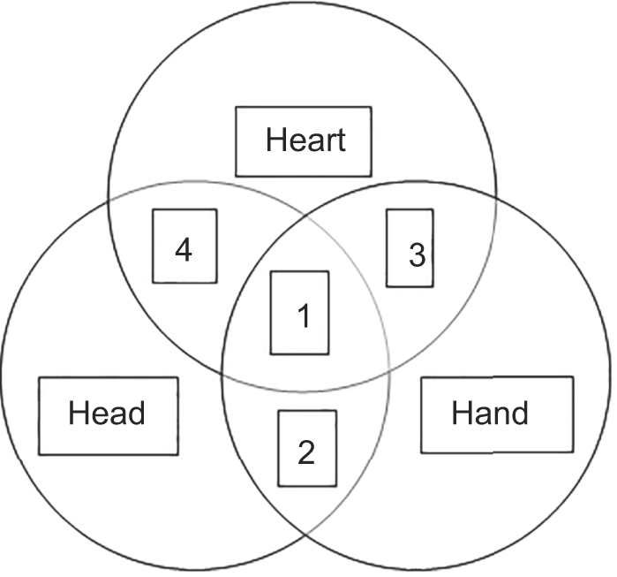
Figure 3: The necessary and sufficient conditions Source: (Yu, 2020).

Four case scenarios are described
Case 4 – Effective Leadership (e.g. by the German Government) (Domain 1 Heart) and a sound strategy (e.g. German Cabinet, Ministry of Health) (Domain 2 Head) are in place but lacking competence and execution parameters from the frontline workers (e.g. Hospital Staff, Vaccination Centers, Eldely Care Home Workers) (Domain 3 Hand).

Case 3 – Effective Leadership (Domain 1 Heart) and Competence and Execution (Domain 3 Hand) are in place but lacking an effective and well-thought through strategy by the head (Domain 2 Hand).

Case 2 – An effective covid pandemic strategy in place (Domain Head) and effective competence and execution (Domain 3 Hand) but missing parameters and a lack in effective motivational leadership from the top of the German Government (Domain 1 Heart).

Case 1 – Holistic Approach: Integration of all 3 domains of Heart, Head and Hand. Applying case 1 will result in all necessary and sufficient parameters for most fruitfully managing throughout the Covid pandemic, most likely achieving the best potential outcomes for Germany.

The corresponding descriptive research method
This paper is based on a descriptive case which utilized reports, press releases, German Government pages, Ministry Pages, Institute Pages (local and internationally allowing triangulation to verify data), journal sources, Government statistics as well as conceptual literature. Data analytics and validation of information and content was the base for interpreting and judging the actions conducted by the German government allowing this descriptive case with a pragmatic rational approach. Conducting government Interviews and first-hand data gathering through questionnaires in Germany was not conducted, due to time and distance constraints, therefore external, highly respected, and verified resources were used. Key management literature was utilized to create the assumptions of this descriptive case and test the statements. (Hypothesis that Germany would have had a chance managing the pandemic throughout the last 2.5 years better). Key focus lies on the government’s / cabinet’s actions as governing organ.

Significance of the issue to society and corresponding research aim and questions
The ultimate effectiveness, of various measures undertaken by the German government, could have been more successful. Research aim is to analyse this hypothesis with an in-depth reflection of the actions undertaken by the government on how efficiently Covid was managed. The guiding research question for this descriptive research paper will be:

Was the staggered (re-) active top-level governments’ actions approach the right way to fight covid to ultimately “tackle” the pandemic in Germany? Could a more integrated approach, utilizing all 3 domains, have helped to bring down active covid and fatality cases?

This paper tries to be utmost objective, utilizing intensively triangulation of sources to confirm above statement belief. In-depth analysis will be done in the discussion session aiming to confirm that the government could have done better. The introductory body gave a first framework of the Covid situation in Germany, creating an understanding about the overarching Covid situation, aiming to be as objective and factual as possible. Investigation and verification of initial assumptions follow in the next chapters.

Related Literature and concepts for the conceptual framework
Over the past decades, there have been assorted publications on strategic crisis management, overarching leadership, and key management concepts. This paper build upon the 3 key components of applying 3H. The upper management, in the paper’s context – the government as the initiating body of Covid measures, whereas the “HAND” domain is rather the managed executing body of the government’s strategy and operations and getting things done through actionable tasks (e.g., hospital nurses, vaccine administering staff, police force bodies, national health centre employees, etc.). The literature review consequently focuses on Holistic Management, Leadership. Efficient execution strategies, strategy translation to action, planning and organising to effective responses, assessment and analysis of situational constraints, implementation strategies as key purpose to define duties, responsibilities for achieving results.

Respective 3H | Field of Expertise | Literature and Relevant Contributors to Theories
Heart | - Transformational Leadership,  - Motivation,  - Emotion,  - Commitment,  - Engagement and Satisfaction,  - Trust,  - Management of Change,  - Values and Organizational  Culture & Behaviour,  - Communication,  - Cross cultural management,  - Understanding of management of  heterogenous stakeholders as  well as ministries, groups, teams | Sirkin, Keenan, Jackson  In recent years, many change management gurus, have forced on soft issues, such as culture, leadership and motivation. Such elements are important,… but managing these aspects alone is not sufficient to implement transformation projects.  (Sirkin, Keenan, Jackson, 2005, p.2).  Burns - Transactional Leadership Characteristics,  Types of Leadership  According to Burns, who introduced in 1978 first the concept of transforming leadership on political leadership, transformational leadership is described as a larger process in which the “leadership and followers (Heart, Head and Hand) help each other for advancing to a higher level of results through holistically combined parameters (morale and motivation).  (Burns, 1978)  Bass  Bass earlier in 1985 focussed in his work on personal leadership traits, attributes, and values of leaders as well as socioemotional talents and interpersonal competencies for achieving results. In the later works he constantly developed leadership also comprising cognitive social psychology and social, political, communications, science.  (Bass, 1985, 2008).  True Transformational Leaders create visions of universal brotherhood.  (Bass and Steidlmeier, 1999).  Christie, Barling and Turner  Pseudo transformational leadership is defined by self-serving leaders, however often highly inspirational and driven. Leaders in this regard do have a perceived heart domain, however often are unwilling to encourage independent thought in sub-ordinates (in this paper’s regard the executing competence body “hand” or healthcare workers). Key when applying is to identify true transformational leaders, pseudo transformational and laissez-faire styles.  (Christie, Barling and Turner 2011)  Kark  Leaders must put the best interest of the group ahead of their own self-interest. Strong ethical values and moral standards are key to be not only perceived as true transformational leader.  (Kark et al. 2003)  Schein  Edgar Schein’s model of organisational culture  is build up on the assumption that over time a countries or companies culture develops. Executing bodies of the government (hand domain, e.g. healthcare workers) as well as employees are over time using basic assumptions to solve intrinsically internal and eternal problems. If positive results are identified the action plans, execution operations are passed on to colleagues or new employees. Often assumed that senior leadership is too detached, and structures self-develop.  (Schein, 2004)
Head | - Strategic Planning, Management Control  - Data Analytics  - Planning Control  - Infrastructure  - Value Chain Analytics  - Institutional Analysis  - Macro Industry Insights  - Strategic Management  - Structure and Organizational  Architecture | Overarching strategic planning should follow a staggered approach, however the Germany Government utilized this approach rather reactive and uncoordinated throughout the last years. The head component of 3H is paramount in the later execution and competence role out of the workforce, healthcare workers. Key is to  - Understand the goals and necessity of a strategic plan with desired and anticipated outcomes (modelling, scenarios)  - Goal Setting and KPI Setting with respective tracking alongside the journey to fight the pandemic  - Assumptions, Deviation Expectations as well as premises need to be considered throughout  - Roadmap of Actions – Issue to Action tracking and strategic analysis through various government bodies and expert networks, advisors as unified strategy to be deployed  - Back-up, alternatives, correction modus to be prepared and value chain analytics required to act on the spot, decide and don’t lose through time-lags, decision vacuum  - Strategic Thinking and Strategic Planning need to be matched ultimately to implement the strategic plan and execute later down the road.  The following theories and relevant contributors were utilized in the analytics section of this paper on how Germany tackled the Coronavirus:  Mintzberg, Strategic Planning  Strategic Planning (e.g. for the German Government) should be about analysis (breaking down an intended outcome/goal into various strategic steps, designing how these steps are then implemented by (e.g. the workforce, healthcare system and executed. In parallel all the respective consequences and anticipated success factors of these steps can be estimated. Here strategically Mintzberg utilized his 5Ps (Plan, Pattern, Position, Perspective and Ploy).  (Mintzberg, 1990, 1994)  Barney  Competitive Advantage Sustainability Test – VRIO  (Valuable, Rare, Inimitable, Organized)  This resource based view focuses on specific resources and highlights that competitive advantage is based on valuable, rare, inimitable resources and organization.  (Barney, 1995, 2003).  Porter  Competitive Strategy and Value Chain, 5 Forces Framework  Porter’s Five Forces Framework can be used to analyse a company’s (competitive) environment. In this paper’s regard it can be used to analyse a country’s competing states in a federal system where different states or government bodies compete about resources, do have different market entrants, suppliers, customers and substitute products which all influence a company’s profitability, or respectively a country’s leadership cabinet. As Porter (1980) stated the strategist (leader) must understand that strategy is “a broad based formula” and comprises many multi-faceted elements.  (Porter, 1979, 1980)  Kaplan and Norton  The Balanced Scorecard to Strategy could be further utilized in the German government for creating a framework to better measure organizational performance (a cabinet’s performance, a health ministry’s performance) using a strategically balanced set of performance measures. Most countries and organizations still use preferred short-term measure of success rather than seeing the overarching holistic and combined end results.  (Kaplan and Norton, 1996, 2001).  Clayton, Christensen and Raynor  Circumstance-contingent theories enable managers to understand what it is about their present situation that has enabled their strategies and tactics to succeed.  (Clayton, Christensen and Raynor, 2003, p.6).
Hand | - Competence,  - Operations  - Execution of Functions (e.g. Finance, HR, IT, and in the paper’s context healthcare officials, nurses, doctors, vaccination center operators, test center operators, hospital chains, healthcare patient management bodies, etc.). | Barney, Competence  Barney states that resource based theory states a simple view that resources need to be connected to a company’s (coutnries’) strategy they aim to pursue. In this paper’s context the strategy needs to be executed by operations and the competence level “in the field” fighting the actual pandemic.  (Barney, 1995, 2001)  Eilstroem, Kock Competence Development in the Workplace.  Competence Development as Key factor behind productivity. It is described that external contextual factors (e.g. increased pandemic demands on society, increased intake on workforce) are necessary but not sufficient conditions for a country. It is required that there is a “good-cliamte” among all competencies and the leadership of a country and a complex interplay between Head and Hand.  (Eilstroem and Kock, 2008)
3H - Integration | Integration and Holistic Management in practice | Yu  A good management is an art and science of getting things done effectively and efficiently through people and other required resources guided by 3H (Yu, 2019).  National Leaders are entrusted with the responsibility of creating the sufficient factor (integration of all 3H domains) to confirm that an effective strategy can be holistically applied throughout. Seamless integration among leadership, strategy and execution is required to create an effective holistic model (Yu, 2021, p.87).  It is essential that top management genuinely commits and supports throughout the entire process of management with effective heart-to-heart communication. Creating an integrated 3-H culture is paramount to support implementation as well as synergistic alignment among 3-H domains (Cheung, Yu, 2020, p.255).

Table2: Individual 3H Domains with conducted literature review and assumed key concepts utilized Source: self-created

Heart, Head and Hand analysis of Germanys staggered approach in containing the pandemic – analysing the identified parameters of the German Government applying the 3H framework

Necessary and Sufficient Factors will be analysed.
1st Heart-oriented leadership analytics motivating the general population, creating emotions, commitment, engagement of a country satisfying the populations’ needs and creating trust in the Government as the utmost necessary factor.

Merkel started with a strong emotional, trust creating leadership message on the 11th of March 2020 in a very rare, televised message addressing Germany’s 84 million population. Merkel, an analytical physicist by profession, never had chosen this way in her 14-year tenure as German Chancellor up to 2020. “Take it seriously” and “it is serious” she stated followed by “I am absolutely sure we will overcome this crisis” but “how many casualties will be there? How many loved ones will we lose?”. Further Merkel added “These are not simply abstract numbers in statistics, but that is a father or grandfather, a mother or grandmother, a partner and we are a community in which every life and every person counts.” (The Washington Post, 2020) (Domain Heart). Merkel was focussing on the heart domain as a leader at the beginning to motivate, commit and engage with the German population realising that the heart-oriented perspective is necessary to address the importance for her government towards people’s lives. However, Merkel lost valuable time in addressing the nation and only approached the general population after immense media pressure over the first 8 weeks in 2020. Germany’s largest tabloid raised several questions in January and February why the Chancellor is not acting and addressing the rising Corona pandemic challenges. Christie, Barling and Turner (2011) found that often this leadership behaviour is recognized as pseudo-transformational leadership with often a clear unwillingness listening or encouraging the competence levels to address their respective independent ideas, thoughts as subordinates. The German Cabinet listened to expert group advise, however did not enact on it in a timely manner neglecting recommendations from operations and competence levels. Research (Kark et al. 2006) has found that idealized influence better occurs when the leadership put the best interest of the nation or an organization (a group) ahead of themselves. Key is to act and show strong ethical values and moral standards. No appearance, no leadership, no communication, no engagement were the driving questions towards the government often in the first weeks of 2020. 15months later in June 2021 Merkel for the first time admitted huge trust and leadership mistakes being made by her Government during the pandemic, especially in the winter 2020 when 30,000 elderly died in nursing and elderly care homes not managing the required change to overcome the constraints efficiently. As Sirkin (2005) states key focus of change management and leadership must also focus on not so-fashionable hard factors with three major categories. All facts need to be measured as direct or in-direct, they must be easily communicable, and a leader or government must be able to influence them quickly. This was not done holistically utilizing the heart factor. Merkel emotionally states that “it was one of the weakest moments of fighting the pandemic” and that “this marked a phase which still makes me very sad” (Gammelin, 2021). The head of Germany’s health insurance scheme describes Merkel’s open comments a year and a half into the pandemic the following. “it speaks for the personal greatness of the outgoing chancellor to admit such an omission.” He further states that “such a mistake must not be repeated” (Gassen, 2021). Merkel’s government made however further communication mistakes throughout the pandemic not creating empathy with high risk-groups stating that a full protection of each individual group would not be feasible nor doable. As described by Sirkin (2005) leaders often worry mostly about the time initiatives take to implement change rather than constantly measuring and following through. These measuring values, strategic change KPIs and organisational culture in the chancellery as well as cross expert group dialogue capabilities were lacking. One example of the heart domain not being fully utilized shows that an expert group paper of Streek and Schmidt-Chanasit (2020) was not considered to only allow access to hospitals and elderly care homes with a negative covid test as well as FFP2 masks. Experts felt not being heard and positive reach out and engagement of the head-oriented parts of the framework did not reach the heart-leadership domain of the German government. Interaction between the domains were not fully utilized matching heart and head accordingly. As Burns (1978) suggests transforming approaches create significant change not only for the life of people but also organizations, in this case a country. Alignment is key utilizing Burns transforming and transactional leadership. Considering the German Governments’ actions Bass (1985) took it to the next level elevating Burn’s theories. Bass (1985) further complemented on how Burn’s transformational leadership can be measured. Merkel’s and her cabinet’s leadership actions should have been measured more transparently to analyse the impact on the executing bodies and their motivation and performance.

Further causes of failure can be identified.
- Throughout the pandemic - the decided lockdown, and lock-down light, measures came significantly too late and were uncoordinated, with government officials hesitating, arguing about jurisdiction and responsibilities, and not stringently enforcing lockdowns and containment measures throughout. Specifically, leadership and other heart domain factors caused major shortfalls resulting in negative outcomes. Key strategic issues were:

Further relaxation measures are announced during the Omicron wave. Baker McKenzie (2022) mentions that hygiene requirements for workplaces will remain in force but obligations for employers to offer remote work from home will expire. 3G access controls could be defined by the federal states accordingly but are often not enforced anymore. It is currently not expected that any further lockdowns will be imposed on the German population as deathrates remain low during the wave. It was already stated by (Schein, 2004, p.2) that leadership and culture is 2 sides of the very same coin. The unique characteristics of leadership in a country should be therefore focussing on establishing a management of culture. A deeper understanding of true needs is required as also Germany as a country has a dynamic culture which is multi-faceted and therefore needs adjusted and adequate leadership strategies to fight Covid.

- The overarching “voice of the population” was not taken into major consideration with dedicated sub-strategies, which were missed out for different groups within society (elderly/retired, working population (either self-employed or salaried personnel), as well as pupils and students’ needs and desires within a pandemic).

2nd Head-oriented leadership applying the overarching organisational readiness of a country in structuring the strategic tasks to fight the pandemic. Here economics as well as macro industrial insights do play a major role in planning control using data and valuable insights and analytics of institutes to have a sound and solid corona strategy. An effective strategic planning is of paramount importance for the second necessary factor.

As stated, Germany is run by a federal system. Germany’s head-oriented strategy, despite having one of the most efficient healthcare systems and infrastructure in the world, did not play out. Mintzberg (1990,1994) states that leadership must understand and comprehend the difference between strategic thinking and strategic planning as ultimately the government needs to define and execute an overarching strategy with all its set goals, implications to society and likelihood to succeed when later implemented by the competence level. During the pandemic Germany’s “zick-zack” staggered strategy did not work out as it did not align strategic thinking and planning consequently. As an example. The value chain and logistics to coordinate 16 state health ministers and corresponding state-premiers (from different ruling parties) across Germany was not feasible and remains a challenge in 2022 as strategies and execution differ tremendously among states. Ultimately each state bears responsibility for respective actions. Overarching guidelines, such as head-oriented strategies being provided centrally (e.g. by the Robert Koch Institute, the federal agency for infectious disease control) were rather used as guidelines than enforcing laws and measures. A balanced scorecard approach could have been better used and utilize. Kaplan and Norton (1996, 2001) suggest to not only use short term measures but to apply a balanced scorecard also including measures such as a populations satisfaction, effectiveness, and acceptance of measures to a nation as overarching principle. The multilateral decisions, which were often one dimensional created confusion over responsibilities and coordination strategies. Mintzberg (2011) already stated that greater collaboration is encouraged and that it is necessary to build genuine systems that do promote health and treat illnesses through cooperation and not competition. German states competed during the pandemic in various fields obtaining different vaccination strategies or lock-down strategies focussing on different age groups. Figure 4 shows in detail the different vaccination rate achievements by the German states ranging from 66% to more than 91% verifying the differences in infrastructural vaccine deployment and organisational strategic architecture.
One example which underscores the federal lack of head-domain coordination is given by the Head of the German Association of Hospitals Mr. Gass “I am surprised by the Berlin’s state government announcement,… that it would build a new hospital with capacity of 1000 patients” without notifying the Hospital Association (Gass, 2020).

Throughout the pandemic until 2022 confusion over responsibility and coordination remains, resulting in severe shortfalls of the head domain. This consequently created further debates over Germany’s federal state system as a coordinated head-dimension strategy would only work in the respective state but not ubiquitously throughout the entire Federal Republic of Germany. Morris, Beck and Noack (2020) describe that the Kekule as Head of the Institute of Medical Microbiology stated that corona really is a stress test for Germanys federal tssystem. Existing resources could have significantly better utilized in Germany using a resource-based view (Barney, 1995, 2001). Germany has the potential to create a sustainable advantage to fight the pandemic identifying valuable resources (in the hand domain) and banking on the importance of key aspects for non-substitutable healthcare services in the government domain (VRIN). Peteraf and Barney (2003) suggest that real competitive management advantage results from the existence and availability of critical resources that are utilized in an utmost efficient way to achieve the best outcomes and results. Germany in this regard should have more strategically utilized its healthcare system and capabilities to a “higher use”.

- Failed Overarching Testing concepts and vaccination role-out strategies.

Very poor communication strategies were applied by the German Government when progressing with the role out of vaccines. An example by the communications research Felix Rebitschek, who is the head of the Harding Centre for Risk Competence in Potsdam, states: “A lot of money was spent to remind people of getting vaccinated who were getting vaccinated anyways”. Wrong messaging and addressing to various target groups led to a very small up taking of vaccines.
According to the Robert Koch Institute and the Federal Ministry of health (as of the 29th of June 2022) only “64.7 M people (77.8 % of the population) have received at least one vaccine dose so far. Of these, 63.3 M people (76.2 %) have received a basic immunization. 51.2 M people (61.6 %) have also received a booster. 5.7 M people (6.9 %) have already received their second booster. In contrast to a vaccination rate of 77.8% still 18.5 M people are currently unvaccinated (22.2 % of the population). For 4.0 M of these people aged between 0 and 4 years (4.8 %), an approved vaccine is not yet available. This raises the question, why Germany was not more successful in achieving higher vaccination rates throughout.

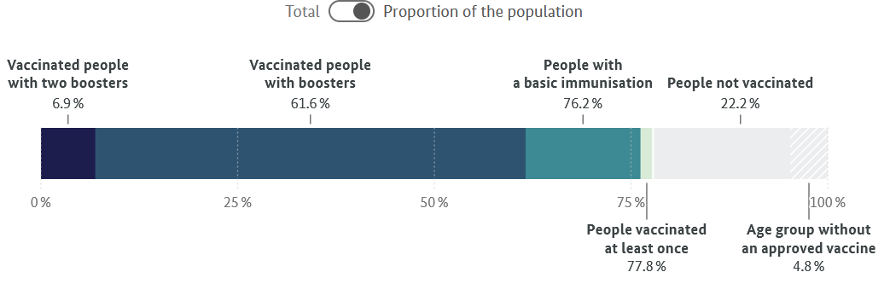
Figure 4: Proportion of Vaccinated German Population as of the 28th of June 2022
Sources: impfdashboard.de, Robert Koch Institute, Der Spiegel, Federal Ministry of Health

Figure 5 shows the current vaccination overview by federal state. In contrast the federal state of Bremen was more successful than Eastern German states (e.g., Saxony) and the overall German government.

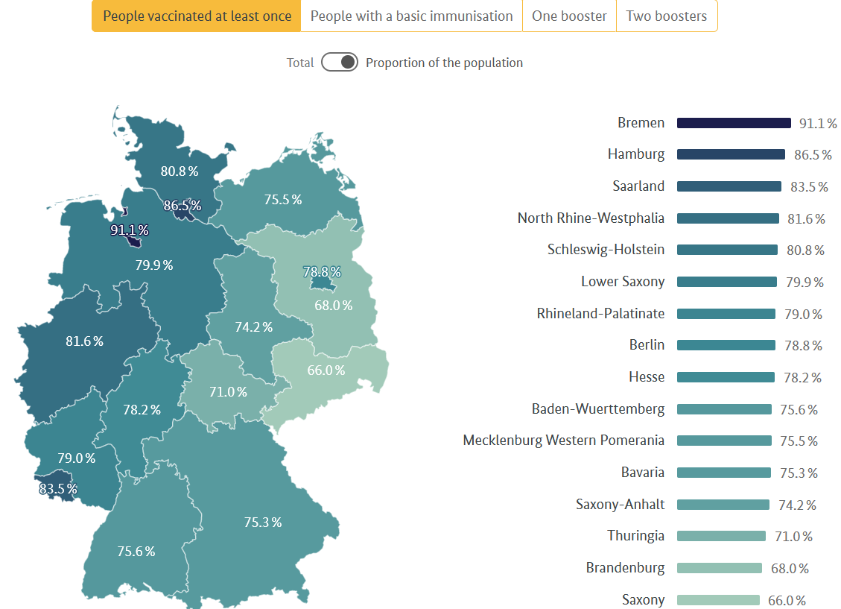
Figure 5: Vaccination Overview by Federal State in Germany as of the 28th of June 2022
Sources: impfdashboard.de, Robert Koch Institute, Der Spiegel, Federal Ministry of Health. as of the 28th of June 2022.
Figure 6 gives an overview on the vaccination progress by age groups. It can be clearly seen that the government focused on administering doses to the elderly throughout the course of the pandemic.
According to the Ministry of Health (2022) it is stated that by the 26th of June 2022, 205.1 M vaccine doses were delivered to authorities in Germany. Manufactured by:
A) BioNTech/Pfizer (147.5 M doses),
B) Moderna (36.1 M Doses),
C) AstraZeneca (14.4 M doses),
D) Johnson & Johnson (5.4 M doses) and Novavax (1.7 M doses).

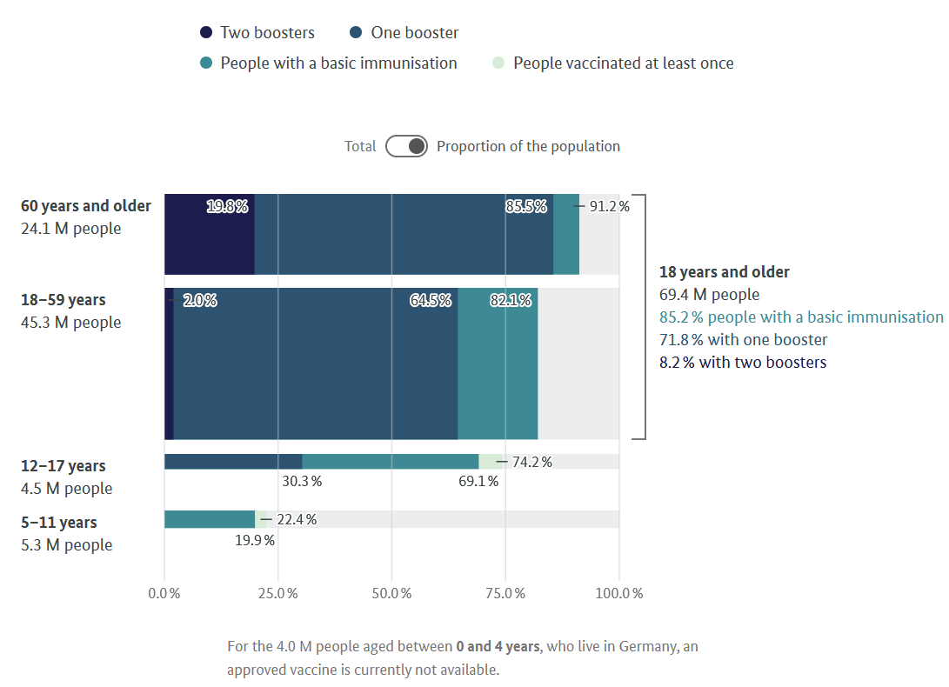
Figure 6: Vaccination progress by age group as of the 28th of June 2022
Sources: impfdashboard.de, Der Spiegel, Robert Koch Institute, Federal Ministry of Health

Considerable response delays, delayed lockdowns and slow uptake of vaccination rates caused higher covid cases among the most vulnerable population groups.

3rd Hand-oriented domains have to execute the operations in the field through their competence and operations network. Here specifically in Germany next to healthcare professionals also vaccination centres, public servants in community centres player a crucial role in Germany’s pandemic executing the set strategic goals of the government.

Germany’s strategy in effectively containing the pandemic over a time window of two and a half years has only been partially successful. Identification, Monitoring, Case Load Reporting as well as Isolation in intensive care units and treatments have been partially successful but could have been more stringent.
As Kock and Eilstroem (2009) describe the competence level of a country and the executing bodies can be achieved by means of continuous on the job learning, learning that can be encouraged or obstructed by the design of a company (in this regard country – federal system) and by the time available to solve issues. Competence development and best utilization of resources are achieved by a complex interplay among all stakeholders and leaders. Figure 7 shows that interestingly, despite being two and a half years in the pandemic, cases remain at the highest summer peak level in June 2022. In the last 2 weeks of June weekly cases spiralled up to 568k respectively 555k cases – the highest numbers seen in summer months in comparison to 2020 and 2021. Even though deaths remain at a relative low end of 173 and 174 weekly cases the executing competence of Germany’s healthcare professionals remains at a stretched and challenged position. Ever changing laws and regulations lead to Covid-fatigue for various nurses and frontline workers leaving their jobs and assignments. The overarching population remains questioning if further lock-downs in the autumn of 2022 will become necessary as vaccination rates remain stagnant at described levels in Figure 6 assuming that efficacy of vaccinations administered will also fade over time.

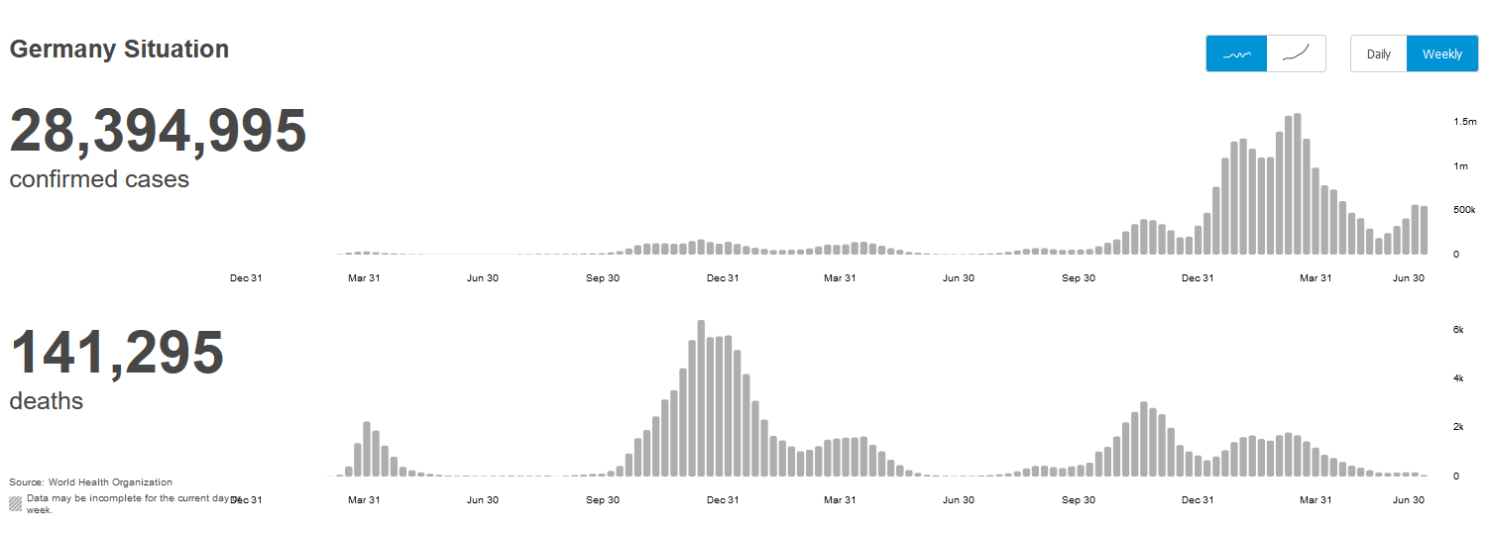
Figure 7: Weekly confirmed corona cases in Germany
Source: (World Health Organization, Confirmed Cases and Deaths, 2022)

The effective integration of all 3H domains as the sufficient factor because of 3 complementing necessary factors.
As described in the conceptual framework section of the descriptive research paper an holistic integration of all 3 domains would have resulted in better outcomes. Yu describes it as following:

The episode of Covid-19 pandemic teaches us that countries even with world-class healthcare specialists, advanced medical technologies, well-equipped hospitals, and ample time for preparation could still badly lose in the pandemic war if their leaders are concerned about political or economic interests more than their people’s lives or failed to unite and engage all people to fight against the pandemic war.
(Yu, 2021, p. 88)

Even though Germany has one of the best healthcare systems in the world and is ranked 8th in the Legatum Prosperity Healthcare Index among 167 countries the country did not achieve an integrated aligned outcome (Healthcare Index, 2021). Germany unfortunately currently ranks on the 5th place in the world with absolute active corona cases being detected (behind the US, India, Brazil and France) with 28,394,995 cases until the 5th of July 2022. In terms of deaths Germany ranks 12th as visible in the Figure 7 from the World Health Organization. Germany is in close range to the United Kingdom with 34,752 cases per 100k population (UK 43,775) with further spiralling cases at current. The US stands at “only” 27k cases per 100k population, which raises questions why Germany did not act more stringent (WHO, 2022b). Table 1 already indicated exemplary a mismatch of immediate actions undertaken to facilitate management solutions for specific economic groups, certain areas of society or industries. However, throughout the pandemic no holistic alignment of heart, head and hand was consecutively applied. More than 35 years after the initial concepts of Burns (1978) and Bass (1985) the German Government should have applied transformational, transactional leadership theories to predict the Corona pandemic strategies performance outcomes.
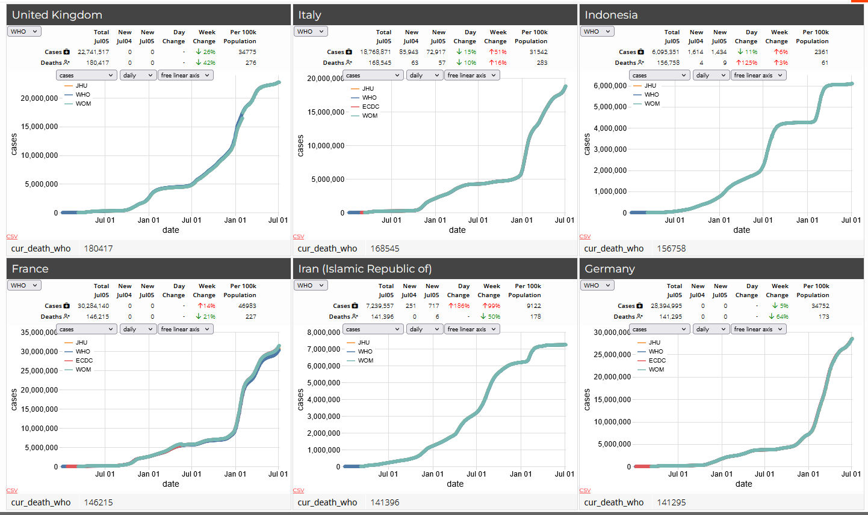
Figure 8: World Health Organization, Countries and Territories - Covid-19 cases and deaths by country – from the 5th of July 2022.
Source: (World Health Organization, 2022)

The German cabinet around Merkel were entrusted by the German population to further contain the Covid pandemic over the last years. Her party and the coalition were ultimately not elected for another term. This led to a new government, as of the 8th of December 2021, with Olaf Scholz as the 9th German chancellor succeeding Merkel and taking over with the Social Democratic Party of Germany.
If and how the new government will be able to contain the pandemic, with a new health minister and strategy, during the next waves remains open as the nation now relies on the new Chancellor’s covid strategy and his cabinet’s responsibility of implementing the sufficient factors (heart, head and hand).

Judging from the past actions of the former German government a holistic effective model has not been applied lacking specifically in H1 and H2. The ongoing process of building a theory of disruption (Christensen, 2005) could be further utilized for prospecting the future, researching in depth- observations in categories, over the last 2 years does not look promising for Germany in containing the next Corona Wave. Here a predicted correlation between the outcomes and respective (unimproved) actions undertaken shows that Germany has a very solid-infrastructure, emergency care units and capable healthcare professionals. However, the utilization of these and circumstances still show that especially the heart and head domains are not fully optimizing these “hand-capabilities”.

Lessons Learnt and Conclusion
As stated above it can be effectively explained that the failure of the government’s covid strategy lies majorly in not fully applying a holistic management approach. Bass and Steidlmeier (1999) found that pseudo transformational leaders often claim the good ideas of the enforcing competence level as their own, while blaming the executing bodies for personal failures. Alignment of all 3 parameters would have been key in Germany. Necessary and sufficient requirements are not combined as assumed in the research objective, resulting in again severely rising corona cases in Q3 2022 and a divided society without providing an overarching solution from the German Government on how to effectively overcome or contain the virus in year 3 of the pandemic. Clayton et al. (2016) found that circumstance-contingent theories are enabling managers (in this paper’s regard “leaders”) to understand their present situation better for applying strategies and tactics. This would have been the utmost key helping German leaders to not only recognise ever shifting covid containment strategy requirements but to also piloting their plane differently to achieve success under new circumstances. It seems to be hard for leaders to change their once set strategy and as Clayton (ibid, p. 8) states for most leaders trying out a new idea to see if it works is simply not an option: There is too much at stake.

Until July 2022 the German government remains not fully able to unite the country and raise the engagement, satisfaction as well as strategic covid management requirements to a level where throughout the pandemic solidarity and larger containment could be achieved. Contradictory, in several states, e.g., Bremen (refer to figure 4) single state measures worked and proofed to be rather holistic and sufficient whereas in states such as e.g., Brandenburg and Saxony a holistic application of the 3H domains seem to not have taken place. As the descriptive research paper focused comprehensively on the entire Federal Republic of Germany it can be concluded that Germany has so far not created a fully effective holistic model which is sufficient and lacks behind its healthcare system capabilities in achieving better results.

To succeed in the long-run and overcome the pandemic more effectively it is recommended that Germany applies for the next months and 2023 a concrete, uniform, and consistent strategy. Managing holistically and applying the 3H model from government side would be key. Even though the country currently observes ongoing and consistently high infection rates; the German federal government has largely relaxed all COVID-19 protection measures since March 2022 further contemplating on respective and right actions among the parties, states, and appointed expert committees. At this stage, after finalizing the descriptive paper, it is currently still unclear, if and how new regulations will be carried out and enforced throughout the remainder of 2022.

References:

BNN, Muench, U. (2021) ‘Corona is challenging the federal State’, Badische Nachrichten, 13th June.
Available at: https://bnn.de/nachrichten/baden-wuerttemberg/corona-stellt-den-foederalismus-auf-den-pruefstand (Accessed: 23rd June 2022).

Baker McKenzie (2022) Germany: Overview of the changes of COVID-19 measures at the workplace from 20 March 2022. Available at: https://insightplus.bakermckenzie.com/bm/employment-compensation/germany-overview-of-the-changes-of-covid-19-measures-at-the-workplace-from-march-20-2022
(Accessed: 29th June 2022).

Barney, J.B. (1995) ‘Looking inside for competitive advantage’. Acad.Manag.Exec. 9(4), pp.49-61.

Barney, J.B. (2001) ‘Resource-based theories of competitive advantage: a ten-year retrospective on the resource-based view’, Journal of Management, Vol.27 No. 6, pp. 643-650.

Barney, J.B. (2001) ‘Is the resource based ‘view” a useful perspective for strategic management research? Yes, Academy of Management Review, Vol. 26 No. 1, pp. 41-56.

Bass, B.M. (1995) ‘Theory of transformational leadership redux’, The Leadership Quarterly, Vol. 6 No.4, pp. 463-478.

Bass, B.M. (2010) ‘Two decades of research and development in transformational leadership’, European Journal of Work and Organizational Psychology, Vol. 8 No. 1, pp. 9-32.

Bass, B.M. (1985) Leadership and Performance, New York: Free Press.

Bass, B.M., Bass, R. and Bass, B.M. (2008). The Bass handbook of leadership: theory, research, and managerial applications. 3rd edn. New York: Free Press.

Bass, B.M. and Steidlmeier, P.: (1999), ‘Ethics, character and Authentic Transformational Leadership Behavior’, Leadership Quarterly, 10, pp. 181–217.

Burns, J.M. (1978) Leadership, New York: Harper and Row.

Christensen, C. (2005) ‘The ongoing process of building a theory of disruption’, Journal of Product Innovation, 23(1), pp. 39-55. DOI: 10.1111/j.1540-5885.2005.00180.x

Christie, A., Barling, J. and Turner, N. (2011) ‘Pseudo-Transformational Leadership: Model Specifications and Outcomes1’, Journal of Applied Social Psychology, 41(12), pp. 2943–2984.
DOI: 10.1111/j.1559-1816.2011.00858.x

Clayton, M., Christensen C. and Raynor, M., (2003) ‘Why Hard-Nosed Executives Should Care About Management Theory’, Harvard Business Review, Harvard Business Review OnPoint, Vol.09, No. 3, pp. 1-9.

Der Spiegel International (2022) A Look at the Worst Mistakes Germany Made in the Coronavirus Pandemic, 20th of May. Available at: https://www.spiegel.de/international/germany/taking-stock-a-look-at-the-worst-mistakes-made-in-the-coronavirus-pandemic-a-e9b02345-7368-450d-b744-b326d99e8840
(Accessed: 23rd June 2022).

Deutschland.de (2020) Chancellor Merkel addressing citizens, 18th of March.
Available at: https://www.deutschland.de/en/news/german-federal-government-informs-about-the-corona-crisis
(Accessed: 23rd June 2022).

Eckerle, I. (2022) Emerging Viruses. Available at: https://www.unige.ch/medecine/demed/en/groupes-de-recherche/isabella-eckerle/
(Accessed: 28th June 2022).

Federal Chancellor (2020) Corona News, 31st of March. Available at: https://www.bundeskanzler.de/bk-en
(Accessed: 23rd June 2022).

Gammelin, K. (2021) ‘I know what we have achieved’, Sueddeutsche Zeitung, 22nd October, p.8.

Gass, G. (2020) ‘Underscoring the lack of coordination’, The Washington Post, 18th March. Available at: https://www.washingtonpost.com/world/europe/germany-coronavirus-merkel/2020/03/18/9f34f2aa-6880-11ea-b199-3a9799c54512_story.html
(Accessed: 05 July 2022).

Gassen, A., Streek, H and Schmidt-Chanasit J. (2020) ‘EVIDENZ- UND ERFAHRUNGSGEWINN IM WEITEREN MANAGEMENT DER COVID-19-PANDEMIE BERÜCKSICHTIGEN’, Position Paper of the Germany's National Association of Statutory Health Insurance Physicians. Available at: https://www.kbv.de/html/48910.php
(Accessed 29th June 2022).

Gassen, A. (2021) ‘Merkel admits the biggest Corona mistake’, Bild Zeitung, 25th October. Available at: https://www.bild.de/politik/inland/politik-inland/corona-merkel-gibt-den-groessten-corona-fehler-zu-78045980.bild.html (Accessed: 04 July 2022).

Governing Mayor of Berlin (2022) ‘Measures against the coronavirus’, 3rd of June. Available at: https://www.berlin.de/corona/en/measures/#headline_1_1
(Accessed: 23rd June 2022).

Helmholtz (2022) Viral Immunomodulation, 20th of March.
Available at: https://www.helmholtz-hzi.de/de/forschung/forschungsschwerpunkte/immunantwort-und-interventionen/virale-immunmodulation/m-brinkmann/
(Accessed: 24th June 2022).

Health Care Index (2021) Best Healthcare in the World 2022, 27t April. Available at:
https://worldpopulationreview.com/country-rankings/best-healthcare-in-the-world
(Accessed:5th of July).

John Hopkins University (2022) Covid-19 Dashboard, Centre for Systems Science and Engineering at John Hopkins University, 28th of June. Available at: https://gisanddata.maps.arcgis.com/apps/dashboards/bda7594740fd40299423467b48e9ecf6
(Accessed: 28th June 2022).

Kaplan, R. S. and Norton, D. P. (1996) The balanced scorecard: translating strategy into action. Boston, Mass.: Harvard Business School Press.

Kaplan, R. S. and Norton, D. P. (2001) The strategy-focused organization: how balanced scorecard companies thrive in the new business environment. Boston, Mass.: Harvard Business School Press.

Kark, R., B. Shamir and G. Chen (2003), ‘The Two Faces of Transformational Leadership: Empowerment and Dependency’, Journal of Applied Psychology, 88, pp. 246–255.

Kock, H., Eilstroem, P.E. (2008) ‚Competence Development in the Workplace: Concepts, Strategies and effects’, Asia Pacific Education Review, 9(1), pp.5-20. DOI: 10.4324/9780203523032
Meyer-Hermann, M. (2020) Europe is locking down a second time. But what is its long-term plan?, 2nd of Nov 2022. Available at: https://www.science.org/content/article/europe-locking-down-second-time-what-its-long-term-plan (Accessed: 29th June 2022).

Ministry for Digital and Transport – The German Federal Ministry for Digital and Transport (2020) German Mobility. Available at: https://www.bmvi.de/SiteGlobals/Forms/Suche/EN/Expertensuche_Formular.html?pageLocale=de&templateQueryStringSearch=corona&submit=search
(Accessed: 26th July 2022)

Ministry of Economic Affairs and Climate Action – The German Federal Ministry of Economic Affairs and Climate Action (2022) Making Every Effort, A Booster for the Economy, Defying the Crisis.
Available at: https://www.bmwk.de/SiteGlobals/BMWI/Forms/Suche/EN/Servicesuche_Formular.html?resourceId=308926&input_=178196&pageLocale=en&selectSort=score+desc&templateQueryStringListen=corona
(Accessed: 26th July 2022)

Ministry of Health – The German Federal Ministry of Health (2020) ‘Coronavirus Pandemic’, 27th of January. Available at: https://www.bundesgesundheitsministerium.de/coronavirus/chronik-coronavirus.html
(Accessed: 23rd June 2022).

Ministry of Labour and Social Affairs – The German Federal Ministry of Labour and Social Affairs (2022) Overcoming the Corona Crisis- Labour and Employment Ministers call for solutions that can be implemented quickly. Available at: https://www.bmas.de/EN/Services/Press/recent-publications/2020/g20-labour-and-employment-ministers-call-for-solutions-that-can-be-implemented-quickly.html
(Accessed 26th July 2022).

Mintzberg, H. (2021) ‘To fix healthcare, ask the right questions’, Harvard Business Review, Volume 8, October 2011.

Mintzberg, H. (1994) ‘The fall and rise of strategic planning’, Harvard Business Review, 72(1), pp. 107-114.

Mintzberg, H. (1990) Strategy formulation: Schools of thought, New York: Harper and Row.

Morris, L., Beck, L. and Noack, R. (2020) ‘Merkel says coronavirus presents gravest crisis since WWII’, The Washington Post, 18th March. Available at: https://www.washingtonpost.com/world/europe/germany-coronavirus-merkel/2020/03/18/9f34f2aa-6880-11ea-b199-3a9799c54512_story.html (Accessed: 05 July 2022).

Peteraf, M.A., Barney J.B. (2003) ‘Unravelling the Resource-Based tangle’, Manag. Decis. Econ., 24(4), pp. 309-323.

Porter, M.E. (1979) ‘How competitive forces shape strategy’, Harvard Business Review, 2(57), pp. 137-145.

Porter, M.E. (1980) Competitive strategy, techniques for analysing industries and Competitors, New York: The Free Press.

Robert Koch Institute, Impfdashboard.de, Federal Ministry of Health (2022) Vaccination – Total proportion of the population, 28th of June 2022. Available at: https://impfdashboard.de/en/
(Accessed: 29th June 2022).

Robert Koch Institute (2022) Robert Koch Institute: Covid 19 Dashboard. Available at: https://experience.arcgis.com/experience/478220a4c454480e823b17327b2bf1d4
(Accessed 26th July 2022).

Robert Koch Institute (2022) Germany’s Corona Situation Report from May 12th 2022. Available at: https://www.rki.de/EN/Content/infections/epidemiology/outbreaks/COVID-19/Situationsberichte_Tab.html;jsessionid=A62AA404CA1C366EFC1A56293D2C606D.internet101?cms_gtp=14466884_list%253D2
(Accessed: 26th of July 2022).

Schein, E. H. (2004) Organizational culture and leadership. 3rd edn., San Francisco: Jossey-Bass.

Senge, P.M. (2003) ‘Taking personal change seriously: the impact of organizational learning on management practice, Academy of Management Perspectives, Vol. 17 No.2, pp. 47-50.

Sirkin, H., Keenan, P. and Jackson, A. (2005) ‘The Hard Side of Change Management’, Harvard Business Review, Vol. 10, No.5, pp. 1-13.

STMGP (2020) Press Release – Bestaetigter Coronavirus-Fall in Bayern – Infektionsschutzmaasnahmen laufen, 27th January. Available at: https://www.stmgp.bayern.de/presse/bestaetigter-coronavirus-fall-in-bayern-infektionsschutzmassnahmen-laufen/
(Accessed: 22nd June 2022).

Streek, H. and Schmidt-Chanasit, J. (2020) Joint Position Paper – Gaining evidence and experience in further management of the Covid-19 pandemic. Berlin: National Association of Statuary Health Insurance Physicians.

Webasto-Group (2020) Employees infected with the coronavirus, 28th of January. Available at: https://www.webasto-group.com/en/press/press-releases/press-release/webasto-informs-about-other-employees-infected-with-the-coronavirus-and-initiates-further-measures/
(Accessed: 22nd June 2022).
WHO (2022), Germany Covid-19 Situation, 22nd June. Available at: https://covid19.who.int/region/euro/country/de (Accessed: 22nd June 2022).

WHO (2022a) Reported cases and deaths by country – Germany”, 5th July. Available at: https://covid19.who.int/region/euro/country/de
(Accessed: 5th July).

WHO (2022b) Countries and Territories Covid-19 cases and deaths by country, 5th of July. Available at: https://portal.who.int/report/eios-covid19-counts/#display=Countries_and_Territories&nrow=2&ncol=3&arr=row&pg=2&labels=cur_death_who&sort=cur_death_who;desc&filter=&sidebar=4&fv=
(Accessed: 5th July).

Yu, Eddie (2020) Introducing 3H framework - working paper. Hong Kong: City University of Hong Kong.

Yu, E. (2021) ‘An analysis of China’s strategy in combating the coronavirus pandemic with the 3H framework’, HKPAA, Emerald Publishing Limited, Vol.24 No.1, pp. 82-84.

Yu, E. and Cheung, H. (2020), ‘A review of the strategic planning process in the Hong Kong Police Force’, HKPAA, Emerald Publishing Limited, Vol. 23, No.3, pp.245-258.

