University of Wales Trinity Saint David
Wales Institute of Science and Art


Analysis and Simulation of a Centrifugal Clutch
Stress Analysis and Dynamics | ACMA5010

Morgan Davies
2205285
December 2023

Contents

Task A 2
Task B 5
References 8

Task A
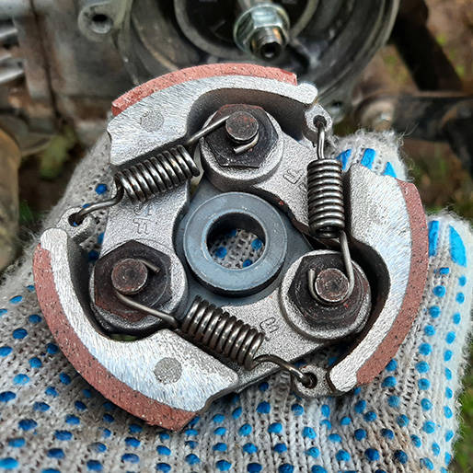
The purpose of this report is to discuss the explain the development of a centrifugal clutch, including the role it plays in today’s engineering principles. A centrifugal clutch works by using centrifugal force to engage to generate power for the driven shaft, usually connected to a wheel axel. The rotating shaft is placed at the centre of the clutch, the outer drum is then concentric to the driving shaft and is connected to this shaft which drives the driven shaft. As the revolutions per minute (RPM) of the engine (rotational velocity) increases, the velocity of the driving shaft increases. Therefore, a centripetal force is produced inwards towards the centre and increases with the velocity, and in turn a reaction force is generated which is equal in magnitude and opposite in direction (following Newton’s 3rd law) outwards to the centre is created which is known as the centrifugal force. An increase in centrifugal force is created, causing the shoes placed on the inner assembly to extend and make contact with the inner wall of the outer drum. The shoes and inner drum wall are made up of a high friction material so that there is a sound connection (Toulas, 2018). This will then allow the drum to rotate at the same velocity as the driving shaft, so the drum will rotate the driven shaft to generate a power output.

Springs
Shoes

Friction Lining
Figure 1- Skill-Lync (2022.). An Engineer’s Guide for Working of a Centrifugal Clutch.

The first development of the centrifugal clutch was prior to 1858. Centrifugal clutches were utilised on railroad locomotives, and they were referred to in an 1899 patent (in relation to electric motors). Later, in the United States during 1898 a trademark for an automotive centrifugal clutch was designed for an electric vehicle. Similarly, the "Automatic Clutch" toy's design was featured in Mechano Magazine in June 1934. Automatic centrifugal clutches were first installed in Armstrong Siddeley vehicles in 1936. The centrifugal clutch for balloon catheters is credited to Thomas Fogerty, who is also recognised as the balloon catheter inventor. Further, in the 1940s they were used in small motor applications (Academic Accelerator 2021).
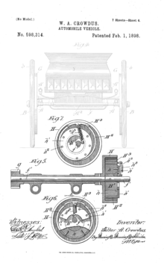

Figure 2- Crowdus,W. (1898). Automobile Vehicle

A centrifugal clutch has many applications in the present day and are commonly used in equipment that have small petrol or diesel engine driven with a high starting inertia. This includes compressors, concrete finishers, transport refrigeration units, mobile water pumps, lawnmowers and go-karts (Lancereal, 2019). To carry out these applications, there are certain operating conditions the centrifugal clutch must abide by to be able to function.
The first condition is that the idle speed needs to be a lower RPM than the engagement speed. This is important so that the friction lining of the shoes do not brush the drum wall for a long period of time, which may burn out the clutch, cause a burning smell and wear down the lining of the shoes. The next condition is that the lining of the shoe must be made from a high friction material with a high friction coefficient, that must also be able to handle the pressure, temperature and wear generated during the processes of engagement and disengagement. The material choices used on centrifugal clutches to appropriately suit these requirements are composite materials such as cork or Kevlar (Kumar, 2023). Additionally, the material choices for a centrifugal clutch shoe can be made from other high friction materials such as ceramic compounds. This is further to ensure there is no slippage with the shoe and drum as the roughness of the lining will provide a suitable grip (O’Keefe, 2012).
Further, another condition that needs to be considered for operation is that the springs that connect to the shoes need to have a suitable spring constant. This is important so that in addition to the first condition, the correct engagement speed is met. If the spring constant is too low, the engagement speed will be too low and potentially at idling RPM. If the spring constant is too high, the engagement speed will be too high, and the shoe could potentially not contact the drum wall and engage when the engine is at its optimum RPM. Finally, the centrifugal clutch must be able to withstand the internal temperature changes it will face when operating. Due to the high levels of friction that will take place during the engagement and disengagement process and the movement of rotating parts, the temperature will increase, therefore, the clutch must be able to withstand these internal changes.
The main advantage of a centrifugal clutch is that the engine it engages can be started under no load. This is due to the driven shaft being disengaged when idling, only when the RPM reaches the engagement speed will there be a connection to the driven shaft. Additionally, this results in no stalling as there is a smooth engagement. A further advantage is that this clutch ensures that a high level of torque is not transmitted back through the flywheel, which could result in irreversible engine damage due to the rotating parts jamming. This could become very costly to replace the equipment; however, the wearing parts of a centrifugal clutch are easily replaced at a low cost. In summary, a centrifugal clutch can allow machinery to run without necessarily operating. This is because a no-load situation is provided, the set engagement speed allows an operator to set which point the clutch can become bound to the driven shaft (Lancereal, 2019).
However, in modern times the centrifugal clutch is becoming less common and mainly used in small equipment. This is due to the increase in the development of alternative clutches, one of these being an electromagnetic clutch. An electromagnetic clutch is a mechanism that engages and disengages power transfer between two spinning shafts in a variety of mechanical systems, similar to a centrifugal clutch. However, the difference is that it uses electromagnetic force to assist in making the process simpler to engage and release the clutch mechanism (Testbook, n.d.). These clutches are used in a variety of applications such as: automatic transmission in automatic cars to control gear shifts, in machinery like a printing press or conveyor systems, agricultural machinery to engage different components, lathes and mills to control spindle rotation, weaving and spinning machines to control fabric tension and marine vessels for engagement and disengagement of propellers (Testbook, n.d.).

Task B
- Diameter of the outer drum:
Radius, r=95+9+4=108mm (including drum thickness)
Diameter=2xr=108x2=216mm=0.216m
- Engagement speed:
$F=mw^{2}r$ $F=kx$ $F=μmg$
$mw^{2}r=kx+μmg$
$w^{2}=\frac{kx+μmg}{mr}$
$w=√\frac{kx+μmg}{mr}$
$w=\sqrt{\frac{\left(7500*0.009\right)+\left(0*9.8\right)}{0.257*0.108}}=49.31rad/s$
In RPM $w=\frac{49.31*60}{2π}=470.92 RPM$
Engagement speed to the nearest RPM= 471 RPM
- Radial force:
$F_{f }=μ$R , $R=F_{c}-F_{c}$
$F_{f}=μ(mw^{2}r-kx)$
$F_{f }=0.35\left(0.275*{\frac{\left(550*2π\right)}{3600}}^{2}*0.108-7500*0.009\right)=10.86N$
- Torque:
$τ=F_{f}*r$
$τ=10.86*0.108=1.17Nm per shoe$
$τ=1.17*4=4.69Nm$
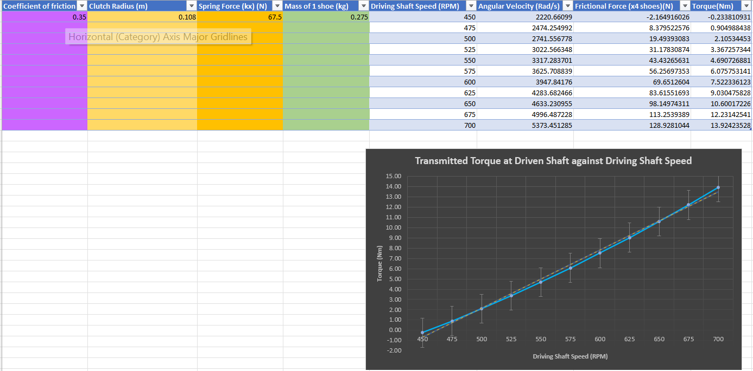

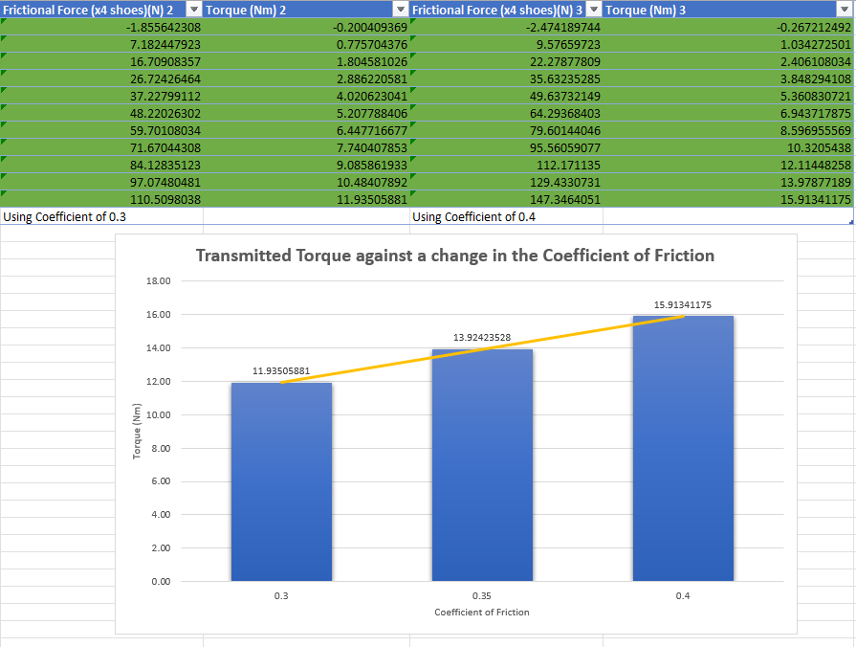

The relationship of this graph shows that as the coefficient of friction increases the transmitted torque to the driven shaft increases at a steady rate from a coefficient of 0.3 to 0.4 in increments of 0.05. This relationship occurs because as the coefficient increases, there is an increase in frictional force and therefore an increase in radial force. Hence, an increase in the torque output.
- Angular acceleration of the drum (using max torque from point 5):
Max torque≈13.92Nm (see table in section 5 for actual value used in calculations) *
Mass= 750grams= 0.75kg
From table, Radial force for a torque of 13.92Nm≈128.93N*
$F=mw^{2}r$ --> $w^{2}=\frac{F}{mr}$
$w^{2}=\frac{128.93}{0.75*0.108}=1591.70 rad/s$
$α=w^{2}r=1591.70*0.108=171.90rad/s^{2}$

References
- Toulas, B. (2018). How does a Centrifugal Clutch work? What are the pros and cons? [Online] EngineeringClicks. Available at: https://www.engineeringclicks.com/centrifugal-clutch/. (Accessed 01/12/2023).
- Lancereal. (2019). Centrifugal Clutch Explained – An Engineer’s Guide to a Centrifugal Clutch. [Online] Available at: https://www.lancereal.com/centrifugal-clutch-explained/ (Accessed 02/12/2023).
- Kumar, S. (2023). What Is Centrifugal Clutch? - Working Principle, Applications, Advantages, Disadvantages. [Online] Available at: https://marinerspointpro.com/centrifugal-clutch/ (Accessed 05/12/2023).
- O’Keefe, P. (2012). Centrifugal Clutch | Engineering Expert Witness Blog. [Online] Available at: http://www.engineeringexpert.net/Engineering-Expert-Witness-Blog/tag/centrifugal-clutch (Accessed 06/12/2023).
- Academic Accelerator. (2021). Centrifugal Clutch . [Online] Available at: https://academic-accelerator.com/encyclopedia/centrifugal-clutch (Accessed 06/12/2023).
- Skill-Lync (2022). An Engineer’s Guide for Working of a Centrifugal Clutch. [Online] Skill-Lync. Available at: https://skill-lync.com/blogs/an-engineers-guide-for-working-of-a-centrifugal-clutch (Accessed 08/12/2023).
- Testbook. (n.d.). Electromagnetic Clutch: Diagram, Working, Advantages, and Uses. [Online] Available at: https://testbook.com/mechanical-engineering/electromagnetic-clutch. Accessed (12/12/2023).

