Extracting forms from observation

Working from the provided studio setup, you are tasked to look, observe and identify emerging shapes and forms.

Working in the confines and format of 26x26cm squares, you will need to divide the 26x26cm squares into quarters to give you four spaces to work with. You will plot imagery into the quarters with a view to exploring colour and pattern in the positive and negative spaces that you have created. You will work with colours from the commercial Farrow and Ball palette, in different medias to create new information.

The session will be led and instructed, allowing you to work through image making and different medias to create a range of ideas.

Additional Tasks: Research (this should be informing your learning, relating to the session, of interest to you and connected to your outcomes).

- Identify and look up at least 4 artists, use the list of names provided on the brief and ensure that you look at the work of Anni Albers (drawings are lovely as well as the weaves), Gunta Stölzl drawings (drawings are lovely as well as the weaves), Miesje Chafer a textile designer, quilter, stitcher and explores the drawn and printed surface too. You are welcome to find your own artists too.

Others not noted but very relevant are;
Steve Attwood Wright, Lilo James, Laura Thomas, Melin Tregwynt, Elvet Mill, these are predominantly weavers or mills with a Welsh background.

- Record your findings and print 3 different images from the 4 artists that you are inspired by, add to your sketchbook. This is suggested, you may have more or less.

- Expand on your findings, note key points about the images, colour, process, technique, media used (small notes, no large chunks of text needed). You should be questioning the relevance of the imagery and how it relates to the learning so far.

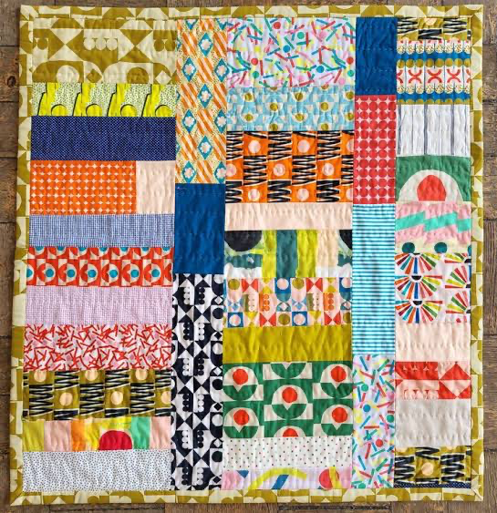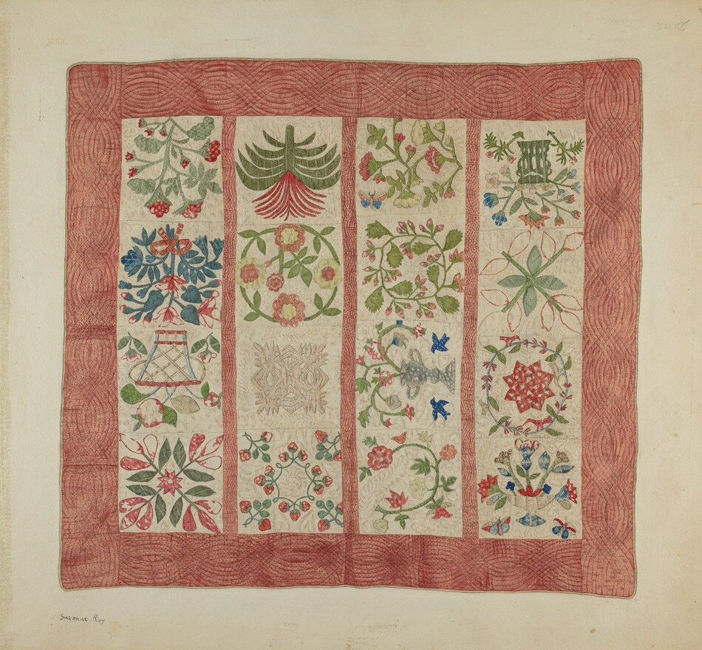
Miesje Chafer Suzanne Roy

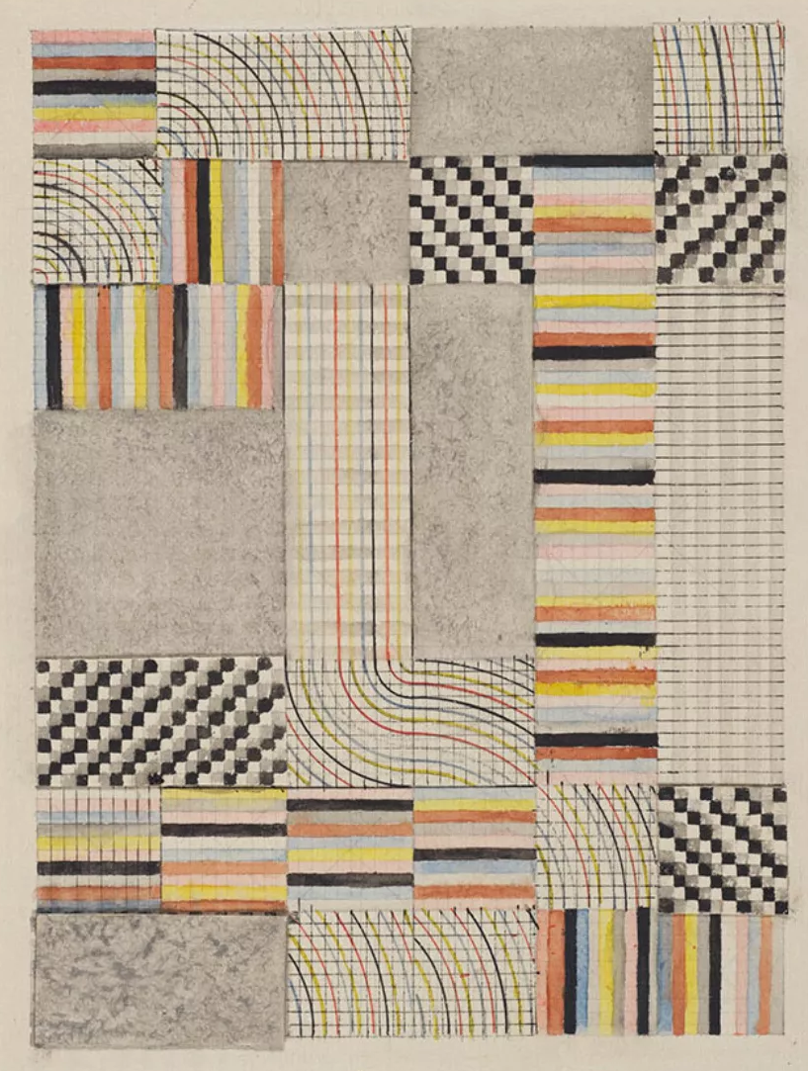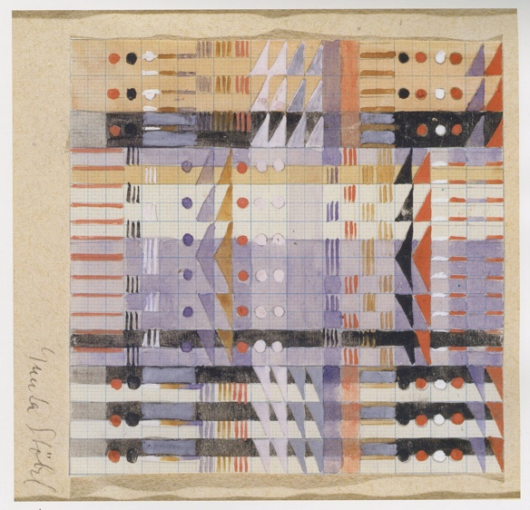
Anni Albers Gunta Stölzl

To extend the session; consider ways that you can divide the 26x26cm squares further perhaps using irregular spaces, instead of the equal quarters, continue to work on your drawing and painting, to extend the body of work and find newness, difference and individuality in your imagery.

