
Hyatt Hotels Corporation

Student Name Axente Paul Adrian
Student Number 2234367
Lecturer Daniel Payne
Module code BMIH5006

Acknowledgement
I confirm that I have not used any AI tools in the research and creation of this assignment. I confirm that I have not presented any AI generated materials as my own work. I confirm I have copies of my drafts, notes, and other resources I used, which I may be asked to provide in evidence.

Executive Summary
Hyatt Hotels Corporation's hybrid structure blends centralization and regional flexibility. The Hyatt Way emphasizes guest service and employee engagement through boosting satisfaction. Technology has helped Hyatt streamline processes, update its loyalty program, and emphasize carbon-reduction post-COVID-19. Hyatt intends to grow into key markets including Asia and Latin America to increase revenue and brand variation. Guest satisfaction and operational efficiency will improve with data-driven customization and intensive personnel training. Social responsibility and innovation distinguish Hyatt in the hotel industry, proving its resilience and adaptability in a fast-changing market.

Table of Contents
Introduction 3
Organisation structure, Culture and Goals 4
Organization structure 4
Organization culture 5
Organization goals 5
Recent Change initiatives 6
Impact of these Initiatives on Hyatt hotels 7
Evaluation of Change management at Hyatt Hotels 8
Strategic Direction 8
Strategic Direction of Hyatt Hotels Corporation 8
Strategies Implemented to Achieve Long-Term Objectives 9
Conclusion 10
Recommendations 10
References 12

Introduction
Management and organizational behavior studies how people and groups interact in an organization and how these interactions affect performance and outcomes, including leadership styles, team dynamics, communication patterns and motivation strategies. The report highlights Hyatt Hotels Corporation's hybrid organizational system that combines centralization and regional flexibility in structure, culture, and strategy. The report investigates "The Hyatt Way," which fosters guest service and employee involvement in the workplace. Technology integration, sustainability, and loyalty program improvements post-COVID-19 affect consumer enjoyment and financial performance. The report provides detail about Hyatt's global expansion, technology advancement and brand diversity. Based on the above criteria, the report suggests personalizing visitor experiences and operational efficiency through data analytics and staff training.
Hyatt Hotels Corporation was founded in the year 1957 and working as a leading global hospitality sector organization with headquarter in Chicago, Illinois. Hyatt Hotel has a portfolio of over 1,300 properties across the world into 76 countries, where the hotel chain operates with diverse range of hotels and resorts under several brand names such as Hyatt Regency, Park Hyatt, Andaz, and Hyatt Place (About.hyatt.com, 2024). The company prioritizes clients for great service and memories. Business and leisure travelers can book 280,714 Hyatt rooms worldwide in 2023 (Statista.com, 2024).
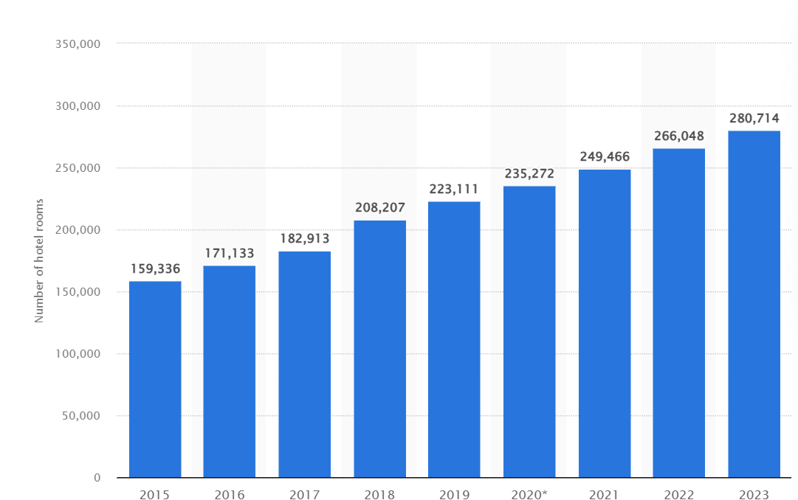
Source: (Statista.com, 2024)
Hyatt expansion strategy includes acquisitions and new projects, where the hotel bought Apple Leisure Group for $2.7 billion in 2021, adding over 100 leisure all-inclusive properties through addressing post-pandemic demand for all-inclusive offerings (Appleleisuregroup.com, 2024). The company revenue increases 0.4% to $1.63 billion for the quarter ending September 2024 at Hyatt Hotels (Nasdaq.com, 2024). With its World of Care initiative, the company hopes to cut carbon emissions and engage the community.

Organisation structure, Culture and Goals

Organization structure
Hyatt Hotels Corporation uses a "hybrid organizational structure" to optimize operations and respond to market dynamics by blending functional and divisional frameworks, where the organization can oversee its basic tasks while letting hotels tailor offerings to local markets by combining centralization and decentralization (Organimi.com, 2024).
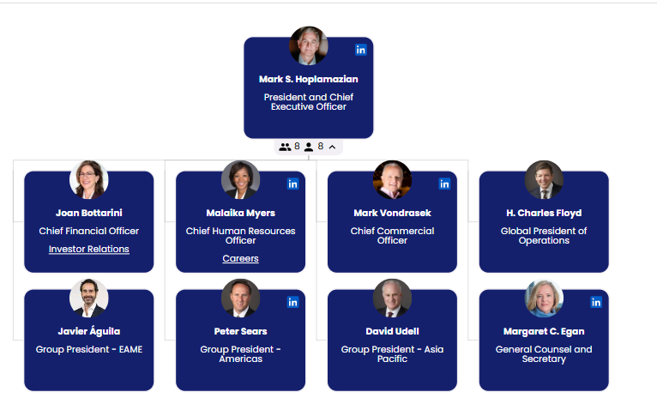
Source: (Organimi.com, 2024)
Board of Directors develops strategy and governs. The CEO and executive team below the board oversee finance, marketing, HR and operations region wise, where the departments makes Hyatt-wider policies. Regional vice presidents oversee Hyatt's North America, Europe, Asia-Pacific, and Latin America divisions, meeting local market needs while implementing company-wide initiatives. Each hotel, whether a full-service Hyatt Regency or a more casual Hyatt Place, can tailor its operations to local tastes to provide culturally appropriate and competitive services (Organimi.com, 2024). Customer expectations vary per region, making this flexibility essential. A hybrid model promotes corporate headquarters-property communication for cross-functional collaboration. Regional teams can tailor marketing to local trends, while HR operations follow corporate standards to ensure employee consistency. Hyatt streamlines operations and helps properties manage resources while keeping brand identity with unified reservations, CRM, and data analytics tools.

Organization culture
Hyatt Hotels' "The Hyatt Way," a corporate culture that cherishes guests and staff, is based on exceptional service and a joyful workplace, where Hyatt's extensive training programs promote professional and personal growth because happy employees generate happy guests. Hyatt culture is based on built upon the practice of empathy, grounded in listening and fueled by care (About.hyatt.com, 2024). Since 2023, Hyatt's employee engagement has outperformed industry averages, indicating a strong workforce. Diversity and inclusion programs for underrepresented groups improve organizational culture. Hyatt's sustainability activities, including as carbon footprint reduction and trash management, fit with workers' and guests' beliefs, establishing a shared commitment to social responsibility that boosts operational performance and customer loyalty. Guest loyalty increases due to Hyatt employees' sincerity and kindness. Hyatt employs systems theory to view its operations as interconnected, emphasizing the synergy between marketing, customer service, and housekeeping to increase efficiency and visitor experience.
The Hyatt Way encourages staff to lead and offer ways to improve service, linking employee success to the company's goal of exceptional guest experiences. Feedback loops encourage employee growth by making them feel valued. The Hyatt Way improves operations by increasing employee happiness and lowering attrition, where Hyatt's turnover rate is 25% compared to 50% for the industry helps in retaining institutional expertise and educate a better team by boosting guest experience (Vcurrtc.org, 2024). Corporate social responsibility at Hyatt includes supporting local charities and environmental sustainability programs through The Hyatt Way.

Organization goals
Corporate-Level Goals: At the corporate level, Hyatt Hotels desires worldwide growth without compromising guest satisfaction or brand integrity, where the corporation plans to open 200 Asian and European hotels annually. Hyatt's loyalty program improves RevPAR increased by 5.9% in the fourth quarter through proving its dedication to financial performance and market competitiveness (Newsroom.hyatt.com, 2023). Hyatt values guest experience, where mobile check-in and data-driven marketing are among the technologies the corporation invests in to improve customer service. Hyatt customer satisfaction increase was 10%, meeting guest expectations.
Individual Unit Goals: At the individual unit level, Each Hyatt hotel sets annual guest satisfaction goals of 90% or above to achieve commercial goals. Through enhanced operations and sustainability, hotels aim to reduce greenhouse gas (GHG) emissions per square meter and water per guest night by 25%. Hyatt's strategy approach to growth and service excellence prioritizes employee training programs, where each unit must hold regularly to improve service delivery, guest experiences, and corporate culture.

Recent Change initiatives
Recent Change Initiatives Undertaken by Hyatt Hotels
Hyatt Hotels Corporation has taken many steps to improve its service, operational efficiency, and brand positioning to react to changing consumer demands, especially following the COVID-19 epidemic, and continue growth.
1. Emphasis on Technology Integration
Hyatt simplified processes and improved guest experiences in 2021 by integrating technology. After the epidemic, the company created a smartphone app for check-in, reservations, and room keys, decreasing contact and enhancing convenience. Hyatt mobile check-ins has been increasing constantly by improving visitor satisfaction.
2. Expansion of Loyalty Programs
The World of Hyatt loyalty program has returned to attract frequent travelers. In 2022, the program added airline and service provider agreements and points earning potential. Mid-2023 World of Hyatt membership increases its members, where the hotel has 30 million+ members, suggesting successful leisure and business expansion (Hollander, 2022).
3. Focus on Sustainability
Hyatt's "Purpose Driven" sustainability plan reduces carbon emissions by 25% by 2030 and conserves water at all properties. Hyatt's will reduce on average an estimated 43,000 metric tons in greenhouse gas emissions this year (Newsroom.hyatt.com, 2023).
4. Diversification of Offerings
Hyatt expanded its market in 2023 with hotel brands. Businesses like "Caption by Hyatt," which promotes community and social interaction, attract younger travelers. Hyatt opened five Caption hotels by 2023 and intends more in urban areas to gain millennial and Gen Z market share and brand repute.
5. Enhanced Health and Safety Protocols
After the pandemic, Hyatt cleaned all properties for health reasons. Guest confidence has returned thanks to the "Hyatt Clean" initiative, which uses hospital-grade disinfectants and strict cleanliness standards. Hyatt average Occupancy Rate is 72.90% as per the year, which is very high in comparison of industry standards (Gurufocus.com, 2024).
6. Expansion into New Markets
Hyatt has spread across Asia and Europe. The company wants to open 25 Asia-Pacific hotels in 2023 to capitalize on the growing travel market, where Hyatt's comparable system-wide hotels RevPAR increased 3.0% compared to the same period in 2023 (Newsroom.hyatt.com, 2024).

Impact of these Initiatives on Hyatt hotels
Increased Customer Satisfaction
Technology, particularly the smartphone app, has improved guest experiences. Mobile check-ins have climbed 66% through improving visitor convenience and customer happiness by boosting occupancy rates and demonstrating Hyatt's dedication to guest satisfaction (Maras, 2022).
Growth in Loyalty Program Membership
In 2023, World of Hyatt membership increases due to incentive program upgrades, suggesting a successful effort to recruit and retain repeat travelers and increase booking frequency. Hyatt says loyal guests produce over 50% of revenue through highlighting this campaign's worth.
Financial Performance Improvement and Market Expansion Success
The Hyatt sustainability plan has boosted brand image and financial performance. With a 25% greenhouse gas emission reduction, Hyatt has won over eco-conscious customers. This may draw eco-friendly customers, increasing revenue. Hyatt's RevPAR increases due to its expansion into Asia-Pacific. Growing openings for Caption by Hyatt indicate expansion and diversification.
Enhanced Brand Image
The "Hyatt Clean" health and safety procedures have regained traveller trust. With 75% of guests expressing enhanced safety confidence, this program has helped boost bookings, especially from wary traveller’s post-pandemic.

Evaluation of Change management at Hyatt Hotels
Strategic Planning and Execution
Hyatt's management performed extensive market research before developing the mobile app to assess guest preferences, where over 60% mobile check-in was achieved when Hyatt modified their offerings using data.
Communication and Stakeholder Engagement
Transformation management at Hyatt needs strong communication. World of Hyatt was implemented with employee and stakeholder input, where real-time feedback and changes boost employee engagement in service industries (Bardukova, 2023).
Adaptability to Market Needs
Hyatt adapts well to market changes. Caption is a young travel company, shows customer trends by growing swiftly. By 2023, this brand had five urban openings, showing Hyatt's market agility.
Challenges and Areas for Improvement
Hyatt struggles to maintain service quality across its brands despite these qualities. The company must avoid sacrificing hospitality's cornerstone, personalized service for technology, where this gap may require staff training and growth.

Strategic Direction

Strategic Direction of Hyatt Hotels Corporation
Vision and Mission
Hyatt's mission statement “To care for people so they can be their best” reflects the company's strategic direction to improve guest experiences, employee relationships and inclusion (Berg, 2021).
Market Positioning
Hyatt promotes luxurious hospitality. Statista expects Hyatt's 2022 sales to reach $5 billion, proving its resilience. Excellent service and unique guest experiences set it apart from Marriott and Hilton.
Sustainability Initiatives and Technology Integration
In alignment with global sustainability trends, Hyatt wants to cut greenhouse gas emissions 25% by 2030 through energy efficiency and sustainable sourcing. For example, Hyatt branch in Pune, India saved 1.8 million gallons of freshwater by working with Ecolab to install 3D TRASAR automation technology for its HVAC systems (Ceowatermandate.org, 2017). The Hyatt uses technology to improve guest service and operations. New Hyatt app allows guests check-in, order room service, and use hotel services remotely. Digital technology can increase consumer satisfaction by 30% for hotel companies, where digital strategy positions Hyatt as a forward-thinking brand in a competitive market.
Customer-Centric Approach and Global Expansion
Over 30 million World of Hyatt members support “Hyatt's customer-centric strategy” by rewarding repeat customers and providing data for targeted marketing. Hyatt's annual report focused on client retention, with loyalty program members generating over 60% of income. Hyatt plans global expansion. Travel demand is booming in Asia-Pacific and Latin America, thus the company is targeting them. Hyatt Hotels Corporation is developing more than 20 luxury and lifestyle hotels in the U.S., Canada, Mexico, Latin America, and the Caribbean until 2025 (Newsroom.hyatt.com, 2024).

Strategies Implemented to Achieve Long-Term Objectives
Growth Strategy
Hyatt prioritizes global expansion in high-demand markets. In 2023, Hyatt stated it would expand its portfolio by 10% over the following several years, targeting Asia and Latin America, where hotel demand is rising, to grab new markets and diversify revenue streams to avoid economic risks.
Sustainability and Corporate Social Responsibility
By satisfying consumer demand for green measures, Hyatt incorporates sustainability. Hyatt has cut energy consumption per square foot by 15% since 2019 as part of its climate-friendly tourist efforts.
Technological Innovation
Hyatt has invested much in technology to improve visitor experience and efficiency. Mobile check-in and contactless payments have improved customer satisfaction since the pandemic., where most of hotel guests feel technology enhances their stay (Gurufocus.com, 2024). Technology fulfils guest needs and makes Hyatt a hospitality innovator.
Brand Diversification
In order to accommodate different tastes and budgets, Hyatt Place and Hyatt House have entered the economic sector, where the method helps Hyatt grow and adapt to market changes.

Conclusion
In conclusion, Hyatt Hotels Corporation's hybrid structure, employee engagement, and customer satisfaction show good management and organization. Technology integration and sustainability help the hospitality company compete. Through "The Hyatt Way," Hyatt boosts business culture and guest loyalty. While expanding globally, Hyatt stresses brand integrity and financial growth, especially in high-demand Asia and Latin America. Adaptability to industry trends and corporate social responsibility boost Hyatt's creative and ethical hospitality image. Hyatt understands guest experiences and operational efficiency in its strategy.

Recommendations
Enhance Personalization Through Data Analytics
- What: Hyatt should invest in modern data analytics to personalize visitor service, where the corporation may tailor discounts and marketing to guest preferences and behavior using World of Hyatt loyalty program data (Gomes, 2023).
- Who: IT, marketing, and guest services should collaborate on this project.
- When: Implementation and trial program in selected sites scheduled for next fiscal quarter within six months.
- Where: The pilot can be run at busy hotels in New York, Los Angeles, and London.
- Why: Personalized experiences increase guest satisfaction, loyalty, and RevPAR.
- How: Consider following Marriott's data-driven marketing best practices. Regular staff training on visitor data use is also possible.
Strengthen Employee Training Programs
- What: Hyatt should improve employee training to emphasize soft skills like personalized client services and technology adaption.
- Who: The HR department and department managers should manage the training program.
- When: Next year, a thorough training program with quarterly sessions can be created.
- Where: Hyatt's corporate offices and properties should offer mixed-learning training with online courses and in-person seminars.
- Why: Well-trained staff improves service, minimizes turnover, and boosts passenger satisfaction.
- How: Hyatt may learn from Ritz-Carlton's training in empowering staff to provide excellent service.

References
About.hyatt.com, 2024. About Hyatt. [Online]
Available at: https://about.hyatt.com/en.html
[Accessed 30 October 2024].
About.hyatt.com, 2024. CULTURE. [Online]
Available at: https://about.hyatt.com/en/world-of-care/caring-for-people/culture.html#:~:text=THE%20HYATT%20FAMILY&text=We%20foster%20an%20inclusive%20environment,listening%20and%20fueled%20by%20care.
[Accessed 30 October 2024].
Appleleisuregroup.com, 2024. HYATT TO ACQUIRE APPLE LEISURE GROUP, EXPANDING GLOBAL BRAND PRESENCE IN LUXURY LEISURE TRAVEL . [Online]
Available at: https://www.appleleisuregroup.com/news-articles/hyatt-toacquire-apple-leisure-group-expanding-global-brand-presence-in-luxury-leisure-travel/#:~:text=CHICAGO%20(August%2015%2C%202021),Partners%2C%20LLC%20for%20%242.7%20billion
[Accessed 30 October 2024].
Bardukova, L., 2023. Navigating the Hospitality Horizon: Current Trends and Strategies for Customer Attraction and Retention in the Hotel Industry. Economics and computer science, 2, pp.88-103.
Berg, P., 2021. Black representation in hospitality industry leadership. THE CONSORTIUM, p.43.
Ceowatermandate.org, 2017. Hyatt Pune Saves Water While Improving Operations (2017). [Online]
Available at: https://ceowatermandate.org/resources/hyatt-pune-ecolab-case-study/#:~:text=A%205%2Dstar%20Hyatt%20hotel,rooms%20while%20saving%20freshwater%20resources.
[Accessed 30 October 2024].
Gomes, M.V.M., 2023. Hyatt Hotels Corporation Equity Research-Implications of the New Industry Outlook (Master's thesis, Universidade NOVA de Lisboa (Portugal)).
Gurufocus.com, 2024. H (Hyatt Hotels) Average Occupancy Rate % : 72.90% (As of Jun. 2024). [Online]
Available at: https://www.gurufocus.com/term/average-occupancy-rate-pct/H#:~:text=H%20(Hyatt%20Hotels)%20Average%20Occupancy%20Rate%20%25%20%3A%2072.90%25,2024)
[Accessed 30 October 2024].
Hollander, J., 2022. Hyatt's 14 Hotel Brands Explained. [Online]
Available at: https://hoteltechreport.com/news/hyatt-hotel-brands
[Accessed 30 October 2024].
Maras, E., 2022. Pandemic drives self-check-in at hotels worldwide. [Online]
Available at: https://www.kioskmarketplace.com/articles/pandemic-drives-self-check-in-at-hotels-worldwide/#:~:text=Self%2Dservice%20technology%2C%20including%20self,service%20(31.5%25)%2C%20self%2D
[Accessed 30 October 2024].
Nasdaq.com, 2024. Compared to Estimates, Hyatt Hotels (H) Q3 Earnings: A Look at Key Metrics. [Online]
Available at: https://www.nasdaq.com/articles/compared-estimates-hyatt-hotels-h-q3-earnings-look-key-metrics#:~:text=Hyatt%20Hotels%20(H)%20reported%20%241.63,a%20surprise%20of%20%2D0.56%25.
[Accessed 30 October 2024].
Newsroom.hyatt.com, 2023. Hyatt Reports fourth quarter and full year 2023 results. [Online]
Available at: https://newsroom.hyatt.com/2023-fourth-quarter-and-full-year-earnings
[Accessed 30 October 2024].
Newsroom.hyatt.com, 2023. Renewable electricity transition of 14 properties around the U.S. through renewable energy certificates supports Hyatt’s World of Care platform and 2030 environmental goals. [Online]
Available at: https://newsroom.hyatt.com/news-releases?item=124404#:~:text=Collectively%2C%20the%2014%20Hyatt%2Downed,used%20to%20power%20more%20than
[Accessed 30 October 2024].
Newsroom.hyatt.com, 2024. Hyatt Grows Luxury and Lifestyle Brand Footprint Across the Americas Region. [Online]
Available at: https://newsroom.hyatt.com/news-releases?item=124526#:~:text=CHICAGO%20(September%2023%2C%202024),and%20the%20Caribbean%20through%202025.
[Accessed 30 October 2024].
Newsroom.hyatt.com, 2024. Hyatt Reports Third Quarter 2024 Results. [Online]
Available at: https://newsroom.hyatt.com/2024-october-31-thirdquarterearnings
[Accessed 30 October 2024].
Organimi.com, 2024. Hyatt Hotels’ Organizational Structure. [Online]
Available at: https://www.organimi.com/organizational-structures/hyatt-hotels/#:~:text=Hyatt%20Hotels%20Corporation%20operates%20with,lines%20of%20responsibility%20and%20accountability.
[Accessed 30 October 2024].
Statista.com, 2024. Number of Hyatt Hotels Corporation hotel rooms worldwide from 2015 to 2023. [Online]
Available at: https://www.statista.com/statistics/824626/number-of-hyatt-hotel-rooms-worldwide/
[Accessed 30 October 2024].
Vcurrtc.org, 2024. Hyatt Hotels and Resorts: Culinary Training Program Case Study. [Online]
Available at: https://vcurrtc.org/resources/viewContent.cfm/43#:~:text=Within%20the%20hotel%20industry%2085,turn%20results%20in%20considerable%20savings.
[Accessed 30 October 2024].

