Target 1 | Continue to use your reading to enhance your understanding of educational issues and concepts.
Target 2 | Further develop and express your knowledge and understanding of communities in Wales.
Target 3 | Make greater use of theory and academic literature to support/justify/question beliefs, assumptions and approaches.

ECAD4008-C: Cycle 1: Leading the Learning: What, how and why am I teaching?

Student Number: 1903950 C. M. Maudie Hughes

Table of Contents

Task Description

- Good teaching and learning means employing a blend of approaches including direct teaching.

- Good teaching and learning sets tasks and selects resources that build on previous knowledge and experience and engage interest.

- Good teaching and learning ranges within and across Areas of Learning and Experience.

(Donaldson, 2015)

Consider the 3 pedagogic principles outlined above. Discuss these principles in relation to your experience in school showing secure understanding, identifying strengths and areas for development for each principle.

Introduction

Education in Wales is presently undergoing a transformational change. Professor Graham Donaldson’s report, Successful Futures, commissioned by the Welsh Assembly Government as part of a comprehensive review of education in Wales provided the catalyst for the development of a new Curriculum for Wales. This carries forward recommendations made to establish four purposes, on which curricula will be designed encompassing the six Areas of Learning and Experience (AoLE) and the three cross curricular strands of numeracy, literacy and digital competence (Education Wales, 2020).

Pedagogy is discussed in some detail in Donaldson’s report. As he states “pedagogy is about more than ‘teaching’ in the narrow sense of the methods used in the classroom” (Donaldson, 2015, p.63) and that for effective learning to take place teachers need to employ a range of skills, methods and approaches combined with theoretical knowledge and understanding. This view is shared by Coe et al. in their report ‘What makes great teaching?’ (Coe, R. et al, 2014) in which they suggest six components that make up great teaching. Donaldson goes on to identify and discuss 12 pedagogical principles that he feels relate to the four purposes and broader curriculum delivery, three of which will be looked at in more detail in this essay. In the context of primary education in Wales these pedagogical principles provide guidance as to what practitioners should be setting out to achieve for and with their learners, for themselves and with their colleagues whilst ensuring that activities undertaken relate to the curriculum. However, it is important to be aware that every individual will have their own personal pedagogical principles alongside these based on their experience, their preferred teaching methods and research they have undertaken (TES, 2018).

At present, schools in Wales are at different stages in a transitional journey towards the implementation of the new Curriculum for Wales. Some continue to follow the existing Foundation Phase Framework (Education Wales, 2015), whilst others are mixing elements of this Framework with aspects of the new Curriculum for Wales. It is worth noting that there are similarities between the two documents; The Foundation Phase Framework has seven Areas of Learning, an approach that is utilised in the new Curriculum for Wales with its six Areas of Learning and Experience. For many working in the Foundation Phase, the transition to the new curriculum will be more straightforward as the underpinning philosophy of the Framework aligns well with it, and many practitioners are already experienced in providing cross curricular learning opportunities and activities.

The Foundation Phase Framework is unique to Wales. Both it and the incoming Curriculum for Wales have drawn on expertise from across the world and the influences of work by theorists such as Malaguzzi (Pound, 2005) who was instrumental in developing the philosophy behind the Reggio Emilia approach, Vygotsky who considered the social element and context of learning, and Bruner who proposed the theory of the spiral curriculum. The influence of Owen and McMillan (Pound, 2005) can be seen in the requirement to include outdoor learning environments, whilst Froebel’s thinking on play is very clearly placed at the core of the Framework. It is designed to be holistic in approach, providing opportunities for both skills and knowledge development whilst building on the previous learning experiences children will have had. It also recognises the importance of equality, diversity and the role parents and carers play as children’s primary educators. In the introductory pages of the Framework document further information is given relating to the progressive nature of the curriculum, acknowledging that children learn and develop at their own pace, through first-hand experiences and in a range of environments.

Foundation Phase Pedagogy and Pedagogical Principles 1 and 3

Of the three pedagogical principles given for consideration in this assignment, the first and third (as stated in the task description) link to techniques and strategies employed in delivering teaching and learning. The Framework documentation is quite clear that the seven Areas of Learning should “complement each other and work together to provide a cross-curricular approach to form a practical relevant curriculum” (Education Wales, 2015, p8).

However, in order to understand the logic behind such an approach it is important to be clear on what the term cross-curricular means. At the most basic level it can be defined as “involving curricula in more than one educational subject” (Lexico, 2020) or “an approach to a topic that includes contributions from several different disciplines and viewpoints” (Collins, 2020). Whereas in secondary schools and to some degree in Key Stage 2 the curriculum is currently delivered in discrete subjects, the Foundation Phase allows and actively encourages cross-curricular delivery, often seen in practice as thematic approaches.

As Barnes suggests in his book Cross-Curricular Learning 3-14 (Barnes, 2007) we live in and experience the world in a cross-curricular way. As such it would appear to make sense to educate children in a similar fashion. However such an approach did not become widely used in the United Kingdom until after the publication of the Plowden Report in 1967, where it was noted that breaking up the curriculum into rigid subject blocks tended to interrupt the train of thought and reduce interest in developing knowledge (Plowden, 1967).

In schools in Wales today, a cross-curricular approach is clearly evident in the majority of foundation phase classrooms, however sessions focussing solely on numeracy and literacy continue to play a regular part in the daily timetable (Welsh Government, 2015). Whilst this practice does not necessarily follow some interpretations of what Foundation Phase delivery should look like, it does provide evidence of direct teaching methods being used. Whilst on placement I observed and taught numeracy and literacy sessions. In these sessions particular skills were being taught, aligned to the expected outcomes and skill descriptors detailed in the curriculum documents. Whilst my placement school is already using the guidance provided in the new curriculum documents, and therefore considering pupil attainment against the Progression Steps rather than the year group indicators detailed in the Foundation Phase Framework, there is still a requirement to detail what skill and knowledge the pupils are to gain.

For example, during a series of numeracy sessions I taught children how to measure using non-standard and standard units. Prior to breaking the class down into smaller groups to undertake a specific task, I discussed measuring with the class as a whole, using several different resources to demonstrate the concept. In one session I used a short animated film to introduce the concept of non-standard measurement, in other I selected at random several children from the class to stand up and asked the remaining children to help me line them up in height order. One particularly successful whole class activity involved use of an online maths game where children had to drag a line along a ruler to the end of the object shown beneath it and then select the correct number card to show the length of the item.

When I then went on to work with the smaller focus groups, I had a number of planet cut outs for the children to measure, firstly using unifix cubes, and then a ruler. This element of the session had some connection to a cross-curricular approach as the theme for work across that fortnight was Space and the Solar System. Through both the whole class and group sessions I used a mixture of direct teaching, and peer to peer teaching when the children were helping each other complete the tasks set. Vygotsky (Pound, 2005) describes this approach as placing children in the zone of proximal development, where they are able to learn new information or skills with the support of another more skilled or experienced person, be that an adult or child. I was also able to provide an opportunity for the children to reinforce their own learning by leaving the on-screen activity available for children who were not engaged in a focus group task, and many children chose to engage with this (Hughes, 2020a).

However, a separate set of sessions I planned and taught were deliberately constructed as cross-curricular. The theme of Space and the Solar System continued to be used to provide an ‘anchor’ for the work and familiarity for the children, something they responded to well. In this case the sessions encompassed three Areas of Learning and Experience from the new curriculum, however they can be aligned with three of the current Foundation Phase Framework Areas of Learning (Hughes, 2020b). The sessions gave the children opportunities to develop and demonstrate their creative skills, language skills and knowledge and understanding of the world. Again, a whole class introduction was used to ‘set the scene’ for the work the children were going to do and provide opportunities for the children to discuss aspects of the tasks with each other and with me.

When the class then separated into the focus groups, further discussion was facilitated as the children were asked to contribute different ideas and suggestions to create a word bank. This also provided an opportunity for them to develop their ideas for the creative task they were going to do. As we continued to do the activity, children were encouraged to peer assess each other’s work. This provided opportunities for the children to respond to each other about their work and demonstrate their understanding of the task, whilst also giving me the opportunity to assess their work alongside them. The use of skill slips to record this information provides evidence of these assessments:

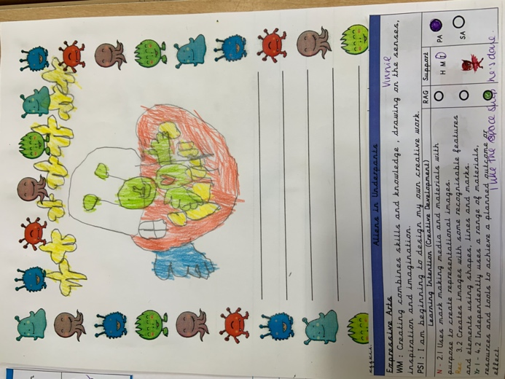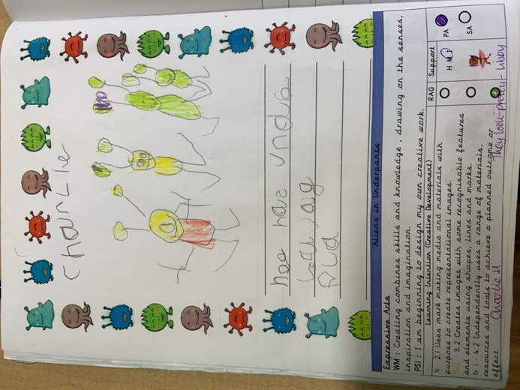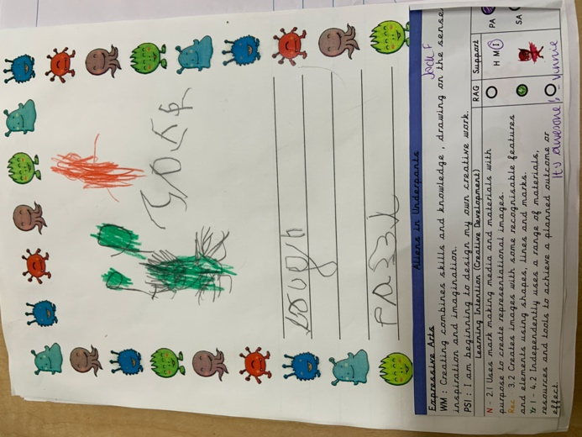
Photo credits: Personal photographs taken with permission of placement school

Formative assessment has an important part to play in the classroom environment and provides a method for teachers to engage pupils actively in their own learning and development (Black and Wiliam, 1998). It provides a means by which teachers can promote and improve the standards of work the children produce through immediate discussion rather than waiting until the work has been completed. Effective use of formative assessment in the classroom enables teachers and pupils to move forward with their work together, developing an ongoing discussion about expectations, understanding and knowledge development. However, it is important to ensure that assessment for learning is handled in a positive manner, with constructive feedback given that directly relates to the quality of the work being produced and not the quantity (The Assessment Reform Group, 1999).

Other methods of assessment can be used as part of good teaching and learning, and as such summative assessment does have a role to play. However, it can be problematic. Some argue that testing (as summative assessment usually takes this form) can have a negative impact on pupil well-being and create a learning environment where lessons are taught based on what will be tested (The Assessment Reform Group, 2006). Assessment of learning is useful for providing an overview of pupil progress at various stages of their academic journey; the data collected can be used to inform wider curriculum, teaching and learning decisions. It should be handled with care however to ensure that pupils do not lose out on broader learning opportunities. It is important to note that the Foundation Phase Framework document refers to outcomes rather than test scores or levels, giving details instead of what practitioners would observe children doing in order to determine the appropriate outcome attained. Overall it is acknowledged that assessment for and of learning are both required as part of good teaching and learning practice. However, there is scope for improvement both in terms of what is being assessed and how it is done (OECD, 2014).
Within my placement school, a number of other approaches are used as part of the teaching and learning environment and experience. In all classes there are images and descriptions of the Learning Pit (Nottingham, 2013) displayed on the walls, and children are actively encouraged to adopt a growth mindset (Dweck, 2012) whilst demonstrating Visible Learning (Hattie, 2009). Flipped learning (Educause, 2012) is used regularly in the school enabling teachers to make greater use of the time available in the classroom for discussion and exploration of ideas. Support is provided for pupils who may not be able to access some of these resources at home so that everyone is able to engage fully with the classroom session.

To effectively deliver good teaching and learning that uses a combination of approaches whilst ranging within and across Areas of Learning, planning is vital. Assessment of the effectiveness of teaching and the progress being made by individual pupils cannot be done without an understanding of what and who is to be assessed, nor can pupils make progress unless a continuum of learning has been set out. I will now consider the second pedagogical principle and how it links with planning in the Foundation Phase.

Planning in the Foundation Phase and Pedagogical Principle 2.

Children are far more likely to engage with learning if the theme or topic is of interest to them, and the activities being offered are fun, enjoyable and appropriately challenging (DCELLS, 2008). With this in mind, practitioners need to have a good understanding of the individual needs and interests of the children in their classes. To some degree this is a knowledge base that will be built up over time as the teacher spends more time with the cohort, however in the early days of a new academic year information will have been gathered through discussion with parents, carers and where appropriate the previous teachers.

One example of good practice I have seen in my placement school is the ‘Identify Day’. Held across the school within each year group, this day provides an opportunity for pupils to share ideas with the teachers and each other about the themes and topics they are interested in and what they would like to learn about. This information then provides the teachers with an outline framework for planning. This is not something that is done simply to tick a box and demonstrate an attempt to engage pupils more fully with their learning, it reflects the evidence collated through research (Flutter, 2007, p343) and the expectations of the UN Convention on the Rights of the Child (UNICEF, 2020).

For example, whilst on placement the themes being explored by the class I was in covered Minibeasts and Space. This provided me with a starting point from which I could discuss with the class teacher the skills the children needed to develop, and then plan and prepare activities and resources that would cover these. My knowledge of the skills and understanding of the children was limited and so it was important for me to seek and utilise the advice given by my class teacher to ensure that the tasks I planned were appropriate. Additionally, when planning tasks and activities I needed to ensure that I provided differentiation within that so as to challenge all children in the class at their individual ability levels.

To maximise the learning opportunities for the children, planning needs to extend beyond the content of lessons and into the provision of enhanced and continuous provision. This provision is identified in the Foundation Phase Framework as child-initiated activity, often also described as being an element of a ‘play-based curriculum’ (New Zealand Government, 2017). Selection of resources for focus group tasks is often driven by the skills to be learned or developed during that session, for example the planets, unifix cubes and rulers I used in my numeracy lesson. However, the resources provided for use in the continuous and enhanced provision areas of the classroom need to be considered carefully as often children will be expected to utilise them with minimal or no adult support. Therefore items such as small world figures, blocks, playdough, themed role play areas and outdoor equipment may be used alongside pictorial guides or ‘WAGOLL – What a good one looks like’ sheets to provide inspiration for the children to develop their skills. In conjunction with the class teacher and other colleagues I was able to contribute to the planning for the enhanced provision areas (Hughes, 2020c) and update the continuous provision to reflect the theme in operation as shown below.
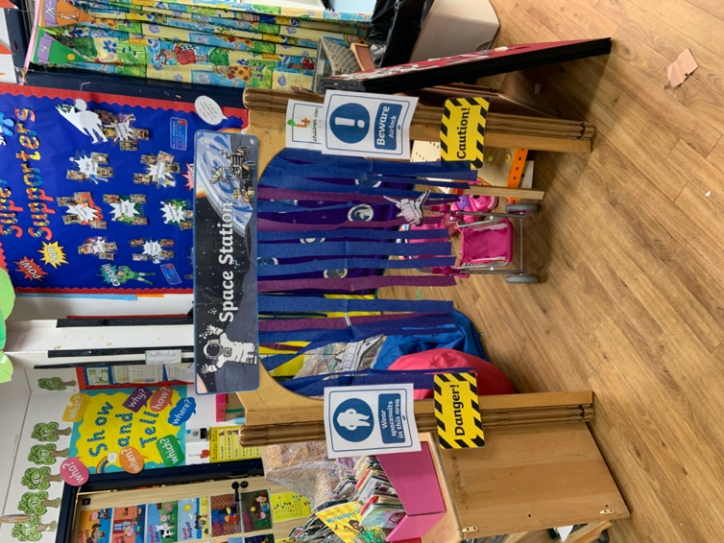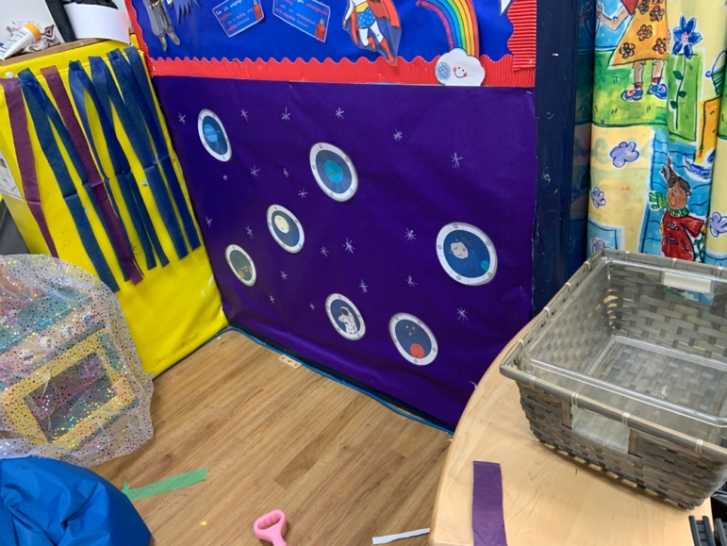
Photo credits: Personal photographs taken with permission of placement school.

Selection of tasks and activities for the children to undertake does not have to be restricted to the classroom and school environment. Learning can take place anywhere and everywhere with multiple influences and experiences impacting the child as shown in Bronfenbrener’s Ecological Systems Model (Pound, 2009). With this in mind, during my placement I set children a ‘story box’ project task to be completed at home, reflecting the learning they would be undertaking on the theme of space. Many of the children took part in this challenge with varying degrees of support from parents or carers, and it was evident in the work produced that they had engaged with and enjoyed both the task and the theme. This also provided opportunities for cross-curricular learning and skills development as children drew on their existing knowledge and experience to create the story boxes, examples of which can be seen in the appendix.

In my placement school, there are four classes for reception age children. Planning sessions for the teachers are timetabled to allow all four class teachers to meet and plan together, and in doing so work collaboratively to provide a range of learning experiences and opportunities for the children. Similarly, differentiation of tasks and challenges is agreed collectively, as are appropriate methods of assessment in line with the approaches used in the school.

Conclusion

As discussed in my introduction, education in Wales is currently undergoing a major transformation. The success of the Foundation Phase Framework philosophy and pedagogy has influenced significant elements of the new Curriculum for Wales; the Areas of Learning and Experience draw on those in use at present in the Foundation Phase, and the concept of Progression Steps could be interpreted as an update and expansion of the Outcomes currently in use. Practitioners in the Foundation Phase are well placed to support colleagues in Key Stage 2 and above in adapting to the structure and ways of working that the new curriculum offers, and this is already happening in some parts of the country (Estyn, 2020). The provision of the 12 pedagogical principles provides a supportive framework for practitioners, aligning the four purposes of the new curriculum to day to day practice, whilst also keeping a link to a more global picture where policies such as the Well-being of Future Generations Act (Welsh Government, 2015) influence decision making. Challenges remain however relating to implementation of the new curriculum, particularly around assessment and school self-evaluation (OECD, 2018), and this has been acknowledged through consultations completed earlier this year (Qualifications Wales, 2019).

From a personal perspective, the experiences I have had during my placement have given me opportunities to observe experienced teachers employing the pedagogical principles suggested by Donaldson and begin developing my own interpretation of them. Feedback I have received from my placement suggests that I have a good understanding of a range of pedagogies and use them appropriately (SWWCTE, 2020). Going forward I will continue to access research to inform my practice and undertake my own in addition to this. It will be important for me to continue developing my subject knowledge, particularly in areas I have identified as being weaker such as Welsh (both language and history). Similarly maintaining an open-minded and flexible approach will be of benefit, enabling me to continually adapt and evolve my practice as I learn and understand more as a result of my studies and observations.

Appendix
Photographs of completed Space themed story boxes. Photographs taken by the class teacher and shared on Twitter, reproduced here with permission granted for photograph use during Professional Teaching Experience placement.
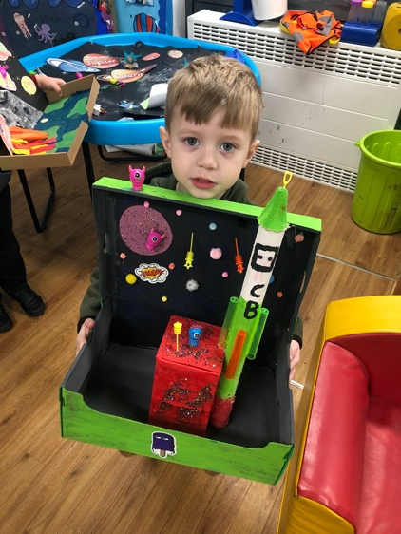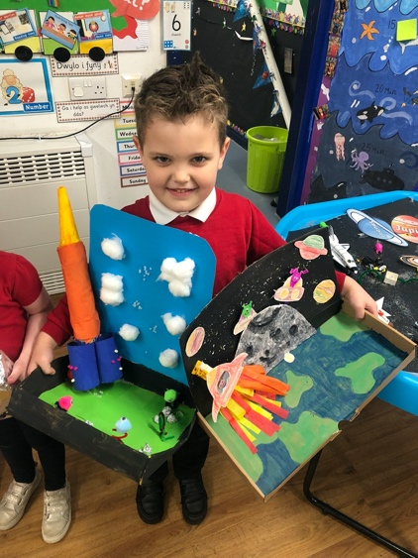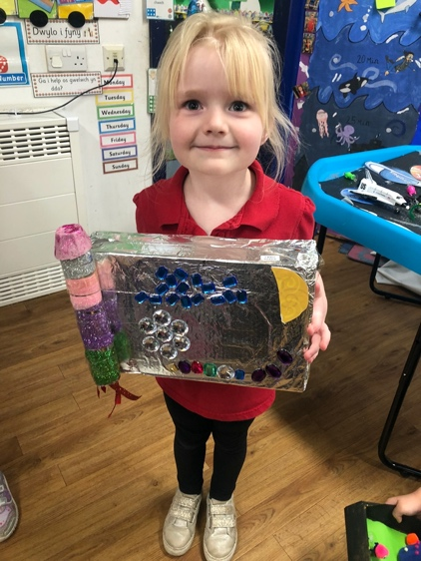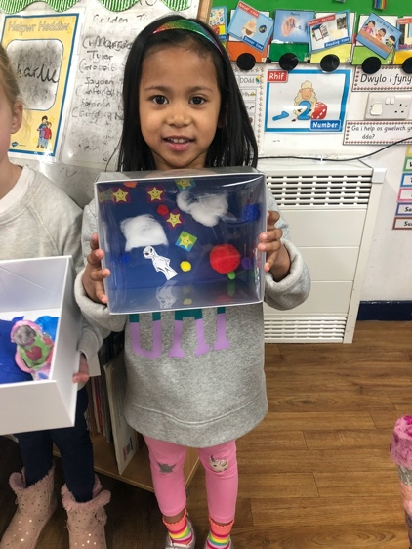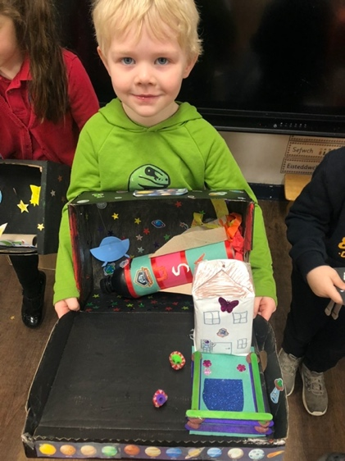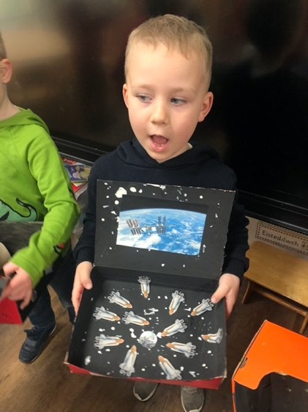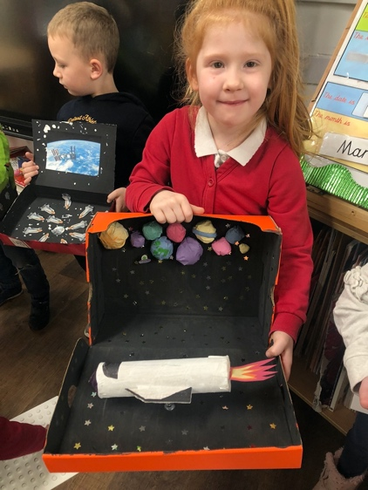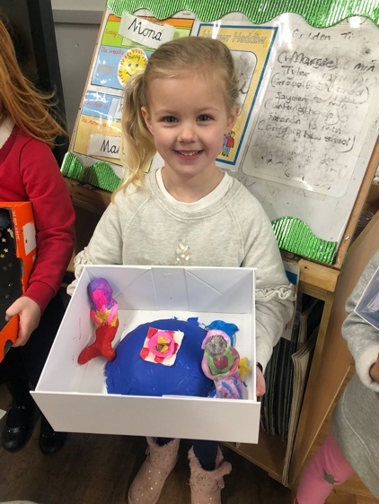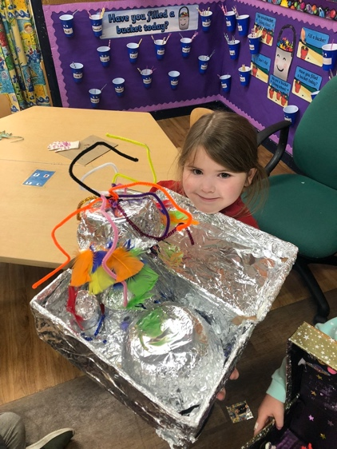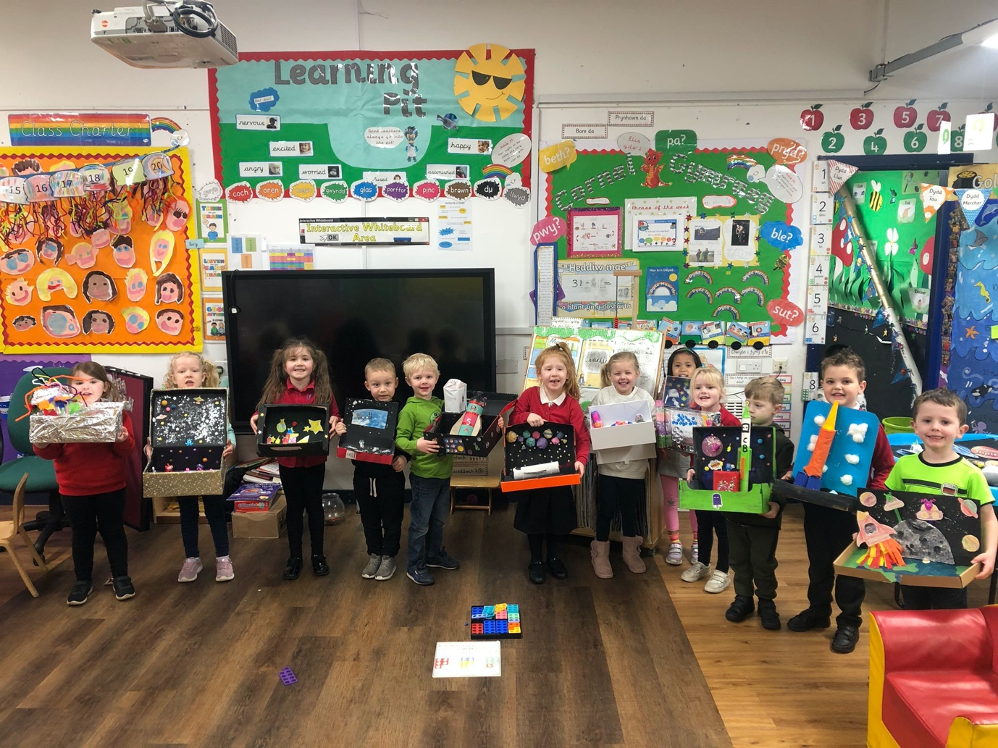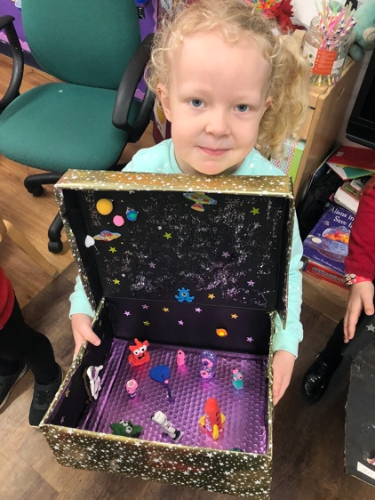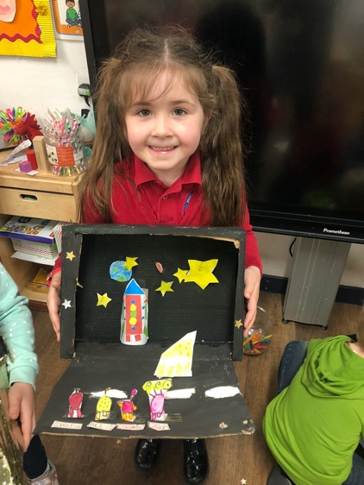

References

Barnes (2007) Cross Curricular Learning 3-14. London: Sage Publications Ltd

Black, P. and Wiliam, D. (1998) Inside the Black Box: Raising Standards Through Classroom Assessment. Available at: https://www.rdc.udel.edu/wp-content/uploads/2015/04/InsideBlackBox.pdf (Accessed: 22 March 2020)

Coe, R et al. (2014) What makes great teaching? Review of the underpinning research. Available at: https://moodle.uwtsd.ac.uk/pluginfile.php/306761/mod_resource/content/0/What-Makes-Great-Teaching-REPORT.pdf (Accessed: 23 March 2020)

Collins (2020) Collins Dictionary. Available at: https://www.collinsdictionary.com/dictionary/english/cross-curricular (Accessed: 24 March 2020)

DCELLS – Department for Children, Education, Lifelong Learning and Skills (2008) Learning and Teaching Pedagogy. Available at: https://hwb.gov.wales/storage/8f0b360f-f1f6-4bec-b11a-df88168007f9/learning-and-teaching-pedagogy.pdf (Accessed: 25 March 2020)

Donaldson, G. (2015) Successful Futures Independent Review of Curriculum and Assessment Arrangements in Wales. Available at: https://dera.ioe.ac.uk/22165/2/150225-successful-futures-en_Redacted.pdf (Accessed: 23 March 2020)

Dweck, C. (2012) Mindset: How you can fulfil your potential. London: Robinson

Education Wales (2015) Curriculum for Wales: Foundation Phase Framework (Revised 2015) Available at: https://hwb.gov.wales/curriculum-for-wales-2008/foundation-phase/foundation-phase-framework/ (Accessed: 24 March 2020)

Education Wales (2020) Curriculum for Wales guidance. Available at: https://hwb.gov.wales/storage/afca43eb-5c50-4846-9c2d-0d56fbffba09/curriculum-for-wales-guidance-120320.pdf (Accessed: 23 March 2020)
Educause (2012) 7 Things you should know about flipped classrooms. Available at: https://library.educause.edu/resources/2012/2/7-things-you-should-know-about-flipped-classrooms (Accessed: 25 March 2020)

Estyn (2020) Evolving Foundation Phase practices at Key Stage 2 generates a pioneering curriculum. Available at: https://www.estyn.gov.wales/effective-practice/evolving-foundation-phase-practices-key-stage-2-generates-pioneering-curriculum (Accessed: 25 March 2020)

Flutter, J. (2007) ‘Teacher Development and Pupil Voice’ Curriculum Journal, 18(3), pp. 343-354. (Accessed: 25 March 2020) DOI: 10.1080/09585170701589983

Hattie, J. (2009) Visible Learning: a synthesis of over 800 meta-analyses relating to achievement. London: Routledge

Hughes, M. (2020a) Numeracy Lesson Plan 4. Available at: https://uowtsd-my.sharepoint.com/:w:/g/personal/1903950_student_uwtsd_ac_uk/EdRusabr8B5HvD2vMw1v4ZUBvdVw5T-Zp0y8ufYuE64XLQ?e=3zfF5f (Accessed: 25 March 2020)

Hughes, M. (2020b) Cross Curricular Session 1. Available at: https://uowtsd-my.sharepoint.com/:w:/g/personal/1903950_student_uwtsd_ac_uk/ER0JGEGj8pZCkvHYWkgRT1QB9_Nla7G66YHhilfes60NvA?e=CwIf14 (Accessed: 25 March 2020)

Hughes, M. (2020c) Enhanced Provision for weeks commencing 9th and 16th March. Available at: https://uowtsd-my.sharepoint.com/:w:/g/personal/1903950_student_uwtsd_ac_uk/EYhYCR-nwxVMilYYmotqNG0BYnsWzx_vKieaXVsyqmp3ow?e=FCX8WC (Accessed: 25 March 2020)

Lexico (2020) Online Dictionary Available at: https://www.lexico.com/definition/cross-curricular (Accessed: 24 March 2020)

New Zealand Government (2017) Te Whāriki Early Childhood Curriculum. Available at: https://education.govt.nz/assets/Documents/Early-Childhood/ELS-Te-Whariki-Early-Childhood-Curriculum-ENG-Web.pdf (Accessed: 22 March 2020)
Nottingham, J. (2013) Encouraging Learning: How you can help children learn. Available at: https://www-dawsonera-com.ezproxy.uwtsd.ac.uk/readonline/9780203559079 (Accessed: 25 March 2020)

OECD (2014) Improving schools in Wales: An OECD Perspective. Available at: http://www.oecd.org/education/Improving-schools-in-Wales.pdf (Accessed: 25 March 2020)

OECD (2018) Developing Schools as Learning Organisations in Wales. Available at: http://www.oecd.org/education/Developing-Schools-as-Learning-Organisations-in-Wales-Highlights.pdf (Accessed: 25 March 2020)

Plowden, B. (1967) The Plowden Report: Children and their Primary Schools. Available at: http://www.educationengland.org.uk/documents/plowden/plowden1967-1.html#16 (Accessed: 24 March 2020)

Pound, L. (2005) How Children Learn. London: Step Forward Publishing

Pound, L. (2009) How Children Learn 3: Contemporary thinking and theorists. London: MA Education Ltd

Qualifications Wales (2019) Qualified for the Future. Available at: https://qualificationswales.org/english/publications/qualified-for-the-future---consultation/ (Accessed: 26 March 2020)

SWWCTE (2020) End of placement summative assessment. Available at: https://swwcte.ac.uk/en/account/summative-assessment?student=1903950&placement=1084&interim=0&partnertype=pr (Accessed: 22 March 2020)

TES (2018) What is pedagogy? Available at: https://www.tes.com/news/what-is-pedagogy-definition (Accessed: 24 March 2020)

The Assessment Reform Group (1999) Assessment for Learning: Beyond the Black Box Available at: https://www.nuffieldfoundation.org/sites/default/files/files/beyond_blackbox.pdf (Accessed: 25 March 2020)
The Assessment Reform Group (2006) The role of teachers in assessment of learning. Available at: https://www.nuffieldfoundation.org/sites/default/files/files/The-role-of-teachers-in-the-assessment-of-learning.pdf (Accessed: 25 March 2020)

UNICEF (2020) The United Nations Convention on the Rights of the Child. Available at: https://downloads.unicef.org.uk/wp-content/uploads/2010/05/UNCRC_united_nations_convention_on_the_rights_of_the_child.pdf?_ga=2.154783352.178550049.1585150623-660125831.1585150623 (Accessed: 25 March 2020)

Welsh Government (2015) Evaluating the Foundation Phase Final Report. Available at: https://gov.wales/sites/default/files/statistics-and-research/2019-07/150514-foundation-phase-final-en_0.pdf (Accessed: 24 March 2020)

Welsh Government (2015) Well-being and Future Generations (Wales) Act. Available at: https://futuregenerations.wales/about-us/future-generations-act/ (Accessed: 25 March 2020)

