In Class Test
Name: James Harris
Student ID: 1902641
Module: Information Engineering
Lecturer: Beverley Holland

Data Flow Diagrams
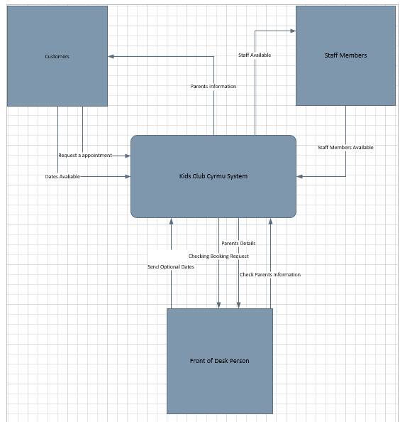
The interfaces required to make a working system.

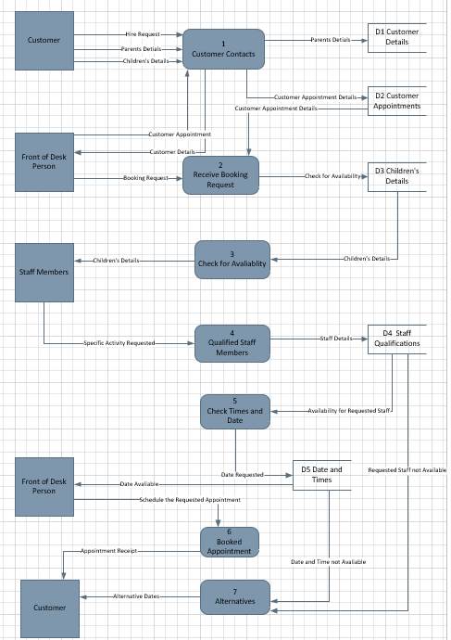
A dataflow diagram showing how the customer will be able to book an appointment for the children.
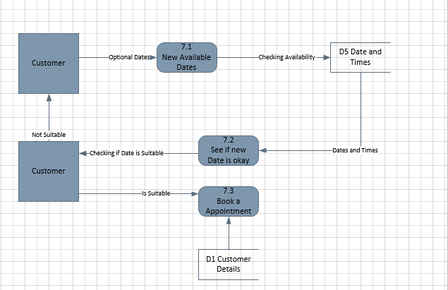
A more enhanced look into how the customer can book an appointment if the specific time requested isn’t available.

Entity Relationship Diagram
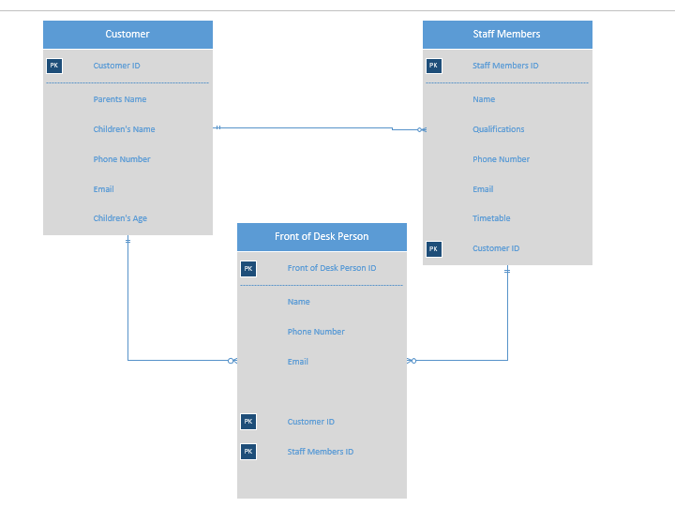
All of the customers information will be going to the front of desk person as they will be the one making the appointment as well as the staff member as they will need to know the information about the child. The staff’s information also has to go to the front of desk person as they will be needing to know if they’re available or not to look after any of the children.

