GLOBAL TOURISM AND DESTINATION MANAGEMENT- M6X01932
India- Assessment of management needs and strategies
Student Name & Student Number: Elena Bogdan-1814439
Lecturer: Olu Adegbite
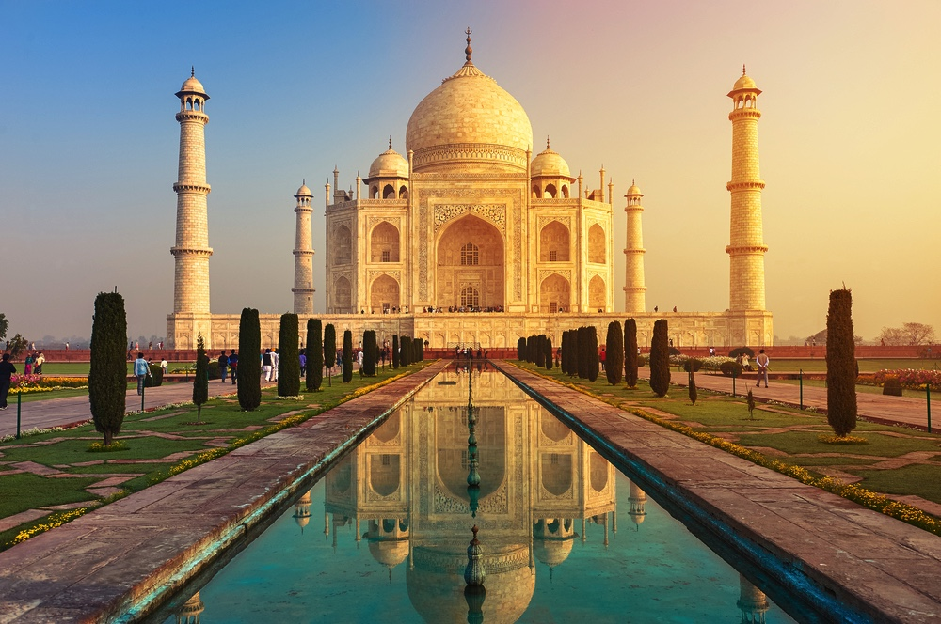
Executive Summary
The report critically examines the approach on strategic tourism management and planning while the whole discussion is focused on the country of India and its viewpoint of the development of the strategic tourism management and planning. A critical revision of a series of tourism management strategies and planning is done from the present global tourism management viewpoint, which are connected to several policies, initiatives and operational strategies. Identified strategic frameworks or approaches are also reviewed in the report that are being followed by India towards destination development and management. The potential merits and demerits of the implemented strategic tourism planning model is analyzed as well in this report. The paper highlights the issues and implications of the models along with a critical reflection on present day models of strategic tourism planning. Discussions have been made about a conceptual framework needed for the developing and improving the tourist destinations of India in future.

Table of Contents
Introduction 3
Reviewing the Implemented Strategic Tourism Planning Model 4
Effectiveness of the Implemented Model 6
Contemporary Issues 7
Conclusion 9
References 11

Introduction
The main purpose of this report will be to critically assess the approach followed in the region of India from the viewpoint of strategic tourism management and planning. The entire discussion will be based on the region of India from the viewpoint of which this strategic tourism planning and management plan will be developed. The effectiveness of this implemented strategic tourism planning model, where the potential benefits or disbenefits will be analysed from the viewpoint of specific strategies, policies and initiatives. The issues as well as the implications of the implemented strategic tourism planning model in India will be highlighted in this paper, along with critically reflecting on present strategic tourism planning model through comparing along with contrasting against a range of examples related to diverse global cases and their respective models. The practical strategic tourism planning models will be taken into account in this paper and the summary of the whole discussion will be given in the conclusion section, at the end of this report.

Reviewing the Implemented Strategic Tourism Planning Model
Tourism plays an integral part in the tourism sector of India. There are plenty of attractive destinations that are situated in this country, which include hill station, sea beaches, historical places and monuments, forest and safaris, adventure tourism and lots of other attractive destinations. The tourism sector also plays an important part in the development and shaping the economy of India. It is also regarded as one of the most rapidly growing business sectors and in this context, it can be noted that tourism is one of most competitive business sectors among all other business industries that operate in this highly global competitive world. The World Travel and Tourism Council calculated that this sector generated a total amount of ₹16.91 lakh crore, which is equivalent to 9.2% of the Gross Domestic Product of India in the year 2018 and supported almost 42.673 million jobs, which can be regarded as 8.1% of its total employment. From various research and studies, it can be estimated that this sector is predicted to grow at an annual rate of 6.9% to ₹32.05 lakh crore by the year 2028, which will be 9.9% of Gross Domestic Product (Uou.ac.in 2020). This sector has been hampered a lot by the recent pandemic that has been caused by coronavirus in recent times, and all the tourist attractions has been closed to stop the outspread of this pandemic. Fresh ideas and approaches need to be followed by the people who are involved in this industry, so that new people can be attracted to avail the services along with increasing the number of repeated visitors, which will automatically help to earn higher revenues along with improving the tourism sector of the country of India.

There are different stakeholders who are involved in the tourism sector of this nation, all with different strategic frameworks or approaches. The citizens of India and the various organizations involved with this sector, their employees, media houses, the state as well as central governments, competitors, business associations, tourism developers and activists and tourists are all regarded as either internal or external stakeholders. Different tourist operators and other companies that are part in this business sector possess different strategic approaches, but all they aim is to maximise their revenue and maintain their growth along with helping the economy of this nation to develop and improve. The market follower strategic approach is one of the strategic frameworks that is followed by most of the business corporations who are involved in Indian tourism industry. This kind of strategy is followed to provide innovative services to the tourists and are not provided by the organizations that operate in other nations. It can be stated in this context that strategic planning is an important factor which helps to win the market along with increasing profitability for the company.
Financial and human resource strategic planning need to be done efficiently by the companies who are associated with the tourism sector of India. Internal analysis of strengths and weaknesses as well as external analysis of opportunities and threats can be regarded as another strategic planning approach which are followed by the internal stakeholders of this sector. Developing sustainable tourism while taking into account that there is a symbiotic relation between the community and tourism is the key to a successful businesses model.

Effectiveness of the Implemented Model
As discussed, tourism is regarded as the largest service provider in the region of India. It provides cultural, heritage, business, medical and sports tourism. The practical strategic tourism planning models will be considered in this paper and the summary of the whole discussion will be given in the conclusion section, at the end of this report.
India’s tourism industry must go through some major challenges as the government’s concerns about security threats are prevailing in this populous world-renowned destination. Though they have launched several campaigns to promote tourism, India’s efforts in this case have always been very limited. In addition to the above-mentioned factors, there are other reasons due to which drawbacks are experienced by the Indian tourism industry. The tourists go through a continuous shifting slate of threats and warnings from the terrorists. Despite the influx of cash from the overseas that is brought by tourism into the country, the Indian tourism industry experiences another challenge that arises within the country. The negative effects of tourism have the potential to include economic boons and thus lead to the migration of workers, an inflation in prices, underemployment due to seasonal work, unnecessary preferences imposed to tourists like water rations. There is an absence of promotion in the tourism sector of India, even though the private organizations and the government spend a huge amount of effort and money for advertising it. Though they have launched a few campaigns to promote tourism, India’s efforts in this case have always been very limited. In addition to the above-mentioned factors, there are further reasons due to which drawbacks are experienced by the Indian tourism industry. It can be noted in this context that tourism plays an integral role in the development of the economy of this region, and the models or frameworks that are related with this sector helps all the stakeholders who are involved with this industry. Even though there are challenges or barriers that are faced constantly by these people, the tourism sector still possesses all the required strength to overcome these challenges and help this sector to grow rapidly. It can be said here that there is an endless number of places capable enough to attract tourists from India as well as from other parts of the world.

Contemporary Issues
The tourism industry of India must go through some major challenges ranging from the concerns of the government to security threats prevailing in this populous world-renowned destination. The regulations of India’s government make the tour operators and tourists get frustrated with the ever-changing visa rules which can result in inconsistent enforcement and leave the travellers in a lurch. Another major problem lingers with the infrastructure issues. When the visitors arrive, several infrastructural problems arise such as inadequacy of roads, sewer, water, telecommunications and hotel services. The airports too need to be expanded so that a greater number of passengers and travellers could be accommodated. There is also a lack of skilled professional workers in the tourist’s facilities who are required to fill all the required positions so that the needs of the global visitors can be catered. The taxes on service, transportation and luxury services are extremely high by which the visitors get hit in their pocket while planning a trip to India. In the first quarter of the year 2013, a drop of over 25 per cent was recorded in the tourism business by the Indian tour operators, resulting from a horrifying and inhuman gang-rape case that occurred in a moving bus in Delhi. The case started bringing in other rape cases from several sex-victims across the country due to which it was reported by the Associated Chambers of Commerce and Industry that female tourism in India dropped by almost 35 per cent in the same quarter. It was also reported by several foreign nations that the rate of crime and violence on tourists have been increasing in India and as such, the female travellers who are travelling alone in India, must refrain from using any private vehicles during the night hours, especially in remote areas or locations. There are other security concerns as well which occurs due to the tension in the borders shared with Pakistan. Due to which, tourists from the U.S. countries were prohibited to visit the disputed area of Kashmir. Foreign tourists were more terrified after the 2008 Mumbai attacks and similar other bombarding incidents conducted by insurgent groups and Islamic terrorists against the Westerners in public places. The tourists go through continuous shifting slate of threats and warnings from the terrorists. In spite of the influx of cash from the overseas that is brought by tourism into a country, Indian tourism industry experiences another challenge that arises within her.

The negative effects of tourism have enough potential to include economic boons and thus lead to migration of workers, inflation in prices, underemployment due to seasonal work, unnecessary preferences offered to tourists like water rations. In India there is a lack of promotion of tourism, while the private organizations and governments of other countries spend a huge amount of effort and money for promoting tourism. Though they have launched a few campaigns to promote tourism, the efforts by India in this case have always been very limited. In addition to the above-mentioned factors, there are some more reasons due to which drawbacks are experienced by the Indian tourism industry. The problems include insufficient airline services during the peak season, delays in case of bookings, cancellation of flights create a lot of difficulties for foreign tourists; lack of proper services in the train; inadequacy of comfortable and hygienic accommodation for travellers; absence of motels for long distance tourists, heavy rush of travellers in the winter season; absence of an integrated program on tourism management and many more (BA and Sami 2016). There are different stakeholders who are involved in the tourism sector of this nation, who all are involved in different strategic frameworks or approaches. The citizens of India, various organizations which are involved with this sector, their employees, media houses, state as well as central governments, competitors, business associations, tourism developers and activists and tourists are all regarded as either internal or external stakeholders.

Future Development and Improvement
The tourism industry of India has to go through some major challenges ranging from the concerns of the government to security threats prevailing in this populous world-renowned destination. The regulations of the government of India make the tour operators and tourists get frustrated with the ever-changing visa rules which can result in inconsistent enforcement and leave the travellers in a lurch. Tourism sector also plays an important part in development and shaping the economy of the country of India.
The whole discussion focused on the country of India and its viewpoint of the development of the strategic tourism planning and management. The potential merits and demerits of this implemented strategic tourism planning model need to be analyzed, so that it will help to identify the flaws within the tourism sector and help to rectify them. Discussions have been made about a conceptual framework needed for the developing and improving the tourist destinations of India in future. The regulations of the government of India make the tour operators and tourists get frustrated with the ever-changing visa rules which can result in inconsistent enforcement and leave the travellers in a lurch. Another major problem lingers with the infrastructure issues. When the visitors arrive, several infrastructural problems arise such as inadequacy of roads, sewer, water, telecommunications and hotel services. Tourism sector also plays an important part in development and shaping the economy of the country of India. It can be noted in this context that tourism is one of most competitive business sectors among all other business industries that operate in this highly global competitive world. It is also regarded as part of the business sector and it can be noted in this context that tourism is one of most competitive business sectors among all other business industries that operate in this highly global competitive world (Arunmozhi and Panneerselvam 2013).

This sector has been hampered a lot by the recent pandemic that has been caused by coronavirus in recent times, and all the tourist attractions has been closed to stop the outspread of this pandemic. Fresh ideas and approaches need to be followed by the people who are involved with this industry, so that new people can be attracted to avail the services of this industry along with increasing the number of repeated visitors, which will automatically help to earn more revenues along with improving the tourism sector of the country of India. Innovative ideas and approaches need to be followed by the people who are involved with this industry, so that new people can be attracted to avail the services of this industry along with increasing the number of repeated visitors, which will automatically help to earn more revenues along with improving the tourism sector of the country of India.

Conclusion
From the above discussion, it can be noted that the tourism sector in India possesses numerous opportunities to use different sets of strategies and frameworks to overcome the issues or challenges that have been discussed in this paper. A series of tourism management and planning strategies that are connected to operational policies and initiatives need be followed by the different stakeholders. Strategic frameworks or approaches have been also reviewed in the report that are being followed by India towards destination management and development. The potential merits and demerits of the strategic tourism planning model which is implemented has been analyzed as well in this report. Discussions have been made about a conceptual framework needed for the developing and improving the tourist destinations of India in future. It is however important to understand the importance the infrastructure plays in this situation. As long as the government invests in infrastructure and offers tourists a diverse range of services at a competitive price, the growth rate of revenues generated by tourism will be ascendant. What is more, it is vital that the state comes up with positive policies and strategies that would catalyze the development of facilities.

References
- Arunmozhi, T. and Panneerselvam, A., 2013. Types of tourism in India. International Journal of Current Research and Academic Review, 1(1), pp.84-88.
- BA, I. and Sami, S., 2016. Journal of Tourism & Hospitality.
- Chauhan, M., 2016. Travel and Tourism Sector in India.
- Dhanoa, R., 2014. Status of tourism and hospitality education in India. International Journal in Multidisciplinary and Academic Research, 3(1), pp.90-94.
- Incredible India V2. 2020. English. [online] Available at: <https://www.incredibleindia.org/content/incredible-india-v2/en.html> [Accessed 10 July 2020].
- India.gov.in. 2020. Travel & Tourism | National Portal Of India. [online] Available at: <https://www.india.gov.in/topics/travel-tourism> [Accessed 10 July 2020].
- Kant, J.P. and Sharma, M., 2016. E–Commerce as Key Factor for Tourism Development in India. International Journal of Pure and Applied Researches, 3(1), pp.112-117.
- Mishra, R. and Shailesh, K., 2012. Making Indian healthcare market a global medical tourism destination. IOSR Journal of Business and Management, 2(4), pp.23-28.
- Parida, Y., Bhardwaj, P. and Chowdhury, J.R., 2015. Impact of terrorism on tourism in India. Economics Bulletin, 35(4), pp.2543-2557.
- Rao, R.S. and Pradesh, V.D., 2014. Emerging trends in hospitality and tourism. International Journal of Research Granthaalayah, 1(1), pp.1-8.
- Secretariat, L.S., 2013. Tourism Sector in India. Members Reference Service, Paliment Library and Reference, Research, Documentation and Information Service (LARRDIS).
- Sharma, N., 2018. Tourism led growth hypothesis: empirical evidence from India. African Journal of Hospitality, Tourism and Leisure, 7(2), pp.1-11.
- Srivastav, S.K. and Kumar, A., 2018. Impact Of Travel & Tourism On Economic Growth In India. Frontiers of Inclusive Growth, 1(1), pp.257-261.
- Subash, T., 2015. Tourism in India: Potentials, Challenges and Opportunities. IJRAR-International Journal of Research and Analytical Reviews, 2(4), pp.8-18.
- Tourism.gov.in. 2020. Home | Ministry Of Tourism. [online] Available at: <http://tourism.gov.in/> [Accessed 10 July 2020].
- Tourism-of-india.com. 2020. India Tours: Holiday Packages In India | Tourism Of India. [online] Available at: <https://www.tourism-of-india.com/> [Accessed 10 July 2020].
- Uou.ac.in. 2020. [online] Available at: <http://www.uou.ac.in/sites/default/files/slm/BTTM-602.pdf> [Accessed 10 July 2020].

