d Segues with Table Rows

It would be nice to swipe for more information about our cafe.

1. Embed the Table View Controller into a Navigation Controller:

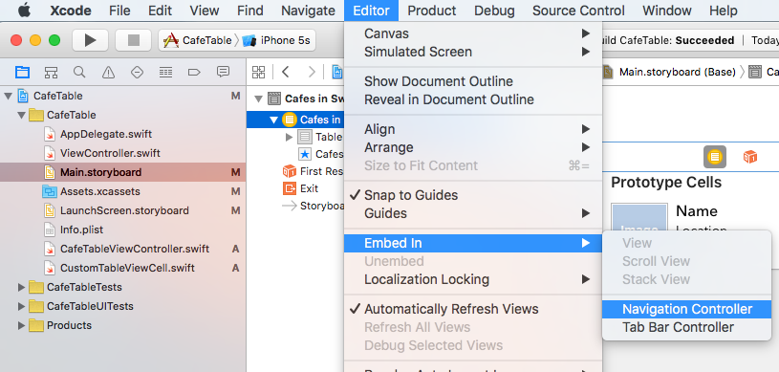

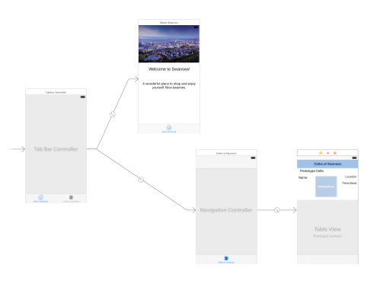

2. Make a title for the Table Controller if you like. This shows up under “Navigation Item” and the attributes menu.

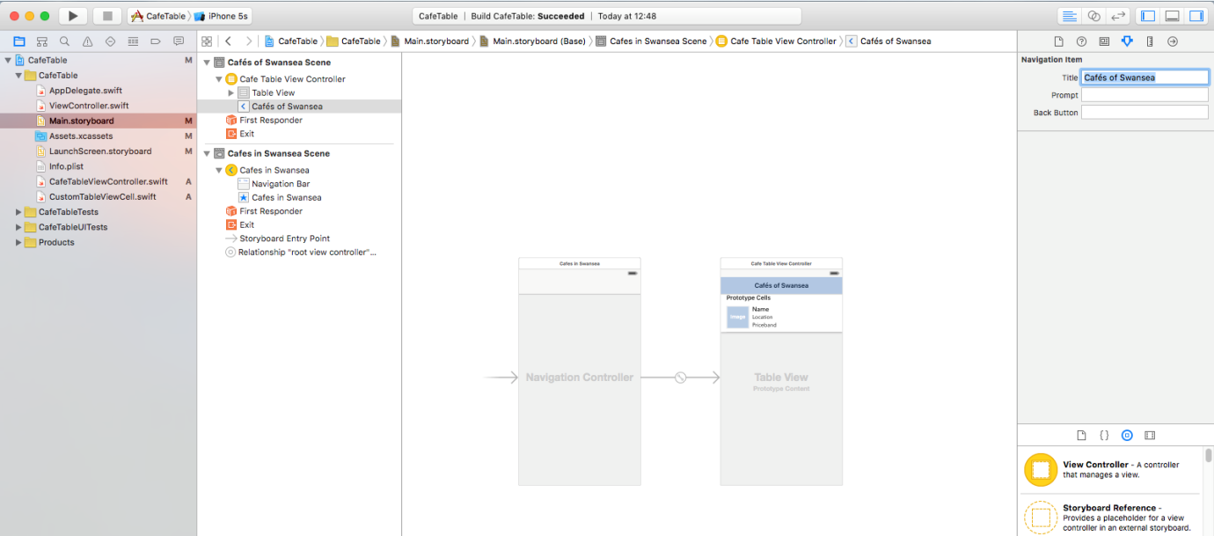

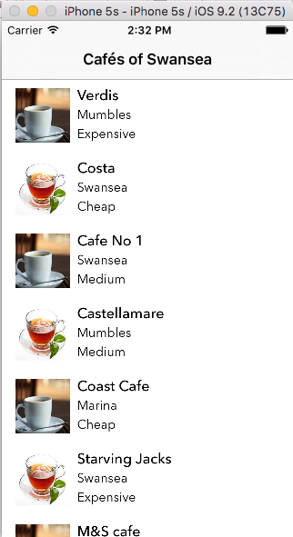

2. We will now create a detailed view page which will show extra information about our cafes.

Add a View Controller and CTRL-click/drag from the cell on the Table View Controller to it. (Make sure you go from the cell to the View Controller, not the other way around.)

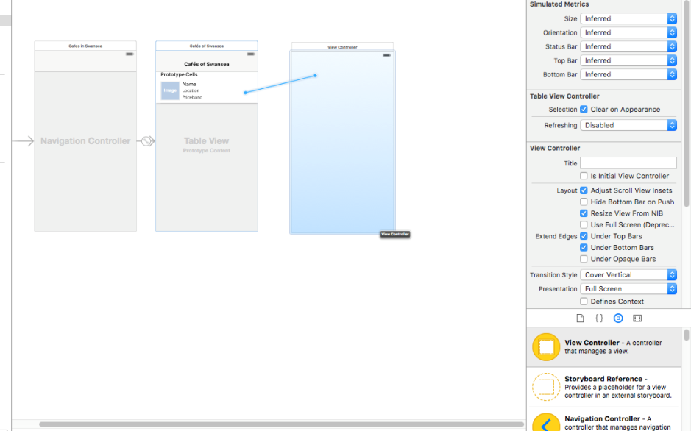

Select “Show”

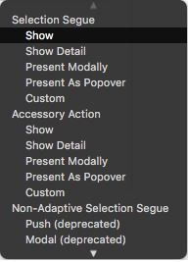

The tables are now joined by this symbol

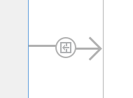

which is a “Show Segue” (formerly known as a "push segue")

…and a small right arrow has appeared on the prototype cell.

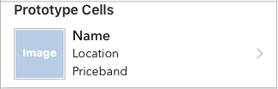

3. Name the segue – click on the Show segue line itself and look in the Attributes Inspector:
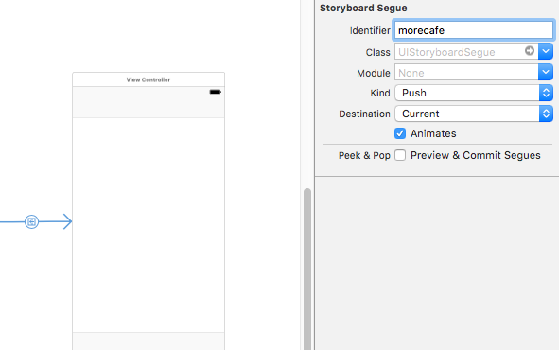

4. Create a new Cocoa touch class which will be the class that controls our new View Controller. Make sure it's a subclass of UIViewController:

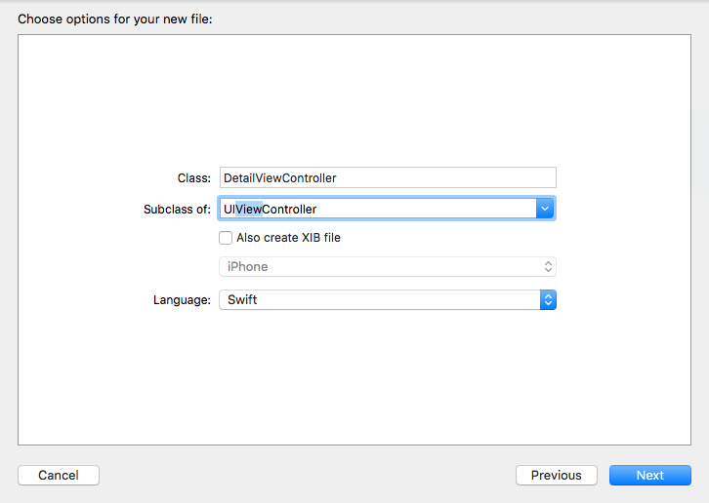

5. Set class of our new View Controller to DetailViewController in the Identity Inspector.

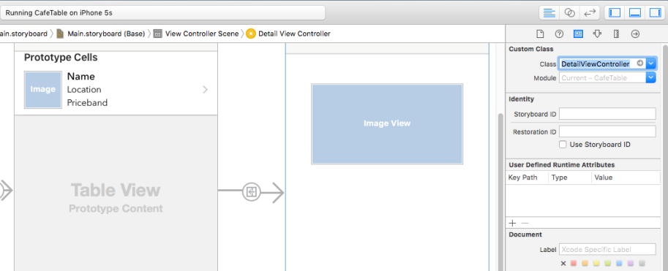

6. In the detail view, we would like to show the cafe picture. Put an ImageView on the new View controller and attach it to DetailViewController.swift. Also add a variable:

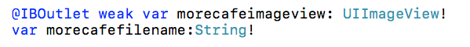

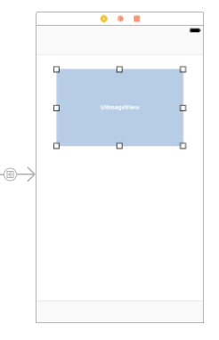

NOTE: The variable morecafefilename will receive the data from the table row. We will then use this variable to write the correct image to our ImageView.

XCode does not like writing directly to the Image.
Back in CafeImageViewController.swift, we will send the cafe image's name through the segue.

Look for a prepare function which is commented out:

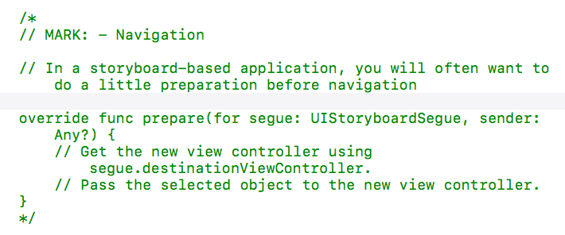

Uncomment it, and add the following:

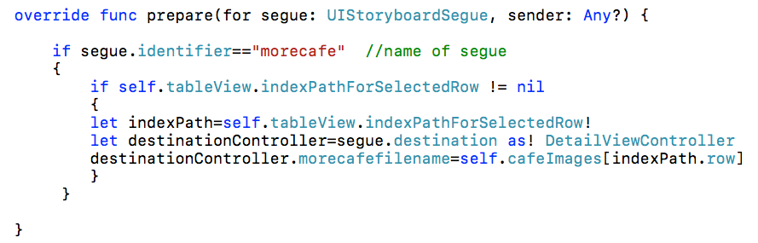
morecafefilename is the variable
in DetailViewController

The above means that if the segue is used, and it is activated while on a cell, the DetailViewController will be loaded and also the filename of the image will be sent.

Now the String variable morecafefilename has received the data, all we need to do in DetailViewController.swift is to use viewdidLoad() to load the relevant picture.

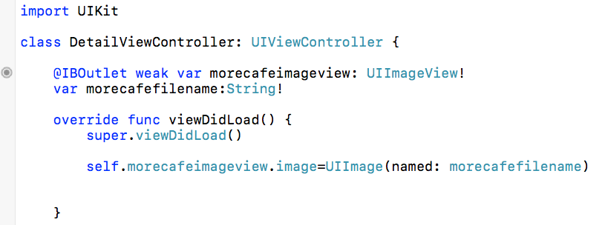
ImageView Variable which
has received filename

Now the image from the original row appears on the segue screen when run in the simulator:

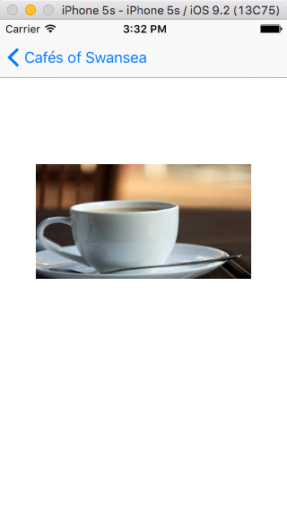

6. Let’s do the same thing for text:

Create a Label:

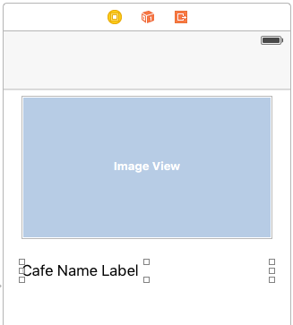

- Go to Detail ViewController.swift and add a label

- Connect and add a variable:

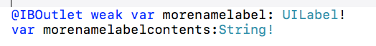

- Send the data down the segue from CafeViewController.swift into the variable morecafefilename

destinationController.morenamelabelcontents=self.cafeNames[indexPath.row]

- Add to DetailViewController.swift's viewDidLoad():

self.morenamelabel.text=morenamelabelcontents

Repeat for other data. (Add in any arrays you might want to hold extra data on the table view controller)

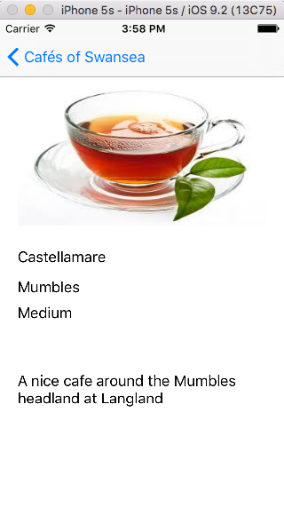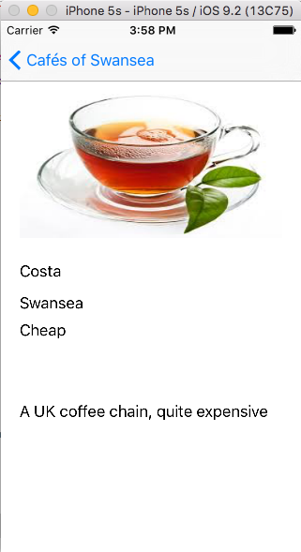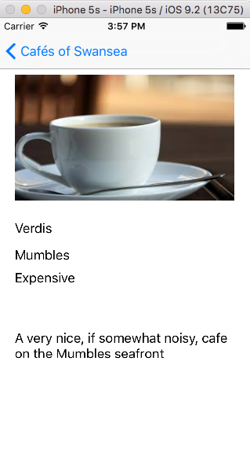

Extra: Write an if statement to say if I’ve been here or not (hint: pass the Boolean value:



