

BMIH6003 Managing Guest Service Operations
Student Learning Log
Student Name: Silvia Daniela Grecu
Student ID: 2245642

Table of Contents
1. Introduction 1
2. Main Body: Department Reflection 1
2.1 Key Issue Identification: Staff Workload and Illness 1
2.2 Theoretical Application: Culture & Teamwork 2
2.3 Three-Step Improvement Plan 4
3. Conclusion 4
References 6

1. Introduction
The following is a learning log about my Level 6 placement in the housekeeping department of the Best Western Abbots Barton Hotel. One of the most basic areas of operation in any hotel is housekeeping, which has a direct impact on the satisfaction of guests, the readiness of the room and efficiency of the service. The duties that I performed during my stay in this department included guest room preparation, linen handling, and keeping the hotels clean.
According to Casado (2012), the housekeeping is the key to the hotel industry since the main product which a hotel sells is a comfortable and clean room. The updated business will not be able to operate without a housekeeping team. Jones (2008) also notes that professional housekeepers must organise their actions to clean rooms quickly and well. I saw this great figure regularly in my replacement. My tight engagement with the team gave me hands-on experience with room preparation's impact on visitor experience. This log will explain a staff workload issue I discovered and apply theoretical frameworks to provide a practical solution for the department.

2. Main Body: Department Reflection

2.1 Key Issue Identification: Staff Workload and Illness
Another challenge that influenced guest service in my placement was dealing with an extra work load because of sudden illness of staff. Applying the Reflective Cycle of Gibbs to analyse this event will assist me in organising my knowledge about the event. One of the team members failed to come to work during a busy morning shift when the number of checks out was high. This meant that the rest of the staff including me had to take care of the physical cleaning of the rooms as well as administrative tasks including linen tracking within a very limited time constraint. First, I experienced a lot of pressure and exhaustion, as we were on a hurry to make rooms ready to receive the people in the afternoon.
As Jayanti (2023) says, the housekeeping departments operate under severe operational pressure, and the lack of staff fast becomes a negative aspect as the rooms are not ready in time, which adversely affects the satisfaction of guests. This was indeed the case as the smaller crew had difficulties with getting the rooms ready in time, which led to a slight delay in early check-ins. Rughubalan (2009) emphasises that housekeeping operation is highly time-educated, and any failure to a set up of the staff schedule will lead to the collapse of service provision.
Thinking of this, I understood that we were able to accomplish the tasks; however, the working environment was very stressful. According to Hagg (2013), one needs to reflect on such challenging workplace events so that they can learn how to solve problems. I also came to know that under high pressure conditions I can manage my tasks and finish the departure rooms with the most urgent ones first. Nonetheless, this experience made it very clear to me that the use of a small number of staff without any contingency plans is an operational risk that affects the overall experience of the guest in a negative way.

2.2 Theoretical Application: Culture & Teamwork
In order to comprehend this staffing problem to the fullest, it is appropriate to connect it to the theories learned in my Level 5 Personnel Resourcing and Development course. The fact that our smaller team managed to complete the shift successfully depended greatly on the high organisational culture and teamwork that existed in the hotel. According to Wood (2013), a good workplace culture motivates employees to offer support to their colleagues whenever there are challenging times in operation. Since there was a high sense of collective responsibility in our team, we shared the additional workload without any disagreement. This is supported by Walker (2021), who adds that hospitality is impossible without effective teamwork since no individual employee is able to provide the whole guest experience.
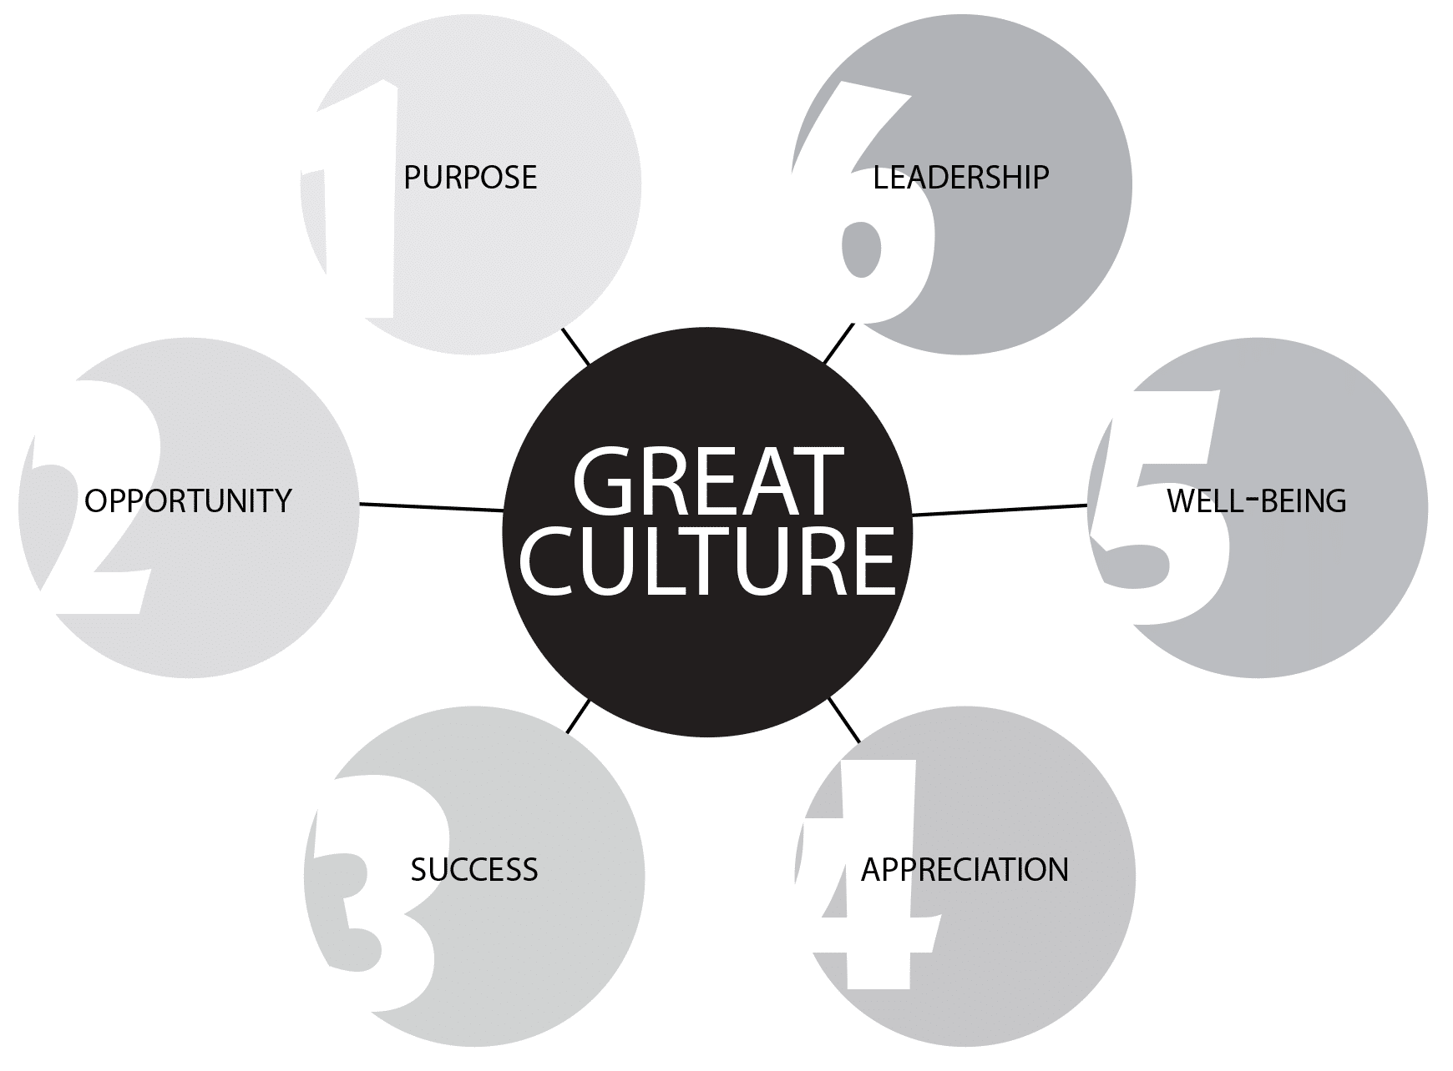
Figure 1 Good Workplace Culture
Moreover, this state of affairs demanded the highly interdepartmental work, especially with the Front Office. We were overstaffed; hence we always needed to communicate with the reception desk to recognise the incoming guests and those who were waiting in the lobby so that we could clean those rooms initially. According to Bardi (2010), the most important communication channel in a hotel is the one which exists between the Housekeeping and the Front Office. Failure to do this communication means that guests will wait in rooms that are not ready. Vallen and Vallen (2014) also report that the process of checking guests in and out is a seamless affair that solely relies on the precision with which the housekeeping provides updates on the room status.
Also, seeing the front desk employees deal with angry guests as they waited to be informed by us showed the importance of being patient and having emotional intelligence. Feeling this pressure first hand made me understand that a positive hotel culture should not only be limited to our respective teams but also be spread throughout the entire hotel. Using the knowledge, I gained in my classroom to this real-life situation made it clear that though a good team culture was the reason we survived the transition, the over-dependence on the flexibility of front-line employees is not a long-term management strategy that the hotel can rely on to manage illness in the future.

2.3 Three-Step Improvement Plan
To tackle the problem of staff shortages and avoid the delays in room readiness in the future, I have come up with a three-step plan of improvements, which is realistic and builds on the best practices in the academic context.
The initial activity is a change in operations: introduction of cross-training programme. The hotel ought to educate a few workers of other departments like the Front Desk or Food and Beverage department on simple housekeeping tasks. In case a housekeeper is sick, a cross-trained worker can be temporarily shifted to help in stripping the beds or to attend to the laundry so that the remaining housekeeping staff do not have to work hard.
Second, changing in line with the best practises in the industry. Johnston et al. (2012) recommend that service operations management should take advantage of cross-training to have a flexible staff capable of adjustments to unexpected demand or workload changes. Rutherford and O'Fallon (2007) recommend cross-training to enhance the efficiency of the hotel and how employees understand the demands of the departments. Felce (2019) states that to address the quality of work-based learning, it is necessary to provide the staff with diverse skills, which is promoted by the current plan. According to Anon (2010), operational acumen is enhanced by the placement of students who have different departmental exposure.
The last step takes into account the satisfaction of the guests. Cross-trained employees make the housekeeping department as fast as it could be despite the labour shortages. It also makes rooms available at the schedule cheque-in time, which will minimise frustration at the lobby. The approach lowers staff burnout and visitor service is hassle free and dependable.

3. Conclusion
To summarise, my experience in the housekeeping department of the Best western Abbots Barton Hotel was an eye-opening experience as it revealed the realities involved in the functioning of a hotel. Tracking down the major problem of employee sickness showed how fast the lack of staff can jeopardise room preparation and customer satisfaction. Using theories on Personnel Resourcing and Development module, I realised that the team culture, which we enjoyed, enabled us to cope with the crisis, however, the structural planning needs to be done better. The three-step improvement plan offered, based on the cross-training of the staff members of other departments, is the realistic solution to this issue. This would allow establishing a more flexible workforce, less pressure on the housekeeping staff, and make sure that guests will always get their rooms on time, which would enhance the overall quality of the guest services experience.

References
Anon (2010) "A Good Practice Guide for Placement and Other Work-based Learning Opportunities in Higher Education - Good Practice for Placements Guides - Volume 2. 52 (4). doi: 10.1108/et.2010.00452dab.013.
Bardi, J. (2010) Hotel Front Office Management. 5th Ed. London: Wiley.
Casado, M. (2012) Housekeeping Management. 2nd Ed. London: Wiley.
Felce, A. (2019) 'Managing the quality of higher education in apprenticeships', Higher education, skills and work-based learning, 9(2), pp. 141-148.
Hagg, E. (2013) Internship Guide: Work Placements Step by Step. 5th Ed. The Hague: Eleven International Publishing.
Jayanti, J. (2023) Hotel housekeeping management: changing trends and developments. Oxford: Goodfellow Publishers.
Johnston, R., Clark, G. & Shulver, M. (2012) Service Operations Management. London: Pearson.
Jones, T.J.A. (2008) Professional management of housekeeping operations. 5th Ed. Hoboken, N.J.: John Wiley & Sons.
Rughubalan, G. (2009) Hotel Housekeeping: Operations and Management. Oxford: Higher Education Press.
Rutherford, D. G. & O'Fallon, M. J. (eds.) (2007) Hotel management and operations. 4th Ed. Hoboken, N.J: John Wiley.
Vallen, G.K. & Vallen, Jerome J. (2014) Check-In Check-Out: Managing Hotel Operations. 9th Ed. Harlow: Pearson Education Limited.
Walker (2021) Introduction to hospitality. 8th Ed. Global edition. Harlow, England: Pearson.
Wood, R.C. (2013) Key Concepts in Hospitality Management. London: SAGE Publications Ltd.

